
BOCES Curriculum and Instruction Council
Thursday, December 11, 2008
8:30 – 10:30 AM
Administration Building

PRÉCIS

Welcome and Introductions

Primer on checking regional scoring sheets – Michele Rourke
- There is a smaller scoring window for ELA scoring this year. As a result, quality control in the home district is all the more important. Any answer sheet that has an error on it will cause the student to be counted as nontested!
- As answer sheets come in they will be scanned, so the sooner you can turn in your answer sheets the better.
- Contact Michelle Rourke or Noelle Hickok at 433-2248 with any questions.
- Their handouts, memos, and charts will be posted electronically soon.

State Education Department Updates
- Status of Differentiated Accountability: The Differentiated Accountability proposal is still under consideration by the USDOE; no final determination has been made at this point. The same is true for Growth Model Status. (http://nysmsa.org/associations/611/files/Growth%20and%20DA.ppt)

- Regents’ State Aid Proposal: The Board of Regents released their state aid proposal. Overall, it calls for a 4.1% increase over last year which is less than they had previously said that they would request. (http://www.oms.nysed.gov/press/stateaid_2009.htm)

- Formative Assessment Initiative: A project between the New York Comprehensive Center and the Syracuse City School District is underway. They are examining the effect of formative assessment use in the classroom on student achievement. There is discussion of a “Formative Assessment Conference” in our area which would be a regional (bigger than our BOCES) enterprise. Is there any interest?

- Board of Regents Recommendations: The Regents are considering the report they paid for with the Gates Foundation money. It includes many recommendations and they hope to reduce the number of recommendations to make them manageable. The Commissioner alluded to the fact that some of the recommendations would be drastic. We can expect them to be announced slowly during the spring.

- ELA Standards Review Update: The standards review for ELA/ELL is pausing due to reorganization at SED (and CDOS is pausing, too, as it is next in line). The following principles have been adopted for this standards review and for all subsequent reviews:

- Include three levels of standards (student, teacher & system)
- Develop a single set of standards for each content area.
- Infuse basic and academic literacy throughout all the content areas.
- Infuse cultural aspects of literacy throughout all the content areas as appropriate.
- Infuse real life application skills throughout all the content areas.
- Develop measurable standards.
- Review PreK-12 standards within the context of a seamless P-16 continuum.
- Integrate technology throughout all the content areas (including presenting and viewing).

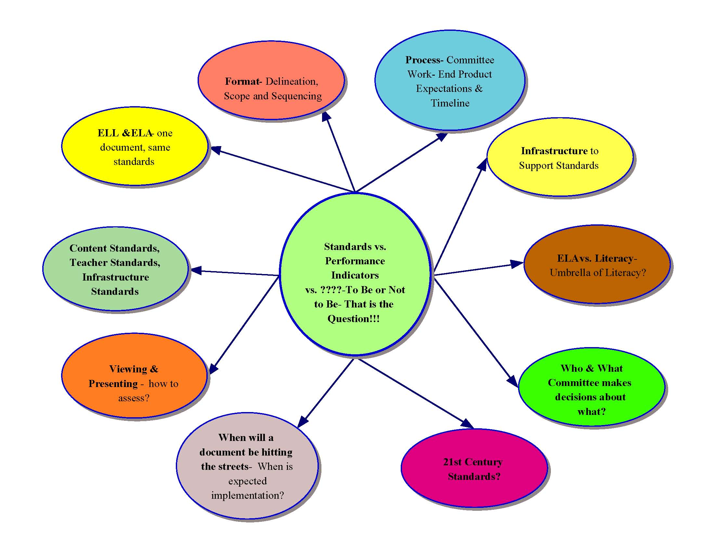
The Regents approved taking the concept of literacy (reading, writing, speaking, listening, presenting, viewing) being in all standards areas. ELA will not be the only content area responsible for literacy. There will be some cross-content literacy expectations and there will be content-specific literacy expectations in each standards area. Presenting involves selecting, synthesizing, and organizing information to convey a message. Viewing involves comprehending, critically examining, and making the use of the information in a presentation.

- 3-8 Testing Odds and Ends:
    - Reminder that no protractors or rulers are coming (http://www.emsc.nysed.gov/osa/mathei/toolsmemo-08.htm)
    - Starting this school year, PDF files of exemplars with associated audio files will be posted on CTB/McGraw-Hill’s New York State web site, www.ctb.com/nys. These will be posted at the same time that the Questions and Answers for Scoring are posted, at 10 a.m. on the last day of each test administration makeup period. The PDF files and associated audio files are being provided instead of the scoring DVDs that were used in previous years. Audio and PDF files will be available for downloading at any Internet-connected computer. Users will be able to listen to and view them "live", or to save them for review at a more convenient time. The audio files will be provided in different formats so they can be played through Windows Media Player, MP3 players, MACs or iPods. PDFs can be opened and printed on any Internet-connected computer that has Adobe Acrobat Reader installed. If the Acrobat Reader is not already installed on the computer, the user may download it from: http://www.adobe.com/products/acrobat/readstep2.html. The printed scoring materials provided for the Grades 3-8 English Language Arts and Mathematics Tests will be delivered in much the same manner as in past years. The complete schedule for the administration and scoring of these examinations may be accessed at: http://emsc.nysed.gov/osa/sched.html.No scoring DVDs this year, on-line scoring information will be available at 10:00 am on the last make-up day. You will be able to download things to make your own copies. Hard copies will be shipped to schools as in the past, at least this year.
    - Testing Accommodations for ELL up to two years after proficient. (http://www.emsc.nysed.gov/sar/accommodations10-08.pdf)
    - There continues to be talk of compressing the 3-5 and 6-8 testing periods for ELA and math for next school year: “For the 2009-10 school year, we can [emphasis added] signal to the field now that a change will be coming so school districts and BOCES will have enough time to design their calendars. To increase test turnaround time, we can condense the testing schedule into approximately seven days and test all grades concurrently. This will still allow schools to administer make-up tests and to make sure that students who require testing accommodations are appropriately assessed.” (http://www.regents.nysed.gov/2008Meetings/May2008/0508emscd1.htm)

Legislative Updates:
- There was nothing new to report; the Governor’s budget will probably spur a round of activity.

Ways to Maintain an Instructional Focus:
- Chocolate, exercise, beer/wings, and wine
- Maintain reinforce/current initiatives to move from adoption to adaption
- Know it’s all about the kids, and set the stage
- Collaboration and communication within the district and beyond
  - Get in the buildings, make people part of the solution
  - Build in time
  - State of the District conversation
- District team reaffirmation of personal and professional purpose
- Review existing staff development model
- Strategic planning with focused areas developed by many stakeholders
- Select 1-2 goals to implement
- Celebrate/focus on successes
- Stay positive and remember that we need to keep students in mind
- Distributive leadership
- Consciously developing teacher leaders and supporting their involvement in the leadership process
- Always keep a focus on the children
  - Remember to visit the children in the classrooms!
- Maintain focus and a strong administrative team
- Forms for sharing ideas and effectiveness
- Instruction, instruction, instruction
- Sense of humor
- Positive attitude, accentuate the positive, “Whale Done” recommendation
- Evaluation of initiatives to demonstrate their effectiveness and cost efficiency
- Don’t always talk about the tough times – don’t create the continued challenge
- Make a commitment to use positive language when communicating
- Find that professional venue to communicate and collaborate
- Consider this time an opportunity to make changes amidst the challenges
- Don’t personalize the discussions and the challenges – don’t own it all
- Consider how to maintain focus in good and bad times
  - Acknowledge how staff is working through these times – consider each of us as an ambassador to the community, recognize the external lives
  - How are we supporting them and each other
  - Write those notes, praise
- Examine things differently
  - Reconsider meetings – purpose, length, who’s involved
  - Redefine and repurpose initiatives

Other Links of Possible Interest:
- Suozzi Commission report (second part addresses consolidation and sharing): http://www.cptr.state.ny.us/
- Local Government and Efficiency & Competitiveness report (also know as the Lundine report): http://www.nyslocalgov.org/report_page.asp
- Framework for 21st Century Skills: http://www.21stcenturyskills.org/index.php?option=com_content&task=view&id=254&Itemid=120
- Information about June 2009 Regents Examination in Geometry: http://www.emsc.nysed.gov/osa/mathre/geometrymemo.pdf
- Geometry Test Sampler and other materials: http://emsc.nysed.gov/osa/new-math.htm
- School Administrator’s Manual: http://www.emsc.nysed.gov/osa/sam/secondary/home.html

Jeff Craig’s Contact Information:
(voice) 315.433.2627 (fax) 315.434.9347
mailto:jcraig@ocmboces.org
http://www.ocmboces.org/iss.cfm

BCIC Website and Resource Collection
- Stay tuned for an announcement about a web-base repository of all handouts, memos, etc. that are addressed at BCIC.

Remaining Meetings:
January 8, 2009
February 12, 2009
March 12, 2009
April 9, 2009
May 14, 2009
Coffee and Conversations 8:00am; meeting 8:30 – 10:30am

