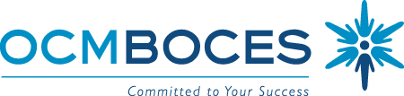

BOCES Curriculum and Instruction Council
June 10, 2010
8:00am Coffee and Conversation

8:30 – 10:30am Meeting
Henry B Conference Room, OCM BOCES Henry Campus, Administration Building

Agenda

Welcome and Introductions

Updates
- State Ed
- Legislative
- CI&A and Just ASK collaboration for 2010-2011, price adjustments
  - Why Didn’t I Learn This in College?
  - 21st Century Mentor (no charge if mentee is enrolled in Why?)
  - Instruction For All Students
  - Leading the Learning (pay for two, send four, and so on)
- Summer Project for this (ISS, ITD, SS)
  - Tech Camp (session B is just about full)
- CNY ASCD Affiliate report

Standards & Assessment (continuing agenda item)
- See State Ed Update

Planning for Next Year
- CI&A Schedule preview
- Common Core (should we do anything other that wait?)
- APPR (while we wait, is there anything we can do?)

21st Century Skills
- Conference update
- Six Implementation Steps

Meeting Schedule:
September 23, 2010
October 7, 2010 (Beyond Textbooks, extended meeting)
November 18, 2010 (tentative Allison Zmuda, extended meeting)
December 9, 2010
January 13, 2011
February 10, 2011
March 10, 2011
April 14, 2011
May 19, 2011
June 9, 2011

Meeting Closure and Evaluation

