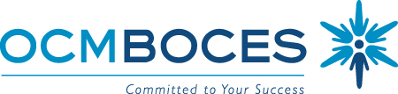

BOCES Curriculum and Instruction Council
May 20, 2010
8:00am Coffee and Conversation

8:30 – 10:30am Meeting
Distance Learning Room, OCM BOCES Henry Campus, Administration Building

Agenda

Welcome and Introductions

Updates
- State Ed
- Legislative
- CI&A and Just ASK collaboration for 2010-2011, price adjustments
  - Why Didn’t I Learn This in College?
  - 21st Century Mentor (no charge if mentee is enrolled in Why?)
  - Instruction For All Students
  - Leading the Learning (pay for two, send four, and so on)
- Summer Project for this (ISS, ITD, SS)
  - Tech Camp (session B is just about full)
- Instructional Technology & Design
  - Blackboard
  - Model Schools Summer Schedule
  - E-learning committee
  - mediaCONNECT
- Central New York – ASCD Affiliate final event of the year
- Teacher Leaders Conference/Event

Standards & Assessment (continuing agenda item)
- Looking back at 3-8 testing this year, looking ahead to next year

Planning for Next Year
- Summary of the survey about PD needs for next year
- Beyond Textbooks: October 7th
- LC21 (Learning Commons in the 21st Century)
- Helping with APPR work
- BCIC next year: Format? Dates? Other? Paper v. electronic?
- Common Core Standards and revising curricula
- Suggesting leadership seminars and new administrator support for next year

21st Century Skills
- A closer look at the Conference including plans and intended outcomes
- Six Implementation Steps

Remaining Meeting:
June 10, 2010

Meeting Closure and Evaluation

