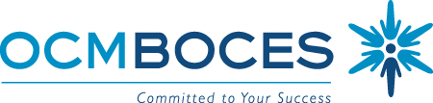

BOCES Curriculum and Instruction Council
March 12, 2009
8:00am Coffee and Conversations
8:30 – 10:30am Meeting

Agenda: RtI Best Practices & Good ideas

Welcome and Introductions

Updates
- State Ed
- State Budget
- Legislative
- Curriculum, Instruction & Assessment (RtI workshop is scheduled)
- Instructional Technology & Design

RtI: Best Practices and Good Ideas
- PBIS
- Solvay
- East Syracuse-Minoa
- Cazenovia

Meeting Closure and Evaluation

Our next BCIC meeting is April 9, 2009

