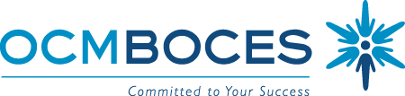

BOCES Curriculum and Instruction Council
October 8, 2009
8:00am Coffee and Conversations
8:30 – 10:30am Meeting
Henry B Conference Room, OCM BOCES Henry Campus, Administration Building

Agenda: 3-8 Testing (Administration and Scoring)

Welcome and Introductions

Updates
- State Ed
- Legislative
- Curriculum, Instruction & Assessment
  - On-line registration active
  - Individual sessions listed on site with link to specific workshop
  - 21st Century Mentor
  - Why Didn’t I Learn This in College
  - Instruction for All Students
  - Leading the Learning: November 15th Preview
- Leadership Activities
  - Leading and Learning in Central New York
  - Principals Meetings
  - Wallace Grant
    - Growing leaders within
    - Recruiting leaders
    - Teacher leaders
- ASCD Collection
- 21st Century Skills: What? Why? How?
- Instructional Technology & Design
- Central New York – NYSASCD
- Possible common article read: “Setting the Record Straight on “High-Yield” Strategies”

Communicating and Coordinating Professional Development Needs for Next Year
- Updating the planning calendar for this year
- Planning for 2010-2011 this Fall (November and December)

3-8 Testing
- Administration
- Scoring

Remaining Meetings:
November 12, 2009
December 10, 2009
January 14, 2010
February 11, 2010
March 11, 2010
April 8, 2010
May 13, 2010
June 10, 2010

Meeting Closure and Evaluation

