
Jeff Craig
Assistant Superintendent for Instructional Support Services
PO Box 4754
Syracuse NY 13221-4754
Phone: (315) 433-2624
FAX: (315) 434-9347
jcraig@ocmboces.org

Curriculum Instruction & Assessment Reorganization

The Curriculum, Instruction & Assessment (CI&A) Department of Instructional Support Services at OCM BOCES is undergoing some changes. The department has been forced to downsize due to a decrease in requested services from component districts and due to a decrease in participation from non-component districts in these trying economic times. As of July 1, the CI&A staff will include:
- Daryll Wheeler, Professional Development Specialist
- Patrick Shaw, Professional Development Specialist
- Kim Loucks, Professional Development Specialist
- Karen Pfanensteil, Office Support
- Jeff Craig, Interim Director

While this reorganization does reduce the overall size of the CI&A staff, we are confident that we have the time, resources, and expertise to assist you with all of your instructional and continuous growth initiatives. If we do not have the in-house expertise we will work with you to locate and arrange for what you need, working to do so in the most collaborative and cooperative way as possible. At the special June BCIC meeting we will work to identify component needs for the upcoming year and begin to make connections among districts as appropriate and expedient.

There are several avenues of communication with the CI&A Department:
- The CI&A website is the first place to go for information about professional development offerings and to electronically register. You can also call the department at 431-2662 with any questions about schedules, offerings, or to reach a member of the CI&A staff.
- Questions about the organization of the office can be addressed to me.
- To discuss and plan programs for the 2009-2010 school year, the first place to start is with me. We can talk about your needs and how we can best provide support for your instructional initiatives. Give me a call and we’ll chat about your plans for next year.

During the next few months I will be working closely with the CI&A staff to ensure a transition that is as smooth as possible. We’ve already been discussing all of the current efforts with districts as well as reviewing the catalog of offerings.

This reorganization was a direct result of the economics of the situation; districts were utilizing the services of CI&A less than had been budgeted. During the next year we will examine the funding mechanism for CI&A to determine whether changes to that funding mechanism are necessary. In the meantime, if is important that all of the ideas you have for CI&A and your district be communicated as soon as possible. Only through advance and careful planning can we avoid such structural changes in the future.

Soon we will be contacting you with news of some new things coming from CI&A, including details about access to the ASCD e-book collection, an updated website, and our expanded efforts to individualize, customize, and sustain our support with all of our professional development. I look forward to working with you in this regard.
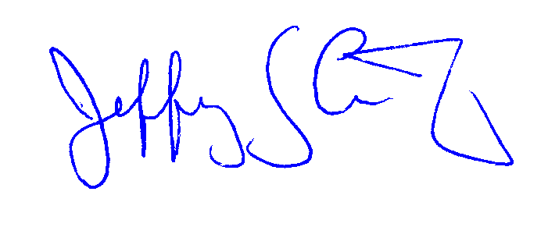
Sincerely,

Jeff Craig

