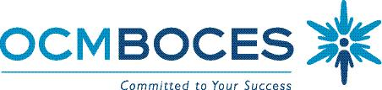

Special Education Council

Meeting Schedule 2017-2018

9:00 -11:00 A.M.
Date of Meeting | Location of Meeting
September 14, 2017 | Cayuga Conference Room:  Main Campus - OCM BOCES  110 Elwood Davis Dr.  Liverpool, NY 13088
* October 5, 2017 | Cayuga Conference Room
November 9, 2017 | Cayuga Conference Room
December 14, 2017 | Cayuga Conference Room
January 11, 2018 | Cayuga Conference Room
March 8, 2018 | Cayuga Conference Room
April 12, 2018 | Cayuga Conference Room
May 10, 2018 | Cayuga Conference Room
June 7, 2018  Date changed to coincide with Special Ed. Graduation | Cayuga Conference Room

6/6/17 SO

All Meetings will be held the 2nd Thursday of the month except for October and June. Those meetings are the first Thursday of the month.

There is no meeting in February.

