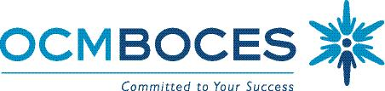

Special Education Council

Meeting Schedule 2016-2017

9:00 -11:00 A.M.
Date of Meeting | Location of Meeting
September 22, 2016 | Cayuga Conference Room:  Main Campus - OCM BOCES  110 Elwood Davis Dr.  Liverpool, NY 13088
October 13, 2016 | Cayuga Conference Room
November 10, 2016 | Cayuga Conference Room
December 8, 2016 | Cayuga Conference Room
January 12, 2017 | Cayuga Conference Room
March 9, 2017 | Cayuga Conference Room
April 13, 2017 | Cayuga Conference Room
May 11, 2017 | Cayuga Conference Room
June 8, 2017 | Cayuga Conference Room

4/6/16 SO

