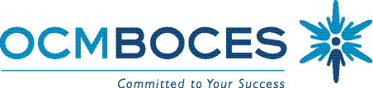

Special Education Council

OCM BOCES
Agenda for October 15, 2015
9:00-11:00
Administration Building, Henry Campus

When | What | Results | Who | How
9:00-9:20 | BOCES Updates  NYSAA Updates  District Updates  SED Updates | - Sharing of Information | All  AnnMarie Rossomano  Karen Volpi | Information
9:20-10:00 | Part 154 Update on Regulations | - Information | Melissa Fenn  Bilingual Special Education Specialist | Presentation
10:00-10:10 | Break | - Networking | All
10:10-11:00 | Overview of PBL with Students with Disabilities “Highlight Special Class” | - Information | Randi Downs  Rosanna Grund  Ann Currie  Kelly Buck  Sarah Snyder | Presentation

