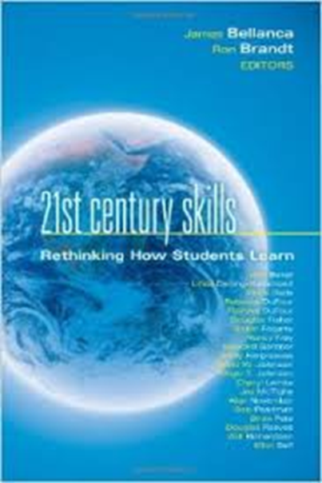
21st Century Skills: Rethinking How Students Learn
- Peruse some of the different chapters.
- Different group members select a [different] chapter of interest.
- Read the chapter.
- When all are done, share the key points.
- As a group, translate this into the “so what” for the book. What are the most important “take-aways?”
- Prepare a chart that expresses this.
- Identify the group member who will serve as the “docent” for your newly created work of art.

21st Century Skills: Rethinking How Students Learn
- Peruse some of the different chapters.
- Different group members select a [different] chapter of interest.
- Read the chapter.
- When all are done, share the key points.
- As a group, translate this into the “so what” for the book. What are the most important “take-aways?”
- Prepare a chart that expresses this.
- Identify the group member who will serve as the “docent” for your newly created work of art.

New York State Teaching Standards
- Go through the Teaching Standards document.
- Underline any parts of the document that connect to the preparation of students for their future.
- Discuss the frequency with which the practices you see in your schools match the parts you have underlined.
- As a group, translate this into the “so what” for the set of standards. What are the most important “take-aways?”
- Prepare a chart that expresses this.
- Identify the group member who will serve as the “docent” for your newly created work of art.

New York State Teaching Standards
- Go through the Teaching Standards document.
- Underline any parts of the document that connect to the preparation of students for their future.
- Discuss the frequency with which the practices you see in your schools match the parts you have underlined.
- As a group, translate this into the “so what” for the set of standards. What are the most important “take-aways?”
- Prepare a chart that expresses this.
- Identify the group member who will serve as the “docent” for your newly created work of art.
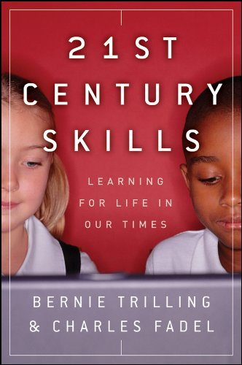
21st Century Skills: Learning for Life in our Times
- Peruse the book to see how it is organized.
- Different group members select [different] parts of the book to look at more closely.
- Read the chosen parts.
- When all are done, share the key points.
- As a group, translate this into the “so what” for the book. What are the most important “take-aways?”
- Prepare a chart that expresses this.
- Identify the group member who will serve as the “docent” for your newly created work of art.

21st Century Skills: Learning for Life in our Times
- Peruse the book to see how it is organized.
- Different group members select [different] parts of the book to look at more closely.
- Read the chosen parts.
- When all are done, share the key points.
- As a group, translate this into the “so what” for the book. What are the most important “take-aways?”
- Prepare a chart that expresses this.
- Identify the group member who will serve as the “docent” for your newly created work of art.

AMA 2010 Critical Skills Survey
- Go through the document which was the genesis of the “4Cs.”
- Underline any parts that seem particularly interesting or important.
- As a group, translate this into the “so what” of the report. What are the most important “take-aways?”
- Prepare a chart that expresses this.
- Identify the group member who will serve as the “docent” for your newly created work of art.

AMA 2010 Critical Skills Survey
- Go through the document which was the genesis of the “4Cs.”
- Underline any parts that seem particularly interesting or important.
- As a group, translate this into the “so what” of the report. What are the most important “take-aways?”
- Prepare a chart that expresses this.
- Identify the group member who will serve as the “docent” for your newly created work of art.

Secretary’s Commission on Achieving Necessary Skills
- Go through the document which was usually referred to as the SCANS Report.
- Independently read and underline any parts that seem particularly interesting or important.
- Talk about the report as a group.
- Consider: is this dated or does it remain relevant? What happened with it? What was its impact?
- As a group, translate this into the “so what” of the report. What are the most important “take-aways?” Prepare a chart that expresses this.
- Identify the group member who will serve as the “docent” for your newly created work of art.

Secretary’s Commission on Achieving Necessary Skills
- Go through the document which was usually referred to as the SCANS Report.
- Independently read and underline any parts that seem particularly interesting or important.
- Talk about the report as a group.
- Consider: is this dated or does it remain relevant? What happened with it? What was its impact?
- As a group, translate this into the “so what” of the report. What are the most important “take-aways?” Prepare a chart that expresses this.
- Identify the group member who will serve as the “docent” for your newly created work of art.

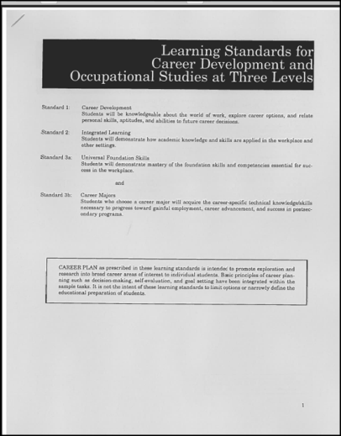
CDOS 3a
- Go through the excerpt of the CDOS Standards (only 3a are here for you). Notice how it is organized.
- Independently read and underline any parts that seem particularly interesting or important.
- Consider: These standards are supposed to apply to all students in all subjects and classes. Do educators know this? Do you see these standards in all classes in your schools?
- Talk about the Standards as a group.
- As a group, translate this into the “so what” of CDOS 3a. What are the most important “take-aways?” Prepare a chart that expresses this.
- Identify the group member who will serve as the “docent” for your newly created work of art.

CDOS 3a
- Go through the excerpt of the CDOS Standards (only 3a are here for you). Notice how it is organized.
- Independently read and underline any parts that seem particularly interesting or important.
- Consider: These standards are supposed to apply to all students in all subjects and classes. Do educators know this? Do you see these standards in all classes in your schools?
- Talk about the Standards as a group.
- As a group, translate this into the “so what” of CDOS 3a. What are the most important “take-aways?” Prepare a chart that expresses this.
- Identify the group member who will serve as the “docent” for your newly created work of art.

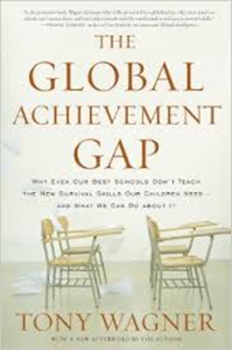
The Global Achievement Gap
- Peruse the book. Look for some sub headers or sections that jump out at you.
- Different group members select a [different] section of interest.
- Read the section.
- When all are done, share the key points.
- As a group, translate this into the “so what” for the book. What are the most important “take-aways?”
- Prepare a chart that expresses this.
- Identify the group member who will serve as the “docent” for your newly created work of art.

The Global Achievement Gap
- Peruse the book. Look for some sub headers or sections that jump out at you.
- Different group members select a [different] section of interest.
- Read the section.
- When all are done, share the key points.
- As a group, translate this into the “so what” for the book. What are the most important “take-aways?”
- Prepare a chart that expresses this.
- Identify the group member who will serve as the “docent” for your newly created work of art.

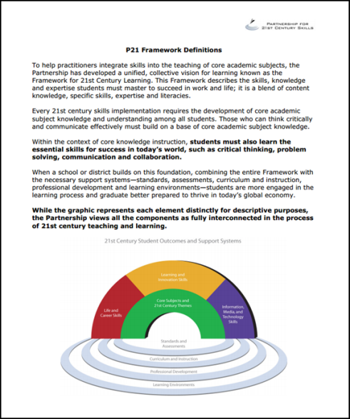
P21 Framework
- Go through complete framework. Notice how it is organized.
- Independently read and underline any parts that seem particularly interesting or important.
- Talk about the Framework as a group.
- As a group, translate this into the “so what” of Framework. What are the most important “take-aways?” Prepare a chart that expresses this.
- Identify the group member who will serve as the “docent” for your newly created work of art.

P21 Framework
- Go through complete framework. Notice how it is organized.
- Independently read and underline any parts that seem particularly interesting or important.
- Talk about the Framework as a group.
- As a group, translate this into the “so what” of Framework. What are the most important “take-aways?” Prepare a chart that expresses this.
- Identify the group member who will serve as the “docent” for your newly created work of art.

