Learning Standards for The Arts
Revised Edition April 1996
THE UNIVERSITY OF THE STATE OF NEW YORK Regents of The University
Carl T. Hayden, Chancellor, A.B., J.D. . . . . . . . . . . . . . . . . . . . . . . . . . . . Elmira Louise P. Matteoni, Vice Chancellor, B.A., M.A., Ph.D.. . . . . . . . . . . . . . Bayside Emlyn I. Griffith, A.B., J.D. . . . . . . . . . . . . . . . . . . . . . . . . . . . . . . . . . . . . Rome Jorge L. Batista, B.A., J.D. . . . . . . . . . .. . . . . . . . . . . . . . . . . . . . . . . . . . . Bronx
J. Edward Meyer, B.A., LL.B.. . . . . . . . . . . . . . . . . . . . . . . . . . . . . . . . . . . Chappaqua
R. Carlos Carballada, Chancellor Emeritus, B.S. . . . . . . . . . . . . . . . . . . Rochester Mimi Levin Lieber, B.A., M.A. . . . . . . . . . . . . . . . . . . . . . . . . . . . . . . . . . . New York Norma Gluck, B.A., M.S.W. . . . . . . . . . . . . . . . . . . . . . . . . . . . . . . . . . . . . . New York Adelaide L. Sanford, B.A., M.A., P.D.. . . . . . . . . . . . . . . . . . . . . . . . . . . . . Hollis Walter Cooper, B.A., Ph.D. . . . . . . . . . . . . . . . . . . . . . . . . . . . . . . . . . . . . . Rochester Diane O’Neill McGivern, B.S.N., M.A., Ph.D. . . . . . . . . . . . . . . . . . . . . . . Staten Island Saul B. Cohen, B.A., M.A., Ph. D. . . . . . . . . . . . . . . . . . . . . . . . . . . . . . . . . New Rochelle James C. Dawson, A.A., B.A., M.S., Ph.D. . . . . . . . . . . . . . . . . . . . . . . . . . Peru Robert M. Bennett, B.A., M.S.. . . . . . . . . . . . . . . . . . . . . . . . . . . . . . . . . . . Tonawanda Robert M. Johnson, B.S., J.D.. . . . . . . . . . . . . . . . . . . . . . . . . . . . . . . . . . . Lloyd Harbor Peter M. Pryor, B.A., LL.B., J.D., LL.D.. . . . . . . . . . . . . . . . . . . . . . . . . . . Albany
President of The University and Commissioner of Education
RICHARD P. MILLS
Executive Deputy Commissioner of Education
THOMAS E. SHELDON
Deputy Commissioner for Elementary, Middle, Secondary, and Continuing Education
JAMES A. KADAMUS
Assistant Commissioner for Curriculum, Instruction, Assessment, and Innovation
EDWARD T. LALOR
Coordinator of Curriculum and Instruction
ROSEANNE DEFABIO
The State Education Department does not discriminate on the basis of age, color, religion, creed, disability, marital status, veteran status, national origin, race, gender or sexual orientation in its educational programs, services and activities. Portions of this publication can be made available in a variety of formats, including braille, large print or audio tape, upon request. Inquiries concerning this policy of nondiscrimination should be directed to the Department’s Office for Diversity, Ethics, and Access, Room 152, Education Building, Albany, NY 12234.
CONTENTS Acknowledgments iv Introduction v LEARNING STANDARDS FOR THE ARTS AT THREE LEVELS 1 SAMPLES OF STUDENT WORK RELATED TO THE STANDARDS 35

In addition to the people recognized in the Preliminary Draft Framework for The Arts, we are grateful to the many teachers from throughout New York State who contributed performance tasks and samples of student work for possible inclusion in this revised edition. Listed below are the names of those educators whose
materials appear in this document.
Contributors
Denise Abbattista, Skaneateles | Karen Henn, Lockport
Cynthia Appold, Huntington Station | Robert Hyndman, Saratoga Springs
Jessica Bayer, Hewlett | Susan Koff, Cliffside, NJ
Stormy Brandenberger, New York | Joe Minutillo, St. James
Margaret Charboneau, Camillus | Gail Nelli, Leicester
Patricia Chiodo, Williamsville | Constance Noelle, Wallkill
Patricia Clahassey, Voorheesville | Judi Paseltiner, Melville
Katy Neyerlin Colletti, Poughkeepsie | Dennis Powell, Endwell
Joan Davidson, New York | Scott Rabeler, Oneonta
Kevin Dirth, Ossining | Arlene Sampson, Troy
Diana Domoracki, Brooklyn | Mary Ellen Shevalier, Henderson
John Fredricksen, New York | John Shorter, Valley Stream
Margaret L. Foster, Buffalo | Frank Vurraro, Greenwich
Jeanne D. Gray, Pittsford | Leslie Wexler, Buffalo
Victoria Harder, Phoenix | Elana Wills, Queens Village
State Education Department
Roseanne DeFabio | Edward S. Marschilok
Jan Christman | John Maryanopolis
Elaine Frankonis | Patricia Webster
Roger Hyndman


This revised edition of the Learning Standards for The Arts incorporates changes to the content standards and the performance indicators based on extensive review by the public. As educational practice improves, these standards will continually be revised.
New in this addition are samples of student work, along with teacher comments on the work. The examples are intended to provide some ideas of tasks that support attainment of the performance standards. They are not models of excellence. Rather, they represent various levels of acceptable work. In the arts these levels have been described as “distinguished,” “proficient” and “competent.” It is important to remember that the work samples are just suggestions of ways the students can demonstrate progress toward achieving the standards.
The Standards for the Arts reflect the educational goals that are common to dance, music, theatre, and the visual arts, while recognizing the distinctive aspects of each discipline. Each art form has its own philosophies, methods, materials, history, and content; each is usually taught as a separate subject. Assessment techniques should account for the similarities and differences among the arts and the varying capabilities and education of students across the four disciplines.
The Arts Standards provide school districts the direction and basic structure for the development of local curricula that link instruction and assessment to the content standards. Taken together, the content standards, performance indicators and the performance standards embodied in actual student work define the learning standards for students in the Arts (dance, music, theatre and visual arts).
The State Education Department will continue to collect and publish samples of student work. As teachers become familiar with the standards and students become more proficient in meeting them, the level of the performance standards and content standards will continue to rise.
The Board of Regents recognizes the diversity of students in New York State, including students with disabilities, students with limited English proficiency, gifted students, and educationally disadvantaged students, and has made a strong commitment to integrating the education of all students into the total school program. The standards apply to all students regardless of their experiential background, capabilities, developmental and learning differences, interests, or ambitions. A classroom typically includes students with a wide range of abilities who may pursue multiple pathways to learn effectively, participate meaningfully, and work towards attaining the curricular standards. Students with diverse learning needs may need accommodations or adaptations of instructional strategies and materials to enhance their learning and/or adjust for their learning capabilities.
Learning Standards for The Arts Expectations for Achievement
All students should participate at an appropriate level and should demonstrate competent, proficient, or distinguished levels of achievement in the following areas by the completion of their secondary schooling:
- Elementary level achievement in the content standards for each of the four disciplines of dance, music, theatre, and visual arts;
- Intermediate level achievement in the content standards for two of the four disciplines of dance, music, theatre, and visual arts;
- Commencement level achievement in the content standards for one of the four disciplines of dance, music, theatre, and visual arts.

vi
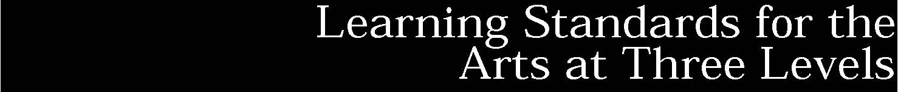
Standard 1: Creating, Performing and Participating in the Arts Students will actively engage in the processes that constitute creation and performance in the arts (dance, music, theatre, and visual arts) and participate in various roles in the arts.
Standard 2: Knowing and Using Arts Materials and Resources Students will be knowledgeable about and make use of the materials and resources available for participation in the arts in various roles.
Standard 3: Responding to and Analyzing Works of Art Students will respond critically to a variety of works in the arts, connecting the individual work to other works and to other aspects of human endeavor and thought.
Standard 4: Understanding the Cultural Dimensions and Contributions of the Arts Students will develop an understanding of the personal and cultural forces that shape artistic communication and how the arts in turn shape the diverse cultures of past and present society.
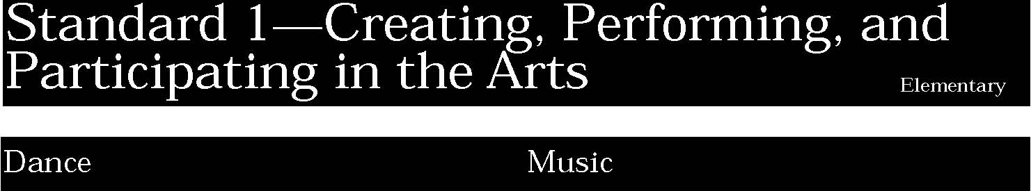
1. Students will perform set dance forms in formal and informal contexts and will improvise, create, and perform dances based on their own movement ideas. They will demonstrate an understanding of choreographic principles, processes, and structures and of the roles of various participants in dance productions.
Students:
- identify and demonstrate movement elements and skills (such as bend, twist, slide, skip, hop) (a)
- demonstrate ways of moving in relation to people, objects, and environments in set dance forms (b)
- create and perform simple dances based on their own movement ideas (c).

This is evident, for example, when students:
- demonstrate the movements of various animals, a cat, a dog, an elephant, a monkey, etc.
- pretend that they are flowers or plants caught in a wind, moving in groups of two or three to suggest the movement
- invent a dance based on a children's game, such as, Farmer in the Dell, London Bridge, etc.

Key ideas are identified by numbers (1). Performance indicators are identified by bullets (•). Sample tasks are identified by triangles (▲ ).
1. Students will compose original music and perform music written by others. They will understand and use the basic elements of music in their performances and compositions. Students will engage in individual and group musical and music-related tasks, and will describe the various roles and means of creating, performing, recording, and producing music.
Students:
- create short pieces consisting of sounds from a variety of traditional (e.g., tambourine, recorder, piano, voice), electronic (e.g., keyboard), and nontraditional sound sources (e.g., water-filled glasses) (a)
- sing songs and play instruments, maintaining tone quality, pitch, rhythm, tempo, and dynamics; perform the music expressively; and sing or play simple repeated patterns (ostinatos) with familiar songs, rounds, partner songs, and harmonizing parts (b)
- read simple standard notation in performance, and follow vocal or keyboard scores in listening (c)
- in performing ensembles, read very easy/easy music (New York State School Music Association [NYSSMA] level I-II)1 and respond appropriately to the gestures of the conductor (d)
- identify and use, in individual and group experiences, some of the roles, processes, and actions used in performing and composing music of their own and others (e).

This is evident, for example, when students:
- improvise a short composition using the black keys on the piano
- sing familiar rounds and folk songs in a group with good tone, tempo, intonation and rhythm
- strum on an autoharp a two or three chord progression alone or with others to accompany student singing
- read and perform standard rhythmic notation on rhythm sticks or other classroom instruments
- play a simple pattern on a mallet instrument to accompany a familiar song such as Frere Jacques
- perform a simple piece of music with others in a band, chorus or orchestra
- conduct other students in performing simple musical pieces.

1 The New York State School Music Association (NYSSMA) has developed a standards-based instructional model that can be used to assess student achievement. In the publication entitled NYSSMA Manual, the Music Association provides rules, regulations, and graded listings of musical literature as a basis for assessing musical performance by individuals, small groups, or large organizations. The emphasis of the model is on “quality of performance.” (NYSSMA 1994,
p. XXVII)
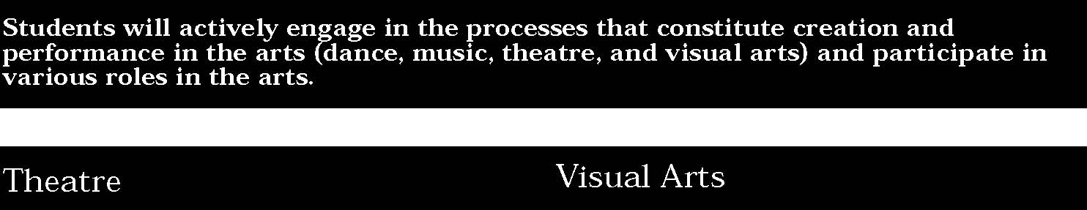
1. Students will create and perform theatre pieces as well as improvisational drama. They will understand and use the basic elements of theatre in their characterizations, improvisations, and play writing. Students will engage in individual and group theatrical and theatre-related tasks, and will describe the various roles and means of creating, performing, and producing theatre.
Students:
- use creative drama to communicate ideas and feelings (a)
- imitate experiences through pantomime, play making, dramatic play, story dramatization, story telling, and role playing (b)
- use language, voice, gesture, movement, and observation to express their experiences and communicate ideas and feelings (c)
- use basic props, simple set pieces, and costume pieces to establish place, time, and character for the participants (d)
- identify and use in individual and group experiences some of the roles, processes, and actions for performing and creating theatre pieces and improvisational drama (e).

This is evident, for example, when students:
▲ use a belonging from home as practice in handling simple props and as an experience in evoking feelings in an audience
▲ pantomime the action of a narrated story
▲ observe the habits of familiar animals and use voice, gesture, body movement to portray the animals to classmates
▲ act out a scene from a well-known fairy tale using basic props, simple set pieces and costume pieces
▲ use puppets to dramatize an event: create the dialogue, voices and movement of the puppets to convey the story working in small groups.

1. Students will make works of art that explore different kinds of subject matter, topics, themes, and metaphors. Students will understand and use sensory elements, organizational principles, and expressive images to communicate their own ideas in works of art. Students will use a variety of art materials, processes, mediums, and techniques, and use appropriate technologies for creating and exhibiting visual art works.
Students:
- experiment and create art works, in a variety of mediums (drawing, painting, sculpture, ceramics, printmaking, video, and computer graphics), based on a range of individual and collective experiences (a)
- develop their own ideas and images through the exploration and creation of art works based on themes, symbols, and events (b)
- understand and use the elements and principles of art (line, color, texture, shape) in order to communicate their ideas (c)
- reveal through their own art work understanding of how art mediums and techniques influence their creative decisions (d)
- identify and use, in individual and group experiences, some of the roles and means for designing, producing, and exhibiting art works (e).

This is evident, for example, when students:
- paint a picture in tempera or watercolor in which they depict an experience that they recall
- make a ceramic vessel which they decorate with symbols
- make a drawing in which they depict three-dimensional space by using overlapping, placement on the picture plane and objects diminishing in size
- select a medium for a work of art based on their experience with the medium and their desire that it should look a certain way
- work with others to plan and produce a group art work, such as a mural, an illustrated book, a stage design
- draw objects from observation and use their imagination to turn those drawings into objects or creatures
- use the primary colors of pigment (cyan, magenta, yellow) to paint a picture from nature.

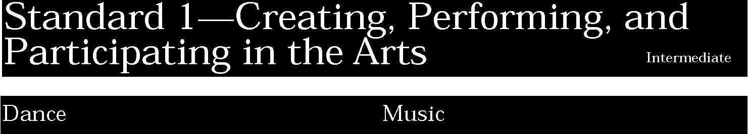
1. Students will perform set dance forms in formal and informal contexts and will improvise, create, and perform dances based on their own movement ideas. They will demonstrate an understanding of choreographic principles, processes, and structures and of the roles of various participants in dance productions.
Students:
- know and demonstrate a range of movement elements and skills (such as balance, alignment, elevation, and landing) and basic dance steps, positions, and patterns (a)
- dance a range of forms from free improvisation to structured choreography (b)
- create or improvise dance phrases, studies, and dances, alone and/or in collaboration with others, in a variety of contexts (c)
- demonstrate the ability to take various roles in group productions and performances (d).

This is evident, for example, when students:
- invent a dance built on at least three different dance steps that creates a pattern and that moves throughout a given space
- select a word or phrase at random from a pile of cards and improvise a movement to express the idea of the word or phrase; others in the class interpret what the dancer is expressing
- take on one of the roles in a class dance production, i.e., choreographer, lighting, costuming, etc.

1. Students will compose original music and perform music written by others. They will understand and use the basic elements of music in their performances and compositions. Students will engage in individual and group musical and music-related tasks, and will describe the various roles and means of creating, performing, recording, and producing music.
Students:
- compose simple pieces that reflect a knowledge of melodic, rhythmic, harmonic, timbrel, and dynamic elements (a)
- sing and/or play, alone and in combination with other voice or instrument parts, a varied repertoire of folk, art, and contemporary songs, from notation, with a good tone, pitch, duration, and loudness (b)
- improvise short musical compositions that exhibit cohesiveness and musical expression (c)
- in performing ensembles, read moderately easy/ moderately difficult music (NYSSMA level III-IV) and respond appropriately to the gestures of the conductor (d)
- identify and use, in individual and group experiences, some of the roles, processes, and actions for performing and composing music of their own and others, and discuss ways to improve them.

This is evident, for example, when students:
- compose a melody that reflects the mood of a four line poem and exhibits knowledge of the basic elements of music (e.g., rhythm and melody)
- sing with classmates a number of songs including folk, art and contemporary
- improvise on a violin a four measure phrase that is cohesive and expressive
- perform moderately easy music (NYSSMA level 2 or 3) on an instrument in a band
- conduct peers through a choral warm-up piece.

1. Students will create and perform theatre pieces as well as improvisational drama. They will understand and use the basic elements of theatre in their characterizations, improvisations, and play writing. Students will engage in individual and group theatrical and theatre-related tasks, and will describe the various roles and means of creating, performing, and producing theatre.
Students:
- use improvisation and guided play writing to communicate ideas and feelings (a)
- imitate various experiences through pantomime, play making, dramatic play, story dramatization, storytelling, role playing, improvisation and guided play writing (b)
- use language, voice, gesture, movement and observation to create character and interact with others in improvisation, rehearsal, and performance (c)
- create props, scenery, and costumes through individual and group effort (d)
- identify and use, in individual and group experiences, some of the roles, processes, and actions for performing and creating theatre pieces and improvisational drama within the school/community, and discuss ways to improve them (e).

This is evident, for example, when students:
- develop a point of view on an issue then use improvisation to convey that point of view to an audience
- recall or observe a simple action or moment, such as shopping for a pair of shoes, cooking from a recipe, typing a letter, and imitate the experience through pantomime
- create and act out character charades by using a prop (e.g., hats) so specific to the character that they indicate what/who the character is (age, gender, occupation)
- select an appropriate scene to perform for a younger class: devise the props, costumes and set pieces and rehearse and perform the piece
- suggest the role conflict plays in drama; write scenes with and without a conflict; discuss the differences.

1. Students will make works of art that explore different kinds of subject matter, topics, themes, and metaphors. Students will understand and use sensory elements, organizational principles, and expressive images to communicate their own ideas in works of art. Students will use a variety of art materials, processes, mediums, and techniques, and use appropriate technologies for creating and exhibiting visual art works.
Students:
- produce a collection of art works, in a variety of mediums, based on a range of individual and collective experiences (a)
- know and use a variety of sources for developing and conveying ideas, images, themes, symbols, and events in their creation of art (b)
- use the elements and principles of art to communicate specific meanings to others in their art work (c)
- during the creative process, reflect on the effectiveness of selected mediums or techniques to convey intended meanings (d)
- identify and use, in individual and group experiences, some of the roles and means for designing, producing, and exhibiting art works and discuss ways to improve them (e).

This is evident, for example, when students:
- research various architectural elements and design a building based on their research and on their plan for its use
- develop an image that is appropriate for a lino cut, transfer it to the linoleum and print it using more than one color
- develop a painting from their drawing of a still-life focusing on composition and color value
- research the style of a selected sculptor and design a work based on that style but expressing the students' ideas.

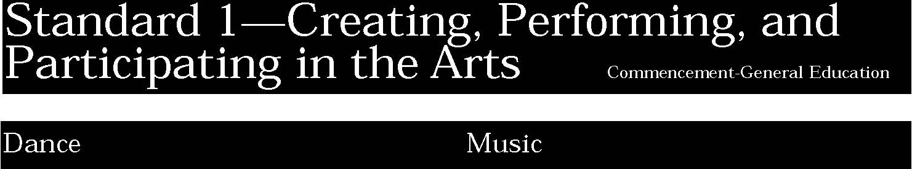
1. Students will perform set dance forms in formal and informal contexts and will improvise, create, and perform dances based on their own movement ideas. They will demonstrate an understanding of choreographic principles, processes, and structures and of the roles of various participants in dance productions.
Students:
- perform movements and dances that require demonstration of complex steps and patterns as well as an understanding of contextual meanings (a)
- create dance studies and full choreographies based on identified and selected dance movement vocabulary (b)
- apply a variety of choreographic processes and structures as appropriate to plan a duet or ensemble performance (c).

This is evident, for example, when students:
- perform a dance which is student choreographed using an excerpt from a selected contemporary piece of music
- develop the choreography for a duet and plan the rehearsal program to achieve the dance
- view a dance company's practice sessions, observe how the dancers develop and integrate their movements and expressions for their own piece and in concert with the other dancers, and then analyze and describe the process
- work as part of a group to research a particular style of dance, develop and create choreography based on that research, and then perform the piece as an ensemble.

1. Students will compose original music and perform music written by others. They will understand and use the basic elements of music in their performances and compositions. Students will engage in individual and group musical and music-related tasks, and will describe the various roles and means of creating, performing, recording, and producing music.
Students:
- compose simple pieces for at least two mediums, including computers (MIDI) and other electronic instruments. (Pieces may combine music with other art forms such as dance, theatre, visual arts, or film/video.) (a)
- sing and/or play recreational instruments accurately, expressively, and with good tone quality, pitch, duration, loudness, technique, and (singing) diction (b)
- use common symbols (notation) to perform music on recreational instruments (c)
- identify and describe the roles, processes, and actions needed to produce professional concerts and musical theatre productions (d)
- explain the commercial-music roles of producer, recordist, public relations director, recording company executive, contractor, musicians, union officials, performers, etc. (e)

This is evident, for example, when students:
- compose a 32 bar musical piece with a simple melody and appropriate harmony on an electronic keyboard or piano
- play a guitar with acceptable tone quality, good technique and correct rhythm to accompany a song
- play on a dulcimer an eight measure melody based on a familiar folk song
- participate in a concert production as a performer, composer/arranger, program annotator, music librarian, stage hand, etc.
- write a short narrative after interviewing a local commercial music person about their career activities.

1. Students will create and perform theatre pieces as well as improvisational drama. They will understand and use the basic elements of theatre in their characterizations, improvisations, and play writing. Students will engage in individual and group theatrical and theatre-related tasks, and will describe the various roles and means of creating, performing, and producing theatre.
Students:
- write monologues and scenes to communicate ideas and feelings (a)
- enact experiences through pantomime, improvisation, play writing, and script analysis (b)
- use language, techniques of sound production (articulation, enunciation, diction, and phrasing), techniques of body, movement, posture, stance, gesture, and facial expression and analysis of script to personify character(s); interact with others in improvisation, rehearsal, and performance; and communicate ideas and feelings (c)
- design and build props, sets, and costumes to communicate the intent of the production (d).
- make acting, directing, and design choices that support and enhance the intent of the class, school, and /or community productions (e).

This is evident, for example, when students:
- write and perform an original monologue which expresses a struggle over a decision of whether to engage in a particular activity with peers
- select an example of visual art (paintings, reproductions, photographs, postcards); study the visual art for setting, mood, and characterization; and improvise a scene ending in a tableau
- perform a reader's theatre piece concentrating on voice and gestures to convey nuances of character, mood and meaning
- create a floor plan of a set design for a play
- assume various roles of theatrical personnel, both onstage and backstage, to assure the success of a school production.

1. Students will make works of art that explore different kinds of subject matter, topics, themes, and metaphors. Students will understand and use sensory elements, organizational principles, and expressive images to communicate their own ideas in works of art. Students will use a variety of art materials, processes, mediums, and techniques, and use appropriate technologies for creating and exhibiting visual art works.
Students:
- create a collection of art work, in a variety of mediums, based on instructional assignments and individual and collective experiences to explore perceptions, ideas, and viewpoints (a)
- create art works in which they use and evaluate different kinds of mediums, subjects, themes, symbols, metaphors, and images (b)
- demonstrate an increasing level of competence in using the elements and principles of art to create art works for public exhibition (c)
- reflect on their developing work to determine the effectiveness of selected mediums and techniques for conveying meaning and adjust their decisions accordingly (d).

This is evident, for example, when students:
- do a series of drawings of posed figures and then incorporate one or more of those figures into a painting to express a specific theme
- use one medium or technique in more than two works to indicate their skill with that medium or technique
- develop an idea for a work of art, research the various ways in which that idea has been expressed by other artists and at other times, select the appropriate medium or technique for that work and complete the work
- produce a computer generated design in which they use their understanding of composition, color, line, space.

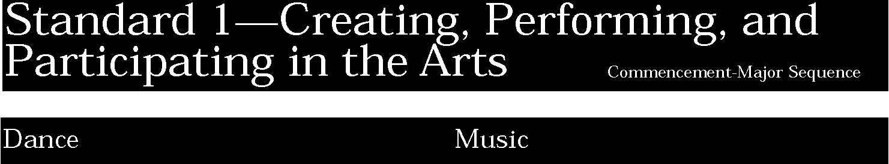
1. Students will perform set dance forms in formal and informal contexts and will improvise, create, and perform dances based on their own movement ideas. They will demonstrate an understanding of choreographic principles, processes, and structures and of the roles of various participants in dance productions.
In addition to the General Education performance indicators, students:
- use a variety of sources to find dance ideas (a)
- select dance structures for use in choreographic projects (b)
- perform dances requiring use of more sophisticated performance elements such as dynamics, phrasing, musicality, expression (c)
- use a variety of choreographic approaches with any number of dancers, props, and performance spaces (d)
- demonstrate ability to work effectively as dancer, choreographer, director, costumer, lighting designer, manager (e).

This is evident, for example, when students:
- select dance structures based on traditional forms and choreograph them into a dance, selecting the music
- create a dance appropriate for elementary school children and instruct the children in bodily movements and dance vocabulary
- prepare and perform a dance recital which shows a high level of expression, dynamics, musicality and phrasing
- create and develop audition pieces that demonstrate knowledge of high level choreographic principles
- arrange, prepare and audition for dance companies, participating in the process with poise and professionalism
- interpret an existing piece of choreography through reflection (e.g., journal writing) and a uniquely personal approach to performance.

1. Students will compose original music and perform music written by others. They will understand and use the basic elements of music in their performances and compositions. Students will engage in individual and group musical and music-related tasks, and will describe the various roles and means of creating, performing, recording, and producing music.
In addition to the General Education performance indicators, students:
- compose a collection of works for wind, string, percussion, vocal, keyboard, or electronic media that demonstrates an understanding and application of the musical elements and music-related technology (a)
- monitor and adjust their performance and compositional techniques, identifying strengths and areas for improvements (b)
- improvise and arrange extended musical compositions that exhibit cohesiveness and musical expression (c)
- in choral and instrumental ensembles, read difficult/very difficult music (NYSSMA level V or VI); exhibit independent control over tone quality, intonation, rhythm, dynamics, balance, blend, expression, and articulation; and respond appropriately to the gestures of the conductor (d)
- adopt at least two of the roles they identify as needed (composer, arranger, copyist, conductor, performer, announcer, instrument maker or provider, program annotator, recordist) to produce the performance of a musical composition in the classroom (e)
- in performing groups, produce musical performances by peer-led small ensembles and sections of larger ensembles (f).

This is evident, for example, when students:
- compose a one movement work for his /her own instrument or voice that demonstrates knowledge of the elements of music and compositional techniques
- describe the strengths and weaknesses of their performance in a music journal
- show improvement over time by recording multiple performances of a musical composition on an audiotape
- improvise and/or arrange a popular song for the school jazz band or show choir
- play his/her instrument exhibiting control of tone quality, technique, etc., when playing alone or in a performing organization
- perform a solo or duet at a NYSSMA evaluation festival
- write about the composer of a standard piece of music while he/she is learning to perform the work
- work with peers to produce a recital for friends and parents
- through a peer group rehearsal improve a section of a large group musical performance.

1. Students will create and perform theatre pieces as well as improvisational drama. They will understand and use the basic elements of theatre in their characterizations, improvisations, and play writing. Students will engage in individual and group theatrical and theatre-related tasks, and will describe the various roles and means of creating, performing, and producing theatre.
In addition to the General Education performance indicators, students:
- write plays to communicate their ideas and feelings (a)
- collaborate in the development of original works which reflect life experiences (b)
- use vocal, movement, and body techniques to create complex characters in monologues, oral interpretation, and scene study (c)
- create props, scenery, and costumes for different styles of plays (d)
- carry out acting, directing, and design choices which support and enhance the intent of a production (e).

This is evident, for example, when students:
- write a play to submit for a student playwrighting competition (e.g., Very Special Arts) following competition guidelines
- use improvisation to discover issues of concern for teenagers and develop original pieces into script format
- use oral interpretation to convey the nuances of character and feeling in a student selected narrative poem
- select an absurdist piece (e.g., a Pinter or Albee play) to produce which highlights sophisticated levels of theatrical understanding
- participate in an internship in theatre technology or business management with a local college, community or professional theatre production.

1. Students will make works of art that explore different kinds of subject matter, topics, themes, and metaphors. Students will understand and use sensory elements, organizational principles, and expressive images to communicate their own ideas in works of art. Students will use a variety of art materials, processes, mediums, and techniques, and use appropriate technologies for creating and exhibiting visual art works.
In addition to the General Education performance indicators, students:
- produce comprehensive and well organized commencement portfolios of their work (a)
- reveal through their work a broad investigation of a variety of individual ideas and at least one theme explored imaginatively and in depth (b)
- give evidence that they have developed an emerging personal style (c)
- use selected mediums and techniques and select the most appropriate mediums and techniques to communicate their ideas (d).

This is evident, for example, when students:
- produce a portfolio with at least ten completed works, together with sketches, notes and research that were used in the development of those works
- include in their portfolios drawings which show their ability to draw from observation and from their imagination
- include in their portfolios one example of a work which was student generated, researched and developed
- use electronic imaging (film, computers, video,cd/rom, etc.) to create individual images.

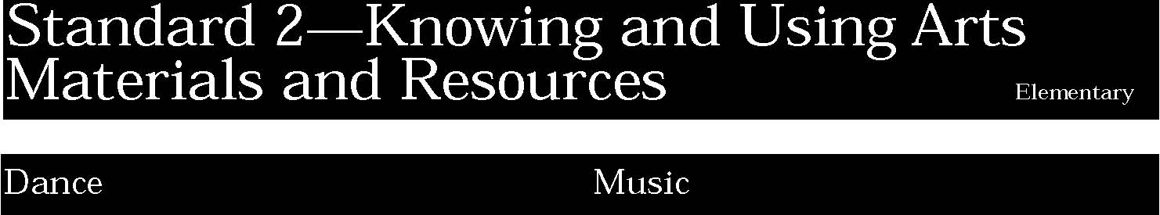
2. Students will know how to access dance and dance-related material from libraries, resource centers, museums, studios, and performance spaces. Students will know various career possibilities in dance and recreational opportunities to dance. Students will attend dance events and participate as appropriate within each setting.
Students:
- demonstrate knowledge of dance resources in video, photography, print, and live performance (a)
- understand the concept of live performance and appropriate conduct (b)
- demonstrate a knowledge of dance-related careers (e.g., dancer, choreographer, composer, lighting designer, historian, teacher) (c).

This is evident, for example, when students:
- discuss the differences between watching a dance performance on video and watching a live performance
- talk to a visiting artist (dancer, choreographer, composer, lighting director) about what he/she does.

2. Students will use traditional instruments, electronic instruments, and a variety of nontraditional sound sources to create and perform music. They will use various resources to expand their knowledge of listening experiences, performance opportunities, and/or information about music. Students will identify opportunities to contribute to their communities’ music institutions, including those embedded in other institutions (church choirs, industrial music ensembles, etc.). Students will know the vocations and avocations available to them in music.
Students:
- use classroom and nontraditional instruments in performing and creating music (a)
- construct instruments out of material not commonly used for musical instruments (b)
- use current technology to manipulate sound (c)
- identify the various settings in which they hear music and the various resources that are used to produce music during a typical week; explain why the particular type of music was used (d)
- demonstrate appropriate audience behavior, including attentive listening, in a variety of musical settings in and out of school (e)
- discuss ways that music is used by various members of the community (f).

This is evident, for example, when students:
- use common items (e.g., keys, classroom blinds, measuring sticks) as “found sounds” to improvise a group composition
- make a shaker from a paper tube to accompany a Native American dance or Latino song
- change pitch or timbre of a sound on the synthesizer
- keep a log of locations where they hear music in the community or home
- exhibit appropriate behavior when listening to music in the school’s auditorium
- describe in class the ways music is used at home and in their community.

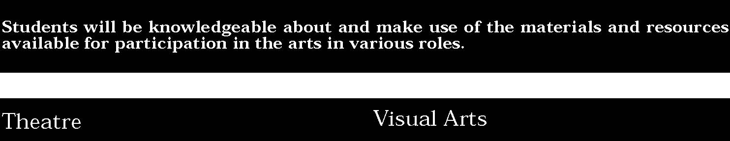
2. Students will know the basic tools, media, and techniques involved in theatrical production. Students will locate and use school, community, and professional resources for theatre experiences. Students will understand the job opportunities available in all aspects of theatre.
Students:
- visit theaters, theatre-related facilities, and/or touring companies to observe aspects of theatrical production (a)
- use the library/media center of their school or community to find story dramatization material or other theatre-related materials and to view videotapes of performances (b)
- attend theatrical performances in their school and demonstrate appropriate audience behavior (c)
- speak with theatre professionals about how they prepare for and perform their jobs (d).

This is evident, for example, when students:
- visit the high school to observe the rehearsal of a play and participate in a question and answer session with the production staff
- search the school library for a story suitable to develop into a play
- discuss and adhere to guidelines for proper behavior when attending a theatrical production, behavior which enhances enjoyment and supports the efforts of the performers
- prepare interview questions to use in a discussion with a theatre professional.

2. Students will know and use a variety of visual arts materials, techniques, and processes. Students will know about resources and opportunities for participation in visual arts in the community (exhibitions, libraries, museums, galleries) and use appropriate materials (art reproductions, slides, print materials, electronic media). Students will be aware of vocational options available in the visual arts.
Students:
- understand the characteristics of various mediums (two-dimensional, three-dimensional, electronic images) in order to select those that are appropriate for their purposes and intent (a)
- develop skills with electronic media as a means of expressing visual ideas (b)
- know about some cultural institutions (museums and galleries) and community opportunities (art festivals) for looking at original art and talking to visiting artists, to increase their understanding of art (c)
- give examples of adults who make their livings in the arts professions (d).

This is evident, for example, when students:
- use a draw/paint computer program to create graphic images
- visit a museum and write a short report of what they saw
- engage a visiting artist in talk about what that artist does, how he/she does it and why.

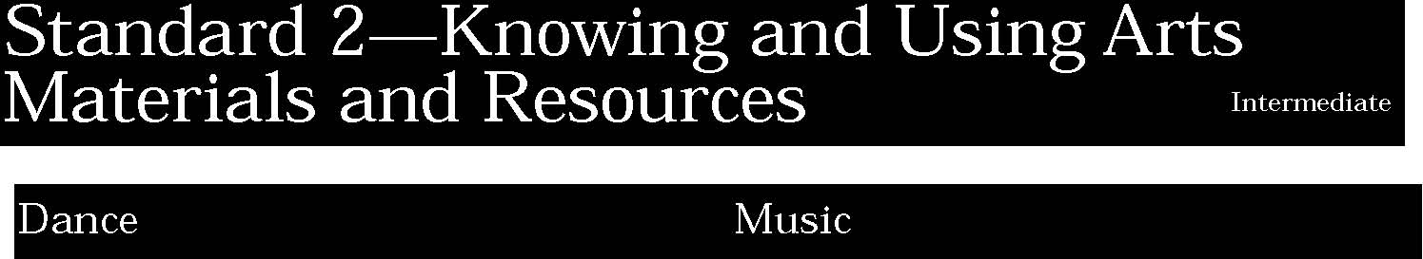
2. Students will know how to access dance and dance-related material from libraries, resource centers, museums, studios, and performance spaces. Students will know various career possibilities in dance and recreational opportunities to dance. Students will attend dance events and participate as appropriate within each setting.
Students:
- demonstrate knowledge of sources for understanding dance technologies: live, print, video, computer, etc. (a)
- demonstrate knowledge of how human structure and function affect movement in parts of dances and dances that they know or have choreographed (b)
- demonstrate knowledge of audience/performer responsibilities and relationships in dance (c)
- demonstrate knowledge of differences in performance venue and the events presented in each (d).

This is evident, for example, when students:
- plan an appropriate venue for a dance they have developed
- use the computer or video to examine dance routines.

2. Students will use traditional instruments, electronic instruments, and a variety of nontraditional sound sources to create and perform music. They will use various resources to expand their knowledge of listening experiences, performance opportunities, and/or information about music. Students will identify opportunities to contribute to their communities’ music institutions, including those embedded in other institutions (church choirs, industrial music ensembles, etc.). Students will know the vocations and avocations available to them in music.
Students:
- use traditional or nontraditional sound sources, including electronic ones, in composing and performing simple pieces (a)
- use school and community resources to develop information on music and musicians (b)
- use current technology to create, produce and record/playback music (c)
- identify a community-based musical interest or role and explain the skills, knowledge, and resources necessary to pursue the interest or adopt the role (d)
- demonstrate appropriate listening and other participatory responses to music of a variety of genres and cultures (e)
- investigate some career options related to their musical interests (f).

This is evident, for example, when students:
- use their voices, traditional instruments, or “found sounds” to create a sound composition which is appropriate for a holiday (e.g., Halloween)
- collect and catalogue the concerts scheduled in their community for an upcoming month
- prepare a solo for performance, use library materials at school or in the community to write a short paper on the composer of a solo work they are preparing
- use a stereo cassette recorder and microphones to record a group composition of their peers and play it back in class
- describe, in their log, a variety of community musical opportunities in which students may participate
- discover and report to the instrumental class lesson what skills are necessary to participate in the regional youth orchestra
- exhibit proper audience behavior when attending a concert given by professional musicians
- determine and record in the log what education and training are needed to become one of the following—a composer, arranger, professional musician, or other occupation associated with music.

2. Students will know the basic tools, media, and techniques involved in theatrical production. Students will locate and use school, community, and professional resources for theatre experiences. Students will understand the job opportunities available in all aspects of theatre.
Students:
- visit theatre technology facilities, including the local high school facility, and interact with professionals and theatre students to learn about theatre technology (e.g., lighting, staging, sound, etc.) (a)
- use the school or community library/media centers and other resources to develop information on various theatre-related topics (b)
- know about local theatrical institutions, attend performances in school and in the community, and demonstrate appropriate audience behavior (c)
- discuss vocations/avocations with theatre professionals and identify the skills and preparation necessary for theatre vocations/avocations (d).

This is evident, for example, when students:
- visit the high school to discover how a lighting system works by participating in hands-on workshop experience with a lighting technician
- research various theatre history time periods in the library and on the computer internet to compile a class booklet on theatre history
- prepare a bulletin board with information about local school, college and community theatres including production schedules and student reviews of productions
- interview various theatre technology artists and report to the class on the preparation necessary to be trained for these careers.

2. Students will know and use a variety of visual arts materials, techniques, and processes. Students will know about resources and opportunities for participation in visual arts in the community (exhibitions, libraries, museums, galleries) and use appropriate materials (art reproductions, slides, print materials, electronic media). Students will be aware of vocational options available in the visual arts.
Students:
- develop skills with a variety of art materials and competence in at least one medium (a)
- use the computer and other electronic media as designing tools and to communicate visual ideas (b)
- take advantage of community opportunities and cultural institutions to learn from professional artists, look at original art, and increase their understanding of art (c)
- understand the variety of careers related to the visual arts and the skills necessary to pursue some of them (d).

This is evident, for example, when students:
- mix paint in a range of shades and tints and apply the paint to their work with skill
- use the computer to develop an idea for a project with sculpture
- visit a museum and look at an original work of art and discuss the differences between the original and the reproduction
- use the internet to explore images of public art.

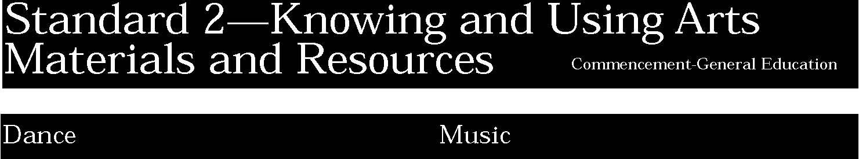
2. Students will know how to access dance and dance-related material from libraries, resource centers, museums, studios, and performance spaces. Students will know various career possibilities in dance and recreational opportunities to dance. Students will attend dance events and participate as appropriate within each setting.
Students:
- use dance technologies without significant supervision (a)
- are familiar with techniques of research about dance (b)
- know about regional performance venues which present dance and how to purchase tickets and access information about events (c)
- know about educational requirements of dance-related careers (d)
- identify major muscles and bones and how they function in dance movement (e).

This is evident, for example, when students:
- select the appropriate dance technologies for a given performance
- know about the role that muscles play in dance and practice correct stretching exercises
- attend a regional dance performance and report to the class about it
- compile an ongoing calendar of community dance events and share this information with other students and the broader community through the broadcast media, publications, or on-line
- attend a variety of dance performances and keep a journal/file of the obvious differences and similarities
- gather information, through research and interviews, about dance-related careers and professional training, and establish a file for use and contributions by other students
- research and compare and contrast the movement and functions of muscles and bones in dance and other physical activities, such as tennis, swimming, etc.

2. Students will use traditional instruments, electronic instruments, and a variety of nontraditional sound sources to create and perform music. They will use various resources to expand their knowledge of listening experiences, performance opportunities, and/or information about music. Students will identify opportunities to contribute to their communities’ music institutions, including those embedded in other institutions (church choirs, industrial music ensembles, etc.). Students will know the vocations and avocations available to them in music.
Students:
- use traditional, electronic, and nontraditional media for composing, arranging, and performing music (a)
- describe and compare the various services provided by community organizations that promote music performance and listening (b)
- use print and electronic media, including recordings, in school and community libraries to gather and report information on music and musicians (c)
- identify and discuss the contributions of local experts in various aspects of music performance, production, and scholarship (d)
- participate as a discriminating member of an audience when listening to performances from a variety of genres, forms, and styles (e)
- understand a broad range of career opportunities in the field of music, including those involved with funding, producing, and marketing musical events (f).

This is evident, for example, when students:
- use an electronic keyboard and computer to compose and print out a sixteen measure composition
- report to the class on a major musical organization in the community and its schedule of performances for the school year
- present a detailed oral report to the class based on information gathered at the local library on a musician and his life which includes recordings of some of the composer’s compositions
- gather information about stereo systems from a local electronics dealer
- attend two different concerts and note similarities, differences and personal reactions in their log
- research and write a report on a musical career.

2. Students will know the basic tools, media, and techniques involved in theatrical production. Students will locate and use school, community, and professional resources for theatre experiences. Students will understand the job opportunities available in all aspects of theatre.
Students:
- use theatre technology skills and facilities in creating a theatrical experience (a)
- use school and community resources, including library/media centers, museums and theatre professionals, as part of the artistic process leading to production (b)
- visit local theatrical institutions and attend theatrical performances in their school and community as an individual and part of a group (c)
- understand a broad range of vocations/avocations in performing, producing, and promoting theatre (d).

This is evident, for example, when students:
- read and follow a lighting plot for a production, handling and focusing lighting instruments properly
- read a script for a production, then complete pictorial research on the costuming and accessories of the time period before designing costumes
- write a short review of a local community performance for publication in the school newspaper
- create a publicity campaign for the high school production.

2. Students will know and use a variety of visual arts materials, techniques, and processes. Students will know about resources and opportunities for participation in visual arts in the community (exhibitions, libraries, museums, galleries) and use appropriate materials (art reproductions, slides, print materials, electronic media). Students will be aware of vocational options available in the visual arts.
Students:
- select and use mediums and processes that communicate intended meaning in their art works, and exhibit competence in at least two mediums (a)
- use the computer and electronic media to express their visual ideas and demonstrate a variety of approaches to artistic creation (b)
- interact with professional artists and participate in school- and community-sponsored programs by art organizations and cultural institutions (c)
- understand a broad range of vocations/avocations in the field of visual arts, including those involved with creating, performing, exhibiting, and promoting art (d).

This is evident, for example, when students:
- select a process or medium for their intended work of art and describe their reasons for that selection
- interview a professional artist about what that artist does, his/her preparation, the organization of his/her business
- produce a mixed media work of art which uses the computer image, the camera, the copy machine and other electronic media.

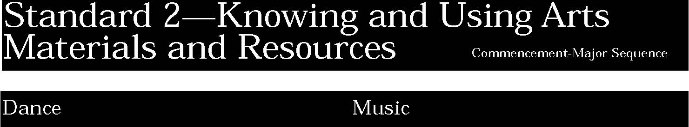
2. Students will know how to access dance and dance-related material from libraries, resource centers, museums, studios, and performance spaces. Students will know various career possibilities in dance and recreational opportunities to dance. Students will attend dance events and participate as appropriate within each setting.
In addition to the General Education performance indicators, students:
- use technologies to research, create, perform, or communicate about dance (a)
- understand the roles of dancers, audience, and creators in a variety of dance forms and contexts (b)
- participate in, or observe, dance events outside of school (c)
- know about educational requirements of dance-related careers and how to prepare for possible entrance into those fields (d)
- know about good nutrition, injury prevention, and how to care for the body (e).

This is evident, for example, when students:
- use the Internet or other means to research dance forms of the 1920's
- intern with a local dance company
- research at least three institutions which have dance programs in order to know the entrance requirements for each
- practice good nutrition and injury prevention techniques
- work alone or with a group of students to research current dance innovations through library and on-line resources and compile a bibliography of sources for class use, including relevant listservs, Home Pages, etc.
- alone or with a group, research the development of one style of dance by using a variety of sources, including archival files
- interview professionals in the dance industry to learn about educational, physiological, and logistical career requirements and document the interviews.

2. Students will use traditional instruments, electronic instruments, and a variety of nontraditional sound sources to create and perform music. They will use various resources to expand their knowledge of listening experiences, performance opportunities, and/or information about music. Students will identify opportunities to contribute to their communities’ music institutions, including those embedded in other institutions (church choirs, industrial music ensembles, etc.). Students will know the vocations and avocations available to them in music.
In addition to the General Education performance indicators, students:
- develop a classified and annotated directory of nearby music-related establishments such as instrument and music retailers, instrument makers and repair persons, recording studios, union representatives, etc. (a)
- identify ways that they have contributed to the support of the musical groups of which they are members (b)
- explain opportunities available to them for further musical growth and professional development in higher education and community institutions (c).

This is evident, for example, when students:
- collect data on the music services available in the community such as recording studios, repair shops, retailers and instrument makers
- volunteer to serve as music librarian ( or other necessary positions such as secretary) for a performing group in which they participate
- via the Internet or a computer data base, generate a list of colleges that offer a particular program in a musical field (e.g., performance, instrument repair, electronics, arts production).

2. Students will know the basic tools, media, and techniques involved in theatrical production. Students will locate and use school, community, and professional resources for theatre experiences. Students will understand the job opportunities available in all aspects of theatre.
In addition to the General Education performance indicators, students:
- identify current technologies, published scripted material, and print and electronic resources available for theatrical productions (a)
- identify college and/or community opportunities in theatre after graduation and the requirements for application or participation (b)
- cooperate in an ensemble as performers, designers, technicians, and managers to create a theatrical production (c)
- design an individualized study program (i.e., internship, mentorship, research project) in a chosen theatre, film, or video vocation/avocation and share the information with the class (d).

This is evident, for example, when students:
- investigate and select a computer program for use in designing floor plans and elevation drawings for a set design
- attend local college and university drama days designed to provide workshop experiences for high school students interested in pursuing theatre as a career and write a school newsletter article about the experience
- form a production team for a play (producer, director, stage manager, technical director and house manager) to plan the necessary schedules and carry out the artistic concept of the director
- participate in a mentorship program with a theatre professional and report to the class about the experience.

2. Students will know and use a variety of visual arts materials, techniques, and processes. Students will know about resources and opportunities for participation in visual arts in the community (exhibitions, libraries, museums, galleries) and use appropriate materials (art reproductions, slides, print materials, electronic media). Students will be aware of vocational options available in the visual arts.
In addition to the General Education performance indicators, students:
- develop Commencement Portfolios that show proficiency in one or more mediums and skill in using and manipulating the computer and other electronic media (a)
- prepare a portfolio that meets the admission requirements of selected institutions (b)
- understand the preparation required for particular art professions and acquire some skills of those professions through internships with local galleries, museums, advertising agencies, architectural firms, and other institutions (c).

This is evident, for example, when students:
- include in their portfolios works of art which show proficiency with two mediums
- investigate the admission requirements of two or three colleges or universities
- investigate the preparation necessary for entrance into one of the arts professions
- exhibit their works in a one-person show and write the accompanying descriptive material.

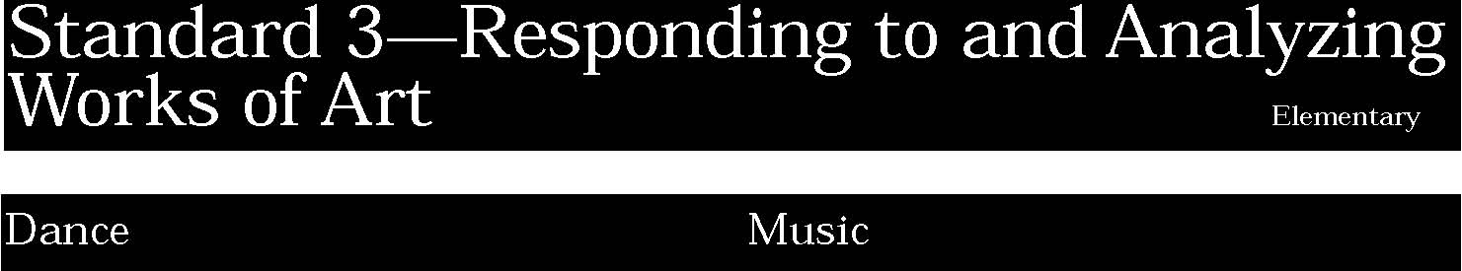
3. Students will express through written and oral language their understanding, interpretation, and evaluation of dances they see, do, and read about. Students will acquire the critical vocabulary to talk and write about a variety of dance forms.
Students:
- demonstrate knowledge of words and symbols (kinetic, visual, tactile, aural and olfactory) that describe movement (a)
- express to others their understanding of specific dance performances, using appropriate language to describe what they have seen and heard (b).

This is evident, for example, when students:
- describe the patterns that they see in a video of a dance, such as, The March of The Wooden Soldiers
- describe the bodily movement that they see in a dance and then imitate it.

3. Students will demonstrate the capacity to listen to and comment on music. They will relate their critical assertions about music to its aesthetic, structural, acoustic, and psychological qualities. Students will use concepts based on the structure of music’s content and context to relate music to other broad areas of knowledge. They will use concepts from other disciplines to enhance their understanding of music.
Students:
- through listening, identify the strengths and weaknesses of specific musical works and performances, including their own and others’ (a)
- describe the music in terms related to basic elements such as melody, rhythm, harmony, dynamics, timbre, form, style, etc. (b)
- discuss the basic means by which the voice and instruments can alter pitch, loudness, duration, and timbre (c)
- describe the music’s context in terms related to its social and psychological functions and settings (e.g., roles of participants, effects of music, uses of music with other events or objects, etc.) (d)
- describe their understandings of particular pieces of music and how they relate to their surroundings (e).

This is evident, for example, when students:
▲ listen to another student’s musical composition and identify elements (such as rhythm, harmony, melody) that they liked and disliked
▲ describe, using correct terminology, the elements of music (such
as timbre, dynamics, form) heard in a musical recording ▲ orally identify the meter of a song sung by their classmates
▲ demonstrate with a rubber band how to raise and lower pitch
▲ write a few sentences on a social function attended (such as a wedding, bar mitzvah, etc.) and how music was used to enhance the function
▲ tell how music can set a mood in a particular setting (e.g., “happy” in an amusement park).

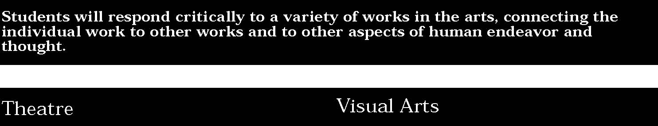
3. Students will reflect on, interpret, and evaluate plays and theatrical performances, both live and recorded, using the language of dramatic criticism. Students will analyze the meaning and role of theatre in society. Students will identify ways in which drama/theatre connects to film and video, other arts, and other disciplines.
Students:
- discuss their understanding, interpretation, and evaluation of a theatrical performance, using basic theatre terminology (a)
- identify the use of other art forms in theatre productions (b)
- explain the relationship of theatre to film and video (c).

This is evident, for example, when students:
- view a scene or dramatic reading by their peers and describe the theatrical elements such as setting, character, conflict, etc.
- discuss how music, dance and the visual arts are used to enhance musical theatre productions
- compare how live theatre differs from filmed or taped performances.

3. Students will reflect on, interpret, and evaluate works of art, using the language of art criticism. Students will analyze the visual characteristics of the natural and built environment and explain the social, cultural, psychological, and environmental dimensions of the visual arts. Students will compare the ways in which a variety of ideas, themes, and concepts are expressed through the visual arts with the ways they are expressed in other disciplines.
Students:
- explain their reflections about the meanings, purposes, and sources of works of art; describe their responses to the works and the reasons for those responses (a)
- explain the visual and other sensory qualities (surfaces, colors, textures, shape, sizes, volumes) found in a wide variety of art works (b)
- explain the themes that are found in works of visual art and how the art works are related to other forms of art (dance, music, theatre, etc.) (c)
- explain how ideas, themes, or concepts in the visual arts are expressed in other disciplines (e.g., mathematics, science, literature, social studies, etc.) (d).

This is evident, for example, when students:
- describe what they see in a work of art and tell what they think the work of art is about
- describe how lines might imply motion, color might convey emotion and size might suggest distance in selected works of art
- show how pattern can be found in a Mondrian painting and in a familiar song.

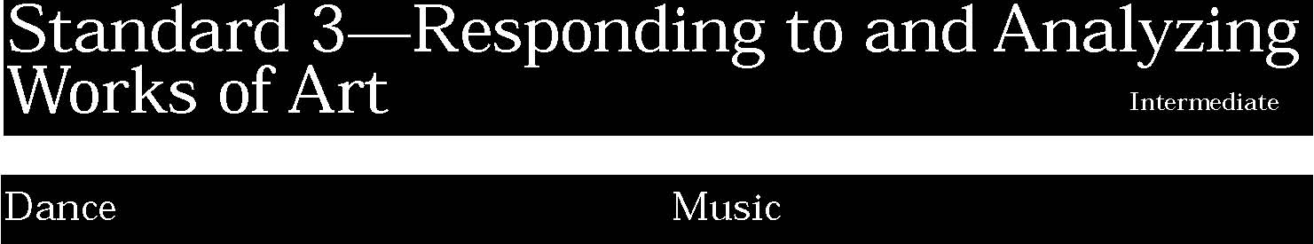
3. Students will express through written and oral language their understanding, interpretation, and evaluation of dances they see, do, and read about. Students will acquire the critical vocabulary to talk and write about a variety of dance forms.
Students:
- demonstrate knowledge of the technical language used in discussing dance performances (a)
- demonstrate knowledge of choreographic principles and processes (b)
- express to others their understanding of specific dance performances, including perceptions, descriptions, analyses, interpretations, and evaluations (c).

This is evident, for example, when students:
- write a short review of a high school dance performance
- after viewing a video of a dance they compare their interpretations with others in the group.

3. Students will demonstrate the capacity to listen to and comment on music. They will relate their critical assertions about music to its aesthetic, structural, acoustic, and psychological qualities. Students will use concepts based on the structure of music’s content and context to relate music to other broad areas of knowledge. They will use concepts from other disciplines to enhance their understanding of music.
Students:
- through listening, analyze and evaluate their own and others’ performances, improvisations, and compositions by identifying and comparing them with similar works and events (a)
- use appropriate terms to reflect a working knowledge of the musical elements (b)
- demonstrate a basic awareness of the technical skills musicians must develop to produce an aesthetically acceptable performance (c)
- use appropriate terms to reflect a working knowledge of social-musical functions and uses (appropriate choices of music for common ceremonies and other events) (d)
- use basic scientific concepts to explain how music-related sound is produced, transmitted through air, and perceived (e)
- use terminology from music and other arts to analyze and compare the structures of musical and other artistic and literary works (f).

This is evident, for example, when students:
- listen to two musical compositions on the same theme (e.g., celebrating a holiday) and point out similarities and differences
- compare and contrast his/her performance of a solo with that of a professional recording
- accurately describe the musical elements employed in an original composition or one written by peers
- describe a technique (e.g., correct hand position or relaxed jaw) that will improve their tone in playing or singing
- plan a social event and list the music (or musicians) that would support the occasion
- use garden hoses (or other tubing) of differing lengths to demonstrate how the lengths affect pitch
- suggest some classical pieces of music that may accompany a show of student art work or poetry and specify why the selections were chosen.

3. Students will reflect on, interpret, and evaluate plays and theatrical performances, both live and recorded, using the language of dramatic criticism. Students will analyze the meaning and role of theatre in society. Students will identify ways in which drama/theatre connects to film and video, other arts, and other disciplines.
Students:
- use the techniques and vocabulary of theatre criticism, both written and oral, to discuss theatre experiences and improve individual and group performances (a)
- examine and discuss the use of other art forms in a theatre production (b)
- explain how drama/theatre experiences relate to other literary and artistic events (c).

This is evident, for example, when students:
- direct a group of their peers and give specific recommendations for improving a small group performance
- design a set, develop costumes or write a song for a scene of a play and explain why the project is appropriate
- compare and contrast a dramatic reading and a silent reading of a particular passage.

3. Students will reflect on, interpret, and evaluate works of art, using the language of art criticism. Students will analyze the visual characteristics of the natural and built environment and explain the social, cultural, psychological, and environmental dimensions of the visual arts. Students will compare the ways in which a variety of ideas, themes, and concepts are expressed through the visual arts with the ways they are expressed in other disciplines.
Students:
- discuss and write their analyses and interpretations of their own works of art and the art of others, using appropriate critical language (a)
- identify, analyze, and interpret the visual and sensory characteristics that they discover in natural and human-made forms (b)
- compare the ways ideas and concepts are communicated through visual art with the various ways that those ideas and concepts are manifested in other art forms (c).
- compare the ways ideas, themes, and concepts are communicated through the visual arts in other disciplines, and the various ways that those ideas, themes, and concepts are manifested within the discipline (d).

This is evident, for example, when students:
- write an interpretation of Horace Pippin's Domino Players after class analysis of the images and composition
- discuss the way in which the black and white and gray of the painting enhances the meaning of Picasso's Guerinca
- analyze the engineering skills and the political skills, in addition to his artistic vision that the artist, Christo, needed in order to complete the Wrapping Of The Reich Stag in 1995.

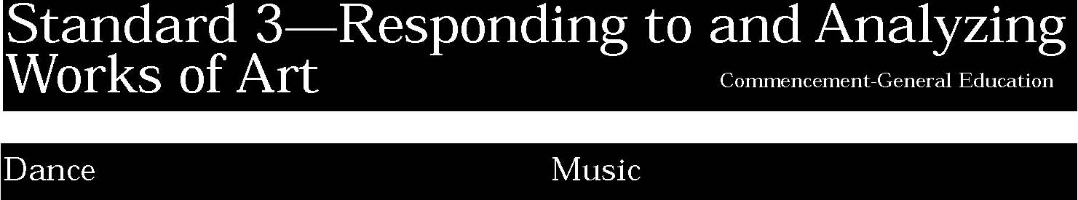
3. Students will express through written and oral language their understanding, interpretation, and evaluation of dances they see, do, and read about. Students will acquire the critical vocabulary to talk and write about a variety of dance forms.
Students:
- make comparisons of the nature and principles of dance to other arts (a)
- analyze and describe similarities and differences in different dance forms and styles (b)
- describe and compare a variety of choreographic approaches used in the creation of dances (c).

This is evident, for example, when students:
▲ compare the rhythm found in a particular dance with the rhythm in a musical piece and with the rhythm found in a painting
▲ do a short research paper in which they trace the origins of modern dance
▲ observe several choreographers working to create their dances and then compare, contrast, and describe the processes
▲ interview a choreographer regarding the origins of the ideas for the choreography, including cultural, esthetics, personal, and other influences and document that interview to share with the class
▲ write a detailed report of the influence of dance education on the student's understanding of other cultures and other disciplines.

3. Students will demonstrate the capacity to listen to and comment on music. They will relate their critical assertions about music to its aesthetic, structural, acoustic, and psychological qualities. Students will use concepts based on the structure of music’s content and context to relate music to other broad areas of knowledge. They will use concepts from other disciplines to enhance their understanding of music.
Students:
- through listening, analyze and evaluate their own and others’ performances, improvisations, and compositions and suggest improvements (a)
- read and write critiques of music that display a broad knowledge of musical elements, genres, and styles (b)
- use anatomical and other scientific terms to explain the musical effectiveness of various sound sources— traditional, nontraditional, and electronic (c)
- use appropriate technical and socio-cultural terms to describe musical performances and compositions (d)
- identify and describe the contributions of both locally and internationally known exemplars of high quality in the major musical genres (e)
- explain how performers, composers, and arrangers make artistic decisions (f).

This is evident, for example, when students:
- listen to a peer’s performance and complete an evaluation form suggesting areas in need of improvement
- use correct terminology when reporting on a school concert for the school newspaper for one performing organization
- explain how overtones are produced and demonstrate them on a string instrument by playing harmonics
- explain how sound is produced on a traditional or electronic instrument
- in the log describe the music and the impact the music had on a social occasion such as a birthday party, parade, etc.
- develop a list of professional musicians in a particular idiom (i.e., jazz saxophone, classical tenor, etc.)
- analyze a solo performance and explain the artistic decisions evident in the performance.

3. Students will reflect on, interpret, and evaluate plays and theatrical performances, both live and recorded, using the language of dramatic criticism. Students will analyze the meaning and role of theatre in society. Students will identify ways in which drama/theatre connects to film and video, other arts, and other disciplines.
Students:
- articulate an understanding, interpretation, and evaluation of a theatre piece as drama and as a realized production, using appropriate critical vocabulary (a)
- evaluate the use of other art forms in a theatre production (b)
- explain how a theatrical production exemplifies major themes and ideas from other disciplines (c).

This is evident, for example, when students:
- view different productions of the same scene from Taming of the Shrew, comparing and contrasting the various mediums (video, film and live performance)
- analyze the impact of costuming, hair and makeup in helping to establish character
- write a critical paper analyzing the themes of a play.

3. Students will reflect on, interpret, and evaluate works of art, using the language of art criticism. Students will analyze the visual characteristics of the natural and built environment and explain the social, cultural, psychological, and environmental dimensions of the visual arts. Students will compare the ways in which a variety of ideas, themes, and concepts are expressed through the visual arts with the ways they are expressed in other disciplines.
Students:
- use the language of art criticism by reading and discussing critical reviews in newspapers and journals and by writing their own critical responses to works of art (either their own or those of others) (a)
- explain the visual and other sensory qualities in art and nature and their relation to the social environment (b)
- analyze and interpret the ways in which political, cultural, social, religious, and psychological concepts and themes have been explored in visual art (c)
- develop connections between the ways ideas, themes, and concepts are expressed through the visual arts and other disciplines in everyday life (d).

This is evident, for example, when students:
- discuss the point of view of a critic in a local newspaper who has reviewed a local exhibition
- analyze the way in which a work of art by Leon Golub expresses a political point of view
- write a review of a student exhibition.

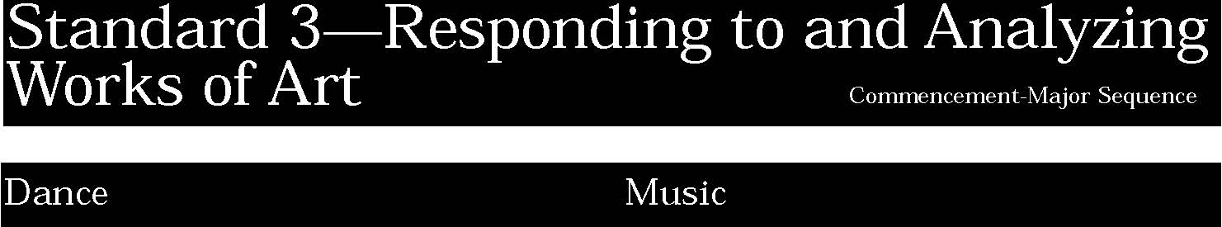
3. Students will express through written and oral language their understanding, interpretation, and evaluation of dances they see, do, and read about. Students will acquire the critical vocabulary to talk and write about a variety of dance forms.
In addition to the General Education performance indicators, students:
- express to others theories about the nature of dance and the underlying assumptions that people have about dance (a)
- describe and analyze similarities and differences between individual performances, and between forms and styles of dance, past and present (b)
- describe and defend an explanation of why people dance, based on experience in dance, witnessing others, and studying contexts (c).

This is evident, for example, when students:
▲ compare the positions of two different critics of dance
▲ develop a personal resource file for information about dance, dance theory etc.
▲ develop and give multi-media presentation that explain theories of dance to younger students
▲ observe a variety of professional dance company performances or rehearsals and develop a matrix that categorizes similarities and differences along styles of dance
▲ research and present a paper defending assumptions and values regarding the importance of dance in a specific culture
▲ write a detailed description of the student's involvement and commitment to dance and dance training for a college application.

3. Students will demonstrate the capacity to listen to and comment on music. They will relate their critical assertions about music to its aesthetic, structural, acoustic, and psychological qualities. Students will use concepts based on the structure of music’s content and context to relate music to other broad areas of knowledge. They will use concepts from other disciplines to enhance their understanding of music.
In addition to the General Education performance indicators, students:
- assess, describe, and evaluate the development of their personal contributions to their own, their school’s, and their community’s musical life by appropriately using musical and socio-cultural terms and concepts (contributions and skills of musicians, functions of music in society, etc.) (a)
- demonstrate a practical knowledge of sound production and architectural acoustics to predict the general effects on sound of room shapes, building construction practices, and common absorbers (b).

This is evident, for example, when students:
- write a detailed report of the student’s involvement in and contribution to music classes and music activities for a college application
- select a venue for a small vocal ensemble where the size of the facility and acoustics are appropriate for the size of the group.

3. Students will reflect upon, interpret, and evaluate plays and theatrical performances, both live and recorded, using the language of dramatic criticism. Students will analyze the meaning and role of theatre in society. Students will identify ways in which drama/theatre connects to film and video, other arts, and other disciplines.
In addition to the General Education performance indicators, students:
- develop a critical vocabulary through the reading and discussion of professional criticism (a)
- explain the meaning and societal function of different types of productions (b)
- design a plan for improving performances, using past and present critiques (c)
- explore various other art forms and technologies, using them in theatre projects (d)
- explain how theatre can enhance other subjects in the curriculum (e)
- compare and contrast theatre, film, and video (f).

This is evident, for example, when students:
- read a review of a local theatre production analyzing the critic's writing style, approach to priorities in the production, and conclusions about the play in performance, discussing the points of agreement and disagreement
- make two diagrams showing the differences between tragedy and melodrama, and comedy and farce
- keep a journal of the process involved in creating a monologue; comment on improvements made in the monologue content and performance
- investigate commedia dell'arte and form an improvisational troupe to perform at area schools
- work with an elementary teacher to incorporate theatre practices in the teaching of social studies
- compare different versions of the same play performed live, on film or on tape; compare a traditional interpretation of a play with a contemporary interpretation, or a musical production of a former drama.

3. Students will reflect upon, interpret, and evaluate works of art, using the language of art criticism. Students will analyze the visual characteristics of the natural and built environment and explain the social, cultural, psychological, and environmental dimensions of the visual arts. Students will compare the ways in which a variety of ideas, themes, and concepts are expressed through the visual arts with the ways they are expressed in other disciplines.
In addition to the General Education performance indicators, students:
- using the language of art criticism, describe the visual and functional characteristics of works of art and interpret the relationships of works of art one to another, to describe the impact of the work on the viewer (a)
- demonstrate an understanding of art criticism, art histories, and aesthetic principles and show their connections to works of art (b)
- give evidence in their Commencement Portfolios that they have researched a theme in-depth and that in their research they have explored the ways the theme has been expressed in other disciplinary forms (c).

This is evident, for example, when students:
- write a review of a local art exhibition
- discuss the role of museums and galleries in defining what current art is
- compare the way in which the migration of the African-Americans to the north is depicted in Jacob Lawrence's series of paintings The Great Migration with the description of that migration in the history textbooks.

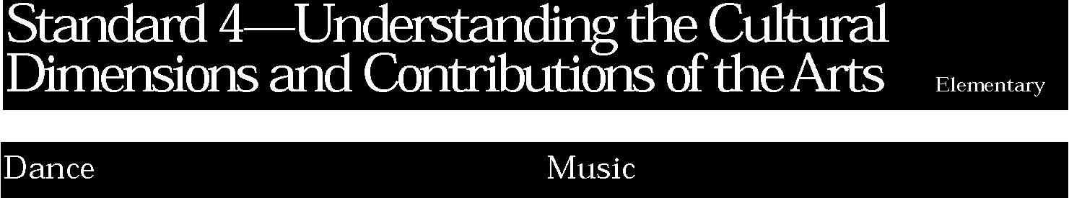
4. Students will know dances from many cultures and times and recognize their relationship to various cultural, social, and historic contexts. Students will recognize that dance is performed in many different cultural settings and serves many functions in diverse societies.
Students:
- identify basic dance movements that are typical of the major world cultures (a)
- explain the settings and circumstances in which dance is found in their lives and those of others, both past and present (b).

This is evident, for example, when students:
- discuss the dance forms of the Plains Indians
- explain the role that dance plays in their community (e.g., weddings, proms, festivals).

4. Students will develop a performing and listening repertoire of music of various genres, styles, and cultures that represent the peoples of the world and their manifestations in the United States. Students will recognize the cultural features of a variety of musical compositions and performances and understand the functions of music within the culture.
Students:
- identify when listening, and perform from memory, a basic repertoire of folk songs/dances and composed songs from the basic cultures that represent the peoples of the world (a)
- identify the titles and composers of well-known examples of classical concert music and blues/jazz selections (b)
- identify the primary cultural, geographical, and historical settings for the music they listen to and perform (c).

This is evident, for example, when students:
- sing folk music common to a period of history in the United States
- recognize and identify some simple pieces of music such as the tango, march and waltz and name the countries and composers most associated with the selections
- record in a log the folksongs sung in class along with the country of origin
- in music class make a pin map which shows the country of origin of folksongs and recordings.

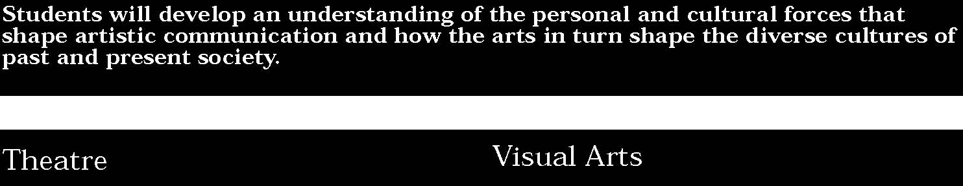

4. Students will gain knowledge about past and present cultures as expressed through theatre. They will interpret how theatre reflects the beliefs, issues, and events of societies past and present.
Students:
- dramatize stories and folk tales from various cultures (a)
- engage in drama/theatre activities including music, dance, and games which reflect other cultures and ethnic groups (b)
- discuss how classroom theatre activities relate to their lives (c).

This is evident, for example, when students:
- read a folk tale in which animals play important roles; improvise being animals, comparing and contrasting the "cultures" of animals and human beings
- attend a community ethnic festival to learn about a particular culture, then share dances, songs and games learned at the festival with another class at school
- discuss responses to a theatrical performance explaining what ideas and feelings were conveyed and why the audience sympathized or was displeased with the main character.

4. Students will explore art and artifacts from various historical periods and world cultures to discover the roles that art plays in the lives of people of a given time and place and to understand how the time and place influence the visual characteristics of the art work. Students will explore art to understand the social, cultural, and environmental dimensions of human society.
Students:
- look at and discuss a variety of art works and artifacts from world cultures to discover some important ideas, issues, and events of those cultures (a)
- look at a variety of art works and artifacts from diverse cultures of the United States and identify some distinguishing characteristics (b)
- create art works that show the influence of a particular culture (c).

This is evident, for example, when students:
- examine the Spanish style of architecture of the Southwest and describe the ways in which that architecture differs from architecture in New England used for the same purposes
- discuss the ways in which the depiction of space differs in Egyptian art with the way it is depicted in Renaissance art and conjecture about the reasons for the differences
- study the style of the Australian Aboriginal art and create a work using that style but expressing their own ideas about nature and animals.

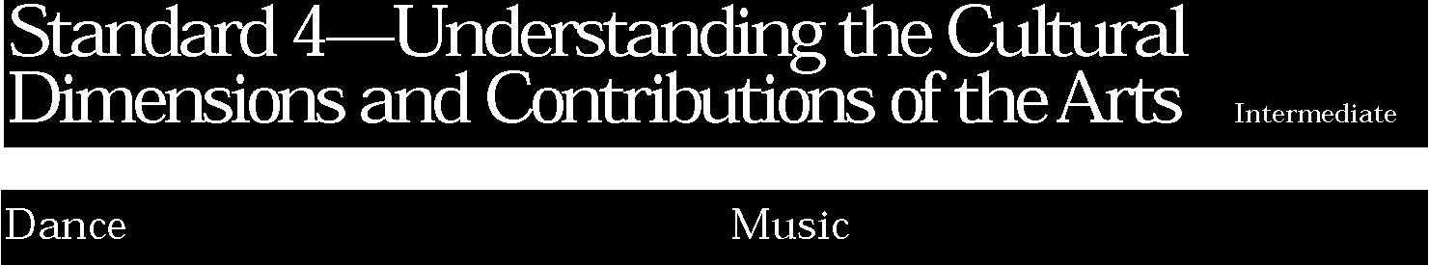
4. Students will know dances from many cultures and times and recognize their relationship to various cultural, social, and historic contexts. Students will recognize that dance is performed in many different cultural settings and serves many functions in diverse societies.
Students:
- identify the major dance forms of specific world cultures past and present (a)
- identify some of the major dance artists from diverse cultures (b)
- show how specific dance forms are related to the culture from which they come (c).

This is evident, for example, when students:
- attend a dance performance of an ethnic group and describe the characteristics of that dance
- discuss dance as ritual in an African group
- research the dance forms of the ethnic group from which they come or the dance forms of their teenage culture
- create a sequence and dance after investigating poems from Africia, India, Asia and South America to discover their rhythmic and metric structure.

4. Students will develop a performing and listening repertoire of music of various genres, styles, and cultures that represent the peoples of the world and their manifestations in the United States. Students will recognize the cultural features of a variety of musical compositions and performances and understand the functions of music within the culture.
Students:
- identify the cultural contexts of a performance or recording and perform (with movement, where culturally appropriate) a varied repertoire of folk, art, and contemporary selections from the basic cultures that represent the peoples of the world (a)
- identify from a performance or recording the titles and composers of well-known examples of classical concert music and blues/jazz selections (b)
- discuss the current and past cultural, social, and political uses for the music they listen to and perform (c)
- in performing ensembles, read and perform repertoire in a culturally authentic manner (d).

This is evident, for example, when students:
- compile a list of listening selections categorized by countries or cultures of the world
- identify, from listening selections, different forms of jazz including blues, Dixieland, boogie woogie, modern, and cool. Name musicians associated with each of the Jazz forms
- discuss how work songs have helped workers during their labors
- after hearing a professional recording of a Sousa march, identify important stylistic concerns and discuss how to apply them in their own performance.

4. Students will gain knowledge about past and present cultures as expressed through theatre. They will interpret how theatre reflects the beliefs, issues, and events of societies past and present.
Students:
- improvise scenes based on information about various cultures (a)
- create intercultural celebrations using props, settings, and costumes (b)
- explain how drama/theatre experiences relate to themselves and others (c).

This is evident, for example, when students:
- explore a ritual within a culture which marks a "rite of passage," then improvise a performance which marks an important event in the students' own lives
- create a Native American Festival representing various tribes and demonstrate the cultural indicators of each tribe e.g., rituals, costume, governmental structure, family life, etc.)
- explain how a dramatic performance on video or film depicts a feeling or event they may have experienced.

4. Students will explore art and artifacts from various historical periods and world cultures to discover the roles that art plays in the lives of people of a given time and place and to understand how the time and place influence the visual characteristics of the art work. Students will explore art to understand the social, cultural, and environmental dimensions of human society.
Students:
- demonstrate how art works and artifacts from diverse world cultures reflect aspects of those cultures (a)
- demonstrate the ways in which some particular art works and artifacts reflect important aspects of the diverse cultures of the United States (b)
- create art works that reflect a particular historical period of a culture (c).

This is evident, for example, when students:
- research the totems and other artifacts of the Northwest Indians and discuss how those images are connected with their rituals and their beliefs about family and clan
- look at traditional Japanese art and identify its visual characteristics
- examine the patterns of Mexican textiles and create a work in which they invent a pattern based on those ideas.

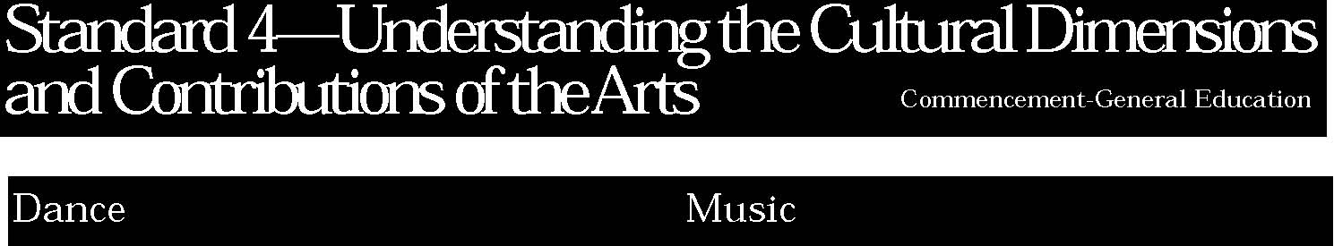
4. Students will know dances from many cultures and times and recognize their relationship to various cultural, social, and historic contexts. Students will recognize that dance is performed in many different cultural settings and serves many functions in diverse societies.
Students:
- explain the interaction of performer and audience in dance as a shared cultural event (a)
- identify the cultural elements in a variety of dances drawn from the folk and classical repertories (b)
- recognize specific contributions of dance and dancers to their own lives and to people in other times and places (c).

This is evident, for example, when students:
- describe their feelings and responses to a live dance performance and the effects that their responses might have on the performers
- view a performance of modern dance and see if they can spot the traditional folk elements present
- discuss the role that dance plays in the lives of a specific cultural group
- research and choreograph a performance that demonstrates the differences and similarities of dances that originated in various cultures
- develop a presentation that uses dance to communicate information about another discipline, e.g., history, literature, science
- in collaboration with another student, research, develop, and choreograph a dance dialogue between the approaches to dance of two different cultures
- attend several dance performances during the school year that reflect a range of styles and approaches to choreography and then compare and contrast the influence of culture on the styles.

4. Students will develop a performing and listening repertoire of music of various genres, styles, and cultures that represent the peoples of the world and their manifestations in the United States. Students will recognize the cultural features of a variety of musical compositions and performances and understand the functions of music within the culture.
Students:
- identify from performances or recordings the cultural contexts of a further varied repertoire of folk, art, and contemporary selections from the basic cultures that represent the peoples of the world (a)
- identify from performances or recordings the titles and composers and discuss the cultural contexts of well-known examples of classical concert music and blues/jazz selections (b)
- relate well-known musical examples from the 17th century onward with the dominant social and historical events (c).

This is evident, for example, when students:
- write program notes for a concert of folksongs and art songs that identify for the audience the source of the songs and how the song was used
- identify dance forms in music and write a report which details the time period these dance forms were performed, costumes worn during the period and the impact they had on the music performed
- compile an annotated list of some important musical compositions from the 1600’s to the 2000’s with references to significant historical and social events.

4. Students will gain knowledge about past and present cultures as expressed through theatre. They will interpret how theatre reflects the beliefs, issues, and events of societies past and present.
Students:
• read and view a variety of plays from different cultures (a)
- using the basic elements of theatre (e.g., speech, gesture, costume, etc.), explain how different theatrical productions represent the cultures from which they come (b)
- articulate the societal beliefs, issues and events of specific theatrical productions (c).

This is evident, for example, when students:
- read a play by a contemporary foreign playwright who writes about a social issue; analyze how the issue is depicted in the drama
- recreate a Kabuki theatre performance piece using appropriate makeup, costuming, set design and acting style showing an understanding of Japanese customs
- read a work from another century and/or another country and write a report explaining how the play realistically portrays life in that time period.

4. Students will explore art and artifacts from various historical periods and world cultures to discover the roles that art plays in the lives of people of a given time and place and to understand how the time and place influence the visual characteristics of the art work. Students will explore art to understand the social, cultural, and environmental dimensions of human society.
Students:
- analyze works of art from diverse world cultures and discuss the ideas, issues, and events of the culture that these works convey (a)
- examine works of art and artifacts from United States cultures and place them within a cultural and historical context (b)
- create art works that reflect a variety of cultural influences (c).

This is evident, for example, when students:
- compare the way the human figure is depicted in Byzantine art with the way it is depicted in High Renaissance art and explore the reasons for the differences
- select a style of art from the 20th century, study the characteristics of that style, research one artist who painted in that style and make a work of art using that style but expressing the students' point of view or idea.

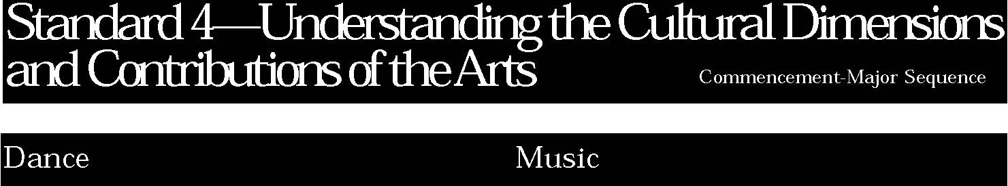
4. Students will know dances from many cultures and times and recognize their relationship to various cultural, social, and historic contexts. Students will recognize that dance is performed in many different cultural settings and serves many functions in diverse societies.
In addition to the General Education performance indicators, students:
- demonstrate an understanding of dance as a shared cultural event when giving presentations (dance, lecture, video, written report) (a)
- demonstrate a knowledge of cultural elements in dance presentations of folk and classical repertories (b)
- prepare formal presentations that use materials about dance and dancers of other times and places (c).

This is evident, for example, when students:
- write the explanatory notes for one segment of a dance festival showcasing various ethnic dances
- write a short research paper on the contributions of dance to a specific culture and the ways in which dance expresses the values and beliefs of that culture
- work in a group to develop and present a comparison of dance steps, styles, and forms of various cultures
- develop a presentation that integrates dance into another art form (e.g., storytelling, visual art, choral singing).

4. Students will develop a performing and listening repertoire of music of various genres, styles, and cultures that represent the peoples of the world and their manifestations in the United States. Students will recognize the cultural features of a variety of musical compositions and performances and understand the functions of music within the culture.
In addition to the General Education performance indicators, students:
- analyze music from various cultures on the basis of its functions, giving examples and describing uses to which music is put in those cultures (a)
- in performing ensembles, read and perform repertoire in a culturally authentic manner and use culture-based criteria for assessing performances, their own and others’ (b).

This is evident, for example, when students:
- compile a list of musical compositions that exemplify the significant characteristics of the major world cultures; describe important musical dimensions and the salient cultural attributes of each
- play rhythmic patterns in an authentic manner when performing different forms of Jazz
- perform in a culturally-based ensemble (e.g., steel drum band, gospel choir, or German brass band).

4. Students will gain knowledge about past and present cultures as expressed through theatre. They will interpret how theatre reflects the beliefs, issues, and events of societies past and present.
In addition to the General Education performance indicators, students:
- conduct an in-depth investigation of the works of a given culture or playwright (a)
- create a multicultural theatre festival of excerpts from plays representing various cultures (c).

This is evident, for example, when students:
- read the plays of Sophocles, Aeschylus, and Euripides from the ancient Greek time period and write a paper which compares and contrasts their style and themes and discusses the impact each had on staging
- produce a festival of plays from different cultures centered on the same theme.

4. Students will explore art and artifacts from various historical periods and world cultures to discover the roles that art plays in the lives of people of a given time and place and to understand how the time and place influence the visual characteristics of the art work. Students will explore art to understand the social, cultural, and environmental dimensions of human society.
In addition to the General Education performance indicators, students:
- present a body of work within their portfolio that reflects the influences of variety of cultural styles (a)
- interpret the meaning of works and artifacts in terms of the cultures that produced them (b)
- explain how cultural values have been expressed in the visual arts, how art works have been used to bring about cultural change and how the art of a culture has been influenced by art works coming from outside that culture (c).

This is evident, for example, when students:
- write a short research paper exploring how the depictions of war in The Third of May by Goya and Napoleon On The Battlefield at Eylau by Gros differ one from another
- discuss the influence of African art on Picasso's Demoiselles D’Avignon
- look at the body of work in their portfolios and describe what they consider to be their style and indicate what has influenced that style.
- compare the work of regionalist artists who documented life of the ordinary people in a given place; such as Thomas Hart Benton, John Stuart Curry, and Grant Wood with the Harlem Renaissance artists like William H. Johnson, Jacob Lawrence, Aaron Douglas, and Romare Bearden.

34

The samples of student work included in this section are intended to begin the process of articulating the performance standards at each level of achievement. This collection is not yet adequate for that purpose in either numbers or scope of examples. Since samples of student work in the Arts usually take forms other than the written word, only a few examples are included here. Most examples will be included on a multimedia format which is under production. As New York State continues to collect work samples from the schools for inclusion in this document and the multimedia format, we expect a much clearer understanding of the performance standards to be evident.
Neither are these samples presented as models of excellence. They vary in degree of “acceptable” achievement. Some are “competent;” others “more proficient.” All are meant to provide examples of the kind of work students might produce to demonstrate progress toward the standards.

