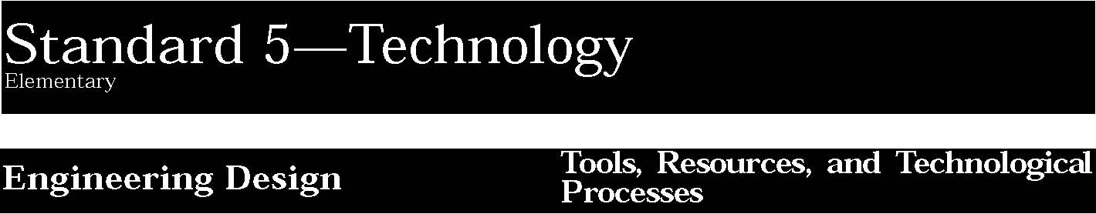

1. Engineering design is an iterative process involving modeling and optimization used to develop technological solutions to problems within given constraints.
Students:
- describe objects, imaginary or real, that might be modeled or made differently and suggest ways in which the objects can be changed, fixed, or improved.
- investigate prior solutions and ideas from books, magazines, family, friends, neighbors, and community members.
- generate ideas for possible solutions, individually and through group activity; apply age-appropriate mathematics and science skills; evaluate the ideas and determine the best solution; and explain reasons for the choices.
- plan and build, under supervision, a model of the solution using familiar materials, processes, and hand tools.
- discuss how best to test the solution; perform the test under teacher supervision; record and portray results through numerical and graphic means; discuss orally why things worked or didn’t work; and summarize results in writing, suggesting ways to make the solution better.

This is evident, for example, when students:
- read a story called Humpty’s Big Day wherein the readers visit the place where Humpty Dumpty had his accident, and are asked to design and model a way to get to the top of the wall and down again safely.
- generate and draw ideas for a space station that includes a pleasant living and working environment.
- design and model footwear that they could use to walk on a cold, sandy surface.

Key ideas are identified by numbers (1). Performance indicators are identified by bullets (•). Sample tasks are identified by triangles (▲ ).

2. Technological tools, materials, and other resources should be selected on the basis of safety, cost, availability, appropriateness, and environmental impact; technological processes change energy, information, and material resources into more useful forms.
Students:
- explore, use, and process a variety of materials and energy sources to design and construct things.
- understand the importance of safety, cost, ease of use, and availability in selecting tools and resources for a specific purpose.
- develop basic skill in the use of hand tools.
- use simple manufacturing processes (e.g., assembly, multiple stages of production, quality control) to produce a product.
- use appropriate graphic and electronic tools and techniques to process information.

This is evident, for example, when students:
- explore and use materials, joining them with the use of adhesives and mechanical fasteners to make a cardboard marionette with moving parts.
- explore materials and use forming processes to heat and bend plastic into a shape that can hold napkins.
- explore energy sources by making a simple motor that uses electrical energy to produce continuous mechanical motion.
- develop skill with a variety of hand tools and use them to make or fix things.
- process information electronically such as using a video system to advertise a product or service.
- process information graphically such as taking photos and developing and printing the pictures.

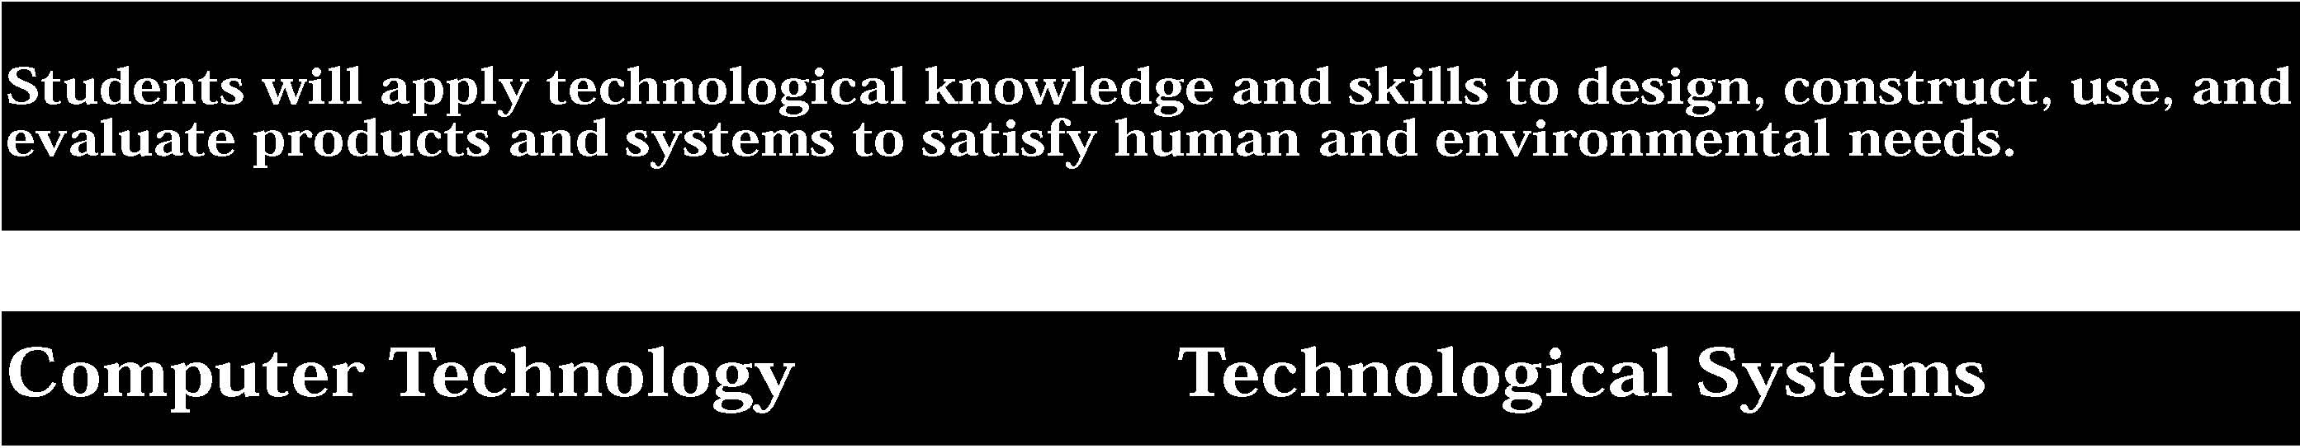

3. Computers, as tools for design, modeling, information processing, communication, and system control, have greatly increased human productivity and knowledge.
Students:
- identify and describe the function of the major components of a computer system.
- use the computer as a tool for generating and drawing ideas.
- control computerized devices and systems through programming.
- model and simulate the design of a complex environment by giving direct commands.

This is evident, for example, when students:
- control the operation of a toy or household appliance by programming it to perform a task.
- execute a computer program, such as SimCity, Theme Park, or The Factory to model and simulate an environment.
- model and simulate a system using construction modeling software, such as The Incredible Machine.

Sample Problem/Activity
4. Technological systems are designed to achieve specific results and produce outputs, such as products, structures, services, energy, or other systems.
Students:
- identify familiar examples of technological systems that are used to satisfy human needs and wants, and select them on the basis of safety, cost, and function.
- assemble and operate simple technological systems, including those with interconnecting mechanisms to achieve different kinds of movement.
- understand that larger systems are made up of smaller component subsystems.

This is evident, for example, when students:
- assemble and operate a system made up from a battery, switch, and doorbell connected in a series circuit.
- assemble a system with interconnecting mechanisms, such as a jack-in-the-box that pops up from a box with a hinged lid.
- model a community-based transportation system which includes subsystems such as roadways, rails, vehicles, and traffic controls.

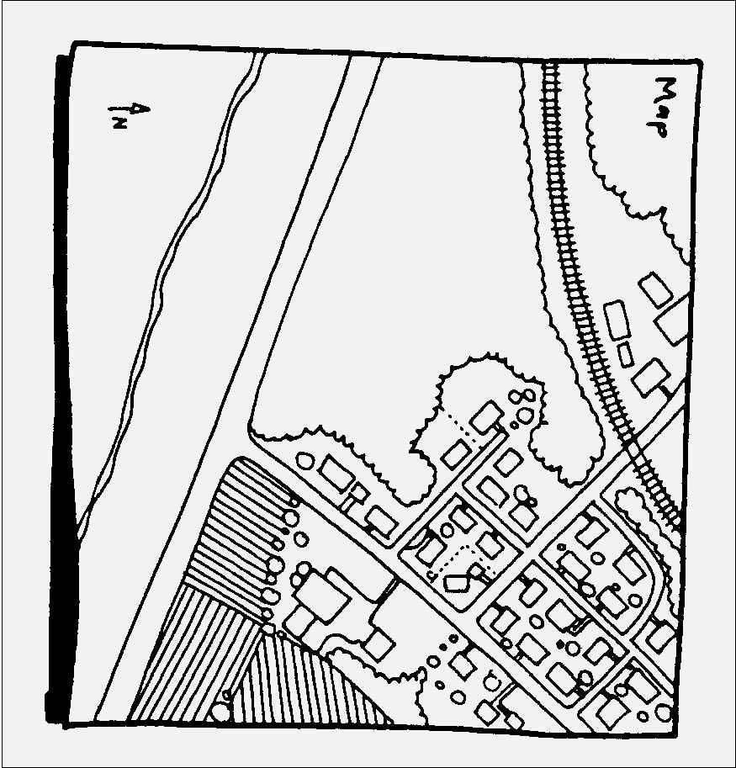
Computer design for model community

5. Technology has been the driving force in the evolution of society from an agricultural to an industrial to an information base.
Students:
• identify technological developments that have significantly accelerated human progress.
This is evident, for example, when students:
- construct a model of an historical or future-oriented technological device or system and describe how it has contributed or might contribute to human progress.
- make a technological timeline in the form of a hanging mobile of technological devices.
- model a variety of timekeeping devices that reflect historical and modern methods of keeping time.
- make a display contrasting early devices or tools with their modern counterparts.

Key ideas are identified by numbers (1). Performance indicators are identified by bullets (•). Sample tasks are identified by triangles (▲ ).
6. Technology can have positive and negative impacts on individuals, society, and the environment and humans have the capability and responsibility to constrain or promote technological development.
Students:
• describe how technology can have positive and negative effects on the environment and on the way people live and work.
This is evident, for example, when students:
- handmake an item and then participate in a line production experience where a quantity of the item is mass produced; compare the benefits and disadvantages of mass production and craft production.
- describe through example, how familiar technologies (including computers) can have positive and negative impacts on the environment and on the way people live and work.
- identify the pros and cons of several possible packaging materials for a student-made product.

Sample Problem/Activity
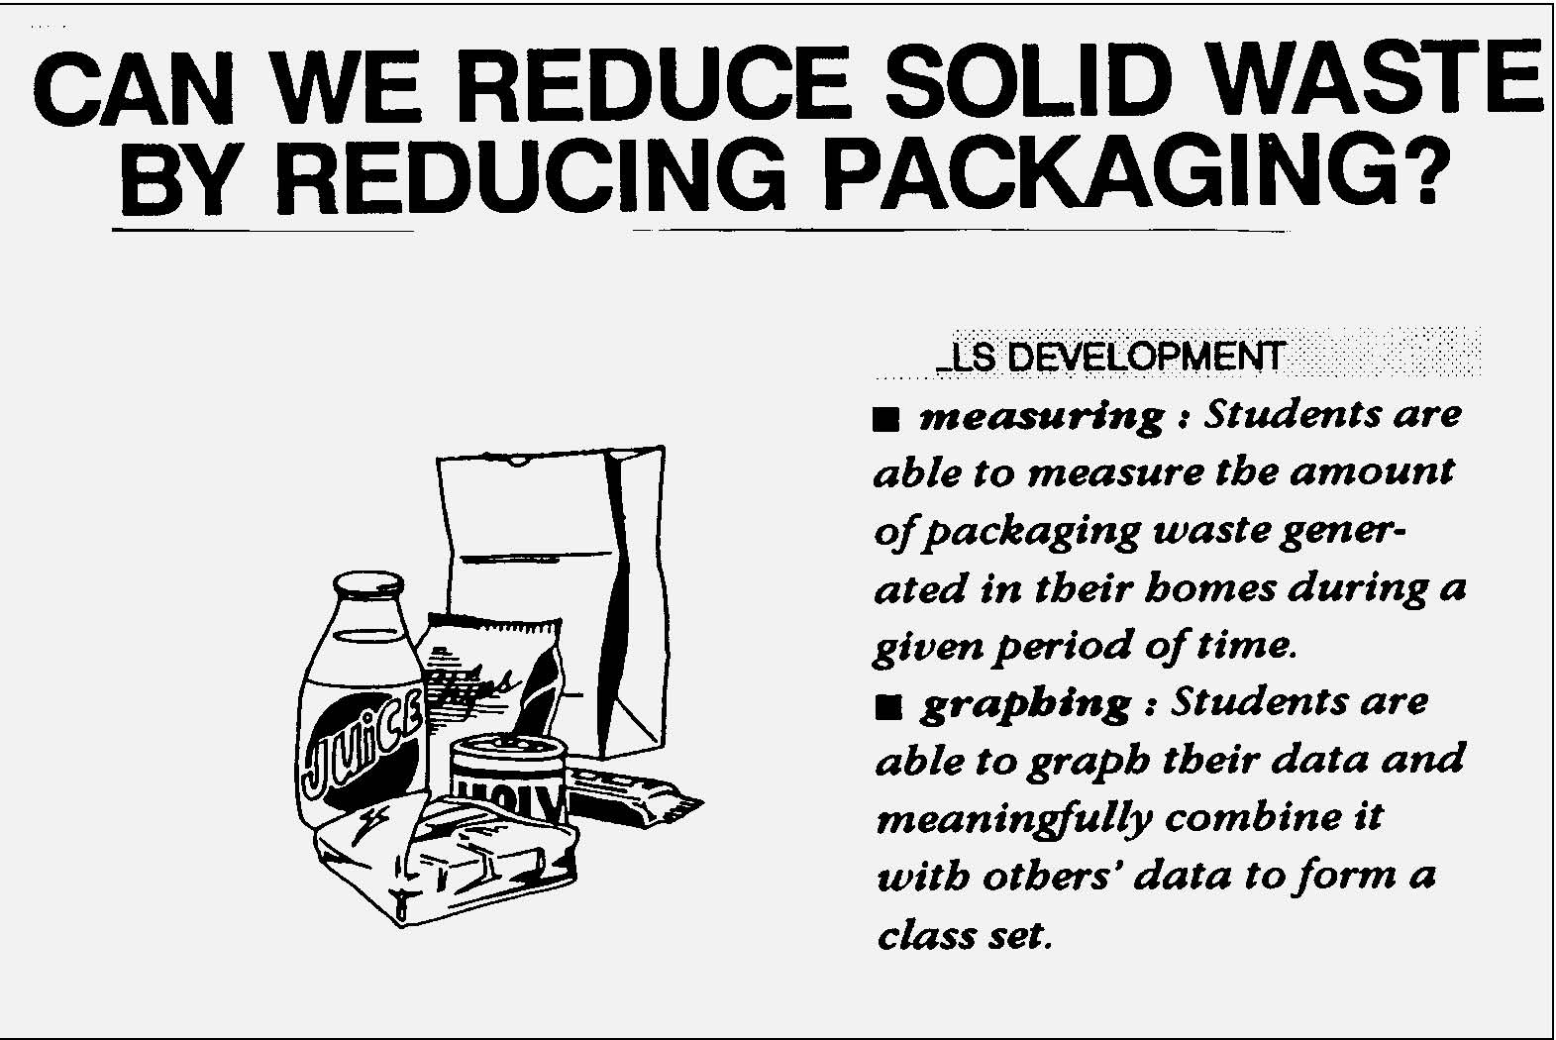
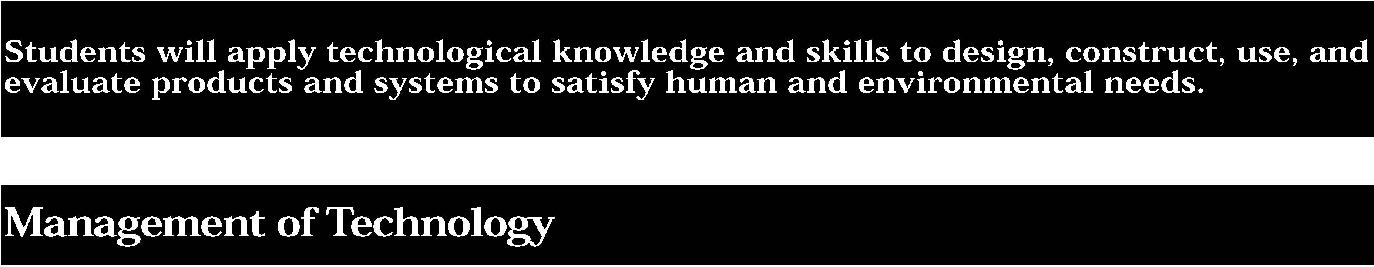
7. Project management is essential to ensuring that technological endeavors are profitable and that products and systems are of high quality and built safely, on schedule, and within budget.
Students:
- participate in small group projects and in structured group tasks requiring planning, financing, production, quality control, and follow-up.
- speculate on and model possible technological solutions that can improve the safety and quality of the school or community environment.

This is evident, for example, when students:
- help a group to plan and implement a school project or activity, such as a school picnic or a fund-raising event.
- plan as a group, division of tasks and construction steps needed to build a simple model of a structure or vehicle.
- redesign the work area in their classroom with an eye toward improving safety.

Sample Problem/Activity
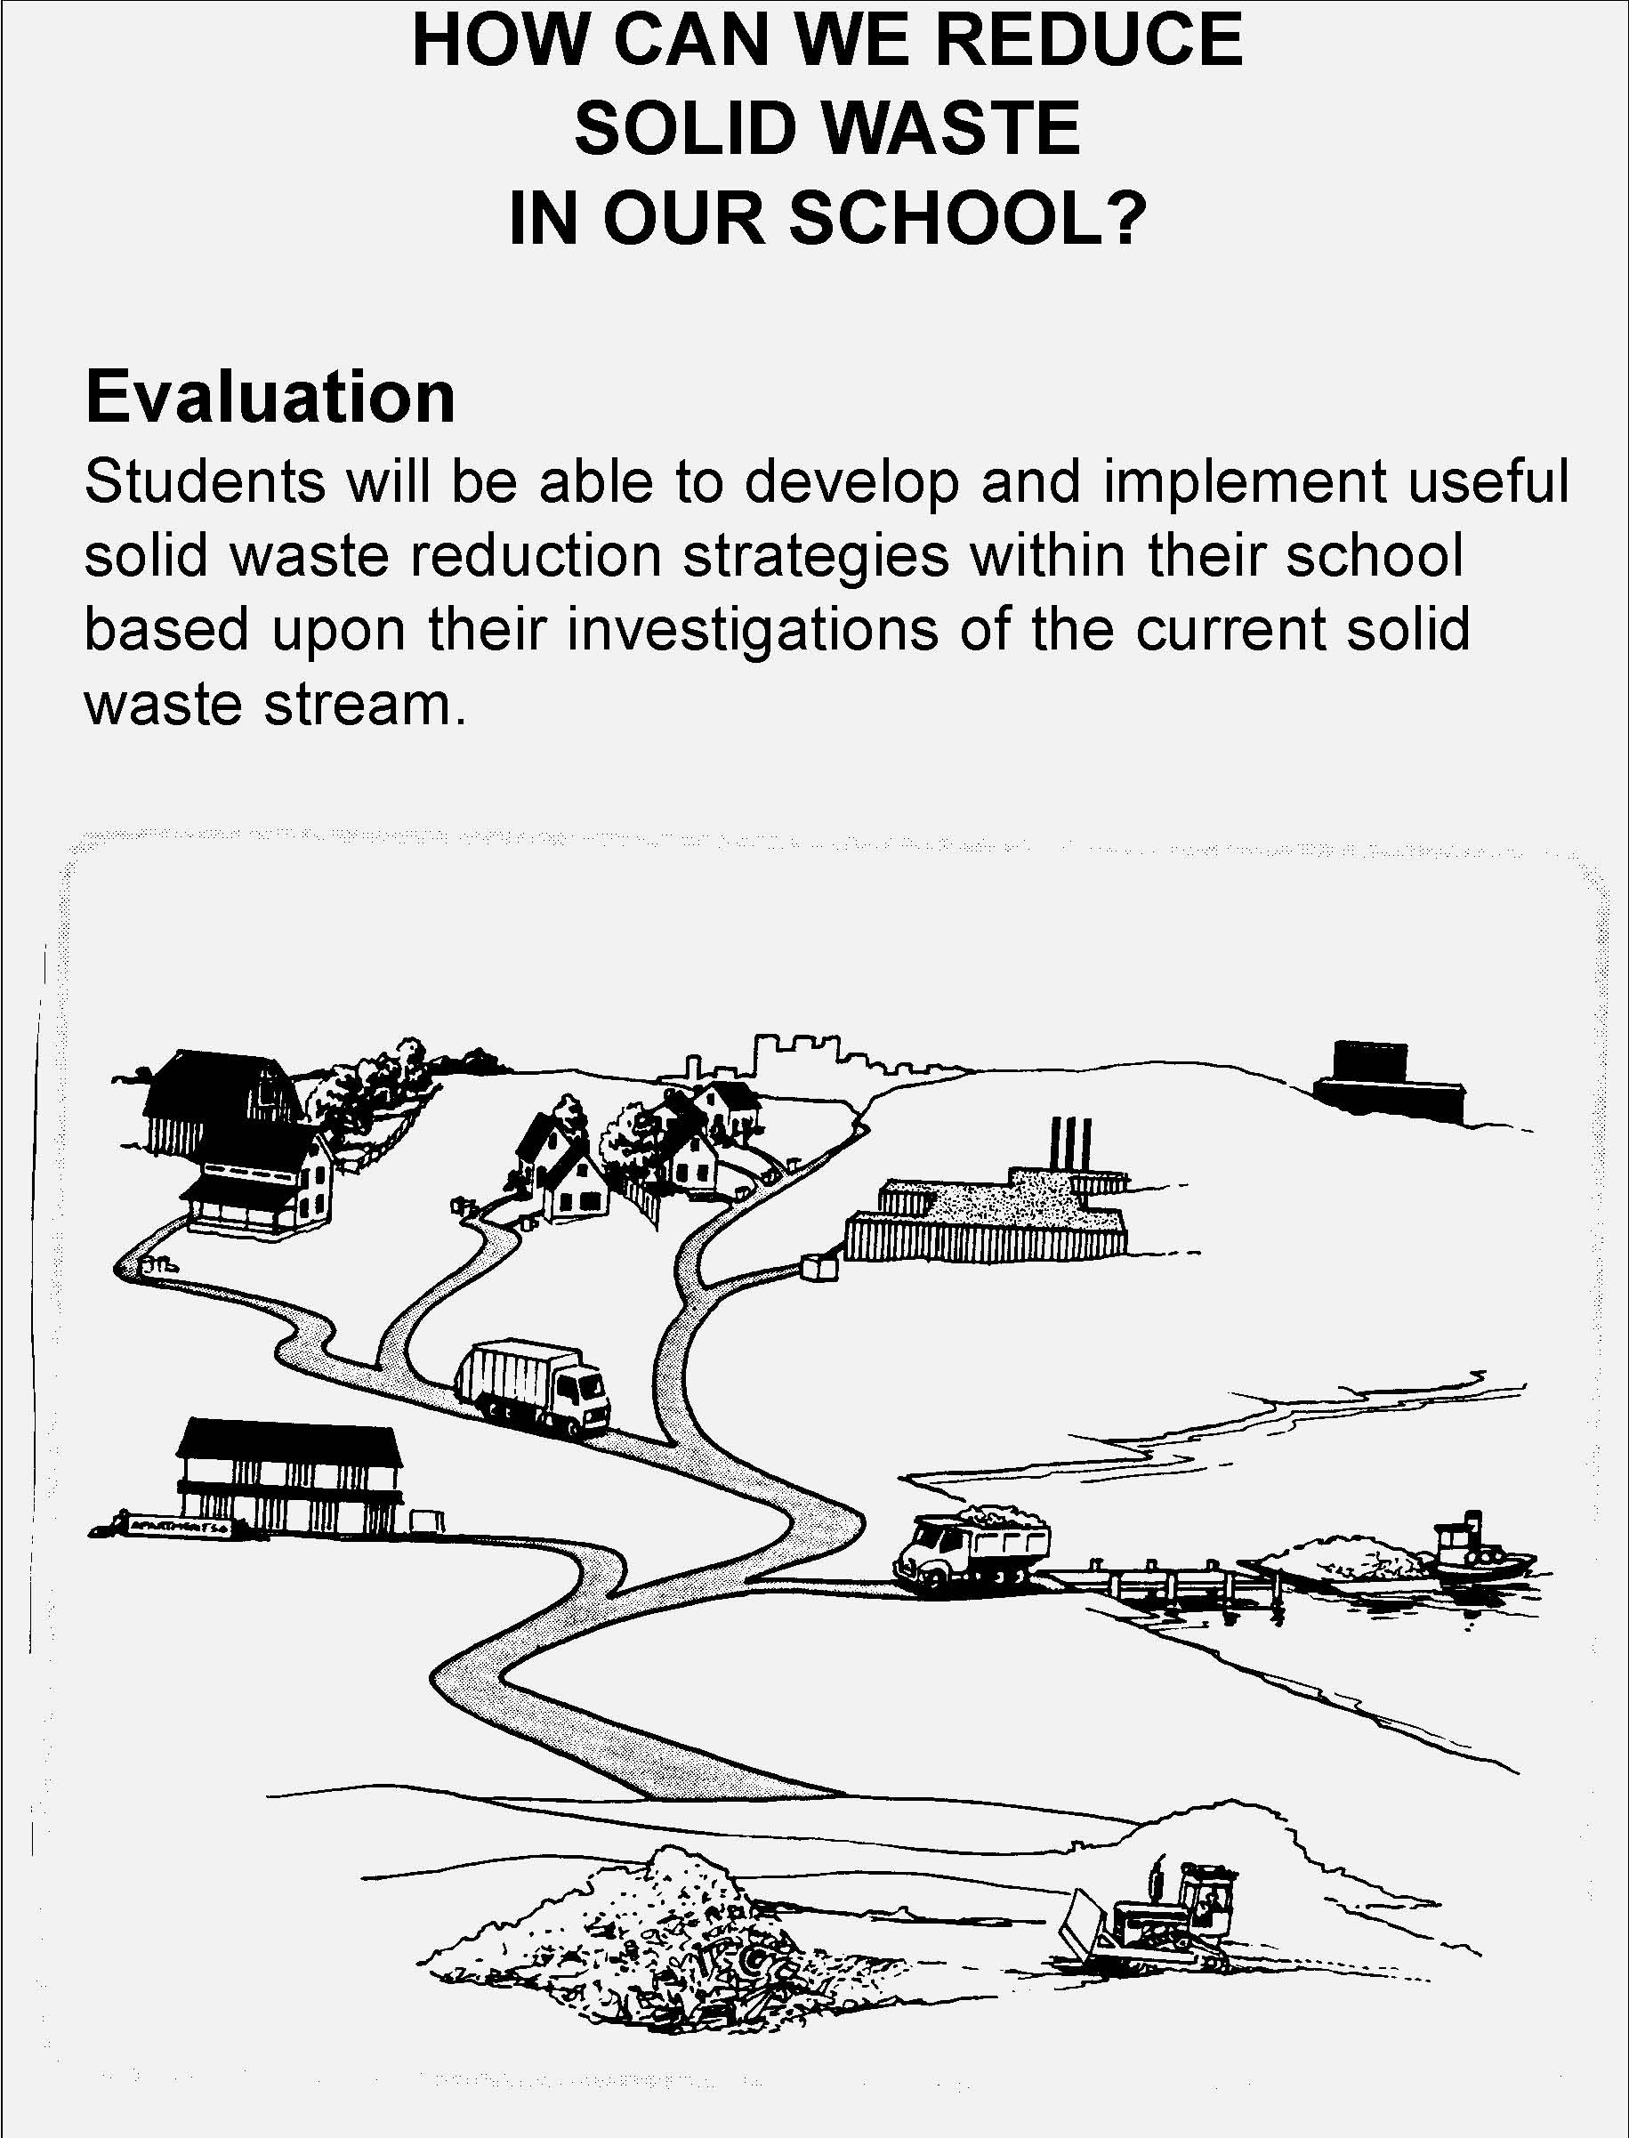


1. Engineering design is an iterative process involving modeling and optimization used to develop technological solutions to problems within given constraints.
Students engage in the following steps in a design process:
- identify needs and opportunities for technical solutions from an investigation of situations of general or social interest.
- locate and utilize a range of printed, electronic, and human information resources to obtain ideas.
- consider constraints and generate several ideas for alternative solutions, using group and individual ideation techniques (group discussion, brainstorming, forced connections, role play); defer judgment until a number of ideas have been generated; evaluate (critique) ideas; and explain why the chosen solution is optimal.
- develop plans, including drawings with measurements and details of construction, and construct a model of the solution, exhibiting a degree of craftsmanship.
- in a group setting, test their solution against design specifications, present and evaluate results, describe how the solution might have been modified for different or better results, and discuss tradeoffs that might have to be made.

This is evident, for example, when students:
- reflect on the need for alternative growing systems in desert environments and design and model a hydroponic greenhouse for growing vegetables without soil.
- brainstorm and evaluate alternative ideas for an adaptive device that will make life easier for a person with a disability, such as a device to pick up objects from the floor.
- design a model vehicle (with a safety belt restraint system and crush zones to absorb impact) to carry a raw egg as a passenger down a ramp and into a barrier without damage to the egg.
- assess the performance of a solution against various design criteria, enter the scores on a spreadsheet, and see how varying the solution might have affected total score.

2. Technological tools, materials, and other resources should be selected on the basis of safety, cost, availability, appropriateness, and environmental impact; technological processes change energy, information, and material resources into more useful forms.
Students:
- choose and use resources for a particular purpose based upon an analysis and understanding of their properties, costs, availability, and environmental impact.
- use a variety of hand tools and machines to change materials into new forms through forming, separating, and combining processes, and processes which cause internal change to occur.
- combine manufacturing processes with other technological processes to produce, market, and distribute a product.
- process energy into other forms and information into more meaningful information.

This is evident, for example, when students:
- choose and use resources to make a model of a building and explain their choice of materials based upon physical properties such as tensile and compressive strength, hardness, and brittleness.
- choose materials based upon their acoustic properties to make a set of wind chimes.
- use a torch to heat a steel rod to a cherry red color and cool it slowly to demonstrate how the process of annealing changes the internal structure of the steel and removes its brittleness.
- change materials into new forms using separate processes such as drilling and sawing.
- process energy into other forms such as assembling a solar cooker using a parabolic reflector to convert light energy to heat energy.
- process information into more meaningful information such as adding a music track or sound effects to an audio tape.

Key ideas are identified by numbers (1). Performance indicators are identified by bullets (•). Sample tasks are identified by triangles (▲ ).
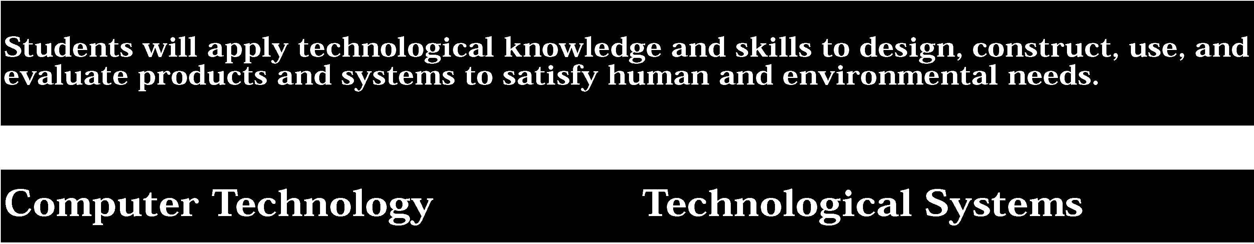

3. Computers, as tools for design, modeling, information processing, communication, and system control, have greatly increased human productivity and knowledge.
Students:
- assemble a computer system including keyboard, central processing unit and disc drives, mouse, modem, printer, and monitor.
- use a computer system to connect to and access needed information from various Internet sites.
- use computer hardware and software to draw and dimension prototypical designs.
- use a computer as a modeling tool.
- use a computer system to monitor and control external events and/or systems.

This is evident, for example, when students:
- use computer hardware and a basic computer-aided design package to draw and dimension plans for a simple project.
- use a computer program, such as Car Builder, to model a vehicle to desired specifications.
- use temperature sensors to monitor and control the temperature of a model greenhouse.
- model a computer-controlled system, such as traffic lights, a merry-go-round, or a vehicle using Lego or other modeling hardware interfaced to a computer.

4. Technological systems are designed to achieve specific results and produce outputs, such as products, structures, services, energy, or other systems.
Students:
- select appropriate technological systems on the basis of safety, function, cost, ease of operation, and quality of post-purchase support.
- assemble, operate, and explain the operation of simple open- and closed-loop electrical, electronic, mechanical, and pneumatic systems.
- describe how subsystems and system elements (inputs, processes, outputs) interact within systems.
- describe how system control requires sensing information, processing it, and making changes.

This is evident, for example, when students:
- assemble an electronic kit that includes sensors and signaling devices and functions as an alarm system.
- use several open loop systems (without feedback control) such as a spray can, bubble gum machine, or wind-up toys, and compare them to closed-loop systems (with feedback control) such as an electric oven with a thermostat, or a line tracker robot.
- use a systems diagram to model a technological system, such as a model rocket, with the command inputs, resource inputs, processes, monitoring and control mechanisms, and system outputs labeled.
- provide examples of modern machines where microprocessors receive information from sensors and serve as controllers.

Sample Problem/Activity
Systems diagram for a filter system
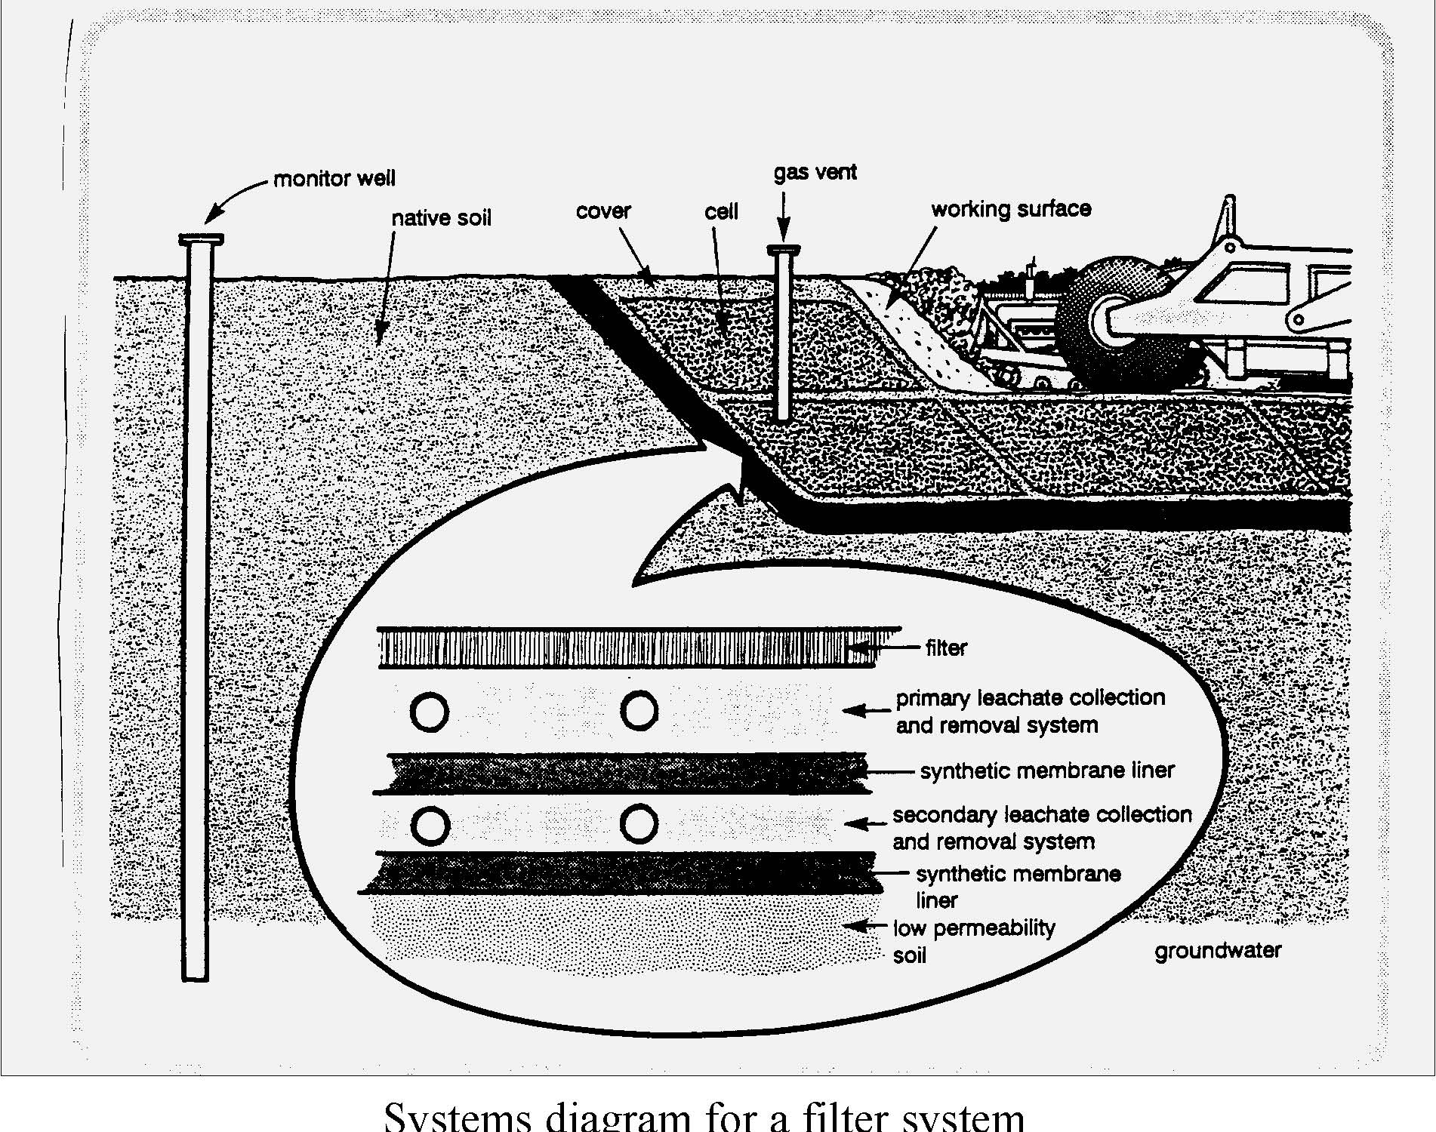


5. Technology has been the driving force in the evolution of society from an agricultural to an industrial to an information base.
Students:
- describe how the evolution of technology led to the shift in society from an agricultural base to an industrial base to an information base.
- understand the contributions of people of different genders, races, and ethnic groups to technological development.
- describe how new technologies have evolved as a result of combining existing technologies (e.g., photography combined optics and chemistry; the airplane combined kite and glider technology with a lightweight gasoline engine).

This is evident, for example, when students:
- construct models of technological devices (e.g., the plow, the printing press, the digital computer) that have significantly affected human progress and that illustrate how the evolution of technology has shifted the economic base of the country.
- develop a display of pictures or models of technological devices invented by people from various cultural backgrounds, along with photographs and short biographies of the inventors.
- make a poster with drawings and photographs showing how an existing technology is the result of combining various technologies.

Sample Problem/Activity
6. Technology can have positive and negative impacts on individuals, society, and the environment and humans have the capability and responsibility to constrain or promote technological development.
Students:
- describe how outputs of a technological system can be desired, undesired, expected, or unexpected.
- describe through examples how modern technology reduces manufacturing and construction costs and produces more uniform products.

This is evident, for example, when students:
- use the automobile, for example, to explain desired (easier travel), undesired (pollution), expected (new jobs created), unexpected (crowded highways and the growth of suburbs) impacts.
- provide an example of an assembly line that produces products with interchangeable parts.
- compare the costs involved in producing a prototype of a product to the per product cost of a batch of 100.


Key ideas are identified by numbers (1). Performance indicators are identified by bullets (•). Sample tasks are identified by triangles (▲ ).
7. Project management is essential to ensuring that technological endeavors are profitable and that products and systems are of high quality and built safely, on schedule, and within budget.
Students:
- manage time and financial resources in a technological project.
- provide examples of products that are well (and poorly) designed and made, describe their positive and negative attributes, and suggest measures that can be implemented to monitor quality during production.
- assume leadership responsibilities within a structured group activity.

This is evident, for example, when students:
▲ make up and follow a project work plan, time schedule, budget, and a bill of materials.
▲ analyze a child’s toy and describe how it might have been better made at a lower cost.
▲ assume leadership on a team to play an audio or video communication system, and use it for an intended purpose (e.g., to inform, educate, persuade, entertain).

Sample Problem/Activity
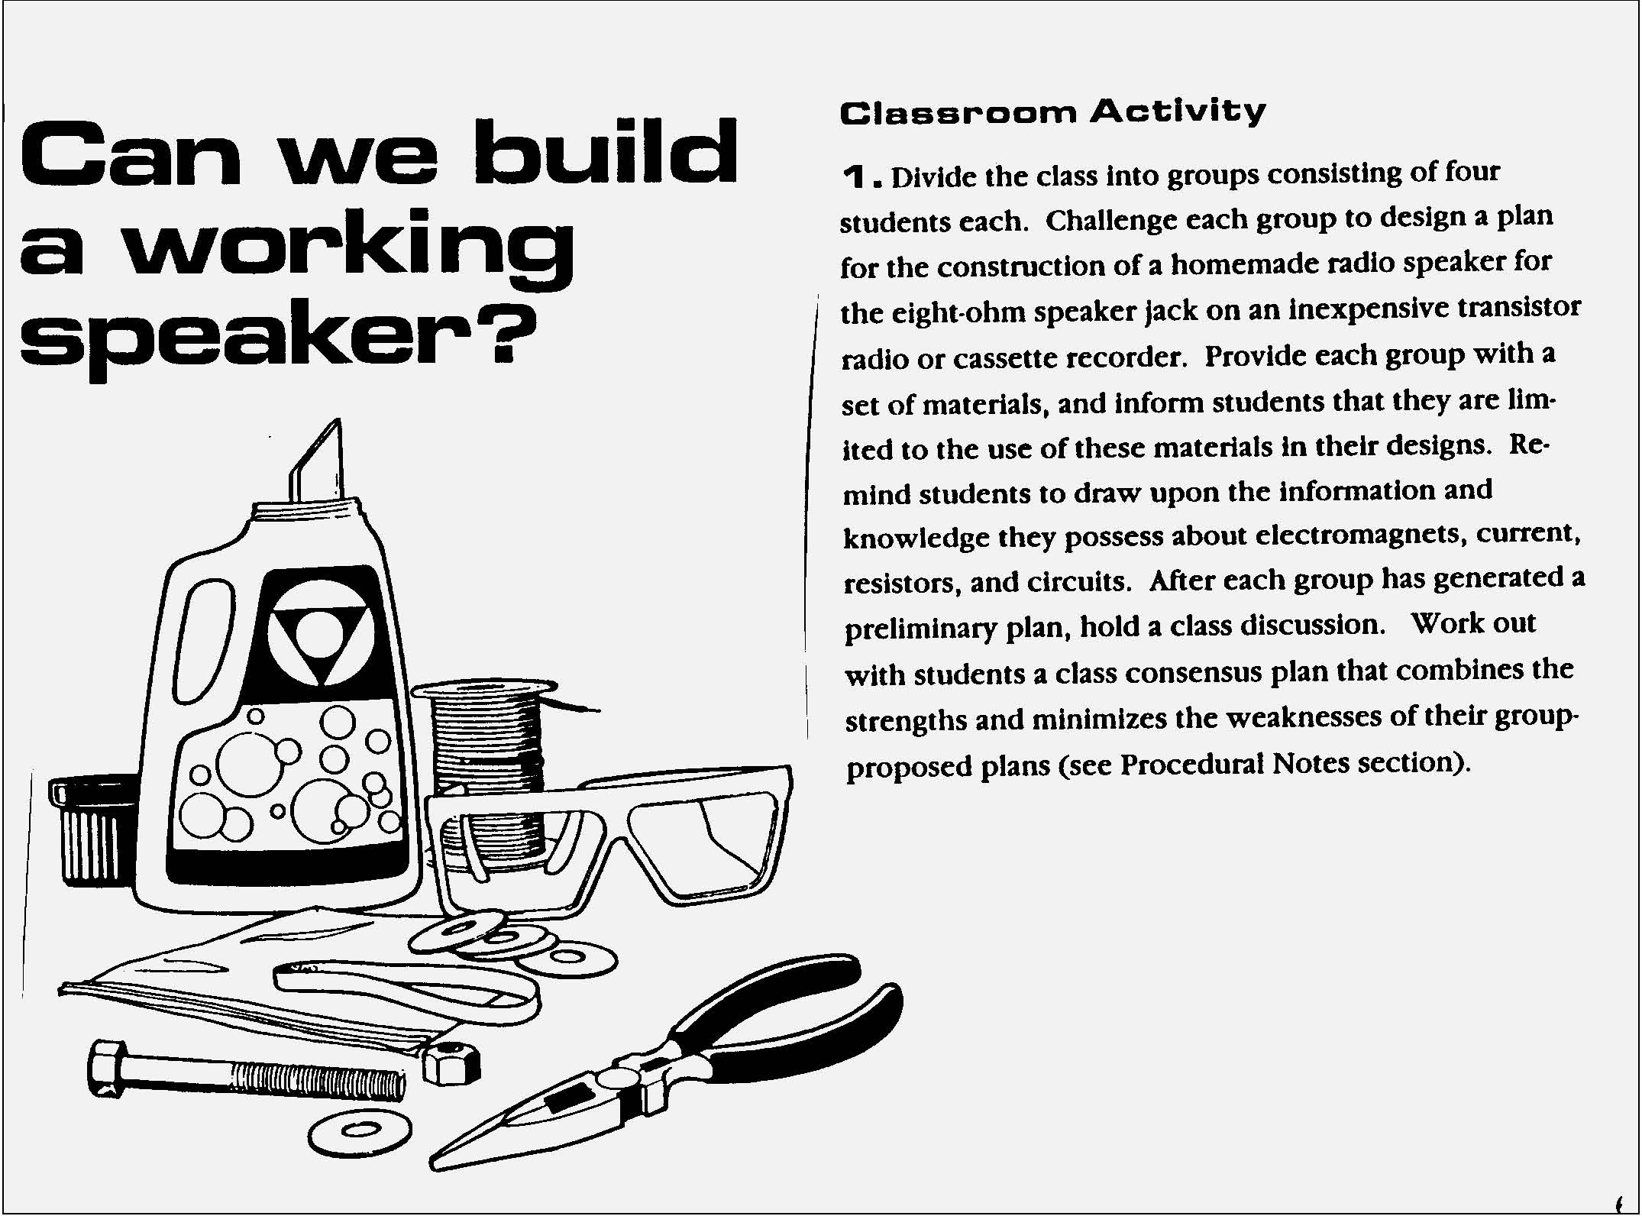


1. Engineering design is an iterative process involving modeling and optimization used to develop technological solutions to problems within given constraints.
Students engage in the following steps in a design process:
- initiate and carry out a thorough investigation of an unfamiliar situation and identify needs and opportunities for technological invention or innovation.
- identify, locate, and use a wide range of information resources including subject experts, library references, magazines, videotapes, films, electronic data bases and on-line services, and discuss and document through notes and sketches how findings relate to the problem.
- generate creative solution ideas, break ideas into the significant functional elements, and explore possible refinements; predict possible outcomes using mathematical and functional modeling techniques; choose the optimal solution to the problem, clearly documenting ideas against design criteria and constraints; and explain how human values, economics, ergonomics, and environmental considerations have influenced the solution.
- develop work schedules and plans which include optimal use and cost of materials, processes, time, and expertise; construct a model of the solution, incorporating developmental modifications while working to a high degree of quality (craftsmanship).
- in a group setting, devise a test of the solution relative to the design criteria and perform the test; record, portray, and logically evaluate performance test results through quantitative, graphic, and verbal means; and use a variety of creative verbal and graphic techniques effectively and persuasively to present conclusions, predict impacts and new problems, and suggest and pursue modifications.

This is evident, for example, when students:
- search the Internet for world wide web sites dealing with renewable energy and sustainable living and research the development and design of an energy efficient home.
- develop plans, diagrams, and working drawings for the construction of a computer-controlled marble sorting system that simulates how parts on an assembly line are sorted by color.
- design and model a portable emergency shelter for a homeless person that could be carried by one person and be heated by the body heat of that person to a life-sustaining temperature when the outside temperature is 20o F.

2. Technological tools, materials, and other resources should be selected on the basis of safety, cost, availability, appropriateness, and environmental impact; technological processes change energy, information, and material resources into more useful forms.
Students:
- test, use, and describe the attributes of a range of material (including synthetic and composite materials), information, and energy resources.
- select appropriate tools, instruments, and equipment and use them correctly to process materials, energy, and information.
- explain tradeoffs made in selecting alternative resources in terms of safety, cost, properties, availability, ease of processing, and disposability.
- describe and model methods (including computer-based methods) to control system processes and monitor system outputs.

This is evident, for example, when students:
- use a range of high- tech composite or synthetic materials to make a model of a product, (e.g., ski, an airplane, earthquake-resistant building) and explain their choice of material.
- design a procedure to test the properties of synthetic and composite materials.
- select appropriate tools, materials, and processes to manufacture a product (chosen on the basis of market research) that appeals to high school students.
- select the appropriate instrument and use it to test voltage and continuity when repairing a household appliance.
- construct two forms of packaging (one from biodegradable materials, the other from any other materials), for a children’s toy and explain the tradeoffs made when choosing one or the other.
- describe and model a method to design and evaluate a system that dispenses candy and counts the number dispensed using, for example, Fischertecnik, Capsela, or Lego.
- describe how the flow, processing, and monitoring of materials is controlled in a manufacturing plant and how information processing systems provide inventory, tracking, and quality control data.

Key ideas are identified by numbers (1). Performance indicators are identified by bullets (•). Sample tasks are identified by triangles (▲ ).

3. Computers, as tools for design, modeling, information processing, communication, and system control, have greatly increased human productivity and knowledge.
Students:
- understand basic computer architecture and describe the function of computer subsystems and peripheral devices.
- select a computer system that meets personal needs.
- attach a modem to a computer system and telephone line, set up and use communications software, connect to various on-line networks, including the Internet, and access needed information using e-mail, telnet, gopher, ftp, and web searches.
- use computer-aided drawing and design (CADD) software to model realistic solutions to design problems.
- develop an understanding of computer programming and attain some facility in writing computer programs.

This is evident, for example, when students:
▲ choose a state-of-the art computer system from computer magazines, price the system, and justify the choice of CPU, CD-ROM and floppy drives, amount of RAM, video and sound cards, modem, printer, and monitor; explain the cost-benefit tradeoffs they have made.
▲ use a computer-aided drawing and design package to design and draw a model of their own room.
▲ write a computer program that works in conjunction with a bar code reader and an optical sensor to distinguish between light and dark areas of the bar code.

4. Technological systems are designed to achieve specific results and produce outputs, such as products, structures, services, energy, or other systems.
Students:
- explain why making tradeoffs among characteristics, such as safety, function, cost, ease of operation, quality of post-purchase support, and environmental impact, is necessary when selecting systems for specific purposes.
- model, explain, and analyze the performance of a feedback control system.
- explain how complex technological systems involve the confluence of numerous other systems.

This is evident, for example, when students:
- model, explain, and analyze how the float mechanism of a toilet tank senses water level, compares the actual level to the desired level, and controls the flow of water into the tank.
- draw a labeled system diagram which explains the performance of a system, and include several subsystems and multiple feedback loops.
- explain how the space shuttle involves communication, transportation, biotechnical, and manufacturing systems.

Sample Problem/Activity
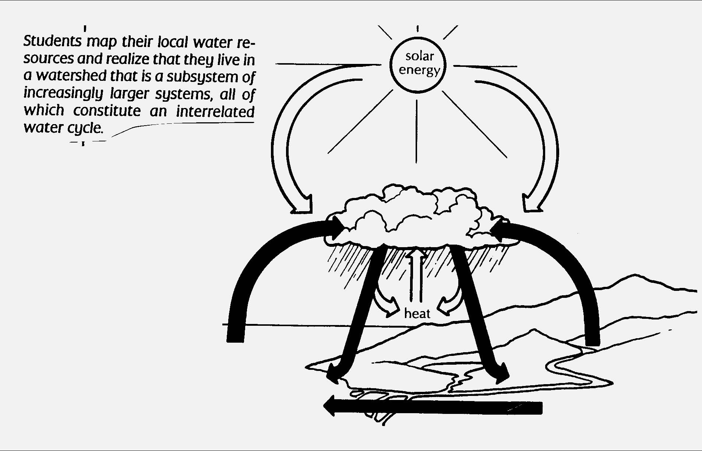


5. Technology has been the driving force in the evolution of society from an agricultural to an industrial to an information base.
Students:
• explain how technological inventions and innovations have caused global growth and interdependence, stimulated economic competitiveness, created new jobs, and made other jobs obsolete.
This is evident, for example, when students:
▲ compare qualitatively and quantitatively the performance of a contemporary manufactured product, such as a household appliance, to the comparable device or system 50-100 years ago, and present results graphically, orally, and in writing.
▲ describe the process that an inventor must follow to obtain a patent for an invention.
▲ explain through examples how some inventions are not translated into products and services with market place demand, and therefore do not become commercial successes.

6. Technology can have positive and negative impacts on individuals, society, and the environment and humans have the capability and responsibility to constrain or promote technological development.
Students:
- explain that although technological effects are complex and difficult to predict accurately, humans can control the development and implementation of technology.
- explain how computers and automation have changed the nature of work.
- explain how national security is dependent upon both military and nonmilitary applications of technology.

This is evident, for example, when students:
- develop and implement a technological device that might be used to assist a disabled person perform a task.
- identify a technology which impacts negatively on the environment and design and model a technological fix.
- identify new or emerging technologies and use a futuring technique (e.g., futures wheel, cross impact matrix, Delphi survey) to predict what might be the second and third order impacts.

Sample Problem/Activity
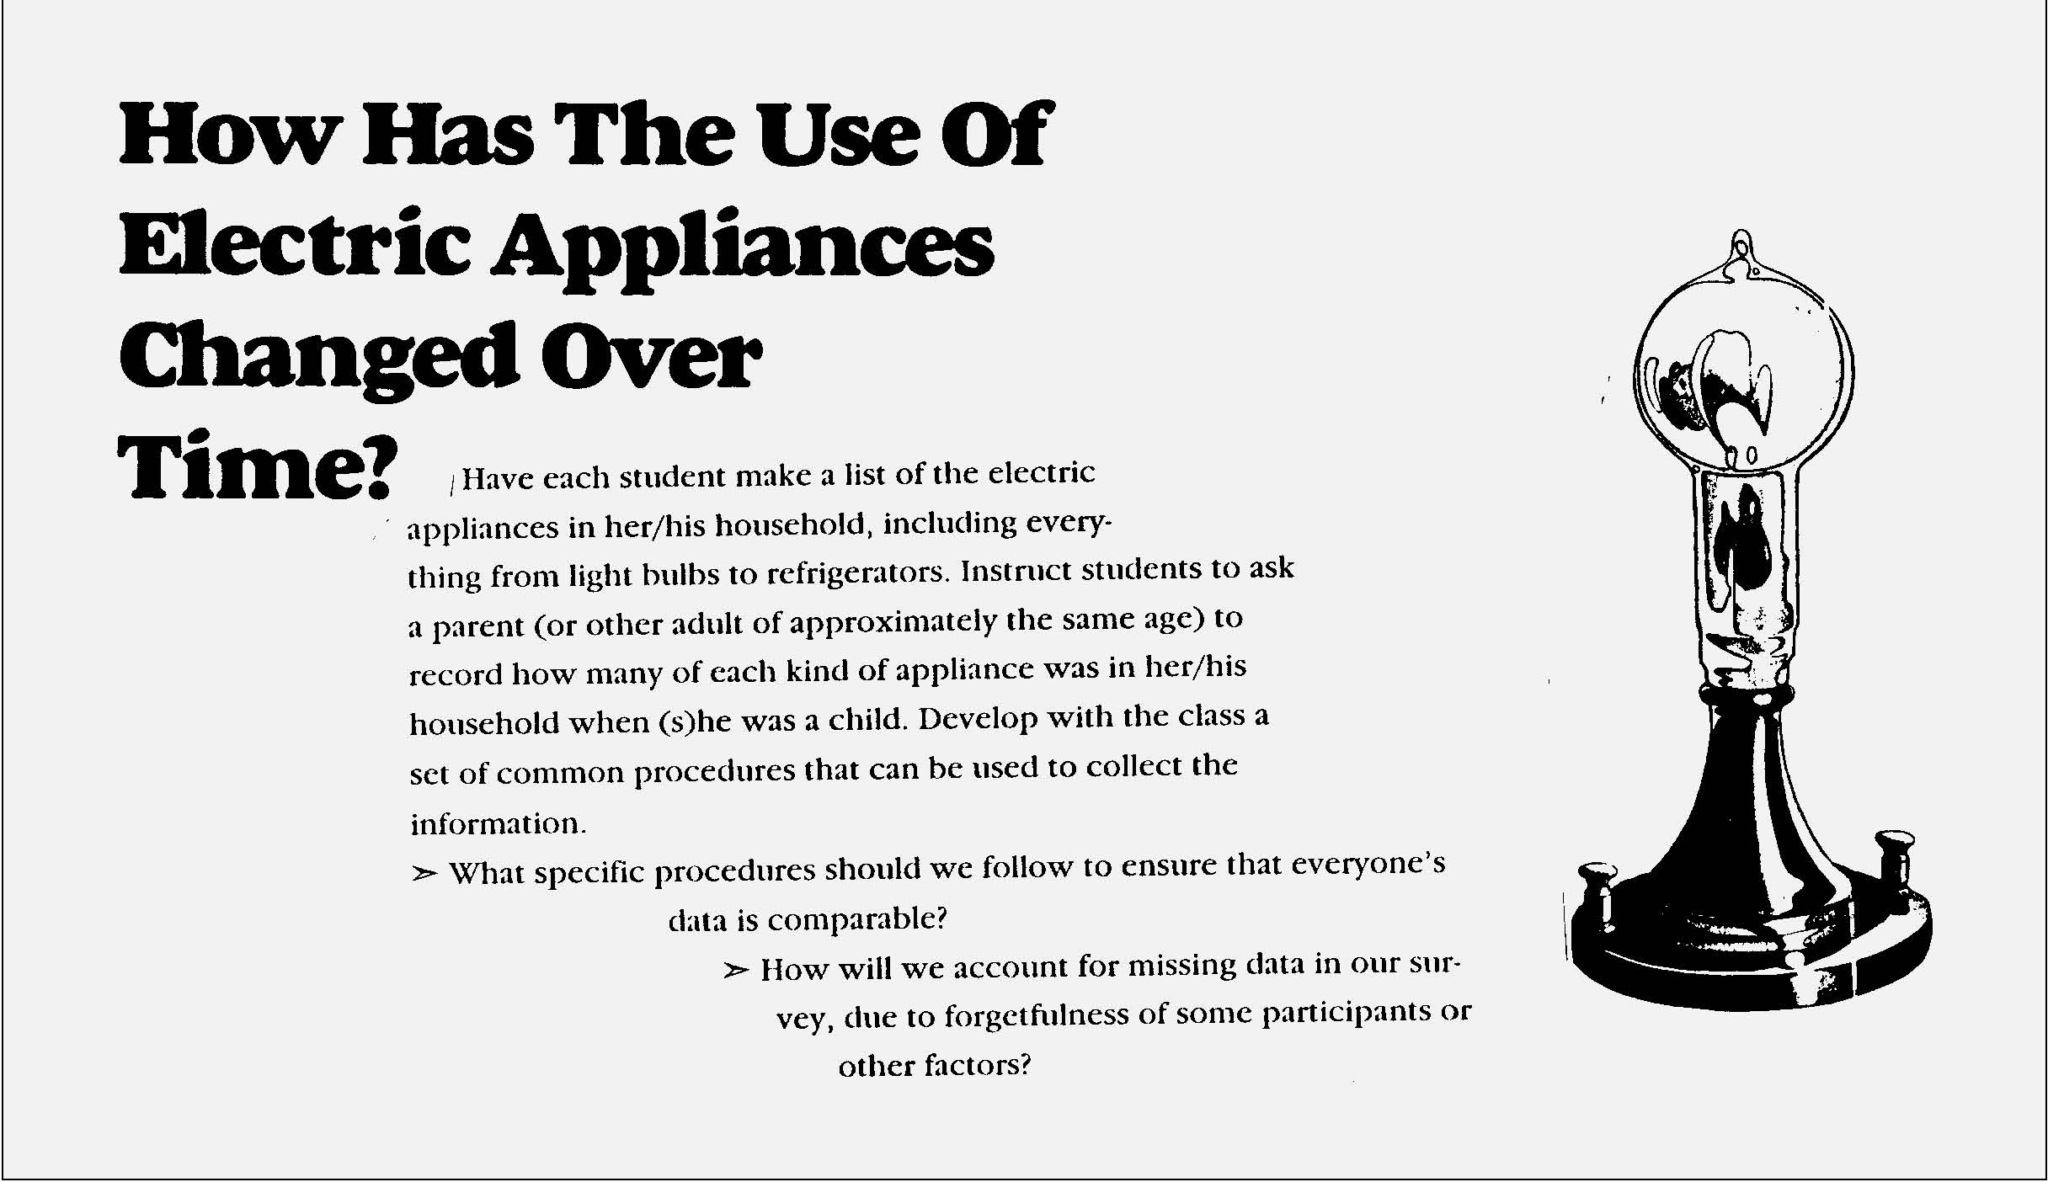
Key ideas are identified by numbers (1). Performance indicators are identified by bullets (•). Sample tasks are identified by triangles (▲ ).
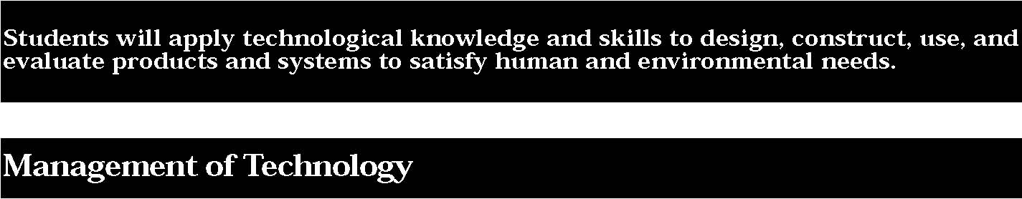

7. Project management is essential to ensuring that technological endeavors are profitable and that products and systems are of high quality and built safely, on schedule, and within budget.
Students:
- develop and use computer-based scheduling and project tracking tools, such as flow charts and graphs.
- explain how statistical process control helps to assure high quality output.
- discuss the role technology has played in the operation of successful U.S. businesses and under what circumstances they are competitive with other countries.
- explain how technological inventions and innovations stimulate economic competitiveness and how, in order for an innovation to lead to commercial success, it must be translated into products and services with marketplace demand.
- describe new management techniques (e.g., computer-aided engineering, computer-integrated manufacturing, total quality management, just-in-time manufacturing), incorporate some of these in a technological endeavor, and explain how they have reduced the length of design-to-manufacture cycles, resulted in more flexible factories, and improved quality and customer satisfaction.
- help to manage a group engaged in planning, designing, implementation, and evaluation of a project to gain understanding of the management dynamics.

This is evident, for example, when students:
- design and carry out a plan to create a computer-based information system that could be used to help manage a manufacturing system (e.g., monitoring inventory, measurement of production rate, development of a safety signal).
- identify several successful companies and explain the reasons for their commercial success.

▲ organize and implement an innovative project, based on market research, that involves design, production, testing, marketing, and sales of a product or a service.
匀礀猀琀攀洀猀搀椀愀最爀愀洀昀漀爀愀昀椀氀琀攀爀猀礀猀琀攀洀

