Learning Standards for Social Studies
Revised Edition June 1996
THE UNIVERSITY OF THE STATE OF NEW YORK Regents of The University
Carl T. Hayden, Chancellor, A.B., J.D. . . . . . . . . . . . . . . . . . . . . . . . . . . . Elmira Louise P. Matteoni, Vice Chancellor, B.A., M.A., Ph.D.. . . . . . . . . . . . . . Bayside Jorge L. Batista, B.A., J.D. . . . . . . . . . .. . . . . . . . . . . . . . . . . . . . . . . . . . . Bronx
J. Edward Meyer, B.A., LL.B.. . . . . . . . . . . . . . . . . . . . . . . . . . . . . . . . . . . Chappaqua
R. Carlos Carballada, Chancellor Emeritus, B.S. . . . . . . . . . . . . . . . . . . Rochester Norma Gluck, B.A., M.S.W. . . . . . . . . . . . . . . . . . . . . . . . . . . . . . . . . . . . . . New York Adelaide L. Sanford, B.A., M.A., P.D.. . . . . . . . . . . . . . . . . . . . . . . . . . . . . Hollis Walter Cooper, B.A., Ph.D. . . . . . . . . . . . . . . . . . . . . . . . . . . . . . . . . . . . . . Rochester Diane O’Neill McGivern, B.S.N., M.A., Ph.D. . . . . . . . . . . . . . . . . . . . . . . Staten Island Saul B. Cohen, B.A., M.A., Ph. D. . . . . . . . . . . . . . . . . . . . . . . . . . . . . . . . . New Rochelle James C. Dawson, A.A., B.A., M.S., Ph.D. . . . . . . . . . . . . . . . . . . . . . . . . . Peru Robert M. Bennett, B.A., M.S.. . . . . . . . . . . . . . . . . . . . . . . . . . . . . . . . . . . Tonawanda Robert M. Johnson, B.S., J.D.. . . . . . . . . . . . . . . . . . . . . . . . . . . . . . . . . . . Lloyd Harbor Peter M. Pryor, B.A., LL.B., J.D., LL.D.. . . . . . . . . . . . . . . . . . . . . . . . . . . Albany Anthony S. Bottar, B.A., J.D . . . . . . . . . . . . . . . . . . . . . . . . . . . . . . . . . . . .Syracuse Merryl H. Tisch, B.A., M.A.. . . . . . . . . . . . . . . . . . . . . . . . . . . . . . . . . . . . . .New York
President of The University and Commissioner of Education
RICHARD P. MILLS
Executive Deputy Commissioner of Education
THOMAS E. SHELDON
Deputy Commissioner for Elementary, Middle, Secondary, and Continuing Education
JAMES A. KADAMUS
Assistant Commissioner for Curriculum, Instruction, Assessment, and Innovation
EDWARD T. LALOR
Coordinator of Curriculum and Instruction
ROSEANNE DEFABIO
The State Education Department does not discriminate on the basis of age, color, religion, creed, disability, marital status, veteran status, national origin, race, gender or sexual orientation in its educational programs, services and activities. Portions of this publication can be made available in a variety of formats, including braille, large print or audio tape, upon request. Inquiries concerning this policy of nondiscrimination should be directed to the Department’s Office for Diversity, Ethics, and Access, Room 152, Education Building, Albany, NY 12234.
CONTENTS Acknowledgments iv Introduction vi LEARNING STANDARDS FOR SOCIAL STUDIES 1 SAMPLES OF STUDENT WORK RELATED TO THE STANDARDS 31

Many contributors to this document are recognized in the Preliminary Draft Framework for Social Studies. We are also grateful to the many teachers from throughout New York State who contributed performance tasks and samples of student work for possible inclusion in this revised edition. Listed below are the names of those educators who submitted or reviewed the materials that appear in this document.
Contributors
Peter Abbey | JHS 240, Brooklyn
Paul Bachorz | Niskayuna High School, Schenectady
John-Paul Bianchi | Community School District #8, The Bronx
Jean Blakley | Honeoye Falls-Lima School District
Marna Burstein | Buffalo Public School #82
Barbara Carson-Jones | Buffalo Traditional School
Robert Clark | Honeoye Falls-Lima School District
Carletta Corron | Beekmantown Central School District, Plattsburgh
Edward Crotty | Niskayuna High School, Schenectady
Doreen Dell | Williamsville Central School District
Mary Eads | Niskayuna High School, Schenectady
William Fetsko | Liverpool Central School District
Ann Fronckowiak | Buffalo Public Schools
Linda Fusco | Williamsville Central School District
Walter Gable | Seneca Falls Central School District
Donald Gee | Seneca Falls Central School District
Anthony Gero | Auburn High School
Steven Goldberg | New Rochelle City School District
Alice Grant | Pelham Union Free School District
Thomas Henry | Liverpool Central School District
Benita Jorkasky | SUNY Brockport
Tamara Lipke | West Irondequoit High School, Rochester
Ruth H. Mowry | Beekmantown Central School District, Plattsburgh
William Neer | Soule Road Middle School, Liverpool
Linda C. Neri | Lafayette High School, Buffalo
Theresa C. Noonan | West Irondequoit High School, Rochester
Jane Orofino | Auburn High School
Tamara Pozantides | Buffalo Bilingual Early Childhood Center #36
Michael Romano | Northport School District
Diane Rosen | JHS 240, Brooklyn
Arlene Simon | Pelham Union Free School District
Sharon Sobierajski | Buffalo Public School #53
Jeffrey H. Trout | Seneca Falls Central School District
Gary VanCour | Beekmantown Central School District, Plattsburgh
David Wetzel | Niskayuna High School, Schenectady
Gregory Wilsey | Law, Youth, and Citizenship Program
Jeanette Zaloom | New Rochelle City School District


State Education Department
Norman Abramowitz Annette Argyros Jan Christman Major Capers Roseanne DeFabio George Gregory Beverly Ivey Barry Jamason Barbara Kelly Edward Lalor JoAnn Larson Gary Warren

Standard 1: History of the United States and New York
Students will use a variety of intellectual skills to demonstrate their understanding of major ideas, eras, themes, developments, and turning points in the history of the United States and New York.
Standard 2: World History
Students will use a variety of intellectual skills to demonstrate their understanding of major ideas, eras, themes, developments, and turning points in world history and examine the broad sweep of history from a variety of perspectives.
Standard 3: Geography
Students will use a variety of intellectual skills to demonstrate their understanding of the geography of the interdependent world in which we live—local, national, and global—including the distribution of people, places, and environments over the Earth’s surface.
Standard 4: Economics
Students will use a variety of intellectual skills to demonstrate their understanding of how the United States and other societies develop economic systems and associated institutions to allocate scarce resources, how major decision-making units function in the United States and other national economies, and how an economy solves the scarcity problem through market and nonmarket mechanisms.
Standard 5: Civics, Citizenship, and Government
Students will use a variety of intellectual skills to demonstrate their understanding of the necessity for establishing governments; the governmental system of the United States and other nations; the United States Constitution; the basic civic values of American constitutional democracy; and the roles, rights, and responsibilities of citizenship, including avenues of participation.
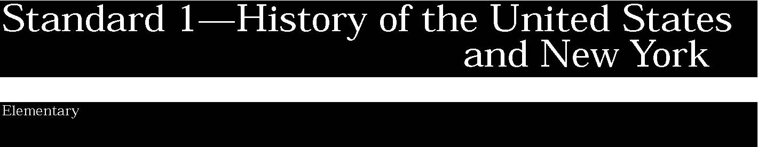

1. The study of New York State and United States history requires an analysis of the development of American culture, its diversity and multicultural context, and the ways people are unified by many values, practices, and traditions.
Students:
- know the roots of American culture, its development from many different traditions, and the ways many people from a variety of groups and backgrounds played a role in creating it
- understand the basic ideals of American democracy as explained in the Declaration of Independence and the Constitution and other important documents
- explain those values, practices, and traditions that unite all Americans.

This is evident, for example, when students:
- read stories about the early days of American society and discuss the way of life of those times
- discuss how basic ideals of American democracy are shown in such speeches as Lincoln’s Gettysburg Address and Martin Luther King’s “I Have a Dream” speech
- explain ways that families long ago expressed and transmitted their beliefs and values through oral traditions, literature, songs, art, religion, community celebrations, mementos, food, and language (Taken from National Standards for History for Grades K-4)
- compare the characters and events described in historical fiction with primary sources such as historic sites themselves; artifacts of the time found in museums and at state historic sites; journals, diaries, and photographs of the historical figures in stories; and news articles and other records from the period in order to judge the historical accuracy and determine the variety of perspectives included in the story. (Adapted from National Standards for History for Grades K-4).

2. Important ideas, social and cultural values, beliefs, and traditions from New York State and United States history illustrate the connections and interactions of people and events across time and from a variety of perspectives.
Students:
- gather and organize information about the traditions transmitted by various groups living in their neighborhood and community
- recognize how traditions and practices were passed from one generation to the next
- distinguish between near and distant past and interpret simple timelines.

This is evident, for example, when students:
- conduct interviews with family members, collect family memorabilia such as letters, diaries, stories, photographs, and keepsakes; classify information by type of activity: social, political, economic, cultural, or religious; discuss how traditions and practices were passed from one generation to the next; determine the extent to which the traditions and practices are shared by other members of the class
- study the history and traditions of their neighborhoods and local communities. Consider the school and school community by describing who attends school (diversity, demographics); the histories of their schools and school communities (then and now); what was taught; and rights, rules, and responsibilities (then and now).
- research the neighborhood or local community, considering location and the significance of its location; its demographics (e.g., ethnicity, languages, religions, levels of education, age groups); the history of why it was settled, when and by whom; economic patterns and changes in employment; social and cultural life; and government and politics
- create personal and family timelines to distinguish between near and distant past and identify family origins; interpret simple timelines by recognizing correct chronological order of major events such as Native American settlement of North America, Columbus’s voyage in 1492, the American Revolution, writing the Constitution, the presidency of Abraham Lincoln, World War I, and the beginning of space exploration.

Key ideas are identified by numbers (1). Performance indicators are identified by bullets (•). Sample tasks are identified by triangles (▲ ).
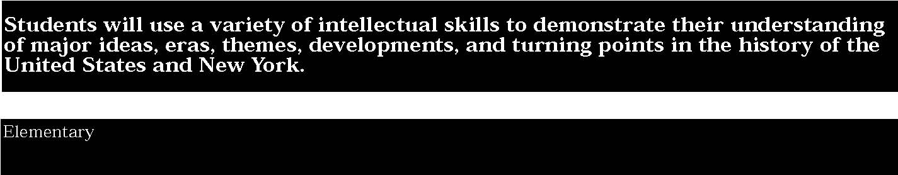

3. Study about the major social, political, economic, cultural, and religious developments in New York State and United States history involves learning about the important roles and contributions of individuals and groups.
Students:
- gather and organize information about the important accomplishments of individuals and groups, including Native American Indians, living in their neighborhoods and communities
- classify information by type of activity: social, political, economic, technological, scientific, cultural, or religious
- identify individuals who have helped to strengthen democracy in the United States and throughout the world.

This is evident, for example, when students:
- listen to and participate in classroom debates and discussions of important events and people in U. S. history and New York history, and examine more than one viewpoint on some events and people
- discuss heroes, why some people are heroes, and why some individuals might be heroes to certain groups and not to others
- conduct a historical case study about an important environmental concern affecting their city’s or neighborhood’s water supply, housing accommodations, or transportation system, and examine competing views on the issues
- investigate the importance of scientific and technological inventions such as the compass, steam engine, internal combustion engine, and computer chip.

4. The skills of historical analysis include the ability to: explain the significance of historical evidence; weigh the importance, reliability, and validity of evidence; understand the concept of multiple causation; understand the importance of changing and competing interpretations of different historical developments.
Students:
- consider different interpretations of key events and/or issues in history and understand the differences in these accounts
- explore different experiences, beliefs, motives, and traditions of people living in their neighborhoods, communities, and State
- view historic events through the eyes of those who were there, as shown in their art, writings, music, and artifacts.

This is evident, for example, when students:
- read historical narratives, literature, and many kinds of documents and investigate building, tools, clothing, and artwork to explore key events and/or issues in the history of their city, community, neighborhood, state, and nation; summarize the main ideas evident in the source and identify the purpose or point of view from which the source was created; discuss how interpretations or perspectives develop and change as new information is learned. (Based on National Standards for History Grades K-4)
- visit historic sites, museums, libraries, and memorials to gather information about important events that affected their neighborhoods, communities, or region
- explore the literature, oral traditions, drama, art, architecture, music, dance, and other primary sources of a particular historic period.

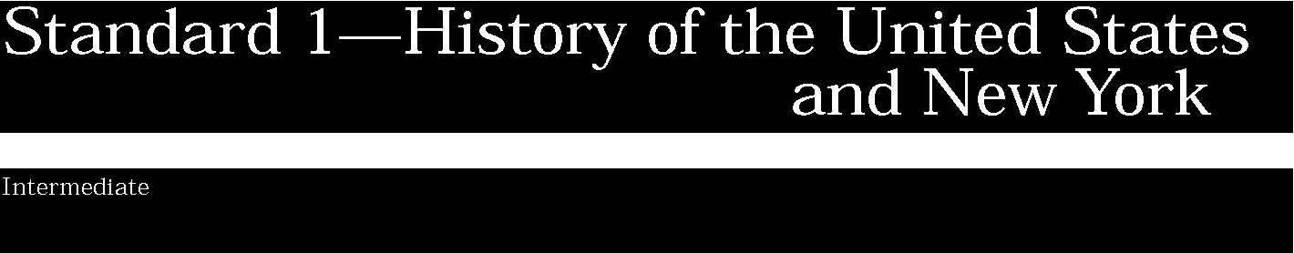

1. The study of New York State and United States history requires an analysis of the development of American culture, its diversity and multicultural context, and the ways people are unified by many values, practices, and traditions.
Students:
- explore the meaning of American culture by identifying the key ideas, beliefs, and patterns of behavior, and traditions that help define it and unite all Americans
- interpret the ideas, values, and beliefs contained in the Declaration of Independence and the New York State Constitution and United States Constitution, Bill of Rights, and other important historical documents.

This is evident, for example, when students:
- explain the ideas embodied in the Declaration of Independence, the United States Constitution, the Bill of Rights, and the New York State Constitution and show how these documents express fundamental and enduring ideas and beliefs
- describe how massive immigration, forced migration, changing roles for women, and internal migration led to new social patterns and conflicts; and identify ideas of national unity that developed amidst growing cultural diversity. (Adapted from

National Standards for U.S. History)
STANDARD 1
Key ideas are identified by numbers (1). Performance indicators are identified by bullets (•). Sample tasks are identified by triangles (▲ ).
2. Important ideas, social and cultural values, beliefs, and traditions from New York State and United States history illustrate the connections and interactions of people and events across time and from a variety of perspectives.
Students:
- describe the reasons for periodizing history in different ways
- investigate key turning points in New York State and United States history and explain why these events or developments are significant
- understand the relationship between the relative importance of United States domestic and foreign policies over time
- analyze the role played by the United States in international politics, past and present.

This is evident, for example, when students:
- use demographic information, mapping exercises, photographs, interviews, population graphs, church records, newspaper accounts, and other sources to conduct case studies of particular groups in the history of the State or nation and classify information according to type of activity: social, political, economic, cultural, or religious
- use a variety of sources to study historic and contemporary events in the United States; investigate different interpretations of the events and identify circumstances of time and place that influence the authors’ perspectives (Adapted from National Standards for U.S. History)
- recognize the reasons for periodizing history and know some designations of historical periods; discuss the usefulness of the following periods:

-Three Worlds and Their Meeting in the Americas (Beginnings to 1607)
-Colonization, Settlement and Communities (1607 to 1763)
-The Revolution and the New Nation (1763 to 1815)
-Expansion and Reform (1801 to 1861)
-Crisis of the Union: Civil War and Reconstruction (1850 to 1877)
-The Development of Modern America (1865 to 1920)
-Modern America and the World Wars (1914 to 1945)
-Contemporary America (1945 to Present) (Taken from U. S. History Framework for the 1994 National Assessment of Educational Progress)
- undertake case studies to research violations of basic civil and human rights and case studies of genocide. Use examples from United States, New York State, and world history. Case studies might include chattel slavery and the Nazi Holocaust. Other civil and human rights violations might focus on the mass starvation in Ireland (1845-50), the forced relocation of Native American Indians, and the internment of Japanese Americans during World War II
- trace the tension between arguments for United States isolation versus engagement during the following time periods: up to 1941, from 1941-1975, and from 1976 to the present.

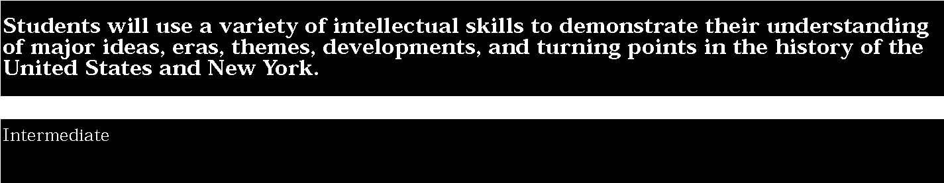

3. Study about the major social, political, economic, cultural, and religious developments in New York State and United States history involves learning about the important roles and contributions of individuals and groups.
Students:
- complete well-documented and historically accurate case studies about individuals and groups who represent different ethnic, national, and religious groups, including Native American Indians, in New York State and the United States at different times and in different locations
- gather and organize information about the important achievements and contributions of individuals and groups living in New York State and the United States
- describe how ordinary people and famous historic figures in the local community, State, and the United States have advanced the fundamental democratic values, beliefs, and traditions expressed in the Declaration of Independence, the New York State and United States Constitutions, the Bill of Rights, and other important historic documents
- classify major developments into categories such as social, political, economic, geographic, technological, scientific, cultural, or religious.

This is evident, for example, when students:
- research major events and themes from New York State and United States history (e.g., the American Revolution, new national period, Civil War, age of industrialization, westward movement and territorial expansion, the World Wars) to develop and test hypotheses and develop conclusions about the roles played by individuals and groups
- after reading about ordinary people in historic time periods, such as a Revolutionary War soldier, a suffragist, or a child laborer during the 1800s, write a short story or diary account explaining how this individual fought to support democratic values and beliefs (Adapted from National Standards for History for Grades K-4)
- explain the importance of different inventions and scientific and technological innovations in agriculture and industry, describing how these inventions and innovations resulted in imporved production of certain products.

4. The skills of historical analysis include the ability to: explain the significance of historical evidence; weigh the importance, reliability, and validity of evidence; understand the concept of multiple causation; understand the importance of changing and competing interpretations of different historical developments.
Students:
- consider the sources of historic documents, narratives, or artifacts and evaluate their reliability
- understand how different experiences, beliefs, values, traditions, and motives cause individuals and groups to interpret historic events and issues from different perspectives
- compare and contrast different interpretations of key events and issues in New York State and United States history and explain reasons for these different accounts
- describe historic events through the eyes and experiences of those who were there. (Taken from

National Standards for History for Grades K-4)
This is evident, for example, when students:
- identify the author’s or artist’s main point of view or purpose in creating a document or artifact
- compare several historical accounts of the same event in New York State or United States history and contrast the different facts included or omitted from each author and determine the different authors’ points of view
- use a variety of sources to study important turning points from different perspectives and to identify varying points of view of the people involved (e.g., European settlement and the impact of diseases on Native American Indian populations, writing the Declaration of Independence and the Constitution, the Civil War, industrialization, significant reform movements, and the Cold War)
- debate various views of United States foreign policies and involvement during the Mexican-American War, World Wars I and II, Vietnam, and the Cold War.

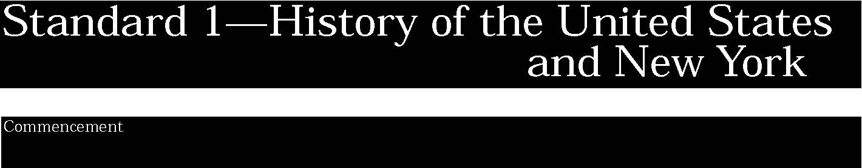

1. The study of New York State and United States history requires an analysis of the development of American culture, its diversity and multicultural context, and the ways people are unified by many values, practices, and traditions.
Students:
- analyze the development of American culture, explaining how ideas, values, beliefs, and traditions have changed over time and how they unite all Americans
- describe the evolution of American democratic values and beliefs as expressed in the Declaration of Independence, the New York State Constitution, the United States Constitution, the Bill of Rights, and other important historical documents.

This is evident, for example, when students:
▲ explore the meaning of the United States motto, “E Pluribus Unum,” by identifying both those forces that unite Americans and those that potentially divide Americans. Based on a study of key events in United States history, such as the American Revolution, the Civil War, the women’s suffrage movement, and the civil rights movement, discuss how at least two core civic ideas, such as individual rights and the consent of the governed, have been forces for national unity in this diverse society
▲ analyze the decisions leading to major turning points in United States history, comparing alternative courses of action, and hypothesizing, within the context of the historic period, about what might have happened if the decision had been different. Investigate decisions and actions such as:
    - the signing of the Declaration of Independence in 1776
    - the forced relocation of Native American Indians
    - the Mexican-American War
    - -Lincoln’s resolve to sustain the Union
    - -Plessy v. Ferguson Supreme Court decision
    - -Progressive reforms
    - -United States entry into World Wars I and II
    - -the decision to refrain from joining the League of Nations
    - -ratification of the Nineteenth Amendment
    - -Roosevelt’s New Deal
    - -the decision to drop the atomic bomb on Japan in 1945
    - -Rosa Parks’ decision to challenge the Jim Crow laws in Alabama in 1955
    - -American involvement in Southeast Asia in the 1960s and 1970s
    - -the end of the Cold War and the democratic revolutions in Eastern European countries
    - ▲ read Dr. Martin Luther King’s “Letter from Birmingham Jail” and discuss how this letter expresses the basic ideas, values, and beliefs found in the United States Constitution and Bill of Rights.

Key ideas are identified by numbers (1). Performance indicators are identified by bullets (•). Sample tasks are identified by triangles (▲ ).
2. Important ideas, social and cultural values, beliefs, and traditions from New York State and United States history illustrate the connections and interactions of people and events across time and from a variety of perspectives.
Students:
- discuss several schemes for periodizing the history of New York State and the United States
- develop and test hypotheses about important events, eras, or issues in New York State and United States history, setting clear and valid criteria for judging the importance and significance of these events, eras, or issues
- compare and contrast the experiences of different groups in the United States
- examine how the Constitution, United States law, and the rights of citizenship provide a major unifying factor in bringing together Americans from diverse roots and traditions
- analyze the United States involvement in foreign affairs and a willingness to engage in international politics, examining the ideas and traditions leading to these foreign policies
- compare and contrast the values exhibited and foreign policies implemented by the United States and other nations over time with those expressed in the United Nations Charter and international law.

This is evident, for example, when students:
- discuss several schemes for periodizing the history of the United States; explain the usefulness of each scheme; comment on why another person might want to use other approaches to periodization; make a case for the scheme that seems best
- explain the contributions of specific groups of people to American society and culture; analyze the metaphors of the “melting pot” and the “salad bowl” to explain the experiences of the first immigrant groups (e.g., Dutch, Irish, English, African American, Spanish, German) as compared to those of later groups (e.g., Italian, Greek, Eastern European, Chinese, Latino, Vietnamese) and present an analysis, supported by historical evidence, of alternative metaphors, such as “a tapestry” or “a mosaic”
- examine the effects of immigration on various Native American groups
- investigate how the United States’ democratic principles have influenced the constitutions and governments of other nations; view this sharing as a two-way exchange, with the United States influencing and being influenced by other nations.

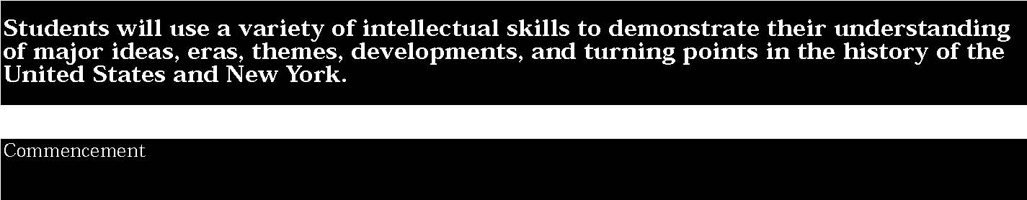

3. Study about the major social, political, economic, cultural, and religious developments in New York State and United States history involves learning about the important roles and contributions of individuals and groups.
Students:
- compare and contrast the experiences of different ethnic, national, and religious groups, including Native American Indians, in the United States, explaining their contributions to American society and culture
- research and analyze the major themes and developments in New York State and United States history (e.g., colonization and settlement; Revolution and New National Period; immigration; expansion and reform era; Civil War and Reconstruction; The American labor movement; Great Depression; World Wars; contemporary United States)
- prepare essays and oral reports about the important social, political, economic, scientific, technological, and cultural developments, issues, and events from New York State and United States history
- understand the interrelationships between world events and developments in New York State and the United States (e.g., causes for immigration, economic opportunities, human rights abuses, and tyranny versus freedom).

This is evident, for example, when students:
- investigate how Americans have reconciled the inherent tensions and conflicts over minority versus majority rights by researching the abolitionist and reform movements of the nineteenth century, the civil rights and women’s rights movements of the twentieth century, or the social protest movements of the 1960s and 1970s
- draw upon literary selections, historical documents, and accounts to analyze the roles played by different individuals and groups during the major eras in New York State and United States history
- compare and analyze the major arguments for and against major political developments in New York State and United States history, such as the ratification of the United States Constitution, Reconstruction, the New Deal, and the Great Society programs of the 1960s
- research how leaders, such as Frederick Douglass, Harriet Tubman, Theodore Parker, Sojourner Truth, David Walker, and Sarah and Angelina Grimke, fought for the rights of African Americans.

4. The skills of historical analysis include the ability to: explain the significance of historical evidence; weigh the importance, reliability, and validity of evidence; understand the concept of multiple causation; understand the importance of changing and competing interpretations of different historical developments.
Students:
- analyze historical narratives about key events in New York State and United States history to identify the facts and evaluate the authors’ perspectives
- consider different historians’ analyses of the same event or development in United States history to understand how different viewpoints and/or frames of reference influence historical interpretations
- evaluate the validity and credibility of historical interpretations of important events or issues in New York State or United States history, revising these interpretations as new information is learned and other interpretations are developed. (Adapted from National Standards for United States History)

This is evident, for example, when students:
- analyze important debates in American history (e.g., ratification of the United States Constitution, abolition of slavery, regulation of big business, restrictions on immigration, the New Deal legislation, women’s suffrage, United States involvement in foreign affairs and wars), focusing on the opposing positions and the historical evidence used to support these positions
- prepare extended research papers on an important issue, problem or theme from New York State or United States history, including an analysis of the differing or competing interpretations of the issue or problem
- develop hypotheses about important events, eras, or issues; move from chronicling to explaining historical events and issues; use information collected from diverse sources (e.g., diaries, census reports, city directories and maps, newspaper and journal accounts, graphs and charts, cartoons, autobiographies, government documents, and other primary and secondary sources) to produce cogently written reports and document-based essays; apply the skills of historiography by comparing, contrasting, and evaluating the interpretations of different historians of an event, era, or issue.

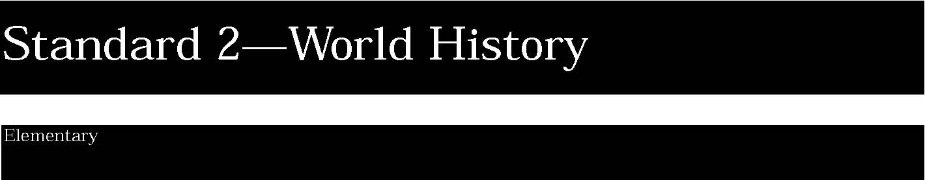
1. The study of world history requires an understanding of world cultures and civilizations, including an analysis of important ideas, social and cultural values, beliefs, and traditions. This study also examines the human condition and the connections and interactions of people across time and space and the ways different people view the same event or issue from a variety of perspectives.
Students:
- read historical narratives, myths, legends, biographies, and autobiographies to learn about how historical figures lived, their motivations, hopes, fears, strengths, and weaknesses
- explore narrative accounts of important events from world history to learn about different accounts of the past to begin to understand how interpretations and perspectives develop
- study about different world cultures and civilizations focusing on their accomplishments, contributions, values, beliefs, and traditions.

This is evident, for example, when students:
- create a list of characteristics for the concept of civilization, focusing on the early civilizations that developed in Mesopotamia, Egypt, and the Indus Valley
- analyze pictures and maps of the civilizations of Kush and Egypt, including information about their architectural, artistic, and technological achievements
- assume the roles of citizens, merchants, foreign residents, or slaves in ancient Sparta or Athens, describing life in these city-states, the rights and responsibilities of a citizen in each city, and their social and political roles
- research different kinds of sources (archaeological, artistic, written) about the civilizations in the Americas before the coming of the Europeans (Taken from National Standards for World History)
- study about the major cultural achievements of an ancient civilization (e.g., West African, Japanese, Chinese, European).

2. Establishing timeframes, exploring different periodizations, examining themes across time and within cultures, and focusing on important turning points in world history help organize the study of world cultures and civilizations.
Students:
- distinguish between past, present, and future time periods
- develop timelines that display important events and eras from world history
- measure and understand the meaning of calendar time in terms of years, decades, centuries, and millennia, using BC and AD as reference points
- compare important events and accomplishments from different time periods in world history.

This is evident, for example, when students:
- arrange the events in a historical narrative, biography, or autobiography in correct chronological order
- group important historic events in world history according to clearly defined time periods (periodization). For example, periods might include early civilizations, rise of empires, age of exploration, the twentieth century
- create, as part of a class, a mural-sized, illustrated timeline of important achievements, inventions, and accomplishments of nineteenth century Europe and America (Adapted from National Standards for World History)
- identify key turning points and important events in world history and explain their significance
- create personal and family timelines to distinguish between near and distant past and interpret simple timelines that show a progression of events in world history; create a picture timeline tracing developments in world history, such as the appearance of the wheel, making simple tools out of iron (Hittites), building the pyramids, building Roman aqueducts, inventing paper in China, astronomical discoveries in the Muslim world, metallurgy advances in West Africa, and the invention of the steam engine in England. (Adapted from National Standards for History for Grades K-4)

Key ideas are identified by numbers (1). Performance indicators are identified by bullets (•). Sample tasks are identified by triangles (▲ ).
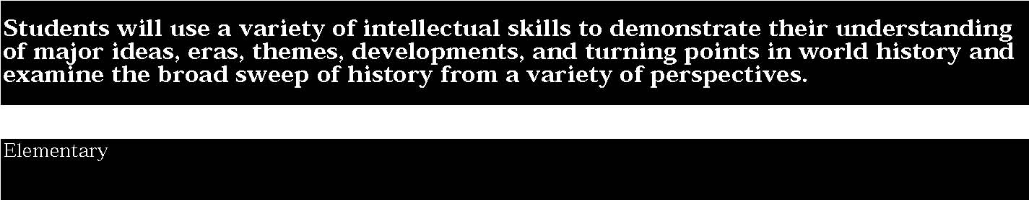

3. Study of the major social, political, cultural, and religious developments in world history involves learning about the important roles and contributions of individuals and groups.
Students:
- understand the roles and contributions of individuals and groups to social, political, economic, cultural, scientific, technological, and religious practices and activities
- gather and present information about important developments from world history
- understand how the terms social, political, economic, and cultural can be used to describe human activities or practices.

This is evident, for example, when students:
- read historical stories, myths, legends, and fables to learn how individuals have solved problems, made important contributions, and influenced the lives of others
- listen to historical narratives about the history of children and families in different cultures throughout the world to learn about different family structures; children’s, women’s, and men’s roles; daily life; religious or spiritual beliefs and practices; customs and traditions
- read biographies about famous historical figures, focusing on their personal lives, goals, and accomplishments and the effects of their achievements on the lives of others
- write historical narratives in the form of letters, diary accounts, or news reports from the point of view of a child who lived during a particular historic time period and who witnessed an important event or development
- listen to and participate in classroom debates and discussions of important myths, legends, people, and events in world history; determine admirable traits and identify examples of courage.

4. The skills of historical analysis include the ability to investigate differing and competing interpretations of the theories of history, hypothesize about why interpretations change over time, explain the importance of historical evidence, and understand the concepts of change and continuity over time.
Students:
- consider different interpretations of key events and developments in world history and understand the differences in these accounts
- explore the lifestyles, beliefs, traditions, rules and laws, and social/cultural needs and wants of people during different periods in history and in different parts of the world
- view historic events through the eyes of those who were there, as shown in their art, writings, music, and artifacts.

This is evident, for example, when students:
- explain different perspectives on the same phenomenon by reading myths from several civilizations, recognizing the different ways those people explained the same phenomenon (e.g., how the world was created)
- listen to historical stories, biographies, or narratives to identify who was involved, what events occurred, where the events took place, and the outcomes or consequences
- list analytical questions to guide their investigations of historical documents, pictures, diary accounts, artifacts, and other records of the past
- construct picture timelines that show important events in their own lives, including descriptions of the events and explanations of why they were important.


1. The study of world history requires an understanding of world cultures and civilizations, including an analysis of important ideas, social and cultural values, beliefs, and traditions. This study also examines the human condition and the connections and interactions of people across time and space and the ways different people view the same event or issue from a variety of perspectives.
Students:
- know the social and economic characteristics, such as customs, traditions, child-rearing practices, ways of making a living, education and socialization practices, gender roles, foods, and religious and spiritual beliefs that distinguish different cultures and civilizations
- know some important historic events and developments of past civilizations
- interpret and analyze documents and artifacts related to significant developments and events in world history.

This is evident, for example, when students:
- propose a list of characteristics to define the concepts of culture and civilization, explaining how civilizations develop and change
- investigate the important achievements and accomplishments of the world’s early civilizations (e.g., African, Greek, Roman, Egyptian, Indian, Chinese)
- analyze how the natural environments of the Tigris-Euphrates, Nile, and Indus valleys shaped the early development of civilization (Taken from National Standards for World History)
- research an important event or development in world history and include information about how different people viewed the same event (e.g., the French Revolution as witnessed by members of the ruling classes, the revolutionaries, members of the Estates General, and the Church)
- identify different ethnic, religious, and socioeconomic groups throughout the world and analyze their varying perspectives on the same historic events and contemporary issues. Explain how these different perspectives developed.

2. Establishing timeframes, exploring different periodizations, examining themes across time and within cultures, and focusing on important turning points in world history help organize the study of world cultures and civilizations.
Students:
- develop timelines by placing important events and developments in world history in their correct chronological order
- measure time periods by years, decades, centuries, and millennia
- study about major turning points in world history by investigating the causes and other factors that brought about change and the results of these changes.

This is evident, for example, when students:
- construct multiple-tier timelines that display a number of important historic events that occurred at the same time or during the same period of time (e.g., age of exploration and contact showing events in Europe, Africa, and the Americas)
- present historical narratives that link together a series of events in the correct chronological order
- recognize the reasons for periodizing history and know some designations of historical periods; discuss the usefulness of the following historical periods:

-The beginnings of Human Society
-Early Civilizations to 1000 BC
-Classical Traditions, Major Religions, and Giant Empires,
1000 BC-300 AD -Expanding Zones of Exchange and Encounter, 300-1000 AD -Intensified Hemispheric Interactions, 1000-1500 -Emergence of the First Global Age, 1450-1770
- The Age of Revolutions, 1750-1914
- The Twentieth Century. (Adapted from National Standards for World History)

Key ideas are identified by numbers (1). Performance indicators are identified by bullets (•). Sample tasks are identified by triangles (▲ ).
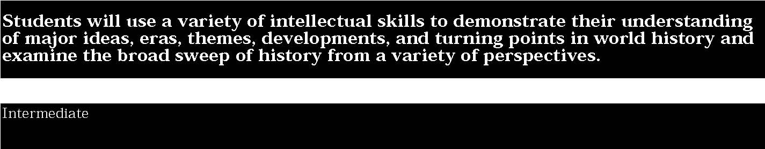

3. Study of the major social, political, cultural, and religious developments in world history involves learning about the important roles and contributions of individuals and groups.
Students:
- investigate the roles and contributions of individuals and groups in relation to key social, political, cultural, and religious practices throughout world history
- interpret and analyze documents and artifacts related to significant developments and events in world history
- classify historic information according to the type of activity or practice: social/cultural, political, economic, geographic, scientific, technological, and historic.

This is evident, for example, when students:
- read historic narratives, biographies, literature, diaries, and letters to learn about the important accomplishments and roles played by individuals and groups throughout world history
- explain some of the following practices as found in particular civilizations and cultures throughout world history: social customs, child-rearing practices, government, ways of making a living and distributing goods and services, language and literature, education and socialization practices, values and traditions, gender roles, foods, and religious/spiritual beliefs and practices
- develop a map of Europe, the Mediterranean world, India, South and Southeast Asia, and China to show the extent of the spread of Buddhism, Christianity, Hinduism, and Confucianism; explain how the spread of these religions changed the lives of people living in these areas of the world (Adapted from National Standards for World History)
- write diary accounts, journal entries, letters, or news accounts from the point of view of a young person living during a particular time period in world history, focusing on an important historic, political, economic, or religious event or accomplishment
- study the historical writings of important figures in world history to learn about their goals, motivations, intentions, influences, and strengths and weaknesses.

STANDARD 2
4. The skills of historical analysis include the ability to investigate differing and competing interpretations of the theories of history, hypothesize about why interpretations change over time, explain the importance of historical evidence, and understand the concepts of change and continuity over time.
Students:
- explain the literal meaning of a historical passage or primary source document, identifying who was involved, what happened, where it happened, what events led up to these developments, and what consequences or outcomes followed (Taken from National Standards for World History)
- analyze different interpretations of important events and themes in world history and explain the various frames of reference expressed by different historians
- view history through the eyes of those who witnessed key events and developments in world history by analyzing their literature, diary accounts, letters, artifacts, art, music, architectural drawings, and other documents
- investigate important events and developments in world history by posing analytical questions, selecting relevant data, distinguishing fact from opinion, hypothesizing cause-and-effect relationships, testing these hypotheses, and forming conclusions.

This is evident, for example, when students:
▲ examine documents related to significant developments in world history (e.g., excerpts from sacred texts of the world’s great religions, important political statements or decrees, literary works, and historians’ commentaries); employ the skills of historical analysis and interpretation in probing the meaning and importance of the documents by:
-identifying authors and sources for the historical documents -comparing and contrasting differing sets of ideals and values contained in each historical document
-considering multiple perspectives presented in the documents
-evaluating major debates among historians about the meaning of each historical document
-hypothesizing about the influence of each document on present-day activities and debates in the international arena. (Adapted from National Standards in World History)
- study about an event or development in world history (e.g., the early civilizations, the age of exchange and global expansion, the industrial revolution, political and social revolutions, imperialism and colonization, case studies of genocide and human rights violations, world wars) by analyzing accounts written by eyewitnesses to the event or development; compare the eyewitness accounts with reports and narratives written by historians after the event or development
- trace the impacts of different technological innovations and advances ( e.g., in transportation and communication, agriculture, health and science, commerce and industry) over time by analyzing the effects of technology on the lives of people.


1. The study of world history requires an understanding of world cultures and civilizations, including an analysis of important ideas, social and cultural values, beliefs, and traditions. This study also examines the human condition and the connections and interactions of people across time and space, and the ways different people view the same event or issue from a variety of perspectives.
Students:
- define culture and civilization, explaining how they developed and changed over time. Investigate the various components of cultures and civilizations including social customs, norms, values, and traditions; political systems; economic systems; religions and spiritual beliefs; and socialization or educational practices
- understand the development and connectedness of Western civilization and other civilizations and cultures in many areas of the world and over time
- analyze historic events from around the world by examining accounts written from different perspectives
- understand the broad patterns, relationships, and interactions of cultures and civilizations during particular eras and across eras
- analyze changing and competing interpretations of issues, events, and developments throughout world history.

This is evident, for example, when students:
- analyze important events and developments in world history through the eyes and experiences of those who were there, as reported in their literature, diaries, letters, debates, art and music, and artifacts (Taken from National Standards for World History)
- compare two or more historical interpretations of an important event in world history, differentiate fact from opinion, and determine which facts are most significant in the historian’s judgment and why (Taken from National Standards for World History)
- explain how an important event or development from world history can be viewed from multiple perspectives, noting how different values, motives, beliefs, frames of reference, and perspectives influence interpretations of the past
- use dramatizations, timelines, debates, and other research reports to explain how different observations of the same event or issue develop
- analyze important developments and turning points in world history; hypothesize what might have happened if decisions or circumstances had been different; investigate such developments and turning points as: -the development of the early civilizations -the development of the Roman Empire -the emergence of the world’s great religions: Buddhism,

Christianity, Hinduism, Islam, Judaism, and Taoism -the rise of the Mongol Empire in China -the Mali Empire in West Africa -the age of exploration and the age of enlightenment -the rise and fall of European colonialism -global interactions and migration -the formation and unification of major European nations (Germany, Italy, Great Britain, and France) -the emergence and global influence of American civilization.
2. Establishing timeframes, exploring different periodizations, examining themes across time and within cultures, and focusing on important turning points in world history help organize the study of world cultures and civilizations.
Students:
- distinguish between the past, present, and future by creating multiple-tier timelines that display important events and developments from world history across time and place
- evaluate the effectiveness of different models for the periodization of important historic events, identifying the reasons why a particular sequence for these events was chosen
- analyze evidence critically and demonstrate an understanding of how circumstances of time and place influence perspective
- explain the importance of analyzing narratives drawn from different times and places to understand historical events
- investigate key events and developments and major turning points in world history to identify the factors that brought about change and the long-term effects of these changes.

This is evident, for example, when students:
- develop composite timelines for different areas of the world (e.g., the Middle East, South and Southeast Asia, Africa south of the Sahara, the Americas), showing important events at any given time
- discuss models for periodizing events from world history, the development of the major civilizations, and the history of other cultures throughout the world. Explain the underlying principles for these models and make a case for why others might want to periodize these events differently
- analyze historical narratives, biographies, or stories to determine their temporal structure. Select an important event from world history and follow it forward over time to determine its consequences and trace it backward to identify its causes
- construct timelines that display key events and developments in world history and which describe the important facts about the event/development and link the event/development to other important events which took place somewhere else in the world
- analyzing historical narratives about the movements of people and ideas over time and place, including reports about the beginnings of human society in Africa, Mesopotamia, Indus, and

China.
Key ideas are identified by numbers (1). Performance indicators are identified by bullets (•). Sample tasks are identified by triangles (▲ ).
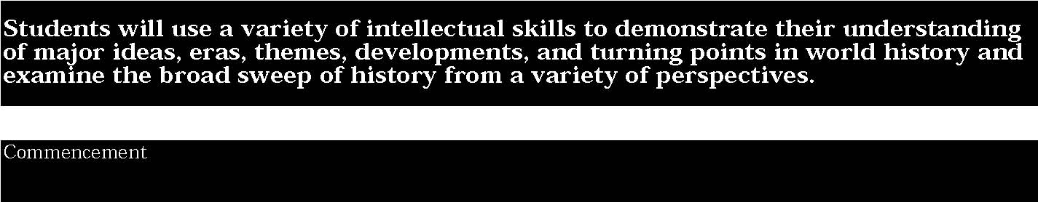

3. Study of the major social, political, cultural, and religious developments in world history involves learning about the important roles and contributions of individuals and groups.
Students:
- analyze the roles and contributions of individuals and groups to social, political, economic, cultural, and religious practices and activities
- explain the dynamics of cultural change and how interactions between and among cultures has affected various cultural groups throughout the world
- examine the social/cultural, political, economic, and religious norms and values of Western and other world cultures.

This is evident, for example, when students:
- investigate how groups of people living in different geographic regions throughout the world (e.g., Africa, the Middle East, Eastern Europe and the former Soviet Union, China) interacted with and structured their natural environments to accommodate their varied lifestyles
- prepare narratives that describe important historic events and developments (e.g., beginnings of human societies; global exploration and expansion; scientific, technological, and intellectual achievements; social and political reform; revolution; case studies of genocide and human rights violations) from the perspectives of the individuals and groups who witnessed them
- investigate the lives of important political and social reformers by describing the conditions they were attempting to improve and evaluating the success of their efforts
- report on the spread of Christianity and Islam throughout world history, identify regions where these religions spread, and describe the effects on the lives of the people who lived in these regions
- trace the experiences of different emigrant groups throughout world history, identify the factors that caused these groups to leave their homelands, and describe the social and economic effects on their new homelands.

STANDARD 2
4. The skills of historical analysis include the ability to investigate differing and competing interpretations of the theories of history, hypothesize about why interpretations change over time, explain the importance of historical evidence, and understand the concepts of change and continuity over time.
Students:
- identify historical problems, pose analytical questions or hypotheses, research analytical questions or test hypotheses, formulate conclusions or generalizations, raise new questions or issues for further investigation
- interpret and analyze documents and artifacts related to significant developments and events in world history
- plan and organize historical research projects related to regional or global interdependence
- analyze different interpretations of important events, issues, or developments in world history by studying the social, political, and economic context in which they were developed; by testing the data source for reliability and validity, credibility, authority, authenticity, and completeness; and by detecting bias, distortion of the facts, and propaganda by omission, suppression, or invention of facts. (Taken from National Standards for World History)

This is evident, for example, when students:
- complete historical/social science research projects focusing on topics and issues drawn from world history; organize data according to the following activities: social, political, economic, cultural, and religious; consider multiple perspectives in interpreting the past and explain how different motives, beliefs, interests, and perspectives influence interpretations of the past (Adapted from National Standards for World History)
- apply the skills of historiography by analyzing different interpretations of key events and developments in world history (e.g., the development of the world’s great empires; the emergence of feudalism; encounters between Europeans and the peoples of sub-Saharan Africa, Asia, and the Americas; nationalism and its global effects). Analyze competing narratives by comparing and contrasting historians’ selection of analytical questions, frames of reference, and values/beliefs to show how different interpretations develop
- evaluate the validity and credibility of historical interpretations, including new or changing interpretations that have developed as new information about events or developments in world history is learned, and new interpretations and methodologies are developed (Taken from National Standards for World History)
- complete social science research projects focusing on topics and issues drawn from world history (e.g., causes of major revolutions, effects of imperialism, causes and consequences of the Industrial Revolution, social reform movements, and global consequences of World Wars I and II). Consider multiple perspectives in interpreting past events and describe how different values, frames of reference, beliefs, and motives influence interpretations of topics and issues.



1. Geography can be divided into six essential elements which can be used to analyze important historic, geographic, economic, and environmental questions and issues. These six elements include: the world in spatial terms, places and regions, physical settings (including natural resources), human systems, environment and society, and the use of geography. (Adapted from The National Geography Standards, 1994: Geography for Life)
Students:
- study about how people live, work, and utilize natural resources
- draw maps and diagrams that serve as representations of places, physical features, and objects
- locate places within the local community, State, and nation; locate the Earth’s continents in relation to each other and to principal parallels and meridians. (Adpated from National Geography Standards, 1994)
- identify and compare the physical, human, and cultural characteristics of different regions and people (Adapted from National Geography Standards, 1994)
- investigate how people depend on and modify the physical environment.

This is evident, for example, when students:
- draw simple maps of their communities or regions showing the major landmarks, industries, residential areas, business districts, transportation networks, health and educational facilities, and recreation areas
- examine different kinds of maps to identify and define their components, including key, title, legend, cardinal and intermediate directions, scale, and grid
- use cardboard, wood, clay, or other materials to make a model of their community or region showing their physical characteristics (Taken from National Geography Standards, 1994)
- read about children living in other cultures to learn about their customs, beliefs, and traditions; natural resource use; food; shelter; socialization and schooling; and other important components of culture
- draw maps and pictures showing how people make use of and modify their physical environments (e.g., land use for agriculture, mining, residential developments, transportation networks, recreation).

2. Geography requires the development and application of the skills of asking and answering geographic questions; analyzing theories of geography; and acquiring, organizing, and analyzing geographic information. (Adapted from: The National Geography Standards, 1994: Geography for Life)
Students:
- ask geographic questions about where places are located; why they are located where they are; what is important about their locations; and how their locations are related to the location of other people and places (Adapted from National Geography Standards, 1994)
- gather and organize geographic information from a variety of sources and display in a number of ways
- analyze geographic information by making relationships, interpreting trends and relationships, and analyzing geographic data. (Adapted from National Geography Standards, 1994)

This is evident, for example, when students:
- read historical narratives and talk about the importance of where places are located, try to determine why they are located where they are, and assess the relationship of location to other locations and people in the story
- use a map grid (e.g., latitude and longitude or an alphanumerical system) to answer questions about location and place
- use different types of map scales (linear, fractional, and word) to measure the distance between two places
- map the locations of places in the community or region, using appropriate symbols (e.g., dots or points for cities and towns; different shapes for residential and business areas; lines for transportation networks)
- present oral and written reports using maps, charts, tables, graphs, and other visual displays showing spatial relationships, locations, and other geographic information.

Key ideas are identified by numbers (1). Performance indicators are identified by bullets (•). Sample tasks are identified by triangles (▲ ).
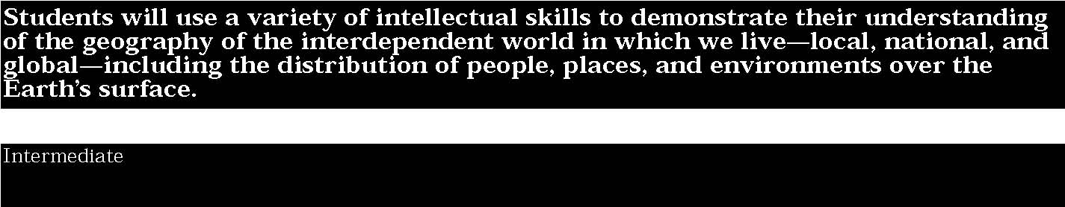

1. Geography can be divided into six essential elements which can be used to analyze important historic, geographic, economic, and environmental questions and issues. These six elements include: the world in spatial terms, places and regions, physical settings (including natural resources), human systems, environment and society, and the use of geography. (Adapted from The National Geography Standards, 1994: Geography for Life)
Students:
- map information about people, places, and environments
- understand the characteristics, functions, and applications of maps, globes, aerial and other photographs, satellite-produced images, and models (Taken from National Geography Standards, 1994)
- investigate why people and places are located where they are located and what patterns can be perceived in these locations
- describe the relationships between people and environments and the connections between people and places.

This is evident, for example, when students:
- investigate how groups of people living in different geographic regions throughout the world interacted with and structured their natural environments to accommodate their varied lifestyles and economies; discuss national, regional, and global interactions
- draw from memory a map of the world on a single sheet of paper and outline and label the major physical features (e.g., continents, oceans, major mountain ranges, significant desert regions, and river systems) and important human features (e.g., major cities of the world, imaginary lines such as the prime meridian and the equator). (Taken from National Geography Standards, 1994)
- apply the five themes of geography to their study of communities and regions throughout the world. Describe how location, place, relationships within places, movement, and regions can be used to analyze different cultures and societies
- complete a geographic/historic study of their community or a region of New York State by focusing on the following questions: Where is your community or region located? How did it get there? What is it like to live and work there? What are its physical characteristics (e.g., climate, elevation, population density, size)?

2. Geography requires the development and application of the skills of asking and answering geographic questions; analyzing theories of geography; and acquiring, organizing, and analyzing geographic information. (Adapted from The National Geography Standards, 1994: Geography for Life)
Students:
- formulate geographic questions and define geographic issues and problems
- use a number of research skills (e.g., computer databases, periodicals, census reports, maps, standard reference works, interviews, surveys) to locate and gather geographical information about issues and problems (Adapted from National Geography Standards, 1994)
- present geographic information in a variety of formats, including maps, tables, graphs, charts, diagrams, and computer-generated models
- interpret geographic information by synthesizing data and developing conclusions and generalizations about geographic issues and problems.

This is evident, for example, when students:
- plan and execute an inquiry to answer these questions about a region of the world: How does the shape of the Earth and the natural environment influence where people live? What natural processes change the shape of the Earth’s surface? How has human habitation changed the surface of the Earth? Derive generalizations and conclusions supported by evidence. (Based on National Geography Standards, 1994)
- pose analytical questions concerning a geographic issue or problem affecting their community, region, or New York State (e.g., issues related to environmental problems and concerns, transportation and traffic needs, land use, housing, natural resource use)
- use a variety of research skills to locate, collect, and organize geographic data related to a geographic or environmental issue, problem, or question; organize the data in logical and meaningful ways; present written and oral reports that include geographic conclusions and generalizations supported by the data collected; propose new questions for further investigation
- develop and present a multimedia report on a geographic topic, issue, problem, or question (e.g., deforestation, energy consumption, resource depletion, natural hazards, major geographic events), making use of maps, graphs, photographs, videos, computer-generated models, and other appropriate sources
- use a variety of maps to answer geographic questions about people, places, and regions.



1. Geography can be divided into six essential elements which can be used to analyze important historic, geographic, economic, and environmental questions and issues. These six elements include: the world in spatial terms, places and regions, physical settings (including natural resources), human systems, environment and society, and the use of geography. (Adapted from The National Geography Standards, 1994: Geography for Life)
Students:
- understand how to develop and use maps and other graphic representations to display geographic issues, problems, and questions
- describe the physical characteristics of the Earth’s surface and investigate the continual reshaping of the surface by physical processes and human activities
- investigate the characteristics, distribution, and migration of human populations on the Earth’s surface (Taken from National Geography Standards, 1994)
- understand the development and interactions of social/cultural, political, economic, and religious systems in different regions of the world
- analyze how the forces of cooperation and conflict among people influence the division and control of the Earth’s surface (Taken from National Geography Standards, 1994)
- explain how technological change affects people, places, and regions.

This is evident, for example, when students:
- evaluate the applications of geographic tools and supporting technologies to serve particular purposes by collecting, comparing, and explaining the significance of maps from different sources and different points of view to illustrate the same phenomena. (Taken from National Geography Standards, 1994)
- choose and give reasons for using different technologies to analyze selected geographic problems. Use aerial photographs, satellite-produced imagery, and geographic information systems (GIS) to define, analyze, and propose solutions to global environmental problems (e.g., deforestation, overpopulation, water pollution, resource depletion)

- complete an in-depth geographic study of a world region by analyzing demographic data (e.g., birth rate, literacy rates for females, infant mortality) and draw conclusions about the influence of these factors on the characteristics of that region; for example, study migration patterns and culture change in and around large cities in Europe, Africa, Latin America, and Asia, with a focus on cities near international borders and in major manufacturing centers; explain how different cultural groups shape the character of these cities and how culture influences conflict, cooperation, and group identity. (Based on National Geography Standards, 1994)
- draw from memory a map of the world; outline the relative location of continents, oceans, major river systems, nations in the news, and important cities
- demonstrate the ability to interpret sophisticated information about people, places, and regions; use a topographical map to lay out a five-mile hike through the countryside or local community; note such items as elevation, slope, distance, direction, and geographic features along the route. (Taken from

National Geography Standards, 1994)
▲ explain the relationship between the geographic setting (ecosystems, spatial distribution of resources, ease of transportation and communication) and the spatial development of societies (e.g., how Africa’s physical geography, vegetation, and technology affect cross-cultural contacts and economic development; the relationship between topography and drainage systems in China and the development of civilization there; the impact of Japan’s insular geography upon its history, cultural identity, and patterns of selective borrowing from other cultures; the impact of the diversity of the physical environment, including the range of climates, in Latin America; the effects of the lack of water on the historic and economic development of the Middle East; the relationship between the physical geography and the historic and economic development of Eastern Europe and Russia; and the influence of the frontier in United States history).

Key ideas are identified by numbers (1). Performance indicators are identified by bullets (•). Sample tasks are identified by triangles (▲ ).
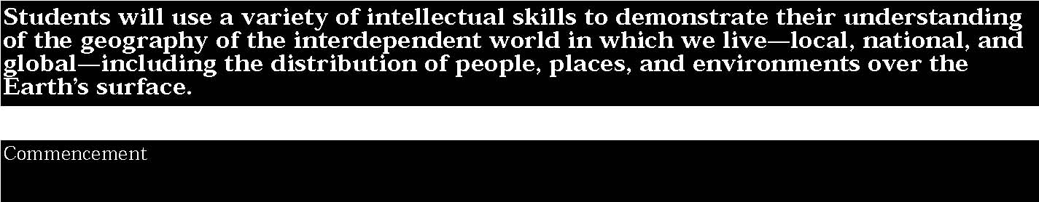

2. Geography requires the development and application of the skills of asking and answering geographic questions; analyzing theories of geography; and acquiring, organizing, and analyzing geographic information. (Adapted from The National Geography Standards, 1994 Geography for Life)
Students:
- plan, organize, and present geographic research projects
- locate and gather geographic information from a variety of primary and secondary sources (Taken from National Geography Standards, 1994)
- select and design maps, graphs, tables, charts, diagrams, and other graphic representations to present geographic information
- analyze geographic information by developing and testing inferences and hypotheses, and formulating conclusions from maps, photographs, computer models, and other geographic representations (Adapted from National Geography Standards, 1994)
- develop and test generalizations and conclusions and pose analytical questions based on the results of geographic inquiry.

This is evident, for example, when students:
▲ examine a collection of maps, photographs, satellite-produced images, databases, graphs, firsthand accounts, and other sources to generate questions and pose problems for investigation
▲ organize primary and secondary geographic sources to investigate local, national, and international environmental problems and issues; determine the many perspectives that individuals and groups advocate as they seek to resolve these problems or issues; apply a geographic perspective along with others in reaching conclusions on the issues. (Based on National Geography Standards, 1994)
▲ analyze geographic information contained in a spatial database or geographic information system (GIS) to answer questions concerning land use, economic development, population shifts, and transportation networks
▲ use maps showing family income, transportation systems, natural resources, recreation areas, educational and health facilities and other data to develop hypotheses about why some regions prosper and others do not (Adapted from National Geography Standards, 1994)
▲ use a variety of research skills to locate and collect descriptive and statistical data and to use the data and maps to collect and compile information (e.g., the use of specific purpose maps to show various geographic aspects of the Earth’s surface and explain the geographic variables that serve as criteria for grouping countries into regions; the use of technology to moderate geographic condition)

- complete a geographic study of a world region, analyzing demographic data (e.g., birth rate, literacy rates for females, infant mortality) to determine how groups and cultures influence the characteristics of that region. For example, study migration patterns and cultural change in and around large cities in Europe, Africa, Latin America, and Asia, focusing on cities near international borders and in major manufacturing centers. Explain how different cultural groups shape the character of these cities and how culture influences conflict, cooperation, and group identity. (Adapted from National Geography Standards, 1994)
- identify the characteristics and distribution of ecosystems, and the changes in meaning, distribution, and importance of resources (e.g., how Africa’s physical geography, vegetation, and technology affect cross-cultural contacts and economic development; the relationship between topography and drainage systems in China and the development of civilization there; the impact of Japan’s insular geography upon its history, cultural identity, and patterns of selective borrowing from other cultures; the diversity of the physical environment, including the tremendous range of climates, in areas referred to as Latin America; the effects physical geography—especially the lack of water—have upon the historic and economic development of the Middle East; the relationship between the physical geography and the historic and economic development of Eastern Europe and Russia; and the influence of the frontier in United States history).



1. The study of economics requires an understanding of major economic concepts and systems, the principles of economic decision making, and the interdependence of economies and economic systems throughout the world.
Students:
- know some ways individuals and groups attempt to satisfy their basic needs and wants by utilizing scarce resources
- explain how people’s wants exceed their limited resources and that this condition defines scarcity
- know that scarcity requires individuals to make choices and that these choices involve costs
- study about how the availability and distribution of resources is important to a nation’s economic growth
- understand how societies organize their economies to answer three fundamental economic questions: What goods and services shall be produced and in what quantities ? How shall goods and services be produced? For whom shall goods and services be produced?
- investigate how production, distribution, exchange, and consumption of goods and services are economic decisions with which all societies and nations must deal.

This is evident, for example, when students:
- role-play a family or group situation in which group members make an economic decision about whether to purchase a new car, plan a family or group trip, or invest the money
- discuss the differences between capital, human, and natural resources and classify pictures of each resource type in the appropriate category
- use map symbols to locate and identify natural resources found in different regions of the United States and in other countries in the Western Hemisphere
- identify several personal as well as family buying choices, list their associated costs and benefits, and explain how and why particular decisions are/have been made; clarify how prices and one’s own values influence individual and family decision making
- describe the characteristics of at least two of the following economic units: a family, a worker, a small business, a labor union, a large corporation, a government agency (local, state, or national); identify the kinds of economic choices each economic unit must make and explain the positive and negative results of at least one choice

▲ organize information based on interviews of a laborer, a service provider, a small business owner, a banker, a business executive, an elected government official, or a government employee to identify how individuals produce and distribute goods and services, why individuals make the kinds of decisions they make, and how individuals describe the effects of their decisions on others
▲ observe economic characteristics of places; draw conclusions about how people in families, schools, and communities all over the world must depend on others to help them meet their needs and wants.
Key ideas are identified by numbers (1). Performance indicators are identified by bullets (•). Sample tasks are identified by triangles (▲ ).
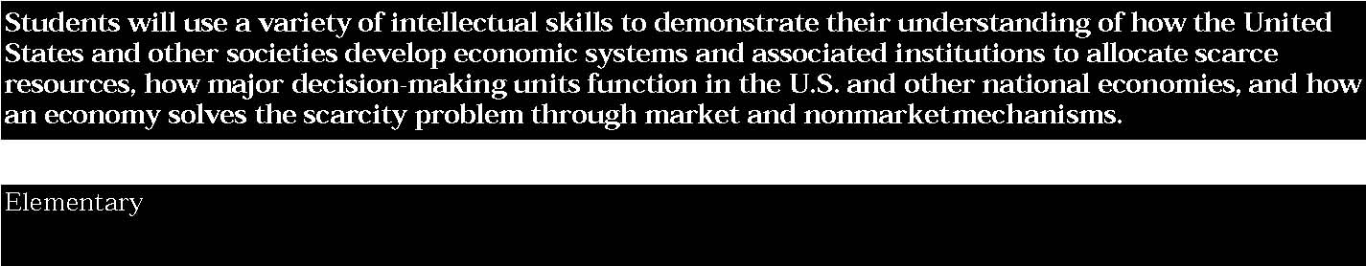

2. Economics requires the development and application of the skills needed to make informed and well-reasoned economic decisions in daily and national life.
Students:
- locate economic information, using card catalogues, computer databases, indices, and library guides
- collect economic information from textbooks, standard references, newspapers, periodicals, and other primary and secondary sources
- make hypotheses about economic issues and problems, testing, refining, and eliminating hypotheses and developing new ones when necessary
- present economic information by developing charts, tables, diagrams, and simple graphs.

This is evident, for example, when students:
- collect and discuss newspaper articles about economic issues and problems affecting their community, region, or the State
- design a display board showing how they might acquire and spend income
- research a local industry to determine what it produces, how it makes this product, its distribution system, and how the finished product is marketed
- analyze a set of graphs or tables showing selected imports and exports for the United States to make hypotheses about what might happen if these imports or exports increase or decrease in value
- use a variety of textbooks and news articles to identify a list of potential economic problems or issues facing the United States or other nations in the Western Hemisphere. Working in groups, brainstorm a list of possible solutions, the potential effects of these solutions, and rank order the solutions in terms of their likelihood of success.



1. The study of economics requires an understanding of major economic concepts and systems, the principles of economic decision making, and the interdependence of economies and economic systems throughout the world.
Students:
- explain how societies and nations attempt to satisfy their basic needs and wants by utilizing scarce capital, natural, and human resources
- define basic economic concepts such as scarcity, supply and demand, markets, opportunity costs, resources, productivity, economic growth, and systems
- understand how scarcity requires people and nations to make choices which involve costs and future considerations
- understand how people in the United States and throughout the world are both producers and consumers of goods and services
- investigate how people in the United States and throughout the world answer the three fundamental economic questions and solve basic economic problems
- describe how traditional, command, market, and mixed economies answer the three fundamental economic questions
- explain how nations throughout the world have joined with one another to promote economic development and growth.

This is evident, for example, when students:
- investigate how different countries in Europe and the Middle East solve problems related to satisfying basic needs. Compile a list of available resources, industries, modes of transportation, and economic problems
- define and apply basic economic concepts such as supply and demand, price, market, and economic growth in an investigation of a national or regional economic question or problem
- understand the concept of opportunity cost (the highest valued alternative not chosen) and how the concept applies to personal and business decision making
- consider case studies comparing economic decisions and choices made by groups and nations involving questions about scarce resources
- compare basic economic systems throughout the world, classifying them as traditional, command, market, or mixed. Focus on questions such as: What is produced? How is it produced, distributed, and consumed? Which natural, capital, and human resources are available? How are prices set? What is meant by economic growth?

Key ideas are identified by numbers (1). Performance indicators are identified by bullets (•). Sample tasks are identified by triangles (▲ ).
- identify the basic ideas and values of the United States economic system (e.g., individual entrepreneurship, private ownership of property, laissez-faire economics, cheap labor supply, free enterprise, monopolies, and governmental regulation) and how these factors contributed to the American economic system; compare these ideas and values to those of other economic systems
- define and apply the concepts of inflation, deflation, depression, fiscal policies, and monetary policy in the context in which these terms are used; examine the historical context of at least one of these concepts during an important event in United States history (e.g., industrialization of America and the rise of the labor movement, the Great Depression, the 1970s inflation)
- develop a case study of a New York-produced product to show how the State participates in a world economy
- investigate the economy of the United States and determine how decisions are made about what goods and services are to be produced, and how they are distributed; compare how these decisions are made in other countries; identify the major imports/exports of the country and explain the effects of international trade on the American and other national economies; discuss how values may influence the economy.

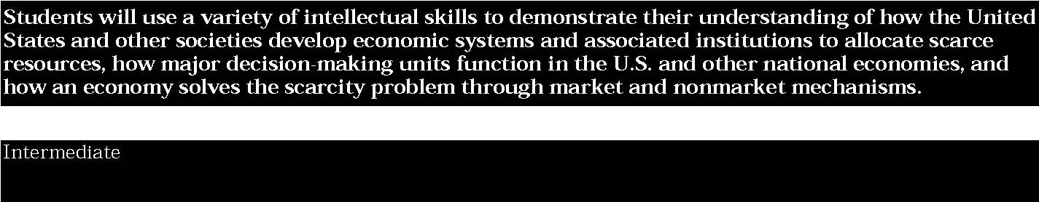

2. Economics requires the development and application of the skills needed to make informed and well-reasoned economic decisions in daily and national life.
Students:
• identify and collect economic information from standard reference works, newspapers, periodicals, computer databases, textbooks, and other primary and secondary sources
• organize and classify economic information by distinguishing relevant from irrelevant information, placing ideas in chronological order, and selecting appropriate labels for data
- evaluate economic data by differentiating fact from opinion and identifying frames of reference
- develop conclusions about economic issues and problems by creating broad statements which summarize findings and solutions
- present economic information by using media and other appropriate visuals such as tables, charts, and graphs to communicate ideas and conclusions.

This is evident, for example, when students:
▲ research a number of economic conditions (e.g., availability of resources, size and distribution of population, degree of technology, political structure) about a particular nation in Europe, Africa, or the Middle East
▲ organize economic information about different kinds of economic systems (i.e., traditional, market, command) in terms of what to produce, how to produce it, and for whom to produce the product
▲ investigate different societies and groups living in Africa, Asia, and the Middle East to determine their available resources, industries, and problems in meeting basic needs. List alternative ways to resolve their economic problems and evaluate the effectiveness of each proposed solution
▲ design a class-size mural that shows how people living in Europe, Asia, and Africa produce and consume various resources, goods, and services. Indicate how these ways of making a living have changed over time
▲ research a major United States industry such as steel, automobile, mining, farming, or banking to determine the governmental controls placed on it either directly or indirectly. Determine the extent to which the federal government interacts with and controls these industries
▲ prepare a classroom questionnaire that asks the historical/economic question: What makes a nation an industrial leader? Survey adults to determine their opinions on the question, categorize the findings, and draw conclusions.



1. The study of economics requires an understanding of major economic concepts and systems, the principles of economic decision making, and the interdependence of economies and economic systems throughout the world.
Students:
- analyze the effectiveness of varying ways societies, nations, and regions of the world attempt to satisfy their basic needs and wants by utilizing scarce resources
- define and apply basic economic concepts such as scarcity, supply/demand, opportunity costs, production, resources, money and banking, economic growth, markets, costs, competition, and world economic systems
- understand the nature of scarcity and how nations of the world make choices which involve economic and social costs and benefits
- describe the ideals, principles, structure, practices, accomplishments, and problems related to the United States economic system
- compare and contrast the United States economic system with other national economic systems, focusing on the three fundamental economic questions
- explain how economic decision making has become global as a result of an interdependent world economy
- understand the roles in the economic system of consumers, producers, workers, investors, and voters.

This is evident, for example, when students:
- through the use of market case studies of the U.S. economy and the economies of other countries, investigate how values and incentives influence people’s choices, how the economic system affects people’s incentives, how people gain from voluntary trade, and how people’s choices influence the value of a good or service
- examine current and historical economic data (e.g., workforce composition and participation, natural resource deposits, industrial base, financial institutions, state’s gross domestic product) to create an economic profile of the New York State and United States economies; investigate the role of government (state and national) with particular attention to services provided that foster economic activity and regulations designed to protect the environment
- complete a case study of a nation or society, focusing on the fundamental economic questions: What goods and services are produced and in what quantities? How are these goods and services produced? For whom are these goods and services produced?

Key ideas are identified by numbers (1). Performance indicators are identified by bullets (•). Sample tasks are identified by triangles (▲ ).
- investigate one or more current economic issues in the United States, including their historical antecedents; issues may include, but are not limited to: impact of fiscal policy, the role of Federal Reserve and monetary policy, corporate downsizing and unemployment, economic growth and the information age, welfare policy, health care policy, the national debt, defense spending, foreign aid, affirmative action; consider policy positions, and the possible conflicting goals of government, such as full employment, price stability, economic justice, economic freedom, and economic security
- recognize why international trade takes place (because of comparative advantage) and the role of exchange rates in fostering or inhibiting trade; become familiar with the basics of the balance of payments and international capital flows; investigate the importance of New York City as a primary world financial center and how the City’s financial role is enhanced by technology
- graph textbook or teacher-developed data to display supply/demand schedules. Interpret graphs identifying prices and situations that would cause the demand and supply schedules to change
- describe a list of economic decisions students will make during the coming year, explaining how the concept of scarcity is involved in each decision. For each decision, discuss a possible opportunity cost involved. Research newspapers, periodicals, and computer databases to compile a list of local, State, or federal government economic decisions explaining how the concept of scarcity affected each decision
- interpret and analyze the graphic information included in the annual Economic Report of the President, describing federal and state expenditures
- analyze how traditional, command, market, and mixed economies would address the following issues: health care for individuals with special needs (i.e., elderly, people with disabilities), price supports for farmers, aid to education, and environmental controls of industries
- examine the nature and functions of money in an economy; understand the basics of banking, including the role of the Federal Reserve Bank system; investigate how forms of money and the nature of credit have changed over time; recognize how technology increases the flow of financial information and increases the speed of financial transactions
- conduct an in-depth investigation and analysis of the economic and historical impact of one of the following: the era of Adam Smith and the emergence of capitalism, the Industrial Revolution, Karl Marx and the emergence of communism, the fall of the Berlin Wall, the “opening up” of former communist countries to capitalism, and how economic change has affected families throughout history.

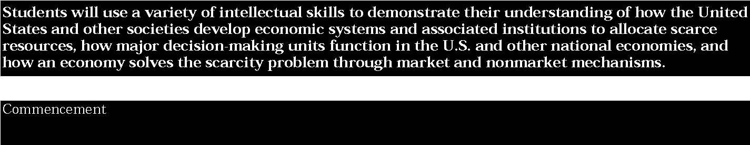

2. Economics requires the development and application of the skills needed to make informed and well-reasoned economic decisions in daily and national life.
Students:
- identify, locate, and evaluate economic information from standard reference works, newspapers, periodicals, computer databases, monographs, textbooks, government publications, and other primary and secondary sources
- use economic information by identifying similarities and differences in trends; inferring relationships between various elements of an economy: organizing and arranging information in charts, tables, and graphs; extrapolating and making conclusions about economic questions, issues, and problems
- apply a problem-solving model to identify economic problems or issues, generate hypotheses, test hypotheses, investigate and analyze selected data, consider alternative solutions or positions, and make decisions about the best solution or position
- present economic information and conclusions in different formats, including graphic representations, computer models, research reports, and oral presentations.

This is evident, for example, when students:
- analyze graphs and charts describing federal, state, and local government expenditures in different categories (e.g., education, police and fire, health care, welfare, transportation) and design a graphic representation or computer model that compares/ contrasts these expenditures
- construct a personal budget showing how they would spend a particular income for a period of months. Classify the expenditures and present this information in graphic form
- research the early struggles of organized labor, including topics such as labor conditions in specific industries in the nineteenth century, important pieces of labor legislation, and major labor conflicts. Prepare an oral or research report that summarizes the findings and evaluates the effectiveness of the solutions to these problems, conflicts, or conditions
- list problems which affect the environment and the quality of life in the United States. Research federal, state, and local government programs developed to resolve these problems. Evaluate the costs and benefits of each governmental action and propose additional actions
- prepare a series of questions for an interview with a commercial banker focusing on the relationship of that bank with the Federal Reserve System and how and why interest rates change. Graph interest rates for a two-year period and explain how and why they might have changed
- research periodicals, computer databases, and government publications to investigate different views on the role of the government in the economy. Take and defend a position on what role government should play in managing the economy.

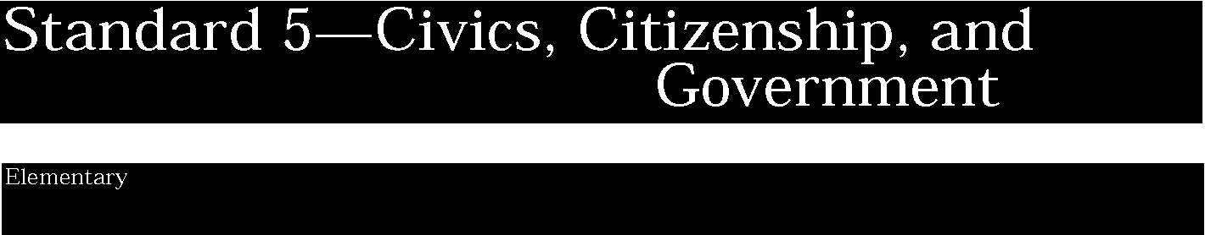

1. The study of civics, citizenship, and government involves learning about political systems; the purposes of government and civic life; and the differing assumptions held by people across time and place regarding power, authority, governance, and law. (Adapted from The National Standards for Civics and Government, 1994)
Students:
- know the meaning of key terms and concepts related to government, including democracy, power, citizenship, nation-state, and justice
- explain the probable consequences of the absence of government and rules
- describe the basic purposes of government and the importance of civic life
- understand that social and political systems are based upon people’s beliefs
- discuss how and why the world is divided into nations and what kinds of governments other nations have.

This is evident, for example, when students:
- create a chart on newsprint listing the reasons for creating governments and the reasons why all groups and societies create rules and laws
- create a class constitution and develop class rules
- role-play a day without rules or laws
- collect and discuss newspaper cartoons dealing with rules and laws
- compile a list of different nations of the world and identify the type of government each nation has
- compare governmental structures of the United States and Canada, and selected nations of Latin America
- hold a mock trial focusing on situations that embody such concepts as fairness, justice, or equality.

2. The state and federal governments established by the Constitutions of the United States and the State of New York embody basic civic values (such as justice, honesty, self-discipline, due process, equality, majority rule with respect for minority rights, and respect for self, others, and property), principles, and practices and establish a system of shared and limited government. (Adapted from The National Standards for Civics and Government, 1994)
Students:
- explain how the Constitutions of New York State and the United States and the Bill of Rights are the basis for democratic values in the United States
- understand the basic civil values that are the foundation of American constitutional democracy
- know what the United States Constitution is and why it is important. (Adapted from The National Standards for Civics and Government, 1994)
- understand that the United States Constitution and the Constitution of the State of New York are written plans for organizing the functions of government
- understand the structure of New York State and local governments, including executive, legislative, and judicial branches
- identify their legislative and executive representatives at the local, state, and national governments. (Adapted from The National Standards for Civics and Government, 1994)

This is evident, for example, when students:
- create a list of basic civic values and discuss how these can best be modeled on the personal and classroom level
- create a chart comparing the organization of local, state, and federal governments
- given a list of local, county, state, and national leaders, determine which are elected and which are appointed
- identify those branches of government responsible for making, enforcing, and interpreting local, state, and national laws
- compare and contrast New York State government with the federal government by creating charts of each level
- simulate or role-play an activity dealing with the functions of the branches of government
- create a timeline that charts events leading up to the writing of the Declaration of Independence and the United States Constitution.

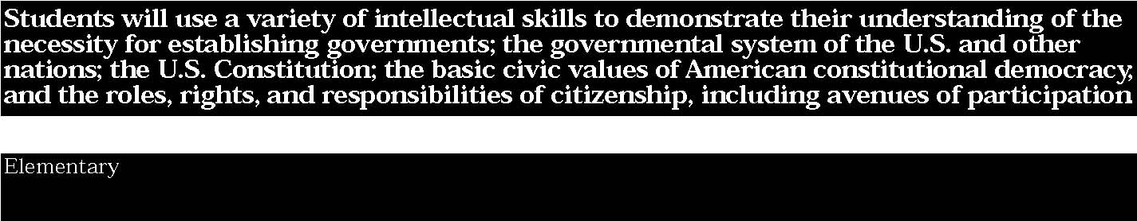

3. Central to civics and citizenship is an understanding of the roles of the citizen within American constitutional democracy and the scope of a citizen’s rights and responsibilities.
Students:
- understand that citizenship includes an awareness of the holidays, celebrations, and symbols of our nation
- examine what it means to be a good citizen in the classroom, school, home, and community
- identify and describe the rules and responsibilities students have at home, in the classroom, and at school
- examine the basic principles of the Declaration of Independence and the Constitutions of the United States and New York State
- understand that effective, informed citizenship is a duty of each citizen, demonstrated by jury service, voting, and community service
- identify basic rights that students have and those that they will acquire as they age.

This is evident, for example, when students:
- interview or survey adults in the community to identify some ways they participate in political action, voluntary activities, or community service
- draft a classroom charter, a constitution, or a set of laws that defines a code of conduct
- discuss and agree on a classroom charter and compare it to the United Nations Convention on the Rights of the Child
- use dramatic play with puppets to investigate the consequences of breaking a rule (e.g., a child arrives home late for dinner)
- make pages for a big book for each holiday
- understand the significance of and recite the Pledge of Allegiance
- discuss the colors of the American flag and make personal flags as symbols of themselves
- examine the flags of other nations
- undertake a mock trial based on themes from classroom books.

4. The study of civics and citizenship requires the ability to probe ideas and assumptions, ask and answer analytical questions, take a skeptical attitude toward questionable arguments, evaluate evidence, formulate rational conclusions, and develop and refine participatory skills.
Students:
- show a willingness to consider other points of view before drawing conclusions or making judgments
- participate in activities that focus on a classroom, school, or community issue or problem
- suggest alternative solutions or courses of action to hypothetical or historic problems
- evaluate the consequences for each alternative solution or course of action
- prioritize the solutions based on established criteria
- propose an action plan to address the issue of how to solve the problem.

This is evident, for example, when students:
- brainstorm a list of alternative solutions for a real classroom or school problem
- write letters to the local paper suggesting preferred alternatives in a local issue
- develop a historic walking tour of the neighborhood or community
- role-play the main characters involved in an actual community controversy, attempting to generate alternatives in their roles
- create a school newpaper or school-wide gallery showing student and faculty works of art
- debate topics important to students
- hold a mock trial including witnesses, attorneys, jurors and a judge.

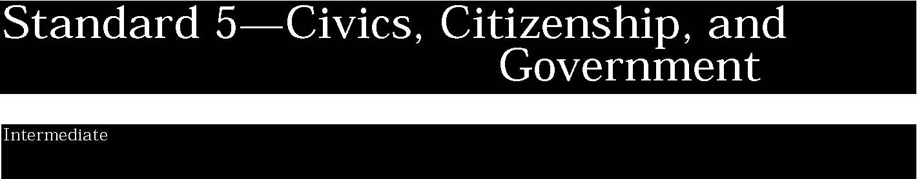

1. The study of civics, citizenship, and government involves learning about political systems; the purposes of government and civic life; and the differing assumptions held by people across time and place regarding power, authority, governance, and law. (Adapted from The National Standards for Civics and Government, 1994)
Students:
- analyze how the values of a nation affect the guarantee of human rights and make provisions for human needs
- consider the nature and evolution of constitutional democracies
- explore the rights of citizens in other parts of the hemisphere and determine how they are similar to and different from the rights of American citizens
- analyze the sources of a nation’s values as embodied in its constitution, statutes, and important court cases.

This is evident, for example, when students:
- using computer databases or the public library, locate constitutions from other nations and compare the rights provided by these constitutions with those found in the Bill of Rights and other amendments of the United States Constitution
- discuss reasons why all citizens should be concerned with issues that relate to people in other countries.
- create a play about a society without any government and without rules. Would students like to live in such a society?
- research the organization and goals of the United Nations, explaining how they represent an international agency which is based on democratic principles
- identify and explain how men and women, through their lives, writings, and work helped to strengthen democracy in the United States and throughout the world (Adapted from The National Standards for Civics and Government, 1994)
- discuss and explore governance and citizenship, focusing on why and how people make and change rules and laws.

Key ideas are identified by numbers (1). Performance indicators are identified by bullets (•). Sample tasks are identified by triangles (▲ ).
2. The state and federal governments established by the Constitutions of the United States and the State of New York embody basic civic values (such as justice, honesty, self-discipline, due process, equality, majority rule with respect for minority rights, and respect for self, others, and property), principles, and practices and establish a system of shared and limited government. (Adapted from The National Standards for Civics and Government, 1994)
Students:
- understand how civic values reflected in United States and New York State Constitutions have been implemented through laws and practices
- understand that the New York State Constitution, along with a number of other documents, served as a model for the development of the United States Constitution
- compare and contrast the development and evolution of the constitutions of the United States and New York State
- define federalism and describe the powers granted the the national and state governments by the United States Constitution
- value the principles, ideals, and core values of the American democratic system based upon the premises of human dignity, liberty, justice, and equality
- understand how the United States and New York State Constitutions support majority rule but also protect the rights of the minority.

This is evident, for example, when students:
- create a list of basic civic values and explore how these values are reflected in key United States Supreme Court decisions
- explore laws dealing with the rights and responsibilities of young people to determine the underlying values on which these young people’s rights are based
- examine core values supporting our system of justice and compare these values to those of other nations
- consider examples from the history of the United States which show the changing nature of federalism, separation of powers, protection of individual rights, and the amendment process
- working in small groups, examine a copy of the original New York State Constitution and a copy of the present State constitution and identify changes that have been made and discuss possible reasons for the changes
- analyze an excerpt written by Alexander Hamilton, John Jay, or James Madison dealing with federalism. Explain the positions each take
- analyze key Supreme Court cases to determine how they embody constitutional values; apply these values to real life situations.

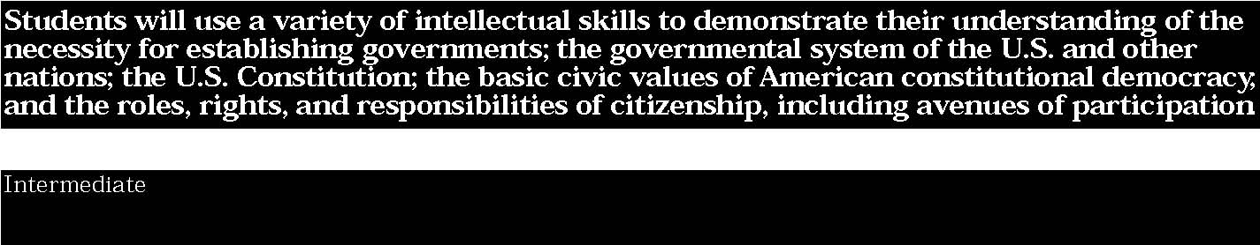

3. Central to civics and citizenship is an understanding of the roles of the citizen within American constitutional democracy and the scope of a citizen’s rights and responsibilities.
Students:
- explain what citizenship means in a democratic society, how citizenship is defined in the Constitution and other laws of the land, and how the definition of citizenship has changed in the United States and New York State over time
- understand that the American legal and political systems guarantee and protect the rights of citizens and assume that citizens will hold and exercise certain civic values and fulfill certain civic responsibilities
- discuss the role of an informed citizen in today’s changing world
- explain how Americans are citizens of their states and of the United States.

This is evident, for example, when students:
- define the concepts of rights and responsibilities of citizens
- investigate the ways a person can become a citizen and the ways in which the rights of citizenship can be lost
- compare and contrast historic documents such as the Seneca Falls “Declaration of Sentiments” (1848) and the Declaration of Independence (1776)
- analyze a collection of cartoons that address the roles of citizens
- investigate historic examples of citizenship in action and create a scale showing the gradations from minimal to basic (voting, jury duty, voluntary activities) to more complex responsibilities (organizing a reform movement)
- examine the role of the average citizen in critical American events, such as the American Revolution, abolitionism, Progressive reforms, support for and protest of American wars, key political campaigns, environmental reforms, and anti-tax protests.

4. The study of civics and citizenship requires the ability to probe ideas and assumptions, ask and answer analytical questions, take a skeptical attitude toward questionable arguments, evaluate evidence, formulate rational conclusions, and develop and refine participatory skills.
Students:
- respect the rights of others in discussions and classroom debates regardless of whether or not one agrees with their viewpoint
- explain the role that civility plays in promoting effective citizenship in preserving democracy
- participate in negotiation and compromise to resolve classroom, school, and community disagreements and problems.

This is evident, for example, when students:
- use value-based dilemmas to provide students with open-ended situations (e.g., witnessing a crime, serving on a jury in a murder trial) that could force them to evaluate their feelings concerning the difficult responsibilities of citizenship
- discuss the options open to people who disagree with a particular political solution to an issue
- conduct mock local, state, and national elections, compare the school’s results with the real outcome of the election
- analyze how complex issues can be addressed when individuals are willing to try to come to agreement through negotiation and compromise (Adapted from The National Standards for Civics and Government, 1994)
- describe how citizens can participate in governmental decisions and how they can monitor and influence their actions and policies
- using historic and current issues or incidents and actual Supreme Court decisions hold mini model trials, appellate arguments, or debates to enhance citizenship skills and knowledge.

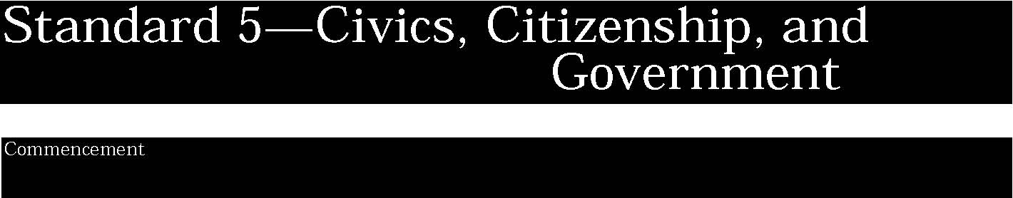

1. The study of civics, citizenship, and government involves learning about political systems; the purposes of government and civic life; and the differing assumptions held by people across time and place regarding power, authority, governance, and law. (Adapted from The National Standards for Civics and Government, 1994)
Students:
- analyze how the values of a nation and international organizations affect the guarantee of human rights and make provisions for human needs
- consider the nature and evolution of constitutional democracies throughout the world
- compare various political systems with that of the United States in terms of ideology, structure, function, institutions, decision-making processes, citizenship roles, and political culture
- identify and analyze advantages and disadvantages of various governmental systems.

This is evident, for example, when students:
- analyze excerpts from the writings of Hobbes, Locke, Rousseau, and others of the Enlightenment Period
- explain what the term “social contract” means and how it was applied to the establishment of civil society and legitimate government in many areas of the world
- compare various political systems throughout the world with that of the United States in terms of their ideologies, structures, functions, institutions, decision-making processes, citizenship roles, and political cultures. (Adapted from Curriculum Standards for the Social Studies, NCSS)
- compare and contrast the American federal system with that of other democratic nations.

Key ideas are identified by numbers (1). Performance indicators are identified by bullets (•). Sample tasks are identified by triangles (▲ ).
2. The state and federal governments established by the Constitutions of the United States and the State of New York embody basic civic values (such as justice, honesty, self-discipline, due process, equality, majority rule with respect for minority rights, and respect for self, others, and property), principles, and practices and establish a system of shared and limited government. (Adapted from The National Standards for Civics and Government, 1994)
Students:
- trace the evolution of American values, beliefs, and institutions
- analyze the disparities between civic values expressed in the United States Constitution and the United Nation Universal Declaration of Human Rights and the realities as evidenced in the political, social, and economic life in the United States and throughout the world
- identify, respect, and model those core civic values inherent in our founding documents that have been forces for unity in American society
- compare and contrast the Constitutions of the United States and New York State
- understand the dynamic relationship between federalism and state’s rights.

This is evident, for example, when students:
- analyze how core American civic values are expressed in those documents that provide the basis for our democratic form of government, including the Magna Carta, the Mayflower Compact, the Declaration of Independence, the Articles of Confederation, the Albany Plan of Union, the Federalist papers, the Constitution, the Bill of Rights, and other amendments
- using the Declaration of Independence, find evidence of the influence of Locke and other Enlightenment philosophers on a political leader like Thomas Jefferson
- analyze key Supreme Court decisions (e.g., Marbury v. Madison, McCulloch v. Maryland, Dred Scott v. Sanford, Plessy v. Ferguson, Brown v. Board of Education of Topeka, Miranda v. Arizona, and Roe v. Wade) in terms of the ongoing struggle to realize democratic ideals; explore how these decisions embody constitutional civic values and the evolution and application of constitutional values within American political, economic, and social life
- present dramatic readings of key excerpts from speeches and writings of Daniel Webster, John C. Calhoun, Henry David Thoreau, Frederick Douglass, and Abraham Lincoln
- analyze the United States Constitution, the United Nations Universal Declaration of Human Rights, United Nations Convention on the Rights of the Child, the Charter of Amnesty International, and other civil/human rights documents to identify and explain the significance of the fundamental values and principles which they espouse.

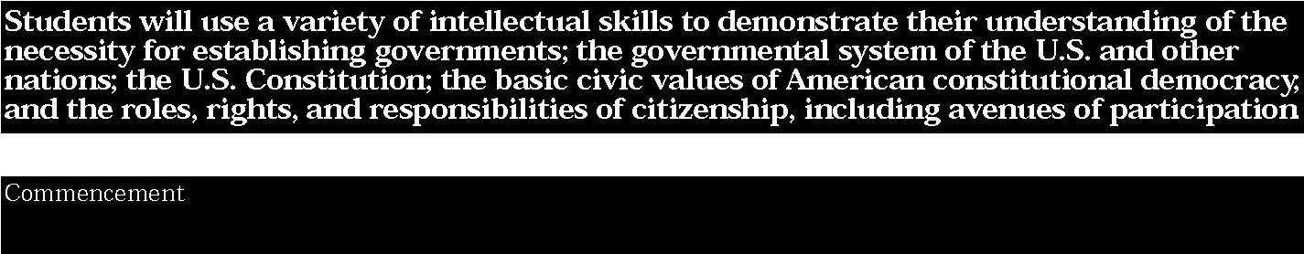

3. Central to civics and citizenship is an understanding of the roles of the citizen within American constitutional democracy and the scope of a citizen’s rights and responsibilities.
Students:
- understand how citizenship includes the exercise of certain personal responsibilities, including voting, considering the rights and interests of others, behaving in a civil manner, and accepting responsibility for the consequences of one’s actions (Adapted from The National Standards for Civics and Government, 1994)
- analyze issues at the local, state, and national levels and prescribe responses that promote the public interest or general welfare, such as planning and carrying out a voter registration campaign
- describe how citizenship is defined by the Constitution and important laws
- explore how citizens influence public policy in a representative democracy.

This is evident, for example, when students:
▲ compare basic British political documents with the United States Constitution, identifying how each system defines leadership, a citizen’s rights and responsibilities, and powers of the government
▲ outline how one can become a citizen and analyze the rights and responsibilities of citizenship
▲ plan and implement a voter registration campaign or other voluntary activity in the community
▲ implement a student court to adjudicate in-school offenses
▲ volunteer and support conflict mediation programs within the school
▲ investigate local environmental issues and propose solutions based on state and federal environmental laws.

4. The study of civics and citizenship requires the ability to probe ideas and assumptions, ask and answer analytical questions, take a skeptical attitude toward questionable arguments, evaluate evidence, formulate rational conclusions, and develop and refine participatory skills.
Students:
- participate as informed citizens in the political justice system and processes of the United States, including voting
- evaluate, take, and defend positions on what the fundamental values and principles of American political life are and their importance to the maintenance of constitutional democracy (Adapted from The National Standards for Civics and Government, 1994)
- take, defend, and evaluate positions about attitudes that facilitate thoughtful and effective participation in public affairs
- consider the need to respect the rights of others, to respect others’ points of view (Adapted from The National Standards for Civics and Government, 1996)
- participate in school/classroom/community activities that focus on an issue or problem
- prepare a plan of action that defines an issue or problem, suggests alternative solutions or courses of action, evaluates the consequences for each alternative solution or course of action, prioritizes the solutions based on established criteria, and proposes an action plan to address the issue or to resolve the problem
- explain how democratic principles have been used in resolving an issue or problem.

This is evident, for example, when students:
- use trade books to sharpen critical thinking skills to analyze issues of citizenship when defending a stance on controversial issues
- analyze issues at the local, state, national, and international levels and prescribe responses that promote the public interest of general welfare, such as planning and carrying out a voter registration campaign
- select a state, regional, national, or international environmental problem or issue. Propose several alternative solutions to the problem. Assess the ethical implications as well as the comparative costs and benefits for each alternative approach to resolving the issue or problem. Defend a solution
- participate in a voter registration campaign
- study current international disputes and apply principles of international law in formulating a proposed course of action
- critically analyze historic Supreme Court cases to determine how well they reflect the intent and spirit of the Constitution then and now.

