

1. Through systems thinking, people can recognize the commonalities that exist among all systems and how parts of a system interrelate and combine to perform specific functions.
Students: • observe and describe interactions among components of simple systems.
• identify common things that can be considered to be systems (e.g., a plant population, a subway system, human beings).
2. Models are simplified representations of objects, structures, or systems used in analysis, explanation, interpretation, or design.
Students:
- analyze, construct, and operate models in order to discover attributes of the real thing.
- discover that a model of something is different from the real thing but can be used to study the real thing.
- use different types of models, such as graphs, sketches, diagrams, and maps, to represent various aspects of the real world.

This is evident, for example, when students:
- compare toy cars with real automobiles in terms of size and function.
- model structures with building blocks.
- design and construct a working model of the human circulatory system to explore how varying pumping pressure might affect blood flow.
- describe the limitations of model cars, planes, or houses.
- use model vehicles or structures to illustrate how the real object functions.
- use a road map to determine distances between towns and cities.

Sample Problem/Activity
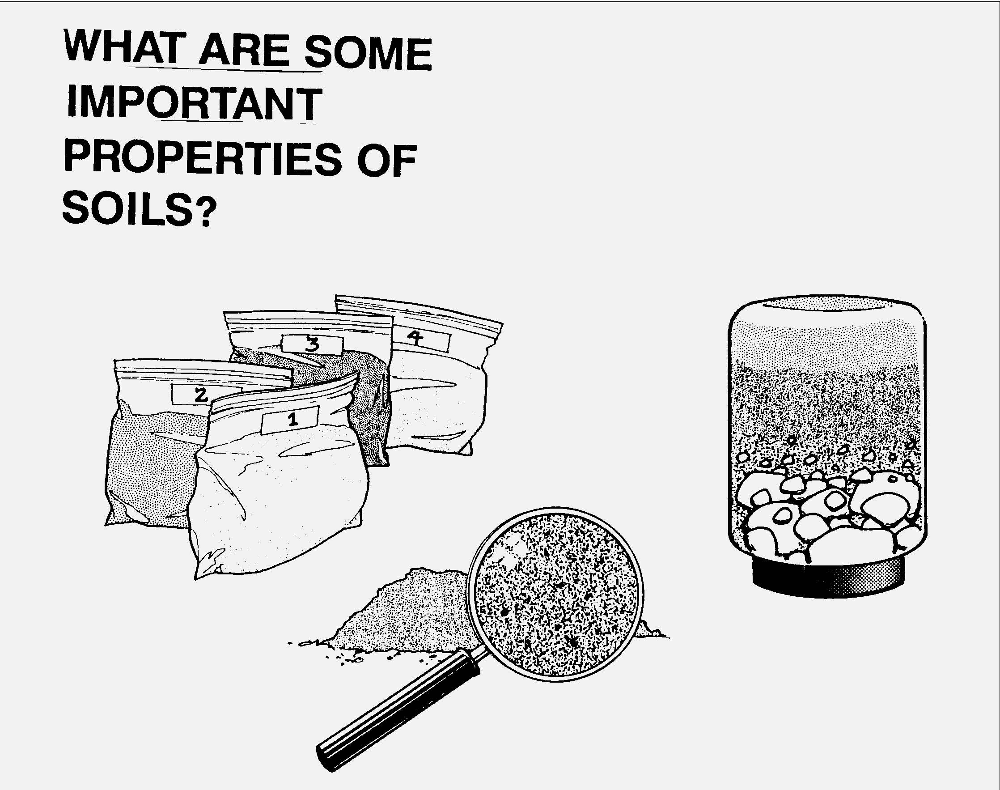
Key ideas are identified by numbers (1). Performance indicators are identified by bullets (•). Sample tasks are identified by triangles (▲ ).
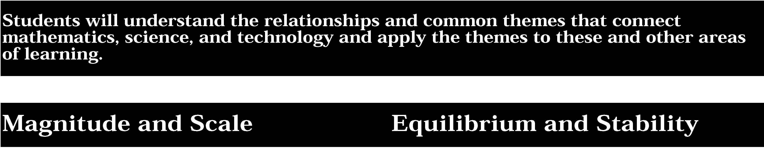

3. The grouping of magnitudes of size, time, frequency, and pressures or other units of measurement into a series of relative order provides a useful way to deal with the immense range and the changes in scale that affect the behavior and design of systems.
Students:
- provide examples of natural and manufactured things that belong to the same category yet have very different sizes, weights, ages, speeds, and other measurements.
- identify the biggest and the smallest values as well as the average value of a system when given information about its characteristics and behavior.

This is evident, for example, when students:
- compare the weight of small and large animals.
- compare the speed of bicycles, cars, and planes.
- compare the life spans of insects and trees.
- collect and analyze data related to the height of the students in their class, identifying the tallest, the shortest, and the average height.
- compare the annual temperature range of their locality.

4. Equilibrium is a state of stability due either to a lack of changes (static equilibrium) or a balance between opposing forces (dynamic equilibrium).
Students:
- cite examples of systems in which some features stay the same while other features change.
- distinguish between reasons for stability—from lack of changes to changes that counterbalance one another to changes within cycles.

This is evident, for example, when students:
- record their body temperatures in different weather conditions and observe that the temperature of a healthy human being stays almost constant even though the external temperature changes.
- identify the reasons for the changing amount of fresh water in a reservoir and determine how a constant supply is maintained.

Sample Problem/Activity
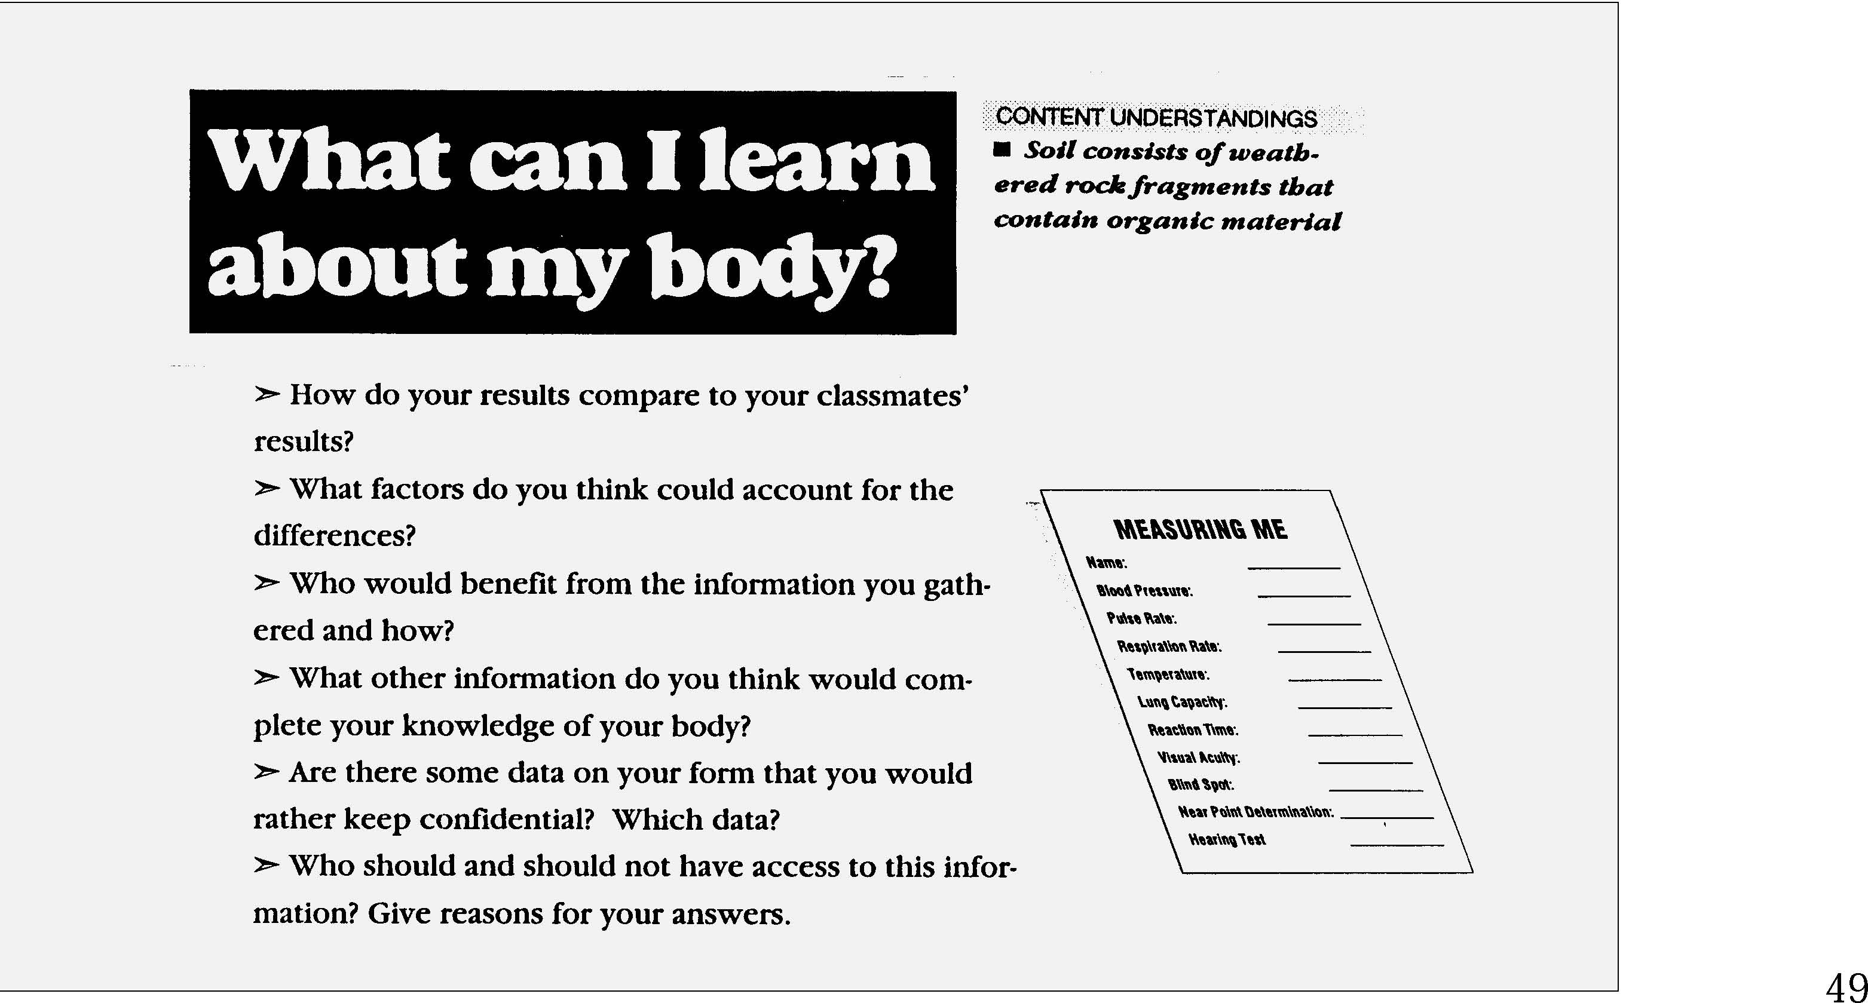


5. Identifying patterns of change is necessary for making predictions about future behavior and conditions.
Students:
- use simple instruments to measure such quantities as distance, size, and weight and look for patterns in the data.
- analyze data by making tables and graphs and looking for patterns of change.

This is evident, for example, when students:
- compare shoe size with the height of people to determine if there is a trend.
- collect data on the speed of balls rolling down ramps of different slopes and determine the relationship between speed and steepness of the ramp.
- take data they have collected and generate tables and graphs to begin the search for patterns of change.

6. In order to arrive at the best solution that meets criteria within constraints, it is often necessary to make trade-offs.
Students:
- determine the criteria and constraints of a simple decision making problem.
- use simple quantitative methods, such as ratios, to compare costs to benefits of a decision problem.

This is evident, for example, when students:
- describe the criteria (e.g., size, color, model) and constraints (e.g., budget) used to select the best bicycle to buy.
- compare the cost of cereal to number of servings to figure out the best buy.

Sample Problem/Activity
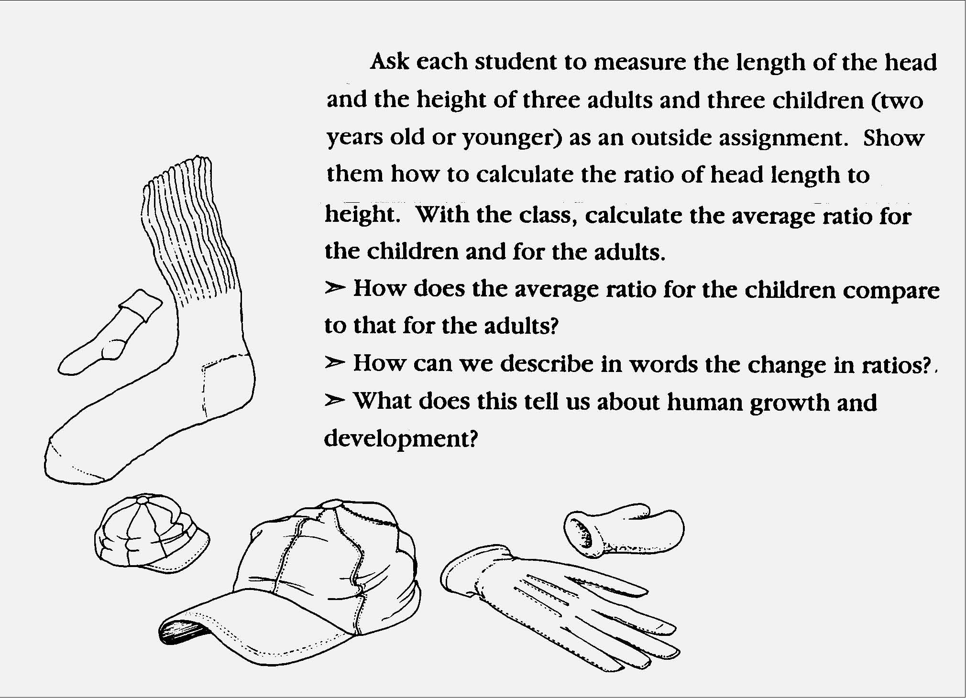
Students will understand the relationships and common themes that connectmathematics, science, and technology and apply the themes to these and other areasof learning.
Sample Problem/Activity



1. Through systems thinking, people can recognize the commonalities that exist among all systems and how parts of a system interrelate and combine to perform specific functions.
Students:
- describe the differences between dynamic systems and organizational systems.
- describe the differences and similarities between engineering systems, natural systems, and social systems.
- describe the differences between open- and closed-loop systems.
- describe how the output from one part of a system (which can include material, energy, or information) can become the input to other parts.

This is evident, for example, when students:
▲ compare systems with internal control (e.g., homeostasis in organisms or an ecological system) to systems of related components without internal control (e.g., the Dewey decimal, solar system).
2. Models are simplified representations of objects, structures, or systems used in analysis, explanation, interpretation, or design.
Students:
- select an appropriate model to begin the search for answers or solutions to a question or problem.
- use models to study processes that cannot be studied directly (e.g., when the real process is too slow, too fast, or too dangerous for direct observation).
- demonstrate the effectiveness of different models to represent the same thing and the same model to represent different things.

This is evident, for example, when students:
- choose a mathematical model to predict the distance a car will travel at a given speed in a given time.
- use a computer simulation to observe the process of growing vegetables or to test the performance of cars.
- compare the relative merits of using a flat map or a globe to model where places are situated on Earth.
- use blueprints or scale models to represent room plans.

Sample Problem/Activity
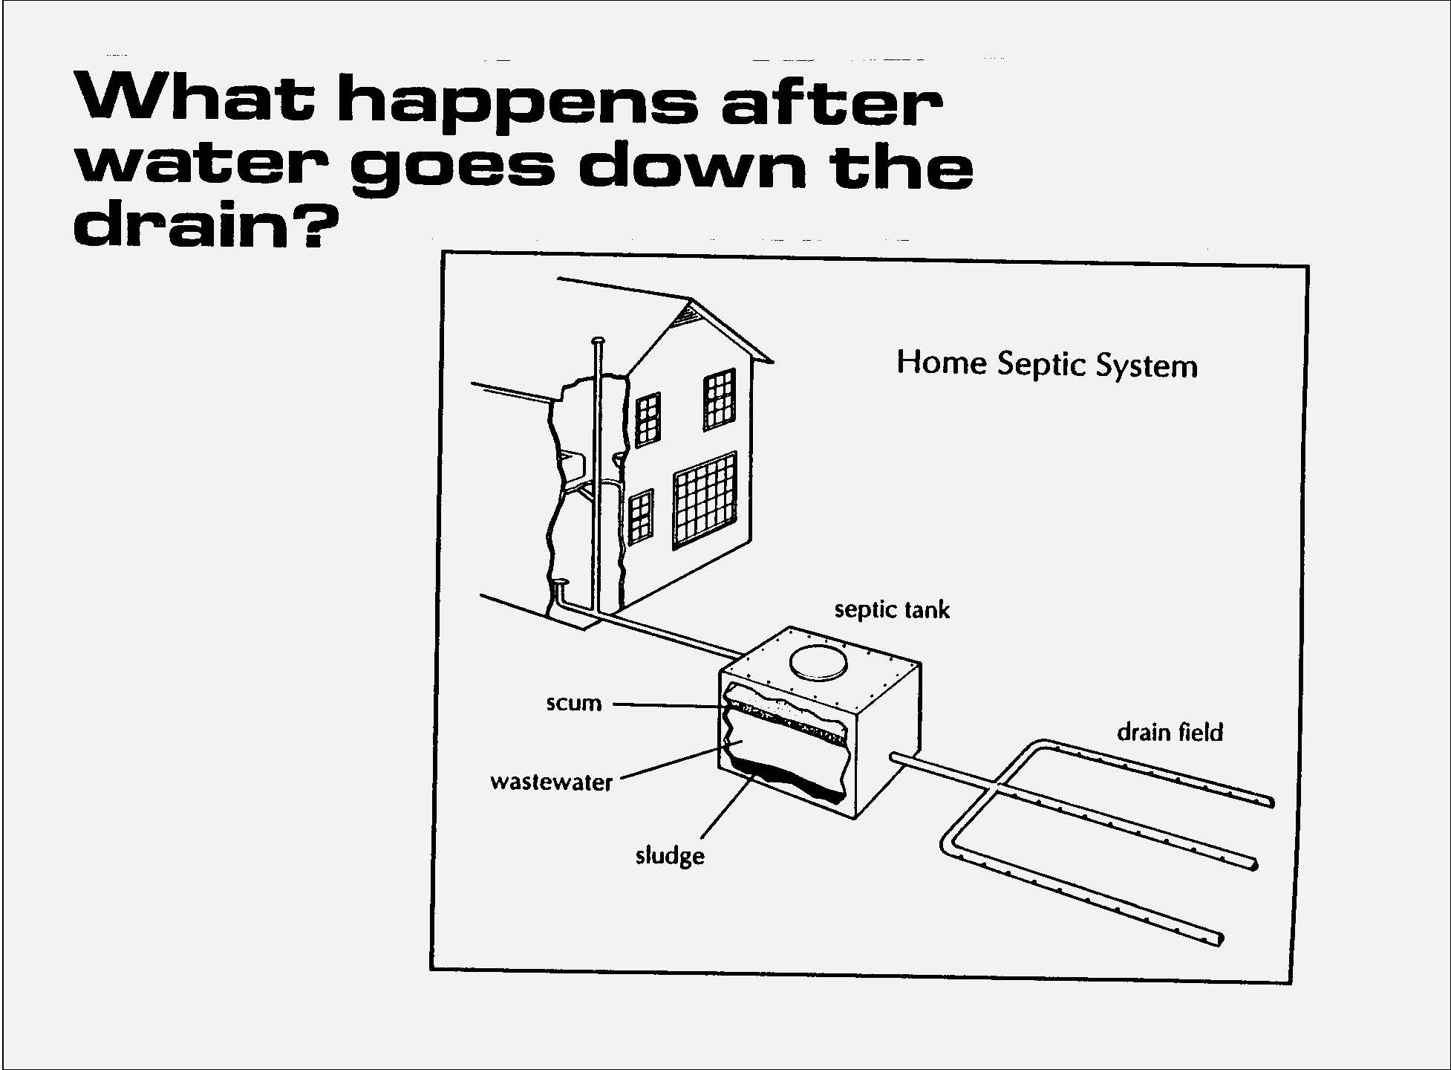
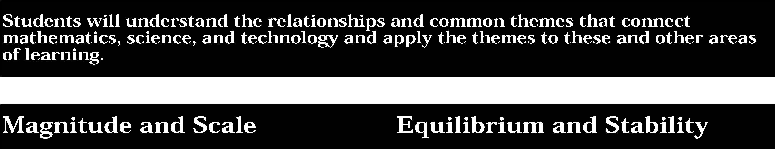

3. The grouping of magnitudes of size, time, frequency, and pressures or other units of measurement into a series of relative order provides a useful way to deal with the immense range and the changes in scale that affect the behavior and design of systems.
Students:
- cite examples of how different aspects of natural and designed systems change at different rates with changes in scale.
- use powers of ten notation to represent very small and very large numbers.

This is evident, for example, when students:
- demonstrate that a large container of hot water (more volume) cools off more slowly than a small container (less volume).
- compare the very low frequencies (60 Hertz AC or 6 x 10 Hertz) to the mid-range frequencies (10 Hertz-FM radio) to the higher frequencies (1015 Hertz) of the electromagnetic spectrum.

4. Equilibrium is a state of stability due either to a lack of changes (static equilibrium) or a balance between opposing forces (dynamic equilibrium).
Students:
- describe how feedback mechanisms are used in both designed and natural systems to keep changes within desired limits.
- describe changes within equilibrium cycles in terms of frequency or cycle length and determine the highest and lowest values and when they occur.

This is evident, for example, when students:
- compare the feedback mechanisms used to keep a house at a constant temperature to those used by the human body to maintain a constant temperature.
- analyze the data for the number of hours of sunlight from the shortest day to the longest day of the year.

Sample Problem/Activity
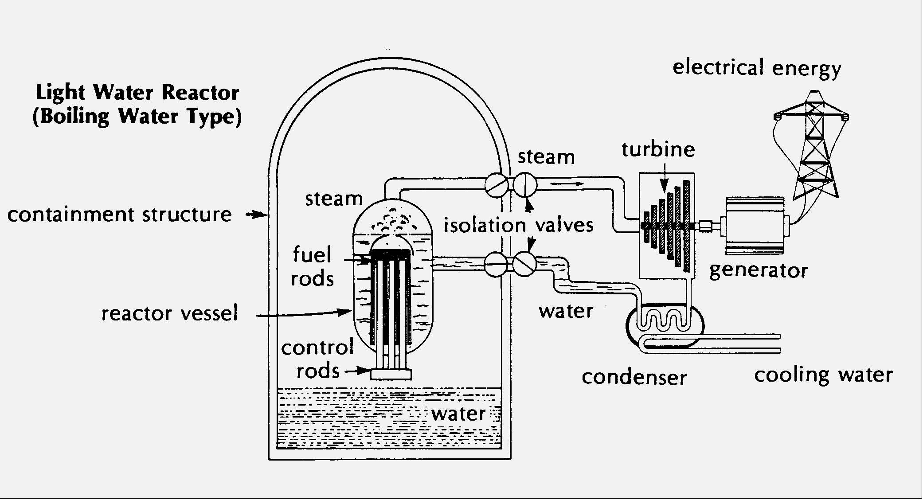


5. Identifying patterns of change is necessary for making predictions about future behavior and conditions.
Students:
• use simple linear equations to represent how a parameter changes with time.
• observe patterns of change in trends or cycles and make predictions on what might happen in the future.
This is evident, for example, when students:
- study how distance changes with time for a car traveling at a constant speed.
- use a graph of a population over time to predict future population levels.

6. In order to arrive at the best solution that meets criteria within constraints, it is often necessary to make trade-offs.
Students:
- determine the criteria and constraints and make tradeoffs to determine the best decision.
- use graphs of information for a decision making problem to determine the optimum solution.

This is evident, for example, when students:
- choose components for a home stereo system.
- determine the best dimensions for fencing in the maximum area.

Sample Problem/Activity
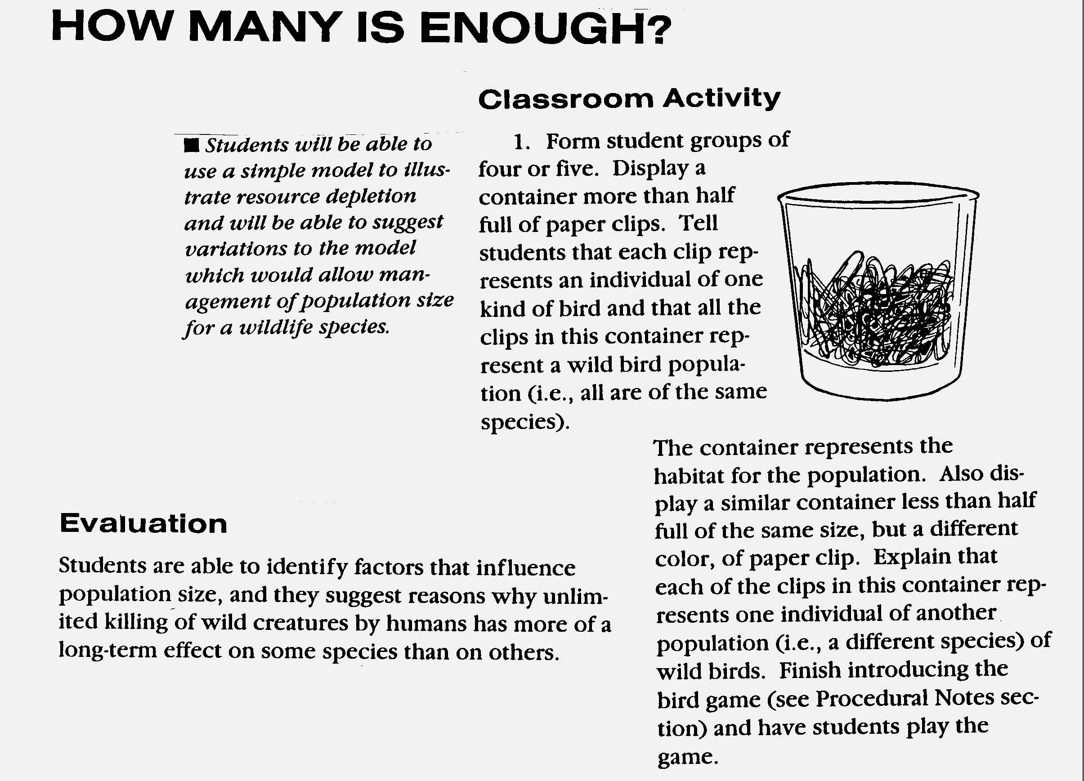

Students will understand the relationships and common themes that connectmathematics, science, and technology and apply the themes to these and other areasof learning.
Sample Problem/Activity
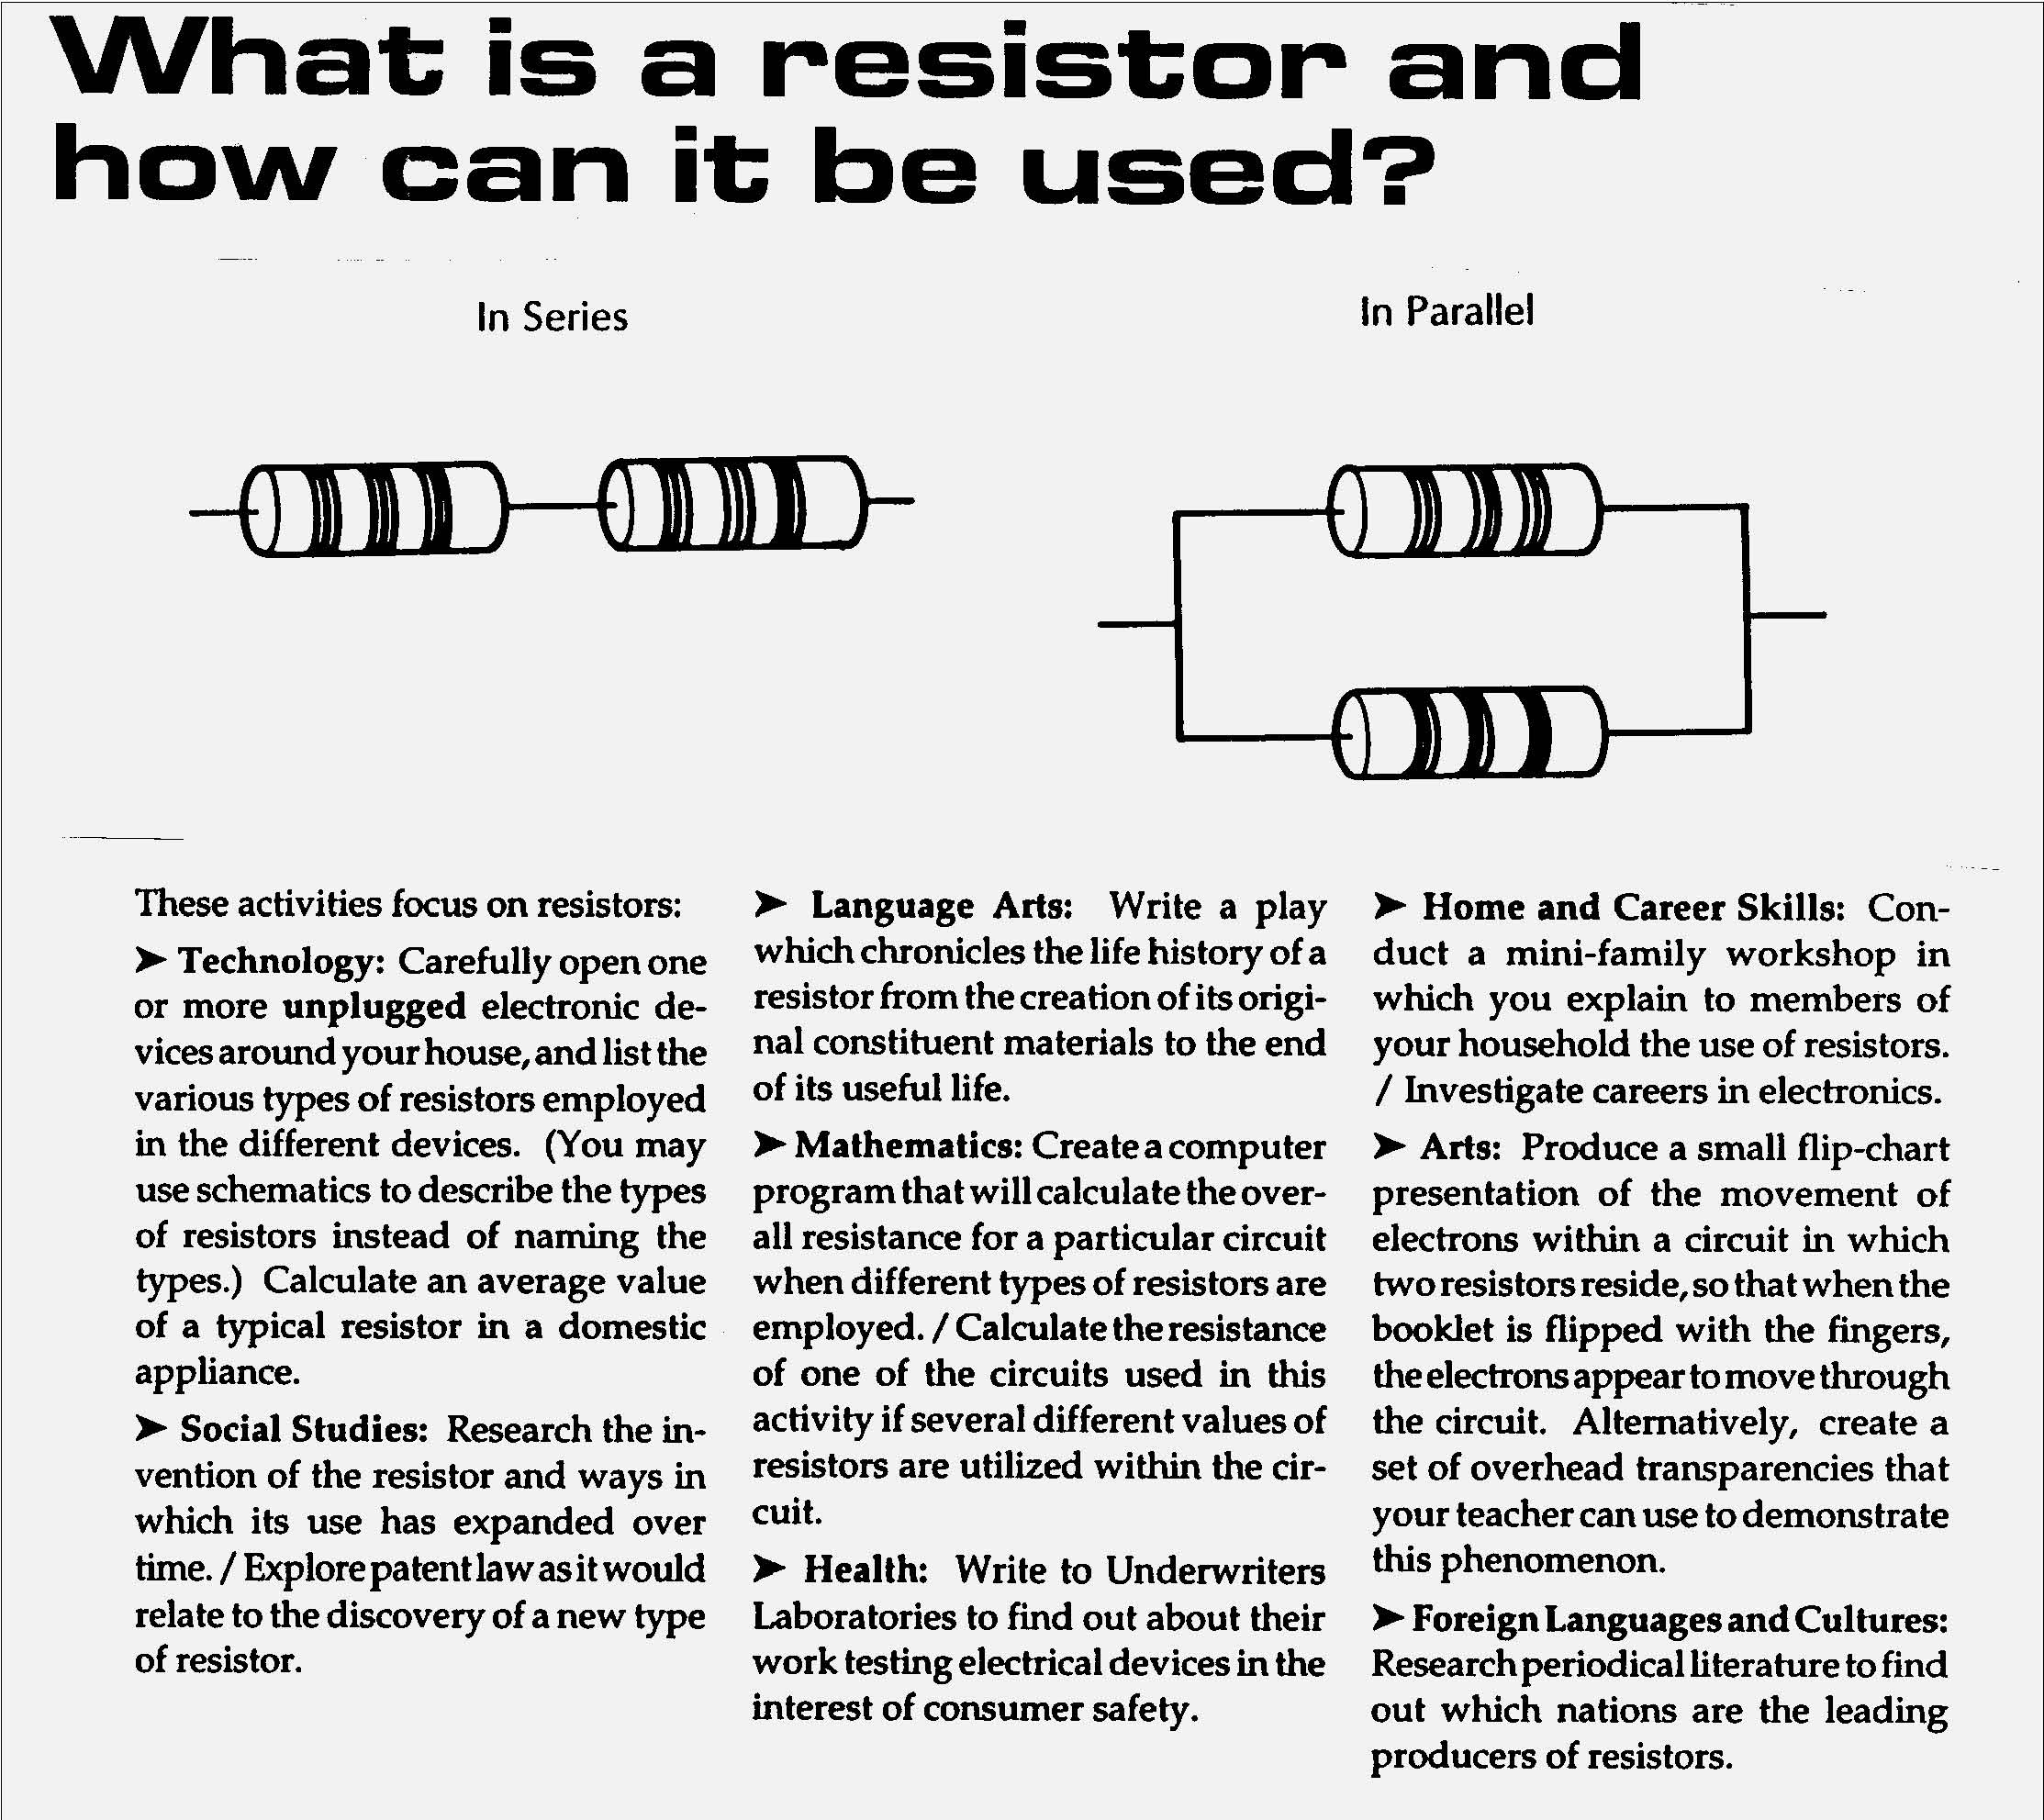

1. Through systems thinking, people can recognize the commonalities that exist among all systems and how parts of a system interrelate and combine to perform specific functions.
Students:
- explain how positive feedback and negative feedback have opposite effects on system outputs.
- use an input-process-output-feedback diagram to model and compare the behavior of natural and engineered systems.
- define boundary conditions when doing systems analysis to determine what influences a system and how it behaves.

This is evident, for example, when students:
▲ describe how negative feedback is used to control loudness automatically in a stereo system and how positive feedback from loudspeaker to microphone results in louder and louder squeals.
2. Models are simplified representations of objects, structures, or systems used in analysis, explanation, interpretation, or design.
Students:
- revise a model to create a more complete or improved representation of the system.
- collect information about the behavior of a system and use modeling tools to represent the operation of the system.
- find and use mathematical models that behave in the same manner as the processes under investigation.
- compare predictions to actual observations using test models.

This is evident, for example, when students:
- add new parameters to an existing spreadsheet model.
- incorporate new design features in a CAD drawing.
- use computer simulation software to create a model of a system under stress, such as a city or an ecosystem.
- design and construct a prototype to test the performance of a temperature control system.
- use mathematical models for scientific laws, such as Hooke’s Law or Newton’s Laws, and relate them to the function of technological systems, such as an automotive suspension system.
- use sinusoidal functions to study systems that exhibit periodic behavior.
- compare actual populations of animals to the numbers predicted by predator/ prey computer simulations.

Key ideas are identified by numbers (1). Performance indicators are identified by bullets (•). Sample tasks are identified by triangles (▲ ).
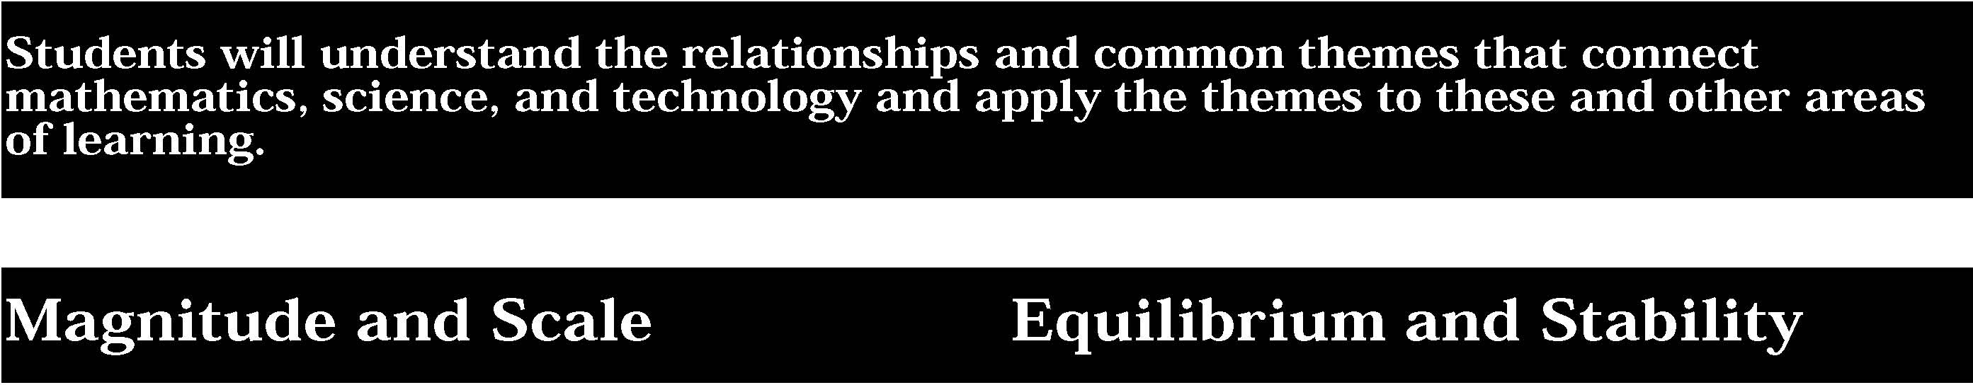

3. The grouping of magnitudes of size, time, frequency, and pressures or other units of measurement into a series of relative order provides a useful way to deal with the immense range and the changes in scale that affect the behavior and design of systems.
Students:
- describe the effects of changes in scale on the functioning of physical, biological, or designed systems.
- extend their use of powers of ten notation to understanding the exponential function and performing operations with exponential factors.

This is evident, for example, when students:
- explain that an increase in the size of an animal or a structure requires larger supports (legs or columns) because of the greater volume or weight.
- use the relationship that v=f λ to determine wave length when given the frequency of an FM radio wave, such as 100.0 megahertz (1.1 x 108 Hertz), and velocity of light or EM waves as 3 x 108m/sec can.

4. Equilibrium is a state of stability due either to a lack of changes (static equilibrium) or a balance between opposing forces (dynamic equilibrium).
Students:
- describe specific instances of how disturbances might affect a system’s equilibrium, from small disturbances that do not upset the equilibrium to larger disturbances (threshold level) that cause the system to become unstable.
- cite specific examples of how dynamic equilibrium is achieved by equality of change in opposing directions.

This is evident, for example, when students:
- use mathematical models to predict under what conditions the spread of a disease will become epidemic.
- document the range of external temperatures in which warmblooded animals can maintain a relatively constant internal temperature and identify the extremes of cold or heat that will cause death.
- experiment with chemical or biological processes when the flow of materials in one way direction is counter-balanced by the flow of materials in the opposite direction.

Sample Problem/Activity
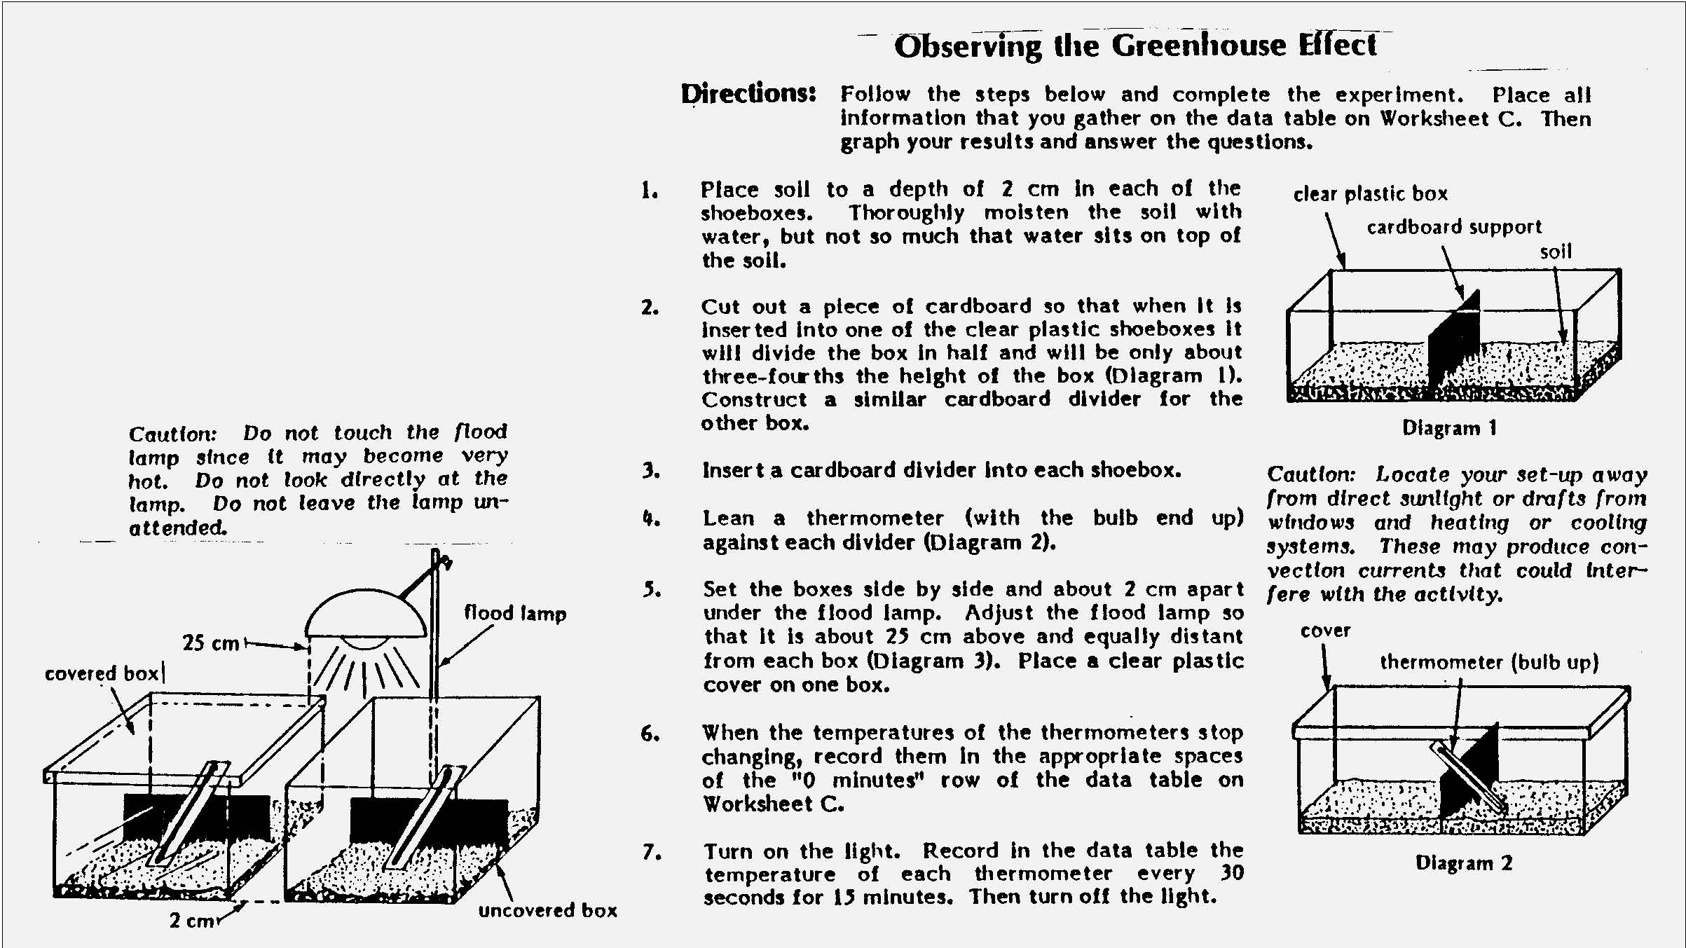


5. Identifying patterns of change is necessary for making predictions about future behavior and conditions.
Students:
- use sophisticated mathematical models, such as graphs and equations of various algebraic or trigonometric functions.
- search for multiple trends when analyzing data for patterns, and identify data that do not fit the trends.

This is evident, for example, when students:
- use a sine pattern to model the property of a sound or electromagnetic wave.
- use graphs or equations to model exponential growth of money or populations.
- explore historical data to determine whether the growth of a parameter is linear or exponential or both.

6. In order to arrive at the best solution that meets criteria within constraints, it is often necessary to make trade-offs.
Students:
- use optimization techniques, such as linear programming, to determine optimum solutions to problems that can be solved using quantitative methods.
- analyze subjective decision making problems to explain the trade-offs that can be made to arrive at the best solution.

This is evident, for example, when students:
- use linear programming to figure the optimum diet for farm animals.
- evaluate alternative proposals for providing people with more access to mass transportation systems.

Sample Problem/Activity
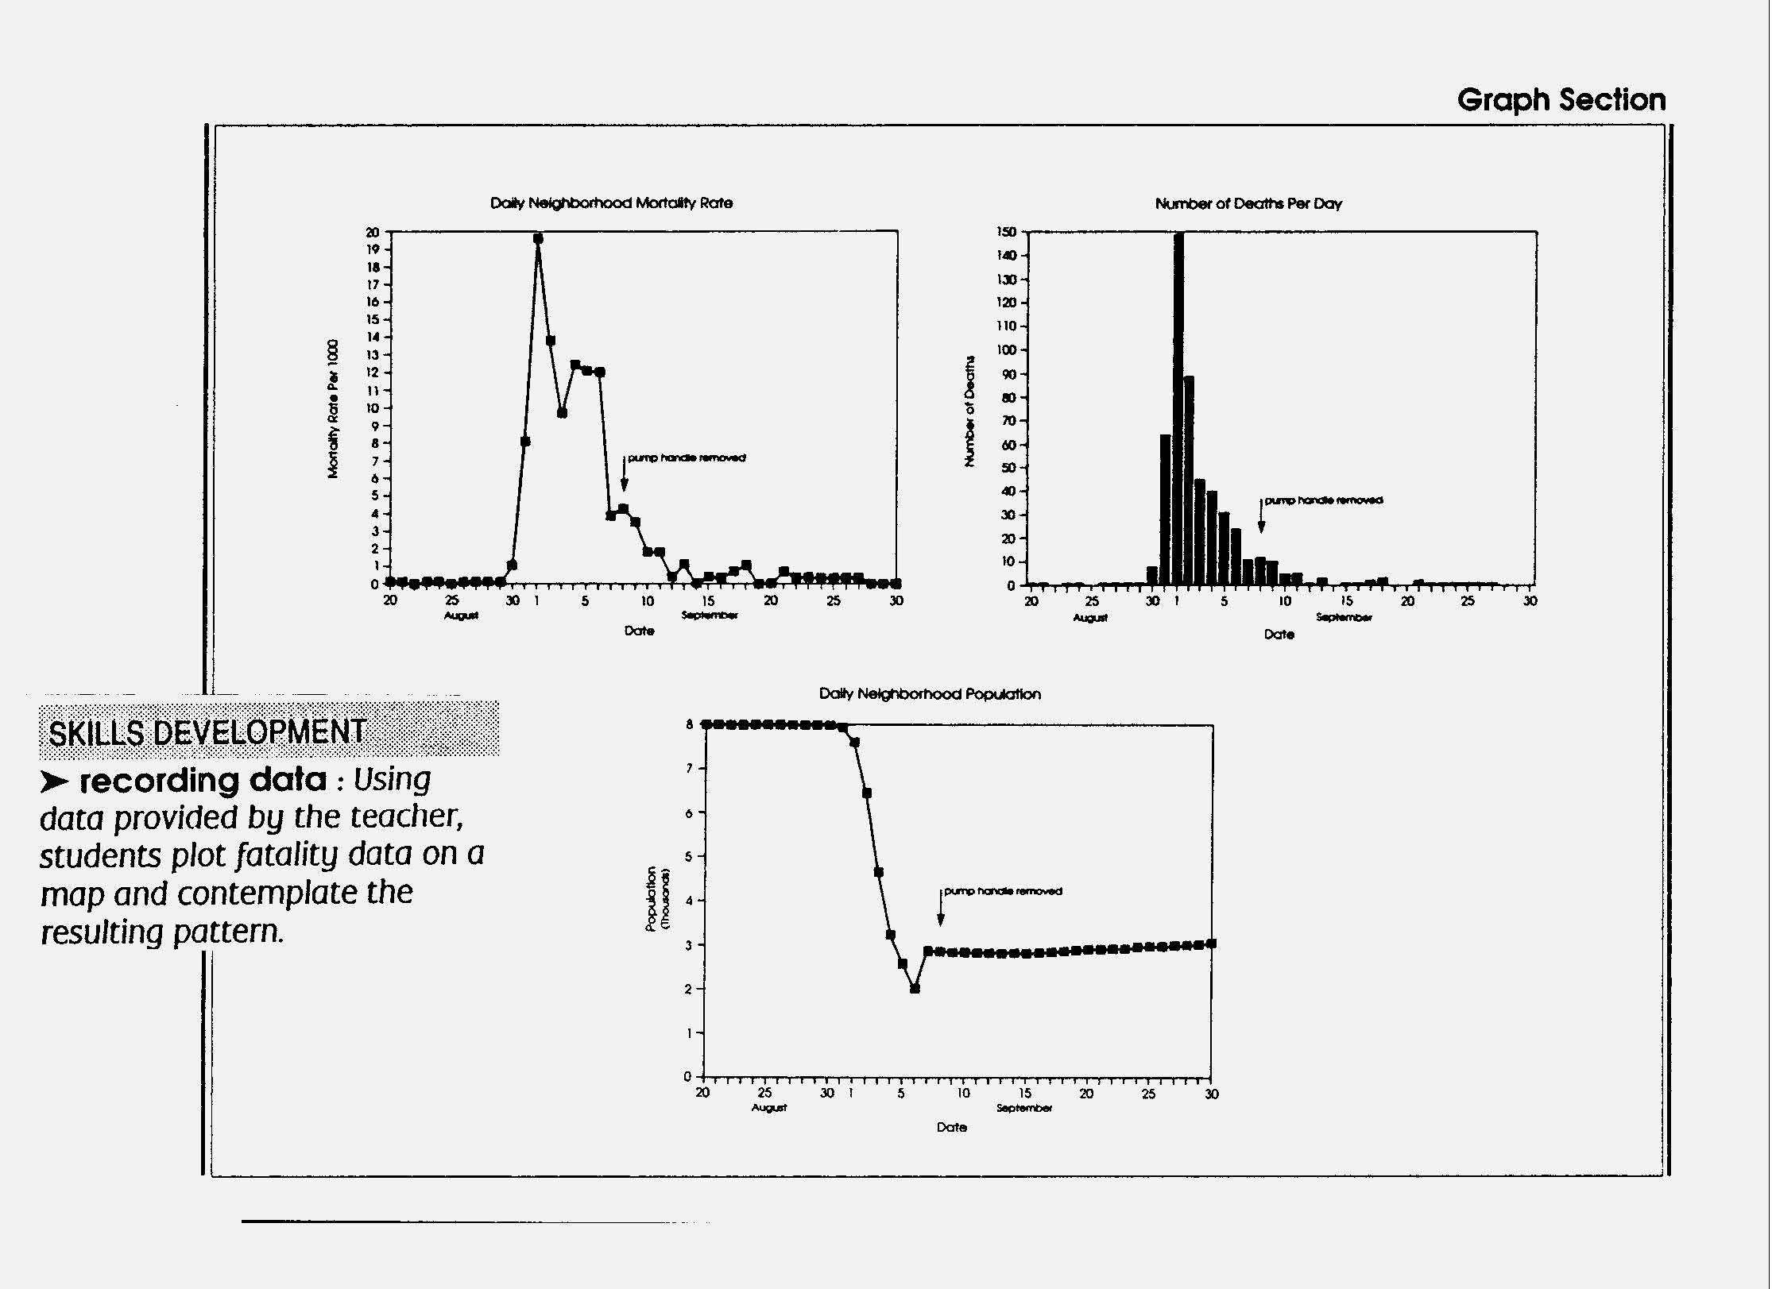

Students will understand the relationships and common themes that connectmathematics, science, and technology and apply the themes to these and other areasof learning.
Sample Problem/Activity
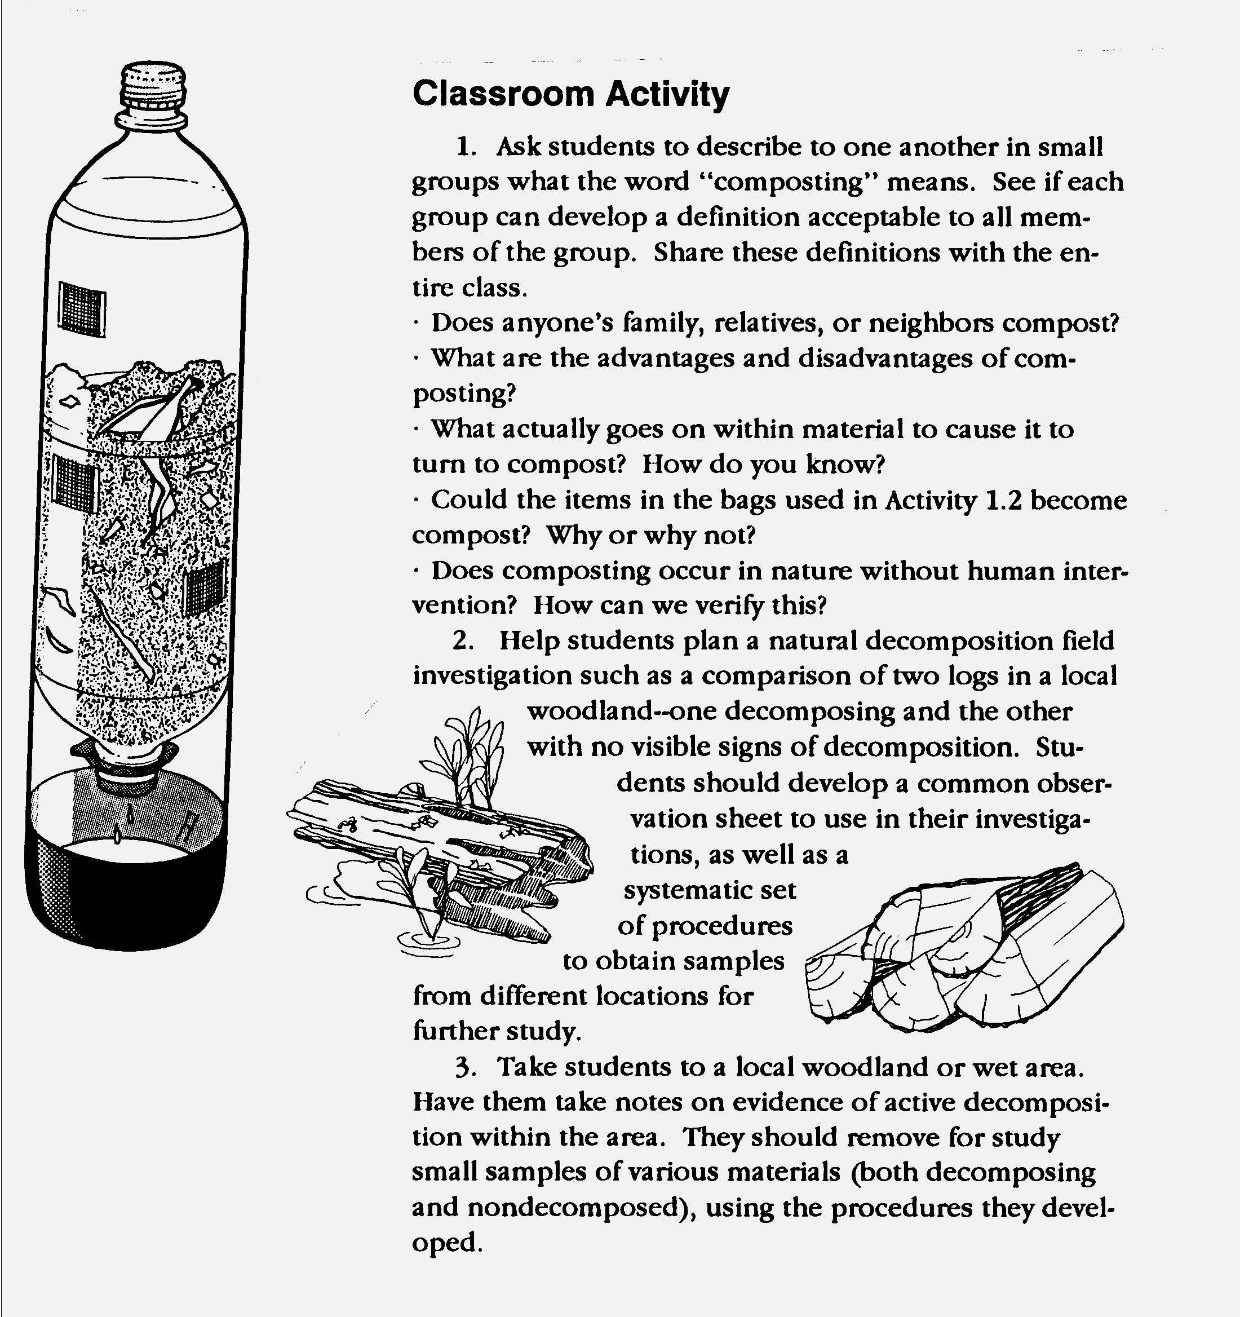


1. The knowledge and skills of mathematics, science, and technology are used together to make informed decisions and solve problems, especially those relating to issues of science/technology/society, consumer decision making, design, and inquiry into phenomena.
Students:
- analyze science/technology/society problems and issues that affect their home, school, orcommunity, and carry out a remedial course of action.
- make informed consumer decisions by applying knowledge about the attributes of particular products and making cost/benefit tradeoffs to arrive at an optimal choice.
- design solutions to problems involving a familiar and real context, investigate related science concepts to inform the solution, and use mathematics to model, quantify, measure, and compute.

• observe phenomena and evaluate them scientifically and mathematically by conducting a fair test of the effect of variables and using mathematical knowledge and technological tools to collect, analyze, and present data and conclusions.
This is evident, for example, when students:
- develop and implement a plan to reduce water or energy consumption in their home.
- choose paper towels based on tests of absorption quality, strength, and cost per sheet.
- design a wheeled vehicle, sketch and develop plans, test different wheel and axle designs to reduce friction, chart results, and produce a working model with correct measurements.
- collect leaves of similar size from different varieties of trees, and compare the ratios of length to width in order to determinet whether the ratios are the same for all species.

2. Solving interdisciplinary problems involves a variety of skills and strategies, including effective work habits; gathering and processing information; generating and analyzing ideas; realizing ideas; making connections among the common themes of mathematics, science, and technology; and presenting results.
Students participate in an extended, culminating mathematics, science, and technology project. The project would require students to:
- work effectively
- gather and process information
- generate and analyze ideas • observe common themes
- realize ideas
- present results

This is evident, for example, when students, addressing the issue of solid waste at the school in an interdisciplinary science/technology/society project:
- use the newspaper index to find out about how solid waste is handled in their community, and interview the custodial staff to collect data about how much solid waste is generated in the school, and they make and use tables and graphs to look for patterns of change. Students work together to reach consensus on the need for recycling and on choosing a material to recycle— in this case, paper.
- investigate the types of paper that could be recycled, measure the amount (weight, volume) of this type of paper in their school during a one-week period, and calculate the cost. Students investigate the processes involved in changing used paper into a useable product and how and why those changes work as they do.
- using simple mixers, wire screens, and lint, leaves, rags, etc., students recycle used paper into useable sheets and evaluate the quality of the product. They present their results using charts, graphs, illustrations, and photographs to the principal and custodial staff.

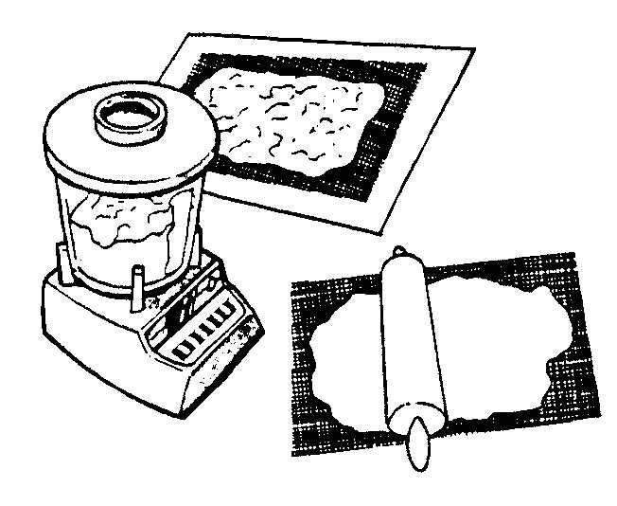
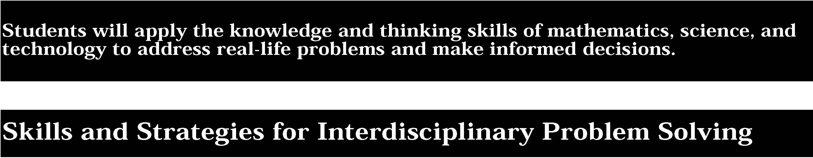

Working Effectively: Contributing to the work of a brainstorming group, laboratory partnership, cooperative learning group, or project team; planning procedures; identify and managing responsibilities of team members; and staying on task, whether working alone or as part of a group.
Gathering and Processing Information: Accessing information from printed media, electronic data bases, and community resources and using the information to develop a definition of the problem and to research possible solutions.
Generating and Analyzing Ideas: Developing ideas for proposed solutions, investigating ideas, collecting data, and showing relationships and patterns in the data.
Common Themes: Observing examples of common unifying themes, applying them to the problem, and using them to better understand the dimensions of the problem.
Realizing Ideas: Constructing components or models, arriving at a solution, and evaluating the result.
Presenting Results: Using a variety of media to present the solution and to communicate the results.
Sample Problem/Activity
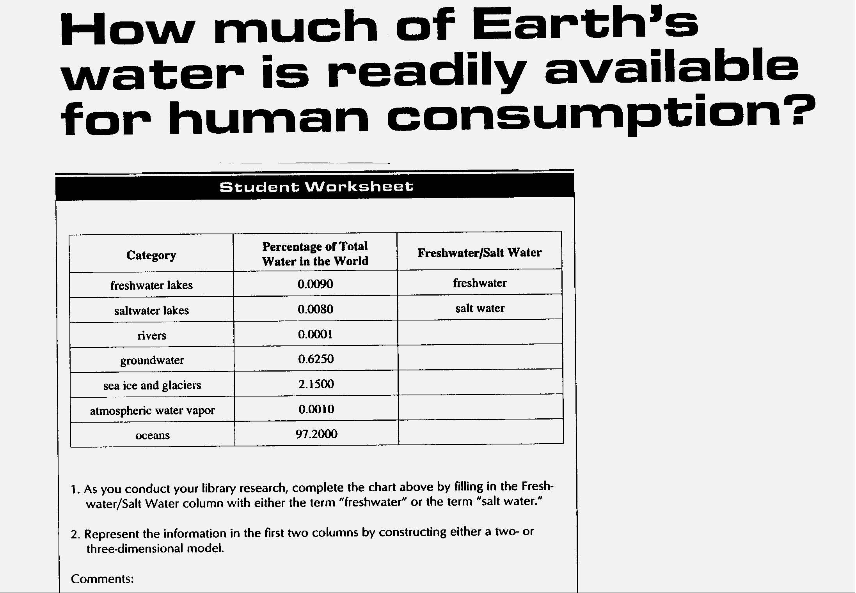


1. The knowledge and skills of mathematics, science, and technology are used together to make informed decisions and solve problems, especially those relating to issues of science/technology/society, consumer decision making, design, and inquiry into phenomena.
Students:
- analyze science/technology/society problems and issues at the local level and plan and carry out a remedial course of action.
- make informed consumer decisions by seeking answers to appropriate questions about products, services, and systems; determining the cost/benefit and risk/benefit tradeoffs; and applying this knowledge to a potential purchase.
- design solutions to real-world problems of general social interest related to home, school, or community using scientific experimentation to inform the solution and applying mathematical concepts and reasoning to assist in developing a solution.
- describe and explain phenomena by designing and conducting investigations involving systematic observations, accurate measurements, and the identification and control of variables; by inquiring into relevant mathematical ideas; and by using mathematical and technological tools and procedures to assist in the investigation.

This is evident, for example, when students:
- improve a habitat for birds at a park or on school property.
- choose a telescope for home use based on diameter of the telescope, magnification, quality of optics and equatorial mount, cost, and ease of use.
- design and construct a working model of an air filtration device that filters out particles above a particular size.
- simulate population change using a simple model (e.g., different colors of paper clips to represent different species of birds). Timed removals of clips from plastic cups represents the action of predators and varying the percentage of the return of clips to cups represent differences in reproductive rates. Students apply mathematical modeling techniques to graph population growth changes and make interpretations related to resource depletion.

2. Solving interdisciplinary problems involves a variety of skills and strategies, including effective work habits; gathering and processing information; generating and analyzing ideas; realizing ideas; making connections among the common themes of mathematics, science, and technology; and presenting results.
Students participate in an extended, culminating mathematics, science, and technology project. The project would require students to:
- work effectively
- gather and process information
- generate and analyze ideas • observe common themes
- realize ideas
- present results

This is evident, for example, when students, addressing the issue of auto safety in an interdisciplinary science/technology/society project:
- use an electronic data base to obtain information on the causes of auto accidents and use e-mail to collect information from government agencies and auto safety organizations. Students gather, analyze, and chart information on the number and causes of auto accidents in their county and look for trends.
- design and construct a model vehicle with a restraint system to hold a raw egg as the passenger and evaluate the effectiveness of the restraint system by rolling the vehicle down a ramp and into a barrier; the vehicle is designed with crush zones to absorb the impact. Students analyze forces and compute acceleration using F=ma calculations. They present their results, including a videotaped segment, to a driver education class.

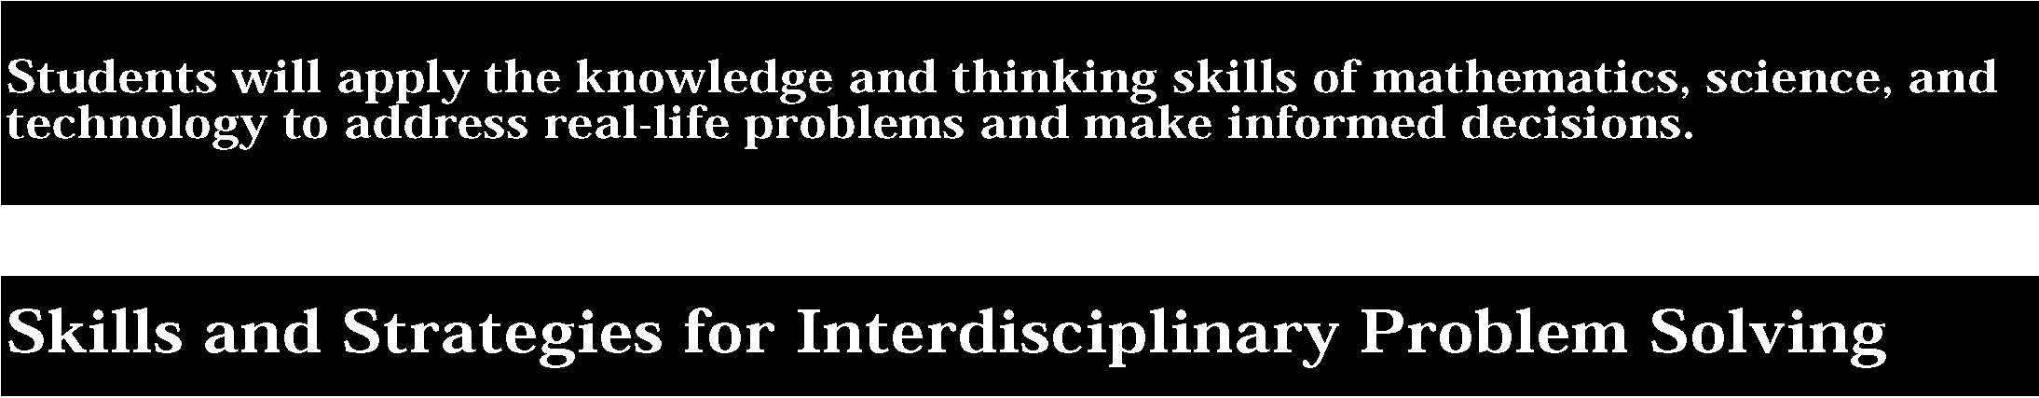

Working Effectively: Contributing to the work of a brainstorming group, laboratory partnership, cooperative learning group, or project team; planning procedures; identify and managing responsibilities of team members; and staying on task, whether working alone or as part of a group.
Gathering and Processing Information: Accessing information from printed media, electronic data bases, and community resources and using the information to develop a definition of the problem and to research possible solutions.
Generating and Analyzing Ideas: Developing ideas for proposed solutions, investigating ideas, collecting data, and showing relationships and patterns in the data.
Common Themes: Observing examples of common unifying themes, applying them to the problem, and using them to better understand the dimensions of the problem.
Realizing Ideas: Constructing components or models, arriving at a solution, and evaluating the result.
Presenting Results: Using a variety of media to present the solution and to communicate the results.
Sample Problem/Activity
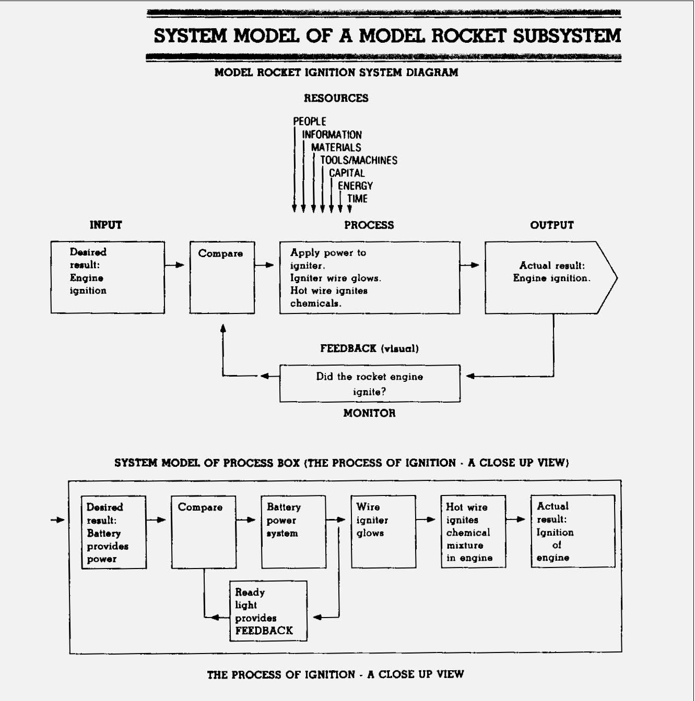
63


1. The knowledge and skills of mathematics, science, and technology are used together to make informed decisions and solve problems, especially those relating to issues of science/technology/society, consumer decision making, design, and inquiry into phenomena.
Students:
- analyze science/technology/society problems and issues on a community, national, or global scale and plan and carry out a remedial course of action.
- analyze and quantify consumer product data, understand environmental and economic impacts, develop a method for judging the value and efficacy of competing products, and discuss cost/benefit and risk/benefit tradeoffs made in arriving at the optimal choice.
- design solutions to real-world problems on a community, national, or global scale using a technological design process that integrates scientific investigation and rigorous mathematical analysis of the problem and of the solution.
- explain and evaluate phenomena mathematically and scientifically by formulating a testable hypothesis, demonstrating the logical connections between the scientific concepts guiding the hypothesis and the design of an experiment, applying and inquiring into the mathematical ideas relating to investigation of phenomena, and using (and if needed, designing) technological tools and procedures to assist in the investigation and in the communication of results.

This is evident, for example, when students:
- analyze the issues related to local energy needs and develop a viable energy generation plan for the community.
- choose whether it is better to purchase a conventional or high definition television after analyzing the differences from quantitative and qualitative points of view, considering such particulars as the number of scanning lines, bandwidth requirements and impact on the frequency spectrum, costs, and existence of international standards.
- design and produce a prototypical device using an electronic voltage divider that can be used to power a portable cassette tape or CD player in a car by reducing the standard automotive accessory power source of approximately 14.8 volts to a lower voltage.
- investigate two similar fossils to determine if they represent a developmental change over time.

2. Solving interdisciplinary problems involves a variety of skills and strategies, including effective work habits; gathering and processing information; generating and analyzing ideas; realizing ideas; making connections among the common themes of mathematics, science, and technology; and presenting results.
Students participate in an extended, culminating mathematics, science, and technology project. The project would require students to:
- work effectively
- gather and process information
- generate and analyze ideas • observe common themes
- realize ideas
- present results

This is evident, for example, when students, addressing the issue of emergency preparedness in an interdisciplinary science/technology/society project:
- are given a scenario—survivors from a disaster are stranded on a mountaintop in the high peaks of the Adirondacks—they are challenged to design a portable shelter that could be heated by the body heat of five survivors to a life sustaining temperature, given an outside temperature of 20oF. Since the shelter would be dropped to survivors by an aircraft, it must be capable of withstanding the impact. Students determine the kinds of data to be collected, for example, snowfall during certain months, average wind velocity, R value of insulating materials, etc. To conduct their research, students gather and analyze information from research data bases, national libraries, and electronic communication networks, including the Internet.
- design and construct scale models or full-sized shelters based on engineering design criteria including wind load, snow load, and insulating properties of materials. Heat flow calculations are done to determine how body heat could be used to heat the shelter. Students evaluate the trade-offs that they make to arrive at the best solution; for example, in order to keep the temperature at 20 degrees F., the shelter may have to be small, and survivors would be very uncomfortable. Another component of the project is assembly instructions—designed so that speakers of any language could quickly install the structure on site.
- prepare a multimedia presentation about their project and present it to the school’s ski club.

Working Effectively: Contributing to the work of a brainstorming group, laboratory partnership, cooperative learning group, or project team; planning procedures; identify and managing responsibilities of team members; and staying on task, whether working alone or as part of a group.
Gathering and Processing Information: Accessing information from printed media, electronic data bases, and community resources and using the information to develop a definition of the problem and to research possible solutions.
Generating and Analyzing Ideas: Developing ideas for proposed solutions, investigating ideas, collecting data, and showing relationships and patterns in the data.
Common Themes: Observing examples of common unifying themes, applying them to the problem, and using them to better understand the dimensions of the problem.
Realizing Ideas: Constructing components or models, arriving at a solution, and evaluating the result.
Presenting Results: Using a variety of media to present the solution and to communicate the results.
Sample Problem/Activity
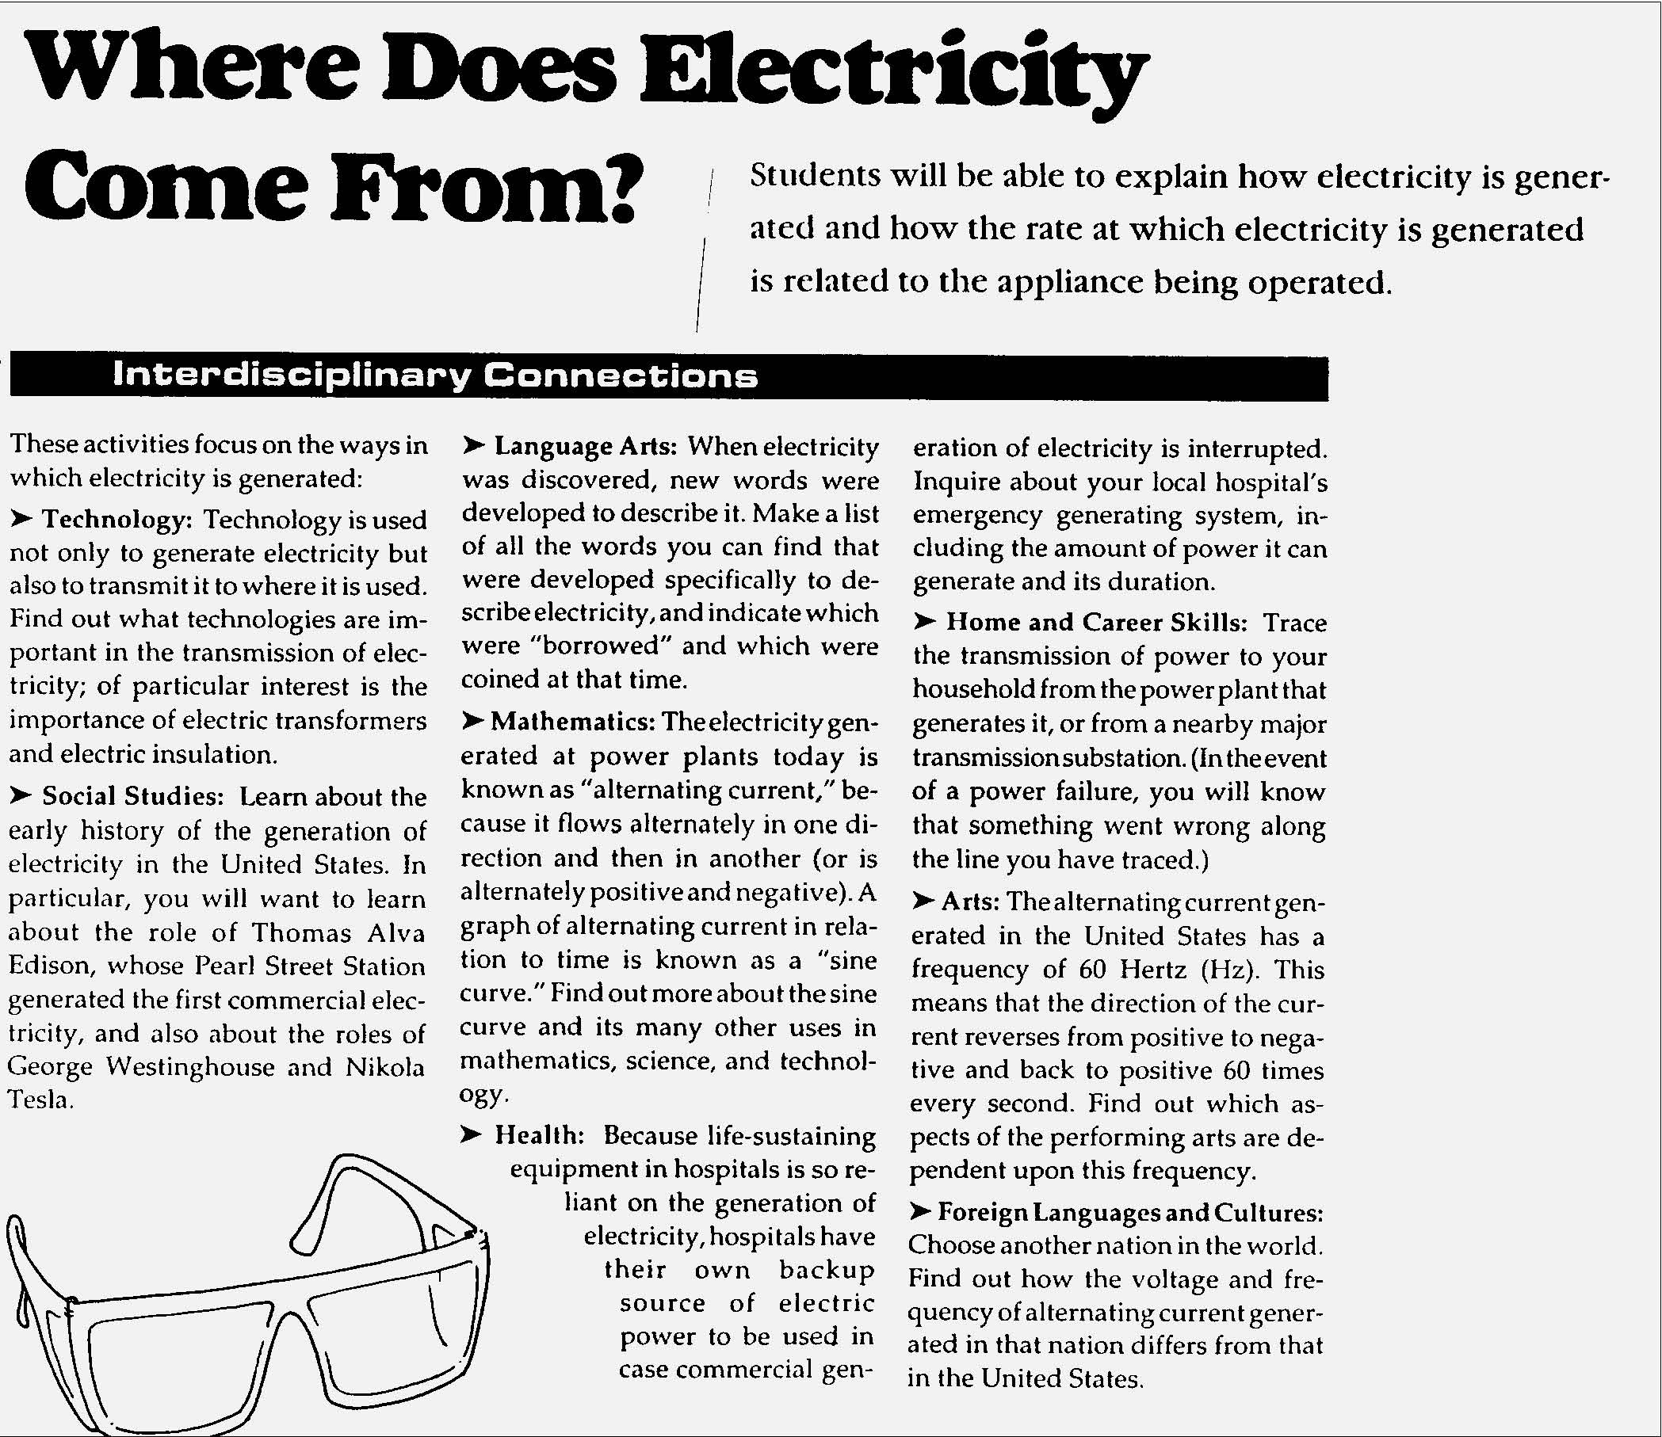
65

The samples of student work included in this section are intended to begin the process of articulating the performance standards at each level of achievement. This collection is not yet adequate for that purpose in either numbers or scope of examples. As New York State continues to collect work samples from the schools for inclusion in the document, we expect a much clearer understanding of the performance standards to be evident.
Neither are these samples presented as models of excellence. They vary in degree of achievement. Some are “acceptable;” others “more proficient.” All are meant to provide examples of the kind of work students might produce to demonstrate progress toward the standard.

