Learning Standards for Mathematics, Science, and Technology
Revised Edition March 1996
THE UNIVERSITY OF THE STATE OF NEW YORK Regents of The University
Carl T. Hayden, Chancellor, A.B., J.D. . . . . . . . . . . . . . . . . . . . . . . . . . . . Elmira Louise P. Matteoni, Vice Chancellor, B.A., M.A., Ph.D.. . . . . . . . . . . . . . Bayside Jorge L. Batista, B.A., J.D. . . . . . . . . . .. . . . . . . . . . . . . . . . . . . . . . . . . . . Bronx
J. Edward Meyer, B.A., LL.B.. . . . . . . . . . . . . . . . . . . . . . . . . . . . . . . . . . . Chappaqua
R. Carlos Carballada, Chancellor Emeritus, B.S. . . . . . . . . . . . . . . . . . . Rochester Norma Gluck, B.A., M.S.W. . . . . . . . . . . . . . . . . . . . . . . . . . . . . . . . . . . . . . New York Adelaide L. Sanford, B.A., M.A., P.D.. . . . . . . . . . . . . . . . . . . . . . . . . . . . . Hollis Walter Cooper, B.A., Ph.D. . . . . . . . . . . . . . . . . . . . . . . . . . . . . . . . . . . . . . Rochester Diane O’Neill McGivern, B.S.N., M.A., Ph.D. . . . . . . . . . . . . . . . . . . . . . . Staten Island Saul B. Cohen, B.A., M.A., Ph. D. . . . . . . . . . . . . . . . . . . . . . . . . . . . . . . . . New Rochelle James C. Dawson, A.A., B.A., M.S., Ph.D. . . . . . . . . . . . . . . . . . . . . . . . . . Peru Robert M. Bennett, B.A., M.S.. . . . . . . . . . . . . . . . . . . . . . . . . . . . . . . . . . . Tonawanda Robert M. Johnson, B.S., J.D.. . . . . . . . . . . . . . . . . . . . . . . . . . . . . . . . . . . Lloyd Harbor Peter M. Pryor, B.A., LL.B., J.D., LL.D.. . . . . . . . . . . . . . . . . . . . . . . . . . . Albany Anthony S. Bottar, B.A., J.D . . . . . . . . . . . . . . . . . . . . . . . . . . . . . . . . . . . .Syracuse Merryl H. Tisch, B.A., M.A.. . . . . . . . . . . . . . . . . . . . . . . . . . . . . . . . . . . . . .New York
President of The University and Commissioner of Education
RICHARD P. MILLS
Executive Deputy Commissioner of Education
THOMAS E. SHELDON
Deputy Commissioner for Elementary, Middle, Secondary, and Continuing Education
JAMES A. KADAMUS
Assistant Commissioner for Curriculum, Instruction, Assessment, and Innovation
EDWARD T. LALOR
Coordinator of Curriculum and Instruction
ROSEANNE DEFABIO
The State Education Department does not discriminate on the basis of age, color, religion, creed, disability, marital status, veteran status, national origin, race, gender or sexual orientation in its educational programs, services and activities. Portions of this publication can be made available in a variety of formats, including braille, large print or audio tape, upon request. Inquiries concerning this policy of nondiscrimination should be directed to the Department’s Office for Diversity, Ethics, and Access, Room 152, Education Building, Albany, NY 12234.
CONTENTS Acknowledgments vi Introduction v LEARNING STANDARDS FOR MATHEMATICS, SCIENCE, AND TECHNOLOGY AT THREE LEVELS 1 SAMPLES OF STUDENT WORK RELATED TO THE STANDARDS 67

In addition to the people recognized in the Preliminary Draft Framework for Mathematics, Science, and
Technology, we are grateful to the many writers whose work is reflected in this edition. Listed below are the names of those writers.
Patricia L. Barker, Newburgh Free Academy Jeffrey J. Hering, Cortland JSHS Betty McKnight, Consultant, Trumansburg, New York Joan Dodway, Deposit JSHS George E. DeBoer, Colgate University Bruce Tulloch, Bethlehem CSD Marian Berke Sloane, New York City Schools Dave Ferguson, SUNY Stony Brook John Weil, Fishers Island School Dorothy Rosenthal, Consultant, Indian Lake, New York Glen Botto, Arlington High School William Peruzzi, NYSTEP Nancy C. Bryan, North JHS, Newburgh Theodore Bredderman, SUNY Albany Myron Rock, Sewenhaka High School Tom Liao, SUNY Stony Brook Irene Jovell, Niskayuna High School James Tien, Rensselaer Polytechnic Institute Merri J. Earl, Chenango Forks Central Schools Monique Havasy, Graduate Student, SUNY Albany
We are also grateful to the many teachers from throughout New York State who contributed performance tasks and samples of student work for possible inclusion in this revised edition. Listed below are the names of those educators whose materials appear in this document.
Helen Sultanik, Yeshiva of Flatbush Sandra LaTourelle, Ausable Valley CSD Glen Botto, Arlington High School Neal Swernofsky, Island Park UFSD Todd Kelly, Avon CSD David Propp, New Rochelle City SD Tom Venezio, North Colonie CSD Shelley Shanok, Fort Hamilton High School, NYC James Luddington, Gananda Central School Rose Ambrosino, Smithtown Middle School Mary Ann Harasymowycz, Transit Middle School,
Williamsville Richard Beeler, Niskayuna High School
New York State Education Department Staff: | Project Editor:
Major Capers | Susan Siegel
Jan Christman
Roseanne DeFabio
Michael Hacker
Virginia Hammer
Barry Jameson
Ed Lalor
Benjamin Lindeman
Toni Meyer
Philip Pillsworth
Lynn Richbart
Elise Russo


This revised edition of the Learning Standards for Mathematics, Science, and Technology incorporates changes to the content standards and performance indicators based on extensive review by the public. As educational practice improves, these standards will continually be revised.
New in this edition are samples of student work, along with teachers’ comments on the work. The examples are intended to provide some ideas of tasks that support attainment of the performance standards. They are not models of excellence. Rather, they vary in degree of achievement. Some are at the “acceptable” level; others are at a “more proficient” level. It is important to remember that these are just suggestions of ways that students can demonstrate progress toward achieving the standards.
The State Education Department will continue to collect and publish samples of student work. As teachers become more familiar with the standards and students become more proficient in meeting them, the level of the performance standards and content standards will continue to rise.
Taken together, the content standards and the performance standards define the learning standards for students in mathematics, science, and technology.
The Board of Regents recognizes the diversity of students in New York State, including students with disabilities, students with limited English proficiency, gifted students, and educationally disadvantaged students, and has made a strong commitment to integrating the education of all students into the total school program. The standards in the framework apply to all students, regardless of their experiential background, capabilities, developmental and learning differences, interests, or ambitions. A classroom typically includes students with a wide range of abilities who may pursue multiple pathways to learn effectively, participate meaningfully, and work towards attaining the curricular standards. Students with diverse learning needs may need accommodations or adaptations of instructional strategies and materials to enhance their learning and/or adjust for their learning capabilities.
vi
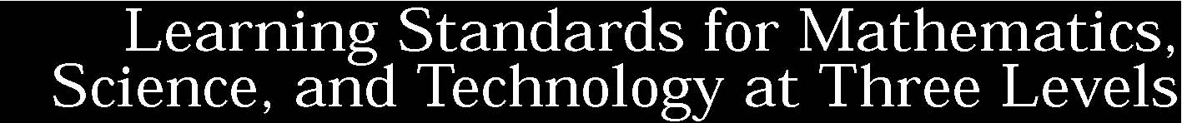
Standard 1: Students will use mathematical analysis, scientific inquiry, and engineering design, as appropriate, to pose questions, seek answers, and develop solutions.
Standard 2: Students will access, generate, process, and transfer information using appropriate technologies.
Standard 3: Students will understand mathematics and become mathematically confident by communicating and reasoning mathematically, by applying mathematics in real-world settings, and by solving problems through the integrated study of number systems, geometry, algebra, data analysis, probability, and trigonometry.
Standard 4: Students will understand and apply scientific concepts, principles, and theories pertaining to the physical setting and living environment and recognize the historical development of ideas in science.
Standard 5: Students will apply technological knowledge and skills to design, construct, use, and evaluate products and systems to satisfy human and environmental needs.
Standard 6: Students will understand the relationships and common themes that connect mathematics, science, and technology and apply the themes to these and other areas of learning.
Standard 7: Students will apply the knowledge and thinking skills of mathematics, science, and technology to address real-life problems and make informed decisions.
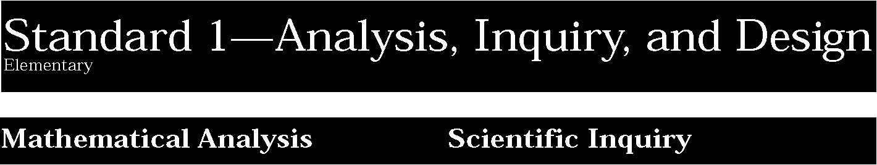

1. Abstraction and symbolic representation are used to communicate mathematically.
Students:
• use special mathematical notation and symbolism to communicate in mathematics and to compare and describe quantities, express relationships, and relate mathematics to their immediate environments.
This is evident, for example, when students:
▲ describe their ages as an inequality such as 7 < ❒ < 10.
2. Deductive and inductive reasoning are used to reach mathematical conclusions.
Students:
• use simple logical reasoning to develop conclusions, recognizing that patterns and relationships present in the environment assist them in reaching these conclusions.
3. Critical thinking skills are used in the solution of mathematical problems.
Students:
• explore and solve problems generated from school, home, and community situations, using concrete objects or manipulative materials when possible.
1. The central purpose of scientific inquiry is to develop explanations of natural phenomena in a continuing, creative process.
Students:
- ask “why” questions in attempts to seek greater understanding concerning objects and events they have observed and heard about.
- question the explanations they hear from others and read about, seeking clarification and comparing them with their own observations and understandings.
- develop relationships among observations to construct descriptions of objects and events and to form their own tentative explanations of what they have observed.

This is evident, for example, when students:
▲ observe a variety of objects that either sink or float when placed in a container of water.* Working in groups, they propose an explanation of why objects sink or float. After sharing and discussing their proposed explanation, they refine it and submit it for assessment. The explanation is rated on clarity and plausibility.
2. Beyond the use of reasoning and consensus, scientific inquiry involves the testing of proposed explanations involving the use of conventional techniques and procedures and usually requiring considerable ingenuity.
Students:
- develop written plans for exploring phenomena or for evaluating explanations guided by questions or proposed explanations they have helped formulate.
- share their research plans with others and revise them based on their suggestions.
- carry out their plans for exploring phenomena through direct observation and through the use of simple instruments that permit measurements of quantities (e.g., length, mass, volume, temperature, and time).

This is evident, for example, when students:
▲ are asked to develop a way of testing their explanation of why objects sink or float when placed in a container of water.* They tell what procedures and materials they will use and indicate what results will support their explanation. Their plan is critiqued by others, they revise it, and submit it for assessment. The plan is rated on clarity, soundness in addressing the issue, and feasibility. After the teacher suggests modifications, the plan is carried out.
Key ideas are identified by numbers (1). Performance indicators are identified by bullets (•). Sample tasks are identified by triangles (▲ ).
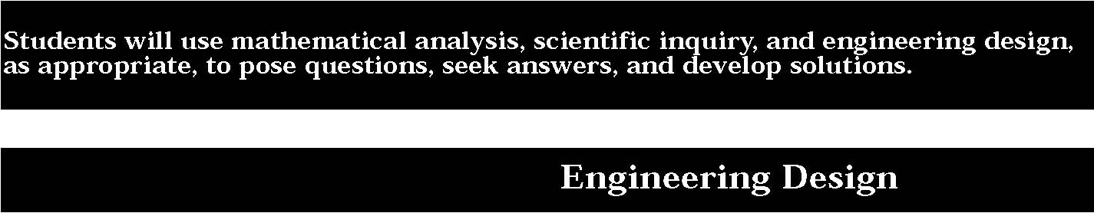

3. The observations made while testing proposed explanations, when analyzed using conventional and invented methods, provide new insights into phenomena.
Students: • organize observations and measurements of objects and events through classification and the preparation of simple charts and tables.
- interpret organized observations and measurements, recognizing simple patterns, sequences, and relationships.
- share their findings with others and actively seek their interpretations and ideas.
- adjust their explanations and understandings of objects and events based on their findings and new ideas.

This is evident, for example, when students:
▲ prepare tables or other representations of their observations and look for evidence which supports or refutes their explanation of why objects sink or float when placed in a container of water.* After sharing and discussing their results with other groups, they prepare a brief research report that includes methods, findings, and conclusions. The report is rated on its clarity, care in carrying out the plan, and presentation of evidence supporting the conclusions.
1. Engineering design is an iterative process involving modeling and optimization finding the best solution within given constraints which is used to develop technological solutions to problems within given constraints.
Students engage in the following steps in a design process:
- describe objects, imaginary or real, that might be modeled or made differently and suggest ways in which the objects can be changed, fixed, or improved.
- investigate prior solutions and ideas from books, magazines, family, friends, neighbors, and community members.
- generate ideas for possible solutions, individually and through group activity; apply age-appropriate mathematics and science skills; evaluate the ideas and determine the best solution; and explain reasons for the choices.
- plan and build, under supervision, a model of the solution using familiar materials, processes, and hand tools.
- discuss how best to test the solution; perform the test under teacher supervision; record and portray results through numerical and graphic means; discuss orally why things worked or didn’t work; and summarize results in writing, suggesting ways to make the solution better.

This is evident, for example, when students:
- read a story called Humpty’s Big Day wherein the readers visit the place where Humpty Dumpty had his accident, and are asked to design and model a way to get to the top of the wall and down again safely.
- generate, draw, and model ideas for a space station that includes a pleasant living and working environment.
- design and model footwear that they could use to walk on a cold, sandy surface.

* A variety of content-specific items can be substituted for the italicized text
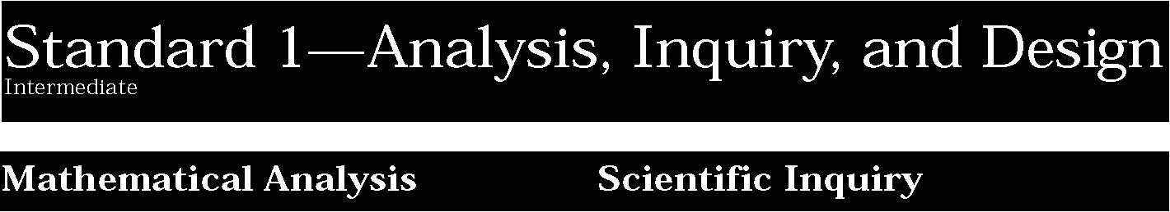

1. Abstraction and symbolic representation are used to communicate mathematically.
Students:
• extend mathematical notation and symbolism to include variables and algebraic expressions in order to describe and compare quantities and express mathematical relationships.
2. Deductive and inductive reasoning are used to reach mathematical conclusions.
Students:
• use inductive reasoning to construct, evaluate, and validate conjectures and arguments, recognizing that patterns and relationships can assist in explaining and extending mathematical phenomena.
This is evident, for example, when students:
▲ predict the next triangular number by examining the pattern 1, 3, 6, 10, ❒ .
3. Critical thinking skills are used in the solution of mathematical problems.
Students:
• apply mathematical knowledge to solve real-world problems and problems that arise from the investigation of mathematical ideas, using representations such as pictures, charts, and tables.
Key ideas are identified by numbers (1). Performance indicators are identified by bullets (•). Sample tasks are identified by triangles (▲ ).
1. The central purpose of scientific inquiry is to develop explanations of natural phenomena in a continuing, creative process.
Students:
- formulate questions independently with the aid of references appropriate for guiding the search for explanations of everyday observations.
- construct explanations independently for natural phenomena, especially by proposing preliminary visual models of phenomena.
- represent, present, and defend their proposed explanations of everyday observations so that they can be understood and assessed by others.
- seek to clarify, to assess critically, and to reconcile with their own thinking the ideas presented by others, including peers, teachers, authors, and scientists.

This is evident, for example, when students:
▲ After being shown the disparity between the amount of solid waste which is recycled and which could be recycled,* students working in small groups are asked to explain why this disparity exists. They develop a set of possible explanations and to select one for intensive study. After their explanation is critiqued by other groups, it is refined and submitted for assessment. The explanation is rated on clarity, plausibility, and appropriateness for intensive study using research methods.
2. Beyond the use of reasoning and consensus, scientific inquiry involves the testing of proposed explanations involving the use of conventional techniques and procedures and usually requiring considerable ingenuity.
Students:
- use conventional techniques and those of their own design to make further observations and refine their explanations, guided by a need for more information.
- develop, present, and defend formal research proposals for testing their own explanations of common phenomena, including ways of obtaining needed observations and ways of conducting simple controlled experiments.
- carry out their research proposals, recording observations and measurements (e.g., lab notes, audio tape, computer disk, video tape) to help assess the explanation.

This is evident, for example, when students:
▲ develop a research plan for studying the accuracy of their explanation of the disparity between the amount of solid waste that is recycled and that could be recycled.* After their tentative plan is critiqued, they refine it and submit it for assessment. The research proposal is rated on clarity, feasibility and soundness as a method of studying the explanations’ accuracy. They carry out the plan, with teacher suggested modifications. This work is rated by the teacher while it is in progress.

3. The observations made while testing proposed explanations, when analyzed using conventional and invented methods, provide new insights into phenomena.
Students:
- design charts, tables, graphs and other representations of observations in conventional and creative ways to help them address their research question or hypothesis.
- interpret the organized data to answer the research question or hypothesis and to gain insight into the problem.
- modify their personal understanding of phenomena based on evaluation of their hypothesis.

This is evident, for example, when students:
▲ carry out their plan making appropriate observations and measurements. They analyze the data, reach conclusions regarding their explanation of the disparity between the amount of solid waste which is recycled and which could be recycled.*, and prepare a tentative report which is critiqued by other groups, refined, and submitted for assessment. The report is rated on clarity, quality of presentation of data and analyses, and soundness of conclusions.
1. Engineering design is an iterative process involving modeling and optimization finding the best solution within given constraints which is used to develop technological solutions to problems within given constraints.
Students engage in the following steps in a design process:
- identify needs and opportunities for technical solutions from an investigation of situations of general or social interest.
- locate and utilize a range of printed, electronic, and human information resources to obtain ideas.
- consider constraints and generate several ideas for alternative solutions, using group and individual ideation techniques (group discussion, brainstorming, forced connections, role play); defer judgment until a number of ideas have been generated; evaluate (critique) ideas; and explain why the chosen solution is optimal.
- develop plans, including drawings with measurements and details of construction, and construct a model of the solution, exhibiting a degree of craftsmanship.
- in a group setting, test their solution against design specifications, present and evaluate results, describe how the solution might have been modified for different or better results, and discuss tradeoffs that might have to be made.

This is evident, for example, when students:
- reflect on the need for alternative growing systems in desert environments and design and model a hydroponic greenhouse for growing vegetables without soil.
- brainstorm and evaluate alternative ideas for an adaptive device that will make life easier for a person with a disability, such as a device to pick up objects from the floor.
- design a model vehicle (with a safety belt restraint system and crush zones to absorb impact) to carry a raw egg as a passenger down a ramp and into a barrier without damage to the egg.
- assess the performance of a solution against various design criteria, enter the scores on a spreadsheet, and see how varying the solution might have affected total score.

* A variety of content-specific items can be substituted for the italicized text


1. Abstraction and symbolic representation are used to communicate mathematically.
Students:
• use algebraic and geometric representations to describe and compare data.
2. Deductive and inductive reasoning are used to reach mathematical conclusions.
Students:
• use deductive reasoning to construct and evaluate conjectures and arguments, recognizing that patterns and relationships in mathematics assist them in arriving at these conjectures and arguments.
3. Critical thinking skills are used in the solution of mathematical problems.
Students:
• apply algebraic and geometric concepts and skills to the solution of problems.
Key ideas are identified by numbers (1). Performance indicators are identified by bullets (•). Sample tasks are identified by triangles (▲ ).
1. The central purpose of scientific inquiry is to develop explanations of natural phenomena in a continuing, creative process.
Students:
- elaborate on basic scientific and personal explanations of natural phenomena, and develop extended visual models and mathematical formulations to represent their thinking.
- hone ideas through reasoning, library research, and discussion with others, including experts.
- work toward reconciling competing explanations; clarifying points of agreement and disagreement.
- coordinate explanations at different levels of scale, points of focus, and degrees of complexity and specificity and recognize the need for such alternative representations of the natural world.

This is evident, for example, when students:
▲ in small groups, are asked to explain why a cactus plant requires much less water to survive than many other plants.* They are asked to develop, through research, a set of explanations for the differences and to select at least one for study. After the proposed explanation is critiqued by others, they refine it by formulating a hypothesis which is rated on clarity, plausibility, and researchability.
2. Beyond the use of reasoning and consensus, scientific inquiry involves the testing of proposed explanations involving the use of conventional techniques and procedures and usually requiring considerable ingenuity.
Students:
- devise ways of making observations to test proposed explanations.
- refine their research ideas through library investigations, including electronic information retrieval and reviews of the literature, and through peer feedback obtained from review and discussion.
- develop and present proposals including formal hypotheses to test their explanations, i.e., they predict what should be observed under specified conditions if the explanation is true.
- carry out their research plan for testing explanations, including selecting and developing techniques, acquiring and building apparatus, and recording observations as necessary.

This is evident, for example, when students:
▲ develop, through research, a proposal to test their hypothesis of why a cactus plant requires much less water to survive than many other plants.* After their proposal is critiqued, it is refined and submitted for assessment by a panel of students. The proposal is rated on clarity, appropriateness, and feasibility. Upon approval, students complete the research. Progress is rated holistically by the teacher.

3. The observations made while testing proposed explanations, when analyzed using conventional and invented methods, provide new insights into phenomena.
Students:
- use various means of representing and organizing observations (e.g., diagrams, tables, charts, graphs, equations, matrices) and insightfully interpret the organized data.
- apply statistical analysis techniques when appropriate to test if chance alone explains the result.
- assess correspondence between the predicted result contained in the hypothesis and the actual result and reach a conclusion as to whether or not the explanation on which the prediction was based is supported.
- based on the results of the test and through public discussion, they revise the explanation and contemplate additional research.
- develop a written report for public scrutiny that describes their proposed explanation, including a literature review, the research they carried out, its result, and suggestions for further research.

This is evident, for example, when students:
▲ carry out a research plan, including keeping a lab book, to test their hypothesis of why a cactus plant requires much less water to survive than many other plants.* After completion, a paper is presented describing the research. Based on the class critique, the paper is rewritten and submitted with the lab book for separate assessment or as part of a portfolio of their science work. It is rated for clarity, thoroughness, soundness of conclusions, and quality of integration with existing literature.
1. Engineering design is an iterative process involving modeling and optimization finding the best solution within given constraints which is used to develop technological solutions to problems within given constraints.
Students engage in the following steps in a design process:
- initiate and carry out a thorough investigation of an unfamiliar situation and identify needs and opportunities for technological invention or innovation.
- identify, locate, and use a wide range of information resources, and document through notes and sketches how findings relate to the problem.
- generate creative solutions, break ideas into significant functional elements, and explore possible refinements; predict possible outcomes using mathematical and functional modeling techniques; choose the optimal solution to the problem, clearly documenting ideas against design criteria and constraints; and explain how human understands, economics, ergonomics, and environmental considerations have influenced the solution.
- develop work schedules and working plans which include optimal use and cost of materials, processes, time, and expertise; construct a model of the solution, incorporating developmental modifications while working to a high degree of quality (craftsmanship).
- devise a test of the solution according to the design criteria and perform the test; record, portray, and logically evaluate performance test results through quantitative, graphic, and verbal means. Use a variety of creative verbal and graphic techniques effectively and persuasively to present conclusions, predict impacts and new problems, and suggest and pursue modifications.

This is evident, for example, when students:
- search the Internet for world wide web sites dealing with renewable energy and sustainable living and research the development and design of an energy efficient home.
- develop plans, diagrams, and working drawings for the construction of a computer-controlled marble sorting system that simulates how parts on an assembly line are sorted by color.
- design and model a portable emergency shelter that could be heated by a person’s body to a life-sustaining temperature when the outside temperature is 20o F.

* A variety of content-specific items can be substituted for the italicized text
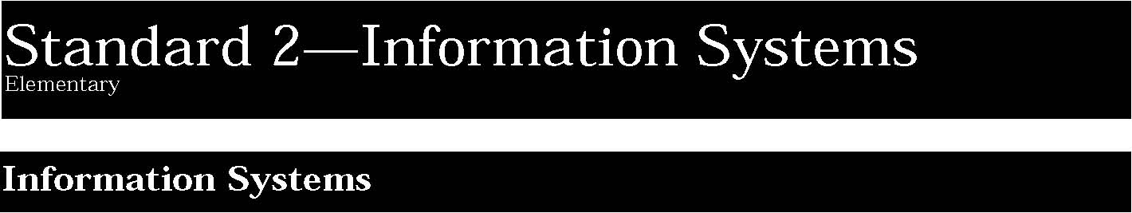

1. Information technology is used to retrieve, process, and communicate information and as a tool to enhance learning.
Students:
- use a variety of equipment and software packages to enter, process, display, and communicate information in different forms using text, tables, pictures, and sound.
- telecommunicate a message to a distant location with teacher help.
- access needed information from printed media, electronic data bases, and community resources.

This is evident, for example, when students:
- use the newspaper or magazine index in a library to find information on a particular topic.
- invite local experts to the school to share their expertise.

2. Knowledge of the impacts and limitations of information systems is essential to its effective and ethical use.
Students:
- describe the uses of information systems in homes, schools, and businesses.
- understand that computers are used to store personal information.
- demonstrate ability to evaluate information.

This is evident, for example, when students:
▲ look for differences among species of bugs collected on the school grounds, and classify them according to preferred habitat.
Key ideas are identified by numbers (1). Performance indicators are identified by bullets (•). Sample tasks are identified by triangles (▲ ).
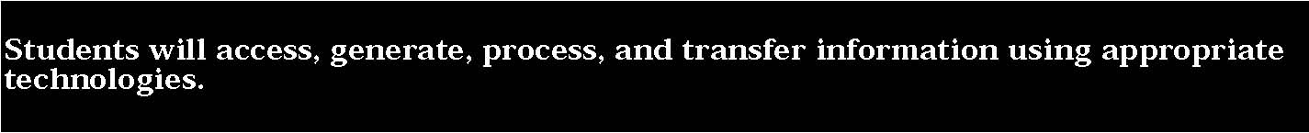

3. Information technology can have positive and negative impacts on society, depending upon how it is used.
Students:
- describe the uses of information systems in homes and schools.
- demonstrate ability to evaluate information critically.



1. Information technology is used to retrieve, process, and communicate information and as a tool to enhance learning.
Students:
- use a range of equipment and software to integrate several forms of information in order to create good quality audio, video, graphic, and text-based presentations.
- use spreadsheets and data-base software to collect, process, display, and analyze information. Students access needed information from electronic data bases and on-line telecommunication services.
- systematically obtain accurate and relevant information pertaining to a particular topic from a range of sources, including local and national media, libraries, museums, governmental agencies, industries, and individuals.
- collect data from probes to measure events and phenomena.
- use simple modeling programs to make predictions.

This is evident, for example, when students:
- compose letters on a word processor and send them to representatives of industry, governmental agencies, museums, or laboratories seeking information pertaining to a student project.
- acquire data from weather stations.
- use a software package, such as Science Tool Kit, to monitor the acceleration of a model car traveling down a given distance on a ramp.
- use computer software to model how plants grow plants under different conditions.

2. Knowledge of the impacts and limitations of information systems is essential to its effective and ethical use.
Students:
- understand the need to question the accuracy of information displayed on a computer because the results produced by a computer may be affected by incorrect data entry.
- identify advantages and limitations of data-handling programs and graphics programs.
- understand why electronically stored personal information has greater potential for misuse than records kept in conventional form.

Key ideas are identified by numbers (1). Performance indicators are identified by bullets (•). Sample tasks are identified by triangles (▲ ).

3. Information technology can have positive and negative impacts on society, depending upon how it is used.
Students:
- use graphical, statistical, and presentation software to presents project to fellow classmates.
- describe applications of information technology in mathematics, science, and other technologies that address needs and solve problems in the community.
- explain the impact of the use and abuse of electronically generated information on individuals and families.



1. Information technology is used to retrieve, process, and communicate information and as a tool to enhance learning.
Students:
- understand and use the more advanced features of word processing, spreadsheets, and data-base software.
- prepare multimedia presentations demonstrating a clear sense of audience and purpose.
- access, select, collate, and analyze information obtained from a wide range of sources such as research data bases, foundations, organizations, national libraries, and electronic communication networks, including the Internet.
- students receive news reports from abroad and work in groups to produce newspapers reflecting the perspectives of different countries.
- utilize electronic networks to share information.
- model solutions to a range of problems in mathematics, science, and technology using computer simulation software.

This is evident, for example, when students:
- collect and amend quantitative and qualitative information for a particular purpose and enter it into a data-handling package for processing and analysis.
- visit businesses, laboratories, environmental areas, and universities to obtain on-site information
- recieve news reports from abroad, and work in groups to produce newspapers reflecting the perspectives of different countries.
- join a list serve and send electronic mail to other persons sharing mutual concerns and interests.
- use computer software to simulate and graph the motion of an object.
- study a system in a dangerous setting (e.g., a nuclear power plant).

2. Knowledge of the impacts and limitations of information systems is essential to its effective and ethical use.
Students:
- explain the impact of the use and abuse of electronically generated information on individuals and families.
- evaluate software packages relative to their suitability to a particular application and their ease of use.
- discuss the ethical and social issues raised by the use and abuse of information systems.

This is evident, for example, when students:
▲ discuss how unauthorized people might gain access to information about their interests and way of life.
Key ideas are identified by numbers (1). Performance indicators are identified by bullets (•). Sample tasks are identified by triangles (▲ ).

3. Information technology can have positive and negative impacts on society, depending upon how it is used.
Students:
- work with a virtual community to conduct a project or solve a problem using the network.
- discuss how applications of information technology can address some major global problems and issues.
- discuss the environmental, ethical, moral, and social issues raised by the use and abuse of information technology.

