Learning Standards for Languages Other Than English
Revised Edition April 1996
THE UNIVERSITY OF THE STATE OF NEW YORK Regents of The University
Carl T. Hayden, Chancellor, A.B., J.D. . . . . . . . . . . . . . . . . . . . . . . . . . . . Elmira Louise P. Matteoni, Vice Chancellor, B.A., M.A., Ph.D.. . . . . . . . . . . . . . Bayside Jorge L. Batista, B.A., J.D. . . . . . . . . . .. . . . . . . . . . . . . . . . . . . . . . . . . . . Bronx
J. Edward Meyer, B.A., LL.B.. . . . . . . . . . . . . . . . . . . . . . . . . . . . . . . . . . . Chappaqua
R. Carlos Carballada, Chancellor Emeritus, B.S. . . . . . . . . . . . . . . . . . . Rochester Norma Gluck, B.A., M.S.W. . . . . . . . . . . . . . . . . . . . . . . . . . . . . . . . . . . . . . New York Adelaide L. Sanford, B.A., M.A., P.D.. . . . . . . . . . . . . . . . . . . . . . . . . . . . . Hollis Walter Cooper, B.A., Ph.D. . . . . . . . . . . . . . . . . . . . . . . . . . . . . . . . . . . . . . Rochester Diane O’Neill McGivern, B.S.N., M.A., Ph.D. . . . . . . . . . . . . . . . . . . . . . . Staten Island Saul B. Cohen, B.A., M.A., Ph. D. . . . . . . . . . . . . . . . . . . . . . . . . . . . . . . . . New Rochelle James C. Dawson, A.A., B.A., M.S., Ph.D. . . . . . . . . . . . . . . . . . . . . . . . . . Peru Robert M. Bennett, B.A., M.S.. . . . . . . . . . . . . . . . . . . . . . . . . . . . . . . . . . . Tonawanda Robert M. Johnson, B.S., J.D.. . . . . . . . . . . . . . . . . . . . . . . . . . . . . . . . . . . Lloyd Harbor Peter M. Pryor, B.A., LL.B., J.D., LL.D.. . . . . . . . . . . . . . . . . . . . . . . . . . . Albany Anthony S. Bottar, B.A., J.D . . . . . . . . . . . . . . . . . . . . . . . . . . . . . . . . . . . .Syracuse Merryl H. Tisch, B.A., M.A.. . . . . . . . . . . . . . . . . . . . . . . . . . . . . . . . . . . . . .New York
President of The University and Commissioner of Education
RICHARD P. MILLS
Executive Deputy Commissioner of Education
THOMAS E. SHELDON
Deputy Commissioner for Elementary, Middle, Secondary, and Continuing Education
JAMES A. KADAMUS
Assistant Commissioner for Curriculum, Instruction, Assessment, and Innovation
EDWARD T. LALOR
Coordinator of Curriculum and Instruction
ROSEANNE DEFABIO
The State Education Department does not discriminate on the basis of age, color, religion, creed, disability, marital status, veteran status, national origin, race, gender or sexual orientation in its educational programs, services and activities. Portions of this publication can be made available in a variety of formats, including braille, large print or audio tape, upon request. Inquiries concerning this policy of nondiscrimination should be directed to the Department’s Office for Diversity, Ethics, and Access, Room 152, Education Building, Albany, NY 12234.
CONTENTS Acknowledgments iv Introduction v LEARNING STANDARDS FOR LANGUAGES OTHER THAN ENGLISH AT THREE LEVELS 1 SAMPLES OF STUDENT WORK RELATED TO THE STANDARDS 21
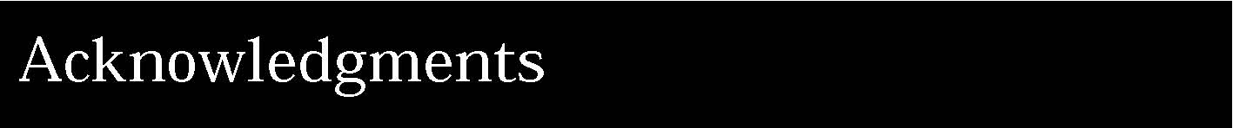
In addition to the people recognized in the Preliminary Draft Framework for Languages Other Than English, we are grateful to the many teachers from throughout New York State who contributed samples of student work for possible inclusion in this revised edition. Listed below are the names of those teachers whose samples appear in this document.
Contributors:
Michelle Bloom, Guilderland Janet Bowman, Ithaca Darlene Cardillo, Albany Kelly Casey, Albany Dolores Chimato, Hunter Jill Crooker, Pittsford Bonita Hogan, Buffalo Lucrezia Lindia, Eastchester Janine Manley, Potsdam Lorraine Miner, Saugerties Michele Pollard, Slingerlands Christine Rant, Guilderland Patricia Sacca, Albany Alfred Valentini, Utica Marie Wilson, Lancaster
Reviewers:
Alessio Evangelista, Rochester Jill Crooker, Pittsford Michelle Bloom, Guilderland Darlene Cardillo, Albany
State Education Department:
Roseanne DeFabio Jan Christman Mary Pillsworth

This revised edition of the Learning Standards for Languages Other Than English incorporates changes to the content standards and performance indicators based on extensive review by the public. It should be considered a working document; as educational practice improves, these standards will continually be revised.
New in this edition are samples of student work, along with teachers’ comments on the work. The examples are intended to provide some ideas of tasks that support attainment of the performance standards. They are not models of excellence. Rather, they vary in degree of achievement. Some are at the “acceptable” level; others are at a “more proficient” level. It is important to remember that these are just suggestions of ways that students can demonstrate progress toward achieving the standards.
The State Education Department will continue to collect and publish samples of student work. As teachers become more familiar with the standards and students become more proficient in meeting them, the level of the performance standards and content standards will continue to rise.
Taken together, the content standards and the performance standards define the learning standards for students in languages other than English.
The Board of Regents recognizes the diversity of students in New York State, including students with disabilities, students with limited English proficiency, gifted students, and educationally disadvantaged students, and has made a strong commitment to integrating the education of all students into the total school program. The standards in the framework apply to all students, regardless of their experiential background, capabilities, developmental and learning differences, interests, or ambitions. A classroom typically includes students with a wide range of abilities who may pursue multiple pathways to learn effectively, participate meaningfully, and work toward attaining the curricular standards. Students with diverse learning needs may need accommodations or adaptations of instructional strategies and materials to enhance their learning and/or adjust for their learning capabilities.
A Note About Checkpoints
Learning a language other than English may begin at any time; therefore, performance standards are keyed to checkpoints, which may be measured at any point in the K-12 continuum, instead of elementary, intermediate, or commencement levels, which have traditionally implied specific grade levels. The achievement of learning standards at any checkpoint varies according to the age when students begin language study, the frequency and length of the lessons, the students’ previous experience with second language learning, and their motivation. Checkpoint A is considered to be a way station en route to proficiency. Checkpoint B corresponds to the level of performance that all students should demonstrate in order to obtain a high school diploma. Checkpoint C proficiency corresponds to a more advanced level of performance that can be attained on an elective basis.
vi
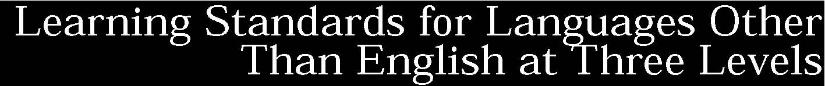
Standard 1: Students will be able to use a language other than English for communication. Standard 2: Students will develop cross-cultural skills and understandings.
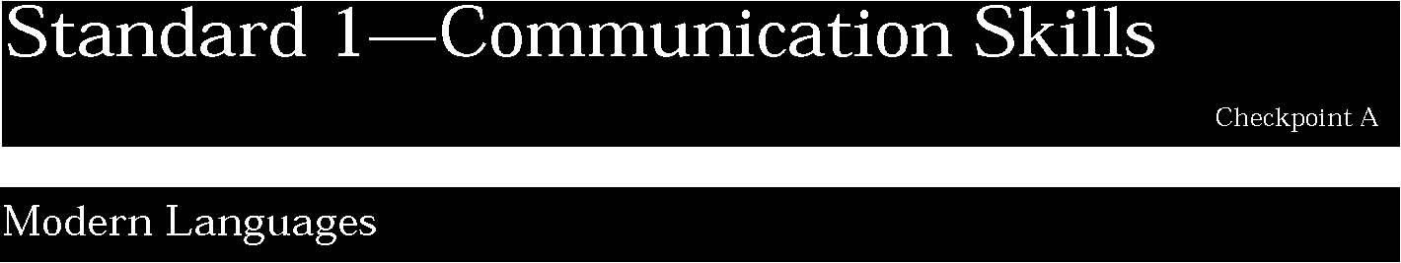
1. Listening and speaking are primary communicative goals in modern language learning. These skills are used for the purposes of socializing, providing and acquiring information, expressing personal feelings and opinions, and getting others to adopt a course of action.
Students can:
- comprehend language consisting of simple vocabulary and structures in face-to-face conversation with peers and familiar adults
- comprehend the main idea of more extended conversations with some unfamiliar vocabulary and structures as well as cognates of English words
- call upon repetition, rephrasing, and nonverbal cues to derive or convey meaning from a language other than English
- use appropriate strategies to initiate and engage in simple conversations with more fluent or native speakers of the same age group, familiar adults, and providers of common public services.

This is evident, for example, when students:
- exchange simple greetings and answer questions about self and family
- listen to radio broadcasts and answer questions about main ideas
- speak in complete sentences, using present tense and, occasionally, markers for past and future tenses
- ask for information or directions
- discuss classroom activities with a peer
- use appropriate body language and gestures to supplement the spoken word.

2. Reading and writing are used in languages other than English for the purposes of socializing, providing and acquiring information, expressing personal feelings and opinions, and getting others to adopt a course of action.
Students can:
- understand the main idea and some details of simple informative materials written for native speakers
- compose short, informal notes and messages to exchange information with members of the target culture.

This is evident, for example, when students:
▲ obtain information from materials written in the target language including short notes, brief messages, posters, printed advertisements, illustrated simple texts from newspapers and magazines
- guess the meaning of more complex written material, using context, recognition of cognates, accompanying illustrations, and prior knowledge of situations and issues
- write a brief message about an everyday activity, using simple sentence structure, not necessarily limited to the present tense.

Key ideas are identified by numbers (1). Performance indicators are identified by bullets (•). Sample tasks are identified by triangles (▲ ).
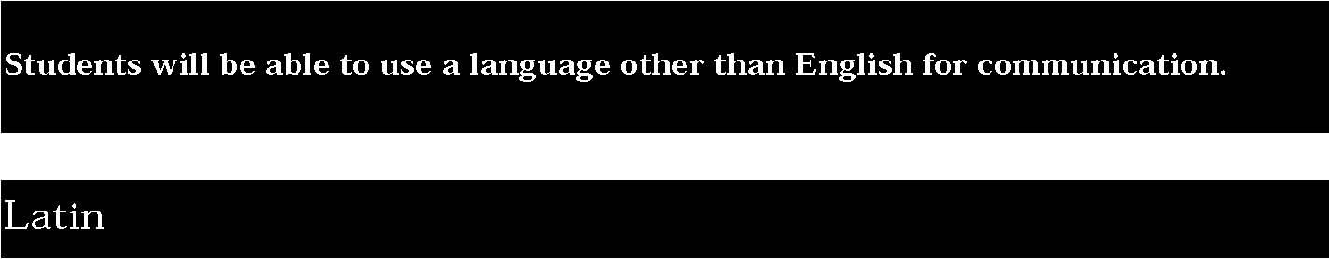
1. Reading is the most important skill that students acquire in learning Latin for it is the vehicle through which communication with the ancient world is possible, and it is also the tool, along with writing, through which students become more aware of their own and other languages.
Students can:
- read and understand simple connected materials written in Latin
- write simple responses to oral, visual, or written stimuli
- demonstrate an awareness of the vocabulary, grammar, derivation, and word structure of English.

This is evident, for example, when students:
- read original texts and simple exercises to derive meaning
- recognize the general principles of the language and understand the grammar in its original context
- write responses to a reading or visual/oral presentation
- transcribe material read aloud by the teacher
- express in written English the meaning of simple Latin passages
- demonstrate an awareness of Latin roots in English
- compare and contrast English and Latin grammar
- do word-building in English through a study of Latin roots, prefixes, and suffixes.

2. Listening and speaking support the reading skills in Latin.
Students can:
- recognize and comprehend simple spoken Latin statements and questions based on classroom situations
- articulate simple Latin phrases and convey meaning in controlled situations.

This is evident, for example, when students:
- listen to Latin being read aloud and begin to recognize and appreciate phrase groupings and voice inflection
- correctly repeat words or phrases spoken by the teacher
- read aloud with generally correct pronunciation
- respond appropriately to questions based on oral communication or reading passages.

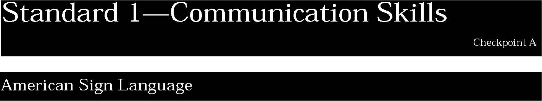
1. Visual-gestural skills provide a means of communication with Deaf people in the context of the Deaf culture.
Students can:
- use receptive skills to comprehend simple statements and questions in standard dialect
- express basic needs and compose statements, questions and short messages to signers of the same age group and to familiar adults
- initiate and engage in simple face-to-face conversations.

This is evident, for example, when students:
- carry on informal, interactive, face-to-face conversations with familiar individuals who are deaf
- understand age-appropriate narratives, including stories, folktales, and other expressions of the Deaf culture
- use repetition and rephrasing to sustain comprehension with more skilled signers
- use gestures to compose simple statements and questions
- use appropriate vocabulary and structure when communicating with native ASL signers
- make their messages comprehensible to fluent signers through repetition and rephrasing.

Key ideas are identified by numbers (1). Performance indicators are identified by bullets (•). Sample tasks are identified by triangles (▲ ).
NOTE: American Sign Language (ASL) is a visual-gestural language, devoid of voice, and it does not have a written form. It is governed by sign production, registers, and nonmanual grammar using facial and body signals. The emphasis on communication is applied in situations characterized as receptive, expressive, and interactive.
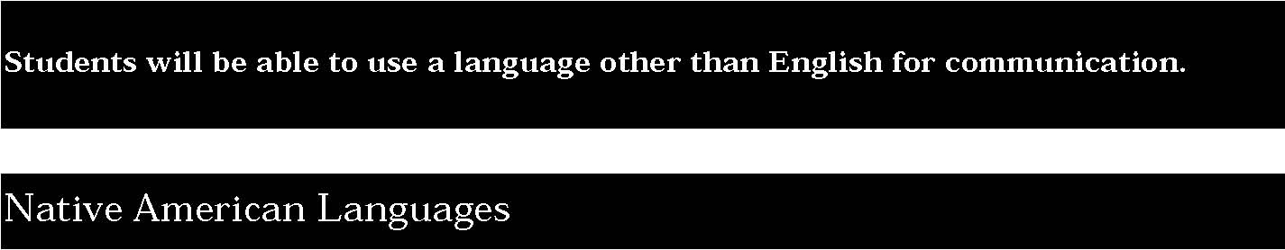

1. Communication in Native languages takes place primarily to share expression of ideas, thoughts, and feelings to preserve Native cultural ideology.
Students can:
- comprehend simple statements and questions in the context of the classroom and the main ideas of more extended messages and conversations
- initiate and respond to simple face-to face conversations.

This is evident, for example, when students:
- follow simple directions
- give appropriate verbal and nonverbal responses
- converse with tribal elders about traditional values.

2. Writing systems, and therefore reading, are recent introductions to Native languages and are used primarily to encourage functional communication in the listening and speaking skills.
Students can:
- comprehend the main ideas of materials containing simple structure and syntax
- compose short messages on familiar topics or to express basic personal needs.

This is evident, for example, when students:
- use visual aids and prior familiarity to derive meaning
- achieve understanding of written material by repetitive readings
- write a brief note requesting information.

NOTE: The primary purpose of instruction in Native languages is to teach children how to speak Native languages and to ensure that these languages do not become extinct. These languages have been historically in the oral tradition, and there is no intent to move away from that tradition. It is only in the past 20 years, with the introduction of Native American language programs in the schools, that a writing system has been developed. Each Nation will have to decide to what extent a writing system will be used in instruction.
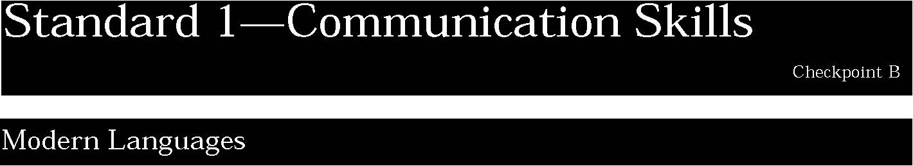

1. Listening and speaking are primary communicative goals in modern language learning. These skills are used for the purposes of socializing, providing and acquiring information, expressing personal feelings and opinions, and getting others to adopt a course of action.
Students can:
- comprehend messages and short conversations when listening to peers, familiar adults, and providers of public services either in face-to-face interactions or on the telephone
- understand the main idea and some discrete information in television, radio, or live presentations
- initiate and sustain conversations, face to face or on the phone, with native-speaking or more fluent individuals
- select vocabulary appropriate to a range of topics, employ simple and complex sentences in present, past, and future time frames, and express details and nuances by using appropriate modifiers
- exhibit spontaneity in their interactions, particularly when the topic is familiar, but often rely on familiar utterances
- use repetition and circumlocution as well as gestures and other nonverbal cues to sustain conversation.

This is evident, for example, when students:
- follow conversations and understand messages that concern everyday life and the larger society
- view slides depicting diversity within the target culture and discuss their reactions
- listen to Native speakers live or on tape, and use nonverbal cues, repetition, and rephrasing to understand
- conduct an interview with a native speaker of the target language
- watch television programs in the target language
- discuss songs, stories, and selected excerpts from the literature of the target language.

2. Reading and writing are used in languages other than English for the purposes of socializing, providing and acquiring information, expressing personal feelings and opinions, and getting others to adopt a course of action.
Students can:
- read and comprehend materials written for native speakers when the topic and language are familiar.
- use cognates and contextual and visual cues to derive meaning from texts that contain unfamiliar words, expressions, and structures
- read simple materials independently, but may have to guess at meanings of longer or more complex material
- write short notes, uncomplicated personal and business letters, brief journals, and short reports
- write brief analyses of more complex content when given the opportunity for organization and advance preparation, though errors may occur more frequently
- produce written narratives and expressions of opinion about radio and television programs, newspaper and magazine articles, and selected stories, songs, and literature of the target language.

This is evident, for example, when students:
- read personal letters and notes, simple business correspondence, pamphlets, feature articles or editorials in newspapers or magazines published for the general public and discuss the positions presented in them
- read selected short stories and poems and identify the main idea and some specific ones
- identify subtleties of meaning through the use of learned vocabulary and structures including present, past, and future tense
- give an oral presentation on an assigned topic, using learned and practiced vocabulary, complex sentence structures in the present and, some sentences in the past and future
- write a short response to a classroom situation.

Key ideas are identified by numbers (1). Performance indicators are identified by bullets (•). Sample tasks are identified by triangles (▲ ).
1. Reading is the most important skill that students acquire in learning Latin for it is the vehicle through which communication with the ancient world is possible, and it is also the tool, along with writing, through which students become more aware of their own and other languages.
Students can:
- understand composed Latin and passages adapted from Latin authors
- respond in simple written Latin and in English to questions based on composed Latin and on passages adapted from Latin authors
- demonstrate a knowledge of basic Latin vocabulary and language structures and an increased English vocabulary based on Latin.

This is evident, for example, when students:
- comprehend selected passages in familiar Latin sentence patterns
- use context, clues, and accumulated experience to understand an unfamiliar passage
- read Latin authors from texts that have been adapted to reflect the interests and language skills of the students
- respond in simple written Latin to questions based on readings that contain authentic vocabulary and language structure
- express in written English the general and/or specific meaning of a passage adapted from a Latin author
- compare and contrast grammar styles of Latin and English through analysis of the same genre of poetry
- produce a list of English words derived from a single Latin root.

2. Listening and speaking support the reading skills in Latin.
Students can:
- comprehend simple spoken Latin statements and questions based on a classroom situation or a simple Latin passage read aloud.
- read familiar Latin aloud and speak Latin with accurate pronunciation, appropriate phrase grouping, voice inflection, and expression in controlled classroom situations.

This is evident, for example, when students:
- make an oral presentation using Latin words, sounds, and forms of expression
- use common Latin phrases in a written assignment
- read Latin passages aloud
- answer specific questions based on a classroom reading.

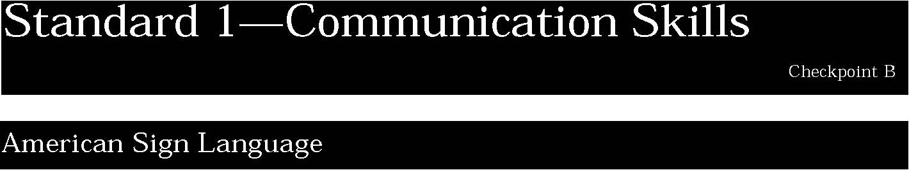
1. Visual-gestural skills provide a means of communication with Deaf people in the context of the Deaf culture.
Students can:
- comprehend messages and short conversations when they contain frequently used grammatical features and word order patterns
- understand some main ideas and some discrete information when watching signed television broadcasts, instructional videotapes, and films on topics of interest to them or to the general public
- express themselves with confidence on a range of topics that include issues related to everyday life, the content of programs on television and videotapes; the content of articles in newspapers or magazines for the general public; and stories and excerpts from Deaf literature
- engage in extended discourse with native ASL signers on a broad range of topics that extends beyond the students’ interests to those of general interest to members of the Deaf culture.

This is evident, for example, when students:
- ask for directions to a nearby cafe, shopping center, Deaf club . . .
- relay the main ideas of a newspaper or magazine article
- make appointments, using present, past, and future time frames
- use appropriate learned vocabulary and structures, although limited control of more complex structures may interfere with communication
- employ simple and complex sentences and all conversational tenses that enable them to communicate in all time frames
- use culturally appropriate behaviors of the Deaf community.

Key ideas are identified by numbers (1). Performance indicators are identified by bullets (•). Sample tasks are identified by triangles (▲ ).
NOTE: American Sign Language (ASL) is a visual-gestural language, devoid of voice, and it does not have a written form. It is governed by sign production, registers, and nonmanual grammar using facial and body signals. The emphasis on communication is applied in situations characterized as receptive, expressive, and interactive.

1. Communication in Native languages takes place primarily to share expression of ideas, thoughts, and feelings to preserve Native cultural ideology.
Students can:
- comprehend messages and short conversations when listening to Native speakers; repetition may be necessary for full understanding
- initiate and sustain conversations with some hesitation and difficulty in pronunciation in short and familiar communicative situations
- produce an extended communication through a series of short connected utterances, using repetition as needed
- comprehend the meaning of myths and legends told to them repeatedly by Native speakers.

This is evident, for example, when students:
- relate an incident, using common verbal structures accurately, although errors occur in more complex patterns
- engage in a simulated classroom dialogue
- respond in complete sentences to questions from Native speakers
- make an oral presentation about a traditional festival
- compare similar myths from differing groups of Native people.

2. Writing systems, and therefore reading, are recent introductions to Native languages and are used primarily to encourage functional communication in the listening and speaking skills.
Students can:
- understand simple narrative and descriptive authentic materials and edited texts within a familiar context
- read Native texts or stories aloud with accurate pronunciation and attention to dialogue
- write short communications that are comprehensible to Native speakers used to dealing with students. Difficulties still occur when expressing more complex thoughts.

This is evident, for example, when students:
- read and comprehend passages with familiar sentence patterns
- acquire essential points of information from simple narrative and descriptive writing
- guess meaning of writing on topics of special interest by using context clues
- write simple notes, letters, and short reports
- use elementary vocabulary and commonly encountered structures accurately
- express themselves in present, future, and past time frames.

NOTE: The primary purpose of instruction in Native languages is to teach children how to speak Native languages and to ensure that these languages do not become extinct. These languages have been historically in the oral tradition, and there is no intent to move away from that tradition. It is only in the past 20 years, with the introduction of Native American language programs in the schools, that a writing system has been developed. Each Nation will have to decide to what extent a writing system will be used in instruction.
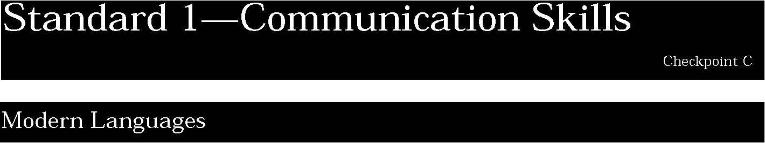
1. Listening and speaking are primary communicative goals in modern language learning. These skills are used for the purposes of socializing, providing and acquiring information, expressing personal feelings and opinions, and getting others to adopt a course of action.
Students can:
- understand standard speech delivered in most authentic settings
- understand the main ideas and significant relevant details of extended discussions or presentations, and of recorded songs, feature programs on radio and television, movies, and other media designed for use by native speakers.
- draw on a wide range of language forms, vocabulary, idioms, and structures learned in class as well as those acquired through independent exposure to the language
- comprehend subtler, nuanced details of meaning with some repetition and rephrasing
- engage in extended discussions with native or fluent speakers on a broad range of topics that extend beyond their daily lives and are of general interest to the target cultures.

This is evident, for example, when students:
- detect emotional overtones and understand inferences in personal communications and formal presentations
- report orally on a radio news broadcast that covers contemporary themes and issues
- give an oral presentation on an assigned topic, using culturally appropriate vocabulary, expressions, gestures, and verbal and nonverbal cues, simple and complex sentences, and the full range of time frames
- maintain a natural conversational pace
- produce virtually error-free speech in brief exchanges with classmates, using simple structures and familiar vocabulary. Errors which may interfere with communication tend to occur during more extended and complicated discourse.

2. Reading and writing are used in languages other than English for the purposes of socializing, providing and acquiring information, expressing personal feelings and opinions, and getting others to adopt a course of action.
Students can:
- comprehend the content of most texts of interest to native speakers
- draw on a broad range of learned vocabulary, idioms, and structures, including the full range of time frames, as well as language acquired through independent reading
- write multiparagraphed essays, journals, personal and business letters, and creative texts in which their thoughts are unified and presented in an organized fashion; errors in form may occur, particularly when the students are writing about complex themes or issues requiring the expression of opinions, or when the topic is outside their realm of experiences
- use culturally appropriate learned vocabulary and structures associated with a broad range of topics, and structures such as simple and complex sentences to communicate through the full range of time frames.

This is evident, for example, when students:
- understand the full meaning of personal and business correspondence and pamphlets, full-length feature articles or editorials in newspapers or other periodicals of interest to the general public, general advertising, documentation accompanying commonly used products
- interpret full-length original versions of poetry and prose that express significant themes and issues of global and cultural concern
- write independently about a broad range of topics that extend beyond the students’ daily lives to include issues, ideas, and opinions that are of general interest to the target cultures as expressed in songs (live and recorded), feature programs on television and radio, movies, articles in newspapers and magazines, other forms of media presentations used by native speakers, and literature selections
- express complex ideas, using simpler forms of language.

Key ideas are identified by numbers (1). Performance indicators are identified by bullets (•). Sample tasks are identified by triangles (▲ ).
1. Reading is the most important skill that students acquire in learning Latin for it is the vehicle through which communication with the ancient world is possible, and it is also the tool, along with writing, through which students become more aware of their own and other languages.
Students can:
- read and understand selected authors of prose and poetry with some assistance
- express in English the general and specific meaning of Latin passages of prose or poetry, assisted by glosses, and can demonstrate a controlled, but increasing, ability to write Latin
- read aloud Latin prose and poetry with attention to features such as the correct metrical structure
- demonstrate an expanding knowledge of Latin vocabulary and language structures, and an increased English vocabulary based on it.

This is evident, for example, when students:
- distinguish main ideas from lesser ones to advance understanding
- recognize some features of an author’s style
- analyze Latin grammar and language patterns in context
- use the aids and resources available to readers of authentic texts of the major authors of Latin prose and poetry
- demonstrate an ability to read authentic Latin prose and poetry, while using appropriate resources
- demonstrate a knowledge of Latin and English grammar through comparison and contrast and through applied use in reading Latin and in reading, listening, speaking, and writing English
- derive meaning from Latin passages based on an increased knowledge of vocabulary and word-building skills
- use knowledge of Latin vocabulary to determine the meaning of English derivations.

2. Listening and speaking support the reading skills in Latin.
Students can:
- recognize and appreciate the linguistic and artistic qualities of oral Latin prose and poetry when read aloud
- read aloud Latin prose and poetry with attention to features such as the correct metrical structure.

This is evident, for example, when students:
- identify some effects of metrical structure and diction
- distinguish between classical and ecclesiastical pronunciation
- read with appropriate attention to metrical structure, phrase grouping, voice inflection, and expression
- respond appropriately in Latin to classroom situations and readings of prose and poetry.

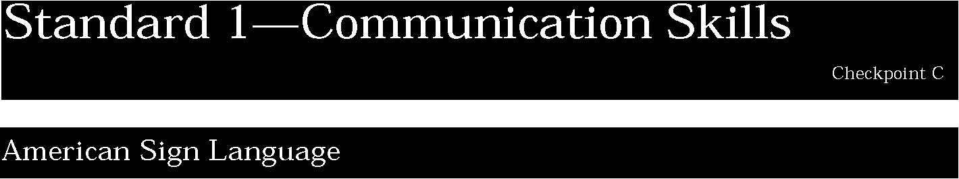

1. Visual-gestural skills provide a means of communication with Deaf people in the context of the Deaf culture.
Students can:
• understand a wide range of registers delivered with some repetition and paraphrasing by fluent ASL signers, comprehension may be hindered when the topics are unfamiliar or when more advanced signed communication is being used
• organize presentations on everyday topics
- express complex ideas with confidence.

This is evident, for example, when students:
- determine the essential content of face-to-face discussions or presentations, of signed feature films, and of signed programs on television and videotape
- understand communications on a wide range of topics, and on issues of concern globally and in Deaf culture
- recognize learned vocabulary and structures as well as those acquired through independent exposure to the language
- demonstrate good control of the morphology of the language and of the most frequently used syntactic structures, although errors may still occur
- use culturally appropriate behaviors regularly.

Key ideas are identified by numbers (1). Performance indicators are identified by bullets (•). Sample tasks are identified by triangles (▲ ).
2. Interactive communication is possible with Deaf people through the use of signs.
Students can:
- converse with confidence
- engage in extended discourse with native ASL signers on a broad range of topics including those of general interest to the Deaf culture.

This is evident, for example, when students:
- use appropriate learned vocabulary and structures
- employ simple and complex sentences and all conversational tenses to communicate in all time frames
- use culturally appropriate behaviors of the Deaf community.

NOTE: American Sign Language (ASL) is a visual-gestural language, devoid of voice, and it does not have a written form. It is governed by sign production, registers, and nonmanual grammar using facial and body signals. The emphasis on communication is applied in situations characterized as receptive, expressive, and interactive.

1. Communication in Native languages takes place primarily to share expression of ideas, thoughts, and feelings to preserve Native cultural ideology.
Students can:
- understand speech delivered with some repetitions and rewording by competent Native speakers
- understand the essential points of discussion or presentations on familiar topics in lengthy messages and presentations
- handle most communicative situations with confidence but may need help with complicated, unfamiliar topics.

This is evident, for example, when students:
- use elementary constructions accurately
- demonstrate some limited control of complex structures
- produce extended communications consisting of simple and more complex utterances.

2. Writing systems, and therefore reading, are recent introductions to Native languages and are used primarily to encourage functional communication in the listening and speaking skills.
Students can:
- understand most factual information in nontechnical prose as well as some informative and descriptive texts on topics related to areas of special interest
- compose unified and organized texts on everyday topics.

This is evident, for example, when students:
- read excerpts from literature for pleasure
- distinguish main ideas and analyze materials for the general public
- detect the overall tone and intent of a text
- demonstrate command of sufficient vocabulary to express oneself clearly
- express complex ideas sequentially with simple language
- write in a style and form comprehensible to Native speakers.

NOTE: The primary purpose of instruction in Native languages is to teach children how to speak Native languages and to ensure that these languages do not become extinct. These languages have been historically in the oral tradition, and there is no intent to move away from that tradition. It is only in the past 20 years, with the introduction of Native American language programs in the schools, that a writing system has been developed. Each Nation will have to decide to what extent a writing system will be used in instruction.
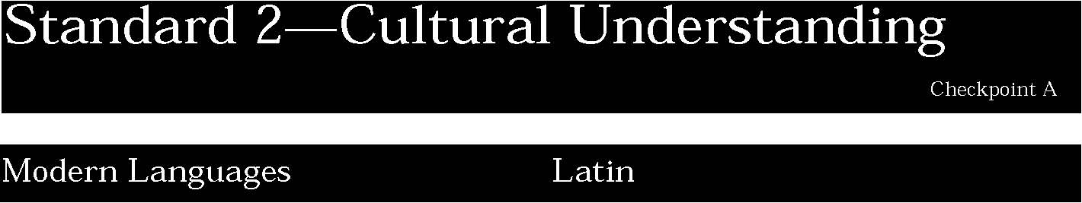

1. Effective communication involves meanings that go beyond words and require an understanding of perceptions, gestures, folklore, and family and community dynamics. All of these elements can affect whether and how well a message is received.
Students can:
• use some key cultural traits of the societies in which the target language is spoken.
This is evident, for example, when students:
- recognize cultural patterns and traditions of the target cultures in the target language;
- understand the cultural implications of the spoken language and of the dynamics of social interaction; and
- correctly use and interpret cultural manifestations, such as gestures accompanying greeting and leave taking and the appropriate distance to maintain.

Key ideas are identified by numbers (1). Performance indicators are identified by bullets (•). Sample tasks are identified by triangles (▲ ).
1. Latin acquisition provides the cultural context for learning about the ancient world and its people. From this basis students can compare and contrast antiquity and the present and thoughtfully contemplate the future.
Students can:
- demonstrate knowledge of some aspects of Greco-Roman culture and selected facts of daily life, myths, history, and architecture
- recognize manifestations of antiquity in the modern world.

This is evident, for example, when students:
- read selections of culturally authentic passages, some of which are based directly on Latin authors, and point out significant cultural aspects
- describe the mythological origins of modern symbols such as Apollo space craft, Nike.

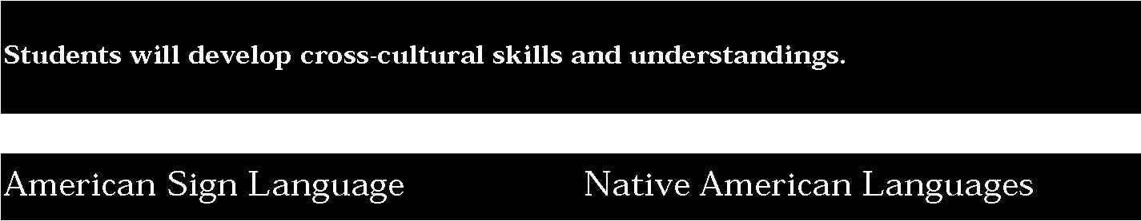

1. Key cultural traits exist within the Deaf culture, and cultural patterns are learned through the use of American Sign Language.
Students can:
- use key cultural traits that exist in settings where American Sign Language is used
- become aware of cultural patterns, learned through the use of American Sign Language, that characterize the Deaf culture.

This is evident, for example, when students:
- correctly use and interpret cultural manifestations for communication about daily activities
- are aware of the implications when a culture exists within a larger culture.

1. Culture is transmitted and preserved through knowledge about the lives of Native American people and the sharing of their cultural ideology.
Students can:
- demonstrate an awareness of Native culture
- recognize the names of cultural items and their uses
- understand the history and cultural symbols of the people
- demonstrate knowledge about the clan system.

This is evident, for example, when students:
- visit and talk with local cultures, or visit a reservation
- study wampum belts that record history
- listen to folktales and myths.

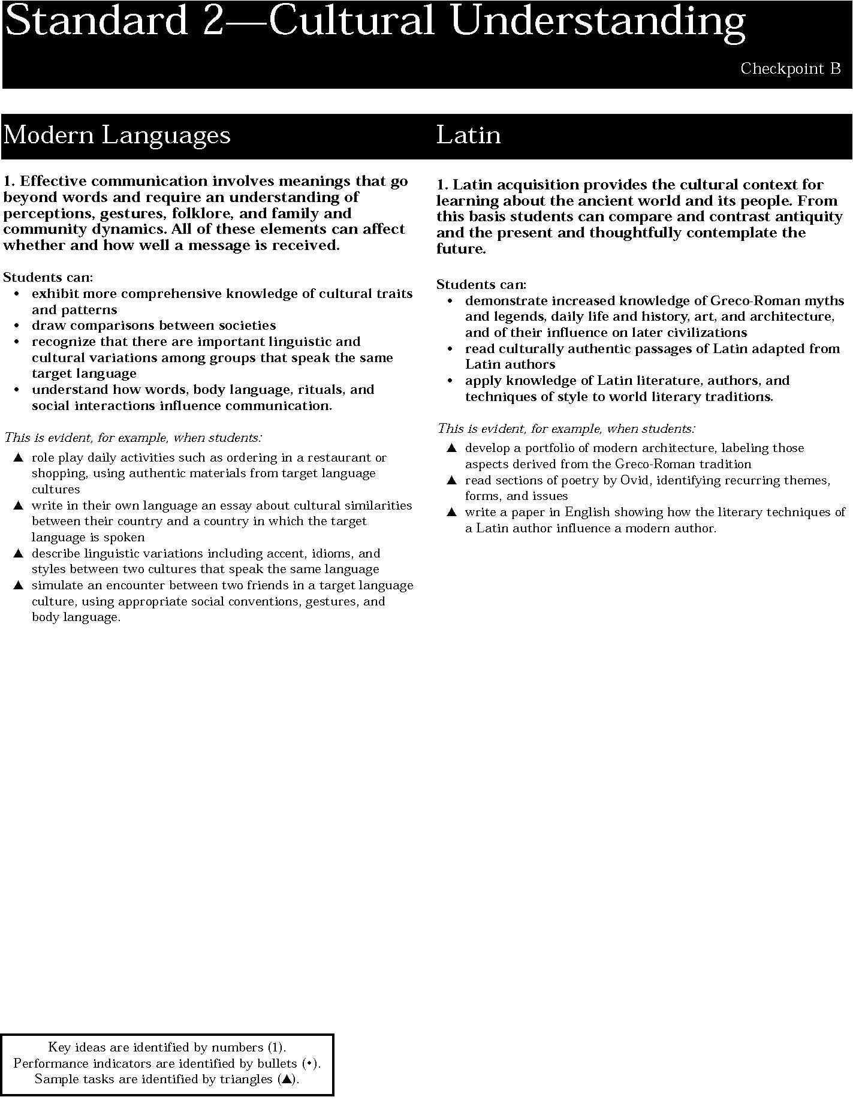

1. Key cultural traits exist within the Deaf culture, and cultural patterns are learned through the use of American Sign Language.
Students can:
- demonstrate more comprehensive knowledge of the Deaf culture
- draw comparisons about different societies both within the Deaf culture and other cultures
- recognize important linguistic and cultural variations among different groups within the culture and in the various states and Canadian provences where American Sign Language is used.

This is evident, for example, when students:
- participate in a discussion about cultural patterns learned through the use of American Sign Language
- understand how daily life in the Deaf culture requires making adjustments to living in a hearing world
- are able to identify regional differences in the signed language
- role play daily activities incorporating appropriate cultural behaviors
- can be understood by a fluent signer of ASL using repetition and rephrasing.

1. Culture is transmitted and preserved through knowledge about the lives of Native American people and the sharing of their cultural ideology.
Students can:
- demonstrate increased knowledge of Native culture through their myths and legends, art and architecture, and literature and government
- recognize how Native cultural ideas exist within modern America.

This is evident, for example, when students:
- recreate a legend through an authentic dance
- write a paper concerning the continuing influence of Native values on modern environmental issues.

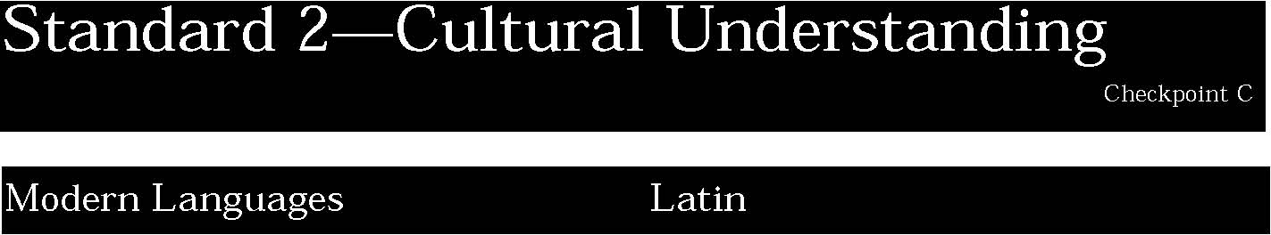

1. Effective communication involves meanings that go beyond words and require an understanding of perceptions, gestures, folklore, and family and community dynamics. All of these elements can affect whether and how well a message is received.
Students can:
- demonstrate sophisticated knowledge of cultural nuances in a target language culture
- model how spoken language, body language, and social interaction influence communication
- use appropriate registers
- write in the target language in a manner that articulates similarities and differences in cultural behaviors.

This is evident, for example, when students:
- read and understand poetry written for Native speakers
- exchange greetings with Native speakers and use culturally appropriate grammatical forms and body language
- write a simulated dialogue between Native speakers about a topic of current interest.

1. Latin acquisition provides the cultural context for learning about the ancient world and its people. From this basis students can compare and contrast antiquity and the present and thoughtfully contemplate the future.
Students can:
- use adapted reading from Latin prose and poetry to broaden knowledge about Greco-Roman civilization and its influence on subsequent civilizations
- make comparisons of Latin literary style with those of world literary traditions.

This is evident, for example, when students:
- read unadapted works of Virgil and identify new features of style and content
- compare and contrast the literary devices employed in an authentic Latin epic with those used in a medieval epic such as El Cid.

Key ideas are identified by numbers (1). Performance indicators are identified by bullets (•). Sample tasks are identified by triangles (▲ ).

1. Key cultural traits exist within the Deaf culture, and cultural patterns are learned through the use of American Sign Language.
Students can:
- produce behaviors that are consistent with the Deaf culture
- reflect a wide variety of different contexts within the Deaf culture.

This is evident, for example, when students:
- use appropriate visual gestures and body language to enrich the signed language
- maintain conversation with individuals who are fluent signers of

ASL ▲ observe and understand a signed play or performance.
1. Culture is transmitted and preserved through knowledge about the lives of Native American people and the sharing of their cultural ideology.
Students can:
- demonstrate a through knowledge of the Native culture
- distinguish between various subgroups
- relate their knowledge and understanding of the culture to other Native American groups.

This is evident, for example, when students:
- discuss issues of community importance with tribal elders
- demonstrate an understanding of the protocols of expected behavior
- prepare a report comparing daily life of the Iroquois to that of the Lakota.

20


The samples of student work included in this section are intended to begin the process of articulating the performance standards at each level of achievement. This collection is not yet adequate for that purpose in either numbers or scope of examples. Nor are these samples presented as models of excellence. They vary in degree of achievement. Some are “acceptable”; others “more proficient.” All are meant to provide examples of the kind of work students might produce to demonstrate progress toward the standard.
The primary goal of second language study is, through the communicative method of instruction, to enable students to communicate face-to-face with native speakers of a language other than English. The listening and speaking skills acquired by students are difficult to showcase in a written format such as this Framework. It is expected that in the near future this document will be available on a CDROM. The visual and sound components of this technology will provide more authentic samples of a student achievement in all language areas, and will make it possible to feature student work in languages that have either little or no written form such as Native American languages and American Sign Language.
A Request to Teachers
The New York State Education Department continues to collect samples of student work for inclusion in future revisions of this document. Samples are needed in all areas of second language study, and the need is especially urgent for student samples in the less commonly taught languages such as Asian and African. If you would like to contribute, we would be happy to send you an instruction sheet and the forms that must accompany each submission. Please contact:
Mary W. Pillsworth, Room 671 EBA New York State Education Department Albany, New York 12234
Telephone: (518) 474-3954 Fax (518) 473-4884

