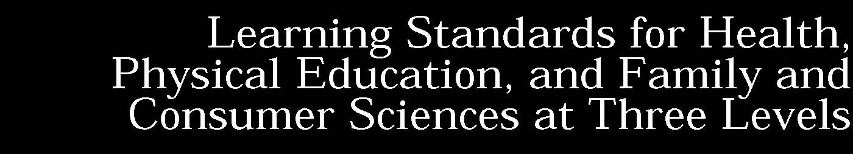
Standard 1: Personal Health and Fitness Students will have the necessary knowledge and skills to establish and maintain physical fitness, participate in physical activity, and maintain personal health.
Standard 2: A Safe and Healthy Environment. Students will acquire the knowledge and ability necessary to create and maintain a safe and healthy environment.
Standard 3: Resource Management. Students will understand and be able to manage their personal and community resources.
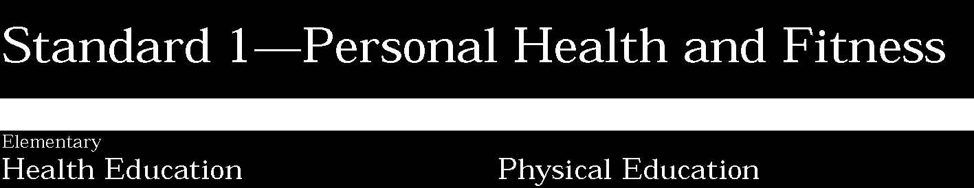
1. Students will understand human growth and development and recognize the relationship between behaviors and healthy development. They will understand ways to promote health and prevent disease and will demonstrate and practice positive health behaviors.
Students:
- know how basic body systems work and interrelate in normal patterns of growth and development
- possess basic knowledge and skills which support positive health choices and behaviors
- understand how behaviors such as food selection, exercise, and rest affect growth and development
- recognize influences which affect health choices and behaviors
- know about some diseases and disorders and how they are prevented and treated
- practice and support others in making healthy choices.

This is evident, for example, when students:
- describe the basic structure and functions of human body systems
- identify the harmful effects of alcohol, tobacco and other drugs
- explain how eating nutritionally balanced meals and snacks promotes health
- describe the physical, social and emotional indicators of healthy people
- demonstrate the use of interpersonal communication skills to enhance health
- identify responsible health behaviors and demonstrate strategies to improve or maintain personal health
- demonstrate health practices such as washing hands, covering one’s mouth when coughing or sneezing, and brushing and flossing teeth
- identify common health problems and indicate how they can be prevented, detected and treated
- set a personal health goal and track progress toward its achievement.

Key ideas are identified by numbers (1). Performance indicators are identified by bullets (•). Sample tasks are identified by triangles (▲).
1. Students will perform basic motor and manipulative skills. They will attain competency in a variety of physical activities and proficiency in a few select complex motor and sports activities. Students will design personal fitness programs to improve cardiorespiratory endurance, flexibility, muscular strength, endurance, and body composition.
Students:
- participate in physical activities (games, sports, exercises) that provide conditioning for each fitness area
- develop physical fitness skills through regular practice, effort, and perseverance
- demonstrate mastery of fundamental motor, non-locomotor, and manipulative skills, and understand fundamental principles of movement
- understand the effects of activity on the body, the risks associated with inactivity, and the basic components of health-related fitness (cardiovascular, muscle strength, muscle endurance, flexibility, and body composition)
- demonstrate and assess their fitness by performing exercises or activities related to each health-related fitness component, and establish personal goals to improve their fitness
- understand the relationship between physical activity and individual well being.

This is evident, for example, when students:
- demonstrate basic motor skills (run, climb, hop), manipulative skills (throw, catch, strike), and non-locomotor skills (balance, weight transfer) using mature motor patterns while engaged in a variety of activities
- apply the concepts and principles of human movement to the development of new skills (e.g., catching objects while moving, throwing objects using opposition)
- adjust performance of skill as a result of monitoring or assessing previous performance (e.g., moves closer to target or throws at altered angle of release following toss that falls short)
- do additional push-ups each day to improve upper body strength, additional stretches to improve flexibility, and additional running to develop cardiorespiratory fitness
- engage in physical activity and frequent monitoring of pulse rate to reach and maintain a target heart rate for an appropriate amount of time
- perform appropriate warm-up and cool-down exercises before and after vigorous activity to avoid muscle injury
- set a personal physical activity goal and track progress toward its achievement.

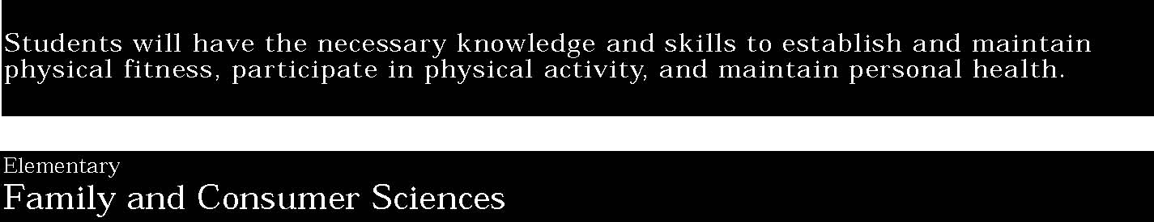
1. Students will use an understanding of the elements of good nutrition to plan appropriate diets for themselves and others. They will know and use the appropriate tools and technologies for safe and healthy food preparation.
Students:
- understand the importance of nutritious food and how it contributes to good health, make simple nutritious food choices, and assist with basic food preparation
- use simple household tools safely to perform a variety of everyday tasks
- recognize how a family contributes to personal health.

This is evident, for example, when students:
- know the food groups as described in the food guide pyramid and plan meals and snacks that include a nutritious balance of foods
- prepare simple snacks, handling food properly, and using utensils safely
- wash hands before and after handling food
- use age appropriate technology such as microwave for food preparation
- identify ways a family helps its members maintain their health.

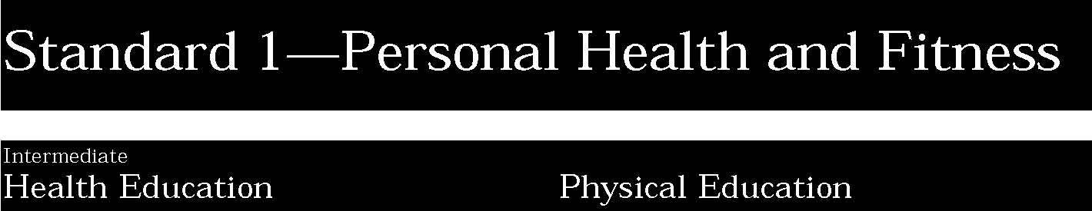
1. Students will understand human growth and development and recognize the relationship between behaviors and healthy development. They will understand ways to promote health and prevent disease and will demonstrate and practice positive health behaviors.
Students:
- integrate knowledge of basic body systems with an understanding of the changes that accompany puberty
- apply prevention and risk reduction strategies to adolescent health problems
- demonstrate the necessary knowledge and skills to promote healthy adolescent development
- analyze the multiple influences which affect health decisions and behaviors.

This is evident, for example, when students:
- describe bodily changes that occur during adolescence
- demonstrate a variety of problem solving, communication and stress management skills to address health compromising behaviors such as fad dieting, alcohol, tobacco, and other drug use, early sexual involvement and violent behavior
- predict how decisions regarding health behaviors have consequences for self and others
- describe the interrelationship of social, emotional and physical health during adolescence
- explain how lifestyle, family history and other factors are related to the cause or prevention of diseases and other health problems.

Key ideas are identified by numbers (1). Performance indicators are identified by bullets (•). Sample tasks are identified by triangles (▲).
1. Students will perform basic motor and manipulative skills. They will attain competency in a variety of physical activities and proficiency in a few select complex motor and sports activities. Students will design personal fitness programs to improve cardiorespiratory endurance, flexibility, muscular strength, endurance, and body composition.
Students:
- demonstrate competency in a variety of physical activities (games, sports, exercises) that provide conditioning for each fitness area
- know that motor skills progress in complexity and need to be used in the context of games and sports with additional environmental constraints
- combine and integrate fundamental skills and adjust technique based on feedback, including self-assessment
- understand the relationship between physical activity and the prevention of illness, disease, and premature death
- develop and implement a personal fitness plan based on self-assessment and goal setting, understand physiological changes that result from training, and understand the health benefits of regular participation in activity
- develop leadership, problem solving, cooperation, and team work by participating in group activities.

This is evident, for example, when students:
- throw objects for accuracy and distance to moving targets, or use a variety of strategies to gain offensive or defensive advantage in a game
- perform motor/movement skills in a variety of structured games and sport activities requiring the integration of skills (e.g., hand or foot dribble while preventing opponent from taking ball)
- self-analyze a skill or strategy in order to improve performance, e.g., adjusting throw using principles of rotation and force application
- select a variety of appropriate activities to improve one or more components of health-related fitness based on a fitness assessment
- monitor heart rate as a means for determining intensity and duration of activity
- demonstrate correct form in various physical activities to prevent injury (e.g., weight training, lifting, and climbing)
- analyze a partner’s performance in a movement task
- use video taping to assist in self assessment of a skill.

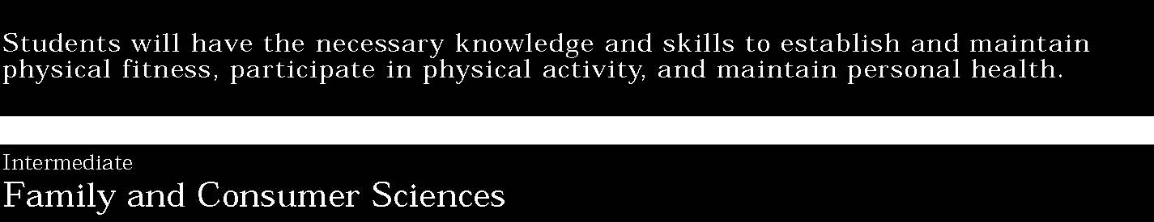
1. Students will use an understanding of the elements of good nutrition to plan appropriate diets for themselves and others. They will know and use the appropriate tools and technologies for safe and healthy food preparation.
Students:
- understand the relationships among diet, health, and physical activities; evaluate their own eating patterns; and use appropriate technology and resources to make food selections and prepare simple, nutritious meals
- apply principles of food safety and sanitation
- recognize the mental, social, and emotional aspects of good health
- apply decision making process to dilemmas related to personal health.

This is evident, for example, when students:
- plan a personal diet that accommodates nutritional needs, activity level, and optimal weight
- prepare a meal with foods from the food groups described in the food guide pyramid, handling food safely to avoid contamination, and using appropriate cooking equipment safely and responsibly
- practice techniques to help reduce stress (e.g., time management)
- identify the impact risky behavior can have on long-term goals (e.g., health, career).

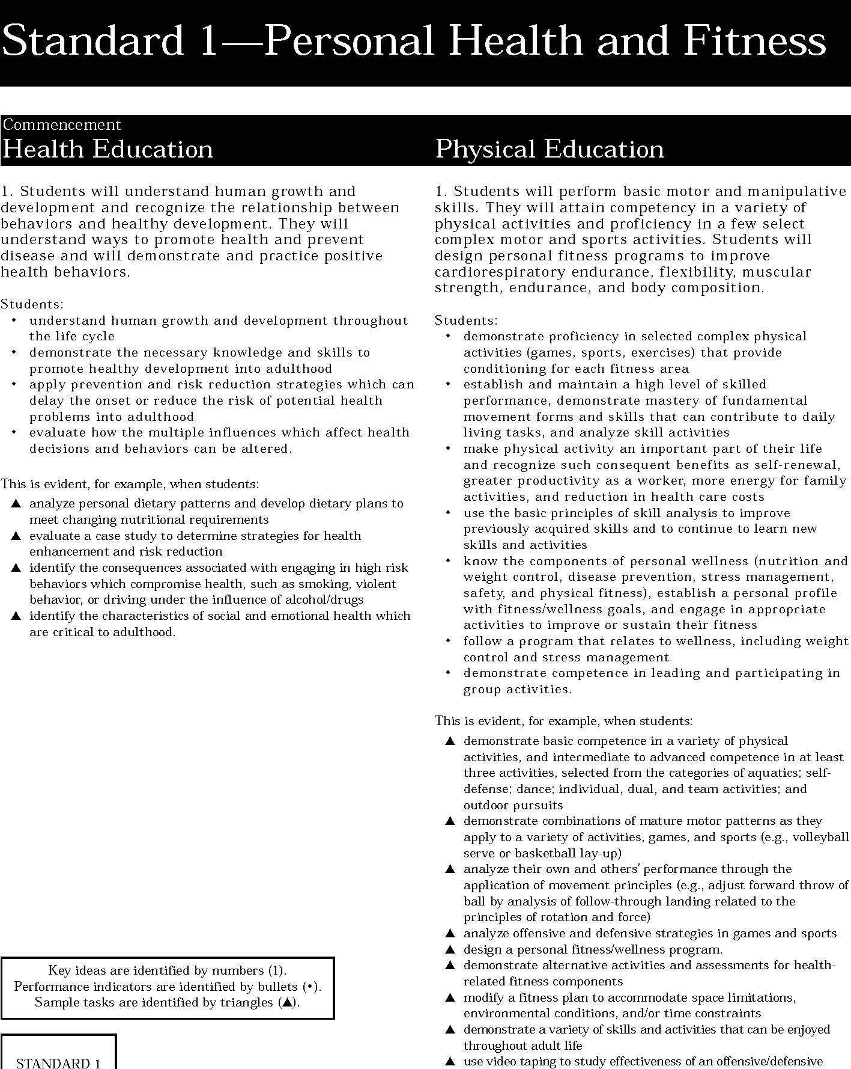
1. Students will perform basic motor and manipulative skills. They will attain competency in a variety of physical activities and proficiency in a few select complex motor and sports activities. Students will design personal fitness programs to improve cardiorespiratory endurance, flexibility, muscular strength, endurance, and body composition.
Students:
- demonstrate proficiency in selected complex physical activities (games, sports, exercises) that provide conditioning for each fitness area
- establish and maintain a high level of skilled performance, demonstrate mastery of fundamental movement forms and skills that can contribute to daily living tasks, and analyze skill activities
- make physical activity an important part of their life and recognize such consequent benefits as self-renewal, greater productivity as a worker, more energy for family activities, and reduction in health care costs
- use the basic principles of skill analysis to improve previously acquired skills and to continue to learn new skills and activities
- know the components of personal wellness (nutrition and weight control, disease prevention, stress management, safety, and physical fitness), establish a personal profile with fitness/wellness goals, and engage in appropriate activities to improve or sustain their fitness
- follow a program that relates to wellness, including weight control and stress management
- demonstrate competence in leading and participating in group activities.

This is evident, for example, when students:
- demonstrate basic competence in a variety of physical activities, and intermediate to advanced competence in at least three activities, selected from the categories of aquatics; self-defense; dance; individual, dual, and team activities; and outdoor pursuits
- demonstrate combinations of mature motor patterns as they apply to a variety of activities, games, and sports (e.g., volleyball serve or basketball lay-up)
- analyze their own and others’ performance through the application of movement principles (e.g., adjust forward throw of ball by analysis of follow-through landing related to the principles of rotation and force)
- analyze offensive and defensive strategies in games and sports
- design a personal fitness/wellness program.
- demonstrate alternative activities and assessments for health-related fitness components
- modify a fitness plan to accommodate space limitations, environmental conditions, and/or time constraints
- demonstrate a variety of skills and activities that can be enjoyed throughout adult life
- use video taping to study effectiveness of an offensive/defensive strategy.

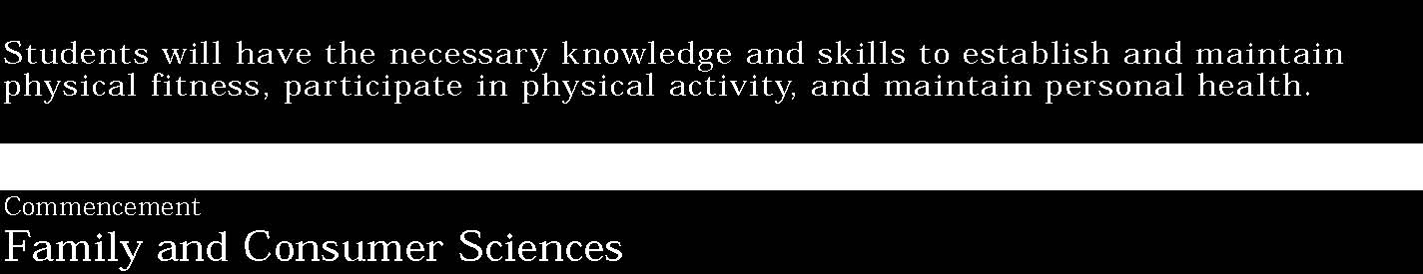
1. Students will use an understanding of the elements of good nutrition to plan appropriate diets for themselves and others. They will know and use the appropriate tools and technologies for safe and healthy food preparation.
Students:
- apply knowledge of food choices and menus to plan a balanced diet, use new technologies to plan and prepare nutritious meals for a variety of dietary needs
- adjust their own diet to accommodate changing levels of activity or to meet their nutritional needs throughout the life cycle
- identify ways to meet basic needs of all family members
- take reasoned action toward reaching personal health goals.

This is evident, for example, when students:
- plan and prepare meals that meet the nutritional needs and dietary restrictions of each family member (e.g., reduce sugar for a diabetic, reduce fat and sodium for those at risk for heart disease)
- create family menus taking into consideration budget, individual tastes, and family schedules over a period of time
- use current technology for diet analysis, meal planning, and food preparation
- are aware of and can access community resources available for helping with dietary needs
- practice communication skills that foster positive interpersonal relationships and optimum health for all family members
- apply decision making process to health-related situations.

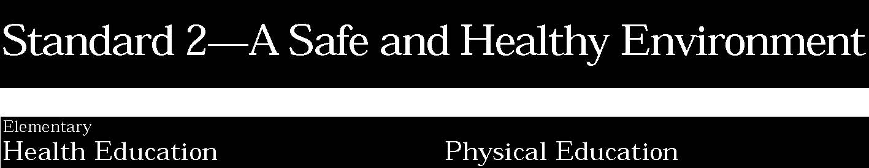

1. Students will demonstrate personally and socially responsible behaviors. They will care for and respect themselves and others. They will recognize threats to the environment and offer appropriate strategies to minimize them.
Students:
- understand basic safety rules
- recognize potentially dangerous situations and know how to avoid or reduce their risk
- know some personal and social skills which contribute to individual safety
- recognize characteristics of the environment that contribute to health.

This is evident, for example, when students:
- describe personal safety rules to avoid such things as abuse, abduction, poisoning, and accidents
- discuss how following safety rules help to protect people at home and in the school and community
- apply safety rules to prevent injury
- demonstrate ways to avoid and reduce threatening situations
- identify ways to care for and show respect for self and others
- demonstrate refusal skills to protect health
- identify ways to protect and preserve a healthy environment
- develop a safety plan for healthy living.

Key ideas are identified by numbers (1). Performance indicators are identified by bullets (•). Sample tasks are identified by triangles (▲).
1. Students will demonstrate responsible personal and social behavior while engaged in physical activity. They will understand that physical activity provides the opportunity for enjoyment, challenge, self-expression, and communication. Students will be able to identify safety hazards and react effectively to ensure a safe and positive experience for all participants.
Students:
- contribute to a safe and healthy environment by observing safe conditions for games, recreation, and outdoor activities
- come to know and practice appropriate participant and spectator behaviors to produce a safe and positive environment
- work constructively with others to accomplish a variety of goals and tasks
- know how injuries from physical activity can be prevented or treated
- demonstrate care, consideration, and respect of self and others during physical activity.

This is evident, for example, when students:
- handle equipment safely
- wear proper attire and protective gear as necessary
- demonstrate appropriate skill in fundamental movement tasks (e.g., lifting, carrying, climbing)
- properly use facilities with attention to safety hazards
- create a dance with a partner that combines movement to music from a specific culture
- modify a game so that individuals with less ability may participate more
- demonstrate self-control and the ability to cope with success and failure
- take turns in playing various roles in games
- follow directions to perform safely and correctly
- accept teammates regardless of ability and treat opponents with respect and courtesy
- know and demonstrate practices necessary to insure safe conditions for physical activity
- demonstrate responsible personal and social behavior while engaged in physical activities.

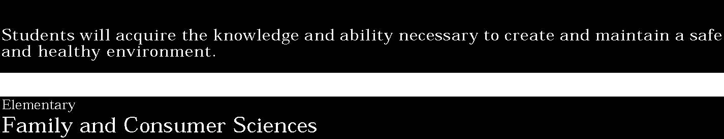

1. Students will know the basic principles of home and community safety. They can demonstrate the skills necessary to maintain their homes and workplaces in a safe and comfortable condition. They can provide a safe and nurturing environment for themselves and others.
Students:
- understand some basic requirements of nurturing people of various ages, and demonstrate appropriate ways to interact with them
- know some conditions necessary for a safe and healthy home and school environment and recognize the various ways individuals contribute to that environment.

This is evident, for example, when students:
- demonstrate procedures to be followed in case of fire, floods, other natural disasters, or personal danger
- describe procedures for safe handling and storage of hazardous materials (e.g., cleaning materials)
- describe aspects of a nurturing and safe environment for self and others
- assist with simple classroom maintenance by disposing of litter properly and keeping aisles and doorways free of obstacles
- describe safe and appropriate toys and activities for young children at different ages
- demonstrate procedures for getting emergency assistance (e.g., calling a neighbor, 911, police)
- maintain personal belongings.

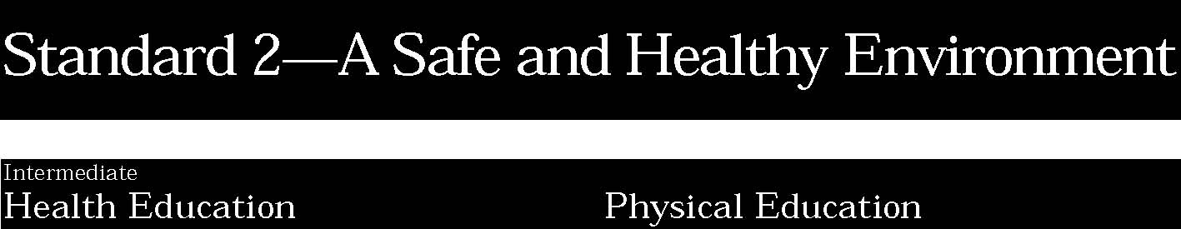

1. Students will demonstrate personally and socially responsible behaviors. They will care for and respect themselves and others. They will recognize threats to the environment and offer appropriate strategies to minimize them.
Students:
- assess potentially dangerous situations and demonstrate the skills to avoid or reduce their risks
- demonstrate personal and social skills which enhance personal health and safety
- understand the need for personal involvement in improving the environment.

This is evident, for example, when students:
- demonstrate conflict management and negotiation skills
- analyze how environment and personal health are inter-related
- analyze the possible causes of conflict among youth in schools and communities
- identify strategies to avoid or reduce threatening peer situations
- apply safety rules in situations which have the potential for harm
- demonstrate ways to care for and show respect for self and others
- demonstrate accurate use of the heimlich manuver.

Key ideas are identified by numbers (1). Performance indicators are identified by bullets (•). Sample tasks are identified by triangles (▲).
1. Students will demonstrate responsible personal and social behavior while engaged in physical activity. They will understand that physical activity provides the opportunity for enjoyment, challenge, self-expression, and communication. Students will be able to identify safety hazards and react effectively to ensure a safe and positive experience for all participants.
Students:
- understand the risks of injury if physical activity is performed incorrectly or performed in extreme environmental conditions, and recognize the importance of safe physical conditions (equipment, facilities) as well as the emotional conditions essential for safety
- develop skills of cooperation and collaboration, as well as fairness, sportsmanship, and respect for others
- work constructively with others to accomplish a goal in a group activity, demonstrating consideration for others involved
- understand the physical and environmental dangers associated with particular activities and demonstrate proper procedures for safe participation in games, sports, and recreational pursuits
- understand the role of physical activity, sport, and games as a balance between cooperative and competitive behaviors and as a possible arena in which to develop and sharpen leadership and problem solving skills, and understand the physical, emotional, and social benefits of participation in physical activities.

This is evident, for example, when students:
- describe risks and preventive measures associated with being physically active in the extreme heat or cold
- analyze facilities and equipment in the gymnasium and fields for possible safety hazards and demonstrate proper use and care of equipment
- identify and take precautions to avoid hazards associated with outdoor activities (e.g., proper clothing and equipment for hiking, cycling, cross country skiing)
- in group challenge activities, take various roles in turn (sometimes leading the team and sometimes supporting the team) in order to accomplish group goals
- demonstrate concern for the safety of all others, including opponents, when engaged in competitive activities
- demonstrate appropriate player and spectator behavior
- show respect to all players regardless of ability, acknowledging the accomplishments of the other players
- adhere to the rules and conventions of an activity in order to participate in a worthwhile competitive experience.

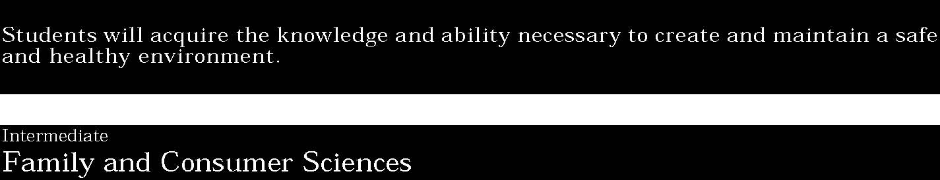

1. Students will know the basic principles of home and community safety. They can demonstrate the skills necessary to maintain their homes and workplaces in a safe and comfortable condition. They can provide a safe and nurturing environment for themselves and others.
Students:
- demonstrate the principles of safe and healthy child care
- know the basics of managing a safe and healthy home
- use age-appropriate techniques to select and maintain clothing.

This is evident, for example, when students:
- describe the normal range of differences among children of the same age and respond appropriately to the different abilities
- describe and demonstrate safe and healthy procedures for clothing, feeding, and supervising children at various stages of development
- appropriately interact with younger children entrusted to their care
- develop a fire safety plan for the home
- develop a list of telephone numbers that would be useful in emergency situations
- demonstrate skills related to a wide variety of household tasks
- use and store appliances, cleaning materials, and tools properly and safely
- read labels and evaluate products for selection, use, and safety
- maintain and organize personal property and living space
- demonstrate appropriate clothing care, maintainance, and selection.

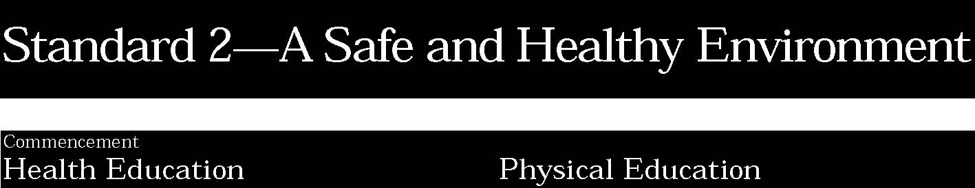

1. Students will demonstrate personally and socially responsible behaviors. They will care for and respect themselves and others. They will recognize threats to the environment and offer appropriate strategies to minimize them.
Students:
- recognize hazardous conditions in the home, school, work place, and community and propose solutions to eliminate or reduce them
- evaluate personal and social skills which contribute to health and safety of self and others
- recognize how individual behavior affects the quality of the environment.

This is evident, for example, when students:
- design and implement a plan to improve safety in the home, school, workplace or community
- use universal precautions and apply first aid, CPR. and other emergency procedures appropriately
- describe and demonstrate appropriate strategies to avoid or cope with potentially dangerous situations, such as dating violence or assault
- develop community approaches which enhance and protect the quality of the environment
- analyze how health laws, policies and regulations protect personal and environmental safety
- demonstrate ways to care for and show respect for self and others.

Key ideas are identified by numbers (1). Performance indicators are identified by bullets (•). Sample tasks are identified by triangles (▲).
1. Students will demonstrate responsible personal and social behavior while engaged in physical activity. They will understand that physical activity provides the opportunity for enjoyment, challenge, self-expression, and communication. Students will be able to identify safety hazards and react effectively to ensure a safe and positive experience for all participants.
Students:
- know the potential safety hazards associated with a wide variety of games and activities and are able to prevent and respond to accidents
- demonstrate responsible personal and social behavior while engaged in physical activities
- accept physical activity as an important part of life. Self-renewal, productivity as a worker, energy for family activities, fitness, weight control, stress management, and reduction in health-care costs are understood as benefits of physical activity
- create a positive climate for group activities by assuming a variety of roles
- understand the physical, social, and emotional benefits of physical activity and can demonstrate leadership and problem solving through participation in organized games or activities.

This is evident, for example, when students:
- plan an activity to provide for the safety of participants, taking into consideration the physical abilities of the participants, the conditions of the facility, and the equipment available
- describe the dangers of overexertion, hypothermia, and heat exhaustion in outdoor activities, with some preventive measures and first aid treatments for each
- identify responsible action and available resources that can be used in the event of an accident or illness incurred during physical activity
- take on the role of a coach, responsible for problem solving and conflict management on behalf of the team
- demonstrate a sensitivity and respect for all individuals, regardless of ability, gender, or other characteristics
- practice fairness, self-control, and initiative when assuming the role of captain or official
- model sportsmanlike behavior.

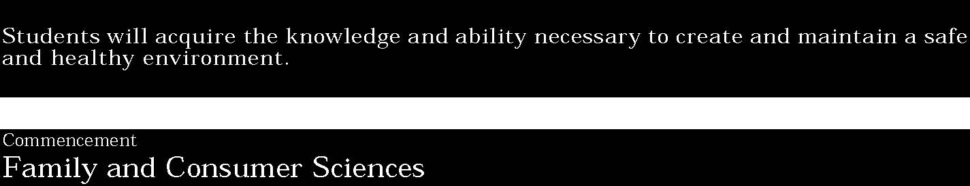

1. Students will know the basic principles of home and community safety. They can demonstrate the skills necessary to maintain their homes and workplaces in a safe and comfortable condition. They can provide a safe and nurturing environment for themselves and others.
Students:
- understand the stages of child development and apply this knowledge to activities designed to enrich the physical, social, mental, and emotional development of a young child
- apply housing principles (e.g., design and safety) to meet the needs of family members of all ages and abilities
- understand essential requirements for selecting and maintaining a home
- apply basic rules of health and safety to a variety of home and work place situations.

This is evident, for example, when students:
- plan a daily program of balanced activity for preschoolers based on knowledge and understanding of patterns of child growth and development
- describe effective ways of promoting positive behavior in children
- identify characteristics of a safe and nurturing home and work environment
- describe criteria for home selection (e.g., safety for children, access for handicapped family members, environmental concerns)
- identify safety risks in case studies related to the home and workplace
- identify ways in which to childproof a home.

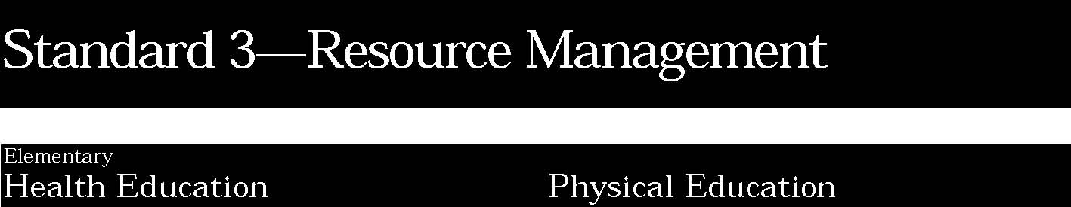
1. Students will understand the influence of culture, media, and technology in making decisions about personal and community health issues. They will know about and use valid health information, products, and services. Students will advocate for healthy families and communities.
Students:
- identify characteristics of valid health information and health-promoting products and services and know where to locate them
- understand how culture contributes to individual family and community beliefs and practices affecting health
- know how to access help when illness, injury, or emergency situations occur
- recognize how the media influences health choices.

This is evident, for example, when students:
- describe how to access resources in the home, school and community to assist with health problems
- demonstrate how to use “911” or similar emergency services
- describe how culture influences personal health behaviors such as selection of food
- identify the ways various media promote products and services that influence health choices.

Key ideas are identified by numbers (1). Performance indicators are identified by bullets (•). Sample tasks are identified by triangles (▲).
1. Students will be aware of and able to access opportunities available to them within their community to engage in physical activity. They will be informed consumers and be able to evaluate facilities and programs. Students will also be aware of some career options in the field of physical fitness and sports.
Students:
- know that resources available at home and in the community offer opportunities to participate in and enjoy a variety of physical activities in their leisure time
- become discriminating consumers of fitness information, health-related fitness activities in their communities, and fitness and sports equipment
- demonstrate the ability to apply the decision making process to physical activity.

This is evident, for example, when students:
- identify community facilities for recreational activities, such as parks, swimming pools, and skating rinks
- identify community programs, such as YMCA/YWCA, Boys/Girls Clubs, Sport Camps, Youth Sports Leagues
- describe how the family influences one’s physical activity
- identify community agencies that advocate for physically active individuals, families, and communities.

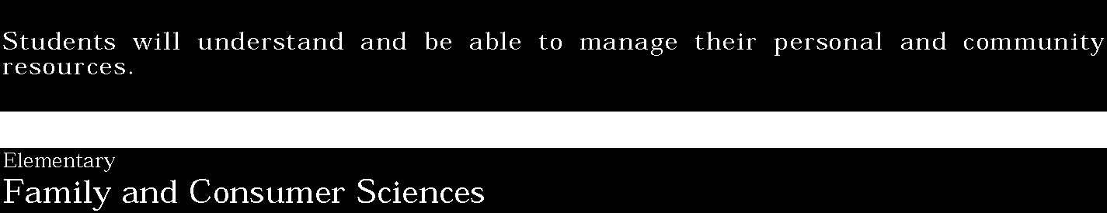
1. Students will understand and be able to manage personal resources of talent, time, energy, and money and make effective decisions in order to balance their obligations to work, family, and self. They will nurture and support positive relationships in their homes, workplaces, and communities. They will develop and use their abilities to contribute to society through pursuit of a career and commitment to long-range planning for their personal, professional, and academic futures. They will know and access community resources.
Students:
- understand the kinds of resources available in their community and make informed decisions related to their own use
- understand how people acquire, use, and protect money and recognize some factors that influence spending
- know the different jobs in their communities and the contributions made by individuals performing those jobs.

This is evident, for example, when students:
- use the decision making process to make informed decisions related to their own resources of talent, time, energy, and money
- identify family, school, and community members who can assist with personal decisions
- participate in a school community service project (e.g., water conservation or recycling program)
- select clothing appropriate for their activities
- describe the relationship between jobs and money
- identify some procedures for keeping money safe
- contribute to a class decision on how to raise and spend funds
- identify specific careers related to personal interests.

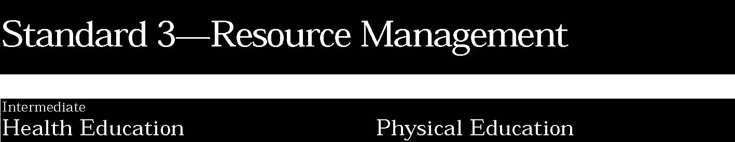
1. Students will understand the influence of culture, media, and technology in making decisions about personal and community health issues. They will know about and use valid health information, products, and services. Students will advocate for healthy families and communities.
Students:
- distinguish between valid and invalid health information, products and services
- recognize how cultural beliefs influence health behaviors and the use of health services
- demonstrate the ability to work cooperatively when advocating for healthy individuals, families and schools
- analyze how media and technology influence the selection of health information, products and services
- recognize the need to be an advocate for family and community health
- demonstrate the ability to access community health services for prevention, illness, and emergency care.

This is evident, for example, when students:
- explain how community norms contribute to health
- identify family and community health issues and propose various solutions to address them
- analyze how information from peers influences health decisions and behaviors
- explain how the timely use of health care services can prevent premature death and disability
- identify community agencies which advocate for healthy families and communities
- analyze the consequences of invalid information on the health of individuals, families and communities
- analyze cultural influences on health and the use of health services.

Key ideas are identified by numbers (1). Performance indicators are identified by bullets (•). Sample tasks are identified by triangles (▲).
1. Students will be aware of and able to access opportunities available to them within their community to engage in physical activity. They will be informed consumers and be able to evaluate facilities and programs. Students will also be aware of some career options in the field of physical fitness and sports.
Students:
- should be informed consumers, aware of the alternatives available to them within their communities for physical activity and should be able to evaluate facilities and programs available
- demonstrate the ability to locate physical activity information, products, and services
- know some career options in the field of physical fitness and sports.

This is evident, for example, when students:
- plan and participate in family and community activities
- describe the difference between good-quality equipment and inferior equipment
- participate in community-sponsored sports programs
- describe some career choices in fitness and sports fields, including the required academic training and job responsibilities.

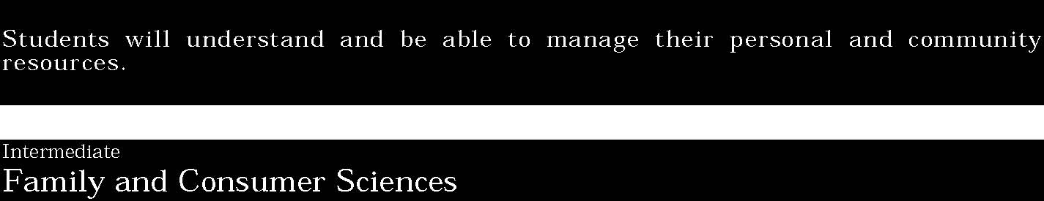
1. Students will understand and be able to manage personal resources of talent, time, energy, and money and make effective decisions in order to balance their obligations to work, family, and self. They will nurture and support positive relationships in their homes, workplaces, and communities. They will develop and use their abilities to contribute to society through pursuit of a career and commitment to long-range planning for their personal, professional, and academic futures. They will know and access community resources.
Students:
- understand how the family can provide for the economic, physical, and emotional needs of its members
- understand the resources available to them, make informed decisions about the use of those resources, and know some ways to expand resources
- are able to budget their time and money
- understand how working contributes to a quality living environment
- identify their own abilities and interests as possible guides to career choice.

This is evident, for example, when students:
- explain ways that families can provide for the economic, physical, and emotional needs of its members
- explain wise use of resources and energy conservation, describing the relationships between family decisions and the environment
- analyze space needs to accommodate purposes such as individual and group activity in a household
- select, care for, and repair clothing
- identify community resources that help families and individuals
- plan a schedule to provide time for schoolwork, recreation and exercise, family activity, and adequate sleep
- develop a personal financial plan, keeping in mind short- and long-term goals
- analyze the influence of marketing and advertisements on purchases
- read and understand labels and consumer information to make informed purchases
- set short- and long-term career goals and take some steps toward those goals (e.g., selecting particular courses of study, visiting workplaces with parents or other relatives)
- analyze their involvement in school and community activities to develop an inventory of experiences and abilities related to career interests
- apply decision making, problem solving, and management skills in everyday situations
- participate in youth leadership organizations.

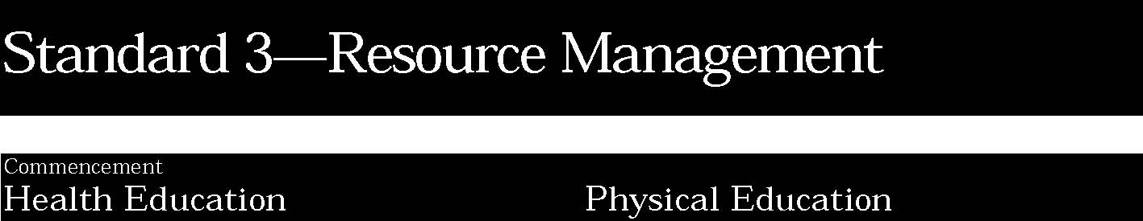
1. Students will understand the influence of culture, media, and technology in making decisions about personal and community health issues. They will know about and use valid health information, products, and services. Students will advocate for healthy families and communities.
Students:
- demonstrate how to evaluate health information, products and services for validity and reliability
- analyze how cultural beliefs influence health behaviors and the use of health products and services
- demonstrate the ability to access community health services for self and others
- use technology and the media to promote positive health messages
- demonstrate advocacy skills in promoting individual, family and community health.

This is evident, for example, when students:
- identify local, state and federal agencies which provide health information and are regulating health products and services
- describe how to obtain health services appropriate for individual needs and how to refer friends and family members to appropriate health services or providers
- identify criteria to measure the accuracy, reliability and validity of claims for health care products and services
- design a media campaign which promotes a positive health message
- analyze how cultural diversity enriches and challenges health behaviors
- assess the internet to assist in research for senior project.

Key ideas are identified by numbers (1). Performance indicators are identified by bullets (•). Sample tasks are identified by triangles (▲).
1. Students will be aware of and able to access opportunities available to them within their community to engage in physical activity. They will be informed consumers and be able to evaluate facilities and programs. Students will also be aware of some career options in the field of physical fitness and sports.
Students:
- recognize their role as concerned and discriminating consumers of physical activities programs and understand the importance of physical activity as a resource for everyone regardless of age or ability
- recognize the benefits of engaging in appropriate physical activities with others, including both older and younger members of the community
- identify a variety of career opportunities associated with sports and fitness and understand the qualifications, educational requirements, and job responsibilities of those careers.

This is evident, for example, when students:
- examine fitness and health clubs’ criteria for quality and service
- analyze media ads and marketing practices for fitness and sports equipment
- mentor younger children in sport or recreational activities
- plan and participate in activities with other family members and friends, regardless of age or ability
- adapt physical activities to accommodate the various interests, ages, or abilities of participants
- demonstrate the ability to access school and community physical activity services for self and others
- develop strategies to improve or maintain personal, family, and community physical activity
- analyze how the availability of and information about community programs encourages physical participation in physical activity
- investigate a career in the sport or fitness field and research the job responsibility qualifications and opportunities that exist for professional advancement.

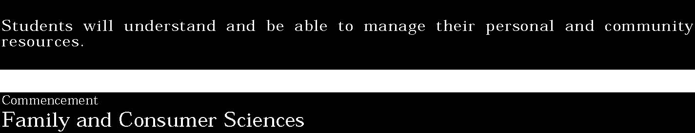
1. Students will understand and be able to manage personal resources of talent, time, energy, and money and make effective decisions in order to balance their obligations to work, family, and self. They will nurture and support positive relationships in their homes, workplaces, and communities. They will develop and use their abilities to contribute to society through pursuit of a career and commitment to long-range planning for their personal, professional, and academic futures. They will know and access community resources.
Students:
- analyze a wide range of factors related to managing personal resources to balance obligations to work, family, and self
- understand the basics of an individual/family budget and plan to obtain, use, and protect money and assets
- analyze abilities and interests in relation to careers, set long-term career goals, and develop a plan for progressing toward their goals
- understand the concept of entrepreneurship as it exists in today’s economy
- develop job skills (e.g., communication, effective time management, problem solving, and leadership).

This is evident, for example, when students:
- describe the variety of banking services available and the procedures for acquiring and using a bank account
- identify consumer rights and responsibilities and consumer organizations and services available
- compare products before purchase (e.g., price, quality, efficiency, and warranties)
- demonstrate how to analyze purchased items for defects and how to make consumer complaints
- participate in work or volunteer experiences to explore career choices
- investigate and assess entrepreneurial career options (e.g., in early childhood, home design, fashion technology, food service)
- identify educational needs to prepare for a chosen career
- demonstrate skills necessary to obtain and keep a job
- develop a financial plan for a career interest including educational costs, supplies, transportation, and clothing
- adjust, adapt, and improvise personal resources in response to the work environment
- are able to keep a checkbook balanced using a computer program.

20

The samples of student work included in this section are intended to begin the process of articulating the performance standards at each level of achievement. This collection is not yet adequate for that purpose in either numbers or scope of examples. As New York State continues to collect work samples from the schools for inclusion in the document, we expect a much clearer understanding of the performance standards to be evident.
Neither are these samples presented as models of excellence. They vary in degree of achievement. Some are “acceptable;” others “more proficient.” All are meant to provide examples of the kind of work students might produce to demonstrate progress toward the standard.

