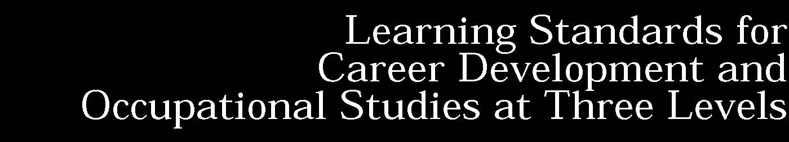

CAREER PLAN as prescribed in these learning standards is intended to promote exploration and research into broad career areas of interest to individual students. Basic principles of career planning such as decision-making, self-evaluation, and goal setting have been integrated within the sample tasks. It is not the intent of these learning standards to limit options or narrowly define the educational preparation of students.
Standard 1: | Career Development Students will be knowledgeable about the world of work, explore career options, and relate personal skills, aptitudes, and abilities to future career decisions.
Standard 2: | Integrated Learning Students will demonstrate how academic knowledge and skills are applied in the workplace and other settings.
Standard 3a: | Universal Foundation Skills Students will demonstrate mastery of the foundation skills and competencies essential for success in the workplace.
 | and
Standard 3b: | Career Majors Students who choose a career major will acquire the career-specific technical knowledge/skills necessary to progress toward gainful employment, career advancement, and success in postsecondary programs.

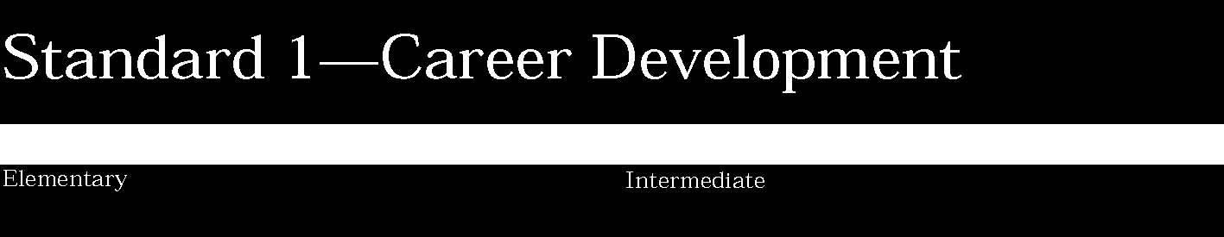

1. Students will learn about the changing nature of the workplace, the value of work to society, and the connection of work to the achievement of personal goals.
Students:
- begin a career plan that would assist in the transition from school to eventual entry into a career option
- demonstrate an awareness of their interests, aptitudes, and abilities
- know the value of work to the individual and society in general
- describe the changing nature of the workplace brought about by global competition and technology
- explore their preferences for working with people, information, and/or things
- demonstrate understanding of the relationship of decision making to the attainment of future goals
- describe the changing roles of men and women at home and in the workplace.

This is evident, for example, when students:
- classify hobbies, favorite school subjects, interests, and special talents with their relationship to working with people, information, or things*
- identify favorite school subjects and special talents and relate them to specific occupations*
- explain reasons why people work, describe different occupations in their community, including those in public service, and how these occupations benefit others (e.g., firefighter, police officer, pharmacist, attorney, teacher)
- identify long-range personal goals and relate their attainment to successful employment*
- identify common skills that would be important for success in the workplace and relate them to personal strengths and areas in need of improvement*
- describe nontraditional career options and provide examples of how the roles of men and women are changing in the home, workplace, and community (e.g., women in law enforcement and men in nursing)
- explain how global competition and technology have changed three specific occupations
- relate the negative impact of unemployment to the health of the individual and the economy in general.

Key ideas are identified by numbers (1). Performance indicators are identified by bullets (•). Sample tasks are identified by triangles (▲). Sample tasks appropriate for inclusion in a student’s career plan are followed by (*).

1. Students will learn about the changing nature of the workplace, the value of work to society, and the connection of work to the achievement of personal goals.
Students:
- continue development of a career plan that would assist in the transition from school to eventual entry into a career option of their choosing
- demonstrate an understanding of the relationship among personal interests, skills and abilities, and career research
- understand the relationship of personal interests, skills, and abilities to successful employment
- demonstrate an understanding of the relationship between the changing nature of work and educational requirements
- understand the relationship of personal choices to future career decisions.

This is evident, for example, when students:
- identify characteristics and educational requirements of three career options, including those considered nontraditional*
- reassess personal interests and abilities and match them to career options*
- contrast the advantages and disadvantages of working for someone else with owning a business
- reevaluate long-range personal goals, including employment priorities such as salary, working conditions, and status*
- explain the importance of punctuality, dependability, integrity, and getting along with others for success in a work environment
- work cooperatively in group situations and analyze the importance of using collective abilities in achieving group goals and objectives*
- explain through example how work can influence an individual’s life style.

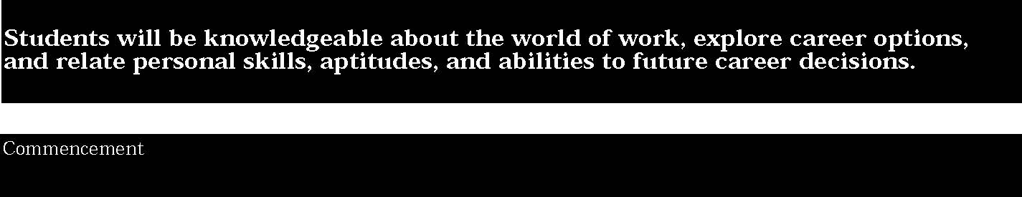

1. Students will learn about the changing nature of the workplace, the value of work to society, and the connection of work to the achievement of personal goals.
Students:
- complete the development of a career plan that would permit eventual entry into a career option of their choosing
- apply decision-making skills in the selection of a career option of strong personal interest
- analyze skills and abilities required in a career option and relate them to their own skills and abilities.

This is evident, for example, when students:
- reevaluate long-range personal goals and match them to a career option*
- prepare a personal balance sheet showing an inventory of acquired skills, qualities, and experiences needed for successful employment in a career option*
- prepare a research paper that contains: -details of three specific jobs within the career option -the education and/or training level and qualifications

necessary for entry-level/career-sustaining employment -the number of job openings in the career option -list of three postsecondary programs offering advanced
study/training in the career option -entrepreneurial possibilities*
- develop resumes and letters of application and demonstrate effective interviewing techniques that could be used to gain entry into a career option*
- design a personal school-to-work plan containing specific steps/activities toward attainment of a career goal.*



1. Integrated learning encourages students to use essential academic concepts, facts, and procedures in applications related to life skills and the world of work. This approach allows students to see the usefulness of the concepts that they are being asked to learn and to understand their potential application in the world of work.
Students:
- identify academic knowledge and skills that are required in specific occupations
- demonstrate the difference between the knowledge of a skill and the ability to use the skill
- solve problems that call for applying academic knowledge and skills.

This is evident, for example, when students:
- describe jobs in the local community; list academic knowledge and technical skills needed to perform a specific job, and make a diorama showing a person engaged in work*
- retell a story about how a school cafeteria employee uses mathematical and English language arts skills on the job
- interview a person from the community in an occupation of interest and describe for the class how the competencies they are learning in school (mathematics, science, health, English language arts) are used in the selected occupation
- integrate mathematical/science concepts to plan and design a garden, basketball court, or fish pond
- describe jobs in the local community, list academic knowledge and technical skills needed to perform a specific job, and make a diorama showing a person engaged in work
- apply mathematical skills to purchase items from a grocery store, compare prices, total their purchases, and count change
- explain why being able to tell time is important to an airline pilot, a football referee, or a teacher
- participate in a show-and-tell exercise to inform their classmates how reading, writing, speaking, and mathematics are used by a poet, musician, nurse, clown, or police officer
- select four samples of their work (completed hands-on projects depicting various occupations) and describe the academic knowledge and technical skills needed for those particular jobs.*

Key ideas are identified by numbers (1). Performance indicators are identified by bullets (•). Sample tasks are identified by triangles (▲). Sample tasks appropriate for inclusion in a student’s career plan are followed by (*).

1. Integrated learning encourages students to use essential academic concepts, facts, and procedures in applications related to life skills and the world of work. This approach allows students to see the usefulness of the concepts that they are being asked to learn and to understand their potential application in the world of work.
Students:
- apply academic knowledge and skills using an interdisciplinary approach to demonstrate the relevance of how these skills are applied in work-related situations in local, state, national, and international communities
- solve problems that call for applying academic knowledge and skills
- use academic knowledge and skills in an occupational context, and demonstrate the application of these skills by using a variety of communication techniques (e.g., sign language, pictures, videos, reports, and technology).

This is evident, for example, when students:
- match an inventory of academic knowledge and technical skills to specific careers in which they would be useful
- prepare job descriptions with emphasis on language arts and mathematic requirements
- work in teams to complete a promotional campaign, applying the principles of various disciplines (e.g., art, music, language arts and languages other than English) to sell products on a national level*
- attend a school or community theater production and then interview the director, cast, and stage crew, and prepare a presentation illustrating academic knowledge and technical skills applied in various theater careers*
- complete a project that demonstrates how two or more academic disciplines are applied to implement news media presentations
- prepare a report based on a shadowing experience, describing the various jobs observed and the academic knowledge and technical skills needed for these jobs
- use mathematical skills to compute performance statistics for a school athletic team
- edit the work of other students for a school newsletter
- use language arts skills to evaluate a student debate
- select six samples of their work (completed hands-on projects depicting various occupations) and describe the academic knowledge and technical skills that are applied for occupations.*

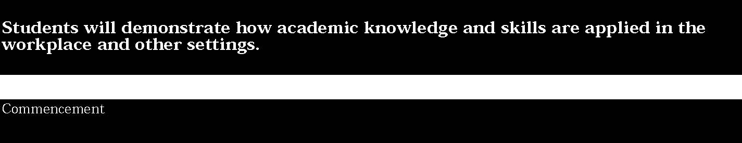

1. Integrated learning encourages students to use essential academic concepts, facts, and procedures in applications related to life skills and the world of work. This approach allows students to see the usefulness of the concepts that they are being asked to learn and to understand their potential application in the world of work.
Students:
- demonstrate the integration and application of academic and occupational skills in their school learning, work, and personal lives.
- use academic knowledge and skills in an occupational context, and demonstrate the application of these skills by using a variety of communication techniques (e.g., sign language, pictures, videos, reports, and technology)
- research, interpret, analyze, and evaluate information and experiences as related to academic knowledge and technical skills when completing a career plan.

This is evident, for example, when students:
- read a series of job descriptions or training plans of interest to identify the necessary application of academic knowledge and technical skills that are required for particular careers as well as the job outlook (decline/growth) and possible earnings*
- interview a medical specialist and develop a presentation using a variety of tools/technology to depict knowledge and skills that are required for this career*
- select several local employers as well as employers with global operations and complete a project (e.g., video, photo collage, or report) that reflects the academic knowledge and technical skills required, along with the job outlook and potential earning capacity in a competitive international marketplace*
- complete an internship which focuses on a particular career of interest (e.g., architect, electrician, or veterinarian) and develop a slide presentation to demonstrate how concepts from mathematics, science, and/or English language arts are applied in a particular career*
- work in teams to formulate a historical presentation on specific careers and demonstrate how job requirements and training are changing due to new technology
- use various forms of technology and communication techniques (e.g., a CD-ROM, a video, slide show and sign language) to describe and illustrate how societal, economic, and governmental changes may require exploring a variety of careers and developing broad-based transferable skills that are needed for gainful employment*
- produce an annual career plan that includes eight samples of their work (e.g., completed hands-on projects, reports based on internships and/or depicting various occupations) and describe why they selected the particular samples of work, and indicate possible career choices of interest*
- use effective skills and techniques in a simulated job interview.

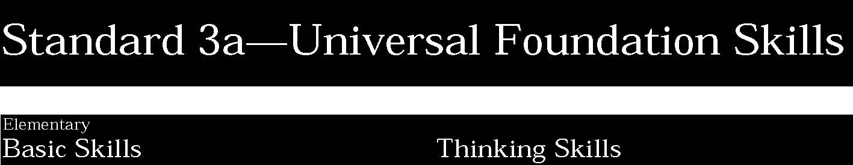

1. Basic skills include the ability to read, write, listen, and speak as well as perform arithmetical and mathematical functions.
Students:
• listen to and read the ideas of others and express themselves both orally and in writing; they use basic mathematical concepts and computations to solve problems.
This is evident, for example, when students:
- listen to and repeat simple directions
- read a variety of materials and prepare a report
- follow directions to power up a computer
- compile an inventory of office equipment
- use probability to solve a problem or use a single statistic to make a prediction
- measure an area for a swimming pool, basketball court, or employee work station.

Key ideas are identified by numbers (1). Performance indicators are identified by bullets (•). Sample tasks are identified by triangles (▲).

2. Thinking skills lead to problem solving, experimenting, and focused observation and allow the application of knowledge to new and unfamiliar situations.
Students:
• use ideas and information to make decisions and solve problems related to accomplishing a task.
This is evident, for example, when students:
- provide examples of ways to raise money for a school field trip
- solve a riddle, puzzle, or problem, using written or oral instructions
- set up a computer, a monitor, and a keyboard according to written or oral instructions.

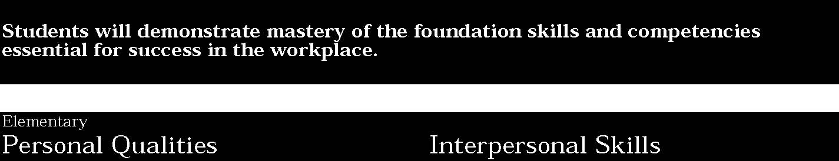

3. Personal qualities generally include competence in self-management and the ability to plan, organize, and take independent action.
Students:
• demonstrate the personal qualities that lead to responsible behavior.
This is evident, for example, when students:
- arrive at school and complete assignments on time; explain why these behaviors would be important to an employer
- provide examples of people acting responsibly/irresponsibly in the community
- complete an inventory of personal strengths and select areas in which they would like to improve
- demonstrate positive behaviors through interactions in the classroom (e.g., sharing resources, helping classmates).

4. Positive interpersonal qualities lead to teamwork and cooperation in large and small groups in family, social, and work situations.
Students:
• relate to people of different ages and from diverse backgrounds.
This is evident, for example, when students:
- work cooperatively with peers to accomplish a task
- describe, as models, successful people of varied backgrounds
- display skills needed to resolve conflicts with other people
- explain the importance of getting along with people in a work environment who are different from oneself.

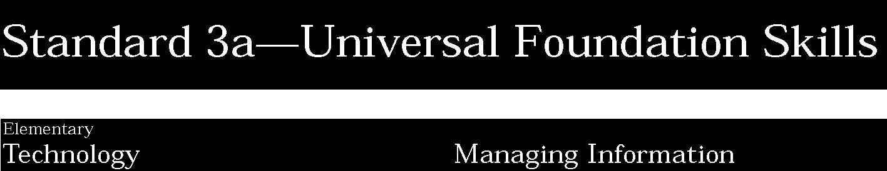

5. Technology is the process and product of human skill and ingenuity in designing and creating things from available resources to satisfy personal and societal needs and wants.
Students:
• demonstrate an awareness of the different types of technology available to them and of how technology affects society.
This is evident, for example, when students:
- select the appropriate technology for designing and creating a flyer for a school-sponsored event
- identify examples of technology found at home, at school, and in a business environment
- choose a career area and research how technology has changed that cluster of occupations.

Key ideas are identified by numbers (1). Performance indicators are identified by bullets (•). Sample tasks are identified by triangles (▲).

6. Information management focuses on the ability to access and use information obtained from other people, community resources, and computer networks.
Students:
• describe the need for data and obtain data to make decisions.
This is evident, for example, when students:
- explain the practical uses of weather forecasting data as it relates to the farm industry
- plan a school store and determine what items might sell best
- listen to a presentation about a career area and write a report summarizing the information.

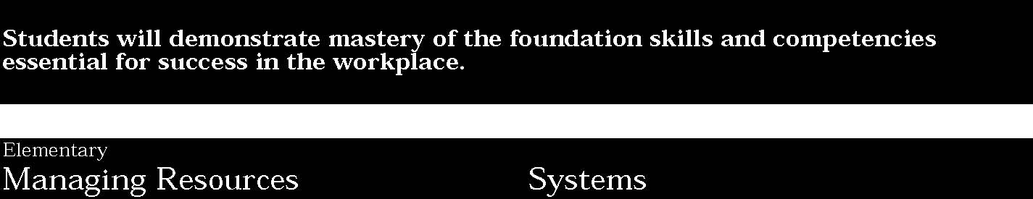

7. Using resources includes the application of financial and human factors, and the elements of time and materials to successfully carry out a planned activity.
Students:
• demonstrate an awareness of the knowledge, skills, abilities, and resources needed to complete a task.
This is evident, for example, when students:
- describe the resources needed to inventory the art supply cabinet in the classroom
- explain the resources needed to build a simple item (e.g., footstool, sandbox).

8. Systems skills include the understanding of and ability to work within natural and constructed systems.
Students:
• demonstrate understanding of how a system operates and identify where to obtain information and resources within the system.
This is evident, for example, when students:
- understand the process used to order supplies for a school store or local business
- explain the various components of the school system.

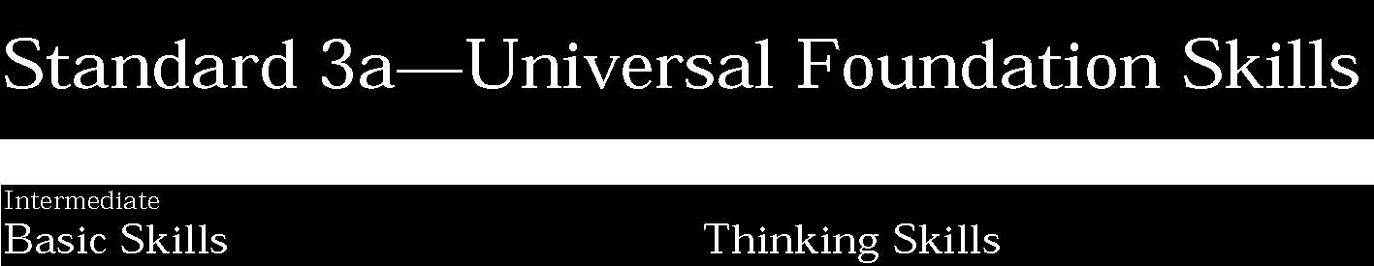

1. Basic skills include the ability to read, write, listen, and speak as well as perform arithmetical and mathematical functions.
Students:
• listen to and read the ideas of others and analyze what they hear and read; acquire and use information from a variety of sources; and apply a combination of mathematical operations to solve problems in oral or written form.
This is evident, for example, when students:
- follow directions that involve a series of actions
- locate and use information on a wide range of topics from many different sources
- present an oral report to the class after investigating several career clusters
- record data and prepare a graph on the movement of the stock market or a particular stock
- explore ways in which geometry is used in everyday life
- solve basic problems involving integers, fractions, and decimals.

Key ideas are identified by numbers (1). Performance indicators are identified by bullets (•). Sample tasks are identified by triangles (▲).
2. Thinking skills lead to problem solving, experimenting, and focused observation and allow the application of knowledge to new and unfamiliar situations.
Students:
• evaluate facts, solve advanced problems, and make decisions by applying logic and reasoning skills.
This is evident, for example, when students:
- describe the best method to evaluate customer interest in the establishment of a new product line for a business
- describe the best method to evaluate student interest in the establishment of a new school sport or club
- create a work schedule to ensure equity in employee hours and days worked
- sequence facts in a logical order to solve a problem.

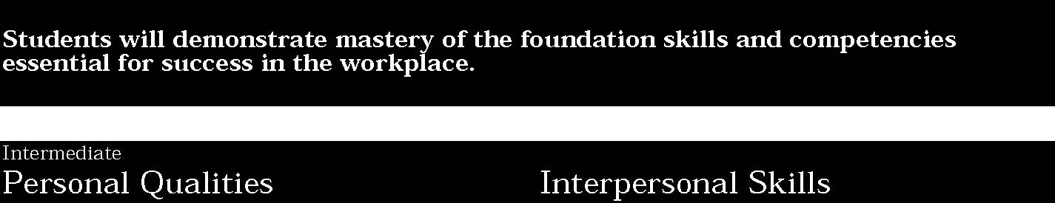

3. Personal qualities generally include competence in self-management and the ability to plan, organize, and take independent action.
Students:
• demonstrate an understanding of the relationship between individuals and society and interact with others in a positive manner.
This is evident, for example, when students:
- participate in a fund-raising activity in or out of school such as carwash, flower sale, etc. (refer to Regents Rule 19.6 governing student fund-raising)
- volunteer to participate in a local charitable organization’s activities
- work with other students on a group project to improve one aspect of the school’s operation.

4. Positive interpersonal qualities lead to teamwork and cooperation in large and small groups in family, social, and work situations.
Students:
• demonstrate the ability to work with others, present facts that support arguments, listen to dissenting points of view, and reach a shared decision.
This is evident, for example, when students:
- react positively to constructive criticism
- work as a member of a team toward a common goal.

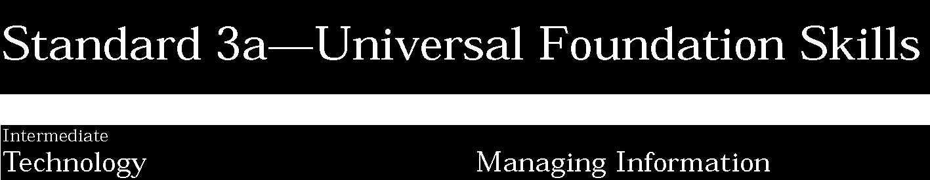

5. Technology is the process and product of human skill and ingenuity in designing and creating things from available resources to satisfy personal and societal needs and wants.
Students:
• select and use appropriate technology to complete a task.
This is evident, for example, when students:
- use a telecommunications service to check current airline schedules and price information for a trip to another state or country
- use appropriate technology to present information in table/chart form
- use word processing software to make an inquiry to a business
- make a presentation explaining how technology has changed the work site.

Key ideas are identified by numbers (1). Performance indicators are identified by bullets (•). Sample tasks are identified by triangles (▲).
6. Information management focuses on the ability to access and use information obtained from other people, community resources, and computer networks.
Students:
• select and communicate information in an appropriate format (e.g., oral, written, graphic, pictorial, multimedia).
This is evident, for example, when students:
- prepare a financial report showing the annual revenue and expenses of a business or club for three years and presenting that information to a group
- design a chart or graph to evaluate personal progress toward a goal or objective
- collect the necessary data from local employers to develop a speakers’ bureau for their school
- given directions, correctly complete a job application.

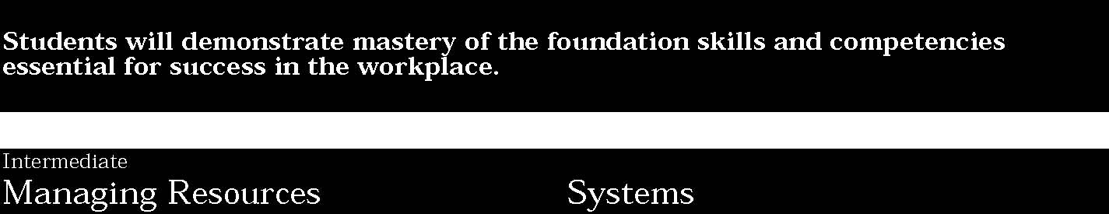

7. Using resources includes the application of financial and human factors, and the elements of time and materials to successfully carry out a planned activity.
Students:
• understand the material, human, and financial resources needed to accomplish tasks and activities.
This is evident, for example, when students:
- develop a plan for a work experience (e.g., lawn mowing, snow removal, paper route) by formulating a budget, allocating equipment, and recording expenses and income
- create and follow a personal schedule to maximize the use of time.

8. Systems skills include the understanding of and ability to work within natural and constructed systems.
Students:
• understand the process of evaluating and modifying systems within an organization.
This is evident, for example, when students:
▲ survey teachers to develop modifications in the school’s discipline policy
▲ observe how customer returns have been handled in a store over a period of time and develop strategies to improve the system
▲ describe the functioning of a simple ecosystem.

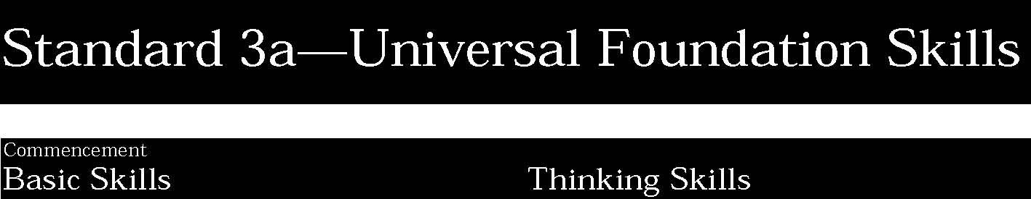

1. Basic skills include the ability to read, write, listen, and speak as well as perform arithmetical and mathematical functions.
Students:
• use a combination of techniques to read or listen to complex information and analyze what they hear or read; convey information confidently and coherently in written or oral form; and analyze and solve mathematical problems requiring use of multiple computational skills.
This is evident, for example, when students:
- gather and use information presented in print and electronic sources to create a research report and database
- examine a case study to evaluate whether the information contained within it is adequate to support generalizations about the topic
- participate in debates, interviews, and panel discussions
- use word processing and desktop publishing software to present information on a sales campaign
- analyze a company’s balance sheet and income statement for industry-recognized ratios for assets, liabilities, and net income/loss

▲ order and price inventory appropriately as part of a work experience program.
Key ideas are identified by numbers (1). Performance indicators are identified by bullets (•). Sample tasks are identified by triangles (▲).
2. Thinking skills lead to problem solving, experimenting, and focused observation and allow the application of knowledge to new and unfamiliar situations.
Students:
• demonstrate the ability to organize and process information and apply skills in new ways.
This is evident, for example, when students:
- provide examples of ways to alter a work schedule to allow for more job sharing among two or more employees
- evaluate a variety of options suggested, select an option, explain the reason for the selection, and provide the strategies for implementation
- recognize a problem and design steps to solve the problem
- prepare and present a report on how knowledge gained from one content area helped solve a problem in another area.

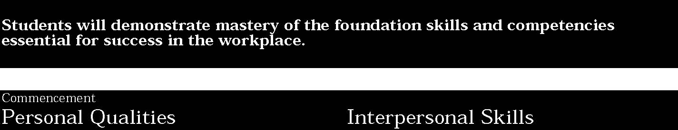

3. Personal qualities generally include competence in self-management and the ability to plan, organize, and take independent action.
Students:
• demonstrate leadership skills in setting goals, monitoring progress, and improving their performance.
This is evident, for example, when students:
- work with a local employer to establish a sales goal and devise a plan to reach that goal
- motivate other group members and demonstrate leadership skills in a student leadership organization or job experience
- give and accept constructive criticism in a group project
- evaluate decisions for legal and ethical implications
- establish a set of personal goals and record progress in attaining them.

4. Positive interpersonal qualities lead to teamwork and cooperation in large and small groups in family, social, and work situations.
Students:
• communicate effectively and help others to learn a new skill.
This is evident, for example, when students:
- demonstrate how to respond effectively to a dissatisfied customer
- assist in the teaching of an acquired skill in an elementary/ middle school class or business environment
- provide feedback to others in a group project
- participate in a job interview.

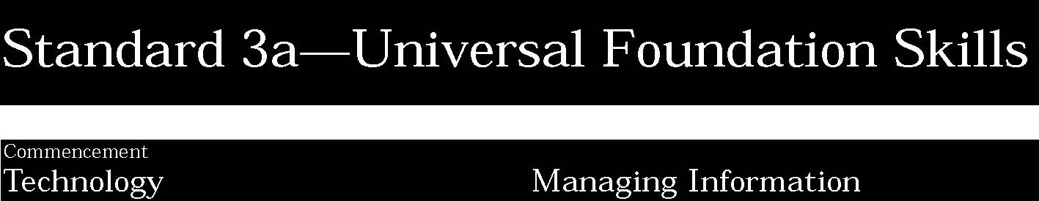

5. Technology is the process and product of human skill and ingenuity in designing and creating things from available resources to satisfy personal and societal needs and wants.
Students:
• apply their knowledge of technology to identify and solve problems.
This is evident, for example, when students:
- evaluate why a school or business facsimile (fax) machine is not working
- take the proper steps to make an inoperative printer work
- use a software program to compile and analyze statistical data and prepare a presentation for a group
- use an integrated software program to solve a business-related problem
- prepare a report predicting how technology may change various aspects of life 50 years from now.

Key ideas are identified by numbers (1). Performance indicators are identified by bullets (•). Sample tasks are identified by triangles (▲).
6. Information management focuses on the ability to access and use information obtained from other people, community resources, and computer networks.
Students:
• use technology to acquire, organize, and communicate information by entering, modifying, retrieving, and storing data.
This is evident, for example, when students:
- construct a computer-generated form to survey local employers for possible participation in a work-study program
- use graphics software to present survey findings to the student body
- use telecommunications software to access and communicate information
- use presentation graphics software which will illustrate to a group of employers the increase in work-based learning experiences
- use a computer to record and organize statistical information to assist a coach of a school athletic team.

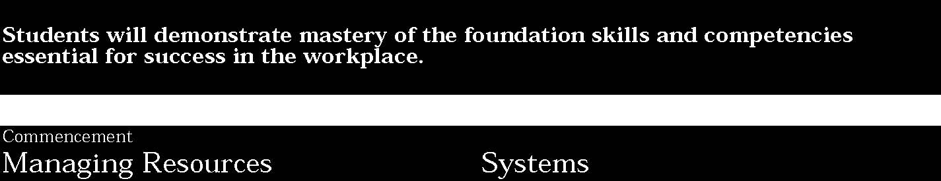

7. Using resources includes the application of financial and human factors, and the elements of time and materials to successfully carry out a planned activity.
Students:
• allocate resources to complete a task.
This is evident, for example, when students:
- plan a two-week activity that requires tasks to be divided among students or coworkers, including determining priorities and following timelines
- prepare a long-range budget for a school organization or hypothetical business
- complete multiple tasks for concurrent activities by adjusting personal schedules or negotiating deadlines
- work as a team to decide how resources should be allocated to accomplish a task.

8. Systems skills include the understanding of and ability to work within natural and constructed systems.
Students:
• demonstrate an understanding of how systems performance relates to the goals, resources, and functions of an organization.
This is evident, for example, when students:
- evaluate the roles or positions within an organization and make suggestions for improvement of the organization
- write a proposal for ways a company can reduce expenses
- prepare an organizational chart for a club or business
- develop a presentation using visual aids to explain how an automobile or other machine operates.



1. Basic Business Understanding
Students:
• demonstrate an understanding of business, marketing, and multinational economic concepts, perform business-related mathematical computations, and analyze/interpret business-related numerical information.
This is evident, for example, when students:
- explain the meaning of basic business and global economic terms
- provide examples of typical problems (e.g., declining sales, outdated hardware) that could arise in a business and explain how steps in the decision-making process could be used to solve such problems
- use spreadsheet software to forecast expenses for a business for three consecutive years
- interpret a 10-year graph of the Gross National Product (GNP) or Gross Domestic Product (GDP)
- demonstrate an understanding of basic international business concepts
- identify and locate major cities and trade regions throughout the world.

2. Business-Related Technology
Students:
• select, apply, and troubleshoot hardware and software used in the processing of business transactions.
This is evident, for example, when students:
- use touch keyboarding techniques to produce business documents (e.g., letters, memorandums, reports)
- use the components of various business technologies (e.g., CPU, disk drive, CD-ROM, modem, fax machine, scanner)
- enter data into various technological systems, using a variety of input devices (e.g., handwriting, keyboard, mouse, scanner, voice recognition)
- produce business documents and reports, using appropriate technology (e.g., business letter/word processing; business graphs and charts/spreadsheet and graphics software; inventory control reports/hand-held bar code scanners)
- use word processing software to prepare a form letter and do a mail merge soliciting customers for a simulated business
- use electronic media (e.g., e-mail, Internet/World Wide Web, fax) to communicate internationally.

STANDARD 3b
Key ideas are identified by numbers (1). Performance indicators are identified by bullets (•). Sample tasks are identified by triangles (▲).
3. Information Management/Communication
Students:
• prepare, maintain, interpret/analyze, and transmit/ distribute information in a variety of formats while demonstrating the oral, nonverbal, and written communication skills essential for working in today’s international service-/information-/technological-based economy.
This is evident, for example, when students:
- compose and produce simple business documents (e.g., letters, memos, reports)
- prepare and deliver a three-minute oral presentation using at least one visual aid (e.g., marketing research report, stock market analysis)
- identify and interpret positive/negative facial expressions and other body language indicators
- identify and explain how and why specialized communication tools are used (e.g., voice mail, electronic mail, beepers, pagers)
- use simple electronic databases and spreadsheet information systems to manage a membership list or prepare a payroll ledger
- recognize challenges in business related to people speaking various languages
- identify international cultural similarities and differences and explain their relationship to international trade.

4. Business Systems
Students:
• demonstrate an understanding of the interrelatedness of business, social, and economic systems/subsystems.
This is evident, for example, when students:
- identify and explain the social, organizational, economic, business, and technological systems that stimulated the transition from an agricultural-based economy through an industrial-based economy to the current service-/information/technological-based economy
- identify and explain aspects of basic systems that typically function in a business enterprise (e.g., administrative, financial, marketing)
- diagram the components (input, processing, output, feedback) of a typical business system and explain what documents/materials/products are used in each component (e.g., billing, legal, marketing)
- explain and provide examples of the interrelationship of the free enterprise system and the marketing concept
- identify basic features of the sole proprietorship, partnership, corporation, and franchise systems, and decide which form of organization would be best for given situations
- identify the currency systems of major countries and calculate currency exchange transactions.

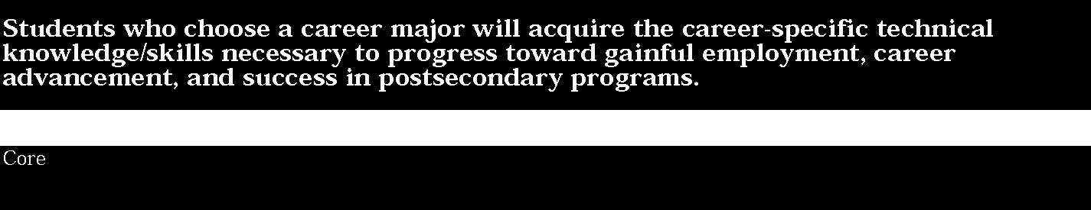
5. Resource Management

Students:
• identify, organize, plan, and allocate resources (e.g., financial, materials/facilities, human, time) in demonstrating the ability to manage their lives as learners, contributing family members, globally competitive workers, and self-sufficient individuals.
This is evident, for example, when students:
▲ explain the need for and the steps incurred by a business in setting goals and priorities to meet company objectives
▲ identify and discuss the process for constructing a simple operating budget for a specific purpose in a small business (e.g., advertising budget)
▲ list and explain various personal and business needs related to banking, investments, and insurance (e.g., personal checkbook, mutual funds, life insurance)
▲ explain various paycheck deductions (e.g., federal and State
taxes, FICA) ▲ open and use personal savings and checking accounts
▲ assist Red Cross personnel in scheduling student volunteers for participation in a local blood donor event.

6. Interpersonal Dynamics
Students:
• exhibit interpersonal skills essential for success in the multinational business world, demonstrate basic leadership abilities/skills, and function effectively as members of a work group or team.
This is evident, for example, when students:
▲ outline essential personal attributes/attitudes for successful interpersonal relationships (e.g., appearance/cleanliness, integrity, punctuality, dedication/commitment)
- explain the many benefits inherent in a business with a culturally diverse workforce
- demonstrate an understanding of how the traditions of various major cultures affect international business practices
- use a case study to illustrate how a business might use a team approach, flextime, or job sharing in its daily operations
- list the key elements necessary to facilitate a business-related meeting
- teach a classmate how to reconcile a checking account or how to use telecommunications software
- participate in a job interview.



1. Basic Business Understanding
Students:
• demonstrate an understanding of business, marketing, and multinational economic concepts, perform business-related mathematical computations, and analyze/interpret business-related numerical information.
This is evident, for example, when students:
- explain and interpret advanced business and economics terms associated with their occupational cluster of study (e.g., reading and interpreting articles in business publications)
- develop a viable solution(s) for a case problem in a business simulation
- conduct a research project and make a presentation illustrating how the “law of supply and demand” applies to the local community
- use accounting or spreadsheet software to prepare an income statement and balance sheet for a simulated service business
- use appropriate software to produce several types of graphs (e.g., bar, pie) of the operating budget for the school district, the school store, or a local business for each of the past five years and provide an analysis of the financial trends
- describe the impact of international business activities on the local, regional, national, and international economies.

2. Business-Related Technology
Students:
• select, apply, and troubleshoot hardware and software used in the processing of business transactions.
This is evident, for example, when students:
- use advanced touch keyboarding techniques to produce complex business documents pertinent to the occupational cluster of study (e.g., purchase orders, newsletters)
- apply user manuals to set up and troubleshoot hardware devices and software programs
- integrate applications and files from various technologies/ operating systems (hardware and software) to produce complex, business-quality products and documents (e.g., Apple OS files to MS-DOS files; integrating graphics into a newsletter)
- conduct a research project and provide a report about the various technologies used at a variety of local businesses
- evaluate which telecommunications technologies/methods are most appropriate for various given international business situations.

Key ideas are identified by numbers (1). Performance indicators are identified by bullets (•). Sample tasks are identified by triangles (▲).
3. Information Management/Communication
Students:
• prepare, maintain, interpret/analyze, and transmit/ distribute information in a variety of formats while demonstrating the oral, nonverbal, and written communication skills essential for working in today’s international service-/information-/technological-based economy.
This is evident, for example, when students:
- compose/produce a multipage, complex business memorandum or business sales letter
- prepare and deliver a persuasive sales presentation and effectively handle customer questions and objections in a simulated situation
- use specialized communication tools, such as voice and electronic mail systems, at typical business productivity standards
- participate in a panel discussion on a business topic which will be critiqued for communication effectiveness
- analyze the effectiveness of individuals communicating in an international business environment, given a specific situation.

4. Business Systems
Students:
• demonstrate an understanding of the interrelatedness of business, social, and economic systems/subsystems.
This is evident, for example, when students:
- analyze the effects that changes in internal and external influences (e.g., human resources, suppliers, government, technology, customs/traditions) have on various business systems
- identify, describe, and diagram systems and subsystems associated with typical businesses in the occupational cluster of study
- plan, implement, analyze, and modify systems and subsystems for a student-operated school store or business in which students are employed
- describe the international monetary system, including the International Monetary Fund, World Bank, and Eurocurrencies.

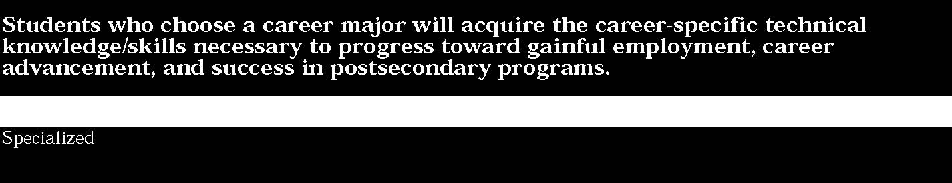
5. Resource Management

Students:
• identify, organize, plan, and allocate resources (e.g., financial, materials/facilities, human, time) in demonstrating the ability to manage their lives as learners, contributing family members, globally competitive workers, and self-sufficient individuals.
This is evident, for example, when students:
- participate on a team to develop a mission statement, goals, objectives, and an annual work plan for a DECA or Future Business Leaders of America (FBLA) chapter
- demonstrate through simulation how an individual business raises capital by selling stock
- visit a bank and meet with a business loan officer to discuss the process involved in applying for a small business start-up loan
- develop a simple budget proposal to refurnish and/or remodel an office or small retail business
- diagram and explain an organizational chart of a small corporation
- identify organizations, government agencies, and other resources that a small or medium-sized business might use to investigate international trade opportunities.

6. Interpersonal Dynamics
Students:
• exhibit interpersonal skills essential for success in the multinational business world, demonstrate basic leadership abilities/skills, and function effectively as members of a work group or team.
This is evident, for example, when students:
- interact congenially, harmoniously, and effectively with comembers of a school club, community youth leadership organization, or business in which they are employed
- plan and implement a meeting between class representatives and the principal to discuss concerns/needs of the class
- survey the personnel policies of a business and develop a report on employer requirements/guidelines
- interview students for positions in a simulated business
- teach a ninth-grade class how to read the stock page
- serve as a negotiator on behalf of the vice principal and students in the handling of student code-of-conduct violations
- identify potential human relations problems/conflict areas in a company with a multinational workforce.



1. Basic Business Understanding
Students:
• demonstrate an understanding of business, marketing, and multinational economic concepts, perform business-related mathematical computations, and analyze/interpret business-related numerical information.
This is evident, for example, when students:
- participate effectively with coworkers, supervisors, suppliers, customers, and others in an employment experience related to their occupational cluster of study
- solve problems/make decisions for a business in which they are employed or for a student-managed school store
- use application software to prepare purchase orders, record inventory received, and maintain accounts receivable/payable records for a business through a Cooperative Occupational Education or a General Education Work Experience Program
- plan an itinerary, make reservations, and prepare a travel expense report for supervisors in a volunteer community service experience
- conduct research, prepare a chart, and make a presentation about the sales volume and market share for a local business
- evaluate and compare the overall effectiveness of global marketing plans for several companies in the community conducting international business
- develop a business plan for an international business venture based on an analysis of current economic statistics.

2. Business-Related Technology
Students:
• select, apply, and troubleshoot hardware and software used in the processing of business transactions.
This is evident, for example, when students:
- use business-related hardware and software to process transactions in an employment setting related to the student’s occupational program (e.g., order-processing technology to assist customers in an auto parts store or CD-ROM software to identify retail outlets for customers)
- demonstrate the ability to set up, maintain, and troubleshoot a fax machine or computer system in a simulated or real employment environment
- use vendor “help lines” to solve business technology hardware and software problems in an employment or volunteer experience
- conduct a research project to determine the cost-effectiveness of recently upgraded production technology installed at their place of employment, and make a presentation about the project, using state-of-the-art software and media tools
- conduct a study and write a proposal to justify the expense of adding new business-related equipment to the school office (e.g., fax machine, electronic mail or voice mail system).

3. Information Management/Communication
Students:
• prepare, maintain, interpret/analyze, and transmit/ distribute information in a variety of formats while demonstrating the oral, nonverbal, and written communication skills essential for working in today’s international service-/information-/technological-based economy.
This is evident, for example, when students:
- use local, regional, national, and/or international telecommunications networks to obtain and/or communicate business information for a capstone project
- facilitate a panel discussion as part of an employment experience
- prepare and deliver a 10-minute oral presentation using a variety of visual aids on an employment or volunteer experience
- develop/produce complex, business-quality documents (e.g., business letters, inventory reports, financial/accounting reports, proposals, advertising/sales brochures) for a capstone business simulation, a work experience situation, or a community service project
- communicate effectively with coworkers and supervisors during an employment or volunteer experience at a company or organization involved in international business
- participate in the public speaking competitive event at a local, State, regional, and/or national leadership conference of DECA or FBLA.

4. Business Systems
Students:
• demonstrate an understanding of the interrelatedness of business, social, and economic systems/subsystems.
This is evident, for example, when students:
- contribute to the effective operation of various systems and subsystems (e.g., office support system, data processing system, computer programming systems) during an employment experience in a Cooperative Occupational Education or a General Education Work Experience Program
- develop a system/subsystem modification to enhance productivity during an internship experience in a community service organization
- start a student-owned and -managed small business through the Junior Achievement program or other school-sponsored program.

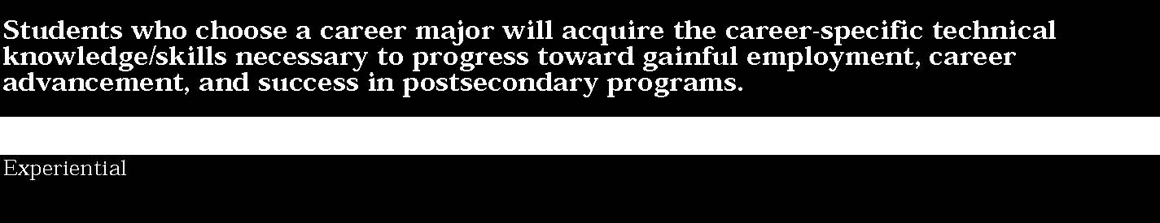
5. Resource Management

Students:
• identify, organize, plan, and allocate resources (e.g., financial, materials/facilities, human, time) in demonstrating the ability to manage their lives as learners, contributing family members, globally competitive workers, and self-sufficient individuals.
This is evident, for example, when students:
- use application software to prepare federal and State income tax returns
- develop an operating budget for the year for a school-sponsored extracurricular organization or the DECA or FBLA chapters
- use calendar-type software to design a student work schedule for a student-operated school store or a business in which students are employed through a Cooperative Occupational Education or a General Education Work Experience Program
- assist in planning a conference for a business or community service organization.

6. Interpersonal Dynamics
Students:
• exhibit interpersonal skills essential for success in the multinational business world, demonstrate basic leadership abilities/skills, and function effectively as members of a work group or team.
This is evident, for example, when students:
- participate in a job performance and attitude evaluation as part of an employment experience
- participate in the job interview competitive event at a local, State, regional, and/or national DECA or FBLA leadership conference
- facilitate a team or work group meeting during an employment or volunteer experience
- conduct a training session for new employees during an employment experience or in a student-operated school store
- conduct a study comparing different approaches to managing human resources in several community businesses involved in international trade.

STANDARD 3b
Key ideas are identified by numbers (1). Performance indicators are identified by bullets (•). Sample tasks are identified by triangles (▲).

1. Academic Foundations
Students:
• apply knowledge/skills acquired in academic subjects to the health care environment.
This is evident, for example, when students:
- identify and describe science concepts (anatomy and physiology, biology, chemistry, physics, growth/development) as they apply to biotechnology equipment and health care
- write an essay describing the importance of understanding science concepts in health careers
- perform mathematical conversions of temperature readings.

2. Health Care Systems
Students:
• understand the current health care system and its impact on health careers.
This is evident, for example, when students:
- list services provided by the health care system
- tour a local general hospital and prepare a report of various services provided
- identify social and economic factors that affect health care delivery
- explain the relationship of economics and health care in our society.

Key ideas are identified by numbers (1). Performance indicators are identified by bullets (•). Sample tasks are identified by triangles (▲).
3. Health Maintenance
Students:
• develop knowledge of the concept of optimal health and identify factors that affect health maintenance.
This is evident, for example, when students:
- describe the physical, mental, and social aspects of health and their interrelationship
- demonstrate good personal health habits to promote physical, mental, and social health
- make a list of their current physical activities and identify how these activities contribute to optimal health
- identify specific community resources involved in the promotion of health
- discuss feelings resulting from school/group social involvement
- develop an individual plan for ideal physical, mental, and social health.

4. Legal and Ethical Responsibilities
Students:
• know the importance of performing their role in the health care system in accordance with laws, regulations, policies, ethics, and the rights of clients.
This is evident, for example, when students:
▲ demonstrate equitable treatment of all people
▲ differentiate between legal and ethical rules
▲ identify and describe client rights and confidentiality
▲ obtain and discuss the “Patient’s Bill of Rights” from a local health care agency
▲ contrast licensure and certification in a selected career area and discuss limitations of each
▲ develop a code of ethics for the class.

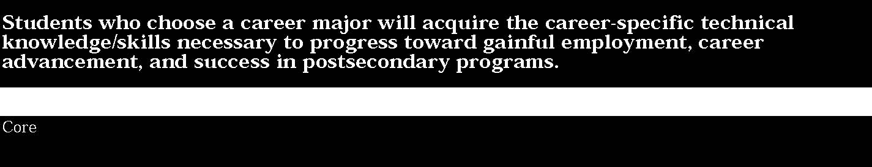

5. Safety
Students:
• identify safety hazards in a health care setting and prevent illness or injury through safe work practices.
This is evident, for example, when students:
- describe fire hazards and other safety hazards and their impact on the health care environment
- define and discuss universal precautions and regulatory guidelines such as those developed by the Occupational Safety and Health Administration (OSHA)
- identify principles of good body mechanics
- discuss procedures/protocols used in classroom emergencies
- list general principles of first aid and their adaptation to the health care environment
- invite a safety officer from a health care agency to speak to the class.

6. Communications
Students:
• communicate information in a variety of formats and media.
This is evident, for example, when students:
- use basic medical terminology appropriately
- discuss the importance of effective communication in the health care field
- access electronically produced information commonly used in a health care setting
- demonstrate differences between verbal and nonverbal communication and the impact on consumers of health care
- demonstrate various communication methods used to give and obtain information
- role-play effective communication involving health care workers.

7. Interpersonal Dynamics
Students:
• interact effectively and sensitively with all other members of the health care team in order to provide high-quality client care.
This is evident, for example, when students:
- work cooperatively in a group and respect the diversity of classmates
- role-play team membership skills (e.g., cooperation, leadership, and listening) and apply them to the health care hierarchy
- discuss the impact of client diversity on health care.

8. Technical Skills
Students:
• identify procedures within their scope of practice and job description and perform them accurately and in a timely fashion.
This is evident, for example, when students:
- identify technical skills for a specific job within the health services area
- demonstrate basic patient/health care skills such as measuring a client’s blood pressure.



1. Academic Foundations
Students:
• apply knowledge/skills acquired in academic subjects to the health care environment.
This is evident, for example, when students:
- apply life sciences and mathematical concepts in a work-site situation
- conduct laboratory tests on body fluid samples
- write an informative, persuasive essay on a health care topic
- research and discuss different cultural responses to health and illness.

2. Health Care Systems
Students:
• understand the current health care system and its impact on health careers.
This is evident, for example, when students:
- describe the American free enterprise system and its effect on the health care system
- describe how social, political, or economic factors affect delivery of health care services in a health care agency.

Key ideas are identified by numbers (1). Performance indicators are identified by bullets (•). Sample tasks are identified by triangles (▲).
3. Health Maintenance
Students:
• develop knowledge of the concept of optimal health and identify factors that affect health maintenance.
This is evident, for example, when students:
- describe the effects of alcohol, tobacco, and drugs on health (physical, mental, and social)
- identify and describe risk behaviors that can jeopardize optimal health
- research the effects of stress on health
- explain preventative health practices (e.g., stress management, good nutrition)
- analyze the effects of risk behaviors for the individual, family, community, and world
- develop a plan that accommodates nutritional needs, stress management, and physical activity.

4. Legal and Ethical Responsibilities
Students:
• know the importance of performing their role in the health care system in accordance with laws, regulations, policies, ethics, and the rights of clients.
This is evident, for example, when students:
- describe legal/ethical rules and responsibilities of workers within the health delivery system and determine what constitutes liability
- describe the consequences of legal and ethical wrongdoing in the health care field
- extract and analyze legal documentation from a case study.

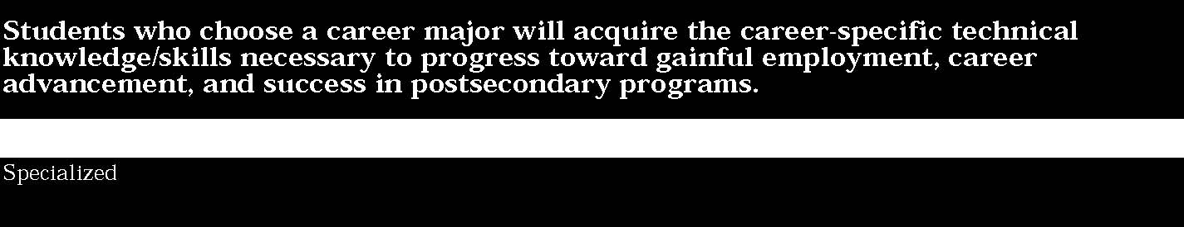

5. Safety
Students:
• identify safety hazards in a health care setting and prevent illness or injury through safe work practices.
This is evident, for example, when students:
- implement methods of preventing accidents in classroom and work-site situations
- use principles of infection control according to OSHA requirements in simulated health care situations
- complete a first aid course
- cite examples of safe practices in a health care work site.

6. Communications
Students:
• communicate information in a variety of formats and media.
This is evident, for example, when students:
- ask appropriate questions to assess the level of understanding of others
- use appropriate medical terminology in work-related situations
- demonstrate ability to ask for clarification as necessary and to report/record accurately information in a work-related situation.

7. Interpersonal Dynamics
Students:
• interact effectively and sensitively with all other members of the health care team in order to provide high-quality client care.
This is evident, for example, when students:
▲ demonstrate the ability to assume the role of leader, recorder, and team member in a health care work setting.
8. Technical Skills
Students:
• identify procedures within their scope of practice and job description and perform them accurately in a timely fashion.
This is evident, for example, when students:
- provide direct care for clients in a health care setting
- use equipment and instruments according to manufacturer

guidelines and facility policy and procedure ▲ organize assignments and their own work.


1. Academic Foundations
Students:
• apply knowledge/skills acquired in academic subjects to the health care environment.
This is evident, for example, when students:
- select a patient and relate his/her specific illness to science concepts that are involved
- compute medication dosages.

2. Health Care Systems
Students:
• understand the current health care system and its impact on health careers.
This is evident, for example, when students:
- prepare insurance forms for services rendered in a health facility
- participate in a debate involving current and proposed national health care policies.

Key ideas are identified by numbers (1). Performance indicators are identified by bullets (•). Sample tasks are identified by triangles (▲).
3. Health Maintenance
Students:
• develop knowledge of the concept of optimal health and identify factors that affect health maintenance.
This is evident, for example, when students:
- contact community health agencies to determine the services provided and present this information to the class
- measure and report a client’s vital signs or other indicators of health status
- access appropriate community resources to help resolve health problems for clients in a health services environment
- conduct classes for diabetic clients
- give a presentation to an elementary school class about preventative health practices such as nutrition, stress management, or dental care.

4. Legal and Ethical Responsibilities
Students:
• know the importance of performing their role in the health care system in accordance with laws, regulations, policies, ethics, and the rights of clients.
This is evident, for example, when students:
- demonstrate legal and ethical behavior in caring for clients with communicable diseases
- comply with legal requirements for documentation of care.

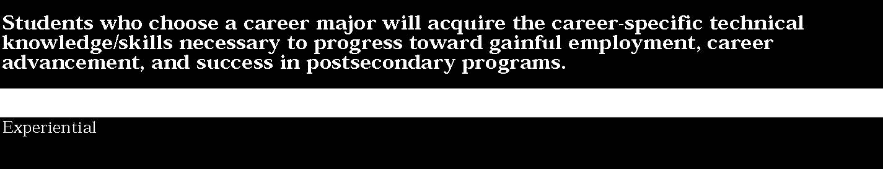

5. Safety
Students:
• identify safety hazards in a health care setting and prevent illness or injury through safe work practices.
This is evident, for example, when students:
- participate in a first aid competition in a local or State competitive events conference of Health Occupations Students of America or Vocational Industrial Clubs of America (HOSA/VICA)
- demonstrate specific first aid techniques
- prevent accidents by using principles of body mechanics when caring for hospitalized clients
- wear protective equipment while working with dental clients
- handle specimens and chemicals appropriately.

6. Communications
Students:
• communicate information in a variety of formats and media.
This is evident, for example, when students:
- record results of serological examinations
- adapt communication to the individual needs of a client within the health care system
- respond to concerns and fears of a nursing home client.

7. Interpersonal Dynamics
Students:
• interact effectively and sensitively with all other members of the health care team in order to provide high-quality client care.
This is evident, for example, when students:
▲ interact effectively with clients, coworkers, and supervisors in a health-care-related situation
▲ deal with differences in opinion in work-related situations by showing respect for the point of view of others.

8. Technical Skills
Students:
• identify procedures within their scope of practice and job description and perform them accurately in a timely fashion.
This is evident, for example, when students:
▲ recognize abnormal results and take action consistent with level of training and scope of practice
▲ monitor and evaluate work to ensure continuous improvement.

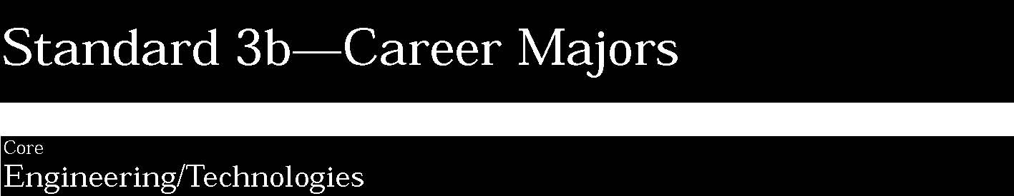

1. Foundation Development
Students:
• develop practical understanding of engineering technology through reading, writing, sample problem solving, and employment experiences.
This is evident, for example, when students:
- research current labor and working condition laws as per OSHA rules and regulations
- use materials, tools, instruments, equipment, and procedures safely in a laboratory
- research and record data through use of computerized information services such as the Internet and World Wide Web
- use general carpentry-related vocabulary to order building materials for a simple construction job
- use simple engineering-related mathematical/scientific concepts to construct a simple series/parallel electrical circuit
- provide examples of simple problems that managers/employees need to solve, and explain the steps in the problem-solving process
- describe how ethics are applied in the world of work.

2. Technology
Students:
• demonstrate how all types of engineering/technical organizations, equipment (hardware/software), and well-trained human resources assist and expedite the production/distribution of goods and services.
This is evident, for example, when students:
- identify the components of a system (input, process, output, monitor, comparison) and draw a labeled model in block diagram form indicating how the system components are linked
- identify and use software programs for specific applications such as word processing, database management, graphics, and telecommunications
- demonstrate how a person can use sensory experience to monitor the output of some technological systems (e.g., toaster, traffic control, heating, smoothness of a finish, stereo system, food quality)
- demonstrate how subsystems can be used as comparison devices (e.g., thermostat, photocell switch, sonar focusing in cameras)
- explain the relationship of rapidly changing technology to global competition, job creation and obsolescence, and societal impact
- describe an educational program appropriate to the requirements for one job (e.g., technician, engineer, or technology education teacher)
- identify transferable skills that might be necessary for continued employment
- use the computer and a variety of input devices (e.g., handwriting, keyboard, mouse, stylus, scanner, voice) as tools to process information and to assist in making decisions.

3. Engineering/Industrial Processes
Students:
• demonstrate knowledge of planning, product development and utilization, and evaluation that meets the needs of industry.
This is evident, for example, when students:
- relate the fundamental principles of flight to aircraft performance
- apply simple engineering-related mathematical concepts and interpret numerical data from computerized automotive engine diagnostic equipment
- demonstrate a basic understanding of troubleshooting and repair of electrical failures in refrigerators and freezers
- plan sequence of part layout based upon blueprint information.

STANDARD 3b
Key ideas are identified by numbers (1). Performance indicators are identified by bullets (•). Sample tasks are identified by triangles (▲).
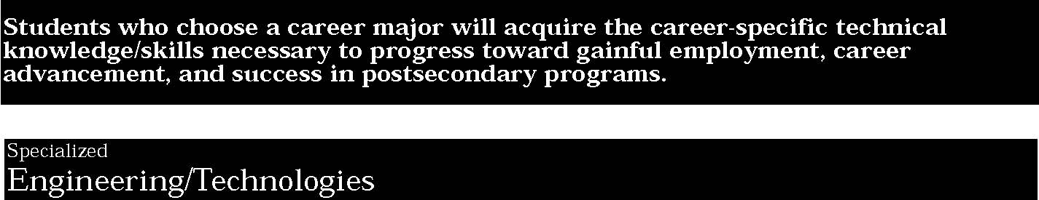
1. Foundation Development
Students:
• develop practical understanding of engineering technology through reading, writing, sample problem solving, and employment experiences.
This is evident, for example, when students:
- engage in biomedical laboratory activities, such as use of living material, construction of devices, and use of working models, charts, graphs, technical drawings, sketches and illustrations, mathematical equations, and computer simulations
- find and apply mathematical/scientific formulas necessary to calculate electrical resistance, aerodynamic lift, and torque
- retrieve automotive engine data specifications, using industry computerized data-retrieval systems
- participate in various competitive events at a local, State, or national VICA (Vocational Industrial Clubs of America) conference.

2. Technology
Students:
• demonstrate how all types of engineering/technical organizations, equipment (hardware/software), and well-trained human resources assist and expedite the production/distribution of goods and services.
This is evident, for example, when students:
- use materials, tools, instruments, equipment, and procedures safely in a laboratory to model technological systems in a range of engineering, technical, and/or trade occupations
- identify resources needed for specific energy conversion processes
- assemble a computer-controlled technological system
- program or input an existing program, and operate a computer-based system to follow a sequence of steps or instructions
- create block diagrams, sketches, and drawings of original technological systems that include the system monitor and control components
- identify and explain the components of various technologies used in the engineering/technical environment (e.g., torque meters, meteorological maps, optical disks, frequency counters).

Key ideas are identified by numbers (1). Performance indicators are identified by bullets (•). Sample tasks are identified by triangles (▲).
3. Engineering/Industrial Processes
Students:
• demonstrate knowledge of planning, product development and utilization, and evaluation that meets the needs of industry.
This is evident, for example, when students:
- apply the decision-making/problem-solving process to develop solutions for a labor relations dispute
- diagnose computer hardware failure, using appropriate software and electronic testing equipment
- read and interpret technical manuals to determine the location of an automotive electrical fault
- lay out a building foundation, using a transit
- install a basic 220-volt line in a newly framed section of a house
- diagnose an automotive engine problem.

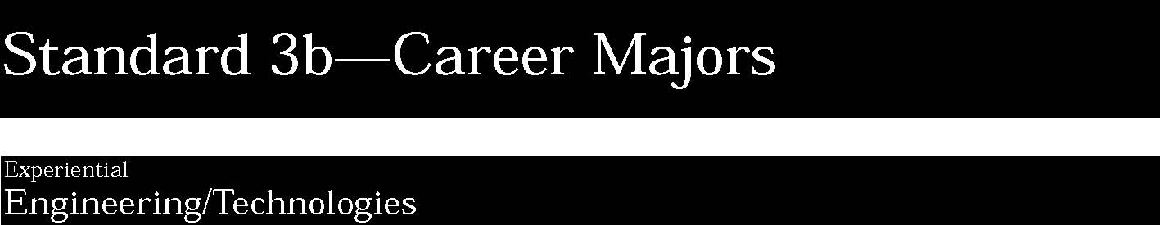
1. Foundation Development
Students:
• develop practical understanding of engineering technology through reading, writing, sample problem solving, and employment experiences.
This is evident, for example, when students:
- converse intelligently and effectively with industry representatives and employers/employees, using technical language associated with the occupational cluster of study
- apply complex computational procedures and concepts used in setting up an assembly line
- explain the causes and physiological effects of working in a fast-paced manufacturing assembly line.

2. Technology
Students:
• demonstrate how all types of engineering/technical organizations, equipment (hardware/software), and well-trained human resources assist and expedite the production/distribution of goods and services.
This is evident, for example, when students:
- demonstrate ability to set up, maintain, and repair various machines, hardware, and devices, using a variety of resources (e.g., manuals, vendor hotlines, electronic equipment) and adhering to all OSHA safety rules and regulations
- demonstrate ability to accomplish high-level engineering/ technical tasks through a variety of experiences (e.g., computer simulations, capstone projects, community-based projects, work-based experiences)
- use computers to design simple systems from engineering sketches.

Key ideas are identified by numbers (1). Performance indicators are identified by bullets (•). Sample tasks are identified by triangles (▲).
3. Engineering/Industrial Processes
Students:
• demonstrate knowledge of planning, product development and utilization, and evaluation that meets the needs of industry.
This is evident, for example, when students:
- apply complex computational procedures and concepts necessary for managing a construction work site
- construct manufacturing design diagrams, using CADD equipment in an employment setting
- use mathematical concepts to calculate fuel consumption for a planned cross-country flight
- write a report on safety procedures regarding the disposal of hazardous waste found on the work site
- apply work-flow scheduling and standardized performance-measuring systems to specific job categories (e.g., construction)
- set up and mill flat surfaces at compound angles with respect to each other.

Students who choose a career major will acquire the career-specific technicalknowledge/skills necessary to progress toward gainful employment, careeradvancement, and success in postsecondary programs.
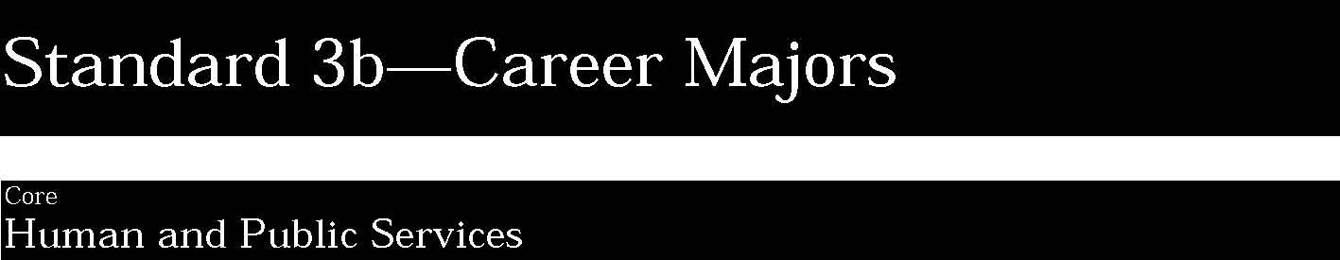
1. Ethical/Legal Responsibilities
Students:
• demonstrate professional, ethical, and legal responsibilities toward customers.
This is evident, for example, when students:
- define ethics and confidentiality in the classroom, home, community, and workplace
- develop and implement a code of ethics for the classroom and potential work environment
- treat all people equally and respect the diversity and special needs of customers.

2. Communication
Students:
• demonstrate effective communication skills needed to meet the expectations of human and public services consumers.
This is evident, for example, when students:
- demonstrate listening skills
- demonstrate skill in oral and written communication
- use alternative and current communication techniques, such as sign language, pictures, and technology
- demonstrate differences between verbal and nonverbal communication.

3. Sanitation
Students:
• demonstrate a knowledge of the principles of sanitation used to prevent the transmission of disease-producing microorganisms from one person/object to another.
This is evident, for example, when students:
- model behaviors that demonstrate understanding of basic principles of sanitation
- recognize the importance of developing good habits of personal hygiene.

Key ideas are identified by numbers (1). Performance indicators are identified by bullets (•). Sample tasks are identified by triangles (▲).
4. Human Growth and Development
Students:
• understand the process of human growth and development and its influence on client needs.
This is evident, for example, when students:
- identify the stages of the life cycle and/or skill-level abilities of customers of human and public services
- identify and develop processes as needed to serve customers based upon their cognitive, social, emotional, and physical development.

5. Interpersonal Dynamics
Students:
• demonstrate how to interact effectively and sensitively with others.
This is evident, for example, when students:
- work cooperatively in a group
- understand the importance of accepting individual differences and special needs.

6. Safety
Students:
• provide safe environments for others.
This is evident, for example, when students:
- identify safety hazards in the home, workplace, and other environments
- anticipate fire hazards through an awareness of dangerous conditions and take preventive measures.

7. Thinking/Problem Solving
Students:
• solve problems, set goals, and make decisions in order to provide services to best meet the needs of others.
This is evident, for example, when students:
- identify steps in critical thinking and goal-setting processes
- identify steps in problem solving
- demonstrate the application of personal problem-solving skills
- identify and use a variety of methods, tools, and resources to meet the needs of customers.

8. Personal Resource Management
Students:
• apply personal and resource management skills.
This is evident, for example, when students:
- identify multiple demands of family members’ roles and suggest strategies to balance work and family roles
- describe qualities critical to workers in human and public services careers
- recognize the importance of personal time management
- describe the need for personal money-management skills
- identify resources available to the individual to facilitate self-employment.

9. Wellness
Students:
• exhibit and promote a positive image of wellness.
This is evident, for example, when students:
- know the food groups as described in the food pyramid and use this information to plan nutritious meals
- practice good personal habits to promote physical, mental, and social health
- describe the physical, mental, and social aspects of health and their interrelationship
- describe techniques for coping with and managing stress in the home, school, work, and community environment
- develop proactive and healthy responses to changes in one’s life and an attitude that will foster positive mental growth.



1. Ethical/Legal Responsibilities
Students:
• demonstrate professional, ethical, and legal responsibilities toward customers.
This is evident, for example, when students:
- describe ethical wrongdoing and breach of confidentiality as related to workplace behavior in the food service industry
- advocate equal treatment of all people and strive to reach all people at their own level regardless of their limitations
- assure confidentiality of data while using current technology in the classroom and/or workplace
- analyze and distinguish between various classifications and designations of offenses under local, county, State, and federal laws (e.g., violations, misdemeanors, felonies)
- participate in a work-based learning program for students interested in the legal profession.

2. Communication
Students:
• demonstrate effective communication skills needed to meet the expectations of human and public services consumers.
This is evident, for example, when students:
- identify the purposes of communication in elder-care services and factors that influence the communication process
- prepare and deliver presentations, using creativity and initiative to seek the most effective resources
- identify the impact of electronic communication on FBI agents
- use interactive electronic communication (Internet/World Wide Web) effectively among coworkers to reschedule a meeting
- participate in the Illustrated Talk STAR event (Students Taking Action for Recognition) at a local, State, or national FHA/HERO leadership conference
- seek the most effective tools to communicate with social services customers so that all might benefit from services
- write technical communications in a clear, concise, and legible manner for use in public and private security occupations.

Key ideas are identified by numbers (1). Performance indicators are identified by bullets (•). Sample tasks are identified by triangles (▲).
3. Sanitation
Students:
• demonstrate a knowledge of the principles of sanitation used to prevent the transmission of disease-producing microorganisms from one person/object to another.
This is evident, for example, when students:
▲ practice sanitation methods needed to prevent the spread of disease in the environment.
4. Human Growth and Development
Students:
• understand the process of human growth and development and its influence on client needs.
This is evident, for example, when students:
- describe stages of the life cycle (prenatal, infancy, childhood, adolescence, adult, middle age, elderly)
- demonstrate basic techniques for appropriate care of a toddler

5. Interpersonal Dynamics
Students:
• demonstrate how to interact effectively and sensitively with others.
This is evident, for example, when students:
- demonstrate effective interpersonal speaking and listening skills
- demonstrate effective interpersonal communication, using a variety of tools
- approach difficulties in personal and/or work-related situations with respect for others’ points of view
- examine the Americans with Disabilities Act and discuss implications for private security law enforcement.

6. Safety
Students:
• provide safe environments for others.
This is evident, for example, when students:
- correct safety hazards in personal and/or work environments
- explain potential workplace safety hazards to others in relation to OSHA guidelines.

7. Thinking/Problem Solving

Students:
• solve problems, set goals, and make decisions in order to provide services to best meet the needs of others.
This is evident, for example, when students:
- make informed decisions and set goals as they relate to self, family, and workplace
- determine the effects on the customer and/or environment of personal habits and make appropriate adjustments in habits.

8. Personal Resource Management
Students:
• apply personal and resource management skills.
This is evident, for example, when students:
- demonstrate ways to balance work and family roles (e.g., strategies to reduce work and family conflicts)
- conduct a self-evaluation to identify personal qualities compatible with a career in the appearance-enhancement industry
- explain factors that lead to successful money management in the appearance-enhancement industry
- describe how a knowledge of available resources and their use enables an individual to become independent/self-sufficient.

9. Wellness
Students:
• exhibit and promote a positive image of wellness.
This is evident, for example, when students:
- plan diets for human and public service customers that take into account nutritional needs as described in the food pyramid
- adapt menus for special dietary needs and make them acceptable in a variety of cultural situations.



1. Ethical/Legal Responsibilities
Students:
• demonstrate professional, ethical, and legal responsibilities toward customers.
This is evident, for example, when students:
▲ exhibit positive behaviors such as reliability, integrity, and responsibility, and abide by agency expectations for personal conduct
▲ provide equitable treatment for all consumers of child care services
▲ obtain a permit to operate a food concession for a student leadership activity
▲ use student leadership activities to demonstrate active citizenship and affect public policy.

2. Communication
Students:
• demonstrate effective communication skills needed to meet the expectations of human and public services consumers.
This is evident, for example, when students:
- exhibit an awareness of multicultural needs of customers of elder-care services
- demonstrate creativity and initiative to use alternative resources to communicate effectively with social services customers
- know and use the correct terminology and procedures necessary for effective inter- and intra-workplace communication (e.g., internal and external food service customers)
- use current technology to communicate effectively with coworkers, supervisors, and consumers
- use interactive electronic communication to contact a public official regarding a policy issue.
- practice use of standard communication equipment as employed in the law enforcement and security fields (e.g., radio, fax, e-mail).

Key ideas are identified by numbers (1). Performance indicators are identified by bullets (•). Sample tasks are identified by triangles (▲).
3. Sanitation
Students:
• demonstrate a knowledge of the principles of sanitation used to prevent the transmission of disease-producing microorganisms from one person/object to another.
This is evident, for example, when students:
- employ sanitation principles as they relate to the food industry
- practice all safety and sanitation procedures required by State board standards for hair cutting.

4. Human Growth and Development
Students:
• understand the process of human growth and development and its influence on client needs.
This is evident, for example, when students:
- develop a plan to open a child care center with special consideration of program goals, child development, sequential learning concepts, and program evaluation
- apply the concept of nurturing to human and public services occupations by volunteering to work in a child care facility
- participate in the Focus on Children (STAR) event at a local, State, or national FHA/HERO leadership conference.

5. Interpersonal Dynamics
Students:
• demonstrate how to interact effectively and sensitively with others.
This is evident, for example, when students:
▲ observe and discuss interdependent relationships and cooperative behaviors between employer/employee, employee/ employee, and employer/consumer
- demonstrate and provide services to customers, using a variety of approaches that indicate an understanding of human nature
- contribute to a positive environment which enables all groups to be productive and fulfilled
- solve group problems effectively in work-related situations
- participate in the Food Service-STAR event at a local, State, or national FHA/HERO leadership conference
- demonstrate diligence, patience, empathy, and tenacity when serving all private security/law enforcement customers.

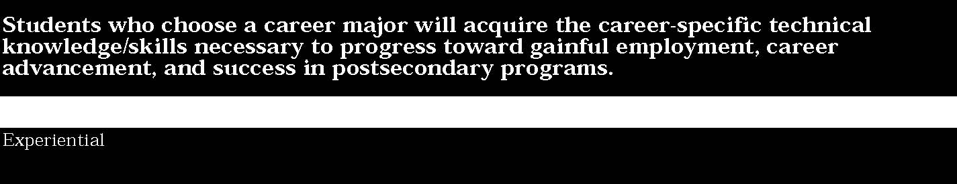

6. Safety
Students:
• provide safe environments for others.
This is evident, for example, when students:
- develop and follow procedures to provide a safe environment in a child care facility
- develop ideas for improving existing evacuation procedures for a local child care facility.

7. Thinking/Problem Solving
Students:
• solve problems, set goals, and make decisions in order to provide services to best meet the needs of others.
This is evident, for example, when students:
- apply critical thinking and goal-setting processes in a variety of human and public services occupational situations
- apply a problem-solving process and take reasoned action to meet consumer and client needs.

8. Personal Resource Management
Students:
• apply personal and resource management skills.
This is evident, for example, when students:
- employ effective coping strategies for self and others to handle developmental or situational changes
- describe cost-effective strategies in a human and public services career
- implement strategies to avoid waste in the appearance-enhancement industry (e.g., duplication of services, damage to equipment)
- use effective coping strategies when handling stressful situations.

9. Wellness
Students:
• exhibit and promote a positive image of wellness.
This is evident, for example, when students:
- apply nutritional concepts to meet the needs of human and public service customers
- demonstrate the ability to access appropriate community resources to help resolve health problems for clients in a human services environment
- use personal resources and skills to cope with change and other stresses in the work, school, home, and community environment.



1. Basic Agriculture Foundation Development
Students:
• demonstrate a solid base of knowledge and skills in natural and agricultural sciences.
This is evident, for example, when students:
- explain knowledge and skills necessary for a broad range of careers in natural and agricultural sciences
- explain the meaning of agricultural business, science, and technology terms
- use simple agricultural-related mathematical concepts and interpret data in agricultural-related applications (e.g., profit/loss, inventory, income/expense)
- use simple agricultural-related science concepts and interpret data (e.g., wise use of natural resources, basic plant and animal nutrition, and principles affecting growth and reproduction)
- explain the concept of social, ethical, and legal responsibility, especially as it relates to agriculture and ecology
- provide examples of simple problems that managers/employees need to solve and explain the steps in the problem-solving process.

2. Agriculture-Related Technology
Students:
• demonstrate the ability to use technology to assist in production and distribution of food goods and services of today’s agricultural industries.
This is evident, for example, when students:
- identify the components of technologies used in the agricultural business environment (e.g., mechanical, chemical, biological, informational)
- select appropriate agricultural software for specific applications
- develop the application of specific agricultural technology to a selected agricultural career (e.g., biotechnology).

STANDARD 3b
Key ideas are identified by numbers (1). Performance indicators are identified by bullets (•). Sample tasks are identified by triangles (▲).
3. Information Management and Communication
Students:
• prepare, maintain, interpret, and disseminate quantitative and qualitative pieces of information relating to the natural and agricultural sciences.
This is evident, for example, when students:
- describe the communication process
- demonstrate listening skills
- demonstrate skill in oral and written communication (e.g., prepare a speech and enter an FFA local public speaking contest)
- signify differences between verbal and nonverbal communication
- use a computer to compose, input, format, and print simple business letters, memos, reports, and agricultural marketing information
- prepare and deliver a three-minute oral presentation (using natural or computer-generated voice), using at least one visual aid for a specific agricultural purpose (e.g., agricultural-related research report, sales presentation)
- identify positive/negative facial expressions and other body language indicators
- use various communications tools including telephone, fax machine, voice mail, electronic mail, and the Internet.

4. Agriculture Business Systems
Students:
• demonstrate an understanding of the interrelationship between agricultural businesses and organizations designed to produce products, services, and information.
This is evident, for example, when students:
- identify and describe social, organizational, and technological systems that have resulted from the increased efficiency of the agricultural sector (e.g., agricultural demographics, production, environmental issues)
- identify the major systems that typically are found in the agricultural business sector (e.g., aquatic and animal production, lawn and greens maintenance, crop production, marketing and governmental regulations)
- diagram the major components of a typical agricultural system (e.g., pesticide management, supplemental irrigation, animal and aquatic nutrition, animal and aquatic health)
- understand that the purpose of agricultural business organizations is to satisfy the demands of consumers within the constraints of governmental regulations and moral obligations as well as to operate at a profit
- categorize agricultural businesses as either production, distribution, or service enterprises and identify distinguishing systems characteristics of each
- identify and explain different systems of agricultural business ownership (e.g., proprietorship, partnership, corporation, cooperative, franchise, limited partnership, joint venture).

5. Resource Management
Students:
• demonstrate the ability to manage personal time, business, and financial resources.
This is evident, for example, when students:
- identify types of resources available
- identify the need for the basic skills of planning, organizing, and setting goals and priorities in a business
- explain the importance of time management
- identify the uses agricultural businesses make of human, capital, natural, and information resources and explain how these resources interrelate to make the organization’s products and/or services more valuable
- identify the basic components of budget preparation in an agricultural business and develop an awareness of banking services, the use of credit, and various components of money-management skills.

6. Interpersonal Dynamics
Students:
• demonstrate the interpersonal skills and abilities needed to function within a sophisticated and sometimes complicated agricultural environment.
This is evident, for example, when students:
- recognize the essential personal requirements for working in an agricultural business (e.g., appearance, integrity, punctuality, dedication, commitment)
- report on the benefits of cultural diversity in the workforce
- interact with other students in a meeting to discuss an agricultural-related topic
- recognize the value of the team approach in solving problems.

7. Safety
Students:
• demonstrate awareness of the importance of safety and accident prevention in all agricultural situations.
This is evident, for example, when students:
- recognize that agricultural jobs are among the highest in incidence of accidents
- identify safety hazards present in agricultural situations and describe the safety precautions required to prevent accidents
- identify potential safety hazards
- describe mechanical hazards
- describe chemical hazards
- recognize safety devices (e.g., roll bars on tractors) placed on equipment or located in an area for emergency use.



1. Basic Agriculture Foundation Development
Students:
• demonstrate a solid base of knowledge and skills in natural and agricultural sciences.
This is evident, for example, when students:
- identify and demonstrate a knowledge of animals, plants, tools, and equipment in the student’s agricultural program
- use computer software to apply mathematical formulas necessary for normal agricultural business operations (e.g., calculating proportions, discounts, income/expenses, inventory, and net worth)
- apply a knowledge of science to understand the principles of keeping plants and animals healthy, growing, and reproducing; applying basic biological principles and techniques to increase production efficiency
- explain the need for a balanced ecological environment
- apply the decision-making/problem-solving process to develop solutions for simulated agricultural business problems.

2. Agriculture-Related Technology
Students:
• demonstrate the ability to use technology to assist in production and distribution of food goods and services of today’s agricultural industries.
This is evident, for example, when students:
- demonstrate knowledge of agricultural technologies to monitor the progress of a plant reproduction activity
- use computer software to calculate animal rations
- complete a comprehensive agricultural business research project, using appropriate technologies to collect, assess, analyze, synthesize, and present research findings
- provide rationale for use of technology while considering economic factors in a job or project (e.g., calculation of time required for equipment and software).

Key ideas are identified by numbers (1). Performance indicators are identified by bullets (•). Sample tasks are identified by triangles (▲).
3. Information Management and Communication
Students:
• prepare, maintain, interpret, and disseminate quantitative and qualitative pieces of information relating to the natural and agricultural sciences.
This is evident, for example, when students:
- conduct research and prepare in writing an extensive agricultural-related report integrating both text and graphics
- develop and produce complex agricultural-related documents (e.g., production and marketing reports, inventory reports, budgets/financial statements, advertising/sales materials), using appropriate manual and electronic tools
- prepare for and participate in a panel discussion on an agricultural issue to be videotaped and critiqued
- use sophisticated communications equipment to send and receive agricultural communications/correspondence regionally, nationally, and internationally (e.g., telephone, fax, electronic mail)
- use local and wide-area communications networks to obtain and exchange agricultural information on a regional, national, and international basis (e.g., the Internet)
- prepare an agricultural presentation to a community organization, using multimedia hardware/software to integrate graphics, audio, and video.

4. Agriculture Business Systems
Students:
• demonstrate an understanding of the interrelationship between agricultural businesses and organizations designed to produce products, services, and information.
This is evident, for example, when students:
- identify and explain how agricultural business systems can be affected by internal and external conditions (e.g., change in resources, supply and demand, risk, government controls, technology, social customs, consumer preferences and weather)
- demonstrate an understanding of the various subsystems within an agricultural enterprise and their interrelationship and interdependence (e.g., finance, procurement, international trade, environmental issues, production operations).

5. Resource Management
Students:
• demonstrate the ability to manage personal time, business, and financial resources.
This is evident, for example, when students:
- develop a mission statement, a set of goals and objectives, and an operating structure for a simulated or real agricultural business
- conduct a self-evaluation to identify personal compatibility with the agricultural career field selected for study
- describe the steps involved in starting a small business (e.g., lawn care—researching the number of homes in a community, average income level, equipment necessary, feasibility of business success)
- research and explore careers, identifying the steps in the job selection process, and refining human relations skills
- identify various sources of income and investments, categorize expenses, use a variety of banking services, and identify the various resources for consumer protection
- work with agencies serving agriculture (e.g., U.S. Department of Agriculture, State Agriculture and Markets, Environmental Conservation)
- complete a supervised occupational work experience.

6. Interpersonal Dynamics
Students:
• demonstrate the interpersonal skills and abilities needed to function within a sophisticated and sometimes complicated agricultural environment.
This is evident, for example, when students:
- understand how an agricultural business uses a team approach to solve problems and operate the business
- survey the personnel policies of a local agricultural enterprise to identify employee requirements and personnel standards
- participate in local, State, and national FFA meetings or contests
- demonstrate understanding of and sensitivity to working in a multicultural workforce (e.g., customs, beliefs, language, family life of migrant workers).

7. Safety
Students:
• demonstrate awareness of the importance of safety and accident prevention in all agricultural situations.
This is evident, for example, when students:
- interpret information and correctly apply it for safe agricultural product use
- identify potential hazards in personal and work-related environments
- develop safety rules for use in an agricultural class, shop, business, and laboratory
- describe and use the class, shop, and laboratory safety rules and regulations
- pass the certification test for pesticide application.


1. Basic Agriculture Foundation Development
Students:
• demonstrate a solid base of knowledge and skills in natural and agricultural sciences.
This is evident, for example, when students:
- communicate and work with others in school/laboratory simulations, work-based activities, agricultural experience programs, and FFA activities
- apply computer technology and concepts necessary for managing/working in a typical agricultural enterprise related to the occupational cluster of study (e.g., interpretation of markets and marketing data to make decisions on production in the agricultural industry)
- develop policies for internal business use in complying with social, legal, ethical, and privacy requirements (e.g., personnel, safety)
- use decision-making/problem-solving skills to assist a local business/organization to develop a plan for protecting an area in a flood plain through conservation
- apply concepts of safety essential to individuals and society when directing the use of hazardous materials (e.g., maintain emergency protection areas, specialized equipment and clothing)
- identify the appropriate education required to enter a variety of careers in agriculture.

2. Agriculture-Related Technology
Students:
• demonstrate the ability to use technology to assist in production and distribution of food goods and services of today’s agricultural industries.
This is evident, for example, when students:
- demonstrate the ability to set up, maintain, and repair various agricultural-related technological devices, using a variety of resources (e.g., manuals, vendor help lines, training courses or computer technology)
- apply technological knowledge and skills from the core and specialized levels, using hands-on learning experiences in more than one situation (e.g., work-based experiences in gathering pollen and hand-pollinating plants, calibrating a fertilizer spreader).

Key ideas are identified by numbers (1). Performance indicators are identified by bullets (•). Sample tasks are identified by triangles (▲).
3. Information Management and Communication
Students:
• prepare, maintain, interpret, and disseminate quantitative and qualitative pieces of information relating to the natural and agricultural sciences.
This is evident, for example, when students:
▲ apply the core- and specialized-level skills of information management and communications knowledge through a variety of experiences, such as school/laboratory simulations, community-based projects, work-based activities, and agricultural experience programs.
4. Agriculture Business Systems
Students:
• demonstrate an understanding of the interrelationship between agricultural businesses and organizations designed to produce products, services, and information.
This is evident, for example, when students:
- identify the various organizations with regulatory responsibilities for an agricultural enterprise area in which students have expressed a career interest (e.g., USDA, State Agriculture and Markets, Soil Conservation Services (SCS), ASC, OSHA)
- design or modify a system for a particular need within a community business/organization related to a chosen occupational cluster (e.g., establishing hydroponic system for plant production)
- apply core- and specialized-level skills and knowledge of systems in a variety of experiences (e.g., school/laboratory simulations, capstone projects, community-based projects, work-based activities, and agricultural experience programs).

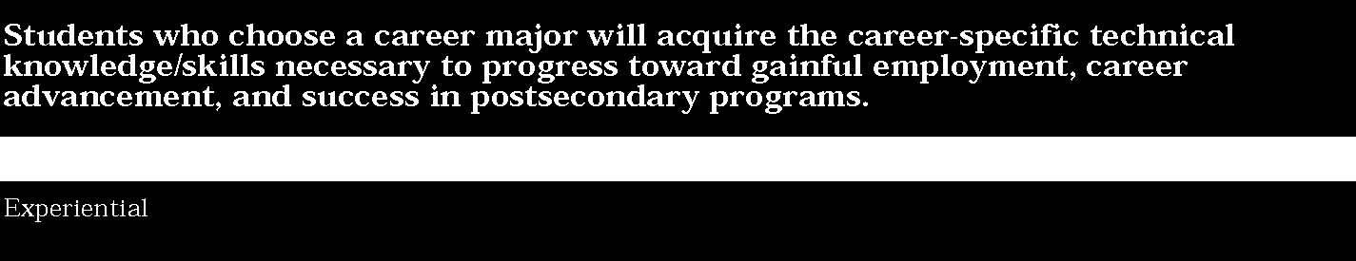
5. Resource Management
Students:
• demonstrate the ability to manage personal time, business, and financial resources.
This is evident, for example, when students:
▲ identify, prioritize, and continually update occupational goals and develop a plan to achieve those goals
▲ describe cost-effective strategies in developing and maintaining personnel (e.g., providing housing, food, and financial incentives for employees)
▲ develop a job search portfolio which might include a resume, interviewing strategies, employment opportunities, education and training requirements, compensation desired, etc.
▲ open a checking account and use bank services, develop a financial plan that will help achieve goals, obtain credit and prepare federal and State agricultural income tax returns, and use consumer protection agencies
▲ work with agricultural agencies involving cooperatives and government
▲ design an employee work schedule to use human resources effectively (e.g., scheduling dates for lawn care applications).

6. Interpersonal Dynamics
Students:
• demonstrate the interpersonal skills and abilities needed to function within a sophisticated and sometimes complicated agricultural environment.
This is evident, for example, when students:
- apply core and specialized levels of knowledge and skills through a variety of experiences with others (e.g., school/ laboratory simulations, student leadership organization activities, community-based projects, work-based activities, and agricultural experience programs)
- identify and employ coping strategies in handling developmental changes for self and others
- demonstrate the ability to teach/train a coworker in the use of computer software to establish and maintain a harvesting work schedule.

7. Safety
Students:
• demonstrate awareness of the importance of safety and accident prevention in all agricultural situations.
This is evident, for example, when students:
- apply the core and specialized levels of knowledge and skills through a variety of experiences (e.g., school/laboratory simulation, student leadership organization activities, community-based projects, work-based activities, and agricultural experience programs)
- identify potential hazards to oneself and others in an agricultural-related environment
- demonstrate practices which will prevent accidents
- describe the appropriate State and national laws that pertain to agricultural safety
- develop solutions to correct safety hazards
- are prepared to make timely and accurate decisions in the event of an accident
- establish a safety program for an agricultural enterprise.


Career areas—dance, music, theatre, visual arts, and writing—in the creative and performing arts receive some attention in performance indicators, sample tasks, and student work referenced in Learning Standards publications for The Arts, English Language Arts, and Health, Physical Education, and Family and Consumer Sciences.
The key ideas, performance indicators, and sample performance tasks contained in this document serve as the basis for developing a career major program in Arts/Humanities. Additional expectations for sequence options in dance, music, theatre, and visual arts can be found in the Learning Standards for The Arts.

1. Foundations
Students:
• demonstrate a solid base of knowledge/skills in one or more of the disciplines and the related professions of visual art, dance, music, theater, and humanities.
This is evident, for example, when students:
- create a series of drawings that demonstrate competency in a wide range of media: acrylics, charcoal, clay, ink, pastel, photography, prints, serigraphy, electronic media, visual communication
- design and produce an original garment. The quality of the garment verifies knowledge of construction techniques and fashion design skills
- perform a solo in one or more of the following genres: ballet, ethnic dance, folk, jazz or modern
- prepare and perform a solo or duet at a New York State School Music Association (NYSSMA) Evaluation Festival at levels III, IV or V
- utilize vocabulary related to various types of writing and edit their own writing using proofreading symbols and the basic forms of revision: addition, deletion, substitution, rearrangement
- create a costume plot with rough sketches for a small cast play, illuminating the differences in the characters of the play
- compose a melody that reflects the mood of a four-line poem and exhibits knowledge of the basic elements of music, e.g., rhythm and melody
- know how to work safely with hazardous materials and equipment.

STANDARD 3b
Key ideas are identified by numbers (1). Performance indicators are identified by bullets (•). Sample tasks are identified by triangles (▲).
2. Communication
Students:
• demonstrate the reading, writing, listening, speaking, graphic and multimedia skills necessary to participate effectively in one or more of the arts/humanities professions.
This is evident, for example, when students:
- interview a practitioner about what that artist does, his/her preparation, and the organization of his/her business
- employ electronic media to communicate visual ideas and promotional campaigns
- complete a publication proposal, including a press release, for a dance performance, concert, theatrical production, or art/fashion show
- express theories about the nature of dance and the underlying assumptions of why people dance
- describe the strengths and weaknesses of their instrumental or voice performances in written form and outline a plan for improvement
- write scenes, monologues, and stories to communicate emotions and ideas

▲ observe a performance or exhibition and report on it orally and in writing.
3. Aesthetics
Students:
• demonstrate the ability to express informed judgments about the arts/humanities and related professions.
This is evident, for example, when students:
- seek reasons to justify their preferences and recognize how rules of logic determine the validity of an argument
- encourage thought-provoking, ethical, and challenging exploration of ideas about the arts and humanities
- identify the strengths and weaknesses of specific musical works and performances, including their own and others
- express theories about the nature of dance and the underlying assumption that people have a need to dance
- write or present orally a critique of a well-known work of art, or literary piece, differentiating among the roles of the historian, critic, and aesthetician
- compare how ideas are communicated through the use of the elements and principles of art in diverse cultures
- compare and contrast news reportage in broadcast and print media
- clarify the nature of a live theatrical performance versus television or movies, including acting, directing, and technical elements.

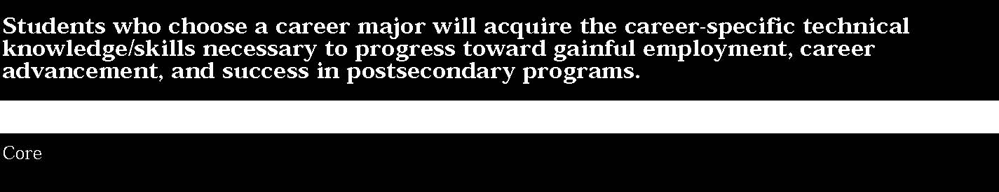

4. Personal Qualities
Students:
• demonstrate the skills necessary to function and interact effectively in a variety of settings within the arts/humanities.
This is evident, for example, when students:
- cultivate attributes essential for working in the arts and humanities such as: attention to detail, stamina, and self-discipline
- exert a high level of effort and perseverance toward goal attainment
- display consistently high standards of attendance, enthusiasm and punctuality
- understand how to manage time and materials efficiently
- exhibit proper audience behavior at school events and community performances.

5. Creative Processes and Practices
Students:
• demonstrate a repertoire of experience when presenting an exhibition, performance, portfolio, or publication.
This is evident, for example, when students:
- combine ideas in original ways; connect apparently unrelated ideas
- use learning techniques to apply and adapt new knowledge and skills to both familiar and changing situations
- discover new or alternate ways to improve results by modifying existing systems/methods
- convey a point of view and personal style via an art work
- capitalize on mistakes in fashioning a dance or theatrical work
- create characters by combining body language, facial expression, and sound
- write a poem using a meaningful sequence of visual and/or verbal images.

6. Making Results Public
Students:
• create an ongoing portfolio that demonstrates the competencies and creative processes delineated in the preceding key ideas.
This is evident, for example, when students:
- document their activities with photographs, sketchbooks, tapes, videos, or written journals
- write and disseminate a press release announcing the opening of an original dance, musical performance or art, fashion, design, craft show or publication of a book, magazine or article
- collaborate to construct and install an educational display of student art
- assemble a collection of concert/recital programs, concert/show reviews, and festival evaluations in which they have participated
- produce an intercultural celebration using props, scenery, costumes and music
- plan and execute a fashion or runway show for the public
- script a school broadcast about arts and humanities happenings
- install bulletin-board displays of creative writing and/or other student creative projects.



1. Foundations
Students:
• demonstrate a solid base of knowledge/skills in one or more of the disciplines and the related professions of visual arts, dance, music, theater, and humanities.
This is evident, for example, when students:
- integrate the knowledge/skills acquired during core level to create examples uniquely applicable to a design specialization: book, electronic media, fashion, film, graphic, interior, and textile
- execute descriptive, accurate drawings based on observation of six structures or natural objects, annotating the function(s) of each
- apply techniques of perspective and technical drawing to render a survey of furniture styles, past and present
- study the decorative arts rooms of a museum or store and duplicate the color and texture of floor, wall, and furniture coverings in watercolor
- use an electronic keyboard and computer to compose and print out a sixteen-measure composition
- demonstrate understanding of a literary work by creating a book jacket for it
- direct a one-act play demonstrating awareness of blocking, pacing, dramatic structure and thematic intent
- perform a solo or duet with a professional orchestra or university school of music.

STANDARD 3b
Key ideas are identified by numbers (1). Performance indicators are identified by bullets (•). Sample tasks are identified by triangles (▲).
2. Communication
Students:
• demonstrate the reading, writing, listening, speaking, graphic and multimedia skills necessary to participate effectively in one or more of the arts/humanities professions.
This is evident, for example, when students:
- diagram similarities and differences between forms and styles of art/dance/literature/music/theater, past, and present
- work collaboratively on an arts career exposition or a fashion show with corporate support in order to introduce role models and employment opportunities to students, parents, and teachers
- write a reflective essay about an art exhibition/musical composition, or drama from a culture other than their own, i.e., CD, tape, record album, TV, video, movie
- participate in a panel discussion on a topic related to the arts
- predict trends in global communication, fashion, public housing, or travel in 2020
- publish a review of a dance/music/theatrical performance in the school or local newspaper
- create a Web page to disseminate a commemorative publication or art exhibition
- determine how dress influences verbal and nonverbal communication.

3. Aesthetics
Students:
• demonstrate the ability to express informed judgments about the arts/humanities and related professions.
This is evident, for example, when students:
- place the arts/humanities within a larger social and historical context
- link aesthetic form, cultural meanings, social content, and universal values to the academic and vocational components of career preparation
- research the roots, analyze, and portray the similarities and differences between forms and styles of the arts—past and present
- respond to the work of a living artist/actor/dancer/musician/writer by learning the details of her/his life and imagining how the biographical facts are reflected in the work
- identify rubrics with criteria for assessment of individual art works and/or thematically grouped art works in an exhibition
- discover folk music melodies embedded in concert music compositions and describe their significance
- inventory and evaluate all the art forms incorporated in a theatrical production
- explain how drama, theatre or music experiences relate to other artistic and literary happenings.

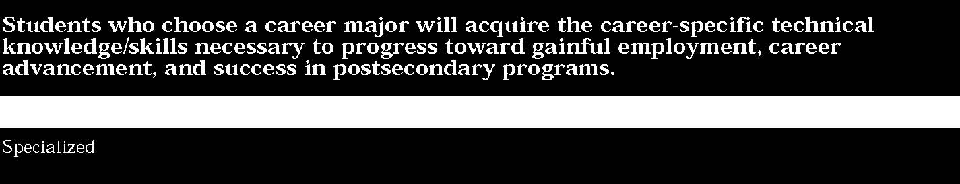

4. Personal Qualities
Students:
• demonstrate the skills necessary to function and interact effectively in a variety of settings with the arts/humanities.
This is evident, for example, when students:
- serve on a team to publicize school/community issues and events or curate an exhibition
- use cooperative decision-making while creating an original work for two or more dancers
- select an instrumental composition and set performance goals with peers that will guide rehearsals
- collaborate with a team in handling all functions involved in editing a radio, film, or video production, i.e., camera, lights, sound and recording
- take credit for the work they do on their own and give appropriate credit to others
- acknowledge their personal assets and shortcomings in order to develop strategies to convert liabilities into assets.

5. Creative Processes and Practices
Students:
• demonstrate a repertoire of experience when presenting an exhibition, performance, portfolio, or publication.
This is evident, for example, when students:
- engage in discussion of their work which utilizes cognitive and social skills and demonstrates mastery of academic and occupational content
- discover how computers manipulate photographic images and the application of this technology to commercial, journalistic, and artistic photography
- apply their study of how people behave, move, think, and are structured to design consumer products e.g., appliances, cars, furniture, toys.
- bring together ideas and concepts as a graphic designer, to market a new product utilizing copy, illustration, and typography
- interpret ideas or concepts to create political, humorous, or narrative cartoons
- design an alternative floor plan/layout for a home furnishing business and explain how the new layout is an improvement over the existing one
- plan the program for a short recital: locate and choose the site; secure musicians; choose the music; publicize and stage the performance.

6. Making Results Public
Students:
• create an ongoing portfolio that demonstrates the competencies and creative processes delineated in the preceding key ideas.
This is evident, for example, when students:
- document the process leading to a culminating event in electronic, pictorial, or written format
- take part in a major school performance, either behind the scenes as director, costumer, scenery artist, advertising manager, stage manager or on stage as actor, singer, dancer, musician
- curate and install an individual or group show in an art gallery setting
- assemble a permanent display of fabric, wallpaper, carpet, and paint samples, arranging them in attractive combinations of color, pattern, and texture
- produce a documentary video that examines, analyzes, modifies, and evaluates a dance from creation to final performance
- display examples of original writing or art in a library or other public setting
- direct elementary students in a school play
- produce an exhibit showing changes in apparel through the ages resulting from political, religious, economic, and social factors.



1. Foundations
Students:
• demonstrate a solid base of knowledge/skills in one or more of the disciplines and the related professions of visual art, dance, music, theater, and humanities.
This is evident, for example, when students:
- complete a successful residency/internship in a professional dance or theater company, newspaper or magazine office, advertising or media agency, choral or instrumental group, media or design firm
- use traditional or nontraditional media to compose/arrange/perform a multi-movement composition for several instruments
- assemble a body of original work that demonstrates competence in the professional practices of a specific career
- develop a comprehensive array of samples that demonstrates mastery in transferring designs from print media to interactive multimedia and/or digital video
- prepare a textiles sample portfolio to explain fabric printing processes from ancient to modern times, e.g., tie-dye, commercial dye bath
- publish a well-researched, organized and formatted report on the local arts in the school newspaper or other publication
- utilize auto CAD for desk-top publishing, graphic, interior, textile, or fashion design or pattern-making
- write program notes for a concert of folk songs that identify the source and background of each one
- protect themselves and others by implementing occupational safety laws and eliminating health hazards.

STANDARD 3b
Key ideas are identified by numbers (1). Performance indicators are identified by bullets (•). Sample tasks are identified by triangles (▲).
2. Communication
Students:
• demonstrate the reading, writing, listening, speaking, graphic and multimedia skills necessary to participate effectively in one or more of the arts/humanities professions.
This is evident, for example, when students:
- know and use correct grammar and terminology for effective workplace communication when creating, performing, exhibiting, and promoting the arts and humanities
- participate in a mock or actual job interview or audition for a career in the arts or humanities
- write a resume and a letter of application for a position advertised in a trade or industry related publication, e.g., Women’s Wear Daily, The New York Review of Books, or Billboard
- plan and carry through an on-site mentorship/internship at a commercial art, publishing, music, or theatrical production company
- keep a daily journal of the obstacles, frustrations, and successes encountered while working in a community service organization or after-school program
- deliver an oral presentation in defense of a semester or yearlong project
- write a business proposal to submit to potential theatrical producers
- prepare a presentation for a production meeting using computer-aided design for costumes, lighting, and sets designs.

3. Aesthetics
Students:
• demonstrate the ability to express informed judgments about the arts/humanities and related professions.
This is evident, for example, when students:
- recognize the stylistic differences in the artifacts, architecture, art, literature, music or theatre of the world’s major cultures
- establish benchmarks to evaluate their own work and the work of peers
- teach a lesson to students in a lower grade level stressing the forces that shape artistic communication
- examine the merits of a work of art, music, or writing from a cultural, historical, or psychological perspective
- justify a personal preference for the work of an author, artist, or performer
- write critical reviews of a variety of theatrical productions, exhibitions, or concerts
- understand how architects, actors, broadcasters, craftsmen, designers, dancers, musicians, painters, sculptors, or writers make artistic decisions
- compare two exhibitions, performances, publications, or videos using appropriate technical vocabulary.

4. Personal Qualities
Students:
• demonstrate the skills necessary to function and interact effectively in a variety of settings within the arts/humanities.
This is evident, for example, when students:
- work collaboratively in leadership roles and as members of a team
- provide evidence of high personal standards through exhibitions, performances or portfolios that are recognized as excellent by the profession
- display diligence and perseverance in the face of unpleasant tasks
- demonstrate adaptable, cooperative, empathetic, enthusiastic, eqalitarian, polite, and responsible behavior in a work group or job setting
- understand the range of possibilities within the career field, determine where their skills and abilities fit within that range, and make plans for further study
- practice creative approaches to conflict resolution
- show behaviors that comply with social, legal, and ethical requirements of the arts, broadcasting, journalism, and publishing
- exemplify positive attitudes toward their work, the workplace, and authority figures.

5. Creative Processes and Practices
Students:
• demonstrate a repertoire of experience when presenting an exhibition, performance, portfolio, or publication.
This is evident, for example, when students:
- decide upon direction for a new body of work based on a review and reflection on their portfolio
- create a product that crosses traditional disciplines, integrating knowledge acquired in school, at work, or at home
- clarify ideas by comparing and contrasting, classifying, sequencing, uncovering assumptions, reasoning and drawing conclusions, comprehending part/whole relationships
- create original works that demonstrate that they are adventurous, courageous, curious, imaginative, independent, and inventive
- defend and/or explain their creative process, practice, and product
- generate alternative possibilities and solutions to a real life problem
- utilize their portfolios and journals as a means for perpetual self-assessment and the ultimate attainment of current workplace standards.

6. Making Results Public
Students:
• create an ongoing portfolio that demonstrates the competencies and creative processes delineated in the preceding key ideas.
This is evident, for example, when students:
- develop a commencement portfolio containing evidence of creative growth and mastery of entry level occupational skills
- produce a professional quality literary/art magazine using a variety of skills: layout, typography, editing, paste-up, proofreading, illustration, photography
- produce a professional quality news magazine broadcast that combines research, sequencing, and interpretive skills
- create and/or produce a professional quality theatrical production using a repertoire of skills: improvisation, scene work, character development, costume, stage and lighting, funding, marketing, promoting
- display original art, craft, design, graphics, manuscripts, poetry or scores in a library or other public setting
- create and produce a professional standard dance performance using a repertoire of skills: choreography, costume, lighting, and stage design, directing, marketing and promotion
- create and produce a professional standard musical event, using a repertoire of skills: performing, funding, marketing, promotion
- create and produce a professional standard art exhibition using a repertoire of skills: mounting, curating, hanging, labeling, lighting, funding, marketing and promotion.

52

The samples of student work included in this section are intended to begin the process of articulating the performance standards at each level of achievement. This collection is not yet adequate for that purpose in either numbers or scope of examples. As New York State continues to collect work samples from the schools for inclusion in the document, we expect a much clearer understanding of the performance standards to be evident.
Neither are these samples presented as models of excellence. They vary in degree of achievement. Some are “acceptable”; others “more proficient.” All are meant to provide examples of the kind of work students might produce to demonstrate progress toward the standard.

