Look Up

Weather Notebook

Name: _____________________________
Activity 1 | Weather Unit Vocabulary List
air | a mixture of gases
atmosphere | the layer of gases surrounding the Earth
climate | the average daily and seasonal weather for a region
weather | the condition of the atmosphere at a certain time
meteorologist | a scientist that studies the atmosphere and weather
Activity 2
air mass | a body of air which has the same characteristics of temperature and moisture
altitude | height above the ground
anemometer | an instrument that measures the force or speed of the wind
gas | a high energy state of matter
jet stream | a narrow band of strong winds in the upper troposphere layer of the atmosphere
latitude | the location North or South of the equator
mass | the amount of matter an object has
prevailing wind | the direction the wind most often blows from over a period of time
source region | where something comes from
wind direction | the direction the wind blows from
wind speed | a measure of how quickly the wind is moving
wind vane | an instrument that measures wind direction
Activity 3
energy | the ability to do work
force | a push or a pull
fluid | a liquid state of matter or able to flow
temperature | measure of the energy of motion or degree of heat
Activity 4
barometer | instrument to measure air pressure
pressure | force on an area
weight | the force of an object due to the force of gravity
air pressure | force exerted by the weight of the air
Activity 5
cold front | A boundary between two air masses, one cold and the other warm, moving so that the colder air replaces the warmer air.
isobar | a line on a map where all the points have equal air pressure
stationary front | A boundary between two air masses that more or less doesn’t move, some stationary fronts can wobble back and forth for several hundred miles a day.
warm front | The boundary between two air masses, one cool and the other warm, moving so that the warmer air replaces the cooler air.
Activity 6
cirrus | thin, wispy clouds formed from ice crystals found at high altitudes
cloud | a visible collection of water or ice particles floating in the air
condensation | gas changing to the liquid state
cumulus | fluffy, mid-level clouds that develop in towering shapes
dew-point temperature | the temperature at which water starts to condense out of a particular air mass.
humidity | the amount of water as water vapor
precipitation | any liquid or solid form of water that falls from clouds to the surface
relative humidity | a comparison of the amount of water actually in the gas state to the total amount that could be a gas at that temperature (a percentage)
stratus | low-lying, gray and sheet like clouds that often produce drizzle
Activity 7
advisory | a forecast that highlights conditions that require caution
blizzard | severe weather with low temperature, winds over 35 mph and reduced visibility for at least 3 hours
dust storm | severe weather with strong winds and dust filled air
flood | unusual high water flow or overflow of rivers and streams
hurricane | severe weather of sustained winds of 74 mph or greater
ice storm | severe weather characterized by falling freezing precipitation
thunderstorm | severe weather of rapidly rising air characterized by strong wind, thunder, lightning and rain or hail
tornado | a violently rotating column of air that is very destructive
Resource: Weather Wiz Kids (www.weatherwizkids.com) and Weather.com
KWL: What do you know about the topic of weather?

What I know about the weather.
What I would like to know about the weather.
Questions that I have.

Weather Senses: How do I experience the weather?

Use the chart below to record your observations about the weather.

The ways that I see the weather are… | The ways that I hear the weather are..
The ways that I smell the weather are… | The ways that I touch the weather are..
The ways that I can taste weather are… | “How do we experience the weather?”

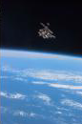
Air Masses: What is an air mass?

Our air is a mixture of different types of matter in gas states. These gases make up the air that surrounds the Earth. The layer of air surrounding the Earth is called the atmosphere. Wherever you go on the Earth the same basic gases are found. These basic gases can have different properties, so there are differences in some of the properties of the atmosphere in different places.

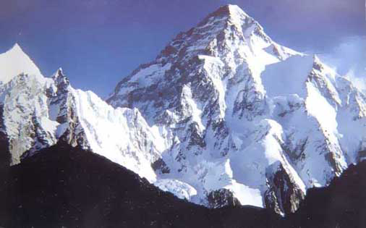
Some places on the Earth have colder air temperatures; some have warmer air temperatures. Some places have more water in the gas state so the air feels wetter; some places have less water in the gas state so the air feels dryer. You can go to places where there is less matter in the gas state. The air there is described as being very thin. So what we have is a quantity of air that can have the properties of being hot or cold, wet or dry, and thin or thick. A large quantity of air with the same properties covering a large part of the Earth is called an “air mass.”
Mountain top air is cold and thin.

Air masses have some observable and measurable properties. The air in the same air mass generally has the same property characteristic. Different air masses can have different property characteristics. For example, an air mass has the property of temperature, but not all air masses have the same temperature measurement. These property differences are related to the where the air mass forms. This is called the source region.

The source region is the place on the Earth over which these large air masses form. The air mass takes on the properties of the part of the Earth that the air mass sits over. For example, if a large air mass sits over the ocean for a while it will pick up more water vapor (gas) and become wetter. If another large air mass sits over a warm surface it becomes warm.

In general, air masses form either over land or over water and near a polar region or near the tropics. Four terms used to describe such air masses are continental, maritime, polar, and tropical. A continental air mass is one that forms over dry land (the continent). A maritime air mass is one that forms over an ocean. (Mare is the Latin word for sea or ocean.) A polar air mass is one that forms near the North or South Pole. A tropical air mass is one that forms near the Tropic of Cancer or the Tropic of Capricorn.

Air Mass Source Regions

Your task is to identify the major source areas for air masses that affect North America. The map found below has arrows that identify these source regions. The arrows show the air mass movement from the source region. Each arrow or set of arrows has a source region labeled with a capital letter. Using the information in Table 1 and the “Helping Descriptions”, place the Air Mass Abbreviation near each letter on the map.

Table 1: Air Mass Name and Characteristics Table
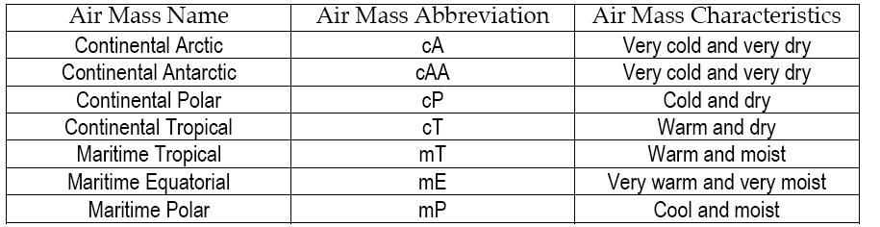
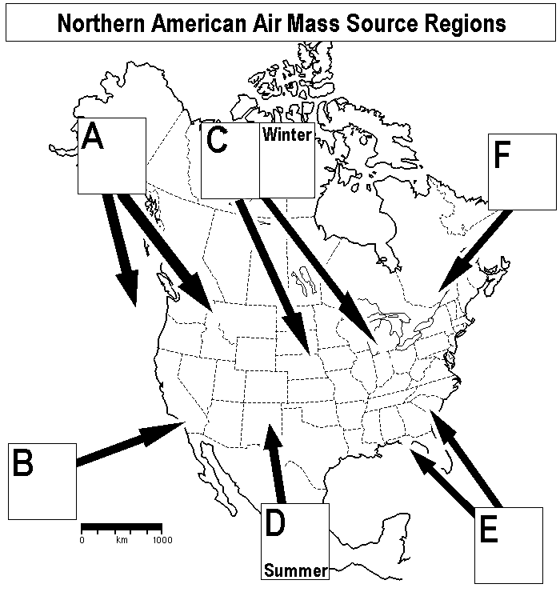
Helping Descriptions:
A: Cool and moist
B: Warm and moist
C: Cold and dry
C: Winter - Very cold and very dry
D: Summer - Warm and dry
E: Warm and moist
F: Cool and moist

In Table 1, circle the abbreviations that you used on the map.

List the source regions that do not directly affect N. America.

(Air Mass Source Regions – con’t)

As air masses move across the Earth they bring their characteristics to us. They bring our weather. Sometimes air masses collide with each other making our weather even more dynamic.

The picture below shows two large air masses. One is moving into the U.S. from a source region in the north (A). The other is moving in from a source region in the south (B).

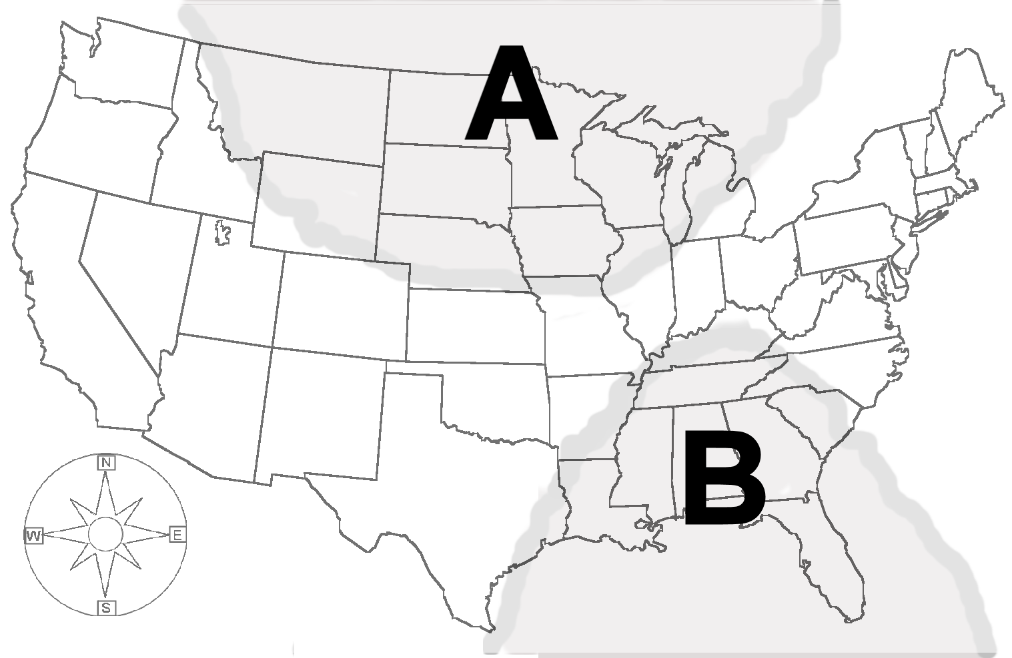
1. Which air mass has the property of being cold? (A or B) ________

2. Which air mass has the property of being warm? _______

3. Which air mass may pick up water vapor from the ocean? ________

4. As a person living in New York State, how might air mass A affect the outdoor party that you are having tomorrow?

5. If air mass B moves into New York state, how might air mass B affect you?

Student Activity A
What properties does a gas have?
Materials: balloon suction cups straws baking soda and vinegar
thermometers 1 oz cups index cards film cases
lunch bags

All matter takes up space and has mass. (Two objects cannot occupy the same space at the same time.)
Matter can have properties of color, hardness, odor, taste, shape, size, mass, volume (take up space), weight (force), temperature, sink/float (buoyancy), conductivity of electricity, magnetism, and wet/dry(contain water). Can you think of others?

1. Pick a visible object in your classroom and describe 3 properties that it has. You can sketch, measure or write a description of its observable properties. Be prepared to share or demonstrate the objects properties. Use the recording space provided below.

Object Properties Recording Space:

2. If a gas is matter it must have observable properties.
a. Using the materials provided and any other materials (as approved by your teacher) demonstrate 3 properties of a gas. You can sketch, measure or write your observations to describe the properties. Be prepared to share or demonstrate the properties.
b. Describe 2 properties for which the gases in the air do not have an easily describable characteristic. (For example, the gases in the air do not have texture.)
(Student Activity A- con’t)
2. Gas Properties Recording Space
2-a.

2-b.
Air Mass Movement: In what general direction do air masses move across the US?

There are four maps shown below. Each represents the US on three different days. The numbers on the maps show different air masses. Your task is to track the movement of the air masses. After doing this you will make a general statement (a generalization) about the direction that air masses move across the US.
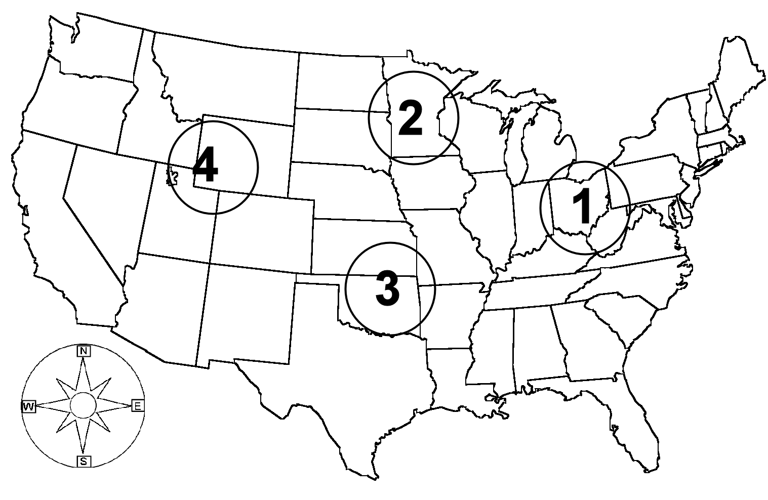
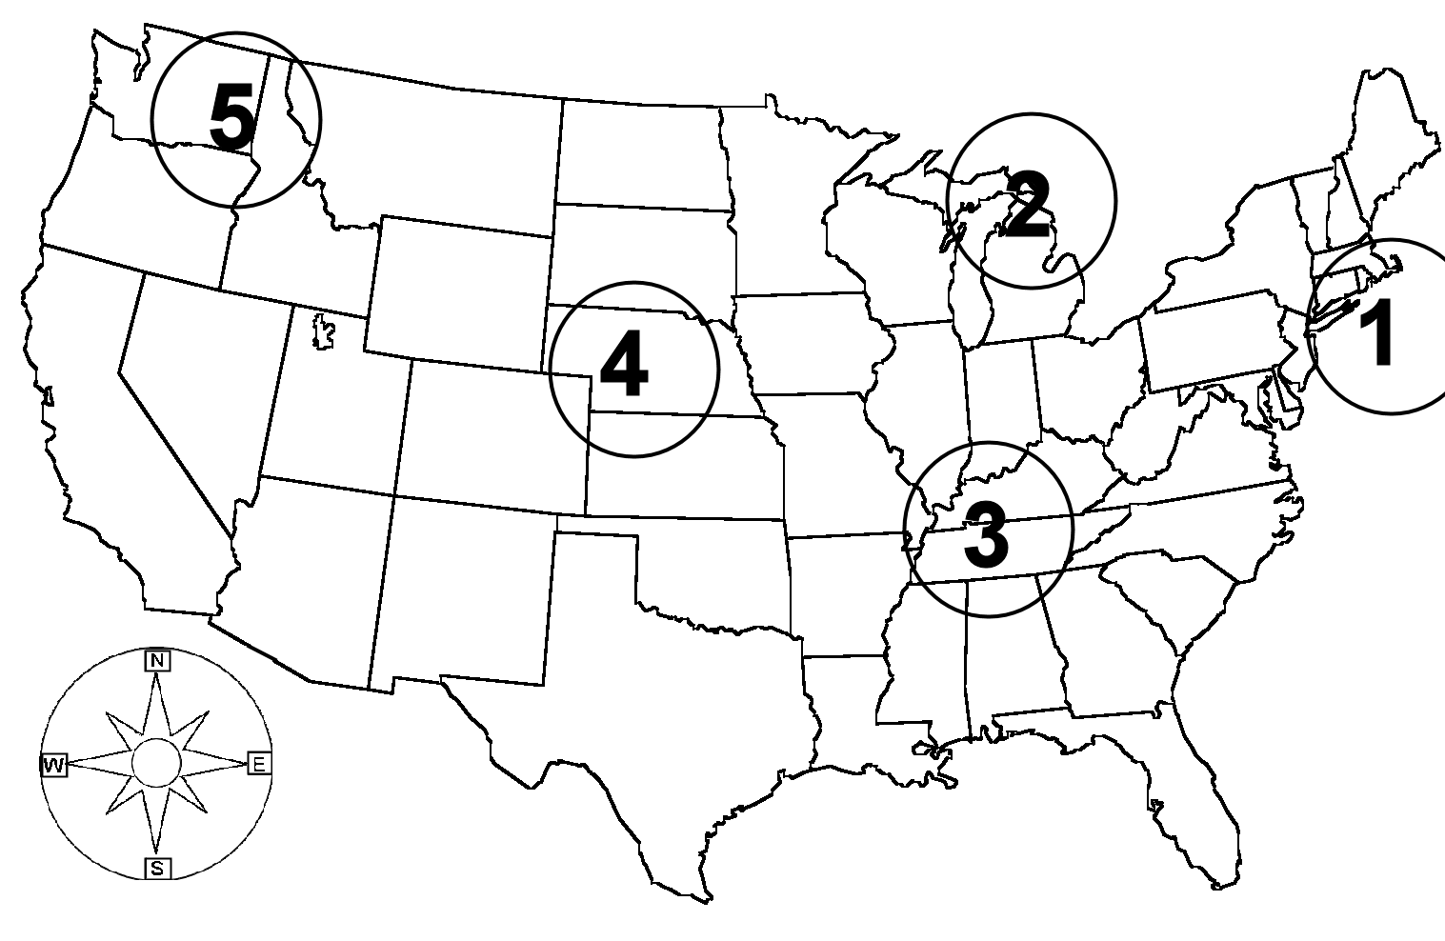
Day 1
Day 2

- Look at air mass 1 on Day 1 and then on Day 2. Which direction has the air mass moved? ___________________

- Look at air mass 2 and 3. Which general direction have the air masses moved?

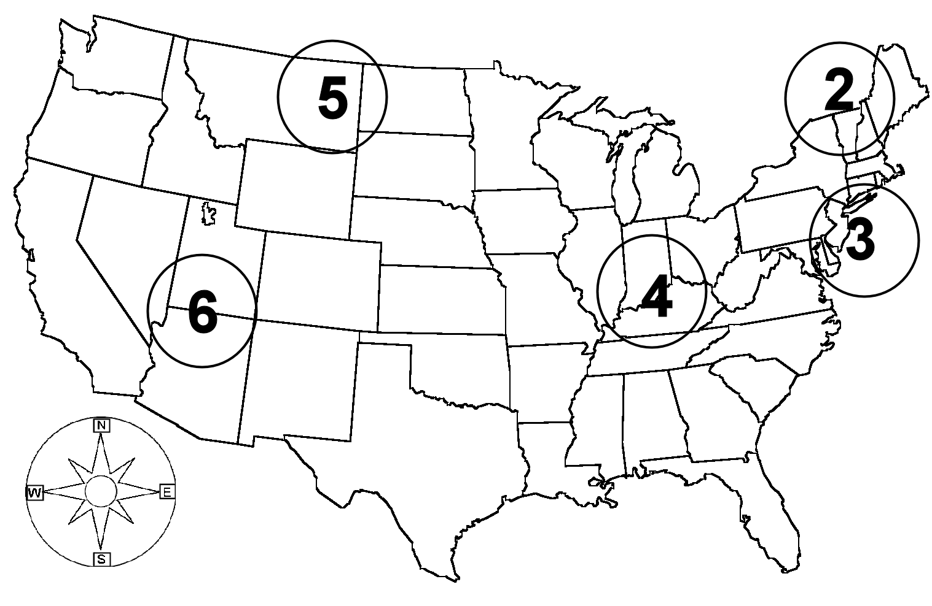
Day 2
Day 3

- Make an observation comparing the air mass diagrams on Day 2 to Day 3.
Day 2
Day 2
Day 2
Day 2

- Find New York State on the US map for Day 3. Which direction did air mass 2 move from to cross New York State? __________________

- Make a general statement about the movement of air masses across the US.
Do our generalizations about air mass motion work with real weather maps?

Your task is to track the movement of weather masses across the US for the next three days. You can do this by using the daily newspaper or an internet website (such as weather.com).

Look for a “Current Weather” map. You will find that two different letters are used to represent the air masses shown on a weather map, H and L. Use these letters on your maps (found below) to track the air mass movements. Write in any observations about the movements of the air masses. Make a local weather observation for each day.

Day 1
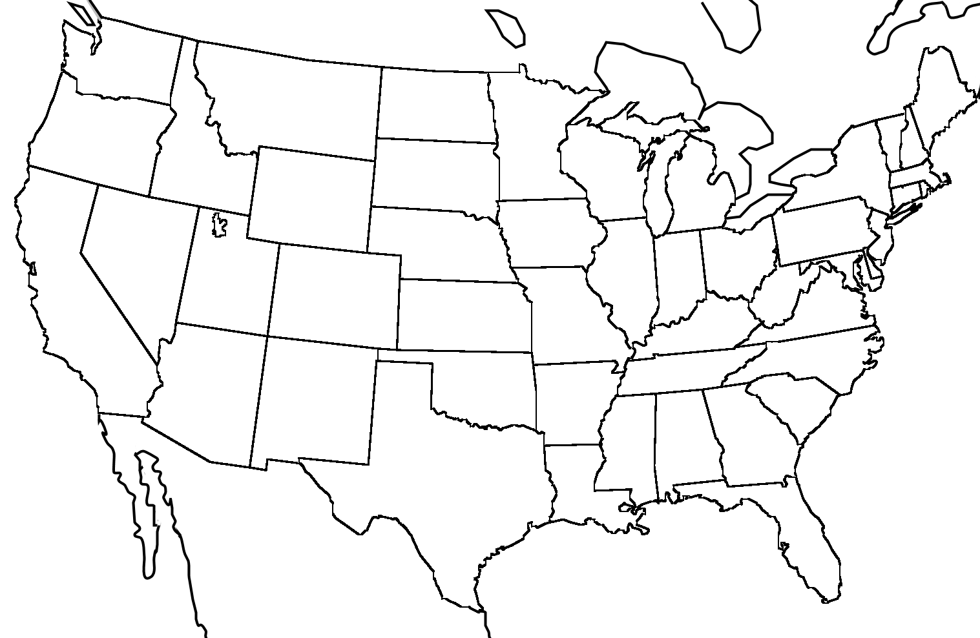  1 | What general direction do you think air masses move across the U.S.?
Weather Observation (shade in NYS on the map):

Day 2
2 | Observation of Day 1 - 2:
Weather Observation (shade in NYS on the map):
Day 3
3 | Do you need to change or modify your generalization about air mass movement? (see Day 1)
Weather Observation (shade in NYS on the map):

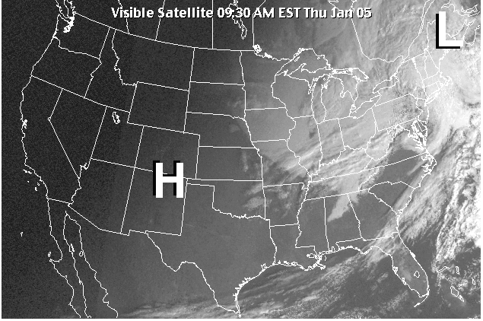
Review: Weather is air in motion.
This picture is a satellite photograph of the U.S. There are two air masses labeled on the map, air mass L and H. Answer the following questions using the map or previous pages in this notebook.

1. What direction do you predict air mass H will move in? _______________
2. Find New York State on the map. Do you think air mass L will move toward or away from New York State? _________________________
3. Which air mass is currently affecting New York? Why do you think that?
__________________________________________________________________________________________________________________________________________________________________________________________
4. What does the term “source region” mean for an air mass? ____________________________________________________________________________________________________________________________
5. Name a state that is experiencing air mass H. ________________________
What powers the movement of air masses across the U.S.?

At the end of this section you will be asked to provide an answer to the above question. Up to this point you have looked at the movement of small air masses. Next, you will be expanding your knowledge to form a model of what powers the movement of these smaller air masses. You will be looking at models of air movement on a global scale. You will use this information to explain your observations on the direction of air mass motion across the U.S.

Prevailing winds: The Earth diagram found below is labeled with zones of major wind movement. The arrows on the diagram show the usual direction that the wind blows in each zone. This direction is the prevailing wind direction for the zone. These global prevailing winds are important in the movement of weather systems. They are also important for the motion of sailing ships. Prevailing winds have been mapped for hundreds of years by sailors, who used them to steer ships.

Use the information from the diagram to answer the questions.
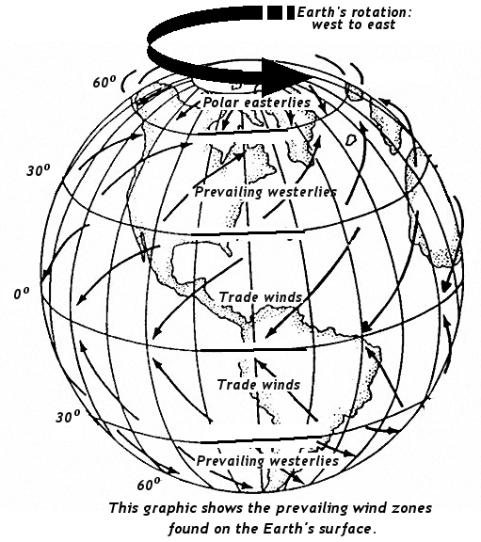
1. Are the prevailing wind zones split by latitude or longitude?

2. What prevailing winds are in the same latitudes as the U.S.?

3. Describe the direction of the prevailing winds in the U.S.

4. Previously, what did you observe as the general direction of the movement of local air masses across the U.S.?

Prevailing Winds Diagram
(What powers the movement of air masses across the U.S.? – con’t.)

5. Compare your answers for question 3 and question 4.

6. What is the range of latitude degrees for the Trade winds north of the equator?

7. Sailors of the Tall Ships period used to rely on the trade wind for their Atlantic crossings. If you were sailing off of the east coast of South America, south of the equator, what would be the wind direction of the Trade winds?

8. What have you learned, so far, about what powers the movement of air masses in the U.S.?

Jet Streams: upper air currents
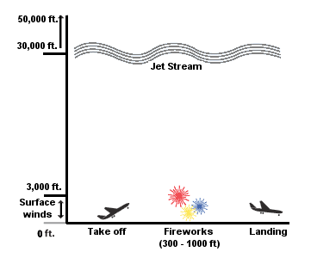
There is another force that powers the movement of large masses of air. It is high speed air currents that occur at high altitudes. These high speed air currents, called “jet streams”, circle the globe.

1. Using the diagram to the left, write down the range of altitude where jet streams are found.

2. How many miles high is the lowest altitude where the jet streams are found?
One mile is equal to 5280 ft. (Round off to the nearest whole mile.)
<Show your work here>

(What powers the movement of air masses across the U.S.? con’t.)
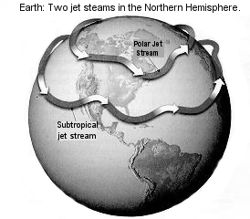
The diagram to the left shows the presence of the two major jet streams found north of the equator.

3. What are the names of the two jet streams?

4. (Fill in the missing words.) According to the diagram, these jet streams move in the general direction from the to the .

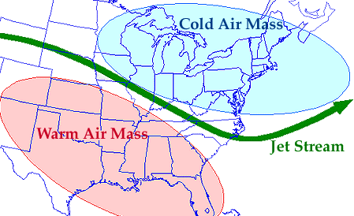
5. The two jet streams in the diagram are the major ones that occur in this region of the world. There are other smaller jet streams that form. Jet streams affect weather and sometimes even the speed of aircraft.
Jet streams are air currents that move horizontally. They occur where there is a meeting of cold and warm air. The greater the difference in temperature between the air masses, the greater the energy of the jet stream. The speed of the air in a jet stream can vary between 90 – 250 mph.

What is a “jet stream”? __________________________________________

6. Summary: What powers the movement of air masses across the U.S.?

Student Activity B
How can we measure wind direction and wind speed?
We can observe the direction and speed of air movement by making local weather measurements.

Wind Vane: A wind direction measurement devise

Materials: large index card tape* T-pin pencil with eraser top*
straw scissors* (* teacher provided)

Set-up procedure:
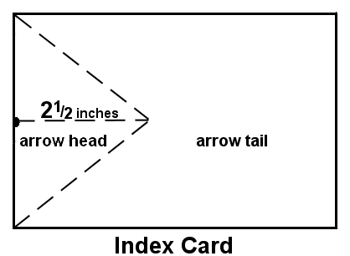
1. You will be cutting an arrow head and tail from the 4”x6” index card.
Do this by doing the following:
- find the middle of the short side of the index card
- make a pencil mark at this point
- draw straight line from this point that is about 2½ inches long
- draw a line the closest 2 corners to the end of the drawn line
- cut out the large triangle

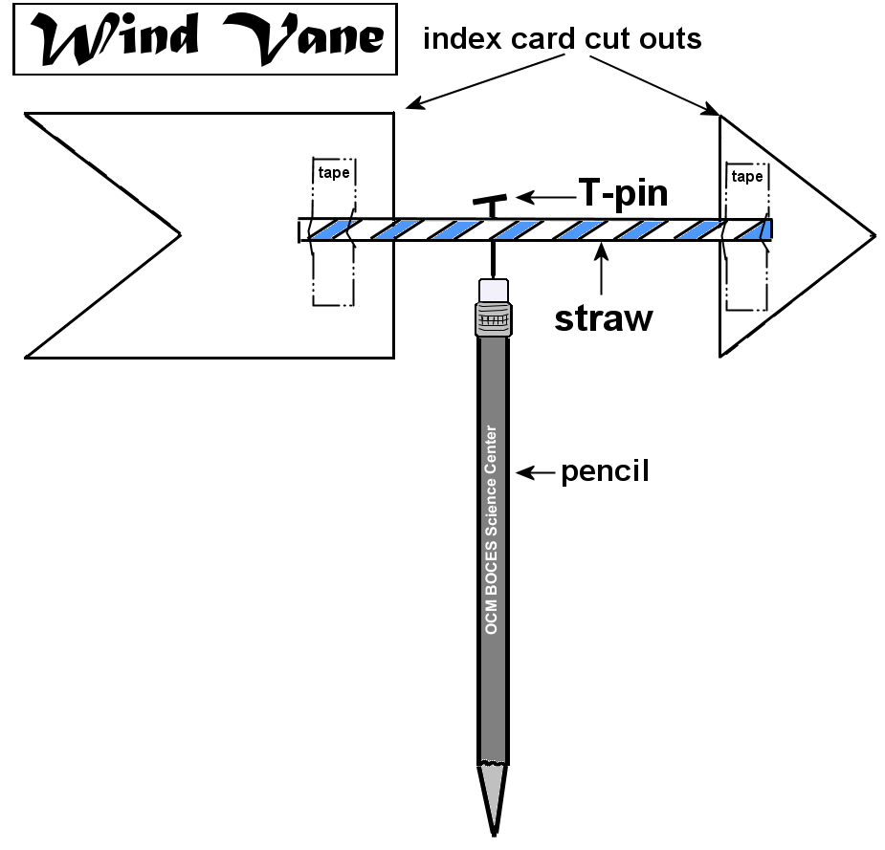
2. The straw will connect the arrow head to the tail. You need to cut a slit in each end of the straw. The slits should be in line with each other. You will be sliding the arrow head and tail into the slit. (Instead of slitting the straw you can tape the arrow head and tail onto the straw.)

3. The T-pin will connect the straw to the pencil. Decide what place on the straw would be a good balance point. Push the T-pin through the straw so that the arrow head and tail are standing up (vertical). Push the T-pin into the eraser head of the pencil. Twirl the wind vane around until it turns easily on the T-pin.

(Student Activity B – con’t.)
Wind Anemometer – A wind speed measurement devise.

Materials: 10 in. fishing line ping pong ball Wind speed sheet
Anemometer sheet plastic sheet protector cardstock sheet
T-pin
Set-up procedure:
- Slide the cardstock sheet into the plastic sheet protector.
- Hold the plastic sheet protector so that the 3-hole punch end is on the top. Slide the Wind speed sheet into the sheet protector, right side up.
- Hold the sheet protector so that the 3-hole punch end is on top. Slide the Anemometer sheet into the side opposite the Wind speed sheet, right side up.
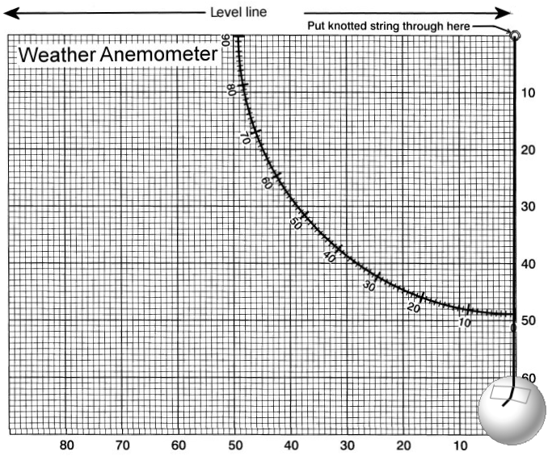
- Using a T-pin put a hole through all the sheets at the place on the Weather Anemometer sheet where it says,”Put knotted string through here.”
- Push one end of the fishing line through the hole. You can knot the string on the back end or tape it to keep it in place.
- Using tape, attach the ping pong ball to the other end of the fishing line. Attach it so that the top of the ball lines up with the 60 on the vertical axis.

How to use the measuring devices
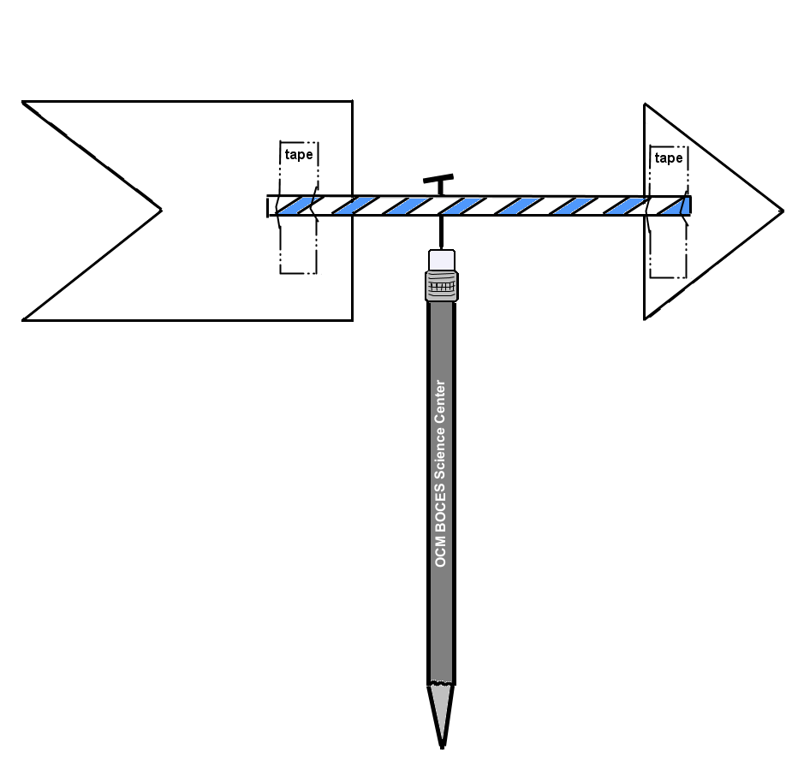
Wind Vane:
Hold the wind vane away from your body. The wind vane will point in the direction that the wind is blowing from. This is how we name wind direction; we name it for the direction from which the wind blows. In order to name the wind direction you need to know the compass points (where North is) for your area.

Weather Anemometer:
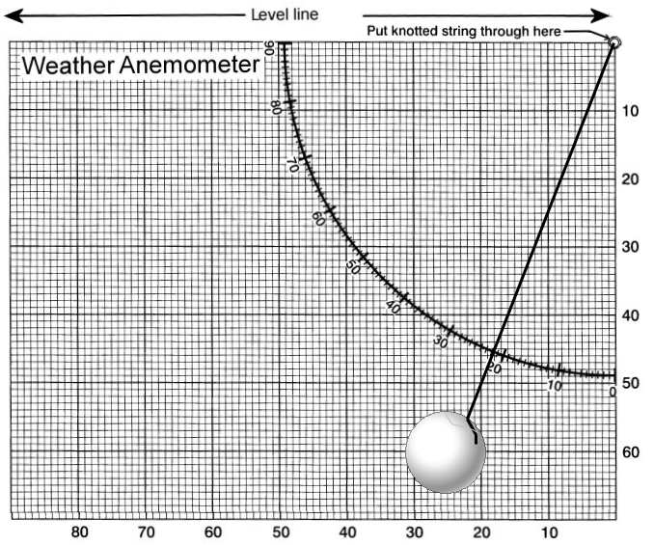
The anemometer needs to be pointed into the wind. You point with the end with the ping pong ball, keeping it as level as you can. The wind will blow the ping pong ball. As the ball moves, the fishing line will move with it. You read the number on the curved line where the string crosses. The wind speed chart will help you to determine the wind speed.
(Student Activity B – con’t.)

Wind Measurements:

Student Activity C (choice 1)
Air Mass Property: Temperature
How is air heated and cooled?

Outdoor Activity:
Task: Your job is to record outdoor temperature measurements. When you do this you should make some observation about the area that the measurement was taken. For example: What was the nearest surface like? Was the area shaded or in full sun? Where there any objects nearby? What was the weather like?

Student Activity C (choice 2)
Indoor or Outdoor Activity:
How do the properties of a surface affect the heating or cooling of the air over that surface?
Create an experiment that answers the above question. You can write out or sketch out your plan. Check with your teacher before you carry out your plan.
What is WIND-CHILL?

-What is wind-chill temperature?
The wind-chill temperature tells you how quickly people and animals feel cold when outside. For you to feel cold your body needs to lose heat. The faster your body loses heat the quicker you feel cold. A colder air temperature will cause your body to lose heat faster. (For example, when you want to cool a can of soda more quickly you put it in the freezer instead of the refrigerator.) Air movement will also cause something to cool faster. (Think of what you do to cool a spoonful of soup. You blow on it.) Wind-chill is a measure of how quickly your body will cool to the outside air temperature when the wind is blowing. As the wind increases, it takes heat energy from your body and decreases the skin temperature. Eventually the internal body temperature decreases too. The wind makes you FEEL colder more quickly due to the increase in speed of cooling. If the temperature is 0°F and the wind is blowing at 15 mph, the wind-chill is -19°F. This means that you (objects) will lose heat faster than at 0ºF. At this wind-chill temperature, exposed skin will freeze in 30 minutes.

-Some tips on how to dress during cold weather.
The best way to avoid hypothermia* and frostbite** is to stay warm and dry. When you must go outside, dress properly. Wear several layers of loose-fitting, lightweight, warm clothing. The trapped air between the layers will insulate you. If you do a lot of physical work outside, remove some layers of clothes to avoid sweating. Sweat on your skin causes you to lose body heat. Outer garments should be tightly woven, water repellent, and hooded. Wear a hat, because half of your body heat can be lost from your head. Cover your mouth to protect your lungs from extreme cold. Cover exposed skin when the air is very cold for skin may freeze. Mittens, snug at the wrist, are better than gloves. Try to stay dry and out of the wind.

* hypothermia – the lowering of a person’s body temperature
** frostbite- when your body tissue freezes (most affected are ears, fingers and toes)

-Is it possible to get frostbite if the temperature is above freezing but the wind-chill is below freezing?
No, the air temperature has to be BELOW freezing in order for frostbite to develop on exposed skin. Wind chill can bring your temperature to below freezing only if the air temperature is below freezing.
How is wind-chill calculated?
Wind-chill is calculated using a complex math formula. To make this task easier, a wind-chill chart has been created.
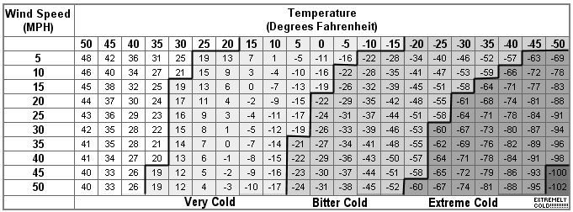
Wind-chill Chart
Frostbite will occur in 15 minutes or less

Answer the following questions using the chart.
- If the temperature is 20ºF and the wind speed is 15 mph, what is the wind-chill measurement? ______________
- If the temperature was 5ºF, what would the wind speed have to be to have a wind-chill of -21? ______________
- What are the two weather conditions that affect the wind-chill measurement? ______________________,_______________________
- What is the highest wind-chill temperature on the chart that is considered “BITTER COLD”? __________ “EXTREME COLD”? _____________

When does the National Weather Service issue a Wind-chill Advisory or Warning?
The National Weather Service will issue a wind-chill advisory (may be dangerous) for wind-chills of -15ºF to -24ºF. A wind chill warning (very dangerous) will be issued for wind-chills of -25ºF and below. Wind-chill increases the risk of frostbite and hypothermia (lowered body temperature). Wearing the proper clothing in layers plus hats, boots, and mittens can greatly reduce a person’s risk.

(Source: NOAA National Weather Service, Office of Climate, Water and Weather Services
http://www.nws.noaa.gov/om/windchill/windchillglossary.shtml)
What happens to air when it is heated??

Respond to teacher demonstration: You task is to write about the activity. You should write about (sketch) the actual activity and tell about what happened. You should include you thoughts on why.
What happens when we mix cooler and warmer fluids?

Teacher Demonstration: Your task is to write about the activity. You should write about (sketch) the actual activity and tell about what happened. You should include your thoughts on your observations. Why do you think that happened?
Student Activity D
How can I tell there are differences in energy levels of cool and warm air?

Materials: glass flask balloon scissor
large plastic jar rubber band cold and warm water
Procedure:
- Cut the stem of off the balloon.
- Stretch the balloon over the top of the flask.
- Secure the balloon cover in place using the rubber band.
- Write/sketch a starting observation.(Observation 1)
- Fill the large plastic jar about half full with very warm water.
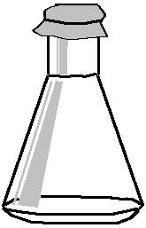
- Place the balloon covered flask in the warm water (you may have to hold it so it doesn’t tip over).
- Write/sketch your observations (Observation2).
- Take the flask out of the ice water.
- Fill the large plastic jar half full with water and ice.
- Place the balloon covered flask in the ice water.
- Write/sketch your observations (Observation3).
- Take the flask out of the water. Place it on the table and allow it to return to room temperature.
- Write/sketch your observations (Observation4).

Observation 1: | Observation 2: | Observation 3:

(Student Activity D – con’t.)
Observation 4: | Other observations/thoughts

Results: What changed? What was different when that change occurred?

Conclusion: How can I tell there are differences in energy levels of cool and warm air?

Air Mass Property: Pressure
1. Define the term “mass”. __________________________________________
2. What does air having the property of mass have to do with:
a kite flying?
a hot air balloon floating?
a windmill turning?
3. How does the air’s mass affect the force of the air?

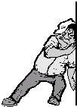
4. What is pressure?
Write a definition of the term “pressure”. Draw a sketch of yourself exerting pressure on an object or an object exerting pressure on you.

What is air pressure? _________________________________
___________________________________________________
Student Activity E
How can we observe air pressure?

How often do you get to experience air pressure? That is the focus of this short activity. Follow the directions for the basic set up and then explore the effects of the force of air.

Materials: 1-plastic jar 1-plastic bag (8x10) 2-rubber bands

Directions:

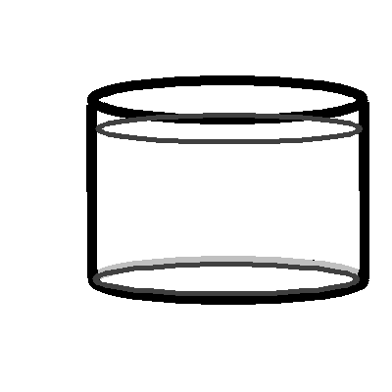
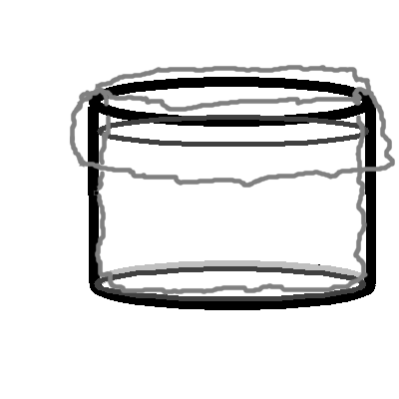
- Take the plastic bag and insert it into the plastic jar. It should fill the jar and hang over on the outside.

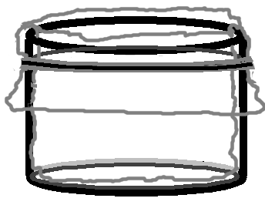
- Grab the bottom of the bag and slowly pull it out of the jar. Do this a few times.

- Replace the bag in the jar and secure it by placing two rubber bands around the rim.

- Grab the bottom of the bag and slowly try to pull it out of the jar. Push the bag back into the jar. Do this a few times.

- Write out your observations and thoughts. Compare the results of Step 2 and Step 4.

________________________________________________________________
________________________________________________________________
________________________________________________________________
________________________________________________________________
________________________________________________________________
Student Activity F
Why does a suction cup work?
Explore the workings of a suction cup. Your task is to make observations about a suction cup and then write your thoughts about the science of suction cups. Draw and write your observations on this page.
Teacher/Student Demonstration 4-C
How can air pressure be increased or decreased?

The Cold Air Temperature – Higher Air Pressure Relationship
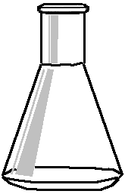
1: Draw 12 air particles in the flask spaced evenly apart. These are the gas particles at room temperature energy levels. Draw 12 more gas particles outside the flask.
2: Draw 12 air particles in the bottom of the flask. These are the air particles at a cooler temperature, lower energy level. Draw the 12 gas particles still outside the flask.
3: Draw 12 gas particles in the bottom of the flask at a lower energy level. The low energy level of these air particles allows more to enter the flask. Show 12 more gas particles entering the flask.
4: Draw a balloon cover on the flask. Use a dashed line to show the balloon cover after the flask has returned to room temperature (energy) levels. Draw 24 gas particles trapped in the flask.

The Warm Air Temperature – Lower Air Pressure Relationship
1: Draw 12 air particles in the flask spaced evenly apart. These are the gas particles at room temperature energy levels. Draw 12 more gas particles outside the flask.
2: The flask is warmed and the temperature rises. The air particles have more energy of motion. Draw 12 air particles, 8 in the flask and 4 leaving. Draw the 12 air particles that are still outside the flask.
3: Draw 6 air particles in the flask spread out and at a higher energy level. Show 2 more air particles leaving the flask. Draw the 16 air particles now outside the flask.
4: Draw a balloon cover on the flask. Use a dashed line to show the balloon cover after the flask has returned to room temperature (energy) levels. Draw 6 air particles in the flask. Draw 18 air particles outside the flask.

Concept Mapping: a visual way to organize information

A good way to organize information about a problem or topic is to construct a “concept map.” This helps to show major ideas, terms or concepts and the relationship between them. The major terms or concepts are placed in boxes or circles. Lines with labels are drawn between the boxes telling how the terms relate.

For example:
gases
air
make up

Concept mapping can become complex with many terms and relating arrows.
gases
air
make up
matter
made of
state of
For example:

Steps to making a concept map:
- Make a list of the major terms or concepts related to the topic.
- Write each term on a separate small piece of paper (Post-It Note or index card).
- Arrange the cards so that related terms are close to each other.
gases
air
matter
temperature
energy

- Once you are comfortable with the arrangement you can tape the terms/concepts to paper or copy the design to paper.
- Draw lines between the terms that you think are related.
- Write on the lines the type of relationship between the terms.
affects
made of
state of
make up
gases
air
matter
temperature
energy
has
property

Weather Concept Map
You have worked with several science concepts so far in this unit on weather. These concepts form the foundation for the science of meteorology. As a method of reviewing the concepts and their relationships, you will be creating two concept maps.
The terms and concepts for each map are listed in the large boxes found below. You can cut out the concepts and create your map on a separate piece of paper. You can use concepts more than once and you can add other concepts or related terms to your map. Try to use all the concepts at least once.

Concept Map 1:

Concept Map 2:

air

temperature

energy

less motion

more motion

less
air
pressure

greater
air
pressure

air
pushed up, rises

air

mass

gravity

air pulled down,
sinking

force

pressure

How can we measure changes in air pressure?

Materials: 1-250ml flask 1-balloon 1-rubber band 1-plastic jar
1-straw 1-popsicle stick 1-scissor* 1-ruler* tape* *class provided
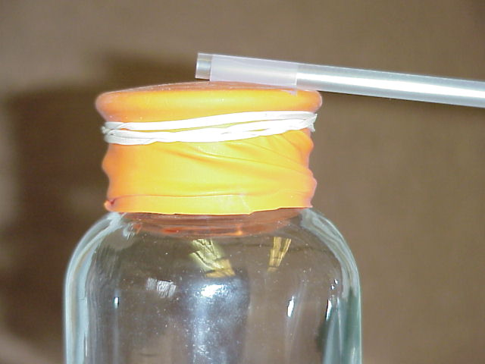
Procedure:

- Cut the stem off of the balloon.
- Stretch the balloon tightly over the top of the gas bottle (or flask) so it is tight and flat.
- Wrap a rubber band around the top of the bottle/flask securing the balloon and sealing the bottle closed.
- Select a straw, unwrap it and cut one end of the straw (about 1 inch of it) at an angle to create a “pointed” end.
- Place the uncut end of the straw on top of the gas bottle (on the balloon) so that the end is in the center of the balloon top. The straw will rest on the edge of the bottle.
- Tape the end of the straw in place. Caution: Once you place the tape on the balloon it will be difficult to reposition without tearing the balloon.
- Tape a popsicle stick or ruler to the side of the plastic jar.
Record the change in air pressure by using the terms:
increased, decreased, stayed the same (same).
Date: ______________  pressure:____________ | Date: ______________  pressure:_____________  __ | Date: ______________  pressure:_____________
Date: ______________  pressure:____________ | Date: ______________  pressure:_____________ | Date: ______________  pressure:_____________
- Place the “ruler” or wooden stick near the end of the pointer. You will be able to record measurements by either reading the measure on the ruler or by placing a mark on the stick that is closest to the pointer end.
- You will be using this “barometer” to record an increase or decrease in air pressure. You will be recording the movement of the pointer.

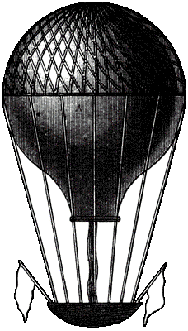
Air Pressure Data Table: Record the movement of the pointer.
NOTEBOOK PAGE TOPIC ___________________________
Write down your observations about the movement of your balloon barometer and the local air pressure measurements.

NOTEBOOK PAGE TOPIC ___________________________
Take some notes on how the changes in air pressure measurements compare to the movement of the air masses (L and H) on the U.S. map.
How do our weather conditions change as the air pressure changes?

Reading About Air Pressure
Air pressure is the force or push of the air molecules against everything on Earth. Air is all around us, pushing with a force of 15 pounds per square inch. Anything not able to withstand this force is crushed. People are not crushed by this weight because air fills all the spaces in our bodies. The air presses outward from inside of us with the same amount of force as the air from the outside pushes in. There are times when this inside-outside air pressure is not in balance. Differences in air pressure can cause objects to expand outward or push inward. This difference would be a problem in space where there is not any outside air pressure. If there was a hole in the space suit where would the air in a space suit go? The air would push out of the suit very quickly.
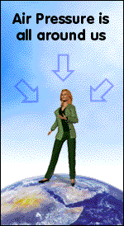
Back to Earth
We can sense changes in air pressure in the Earth’s atmosphere. We can sense changes when we travel higher or lower in the air, as in an airplane. Airplane cabins are pressurized at higher altitudes to an air pressure at which we are comfortable. Air pressure change affects us even when we travel on the Earth’s surface, as in up and down hills. For a moment, our ears may feel stopped up, but then our ears "pop." When this happens our ears are actually making the pressure the same between inside our heads and the outside atmosphere. In the case of smaller changes in pressure, our bodies slowly adjust and we may not notice any change. So, the amount of pressure the air has is affected by the altitude (height in the air) and by geography.
Let’s talk geography.
Air at sea level is what we're used to. In fact, we're so used to it that we forget we're actually feeling air pressure all the time. You would feel changes in air pressure if you were to travel from Death Valley to the top of Mount Washington. Death Valley is very deep below ground. Death Valley is the lowest point in the Western Hemisphere 282 feet below sea level. Mt. Washington, the highest mountain in the northeast, is one over a mile high (6,288 feet above sea level).
In Death Valley the air pressure is high. It is high because you have a very high column of air over you. The layer of air over you is greater than it would be if
(Reading About Air Pressure – con’t.)

you were standing at sea level. It is all squishing down filling the valley. If you are in Death Valley then you’re in the bottom of the pile. In fact, you have 282 feet more of air pressing down on you in Death Valley than if you were standing at sea level.
If you filled a water bottle in Death Valley, capped it and carried it with you to the top of the mountain, it would "puff up" during that change in altitude? Why do you think it would do that?
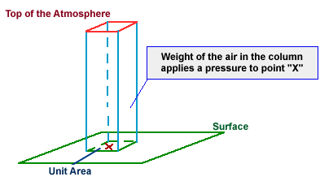
As you increase altitude or climb upwards, air pressure decreases because there is less air pushing on you.
If you continue upwards to the top of Mt. Washington, the air becomes very thin. It becomes less dense (less air particles, the air is “thinner”) and you have less and less air pressing down on you as you climb higher. There is less air to push and less air above you so the air pressure will be low. Low air pressure makes it difficult for us to fill our lungs. At high altitudes people breathe in less oxygen than they need to move around. This is a big problem for mountain climbers.
In addition to life functions, humans use air pressure in technology and toys. We count on air pressure to fill tires, inflate mattresses, fill tubes, to work pneumatic drills or “jack” hammers, to pressurize cabins in airplanes, fill balloons, and “super soakers”. We also have found uses for air pressure measurements. Air pressure measurements are used to help in our study of weather. We have found that air pressure changes can happen from day to day at a certain location. We can use these changes in air pressure to help us predict changes in weather. Air Pressure or barometric pressure is measured using an instrument called a barometer.
The Barometer
The Italian scientist Evangelista Torricelli invented the barometer in 1643. Torricelli used a column of water in a tube 34 ft (10.4 m) high to measure air pressure. A more practical air pressure instrument was needed so a column of mercury soon replaced this very high water column. Mercury is denser than water so it takes more air pressure to move it. A mercury barometer tube is about 3 ft
(Reading About Air Pressure – con’t.)

(0.9 m) long. Recently, we have changed the barometer design to make a smaller one called an aneroid barometer.
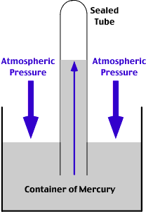
In both types of barometers an increase or decrease in air pressure causes movement to occur.

In the mercury barometer the surface of a small pool of mercury is pressed down upon when the air pressure increases. This causes the mercury to be forced up a tube. When the air pressure decreases the lower downward push of the air allows the mercury to flow down the column and refill the small pool.
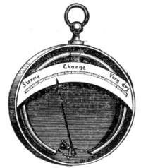

The aneroid barometer is a metallic box made so that the box surface gets pushed in or pushed outward with air pressure changes. This motion causes a chain of levers to move a pointer. The pointer lines up with an air pressure scale that can be recorded.
Air Pressure Measurements
Average air pressures:
Sea level = 1013mb = 29.9 in.Hg
Death Valley = 1045mb = 30.86 in.Hg
Mt. Washington = 800mb = 23.6 in.Hg

Range of sea level air pressures
970 – 1040mb = 28.6 – 30.7 in.Hg
Lowest recorded = 870mb = 25.7 in.Hg
Highest recorded = 1085mb = 32.0 in.Hg
Air Pressure at sea-level is about 14.7 lb per sq inch, which would push a column of mercury 29.92 inches high. Air Pressure is measured in:
- inches of mercury (in.Hg)
- millibars (mb, metric).

Reading Questions:
1. What is air pressure? _______________________________________________________________
_______________________________________________________________
2. Where is there less air pressure, at sea level or at the top of a mountain?
_______________________________________________________________________________
3. How is air pressure measured? What units are used?

NOTEBOOK PAGE TOPIC: _______________________________

Write a bulleted list of what you know about air pressure and how it affects you. (How do we use air pressure in our everyday lives? What are some situations where air pressure is important?)
How do meteorologists use air pressure measurements?

During this unit we have studied air masses. We have identified the major source regions of air masses and how they tend to move across the U.S. Each source region produces an air mass with certain characteristics. The characteristics relate to the air’s temperature and moisture level (see Student Notebook page 6). Meteorologists have found that they can identify air masses by their air pressure measurements. By looking at air pressure readings across a map they can find larger areas of low and high pressure. Meteorologists can track air mass movement by watching for changes in air pressure.

Meteorologists track the movement of these high and low air pressure systems by obtaining air pressure measurements. As a low pressure system moves into an area the air pressure goes down. As a high pressure system moves into an area the air pressure rises. Another technique that meteorologists use is to map air pressure measurements over a larger area.

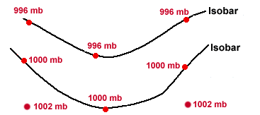
On these maps meteorologists look for the lowest and the highest air pressure measurements to locate the low and high pressure systems. They draw lines to connect all the places with the same air pressure readings. This requires a lot of weather station reports. The diagram on the right shows a sample map of air pressure lines. These lines of equal air pressure measurements are called “isobars”.
Pressure report using Isobars: The measurements on this map are in millibars. The millibar is the metric measure of air pressure. It is written as “mb”.

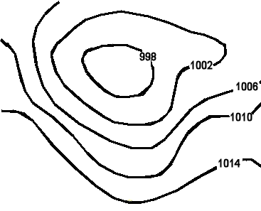
The pressure map looks very similar to a contour map that has lines of equal elevation.
The air pressure map has lines of equal air pressure measured in millibars (mb). Look at the number labels for each line.
What is the lowest numbered line? ______mb
What is the highest numbered line? _____mb
Write a large “L” on the map in the area where the air pressure is the lowest.
(How do meteorologists use air pressure measurements? – con’t.)

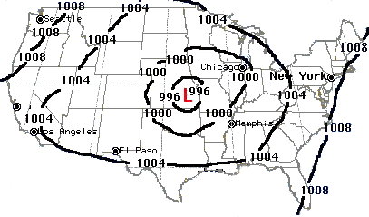
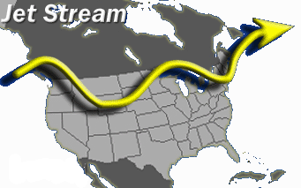
Meteorologists collect data from weather stations placed all over the country and all over the world. They use the air pressure measurements from these stations to map where the low and high pressure systems are forming. Using the information that is gathered about the prevailing winds and the jet streams meteorologists predict the movement of these pressure systems.

Answer the following questions using the map above. (Be sure to include units.)
1. What is the air pressure measurement for Chicago? __________
2. What is the air pressure measurement for New York City? _________
3. On the map, how will the jet stream affect the low pressure air mass’s direction of motion?
____________________________________________________________
____________________________________________________________
3. Will the air pressure in New York City go up or down over the next few days? ___
Explain your answer. _____________________________________________
_______________________________________________________________
_______________________________________________________________

What other weather conditions move with low and high pressure systems?
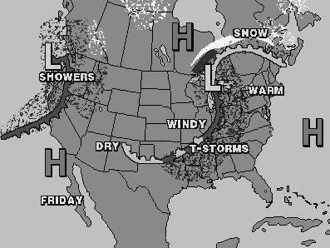
The graphic shows a weather map. Use the map and your knowledge from this unit to answer the questions.

- What is the meaning of the “L” and “H” symbols? _______________________
____________________________________________________________________________________________________________________________
- Compare the location of the “L” and “H” symbols and the type of weather nearby.
____________________________________________________________________________________________________________________________
- Look at the other symbols on the map. Compare the location of the “L” and “H” symbols to the other symbols on the map.
________________________________________________________________________________________________________________________________
- Look at a weather map for today (or yesterday). If there are any Low Pressure Systems on the map, what is the weather like around those systems?
______________________________________________________________
________________________________________________________________
What are the long lines that are drawn attached to the low pressure systems on a weather map?
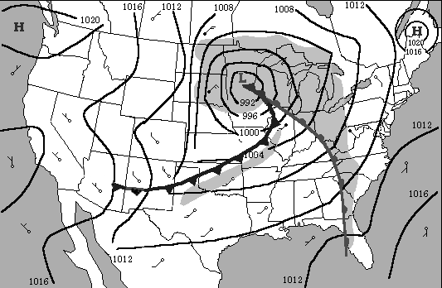
Find the Low Pressure System on the map.

A. What does the number 992 near the L symbol measure?

B. In which direction do you think the Low Pressure System is moving? ____________

C. Find the long “legs” lines attached to the low pressure area on the map. On the lines below, list one way that the lines are the same and one way that they are different.

These long lines attached to the area of low pressure are called weather fronts.
Fronts are the leading edges of air masses.
Fronts are a boundary area between air masses of different temperatures.
There are three basic types of fronts. They are named by the type of air moving into an area. There are warm fronts and cold fronts. The air mass moving in pushes out the resident air mass. If a warm front or cold front stops moving it becomes a stationary front. When it starts moving it becomes a warm or cold front once again. So, in summary, there are cold fronts, warm fronts, and stationary fronts.
D-1 | D-2

D. Fronts: In each of the boxes below draw one of the fronts from the above map.
Fronts are named by classifying the temperature of the air moving into an area. The air is classified as warm or cold. This is done by comparing the temperature of the air moving in to the temperature of the air already in the area.

E. Each diagram below shows an air mass moving into an area. The arrow shows the direction of motion. The numbers are weather station temperature readings.
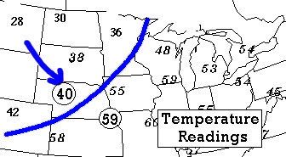
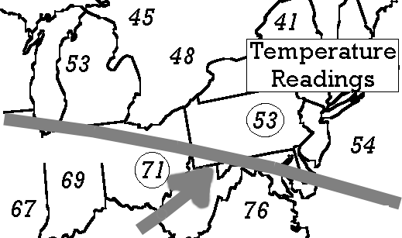
You’re task is to label each diagram as a warm front or a cold front.

E-1.___________________________ E-2. __________________________

On the previous page you drew each of the fronts from the map on that page. One of your drawings was a line with bumps on it. The other was a line with “teeth” on it. The line with bumps is a warm front. The line with teeth is a cold front. There is a third possible front, a stationary front. The drawing for this front is a combination of bumps and teeth.
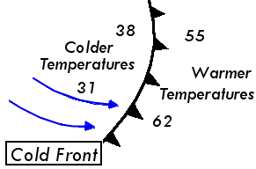
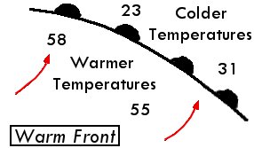
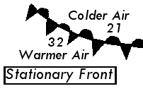

F. Go back to part E on this page. Draw the correct front symbols on each diagram.

G. Go back to the previous page and label the fronts as “warm” or “cold” fronts.

NOTEBOOK PAGE TOPIC: __________________________

Student Activity H
What is needed for a cloud to form?

Materials: glass flask, stopper, 4” glass tube, 12” plastic hose
water* matches air syringe

- Wet the glass tube and with a gentle turning motion push it into the hole in the stopper. Push it in until you can just start to see it coming out the bottom of the stopper.
- Attach the plastic hose to the long end of the glass rod.
- Attach the air syringe to the plastic hose end.
This set up gives you a way of changing the air pressure inside of the flask.
Pulling out the plunger removes air from the flask. This causes the air pressure to decrease.

At this point it is your task to make a cloud form in the flask. The directions from this point on will help you to do this. One team member should hold the flask to keep it from tipping.

- Place the flask on a dark surface. Gently push the stopper into the flask. Pull on the air syringe and observe what happens inside the flask.
- Place 50ml of warm water in the bottom of the flask. Replace the stopper.
- Place the flask on a dark surface. Pull on the air syringe and observe what happens inside the flask.
- Light a match, blow it out and gently blow some smoke into the flask. Quickly and carefully, place the stopper in the flask.
- Place the flask on a dark surface. Pull on the air syringe and observe what happens inside the flask.
- Make a change to the set up and see if it affects your results or observations.
OUR CHANGE:

Conclusions about cloud formation:

Student Activity I
How are clouds the same and different?
One of the observations that you have made during your life is that there are clouds in the sky. You have also observed that clouds are not always present in the sky but are definitely there when we have stormy weather. In this lesson section you are going to take a closer look at clouds. Take some time to observe the clouds and make some sketches. Write some words to describe each sketch.
Student Activity J
How do you measure the amount of sky covered with clouds?
You have heard the local weather station report on the amount of cloud cover there is on a certain day. Your task is to look at the sky and decide how you would report the amount of cloud cover. Think about and write notes on how you would do this. Carry out the measuring process. Decide on how you would report the measurement. Share your report.

What are the cloud types? -1
What are the basic cloud types used to classify clouds?

Clouds are classified in two ways. They are named by their appearance. They are named according to the altitude at which they form.
There are three basic cloud types named by their appearance. They are cirrus, cumulus, and stratus.

Name | Descriptive terms | Example
Cirrus | high, wispy, feathery, mare’s tails, curl,  (these clouds form very high up from ice crystals so they are very thin) | 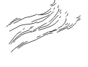
Cumulus | piled, cotton balls, heap  (these clouds are low level clouds that can grow vertically, often found on sunny days) | 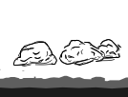
Stratus | layer, sheet, blanket  (these low level clouds cover the sky with a layer of clouds and are often rain clouds) | 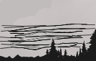

Actual clouds are often a combination of these types. Prefixes are added to describe the height or altitude of the cloud. “Cirro” is added to describe very high clouds. “Alto“is added for mid-level clouds. If precipitation is coming from the cloud the prefix “nimbo” or suffix “nimbus” is added. Here are some combination examples.
Name | Description
nimbostratus | Rainy, stormy layer of clouds, dark clouds
cirrostratus | Very high thin layer
altocumulus | High up puffy clouds
cumulonimbus | Stormy tall cumulus cloud, dark clouds, thunderhead
What are the cloud types? -2

1. If you did any cloud sketching, take a look at your pictures. What types of clouds do you think they were?
_______________________________________________________________
_______________________________________________________________
2. What types of clouds are in the sky today? Are they low, high or very high clouds? Are they light or dark colored? Is there precipitation falling?
______________________________________________________________________________________________________________________________
_______________________________________________________________

3. Write the name of the cloud type under each of the three pictures below.
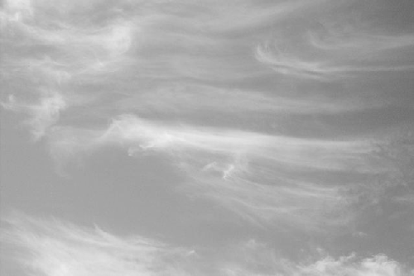
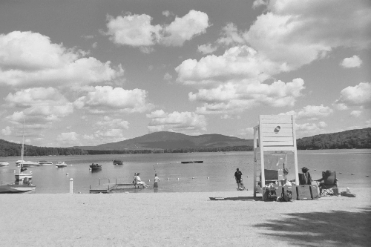
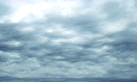

4. Research: Find a picture and make a sketch of a cumulonimbus cloud (thunderhead.) Draw your own sketch below. Add an information box with facts about this cloud.

How do we measure and report cloud cover?
Meteorologists use certain terms to tell about cloud cover. The cloud cover names are listed below. Write one of the cloud cover names under each circle. Next, shade in the circles using these cloud cover descriptions:
- SCATTERED CLOUDS- covered one quarter of the way with clouds
- PARTLY CLOUDY-half with clouds
- MOSTLY CLOUDY- mostly with clouds, three quarters
- OVERCAST- all the way covered with clouds
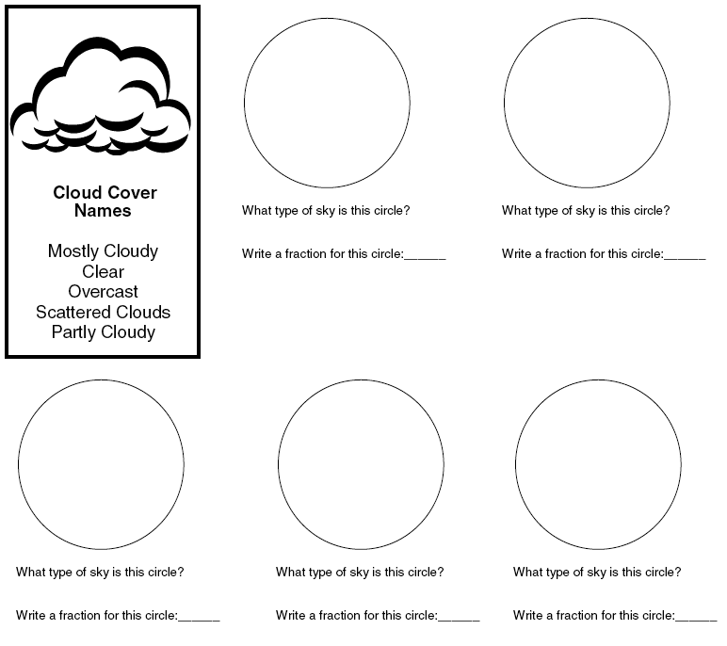
- CLEAR- not shaded

How do we find the temperature at which water condenses on surfaces?

Sometimes when you walk outside in the morning there is water on the grass or on the car. Sometimes it is frozen as ice. This liquid water is called “dew”. The solid water is called “frost”. Due to a decrease in the temperature, this water has condensed from water as a vapor to a liquid. There was a certain temperature when it was cool enough for this to happen. This temperature, below which water starts to change from a gas to a liquid, is called the “dew-point temperature.” You are going to do an activity to explore dew-point temperature.

Materials: 2 thermometers small metal cup plastic cup
3cm piece of shoe lace cold water or ice*
room temperature water*
(* provided by teacher)

Procedure 1: (using ice water)
- Read the temperature on a thermometer. This is the ambient temperature or “room” temperature. Write it down in the data area.
- Place the thermometer in the small metal cup.
- Add enough room temperature water to cover the thermometer bulb.
- Add cold water or water and ice until the metal cup is almost full.
- Condensation Temperature: Watch the sides of the metal cup for signs of condensation. Record the temperature of the water the moment you see any condensation forming.
- When you are finished you will have two temperature readings. Be sure to label them.

Data:

Procedure 2: (using a wet-bulb thermometer)
- Place two thermometers on the table in front of you.
- Take one thermometer and slide the piece of shoe lace onto the bulb.
The shoe lace can also be called a “wick” because it allows liquid to flow through it.
- Completely wet the wick by dipping it in room temperature water. This is now the “wet-bulb” thermometer.
- Place the “wet-bulb” thermometer and the “dry” thermometer on the table side-by-side with the bulbs hanging over the edge. Tape them down.
- Look at each thermometer and note the temperature every few minutes. Blow on the thermometers or fan them every once in a while.
- Record the temperature on the thermometers when there are no longer any changes.

Data:

The temperature below which condensation starts to occur is called the “dew-point temperature”. The dew-point temperature can be determined using the wet-bulb and dry-bulb thermometer readings and a chart.

Look at your data from Procedure 2.
1. Write down the temperatures.
Dry-bulb Temperature: Procedure 2________°F
Wet-bulb Temperature Procedure 2________°F
2. Use the chart found on p. 57 to calculate the dew-point temperature.
Dew-point temperature for Procedure 2 _________°F

3. What does Dew-Point temperature mean?

4. In Procedure 1 and 2 the condensation temperature is obtained in different ways. Which procedure so you think is more accurate? Why do you think this?

Calculating Dew Point
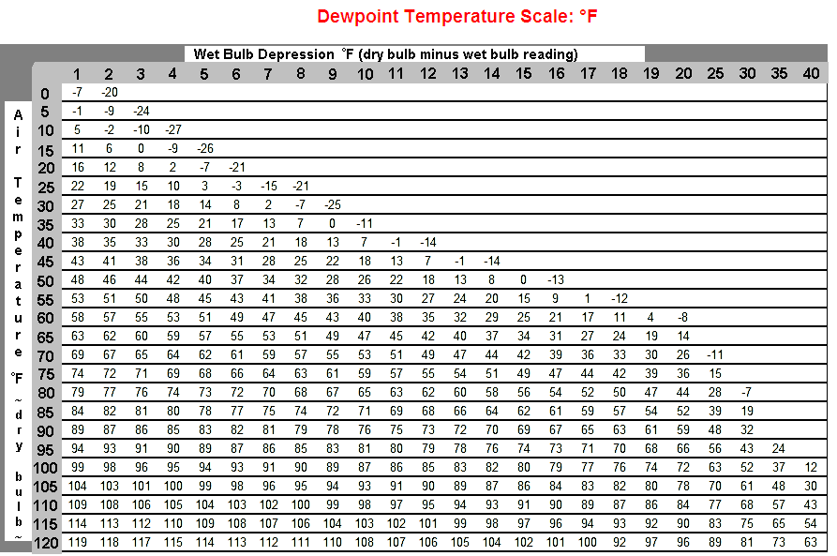
To determine the dew point temperature, subtract the wet bulb reading from the dry bulb reading to determine the "wet bulb depression." Then look up the wet bulb depression and dry bulb temperature readings on the chart. The wet bulb depression is listed horizontally (across the top) and the dry bulb temperature is listed vertically (down the left side). The dew point temperature is where the row and column meet.

Why is dew-point temperature important? If you know the dew-point temperature then you know how much water there is as water vapor. This can be important for predicting how much evaporation will occur. It can help to predict how much condensation might occur. This is important for weather forecasting and for many industries. The amount of water vapor in the environment can have an affect on manufacturing processes.

Knowing the dew-point temperature can answer some questions, such as:

Will my clothes dry quickly? Will the chair I painted dry soon?
If the dew-point is much lower than the air temperature then we can say the atmosphere is “dry”. Evaporation will happen quickly. We can expect things to dry out fairly quickly.
If the dew-point temperature is close to the air temperature then the atmosphere is already fairly “wet”. Evaporation will happen slowly. We can expect things to dry out slowly.

Will water form on the windows inside my house? Will mold grow?
It may if the dew-point is equal to the ambient temperature. When the dew-point temperature is close to the ambient temperature the water vapor is close to condensing onto surfaces. You just need a small drop in the ambient temperature, as often occur near windows, and condensation will form on the window surface. Surfaces that are wet will stay wet, so mold may grow.

Who cares about measuring dew-point temperature?
Meteorologists use the dew-point temperature reading in gathering data about the water vapor in the atmosphere. Dew-point information is also used in industry for candy making, food storage, crop growth and irrigation, engine performance, and home heating/cooling, to name a few uses. People care about dew-point but they may not realize it.
Water vapor is condensing and evaporating all the time and at the same time. We are more aware of it when wet things dry out and when it rains or snows.

(Why is dew-point temperature important?- con’t.)
Your body and dew-point temperature
In order to keep your core body temperature at 98.6°F, your body is constantly adjusting to the environment. If it becomes cooler, your body works to warm itself up. One way your body does this is by decreasing heat loss to the environment. It lowers the blood circulation to your skin and your fingers and toes. Hmm, could that be why your fingers and toes get cold first and your lips turn blue? If this doesn’t work your body tries to make heat by causing you to move your muscles by shivering.
If it becomes too warm, your body has to cool itself down. Your body depends upon evaporation of water from your skin to help keep you cool. Sweating places water on your skin. The heat energy from your body is used to evaporate the sweat. This use of this heat energy cools you. Adding a little air motion, such as wind or a fan, speeds up evaporation. It speeds up your cooling. Too little evaporation makes you feel hot and “sticky”. Too much evaporation dries your skin out. The “Dew-Point Temperature Comfort Level” table for indoor temperatures gives, in a general way, the relationship between dew-point and our comfort zone.
Humidity: The amount of water in the gas state in a certain air mass.
DEW-POINT TEMPERATURE ( ºF) Comfort Level
Less than 50° | Very Dry
50 ° - 55 ° | Comfortable
56° - 60° | Pleasant
61° - 65° | Slightly Humid
66° - 70° | Humid
73 °- 75° | Very Humid
76° or higher | Oppressive
- What is today’s dew-point temperature? ________
- Compare today’s dew-point temperature to the air temperature?
- What does dew-point temperature have to do with cloud formation (Think about clouds and condensation.)
NOTEBOOK PAGE TOPIC: ______________________
NOTEBOOK PAGE TOPIC: ______________________

Topics/Questions |   Notes/Answers
Topics/Questions | Notes/Answers

