Weather Kit #78

Blackline
Masters

Revised May 2009 – Revised formatting, added Unit test


Student’s Name: _____________________________ Date:___________________

Student Science Notebook Rubrics

Score | Criteria | Comments
3 | The writing/drawing shows detail and accuracy in recording observations; the student uses rich science vocabulary, and is able to answer related questions.
2 | The writing/drawing includes mostly accurate details; some may be inaccurate or missing.
1 | The writing/drawing shows partial knowledge; lacks detail.
0 | There are little or no response or the writing/drawing is inaccurate or unrelated.

Kite Building
Material list:
- 1 sheet of 8 1/2" x 11" copy paper.
- an 8" stick (re-size a planter stick).
- a 5-foot piece of crepe paper streamer. (A plastic bag cut in a 1" wide spiral all around will also make a great tail.)
- 1 roll 1/2"wide masking tape or any type of plastic tape.
- a piece of 1"x 3" cardboard on which to wind the string.
- 10 foot long piece of string
- Hole punch
1. Fold a sheet of 8 1/2" x 11" paper in half (hamburger style). | 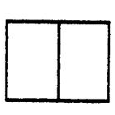
2. Fold again along the diagonal line A.  To help you do this:  - measure from the fold at the very top of the page and draw a dot at 3/4".  - Draw a dot at 2 1/2" in on the bottom edge.  - Lay a ruler across the paper to connect the dots and draw a line.  - The line shows you where the diagonal fold will go. You can keep the ruler along the line to help you fold the paper back.  3. Fold back one side forming the kite shape. Place tape firmly along fold line AB. | 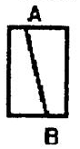  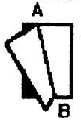

Directions:

(Kite Building continued)
4. Place the stick from point C to D and tape it down firmly. The kite will not be flat after you do this.
5. Tape the streamer to the bottom of the kite at B.  6. Flip kite over onto its back and fold the front flap back and forth until it stands straight up.(Otherwise it acts like a rudder and the kite spins around in circles.) | 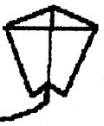
7. Punch a hole in the front flap about 3 inches down from the top point A.  8. Tie one end of the string to the hole and wind the other end onto the cardboard string winder. | 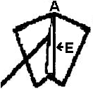  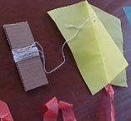
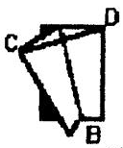

For over 15 years the Big Wind Kite Factory has been giving kite building classes for the children on the island of Molokai in Hawaii. These are the instructions to get kids making their own kites and flying them in 20 minutes

http://www.molokai.com/kites/20kidskites.html


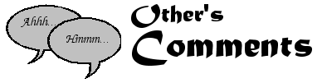
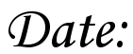
about today’s weather.
Name: ____________________________

Name: _____________________________
Weather Poems Name: _________________________
What are the “Shivery” weather Conditions?

How does the writer feel about the weather?
Shivery
This cold cold weather, bids me not
to energetic spree
I stand and shiver, wondering how
To warm that cold cold me
If only I could make a start
It would not be bad it seems.
But somehow I just linger on
And do it, in my dreams.
My ideas are brilliant
They are plain to see
But ho, this cold cold weather
Does waste my time for me.
Mary Gore

What are the “Winter Wonderland” weather Conditions?

How does the writer feel about the weather?
Winter Wonderland
There are strange and mysterious sounds
When the winds of winter blow,
The long nights are crystal clear and cold,
And the fields and meadows are covered
with snow.
The stars are frosty against the sky,
And the wind's whistle is shrill,
As the snow blows against the house
And drifts against the hill.
Yet, I like to see during the winter
A white carpet on the ground,
To plod aimlessly in the deep snow,
where deer tracks abound.
I like to feel the stillness
Of a crisp winter's night,
Watching a full moon rise over the horizon,
Exposing a winter wonderland beautiful
and bright.
Joseph T. Renaldi
Activity 1: Checkpoint Name: __________________
Weather Circle

The circle below has 8 sections and a center oval.
Fill in the sections using the following rules:
Fill in the center oval with the topic for the circle.
Fill in each of:
- 1 and 2 with a word that is part of a definition of the term weather.
- 3 and 4 with a word that describes what weather is not.
- 5 and 6 with a weather observation word that is an adjective.
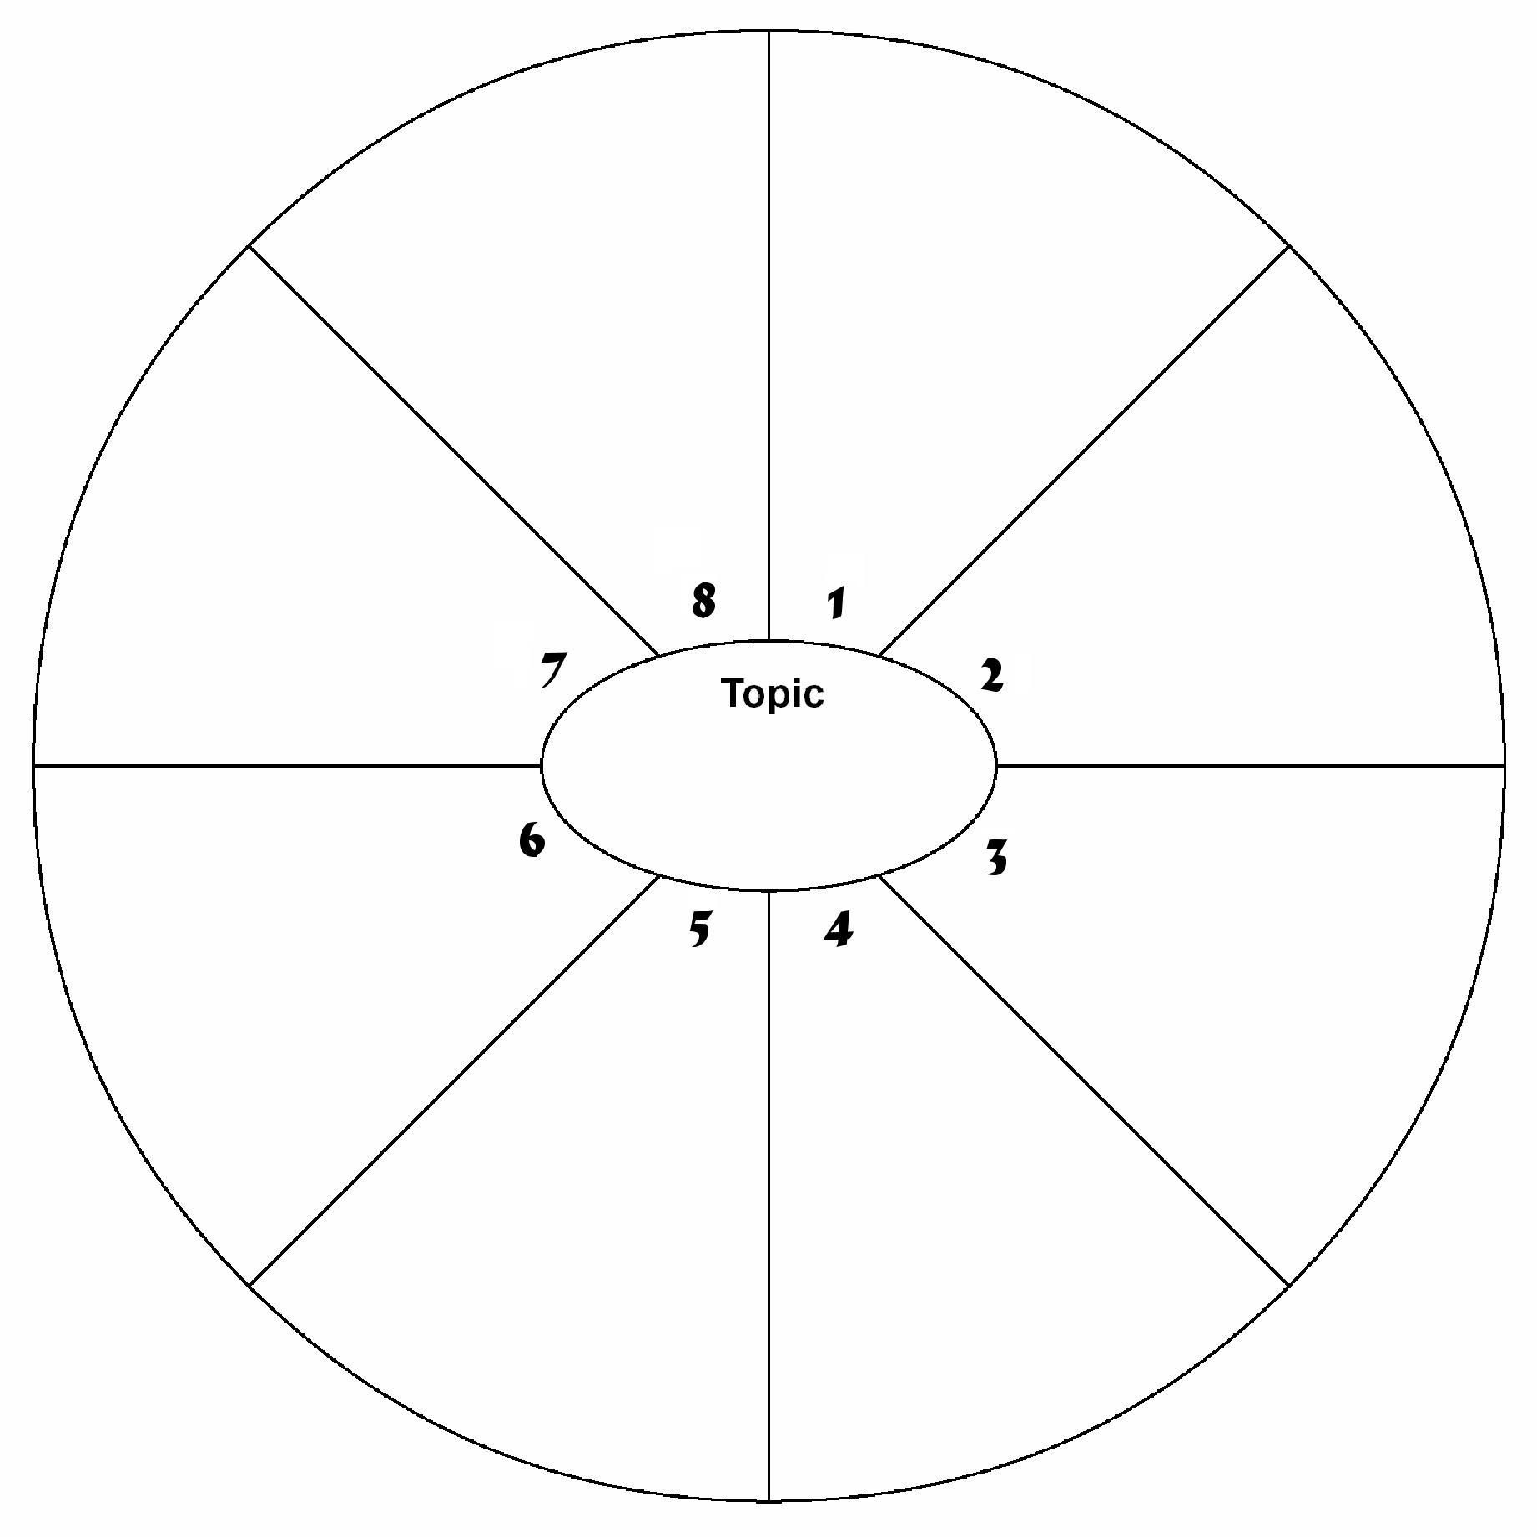
- 7 and 8 with a weather observation word that is a verb.

Map for AIR Mass-sters Team: ____________________________________________________
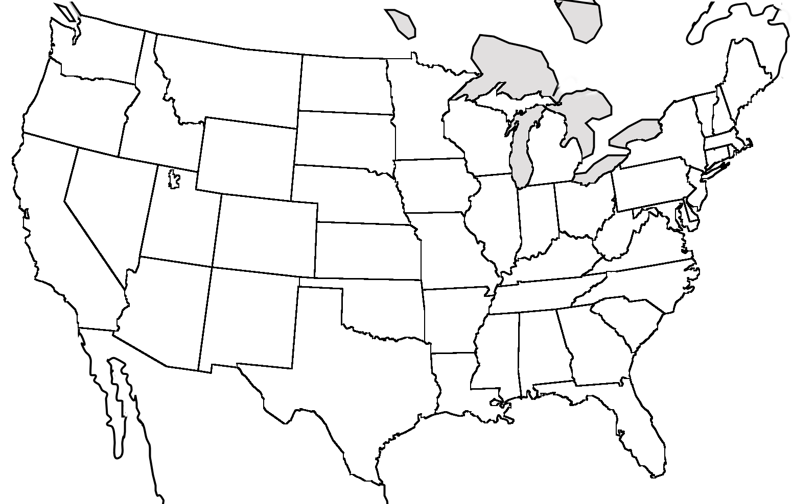
Date:Time:Data Source:

Date:Time:Data Source:
Date:Time:Data Source:
Date:Time:Data Source:
Date:Time:Data Source:

Date:_____________  Notes: |  | Date:_____________  Notes: |  | Date:_____________  Notes:
Cloud Cover |  | Cloud Cover |  | Cloud Cover
Cloud Type (draw sky) |  | Cloud Type (draw sky) |  | Cloud Type (draw sky)
  Precipitation:______ |  | Precipitation:______ |  | Precipitation:______
Wind Speed  and  Direction |  | Wind Speed  and  Direction |  | Wind Speed  and  Direction
Temperature:  Local:_________  Regional:_________ |  | Temperature:  Local:_________  Regional:_________ |  | Temperature:  Local:_________  Regional:_________
Dew Point Temp.: ______  Relative Humidity:______ |  | Dew Point Temp.: ______  Relative Humidity:______ |  | Dew Point Temp.: ______  Relative Humidity:______
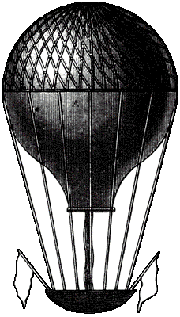  Air Pressure  Local:_____________  Regional:__________ |  | Air Pressure  Local:_____________  Regional:__________ |  | Air Pressure  Local:______________  Regional:___________
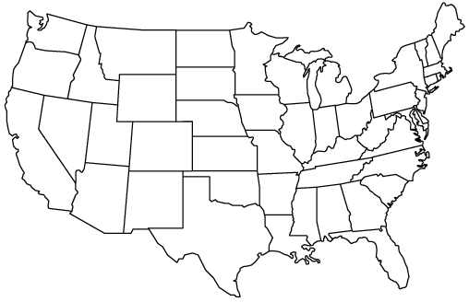

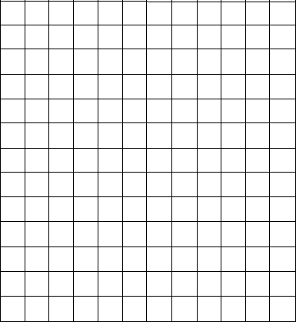
Notebook Page Topic: Name:
Around and Around It Goes.
How does the Earth’s rotation affect air movement? (Coriolis Effect)
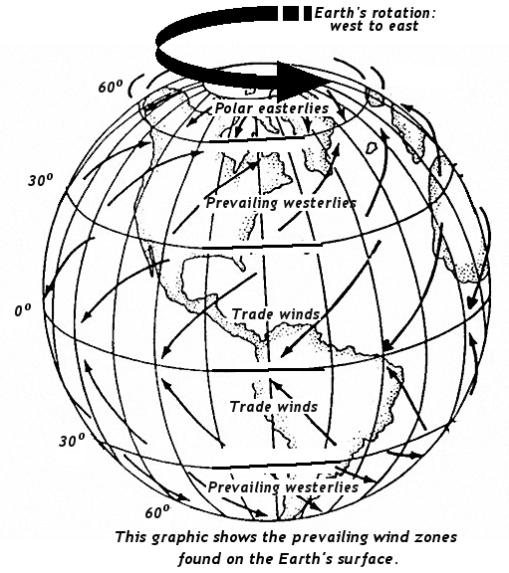
Previously you have read about the prevailing winds. These major air movements affect the movement of small air masses across the U.S. Look at the diagram on this page of the Earth and its prevailing winds.

- What is the direction of the prevailing winds between 30ºN and 60ºN latitude?
from the _____________
to the ______________
- How would you describe the direction of the Earth’s rotation, would it be clockwise or counter-clockwise? ______________________

- Stand up. Picture yourself standing in a corn field in the Midwest of the U.S. You are facing north. You put your arms out. Your left arm is pointing west. Your right arm is pointing east.
- Here, the prevailing winds want to blow to the North from
the South. If they did they would hit your back (solid arrow).
But the wind traveling North has a rotational speed to the east. The wind is shifted to the east, blowing from the South to the Northeast (dotted line).
- As you are facing North, is the East on your right or left? ____________
So the wind shift is to the east or to your _______________.
This shift in air motion due to the Earth’s rotation is called the Coriolis Effect. In the Northern Hemisphere prevailing winds are shifted to the right of their direction of motion. (Southern Hemisphere they shift to the left.)
(Coriolis Effect continued)
Applying the Coriolis Effect:
The Earth’s rotational speed affects the direction of motion of an air bound object moving over a long distance. In the Northern Hemisphere a flying object will be deflected to the right of the direction it is traveling.

THE RULE: MOVING OBJECTS ARE DEFLECTED TO THE RIGHT OF THEIR LINE OF MOTION IN THE NORTHERN HEMISPHERE (if they fly long distances)

Below, there is a diagram of a compass rose. An object traveling in one of the four directions may be deflected. Draw a dotted line to show the direction in which a flying object or the wind will be deflected. An example has been done for you.

An east bound object will be

deflected to the ___________

Let us say that you wanted to fly an airplane from Texas to a city in North Dakota. What directional adjustments may you have to make?

Why does the Coriolis Effect only affect air bound objects (wind is air bound gases)?
AIR Speed-sters Team
Recording Wind Speed and Direction (Station Model Method)
You can choose to draw station models to share your wind direction and speed information with the class.
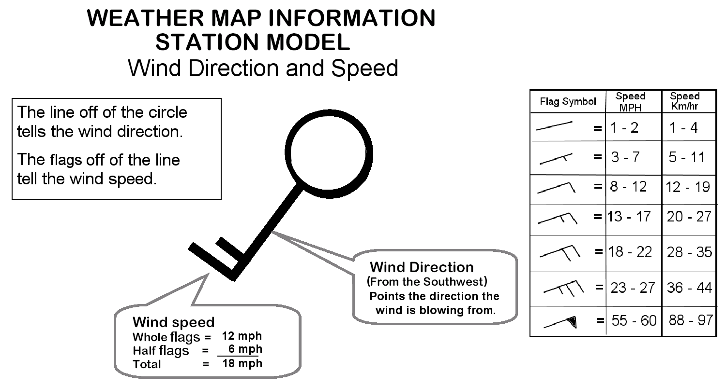
Meteorologists use a special symbol to show weather measurements on a weather map. This symbol called a “station model” shows the measurements taken at a weather station. Two of the measurements that are part of a station model are wind speed and wind direction.
Teach the class: Share with the class how a station model can show wind direction and speed.
There are different types of maps that show wind direction and speed. One type uses the station model symbols.
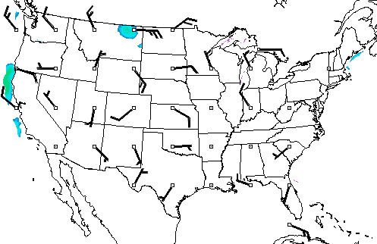
Ask the class to draw, in their notebooks, a station model to show today’s wind direction and wind speed information.

Field Trip:
National Oceanic and Atmospheric Administration (NOAA)
National Weather Service (NWS)
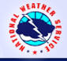
The National Weather Service is a public agency that gathers data. The data is analyzed to provide weather, water related and climate forecasts and warnings for the United States, its territories, adjacent waters and ocean areas. This is done for the protection of life and property and the benefit of the national economy. NWS data and products form a national information database and organization which can be used by other governmental agencies, the private sector, the public, and the global community.

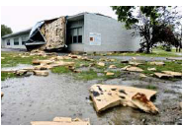
As an individual you have access to the NWS information. The information may be national or local in nature. Let’s take a look at the NWS web site. Your task is to follow the directions on using the web site and answer the questions (on a separate piece of paper.)
NWS Home Page (www.nws.noaa.gov)
- National Information: On the NWS Home page there is a national map that shows “Warnings & Forecasts”. Look at the map. Locate an area of the country that has a warning. Write down the type of warning and the state or states included in the warning.

- Look at other maps by clicking on the tabs. Choose one of these maps. Write a short paragraph about the information that map is currently sharing. (What’s happening across the country?)

- Return to the “Warnings & Forecasts” map. Find New York state on the map. Write down any warnings for NYS.

- Click on New York. Select either Syracuse or Binghamton on the map and click on it. Write down the name of the city, the weather for today and the forecast for tomorrow.

- Go back to the New York (previous) map. Find the link to “Spotters/ Skywarn” and click on it. Find out and write down what a “Storm Spotter” is and what they do for the NWS. Find the link to the Spotters Newsletter. What is the name of the most recent newsletter?
Activity 2: Check Point Number 1 - Air Masses

The diagram shows two air masses entering the U.S. The arrows show the direction of motion of the air masses. Using the diagram, answer the questions.
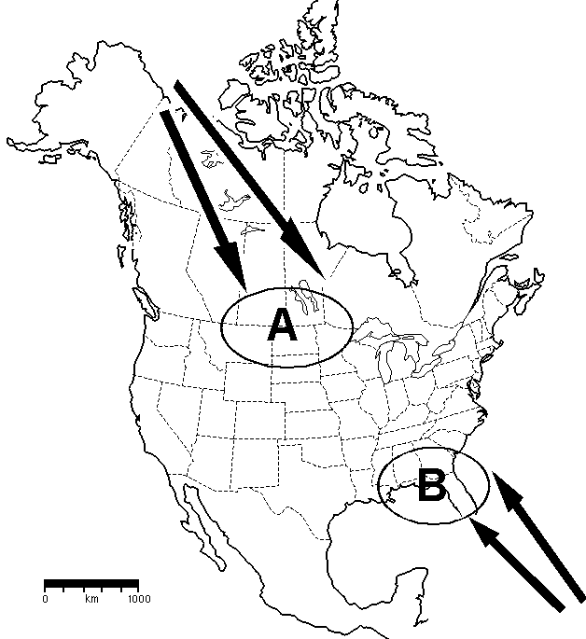
1. What direction did each air mass come from?
A. __________________
B. __________________

2. What is the term for an area in which an air mass forms?
_________________________
3. Give two characteristics of each of the air masses.
A.______________________
______________________
B.______________________
______________________
4. In which direction do you think air mass A will move? On the U.S. map above, draw an arrow to show the direction.
5. Complete this general statement about the movement of air masses across the U.S.
Air masses generally move from the _____________ to the ____________ across the U.S. This movement is powered by the _____________________ and the ____________________.

Activity 2: Check Point Number 2- Air Motion Words

Concept Maps: Weather is air in motion!
On the arrow, use one or two words to write the relationship between the two words.
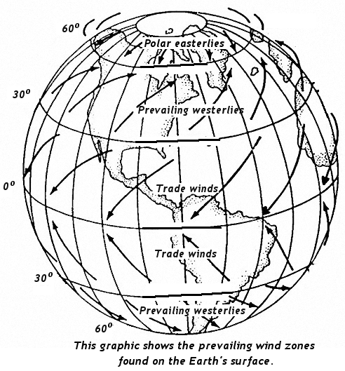
Example:
latitude
prevailing winds
change by

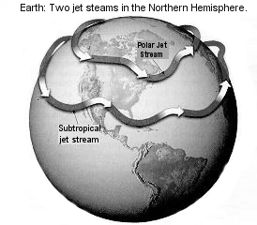
altitudes
jet stream
1.

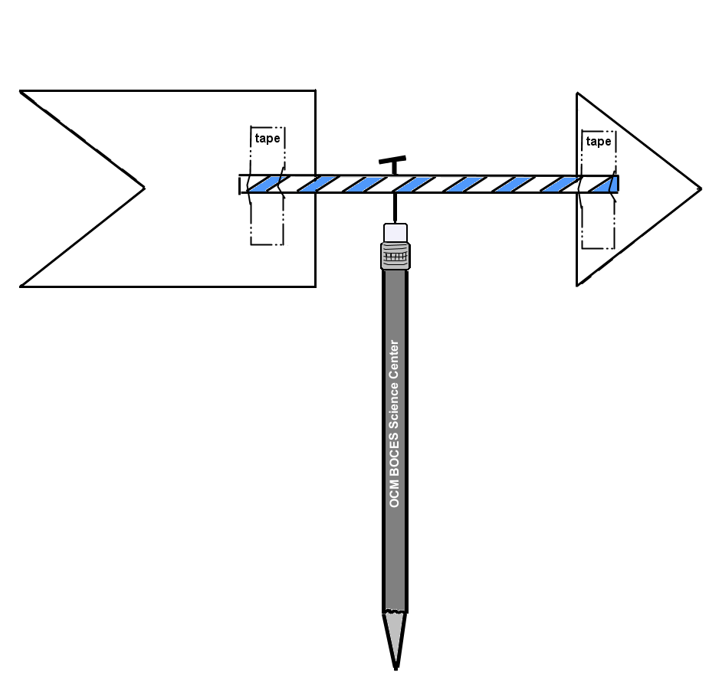
2.
wind direction
wind vane

3.
prevailing wind
wind direction

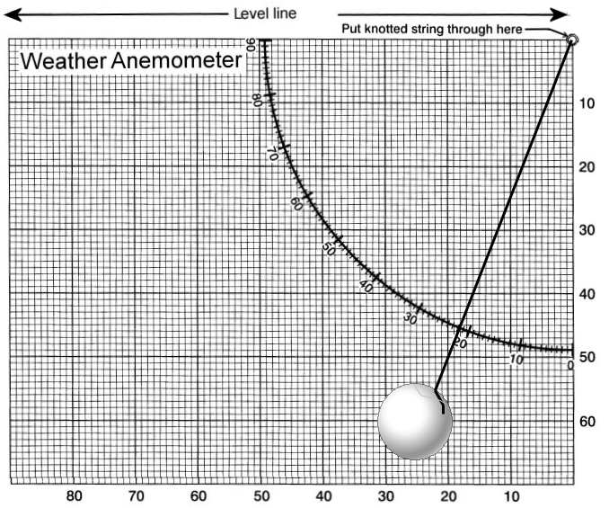
4.
wind speed
anemometer

5. This concept map has 5 relationships to label.

air masses
gases
jet stream
mass
prevailing wind
source region

Graphic Organizers: Telling about the Atmosphere
Use the information on the graphics to answer the questions.
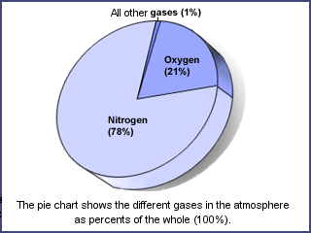
1. What percent of the air is oxygen? ______

2. What gas forms the greatest part of the atmosphere? ___________________

3. What percent of the air is Nitrogen and Oxygen together? ________________

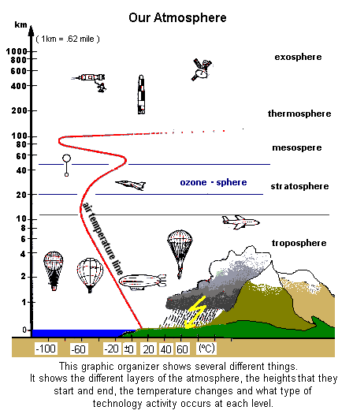
4. How many major layers does the atmosphere have? _______

5. We find that 99% of the mass of the atmosphere is in the first 50 km. What two layers make up this area?

6. Our weather occurs in the lowest layer where the most mixing of the air happens. Which layer is this?

7. In which layer do you find satellites orbiting the Earth?
_____________________

8. Find the air temperature line on the diagram. Does the temperature increase or decrease as you get higher in the troposphere? _____________________
Challenge: Mt. Everest is 29, 028 ft. high.

How many miles high is it? __________

How many km high is it? ____________
AIR Temp-sters Team
Recording Air Temperature (Station Model Method)

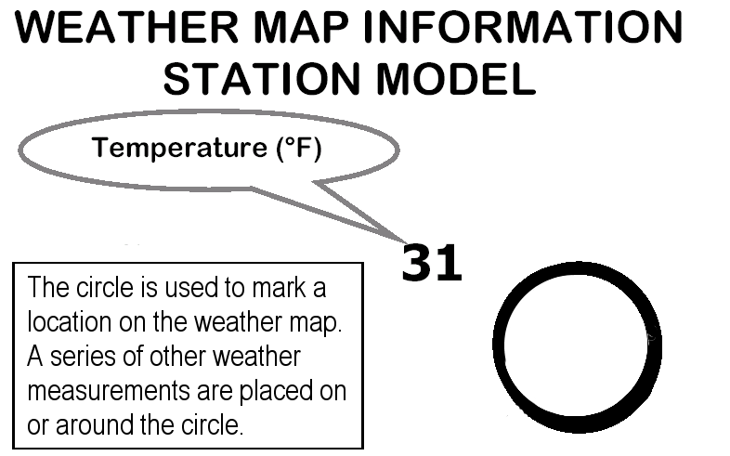
Meteorologists use a special symbol to show weather measurements on a weather map. This symbol called a “station model” shows the measurements taken at a weather station. One measurement that is part of a station model is air temperature. The temperature is written to the upper left of the circle.

Teach the class: Share with the class how a station model can show temperature.
There are different types of maps that show air temperature measurements. The map below only shows one weather variable, air temperature. It shows the air temperature of various locations. You can show several weather readings for a location using a station model.
Ask the class to draw a station model for today’s weather measurements that shows the air temperature, wind direction and wind speed.
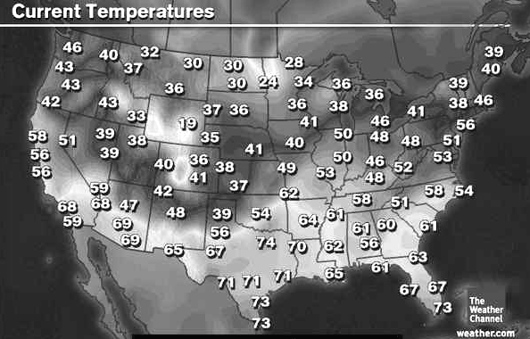

Ask the class “What time of year do you think this map is for? Why do you think that?”

Web Quest: “Lighter than Air” Transportation
Your task is to compare and contrast lighter than air transportation. You are given a concept map to fill in. There is a list of suggested web sites to find the answers. As an example, the glider has been done for you.
Lighter than air transportation
type of
type of
type of

pushed by
(propelled)
pushed by
(propelled)
glider
shape, size
pushed by
(propelled)
air currents
One fact about:
One fact about:

One fact about: They have to be towed into the air by an aircraft.

made lighter by
made lighter by
made lighter by

(Web Quest: “Lighter than Air” Transportation continued)
Websites:
http://en.wikipedia.org/wiki/Aviation
http://encarta.msn.com/encyclopedia_761558787_3/Transportation.html
http://inventors.about.com/od/astartinventions/ss/airship.htm
http://travel.howstuffworks.com/blimp1.htm
http://inventors.about.com/od/astartinventions/ss/airship_2.htm
http://www.uh.edu/engines/epi75.htm
http://en.wikipedia.org/wiki/Hot_air_balloon
http://www.hotairballooning.com/faq.html

Draw a picture of two different “lighter than air” vehicles.

How can the heating of air affect the weather?

For centuries the crews of sailing ships dreaded sailing into a certain region of ocean. This region was near the equator just 5 degrees North and South of the equator. The northeast and southwest trade winds meet here. The warmed air here is pushed slowly upwards.

A. On the diagram, find and label the northeast (NE) and southwest (SW) trade winds.
B. On the diagram find and darken the 0º latitude line or equator where the trade winds meet.

The moving air near the equator produces only light winds and few ocean currents. Wind-powered ships became becalmed here for days or weeks on end. The ship's crews often became listless and depressed. Over time, this region took on the name of the “Doldrums”.
doldrums: a period of listlessness or lack of energy “Sailors suffered the doldrums.”

C. On the diagram, label the area just above and below the darkened line area as the “Doldrums”.
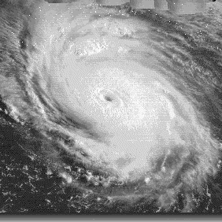
Interestingly, some of the Caribbean's most violent storms begin in the calm, warm waters of the Doldrums. This region, that appears very calm, has come to be known as the hurricane incubator. The waters in this region may heat up to 26º C (79 ºF), or higher. The heat from the water (surface) gives energy to the air above it. This warmed air is pushed upwards. Baby hurricanes grow over heated ocean waters. In fact, hurricanes cannot form in northern climates or in winter months when the ocean's waters are cool. Late in hurricane season (which officially starts June 1 and ends November 1), hurricanes in the Western Hemisphere can form off of Central America, and swirl around the Gulf of Mexico. This is caused by the warm Gulf water current.

D. Place a large X on the diagram to mark the Gulf of Mexico.
http://www.e-missions.net/om/2weeks/howHurricanesWork.aspx
E. (Circle the answer) Hurricanes form over the world’s (warmest / coolest) waters.
Activity 3: Check Point
PART A
Fill in the blanks using the words from the word bank:
1. Air takes up space because it is made of _______________________.
2. Air is made up of gases that flow or are _________________.
3. Heating air changes the amount off ________________ of motion of the gases.
4. Cooling air ______________ the energy of motion of the gases.
5. Cooler air has greater _______________ than warm air.
6. A mass of air pulled by gravity has the property of ________________.
7. One way to measure the energy of motion of air is to measure its ___________________.
8. ______________________________ is a measure of the temperature of the surroundings.
Word Bank:
matter energy temperature decrease increase
fluid density force ambient temperature

PART B
Using the diagram answer the questions.
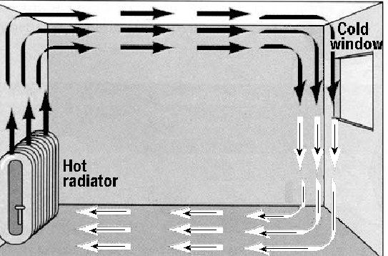
9. What is pulling the air downwards near the window?

____________________________

10. What pushing the air upwards over the radiator?

____________________________

11. What is heating and cooling the air? (choose an answer by circling the letter)

a. the temperature c. the ceiling
b. surfaces d. sunlight

(Activity 3 Check Point continued)
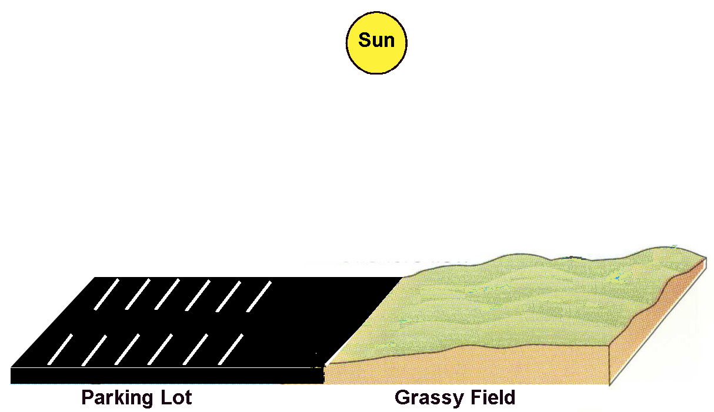
PART C
Using the diagram
answer the questions:

12. What is the source of energy in the diagram? ____________________________
13. During the daylight hours, will the air temperature over the “Parking Lot” and “Grassy Field” be the same or different? ___________
Why do you think this?

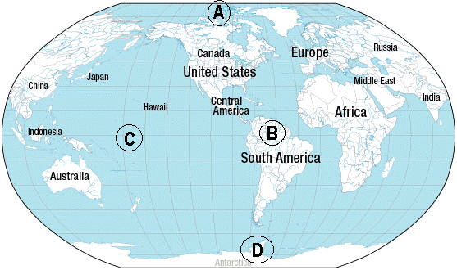
14. The picture of the Earth has letters on different geographic areas. You can see that those letters are listed below. Next to each letter write the words “pulled down” or “pushed up” to show how the air is moving in each area on the Earth.

A. ___________________________ B. _____________________________

C. _ ______________________________ D. _________________________________
AIR Press-sters Team
Recording Air Pressure (Station Model Method)

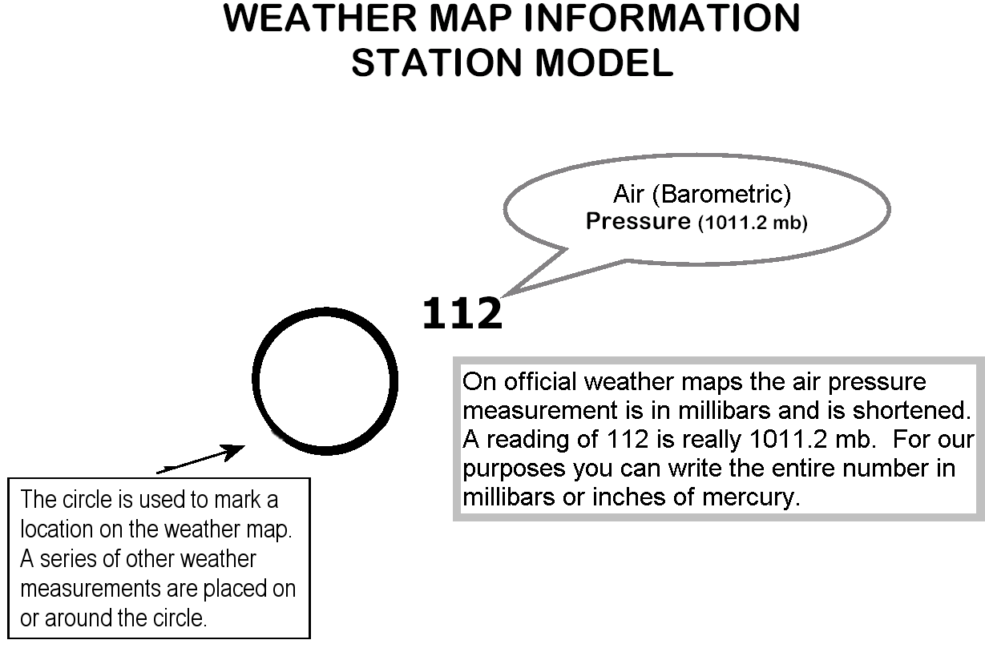
Meteorologists use a special symbol to show weather measurements on a weather map. This symbol, called a “station model”, shows the measurements taken at a weather station. One measurements shown on a station model is air pressure. The pressure is written to the upper right of the circle.

Teach the class: Share with the class how a station model can show air pressure.

There are different types of maps that show air pressure measurements. The map below shows lines of equal air pressure known as “isobars”. These lines were drawn using the air pressure readings reported on the station models.
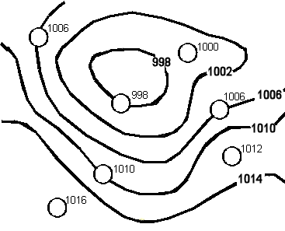

Ask the class “Is there a high or low pressure system on this map?

Air Pressure: This page is to record daily air pressure using the Aneroid Barometer and a resource for regional air pressure readings. The resource could be a weather report or an Internet website, such as “www.weather.com”.
Use the arrow box to track air pressure changes (↑ or ↓). Use the U.S. Map to track movement of air masses.
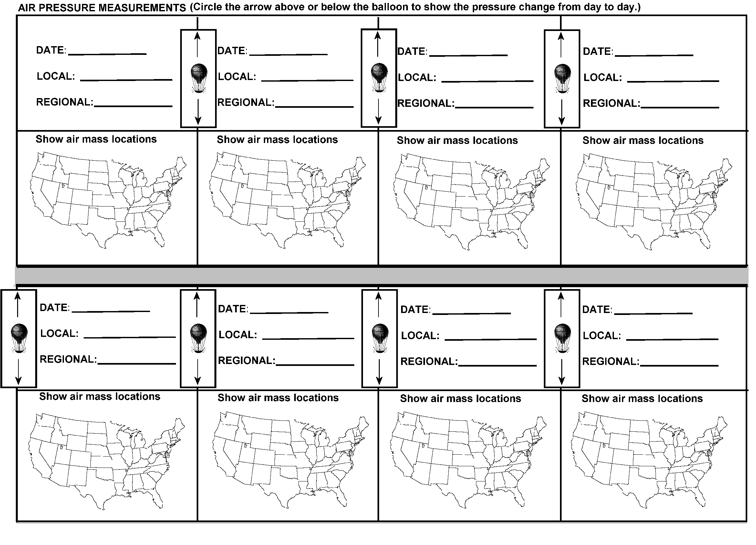
Air Pressure Wheel: The circle below has 8 sections and a center oval.
Fill in the sections using the following rules:
Fill in the center oval with the topic for the circle.
Fill in each of:
- 1 and 2 with a word that is part of a definition of the term air pressure.
- 3 and 4 with an air pressure unit of measurement.
- 5 and 6 with a word that describes air pressure that is an adjective.
- 7 and 8 with a way that we use air pressure in our lives.

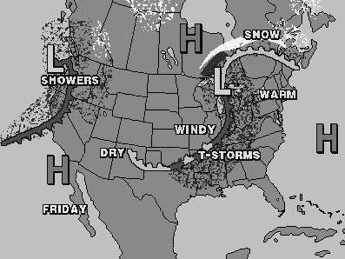
Air Pressure and Weather Maps

In Activity 4 you focused on air pressure. Air pressure is a measurable property of air. Air pressure measurements are used by meteorologists to locate areas of higher or lower air pressure. We have discovered that areas of high or low air pressure affect air movement. This affects the weather.

Your task is to draw the current locations of any high or low air pressure systems on the U.S. map. You can do this by watching a weather report on TV, looking at a newspaper or going to a weather website on the internet.

In addition to drawing the weather systems, you should:
- write down what the weather is like near the weather system.
- draw arrows showing to where the systems are predicted to move.
- tell whether you think a weather system is affecting your local weather and why you think this.

Activity 5: Check Point
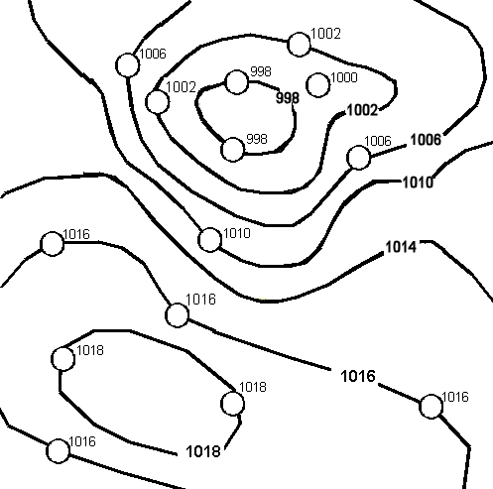
The map on the right is a weather map. It has lines on it that show air pressure measurements. The air pressure readings along each of these lines are the same.

- What is the term for a line on a weather map that shows where the air pressure is the same or equal?
- Look closely at Map A. Decide where the area of lowest air pressure is and place a large “L” there.
Map A
- Decide where the area of highest air pressure is and place a large “H” there.
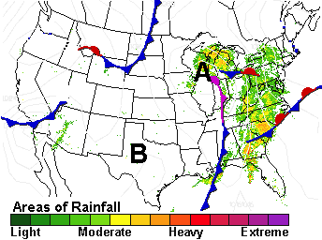
- Weather Map B on the right shows two weather systems, A and B.
Which is a low pressure system? ____
Why do you think that? What is the evidence to support your answer?
____________________________
____________________________
____________________________
__________________________________________________________
__________________________________________________________
Map B
(Activity 5: Check Point continued)
- What is a weather front? ______________________________________
__________________________________________________________
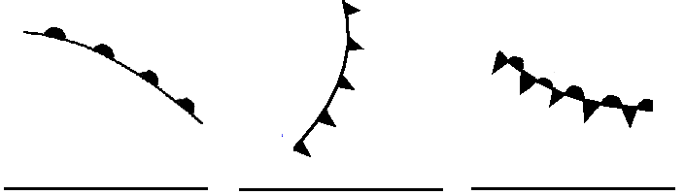
- Look at the diagram to the below. Under each symbol write the type of front that it represents.
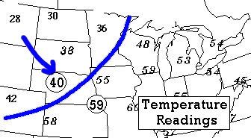
- Look at the weather map below. It has air temperature measurements written on it. There is a line drawn across the map. The line shows a weather front but you can not tell what type it is. The arrow tells you the direction of air movement. Look at the map and decide what type of weather front it is. Label the front line.
- Why does air have the property of pressure?
__________________________________________________________
__________________________________________________________
__________________________________________________________
Cloud-sters Weather Team
Recording Cloud Cover (Station Model Method)

Meteorologists use a special symbol to show weather measurements on a weather map. This symbol, called a “station model”, shows the measurements taken at a weather station. One measurements shown on a station model is cloud cover. The cloud cover is shown by shading in all or part of the circle.
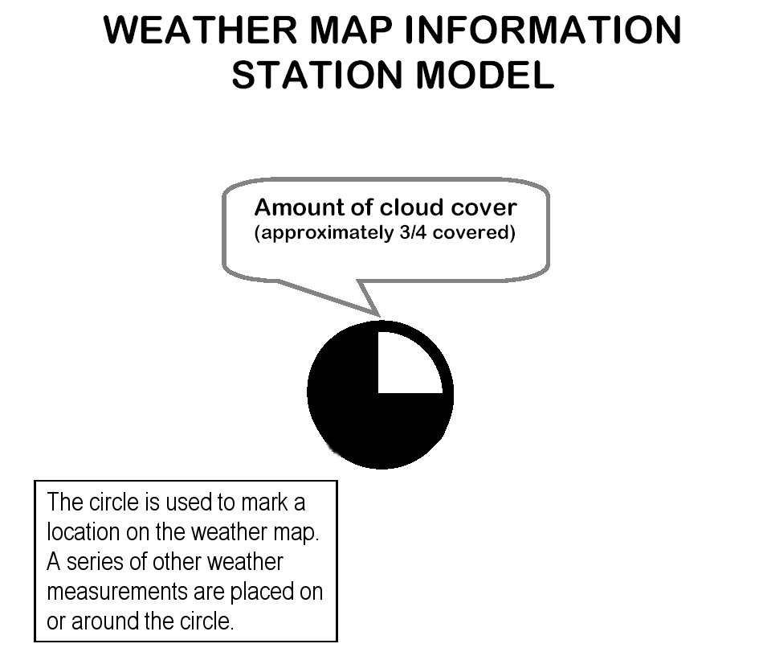
Teach the class: Share with the class how a station model can show cloud cover.
There are different types of maps that show cloud cover. Some are satellite images and others use station models to report the data.
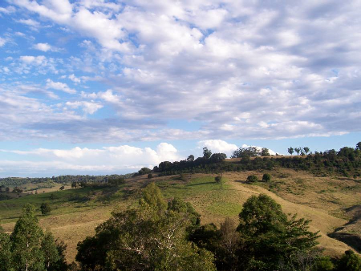
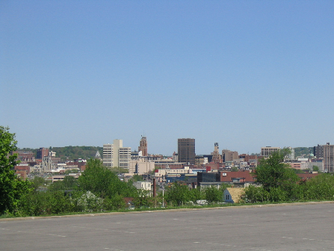

Ask the class to show the amount of cloud cover for today or use the above pictures. Draw station models that show the cloud cover.
What is relative humidity?
Sometimes knowing the dew-point temperature is not enough information. The dew-point tells you a temperature at which the greatest amount of water is in the vapor state. It doesn’t tell you the amount of water in the vapor state. The term “humidity” refers to the amount of water in the vapor state. Humidity is a quantity. Often the question is “Can more water evaporate?” or “Is the water vapor going to condense?” The answer to this question depends upon the ambient temperature. We have found that the higher the ambient temperature the more water that can be in the vapor state. Less water can be in the vapor state at a lower ambient temperature. So, the same amount of water vapor can mean different things at different temperatures. Let’s look at a visual model of this concept.

The size of the glass represents the amount of water that can be in the vapor state. The spheres in the glass show the amount of actual water vapor.
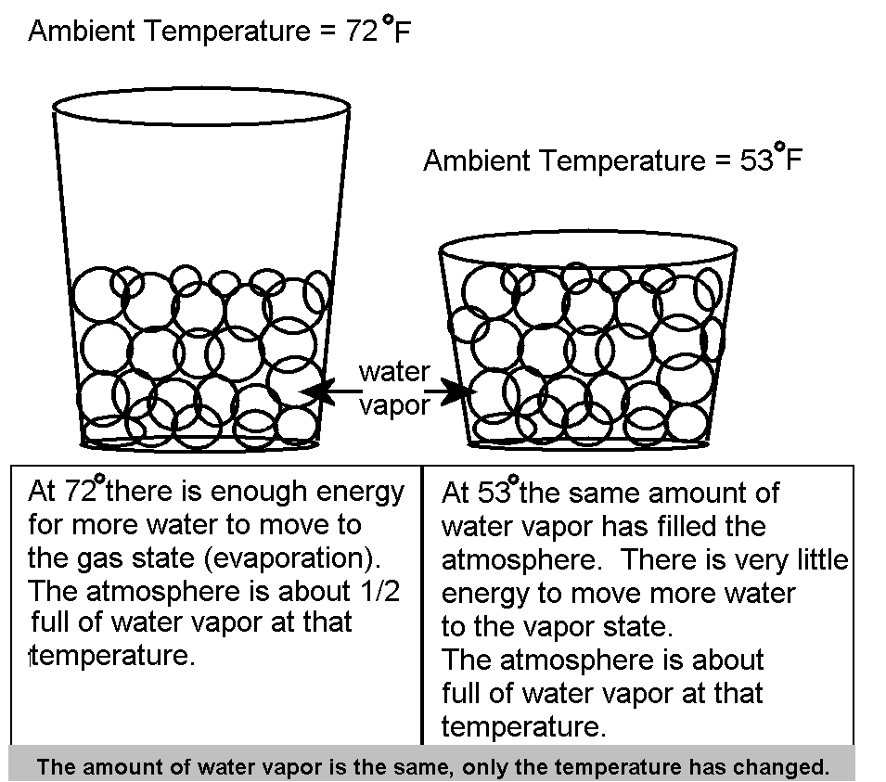

Draw a glass to show what you think would happen if the ambient temperature were to drop to 33º F.

Relative humidity (R.H.) is written as a percentage. It tells you what part of the total amount of water that can be water vapor is actually water vapor at the current temperature.
A R.H. of 60% tells you that 40% more water can be energized into the vapor state.

To measure relative humidity you use a dry-bulb thermometer, a wet-bulb thermometer and a reference chart. The science instrument that has wet and dry bulb thermometers attached to a handle is called a “sling psychrometer”. Let’s measure the R.H.
How Do You Use A Relative Humidity Chart?
To use the chart you need a wet and dry thermometer reading in °F. You subtract the wet-bulb reading from the dry-bulb reading to find the “Wet bulb depression” on the top of the chart. Locate the dry-bulb temperature on the left side. Find where the two lines meet and read the relative humidity measurement.
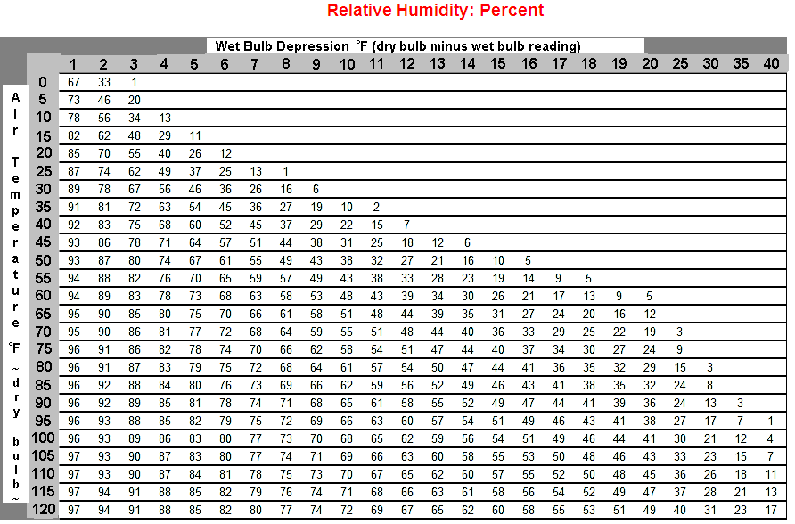

Activity 6 Homework (Review)
Fill in each of the concept maps by using the words in each “Word Box”. For questions 7 – 11 answer the questions by filling in the blanks.

Word Box: precipitation condensation evaporation

liquid water
water vapor
clouds
3.
2.
ground water
1.

Word Box: layered wispy fluffy

Cloud Types
cirrus
cumulus
stratus
4.
5.
6.

List the three items needed for clouds to form:
7. 8. 9.

10. What do we call the temperature at which water vapor condenses on a surface?

11. If you were to look at a weather map, where would you expect to see major cloud formation and precipitation?
Activity 6 Checkpoint

1. Write on the line below each picture the type of cloud.

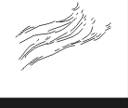
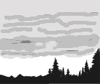
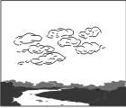
A
B
C

2. Look at the Venn Diagram. Each circle has some cloud describing words. Place on each line in each circle the letter of the cloud type shown in question 1 that best matches each set of words.

3. Look at the Venn Diagram. In the Venn Diagram, in the area where the circles overlap, you would place the items that the clouds have in common. In the boxes provided write about what clouds have in common.
fluffy
piled up
fair weather
layered
flat
low lying
stormy
wispy
very high
ice crystals
stormy

What all clouds need to form:
a. ______________
b. ______________
c. ______________

d. Clouds are formed by water vapor changing to _____________.
This process is called
_______________.

Act. 6 Checkpoint Continued - Precipitation:
4. List three forms of precipitation.

5. From where does precipitation come? (be specific)

6. Is precipitation measured in inches, ounces or milliliters? ________________

Pressure Systems, Fronts and Clouds
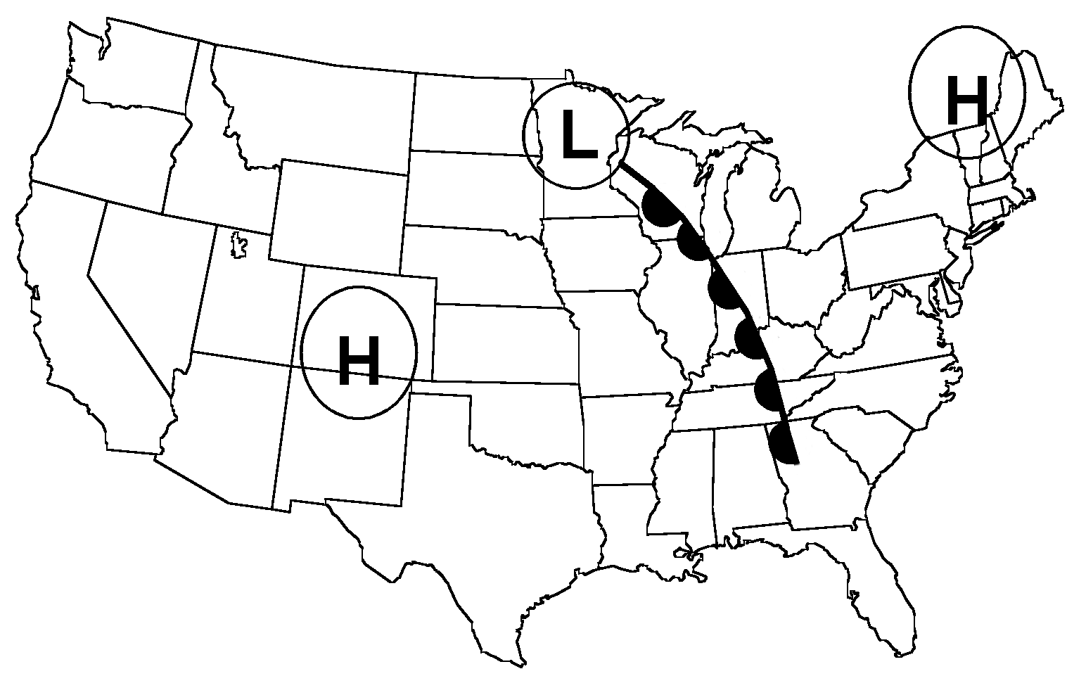

The weather map above shows some weather systems across the U.S. Use the map to answer a question or do a task.

7. Shade the areas of the map where you would expect clouds and precipitation.

8. Label with “R”s the places on the map where you would expect air to be rising.

9. Find New York state on the map. Do you think that it is 100% cloud cover in Central New York? Why do you think that?

BONUS: If it is 42°F outside and it is foggy, is the dew-point temperature:
A. much higher than 42°F B. much lower than 42°F C. near to 42°F
Select A, B, or C and tell why you selected that temperature.
WEATHER READINGS PUZZLERS
ANSWERS:
1  Date:___Nov. 30___ | Temperature:  Puzzler 1:  The temperature reading is too high for November (the date is not a weather reading so we wouldn’t look to change the date).  Local: ____88º F_______
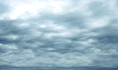  Cloud Cover  L | Air Pressure  Local: _29.4 in Hg (996 mb)
Cloud Type (draw sky)
Stratus clouds

2  Date:___Dec. 12___ | Temperature:  Puzzler 2:  The cloud type is incorrect. The fluffy clouds are cumulus. Stratus clouds are a layer of clouds.  There is a High Pressure system not a Low over NYS.  Local: ____33º F___
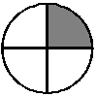  Cloud Cover | Air Pressure  Local: _29.4 in Hg (996 mb)
Cloud Type (draw sky)  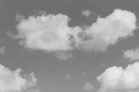  Stratus clouds | L  H

3  Date:___Nov. 30___ | Temperature:  Puzzler 3:  The cloud cover is incorrect. Stratus clouds are a layer of clouds. The sky can not be “clear’ with clouds indicated.  Local: ____42º F___
Cloud Cover  L | Air Pressure  Local: _29.4 in Hg (996 mb)
Cloud Type (draw sky)
Stratus clouds

(Weather Readings Puzzler continued)

4  Date:___July 4___ | Temperature:  Puzzler 4:  The air pressure is to low. A high pressure system is in the NY area. Standard air pressure is 29.9 in Hg or 1013 mb. High pressure systems tend to be above this reading.  Local: ___89º F___
Cloud Cover  H | Air Pressure  Local: _29.4 in Hg (996 mb)
Cloud Type (draw sky)
Cumulus clouds

Super Challenge: find three incorrect readings
Puzzler 5:
The air temperature is too high for March.

The air pressure indicates a high pressure reading and there is low pressure in the area.

The wind direction would be more from the south or southeast. There is counter-clockwise air movement around a low.

The dew-point temperature is very low. This indicates very little water as vapor, yet, there are many clouds.

A relative humidity of 50% also indicates a low amount of water as vapor.
5  Date:___March 2___ | Temperature:  Local: ____92º F_______
Cloud Cover  L | Air Pressure  Local: _30.2 in Hg (1022 mb)
Cloud Type (draw sky)
Stratus clouds
Wind Speed and Direction | Dew Point Temperature  ____10º F____  Relative Humidity  _____50 %____


Notebook Page Topic:
Part A: Match the Word and Definition by writing the definition letter before the word.

 | Word |  | Letter | Definition
1. | weather |  | A | the layer of gases around Earth
2. | climate |  | B | a fast moving “river” of air
3. | atmosphere |  | C | the air that most often blows into an area
4. | meteorologist |  | D | character of the atmosphere at a certain moment
5. | altitude |  | E | changing from a gas to a liquid
6. | gas |  | F | temperature of the surroundings
7. | prevailing wind |  | G | a state of matter
8. | jet stream |  | H | a measure of distance from the Earth’s surface
9. | ambient temperature |  | I | seasonal weather for an area
10. | condensation |  | J | a scientist that studies weather

Part B: Fill in the blank with the best choice of words.
- Air pressure is measured using an instrument called a ___________________.
- A thermometer makes a measurement called a _________________________.
- An anemometer measures __________________________.
- A unit used to measure the amount of precipitation is ________________.
- The wind direction is measured using a ____________________________.
- The property of a gas that is related to the number of gas particles is the ________________.
- Weigh and pressure are similar in that they both measure ________________.
- A name of one type of cloud is ______________________.
- The temperature that water starts to condense onto surfaces is the _____________________ temperature.
- A line or boundary between two air masses having different temperatures is called a __________________.
- The amount of water in the air as water vapor is the ____________________.
Part C: Select the best answer for the following questions by circling the letter.

Base your answers to questions 22 and 23 on the map below and on your knowledge of science. The map shows the origin of a maritime tropical air mass. The arrow shows the general track of this air mass. New York State is labeled NY.
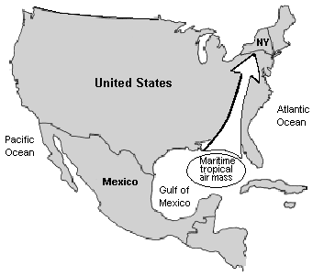

22. Which temperature and moisture conditions are associated with this air mass?
(1) cold and dry (3) cold and humid
(2) warm and humid (4) warm and dry

23. Which factor has the greatest influence on the direction of the air-mass track?
(1) upper air currents (3) sea breezes
(2) ocean currents (4) mountain barriers

24. Earth’s weather is primarily caused by the
(1) drifting of Earth’s crustal plates
(2) gravitational attraction of the Moon
(3) uneven heating of Earth’s surface
(4) changing distance between Earth and the Sun

Note that question 25 has only three choices.
25. As altitude increases, air pressure
(1) decreases
(2) increases
(3) remains the same
Part D: Use the weather map below for questions 26 – 30. The weather map below shows the locations of a weather system over part of North America.
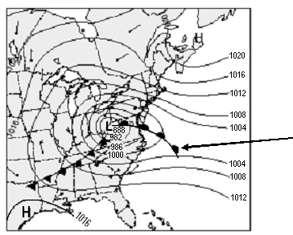

26. The numbered lines on the weather map connect locations with the same
(1) wind direction (3) air temperature
(2) wind speed (4) air pressure

27. The letters “H” and “L” on the weather map indicate
(1) pressure systems (2) temperature systems
(3) location of cities (4) wind speeds

28. The line attached to the “L” with the arrow pointing to it is a
(1) isobar (2) warm front
(3) cold front (4) isotherm

29. You would predict the weather system (L) to move
(1) northwest (2) southeast
(3) south (3) northeast

30. What type of weather would you expect this weather system (L) to bring
(1) cloudy and rainy (2) clear and warm
(3) scattered clouds (3) clear and cold

31. A wet shirt is put on a clothesline to dry on a sunny day. The shirt dries because water molecules
(1) gain heat energy and condense
(2) gain heat energy and evaporate
(3) lose heat energy and condense
(4) lose heat energy and evaporate
Part E:
Use the weather map below, which shows weather systems located over part of North America in May, to answer question 32. The numbers on the map indicate the air temperature in degrees Fahrenheit.

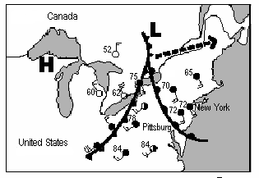

32. Shade the areas of the map where you would expect clouds and precipitation.

33. What are the three basic conditions needed for clouds to form?

The map shows the relative size and track of a certain weather event.
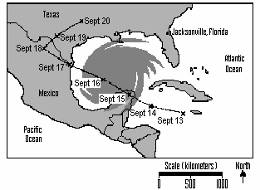

34. Which weather event is shown on the map?
(1) tornado (3) hurricane
(2) blizzard (4) thunderstorm

Part F: Extension (35 – 36) Base your answers to questions 35 and 36 on the table below and on your knowledge of science. The table shows the location of Hurricane Betsy at 1:00 a.m. on several dates in 1965.
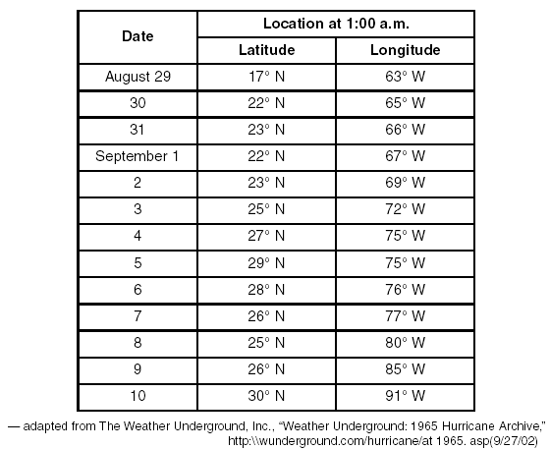
Location of Hurricane Betsy August 29 — September 10, 1965

35. The locations for August 29 through September 5 have been plotted on the hurricane tracking chart on the next page.

Plot the five remaining locations of Hurricane Betsy shown on the data table by following the directions below.

a. Place an X for each remaining location of Hurricane Betsy from September 6 through September 10.

b. Label each X with the appropriate date.

c. Connect the Xs using straight lines to show the continuing path of Hurricane Betsy.

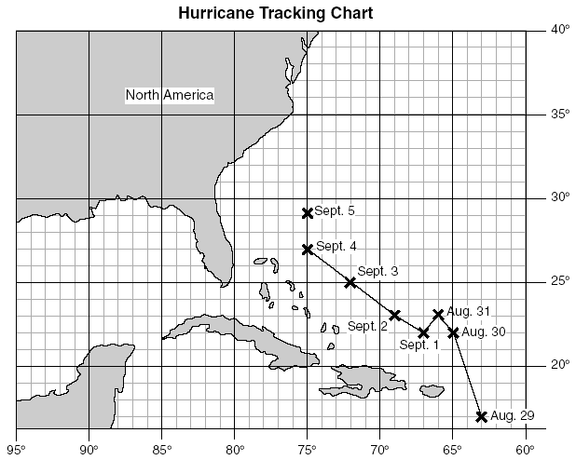

36. The United States Weather Bureau issued hurricane warnings before Hurricane Betsy moved over land areas. Write down two actions the United States Weather Bureau most likely advised coastal residents to take to prepare for Hurricane Betsy.

(a)

(b)

