
Kit #15
Rocks & Minerals
Student Journal

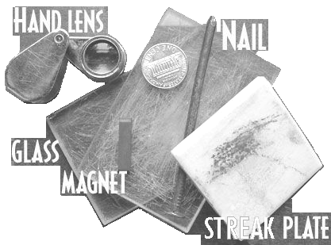

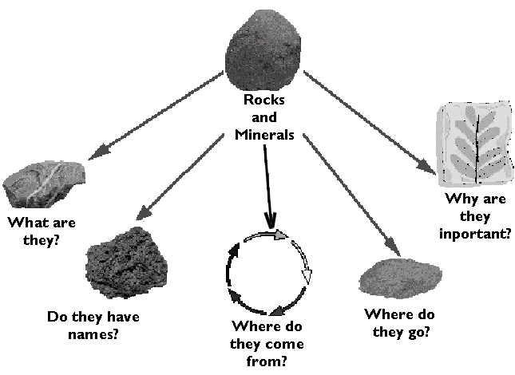



Rock Hound’s Name: ______________________________________

Revised June 2008 (graphics, formatting modifications)

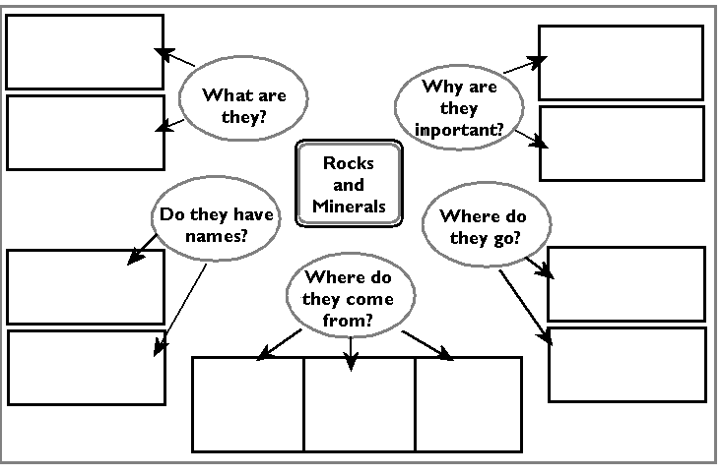
Concept Map: Fill in the concepts as you do the Rocks and Minerals Kit.

Activity 1: What are rocks?
Identifying Rocks & Minerals

It is not easy to pick up a rock and tell what type it is. This is because there are so many kinds of them. It takes years of study to be able to identify a mystery rock. Even rock hounds want to know where the specimen came from to help tell what type of rock it is.

Rocks and minerals can be difficult to tell apart. All rocks are made of minerals, but minerals are not made of rocks. A rock is made of two or more minerals. A mineral is the same matter all the way through. That piece of the earth’s crust that you think looks so neat could be a mineral instead of a rock. That is one reason we may call an unknown rock a “sample” rather than a “rock.”

As a rock hound, you may start out by just looking at rocks and getting to know them. But after a while, you're going to want to know more. Field Guides are a great source of information. An excellent one is Simon & Schuster’s Guide to Rocks and Minerals (ISBN 0-671-24417-5), a rock hound favorite. There are a number of other field guides that have been written, including guides to fossils and gemstones.

The Earth's Crust

The whole earth is made of rocks and minerals. Inside the earth there is a liquid core of melted rock. On the outside there is a hard crust. If you compare the earth to an egg, the shell on an egg is like the crust on the earth. The crust is made up of solid rocks and minerals. Much of the crust is covered by water, sand, soil, and ice. If you dig deep enough, you will always hit rock. If you keep digging you will hit bedrock, which is a solid layer of rock. No one has ever been to the center of the earth.
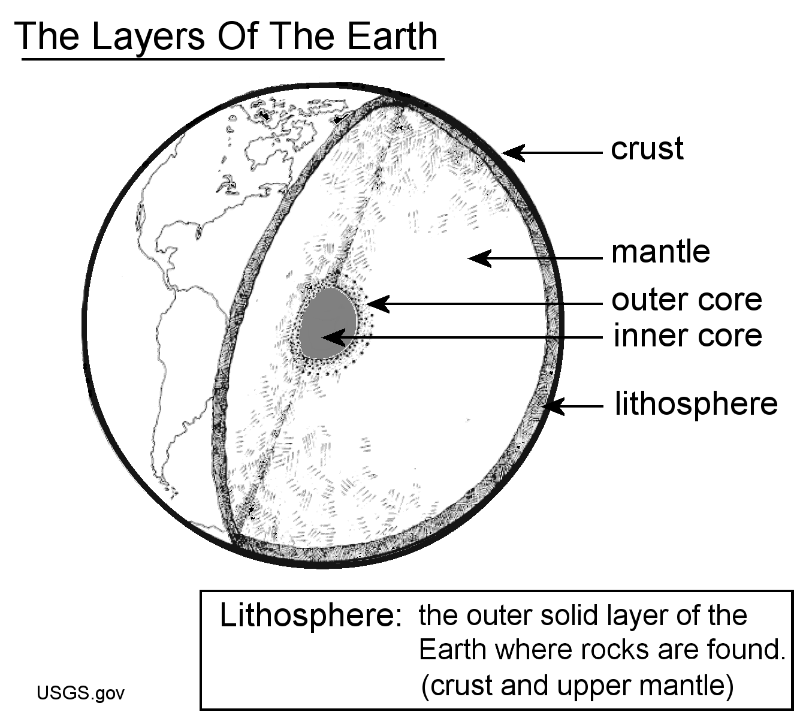

Geologists are scientists who study the earth. Geologists have had to figure out what the inner parts of the earth are like. The layer below the crust, the mantle, is where the melted rock comes from for volcanoes. The temperature at the mantle is about 1,000 degrees Celsius. That’s 1,832 degrees Fahrenheit!

Activity 1: What are rocks? continued

The Earth’s Crust, continued

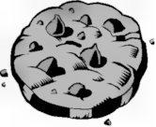
The rocks you see around you (the mountains, canyons and riverbeds) are all made of minerals. A rock is made up of two or more minerals. Think of a chocolate chip cookie as a rock. The cookie is made of flour, butter, sugar, and chocolate. The cookie is like a rock and the flour, butter, sugar, and chocolate are like minerals. (This part is making me hungry!) You need minerals to make rocks, but you do not need rocks to make minerals. All rocks are made of minerals.

The scientific study of rocks is called petrology. A scientist who studies rocks and how they are made is called a petrologist.

Minerals

Most of the earth, except plants and animals, is made of minerals. If you were to cut a mineral sample, it would look the same all through it. There are about 3,000 different minerals in the world. Minerals are made of chemicals: either a single chemical or a combination of chemicals. Minerals are natural, not man-made, and have never been alive.

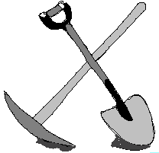
Sand, Soil & Dirt

When rocks break down into smaller and smaller pieces, they turn into sand. The breaking down of rocks is called weathering. If you look at the sand under a microscope, you will see that sand is made up of the same minerals as the rocks that the sand came from. If plants start to sprout up in the sand, then this starts the change from being just small bits of rock to being soil. Soil has organic matter in it.

Soil is very important to life on earth. It supports plant life. We could not live without plants. Soil is made up of sand, silt, and clay along with decaying plants and animals. Soil is called many names, including clay, silt, mud, dirt, topsoil, dust, potting soil, and humus. The names usually tell you what is in the soil sample.

(Research question: What is the difference between sand, silt and clay?)

Most rock hounds start out by just looking at rocks and getting to know them. This is what we are going to do. We are going to start out by just looking at rocks and getting to know them … so let’s get some rock samples and introduce ourselves.
Activity 1: What are rocks? continued

“The Earth Rocks!”

Using the words in the word list below create word groups. For each group write a word or phrase that tells why you grouped those words together. You can use a word in more than one group. Use all the words at least once. (Look back at pages 2 and 3 for help.)

Example
Chemicals make up:
minerals
rocks
earth

rock
mineral
lithosphere
same
different
soil
sand
silt
clay
petrology
organic matter
bedrock
earth
natural
crust
chemicals

Activity 1: What are rocks? continued

What are some rock properties?

“Getting to know you … hey, you look familiar.”
Observable properties: characteristics of an object that can be “known” through the use of our senses.

Materials:
-5 different rock samples
-hand magnifier

-sorting charts (Student Journal, pgs. 6-7)

Procedure:

- Place all your rock samples in the top box (Box 1) of the sorting chart.

- Use the question written in Box 1 to sort the rocks into Box A or Box B.

- Think about the properties of the rocks in Box A. Think of a question that would sort the rocks into two groups. It should be a question that would have a “yes” or “no” answer. Write the question in Box A. (Do not use the property already used in Box 1.)

- Sort the rocks in Box A. Move them to Box C (yes) or Box D (no).

- Think about the properties of the rocks in Box B. Write a question that would have a “yes” or “no” answer. Use this question to sort the rocks into two groups. (Do not use the property already used in Box 1).

- Sort the rocks in Box B. Move them to Box E (yes) or Box F (no).

- Write a description of each of the rock samples (in Boxes C, D, E, F) using properties that can be observed.

Return your rock samples to your teacher.

Activity 1: What are rocks? continued

What are some rock properties?

“Getting to know you … hey, you look familiar.” (continued)
BOX 1: Is the rock shiny like glass? It may have large glittering pieces.

Glassy =Yes Not glassy = No

Box A:Write your question here.
Box B:Write your question here.

YES, move yes rocks here
NO, move no rocks here

Box C:  Write a description of your rocks. | Box D:  Write a description of your rocks. |  | Box E:  Write a description of your rocks. | Box F:  Write a description of your rocks.

Activity 1: What are rocks? continued

What are some rock properties?
“Getting to know you … hey, you look familiar.” (continued)

Box A Question

Box B Question

YES
NO
YES
NO

Activity 2: Can we identify a rock by its properties?

“Rock Hound, What’s in a Name?”

How can you tell a rock from a mineral? How can you know the name of a rock? It is not easy. There are so many kinds of rocks. Someone may study rocks for years before they can name a mystery rock. Most rock hounds start out by just looking at rocks and getting to know them.

In Activity 1 you sorted rock samples. You sorted them using their properties. The properties were ones you could observe.

The first sort in Activity 1 used the property called “luster”. Luster describes the way light reflects off of a mineral. Words used to describe luster are dull, shiny, pearly, greasy, and metallic.

Next, you studied the rocks. You were told to think of another property to sort the rocks. You then wrote a question about that property. Using the answer to the question, you sorted the rocks a second time.

Color and luster are rock properties. There are other properties that earth scientists use to sort rock samples. In this next activity you will be sorting rock samples using some of these other properties.
Hardness: Rocks and minerals are soft or hard depending on what they are made of and how they formed. In 1822, Friedrich Mohs, a German mineralogist, established a practical method of comparing hardness or scratch resistance of minerals. It has become universally known as Mohs scale.  Notes for testing  1. Scratch the sample with your fingernail first, then the  penny and finally the nail.  2. As soon as there is a scratch, you are finished.  3. Don’t press too hard.  4. Corners or edges of the samples are softer.  5. Small pieces seem softer than larger pieces.  Testing Chart (Adapted from Moh’s hardness scale)  4 | Mineral/Rock Properties Testing Booklet  COLOR: Rocks and minerals can have beautiful colors. We can’t depend on color to tell us what type of rock or mineral it is.  LUSTER: This describes the way light reflects off of the surface of a mineral. Words that are used to describe luster are dull, shiny, pearly, greasy, and metallic.  ACID TEST: Some rocks contain a substance (a chemical) that reacts with acid.  Acid Test Tools:  Dropper bottle of Hydrochloric Acid (HCl)*, 1oz. plastic cup, safety goggles, vinyl gloves, paper towels  (* Caution, handle with care. Wash your hands before touching your clothing or putting hands near your eyes.)  Place the rock sample in the 1 oz cup or on a piece of paper towel. Put 1-2 drops of acid on the sample. Watch for bubbling or listen for fizzing sound.  Rinse off the rock sample, towel dry and replace into bag.  WASH YOUR HANDS WHEN DONE!!  1
  Rating | Description
  1 – 2  SOFT | Easily crumbles. Can be scratched with a fingernail.
  3 – 4 | Can be scratched with a copper penny.
  5 – 6 | Can be scratched with a common nail. Minerals with a hardness 6 or more will scratch glass
  7 – 9 | If you can not scratch the mineral with a steel nail it has a hardness of 7-9. If a mineral can be scratched by a diamond it has a hardness of 7-9.
  10 HARD | A diamond has a hardness of 10.
STREAK  Streak Tools:  Streak plate, paper towel and water to clean the plate off.  Streak is a way to test for color. This test is done by using a rock sample to make a mark on a “streak plate.”  A streak plate is a small rectangle shaped piece of tile. The tile is not glazed. It doesn’t have a super hard shiny surface like you may have seen on tiles in your home.  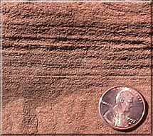  A rock sample may or may not leave a streak color. A mineral or rock that does will tend to always leave the same color. The color of the rock sample may vary but the color of the streak for a certain rock type is usually the same. Some usual streak colors are white, gray, black, reddish brown, grayish brown, golden green. The white streak is often hard to see because the streak plate is white. You have to look closely for it.  2  LAYERS  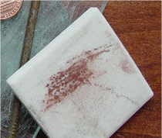  This describes the way the rock material  is placed in the rock. You may see layers  of color; one on top of the other. This tells you how the rock was created. | MAGNETIC  Magnetic Tools:  Small magnet  This test is as simple as testing to see if the rock sample is attracted to the magnet.  How strong the attraction is depends on the iron in the rock sample.  CONDUCTS ELECTRICITY  Tools:  Copper wire (about 15 cm long), a light bulb (#48), one “D” cell battery.  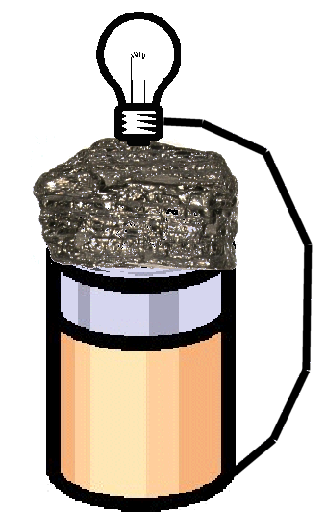  You can test a rock sample to see if it conducts electricity. You do this by making it a part of an electrical circuit. Use the diagram below as your guide.  3  Place the rock sample as shown. One end of the copper wire must touch the center of the bottom of the battery. The other end touches the side of the base of the light bulb. Test your circuit by placing the light bulb on the battery without the rock sample.

Activity 2: Can we identify a rock by its properties? continued

Rock/Mineral Testing

“Trial Run, Practice”

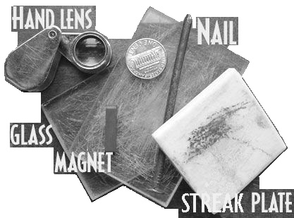
Materials:
-rock/mineral sample (shale, kaolinite)
-Mineral/Rock Properties Testing Booklet
(created from your Student Journal, pgs. 9-10)
-plaster of Paris
-materials for each test (your teacher may have set up test stations)

Testing Process: (Read through the directions before starting.)

- In your Mineral/Rock Properties Testing Booklet you will see eight different ways to test each rock sample. Read through your booklet.

***Acid Test Practice:***
When you do the acid test on your rock samples also do a test on a sample of plaster of Paris.

a. Place a small amount of the plaster of Paris powder in a 1 oz. plastic cup
b. Add 1-2 drops of hydrochloric acid (HCl). Make sure to follow all safety rules.

- Record the results of each test. Organize the information.

- Share your testing data with the class.

Activity 2: Can we identify a rock by its properties? continued

Rock/Mineral Testing (continued)

IT’S THE BIG ONE!!

“What’s My Name?”

Materials:

-12 different rock samples
-12 small zip lock plastic bags
-hand magnifier
-marker or pen*
-set of Sorting Charts

-Mineral/Rock Properties Testing Booklet
*teacher supplied

Procedure:

- Place a sample of each rock in a small zip lock bag. Write the ID number on the outside of the bag to identify that sample.

- You will be sorting your rock/mineral samples. You will do this by making observations or doing tests on the samples. There is a set of Sorting Charts with questions that will help you to complete a step-by-step sort of your samples. When you think you have a name for a sample, write it on a small piece of paper and place it in the plastic bag with the sample.

- On pg. 13 of your Student Journal is a blank chart that you could use. It may help you to keep track of your testing. On pg. 14 of your Student Journal is a blank “Rock and Mineral ID Flow Chart Overview” that may also help in keeping track of information you have discovered.

Rock No. | Observations  (color, luster, feel) | Layers (yes/no) | Hardness (number) | Streak (color) | Magnetic (yes/no) | Conducts Electricity  (yes/no) | Reacts to Acid?  (yes/no) | Name
The Twelve Rocks and Minerals Info Data Table

Rock and Mineral ID Flow Chart Overview
1
A
B
A-2
A-1
B-1
B-2

YES
NO

NO
NO
YES
YES

A-4
A-3
E
F
D
C
F-2
F-1
G
H
I
J
NO
NO
YES
YES

NO
YES

You can write the numbers of your rock samples in the boxes. It will help you to keep track of them.
NO
NO
NO
YES
YES
YES
Activity 3: Can rocks be sorted by how they are formed?

Where do they come from?
Rocks are constantly being “born.” That is, rocks are always being formed. Rocks are also constantly being worn down. Then they are formed again. This cycle of rocks is known as the rock cycle. It is like the water cycle, but it takes a lot longer. It takes thousands and millions of years for rocks to form, wear down, and form again.

Types of Rocks
Rocks are classified into three types: igneous, sedimentary, and metamorphic. The three types of rocks are sorted by how the rock was formed.

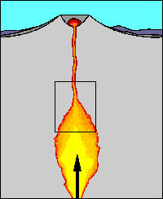
Igneous
Igneous means made from fire or heat. When volcanoes erupt and the liquid rock comes up to the earth's surface, a new igneous rock is made. When the rock is liquid and inside the earth, it is called magma. When the magma cools inside the crust, it will turn into a rock, such as granite. Most mountains are made of granite. Igneous rocks made from cooled magma are very hard.

Magma that gets up to the surface and flows out is called lava. This is what happens when a volcano erupts. Lava flows down the sides of the volcano. The type of rock formed when lava cools depends on how quickly or slowly it cools. Obsidian is a quickly cooled lava rock. Lava that has trapped gases will cool to form rocks that are filled with air pockets. Pumice is an example of this.

Igneous rocks are usually very hard and have small or large crystals that have grown together (interlocked) as the rock cools. Some examples of igneous rocks are granite, gabbro, obsidian, and pumice.
Activity 3: Can rocks be sorted by how they are formed? continued
Sedimentary
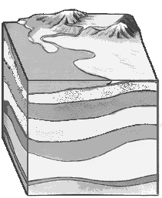
Rain, freezing, wind, and running water will cause all rocks to crumble a little bit at a time. After a while, most of the broken bits of the rock end up in the streams and rivers. These little bits of rock and sand are called sediments. When the water slows down enough, these sediments settle to the bottom of the lake or oceans. Over many years, layers of different rock bits settle at the bottom of lakes and oceans.
Sedimentary rock layers
Erosion: the process by which material is transported along the earth's surface
Think of each rock layer as a page in a book. One piece of paper is not heavy. But a stack of telephone books is very heavy. It would squish anything that was underneath. Over time, the layers of sand and mud buried at the bottom of lakes and oceans are turned into rock. These sediments are cemented together by natural cements and by a squeezing force or pressure. These are called sedimentary rocks. Sedimentary rocks cover most of the earth’s surface.

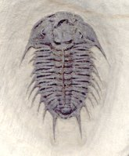
Sedimentary rocks often contain fossils. Fossils are imprints of plants or animals that have died. After an organism dies it may become buried in layers of sediment. As the sediments are changed into rock they leave a picture in the sedimentary rock layer. Most fossils we find are fossils of plants and animals that lived in the sea. They settled to the bottom and were covered. Other fossils are from plants and animals that died in swamps, marshes, or the edge of lakes.

Sedimentary rock properties are as follows: it is not as hard as the other types of rock; the grains can be rubbed off; and it is often found in layers. Some examples of sedimentary rocks are sandstone, shale, limestone and gypsum.
Activity 3: Can rocks be sorted by how they are formed? continued
Metamorphic
Metamorphic rocks are rocks that have changed in structure or composition. The word “metamorphosis” means to change. Just as a caterpillar changes to a butterfly, rocks can change also. Metamorphic rocks were once igneous or sedimentary rocks. Some of these igneous or sedimentary rocks end up buried deep in the earth’s crust. They are so deep that there is a lot of pressure on them. There is also heat. The pressure squeezes them to form a new rock type. The heat helps to change the rock too.

Rocks may also be caught in places where the earth's crust moves. The movement squeezes the rocks and helps to change them.
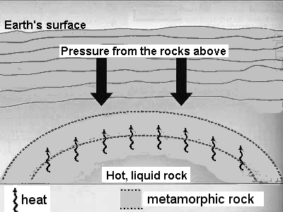

Squeeze your hands together very hard. Do you feel heat and pressure? When the earth's crust moves, it causes rocks to get squeezed. They are squeezed so hard that the heat causes the rock to change. Marble is a metamorphic rock. The sedimentary rock called limestone can be changed into marble. These rocks are often shiny, very hard, and may have bands of color.
Some examples of metamorphic rocks are marble, slate, schist, gneiss (pronounced like nīce), hard coal, and quartzite.
Activity 3: Can rocks be sorted by how they are formed? continued
“Rocking Notes on Rock Types”

Fill in the outline using the information from Student Journal, pgs. 15–17.

Rocks are sorted by ________________________________________.

I. Igneous Rocks
1. These rocks are formed by _______________________________.
- Two forms of melted rock are ____________ and _____________.
- Two properties of igneous rocks:
A.______________________________________
B.______________________________________
- Some examples are:
A.__________________________
B.__________________________
C.__________________________

II. Sedimentary Rocks
1. These rocks are formed by _______________________________________ ___________________________________________________________.
- Three properties of sedimentary rocks:
A.______________________________________
B.______________________________________
C.______________________________________
- Some examples are:
A.______________________________________
B.______________________________________
C.______________________________________
Activity 3: Can rocks be sorted by how they are formed? continued
“Rocking Notes on Rock Types”
(continued)

III. Metamorphic Rocks
1. These rocks are formed by _______________________________________ ___________________________________________________________.
- Three properties of sedimentary rocks:
A.______________________________________
B.______________________________________
C.______________________________________
- Some examples are:
A.______________________________________
B.______________________________________
C.______________________________________

Activity 3: Can rocks be sorted by how they are formed? continued

“What are Rock Groups?”
Materials:
-12 rock samples (each in a labeled plastic bag)
-“Rock Group Chart” (on Student Journal, pg. 21)
-4 pieces of paper* *teacher supplied

Procedure:
- On the top of each page write the name of a group of rocks. On the 4th page write the word minerals.
- Use the “Rock Group Chart” to find one of each of the rock types in the rock collection.
- Place them on the correct piece of paper.
- Sort the rest of the rock samples into the four groups: minerals, igneous, sedimentary, or metamorphic.
- Organize the samples’ names into the four groups using the blank data table.
- Create a graphic organizer that compares/contrasts the rock groups.
- Answer the “Thought Questions” found below.
Thought Questions:
A. A mineral is described as “the same all the way through.” Look at the mineral samples. Write a sentence telling if you think they fit this description.

- Look at all of the sample groups. Write about which group seems to sparkle (glitter) the most, and which seems to sparkle the least.

Activity 3: Can rocks be sorted by how they are formed? continued

What are Rock Groups? continued
“Rock Group Chart”
Reorganize by Rock Groups
No. | Name (Rock Type) | Key:  Min = Mineral  M = Metamorphic  S = Sedimentary  I = Igneous | No. | Name (Rock Type)
 | TALC (Min)
 | HEMATITE (Min)
 | GALENA (Min)
 | MARBLE (M)
 | PUMICE (I)
 | GRAPHITE (Min)
 | MAGNETITE (Min)
 | LIMESTONE (S)
 | CALCITE (Min)
 | ANTHRACITE (M) (Hard Coal)
 | OBSIDIAN (I)
 | SANDSTONE (S)

Activity 3: Can rocks be sorted by how they are formed? continued

“Graphic Organizer”

Create a graphic organizer that sorts the rocks from the Rock Group Chart.
(Add some information about each group to your graphic organizer.)

Activity 4: Where do rocks go?

As part of the rock cycle, rocks wear down or “weather.” Weathering is a good name for this wearing down. This is because the main forces that weather rocks are water and wind. By weathering, pieces of rock are broken off of larger rocks. When rocks break down into smaller and smaller pieces, they turn into sand. If you look closely at the sand, you will see that sand is made up of the same minerals as the rocks that the sand came from.

Erosion is a key part of the rock cycle. Erosion is the process by which weathered material is displaced from the earth's surface. Weathering is a process caused by wind, water or ice, which causes erosion to take place. Gravity is a major force that moves rock pieces (sediment). Sediments are transported to a new location as a result of erosion. Erosion forms much of the interesting landscape that is around us. It can also be a major problem for people. As people live in certain areas they get used to the environment being a certain way. As an area erodes, the land changes. This can cause houses to move, roads to cave in, and underground pipes to be unburied. People can do things to increase erosion or slow it down.

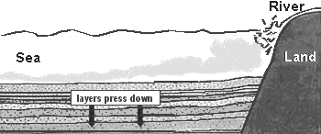
As pieces of rock (stones, pebbles, sand) are moved by wind and water, they get placed somewhere else. This deposited material is the start of a new rock in that place. This rock building will take a very long time. If plants start to sprout up, this starts the change from being just small bits of rock to being soil. Soil is made up of broken down pieces of once living (organic) and nonliving (inorganic) material plus water and air. Soil is usually found in a layer on top of the rock layer.
Soil, pieces of rock, sand and silt
settle in layers on the bottom.

Sediments are eroded by water, wind and gravity.
In the diagram, a river delivers sediments to the sea
Activity 4: Where do rocks go? continued
“What is Sand?”

You can learn a lot by looking at sand. You can learn what the sand is made of. You can observe how big the grains are, how round the grains are, and how well the sand was sorted. This can tell you about the area the sand is found in. You can also tell how far it may have traveled, and where it came from. Doing detective work and solving sand mysteries can be exciting and fun. Besides, some sand is simply beautiful to look at.
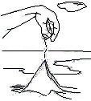
Materials:
-sample of sand
-12 rock samples (each in a labeled plastic bag)
-hand magnifier
-piece of paper* *teacher provided

Procedure:
1. Place some of the sand on the paper.
2. Use the magnifier to look closely at the sand.
3. Try to match pieces of the sand with some of the rock samples. Think about what one grain of the rock sample may look like.
4. Write the names of the rock samples that you chose. Explain your thinking.

Observations:
Rock Name | Explain your thinking
Writing a hypothesis is writing an educated guess to a question. The hypothesis is usually based on research. From your research observations, write a hypothesis to the activity question.

Hypothesis:
Activity 4: Where do rocks go? continued

“Erosion in Our World”

Sand is the result of the weathering of rocks. Rocks are weathered (broken down) by water, ice, wind, and chemical action. Chemical action can be the work of naturally formed acids. These rock pieces are carried and dropped in new places by water and wind. The process of erosion will move these pieces to a new location. The dropping of this material in new places is called deposition. The root word of deposition is “deposit.” When you deposit something you place it somewhere. Sand dunes, sand bars, and sand spits are landforms created by erosion and deposition. All types of rock material can be carried and deposited somewhere else.

Take a walk around your schoolyard or your neighborhood. Look for places that have been eroded. It can be a very small place, like by the edge of a road. It can be a large area, like near a drainage pipe. If water has been at work you will often find the eroded material in a “fan-shaped” deposit.
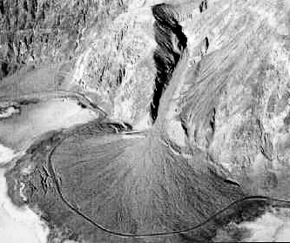

Activity 4: Where do rocks go? continued

“Erosion in Our World” continued

YOUR TASK:
1. Find a place where weathering and erosion have been at work.
2. Draw a picture of a place that shows the work of erosion.
3. Label the place in your drawing where you think the rock material moved from. Label the rock material that was moved (gravel, stones, sand, soil.)
4. Label your drawing to show where the soil, sand or rocks were carried.
Draw your picture here.

5. Write a few sentences telling your thoughts. What erosion forces were at work? Why did erosion happen at that place?

Activity 5: Do rocks have a natural cycle?

“Putting It All Together”

You have looked at or read about all the parts of the rock cycle. Your challenge is to label this rock cycle diagram. You may want to focus on one part of the cycle at a time. Put your hand over the other parts. Place the name of each of the rock types in the correct place in the rock cycle.

Sedimentary Igneous Metamorphic
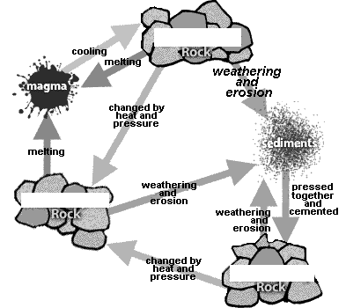
(sediments) (fire) (changed)

Explain the answer to the question, “Do rocks have a natural cycle?”
_________________________________________________________
__________________________________________________________________________________________________________________
_________________________________________________________

Activity 5: Do rocks have a natural cycle? continued

Rock Cycle Cause and Effect

“Why did it Happen? What Happened?”

In this graphic organizer you can see a place for a CAUSE and an EFFECT. Your task is to write a cause or an effect for things that happen in a rock cycle. For the last one you need to write in an effect and a cause of your own.

CAUSE

Very high temperatures
deep in the Earth’s crust
EFFECT

CAUSE

EFFECT

A rock is changed to a different type of rock.
CAUSE

The forces of weathering and
erosion
CAUSE

EFFECT

EFFECT

Activity 6: Why are rocks and minerals important to us?
You cannot escape from rocks and minerals. They are in our homes, schools, stores, and churches. They are a part of our everyday lives. They are natural resources. Rocks and minerals are used in places that may surprise you.

How about in a book or magazine? Most of the paper used to make books contains china clay. The clay, also called kaolin, makes the paper white, and takes on a shine as it is processed. This makes the paper look glossy and expensive.

How about our skin? A pumice stone is used to get rid of dry skin on your feet. This really is volcanic pumice. Talcum powder, found in baby powder, is ground-up talc, the softest mineral in the world.

How about in the kitchen? Aluminum, used to make aluminum foil, is found in the ore “bauxite.” Bauxite is mined. Feldspar is used to make glass and pottery. Halite is a mineral which is also known as salt. Marble and slate can be used for kitchen counters.

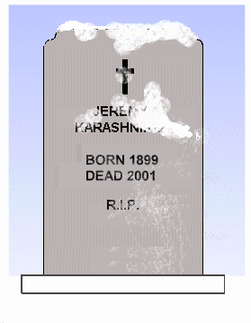
How about buildings? Churches and gravestones are often made of natural rock. Sometimes the outside of a building is made of stone. Marble, granite, limestone, and gypsum are used in buildings. Gypsum is used to make wallboard and plaster. The foundation of a building is often made using concrete. Concrete (cement) is made from limestone, clay, gypsum and shale.

How about … there are about 35 different minerals and metals found in a computer? Oh, and don’t forget coal, which is burned to produce energy. All of these rocks and minerals have to be mined and transported so we can make use of them.
Challenge! What is the name of the New York State gem?
What rock was used to build much of the Erie Canal?
Activity 6: Why are rocks and minerals important to us? continued
“What is the message?”
Look at Student Journal pg. 29 or page provided by your teacher.
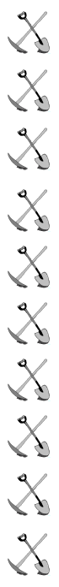
Answer the following questions about the selection.
- Looking at the page, what is the main idea?
- Give three facts (ideas or concepts) that are found on the page. These may be stated directly or inferred.
- Write one idea or piece of information that you didn’t know before.

Activity 6: Why are rocks and minerals important to us? continued

“Why Scientists Study Rocks”

Collecting rocks is fun. But that's not the only reason scientists do it.
By studying rocks, scientists can learn many things. Scientists can make predictions by knowing about rock properties. They can predict how erosion will affect an area. They can make models to help predict when and where the earth may move. They can learn where to build houses, roads, bridges, and other buildings.

Scientists study the land and soil. Scientists help the mining industry find rocks and minerals to mine. They also help to find new uses for rocks and minerals.
Scientists also study rocks to learn about the history of the world. Some animals that lived years ago aren't around today. One example is the Dodo bird. Dodo birds were hunted until there were no more. They became extinct. Other animals, like dinosaurs, are extinct for other reasons. Scientists study the fossils found in sedimentary rock. They do this to find out about plants and animals that lived long ago. They try to find out what the living organism looked like. They would like to learn all about it and why it became extinct.

Scientists study rocks to tell about the past. They also study rocks to help to plan for the future.

Research Challenge: What do each of these scientists study?
Scientist This scientist studies…
petrologist
paleontologist
geochemist
geophysicist
bedrock | -
clay | -
conductor | -
cycle | -
deposition | -
erosion | -
fossils | -
gem stone | -
gravity | -
hardness | -
hydrochloric acid | -
igneous | -
lava | -
lithosphere | -
luster | -
magma | -

Rocks and Minerals Unit Vocabulary Words

Rocks and Minerals Unit Vocabulary Words (continued)

magnetic | -
metamorphic | -
mineral | -
model | -
natural resource | -
petrologist | -
petrology | -
rock | -
rock hound | -
sand | -
sedimentary | -
sediments | -
silt | -
soil | -
streak | -
weathering | -

