

Kit #15
Rocks and Minerals

Blackline Masters

Rocks and Minerals ID Flow Charts 1-9
Rocks and Minerals ID Flow Chart Overview 10
The Rock Cycle 11
Every American Born Will Need 12
Mining 13
Dig a Little Deeper 14-17
Rocking Up and Down Crossword Puzzle 18
End of Unit Assessment 19-24

Revised November 2006

Logo – footers- revision June 2008 OCM BOCES Science Center
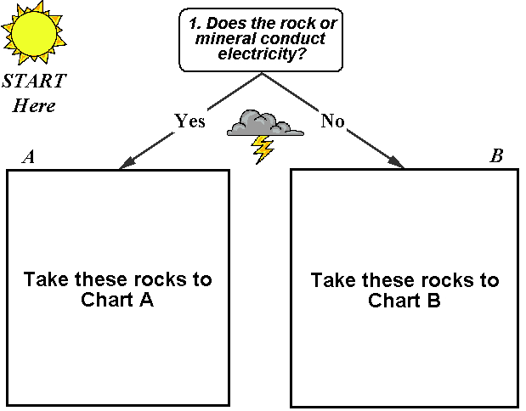
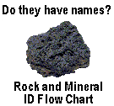
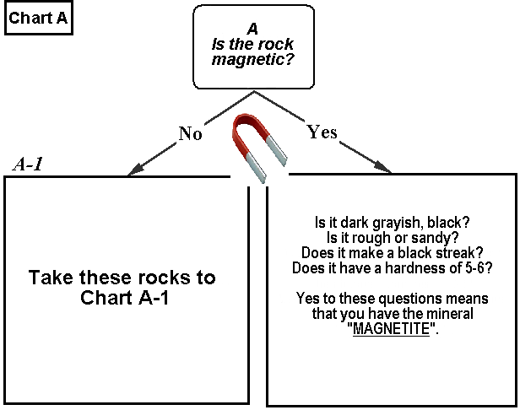
A-2
A-3
A-4
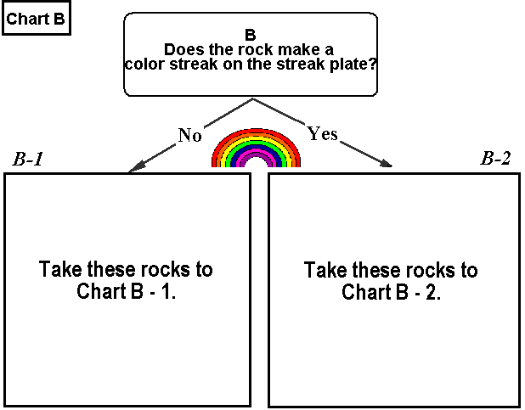
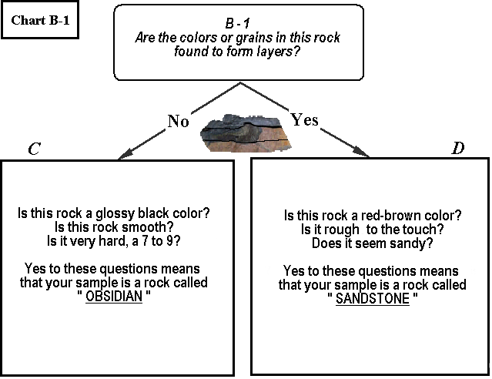
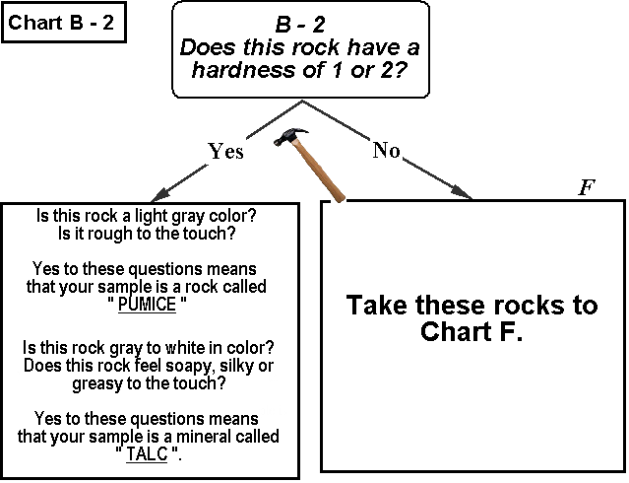
E
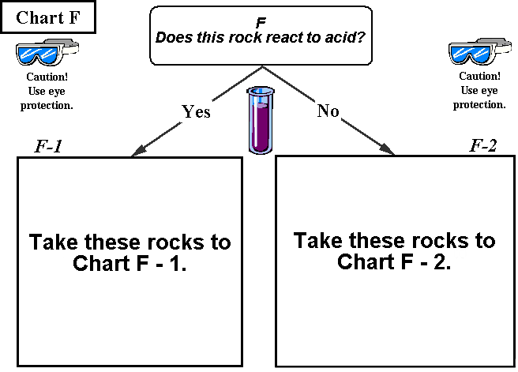
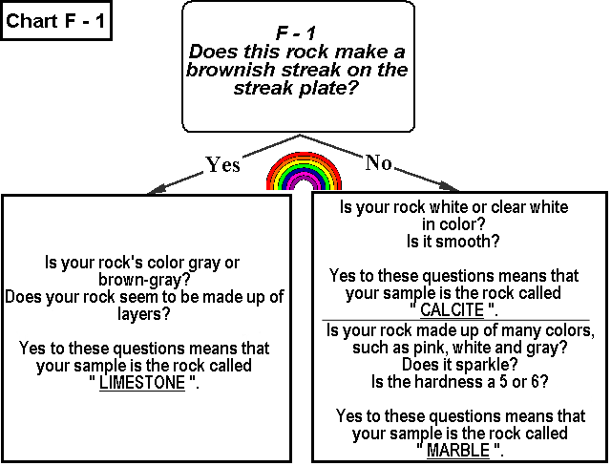
H
G
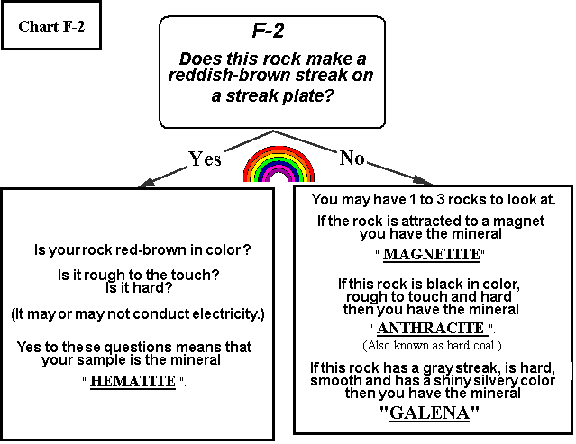
I
J
1 Start with all rock samples

Does this rock conduct electricity?
A
Is the rock magnetic?

NO YES
B
Does this rock have a streak plate color?

NO YES
A-2

Magnetite
A-1
Hardness of 1 or 2?

YES NO
B-1

Layered?

NO YES
B-2

Hardness of
1 or 2?

YES NO
Rocks and Minerals ID Flow Chart Overview

A-4
Galena
A-3
Graphite
E
Pumice
Talc
F
Reacts to acid test.
YES NO
D
Sandstone
C
Obsidian
F-2
Red-brown Streak plate color
F-1
Brown Streak plate color
G
Limestone
H
Calcite
Marble
I
Hematite
J
Magnetite
Anthracite
Galena

YES
NO
NO
YES

THE ROCK CYCLE

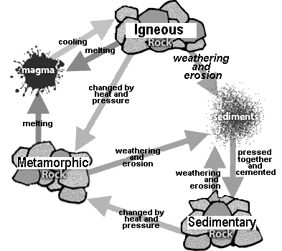

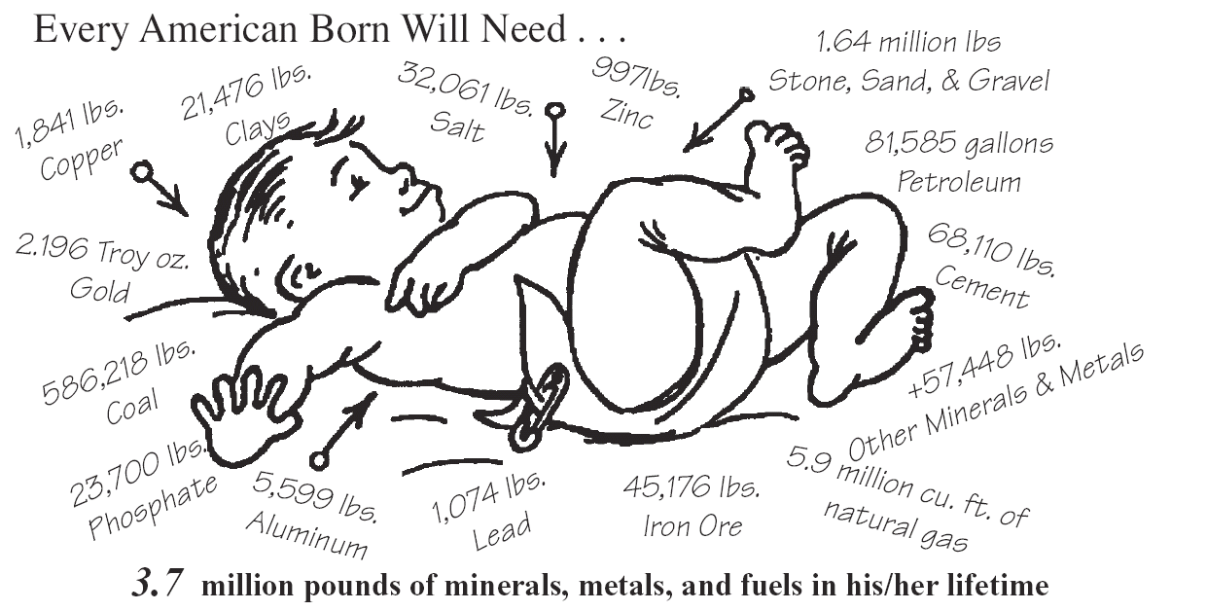
Every year, more than 48,427 pounds of new minerals must be provided for every person in the United States to maintain our standard of living.
This is a good reason for us to conserve our natural resources by recycling.

Mining has become a big business. Like many businesses it uses a great deal of energy.
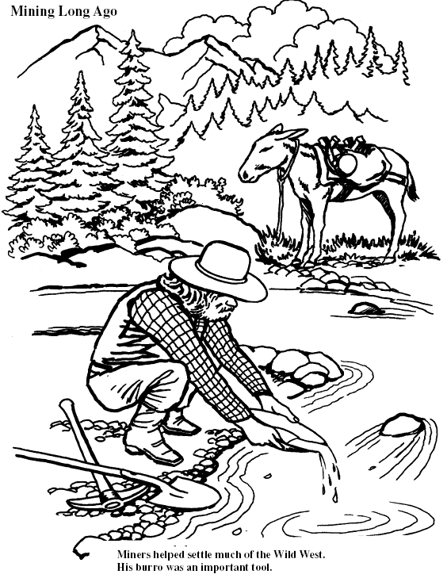
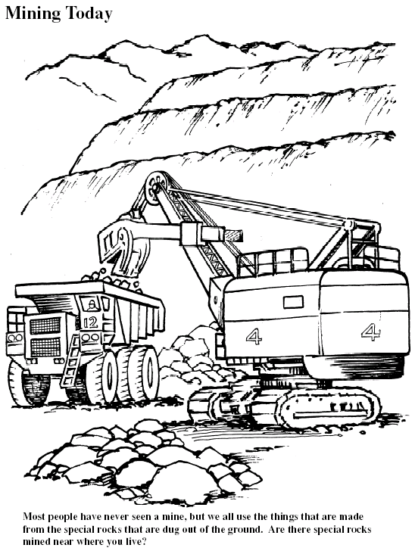
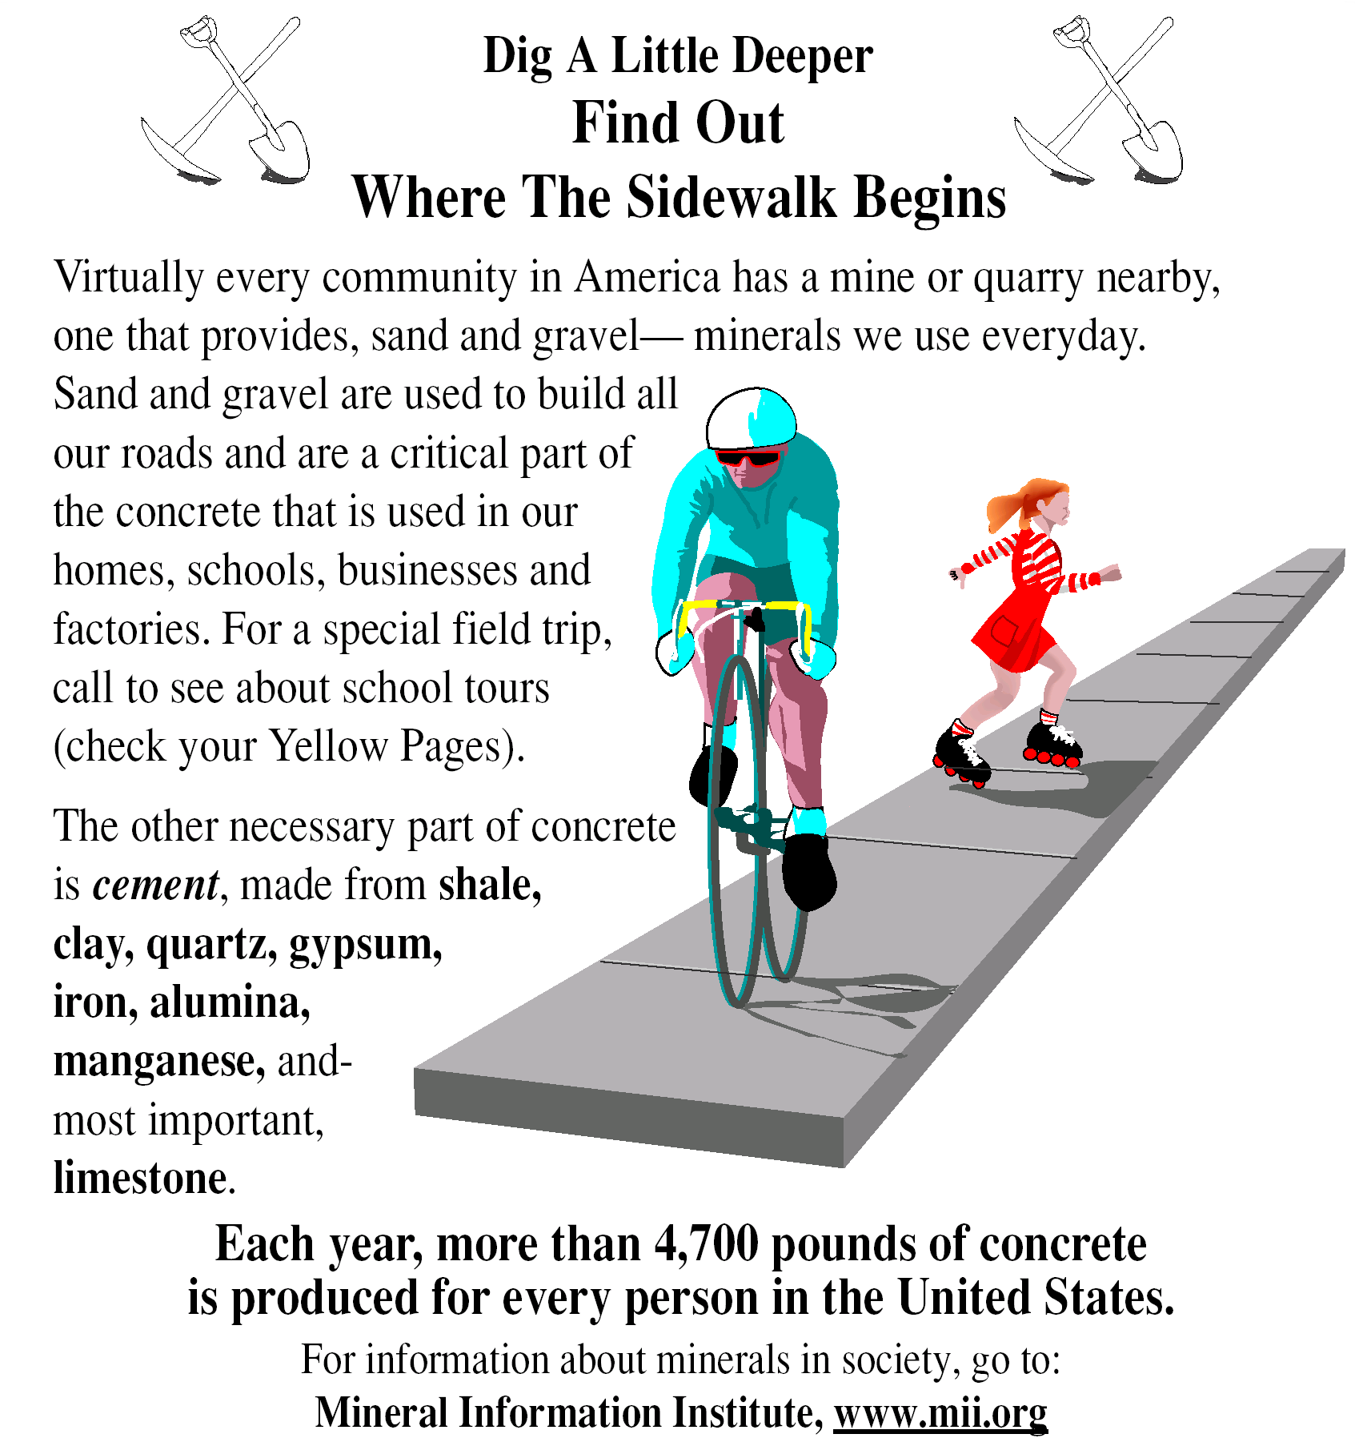

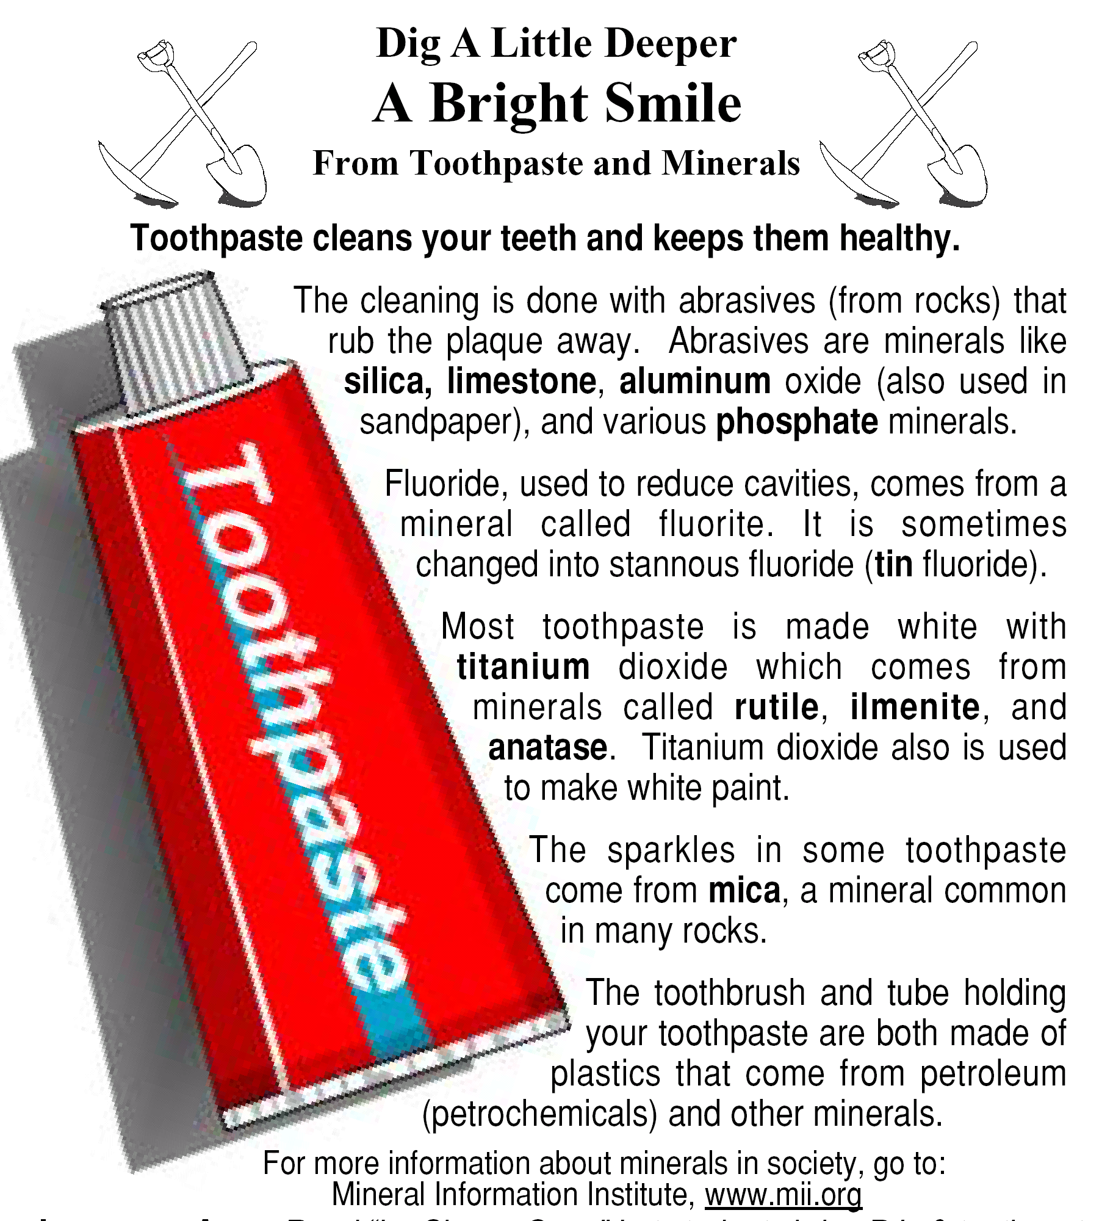

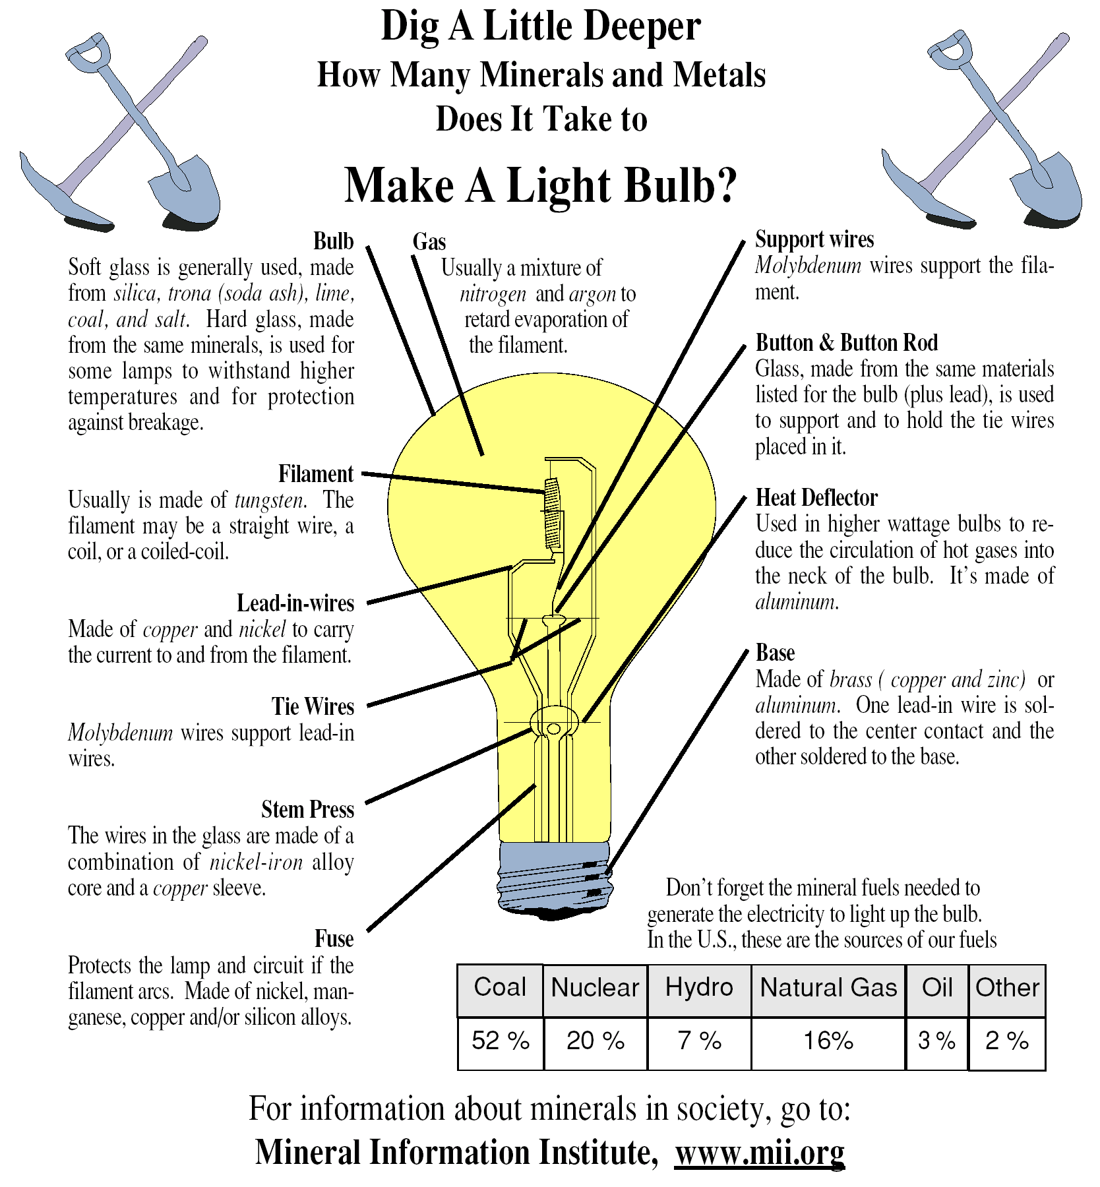

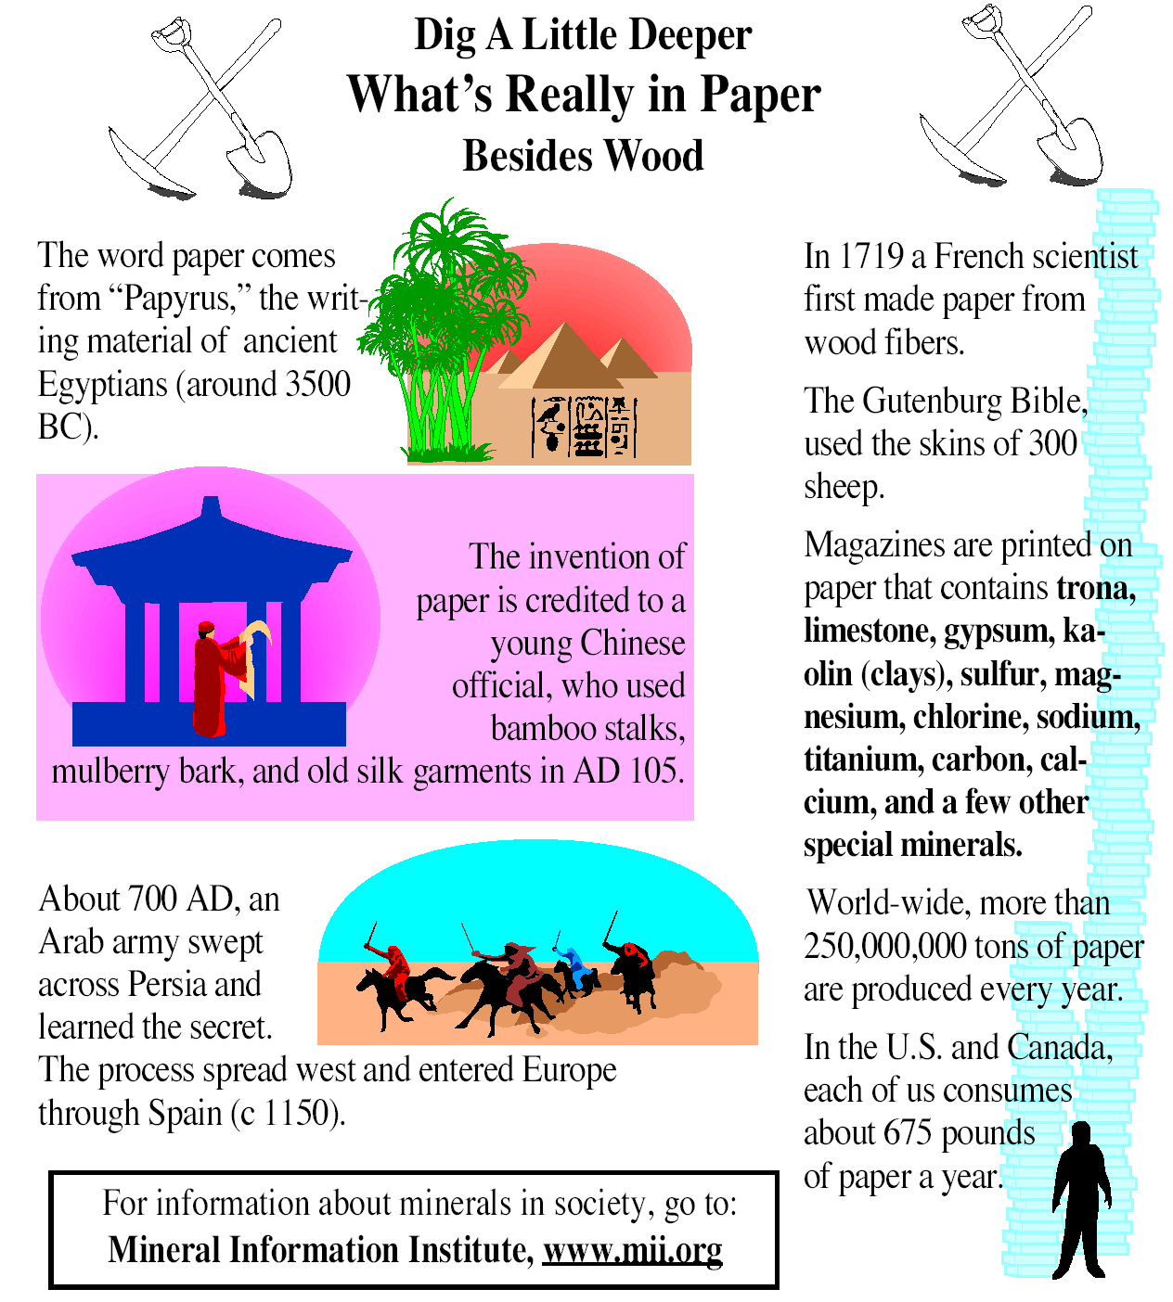
Name- _______________________________
Rocking Up and Down
Vocabulary Words

Across
3. a scientist that studies rocks, minerals and how they are formed
6. a rock type formed from melted rock material
8. the outer solid layer of the earth, the crust
10. a rock type formed by changing rocks through heat and pressure
12. the process of breaking up of rocks by wind, water and ice
13. the thick rock layer found below the surface rocks and soil
14. hot liquid rock found below the surface
15. small pieces of rock that are larger than those found in silt
16. the movement of rock material by wind, water and gravity
17. melted rock found on the ground or surface

Down
1. the prints of very old plants and animals found in rocks
2. a naturally formed solid made up of minerals
4. matter found on the earth's surface made up of pieces of rock, organic matter, air and water
5. a property of being shiny or dull
7. a rock type formed by cementing sediments together using natural cements or pressure
9. the property of leaving a mark on a ceramic plate
11. a property of resisting scratching
14. a natural occurring rock forming material

Kit #15
Rocks and Minerals

End of Unit Assessment

Important Teacher Note:

Because this unit is aligned to both the NYS Elementary and Intermediate Level Science Core Curriculums, the first three pages apply to fourth grade students, whereas all pages apply to fifth grade students.

(Each student should be provided with a rock sample)


You are a rock hound and have found some interesting rocks in a nearby stream. You are going to make some observations and do some tests on the rock to find out more about it. Answer the following questions as they relate to your study of this rock.
- This is a list of observations you are going to make about your rock. Next to each item, write the name of the sense that you would use to make the observation. You can write down more than one sense for a test but not more than two.

Observation |  | Sense used for observation
Hardness
Streak
Magnetic
Reacts with acid
Texture

- Look at the rock sample. Write four words that would describe four different properties of your rock sample.

- One of your rocks is attracted to a magnet. Why is this rock attracted to a magnet?

a. It is strong.
b. It is made of material attracted to magnets.
c. It came from the north.
d. Its property is shiny.

- One of your rock samples allowed electricity to flow through it. As part of an electrical circuit, it allowed a light bulb to light. Why did this rock do this?

a. It is not an electrical conductor.
b. The rock had holes in it.
c. It is made of material that allows electricity to flow.
d. It was once melted.

5. The scientific name for the earth’s crust is the .

- The three boxes below state the properties of three different rock samples. Your task is to sort the three rocks into two groups by using the rocks’ properties. Make sure at least one rock is in each group.

First, write the property that you will use to sort the rocks.
Next, write a question about that property for you to sort on. (The question should have a yes or no answer.)
Lastly, sort the rocks by placing the letters in the correct box.

Rock A
rough
glittery
white streak
not magnetic
Rock B
rough
dull
brown streak
magnetic

Rock C
rough
shiny
no streak
not magnetic

Property: _________________

Question: ______________________________________________________
Sort:
YES
NO

- Which piece of information about your rock samples will give you the most information about them?

a. The size of the rock.
b. The weight of the rock.
c. The temperature of the rock.
d. The minerals in the rock.

- The three classes of rocks are listed below. Choose two items from the list that best describe how each type of rock is formed. Write the letters of your choices in the box next to the rock class. Use each letter once.
Igneous |  |  | A | formed from rock pieces
Igneous |  |  | B | changed by pressure
Sedimentary |  |  | C | formed from magma
Sedimentary |  |  | D | changed by heat
Metamorphic |  |  | E | cemented together
Metamorphic |  |  | F | cooled

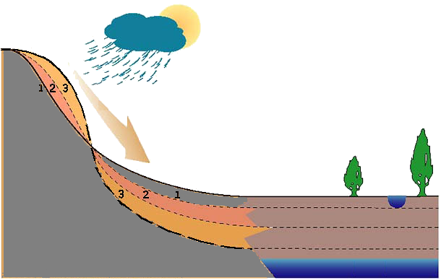
9. The diagram below shows a mountain where rock pieces have been moved from the top of the mountain to the bottom of the mountain. The numbers 1, 2 and 3 show the materials that were moved.
Write a paragraph about what is happening in the diagram. Use the words from the word box in your description.
model, weathering, erosion, deposition, water, gravity, natural cycle

Complete the sentences by filling in the blanks.

10. As people, we depend on rocks and minerals
.

11. By mining rocks and minerals, humans _________________________ their environment.

12. Refer to the diagram below to answer questions a-e.

Title: _________________________________
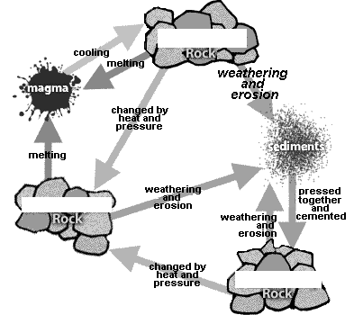
A
B
C

Time span:______________ years

- Write a title for the natural cycle that the diagram is showing.
- Label the three rock types that are part of the cycle.
- On the diagram draw boxes around the four forces at work in the cycle.
- List four different changes that are occurring in the cycle.

- In the “Time” box above write an estimate of how long this cycle takes to happen. You may choose to write: five, ten, a hundred, or a thousand.

13. List four uses of rocks or minerals in your everyday environment.

14. As humans we can conserve our natural mineral resources by:
a. digging more mines
b. recycling products
c. making more products to buy
d. using man-made products

