
Astronomy

Journal

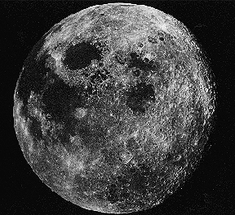

Grade 5

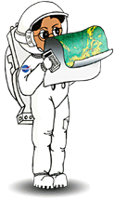

Revised August 2004
Logo- revision June2008

Race to the Moon!
By Laura G. Smith
Activity 1

¹ On July 20, 1969, millions of people gathered around their TV sets to watch an amazing event in history. It was the day a man walked on the moon for the very first time! That man was American astronaut Neil Armstrong. As he stepped onto the rocky surface of the moon, Mr. Armstrong spoke the famous words, "That's one small step for man, one giant leap for mankind."
² Space travel began 12 years before that first walk on the moon. It started on October 4, 1957 when Russia sent Sputnik I, the first artificial satellite, into space. A satellite is an object that orbits or travels around the sun, earth, or another heavenly body. Sputnik I is an "artificial" satellite, because it is man-made. Man-made satellites are used for many different reasons. Some collect information about the weather and send it back to Earth. Others send radio, television, and telephone signals from one place on Earth to another. Artificial satellites can also help sailors or airplane pilots find their way during a bad storm, and some can even spy on the enemy during a war!
³ Russia's second artificial satellite, Sputnik II, was launched in November of 1957 carrying a dog named Laika, the first animal sent into orbit. As scientists studied how animals lived in space, it helped them learn how to prepare humans to be able to live in the same conditions.
⁴ While Russia was working hard to develop their space program, the United States was close behind in their exploration of space. The U.S. sent their first artificial satellite, Explorer I, into orbit on January 31, 1958. In the 1960's and 1970's, both Russia and the U.S. launched many other satellites and scientific spacecraft for the purpose of gathering and sending information to the earth. It seemed as though the two countries were having a contest to see who would win the "race to space"!
⁵ The next big step in the space race was to launch a spaceship with an astronaut on board. Up until this time, the satellites and other spacecraft that were used to take pictures and collect information did not have men or women traveling on them.

Activity 1 (“Race to the Moon” page 2)

⁶ On April 12,1961 Russian cosmonaut (a Russian astronaut) Yuri A.
Gagarin became the first man to orbit the earth in his spaceship, Vostok I. Soon after that, the United States launched its first manned flight on May 5, 1961 as astronaut Alan B. Shepherd, Jr. flew in Freedom 7. The flight only lasted 15 minutes, and Shepherd did not go into orbit.
⁷ John H. Glenn, Jr., became the first American to actually orbit the earth. He made three revolutions (trips around the earth) on February 20, 1962, during his five-hour flight on Friendship 7.
⁸ In 1964 and 1965, three United States spaceships sent more than 17,000 close-up pictures of the moon back to earth in order to help prepare for man to land there. Three years later, three American astronauts flew in the first spacecraft to circle the moon! They orbited the moon 10 times in their Apollo 8 spaceship. On Apollo 9 and Apollo 10 missions, more studies were done to test the lunar landing craft.
⁹ On July 16, 1969, America watched as Apollo 11 was launched into space! Four days later, Astronauts Neil A. Armstrong and Edwin "Buzz" Aldrin, Jr. stepped out of the Apollo 11 lunar module, Eagle, and onto the moon's surface. They explored the nearby area for three hours, picking up rock and soil samples and setting up several scientific experiments. They also planted an American flag in the lunar soil before lifting off of the moon. After an 8-day flight, Apollo 11 returned safely to Earth, splashing down in the Pacific Ocean on July 24.
¹⁰ So who won the race to the moon?
¹¹ It's not easy to say who won. Russia had powerful rockets that could launch heavy spacecraft on long flights, but the United States launched more spacecraft for communication and weather reporting. By the early 70's, the United States' astronauts had landed on moon, and unmanned Russian spacecraft had explored the moon and brought soil samples to earth. It can be said that each country helped in different ways to bring about man's successful landing on the moon.

Activity 1 (“Race to the Moon” page 3)

“Race To the Moon” Questions
Darken the correct choice or write in an answer to the question.
  1. | Space travel began when  Russia launched Sputnik 1 into orbit  Neil Armstrong first stepped on the moon  John Glenn orbited the earth  America launched Explorer 1 into orbit
  2. | Sputnik I is an artificial satellite because it is ______________.  Not an orbiting object  Not really a satellite  Man-made  Made of plastic
  3. | "Laika" was the first _____________ in space.  Astronaut  Animal  Woman  Cosmonaut
  4. | Artificial satellites collect and send information back to the earth for many reasons. List three reasons.
  5. | John H. Glenn, Jr., was the first American to  Walk on the moon  Walk in space  Travel in space  Orbit the earth
  6. | ____________ was the first country to launch a manned spaceship that orbited the moon.  America  France  Russia  China
  7. | Since America was the first country to put a man on the moon, it's safe to say they won the race to the moon.  True  False
  8. | When Neil Armstrong stepped out of the lunar module Eagle onto the moon's surface, he said, "That's one small step for man, one giant leap for mankind." Do you think Neil Armstrong thought this was an important event? Which of his words tells you that?

SunMonTueWedThuFriSat

A
Current Moon Phases Calendar for the Month of:


Activity 1 Fill in the outline with moon info. (You may not need to
use all the lines. You may need to use more paper.)
Moon Research
- Moons
  - Where did our Moon come from? (hypothesis)
    - ____________________________________________________________
    - ____________________________________________________________
  - Moon shapes
    - ____________________________________________________
    - ____________________________________________________
  - Pattern of motion of a moon
    - ____________________________________________________________
  - Number of Moons each Planet has
    - _______________________ _________
    - _______________________ _________
    - _______________________ _________
    - _______________________ _________
    - _______________________ _________
    - _______________________ _________
    - _______________________ _________
    - _______________________ _________
    - _______________________ _________
  - Size of our Moon compared to Earth
    - _____________________________________________________________
  - Moon’s Landforms
Compared to Earth’s Landforms
    - ___________________________
    - ___________________________
    - ___________________________
  - Moon’s orbit
    - What is it like? How far is the Moon from the Earth?
      - __________________________________________________________
    - What causes it?
      - __________________________________________________________
  - Moon shine: Why can we see the Moon?
    - _____________________________________________________________
 | The Moon: Earth's Satellite
 | The Moon is the only place in our solar system, other than Earth, where humans have visited. On July 20, 1969, astronauts Neil Armstrong and Edwin Aldrin landed the Lunar Module of Apollo 11 on the Moon's surface. Neil Armstrong was the first human to set foot on the Moon.

The Moon is like a desert with plains, mountains, and valleys. It also has many craters, which are holes created when space objects hit the Moon's surface at a high speed. There is no air to breathe on the Moon. Recently water ice was discovered at the poles (or top and bottom) of the Moon. The ice is buried beneath some of the dust of the Moon's surface. Scientists think the ice may be left over from a comet that once collided with the Moon.
  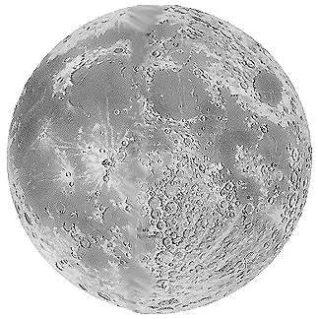
The Moon travels around the Earth in an oval shaped orbit. Scientists think the Moon was formed long ago when Earth collided with another space object. The collision may have caused a big chunk of rocky material to be thrown out into space to form the Moon.
The Moon is a little lopsided. Its crust is thicker on one side than the other. The Moon is much smaller than the Earth. However, the pull of its gravity can still affect the Earth's ocean tides. We always see the same side of the Moon from Earth. You have to go into space to see the other side.
(Printed from “Starchild” produced by the Laboratory for High Energy Astrophysics at NASA. http://starchild.gsfc.nasa.gov )


Wow!
A crater containing a pond of ice was recently discovered on the dark side of the Moon. The crater is believed to be twice the size of Puerto Rico and deeper than Mt. Everest is high! The ice is believed to be a remnant of a comet that crashed into the Moon 3.6 billion years ago.

The Moon travels around Earth in an oval orbit at 3680 kilometers per hour. The Moon does not have an atmosphere, so temperatures range from -184 degrees Celsius during its night to 214 degrees Celsius during its day except at the poles where the temperature is a constant -96 degrees Celsius.
The Moon is actually a little lopsided due to the lunar crust being thicker on one side than the other. When you look at the Moon, you will see dark and light areas. The dark areas are young plains called maria and are composed of basalt (a type of volcanic rock). Lava flowed in and flooded the areas created by huge impacts with an asteroids or comets. The light areas are the highlands, which are mountains that were uplifted as a result of impacts. The lunar surface is covered by a fine-grained soil called "regolith" which results from the constant bombardment of the lunar rocks by small meteorites. Scientists theorize that the Moon was the result of a collision between Earth and an object the size of Mars. One theory states that the debris from the impact was hurtled into space where, due to gravity, it collapsed into a sphere. This resulted in the formation of the Moon.
The gravitational pull of the Moon on the Earth affects the ocean tides on Earth. The closer the Moon is to Earth, the greater the effect. The time between high tides is about 12 hours and 25 minutes.
The phasing, or changing appearance, of the Moon depends on its position relative to the position of the Sun. When the Moon is between the Sun and the Earth, the side of the Moon facing the Earth is dark. This is called a "new moon.” As the Moon travels eastward in its orbit, more of its sunlit side becomes visible to Earth and the Moon is said to be "waxing.” As the side of the Moon facing Earth becomes fully lit we see a full circle. This is called a "full moon" phase. As the Moon travels further around in its orbit, the lit portion of the Moon visible to Earth becomes smaller, so the Moon is now said to be "waning.” This second part of the cycle continues until none of the side of the Moon facing us is lit. We are then back to the “new moon.”

(Printed from “Imagine the Universe” , Laboratory for High Energy Astrophysics at NASA. http://imagine.gsfc.nasa.gov )
Activity 1
FYI:
The Moon orbits Earth at an average distance of 382,400 kilometers (225,000 mi).

One lunar month is equal to the 291/2 days it takes to go through all its phases. It takes the moon 271/3 days for the moon to make one trip around the Earth or one revolution.

Just like the Earth, half of the Moon is lit by the Sun while the other half is in darkness. The diagram below on the right is one you typically see in books.

The side lit by the Sun is always the side that is pointed toward the Sun, as seen in the diagram below on the left.
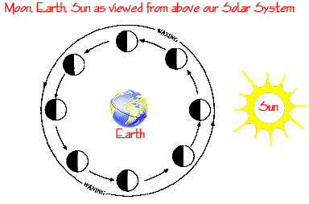

During the course of a month, the Moon circles once around the Earth.

It takes the Moon about 27 Earth days to do this.

(Hmmm, 27 days to make one revolution around the Earth but 29 days to cycle through all the phases. I wonder why there is a difference.)

If we could magically look down on our solar system, we would see that the half of the Moon facing the Sun is always lit. But the whole lit side does not always face the Earth! As the Moon circles the Earth, the amount of the lit side we see changes. These changes are known as the phases of the Moon and the phase cycle repeats in a certain way over and over again throughout the year.

Activity 2
Moon Phase Name Worksheet

Moon Phases
The moon seems to change its shape.
Color the pictures so you can see the different moon shapes.
Color the Y area – yellow Color the b area – black

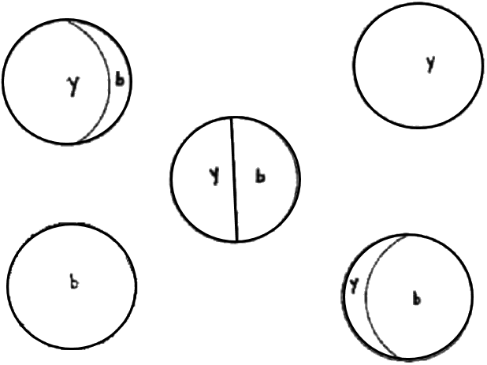

Phase Name Challenge!!
Write each of the moon shape names under the correct picture.
New Moon | (all dark)
Full Moon | (all lighted)
Crescent Moon | (small part lighted)
Quarter Moon | (half light, half dark)
Gibbous Moon | (large part lighted)

Activity 3

Waxing and Waning Worksheet
Astronomers use the terms “waxing” or “waning” to better identify each moon phase. Here are some helpful hints for identifying a waxing or waning phase.

Waxing phases:
A waxing phase is a phase heading towards a Full Moon. Think of waxing as getting brighter (more lit up). A waxing phase has the right side of the moon lighted.

Waning phases:
A waning phase is a phase heading towards a New Moon. Think of waning as leaving. A waning phase has the left side of the moon lighted. Waning is thought of as the ending of the Moon’s phase pattern. The cycle then starts again with a New Moon. The rule for waning is “left lit is last.”

A waxing quarter is “First Quarter”; a waning quarter is “Last Quarter.”
Moon Phase Cycle: Label the phases. Circle waxing or waning.

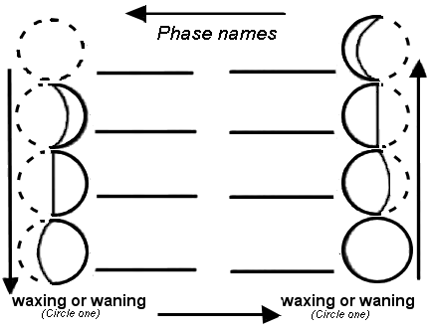

Activity 3

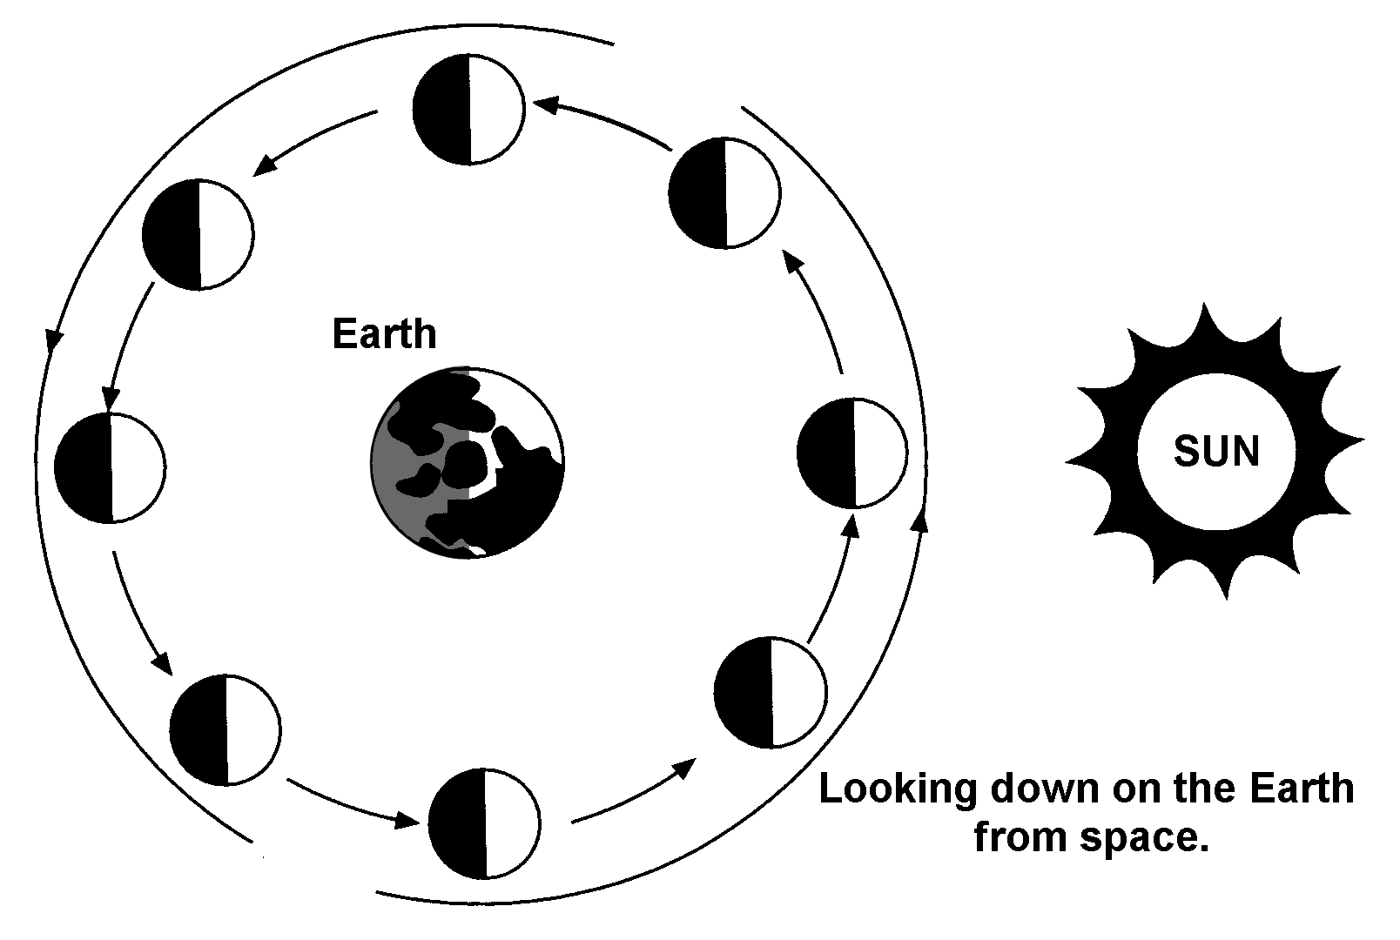
Views of the Moon

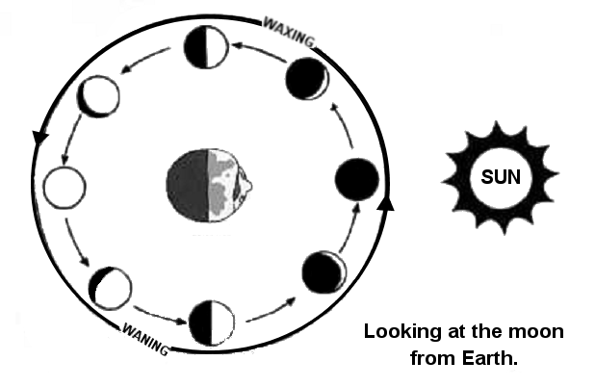

Activity 3

Motion is Relative.

Sketch a picture of your classroom. In your picture, show where you are sitting

Describe where you are sitting in your classroom.

1.

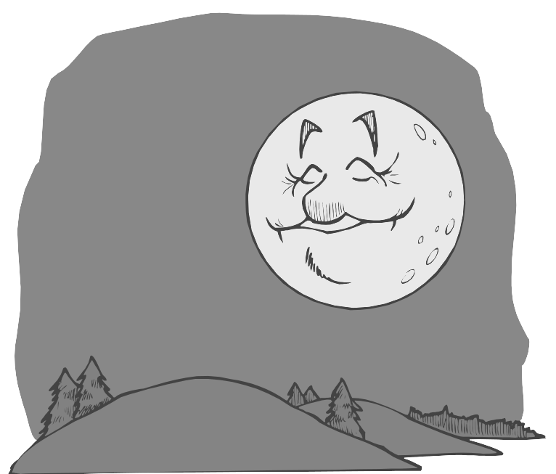
- RULE: Where something is located is always described in relation to some other object or place.

Sketch a picture of the Moon in space with the Earth and Sun.
Describe where the Moon is in space.

2.

How did you answer this question? What did you use as a reference? The Earth? The Sun? If you knew some measured distances, you could have included that in your description.

Some people in your classroom may be sitting still in their chairs while others may be moving about the room. All of the students, sitting or moving, can be described by their place in the room at any moment. All of the students also have a direction of motion and a speed of movement. What would be your direction of motion and speed if you were sitting still? Your direction of motion would be none and your speed would be zero. Yet, there are times when you are sitting still but someone could say you are in motion? When could this be? (Hint: You can be sitting and catch a ride in a …)
You are in motion even when you are sitting still in your classroom chair. How can this be?
3.

Activity 3 (“Motion is Relative” page 2)

It’s really neat when you stop to think about it. We are in motion with the Earth as it turns and we are moving with the Earth in its trip around the Sun. We have a direction of motion and a rate or speed of motion.

Does the Moon move?

Describe the motion of the Moon in relation to the Earth.

4.

- RULE: The motion of an object is described in reference to some other object or place.

For the next question use the “Views of the Moon” diagrams on the first page.
5. Look at the 2 views of the Moon, one from space and one from Earth.
Think about what is the same in the views and what is different.
Write your thoughts down. (Think of the Moon in relation to the Earth.)

SPACE VIEW
SPACE AND EARTH VIEW
EARTH

Activity 4

1. Write 2 synonyms for the word “eclipse”. ____________, _______________
2. Write an astronomer’s definition of an eclipse.

3. Use each of the title words in a sentence (eclipse, eclipsing, eclipsed)

A.
B.
C.

4. Draw the relative locations of the Sun, Moon and Earth for someone on the Earth to experience a Solar Eclipse. (Bonus: Draw in any shadows.)

Describe the relative positions of the Sun, Moon and Earth in a Solar Eclipse.

Activity 4 (“Eclipses” page 2)

5. Draw the relative locations of the Sun, Moon and Earth for someone on the Earth to experience a Lunar Eclipse. (Bonus: Draw in any shadows.)

Describe the relative positions of the Sun, Moon and Earth in a Lunar Eclipse.

6. Think about the position of the Moon in its orbit during a Solar Eclipse. What would the phase of the moon be?

7. Think about the position of the Moon in its orbit during a Lunar Eclipse. What would the phase of the moon be?

Activity 4

LUNAR ECLIPSE (viewed from space)
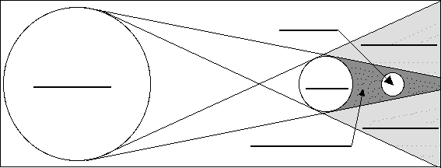

A lunar eclipse happens when _______________________________________________________________________.

There are two types of lunar eclipses ____________________ and _________________________.

All of the moon has to move into the Earth’s darkest shadow area (umbra) for a ______________________

eclipse to occur. If only part of the moon enters this area then a _________________ eclipse is seen.

Word Bank: total partial
Label the diagram using these words: Sun Earth Moon umbra penumbra

Activity 4
SOLAR ECLIPSE: Draw the Sun, Moon and Earth in the relative positions for a solar eclipse to occur. (as viewed from space)

A solar eclipse happens when __________________________________________________________________.

There are two types of solar eclipses __________________________ and _____________________________.

All of the Sun has to be blocked by the Moon for a __________________________ eclipse to occur.

If the Moon blocks only part of the Sun then a _____________________ eclipse is seen.

Word Bank: total partial Sun Earth Moon umbra penumbra

Activity 4

Summer Full Moon
A bright full Moon makes a pretty night. As you look at the full Moon, you can see the shapes that make up the face of the 'man in the Moon.’ Those shapes are craters from asteroid crashes, lava fields and mountains. You can even see the large dark area where astronauts landed and explored!
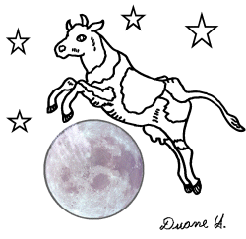
Have you ever seen the Moon when it looks huge? This is usually seen when the Moon is rising or setting. When the Moon is rising or setting it is low in the sky. Low in the sky means it is close to the “horizon.” When the Moon is low in the sky, it looks bigger. The horizon is the place in the distance where the sky and ground come together. A Moon near the horizon seems much larger than a Moon that is high in the sky. That is because your eyes are playing tricks on you! When the Moon is low in the sky, your brain makes it look bigger.
When your eyes and brain fool you, it is called an optical illusion. Look at the optical illusion below.
A
Optical Illusion: Which middle line looks longer, A or B?
Use a ruler to check your answer.
B

Activity 4 (“Summer Full Moon” page 2)
You should have found both middle lines to be equal in length. If you remove the extra lines they will appear more equal in size. You can make the “big moon” illusion go away by looking at the Moon through a tube. By looking through a tube you see only the moon. Take the inside of a toilet paper roll or paper towel roll and save it until the Moon comes up.
As the full moon rises, look at the Moon with just your eyes and notice how big it is. Now look through your tube. Did the Moon just get smaller? You just tricked your tricky brain!
A Summer Full Moon that is low in the sky is interesting to observe because it seems easier to see its features. The light areas are old hills that have many craters. The dark areas, called seas, are giant craters that were later filled with lava. Most of the Moon is covered with a mixture of fine dust and rocks.
This “ big” Moon may also have pretty colors. The summer full Moon may seem to be pink or orange as it hangs close the horizon. The dust in the atmosphere might make the Moon have the same colors as a pretty sunset.
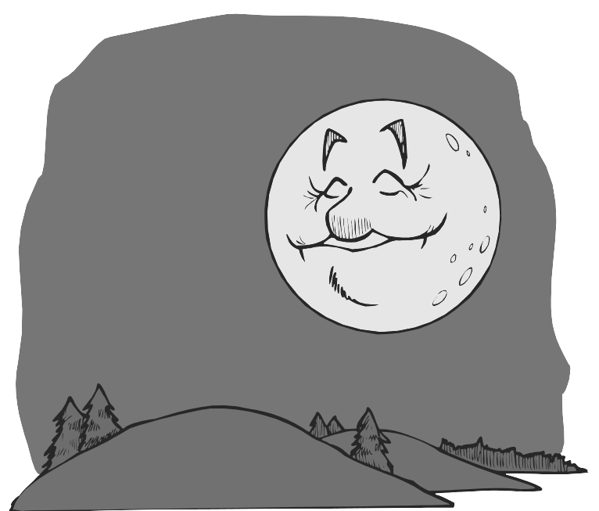
The full Moon is always beautiful. A rising Full Moon in the summer is even more beautiful because it seems to be bigger and more colorful than most full Moons. Stay up until sunset and have a Moon party. What will you see?

Activity 5
Constellations: Circumpolar

I. Definitions
- star: ___________________________________________

- constellation: ____________________________________

- circumpolar: _____________________________________

II. Circumpolar constellations

- What are they? ________________________________________

- Some circumpolar constellations are:
  - ________________________________________________

  - ________________________________________________

  - ________________________________________________

- The daily pattern of motion of the circumpolar constellations

Is _________________________________________________.

- You can see this pattern of motion if you are standing ______

_____________________________ (This is called a point of reference.)
Activity 5
More Celestial Objects:
What is a star?
A Star is large celestial body made of hot gases. Stars make and give off their own light and heat. They do this because of nuclear reactions inside the star. The sun is a star. Except for the sun, the stars appear to be fixed in place in the sky. They show the same pattern in the skies year after year.

What are constellations?

Constellations are a group of stars connected together to form a pattern or picture. The stars of a constellation appear close to each other on the sky. Like playing a game of “connect the dots,” people have created these pictures in the sky. Long ago people spent a lot of time looking at the sky. They saw the stars as pictures of people, animals and objects that illustrated stories from their culture.

Why do celestial objects look like they move?

The sun, planets, the moon, and stars appear to move through the sky in different ways. We see the same Sun each day and we see the other stars at night because Earth turns. We see the moon go through changing phases. We see the moon at different times of the day or night. We see it in different places in the sky. This is because it moves around the Earth. Through the year the planets orbit the Sun and look like they wander through the star patterns.

Where the Earth is, in its orbit around the Sun, affects the stars and constellations that we see during different seasons (spring, summer, fall, and winter). Some constellations never rise or set which means that they are always in the night sky. They are called circumpolar. All the other constellations rise and set each night as the Earth turns. These constellations can only be seen during certain months of the year as the Earth orbits around the sun. They are called seasonal constellations.

The constellations appear to move differently depending on where you are observing from on the Earth. The circumpolar constellations that are always in our night sky rise in the east and set in the west for people living near the equator. Your reference is different from different locations.
Activity 5 (“More Celestial Objects” page 2)

What does circumpolar mean?

The word circumpolar means "to circle around the pole.” For those of us living in the Northern Hemisphere, circumpolar stars or constellations are found in the sky over the north pole of the Earth. Each day they appear to move in a circle without ever “setting” or dipping below the horizon. These constellations seem to move in a counterclockwise direction because of Earth’s rotation. On any given night, these same constellations can be seen. They appear somewhere in their circle-like path. The constellations are hidden in the daylight sky by the light from our nearest star, the Sun.
Circumpolar Constellations:
- Ursa Major, the Big Bear (includes the Big Dipper)
- Ursa Minor, the Little Bear
- Cassiopeia, the Queen of Ethiopia
- Cepheus, the King of Ethiopia
- Draco the Dragon

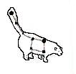
Ursa Major and Ursa Minor
Ursa Major or the Big Bear is the third largest of the 88 constellations. Seven stars form a well-known group of stars within the Big Bear. In America they are called the Big Dipper or "Drinking Gourd." The Big Dipper is one of the most recognized groups of stars in the sky. It is called circumpolar because it never completely leaves the sky. It is visible in northern skies year-round.
You can learn, as did ancient sailors and western cowhands on night watch, to tell the time of the night by where the Big Dipper is. The dipper appears to rotate around the North Star every twenty-four hours. By watching where the dipper is in the night sky you can tell what time of night is it.
Activity 5 (“More Celestial Objects” page 3)

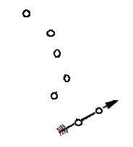
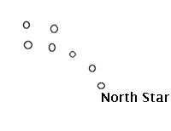
The tail of the Little Bear ends with the North Star, Polaris. It is called the North Star because it is above the North Pole. This is the place in space that Earth’s North Pole points to. To find Polaris, first find the Big Dipper. Draw a line connecting the “pointer stars.” They are on the end of the "bowl.” If you keep drawing the line from the bottom of the bowl to the top of the bowl, it will come to the North Star. Pretty neat!

As the night hours pass and the Earth turns, the stars turn in circles around the North Star. The North Star or Polaris appears to stand still. Some constellations are close enough to Polaris that they never go out of sight. These are the circumpolar stars. Most stars are farther away from Polaris, and fall below the horizon. These appear to rise in the east, cross overhead, and set in the west, much like the Sun. These are the seasonal constellations.
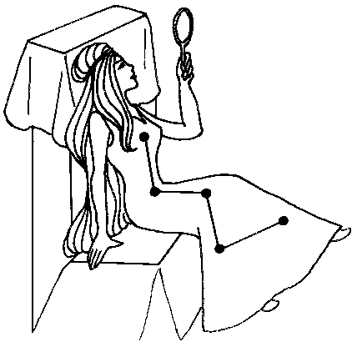
Cassiopeia and Cepheus
Trace an imaginary line from the Big Bear's pointers on past Polaris. At an equal distance on the opposite side from the Big Dipper is Cassiopeia (KASS-ee-oh-PEE-uh), an ancient Queen of Ethiopia. As she sits on her W-shaped throne she circles round and round the pole. In the fall Cassiopeia is in the shape of a W and in the spring she is in the shape of an M.
Cepheus is a constellation named after a king. The stars that make up Cepheus form the shape of a house. This constellation is between Cassiopeia and the North Star.

Activity 5 (“More Celestial Objects” page 4)
Like the Big Dipper, Cassiopeia and Cepheus are circumpolar and, therefore, are visible no matter what the season or time of night.
According to the story, Cassiopeia was the queen of an ancient land. She and her husband, Cepheus, had a daughter named Andromeda. Cassiopeia would always say she was prettier than the sea nymphs. A monster called Cetus was sent to punish her. It was about to eat Andromeda, when Perseus saved her. All five characters from this story are now constellations.
Draco
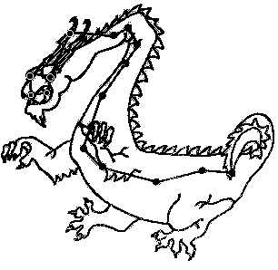
Draco the dragon is a long constellation found in the sky of the Northern Hemisphere. It is a northern circumpolar constellation. People in the Southern Hemisphere can't see it.
The head is made of four stars. The body of Draco slithers around and ends between the Big and Little Dippers.
Draco the dragon is famous throughout mythology One myth about the dragon comes from Greece. In the story, the
dragon protects a garden where apples made of gold grow on trees. He must make sure thieves do not steal the apples. The story involves Hercules and Atlas.
Another story is set during the Titan war with Zeus. In that story a dragon attacked Athena. She flung it into the air, wrapping it around the pole. To this day, the dragon remains in the night sky near the Pole Star.

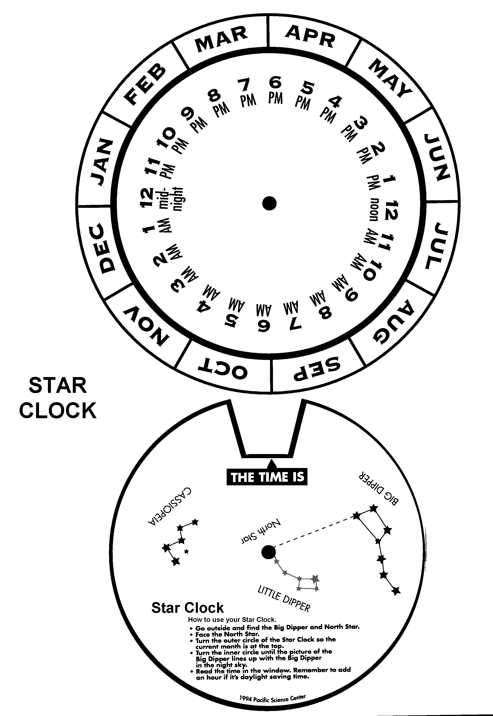
Activity 5

Activity 5
Adopt a Constellation

Constellation _______________________
Nickname _________________________
My Constellation

History:

Stars in my constellation:
Name | Type of star | Distance from Earth

Interesting facts about my constellation:

1. (When do we see this constellation?)

2.

3.
Activity 5
Constellations: Seasonal
III. Seasonal Constellations
- What are they?

- Why is the pattern of these constellations “seasonal”?

- Some seasonal constellations are:
  - Spring______________________________
  - Summer_____________________________
  - Autumn______________________________
  - Winter______________________________

- Nightly pattern of motion of the seasonal constellations in the

night sky is _____________________________________.

- You can see this pattern of motion if you are standing ______

____________________(This is called a point of reference.)

Vocabulary List

celestial | relating to the sky
constellation | a pattern of stars
crescent | a shape that is a small slice of a circle
cycle | a repeated series of events, over a time period
eclipse | to block or over shadow something, to hide
full | unable to hold more
gibbous | more than half but less than full
gravity | the force of attraction between two objects, it is affected by the amount of matter in the object and the distance between objects
lunar | relating to the moon
new | unused or not filled in (not lighted)
orbit | a path followed by on object (planet, moon, satellite)
phase | a part of a plan or pattern of events
quarter | one fourth of the whole
relative | in comparison to something else
revolution | moving around a point or object, an orbit
rotation | turning around a center or axis, to turn
seasonal | happening during or relating to a season of the year
solar | relating to the sun
waning | leaving, going away (getting smaller)
waxing | coming into view (getting larger)
zenith | the highest point, the point of the sky directly overhead

