

Blackline Masters

Astronomy Gr 5
Kit #65

Revised August 2004 OCM BOCES Science Center
Logo: revision June 2008

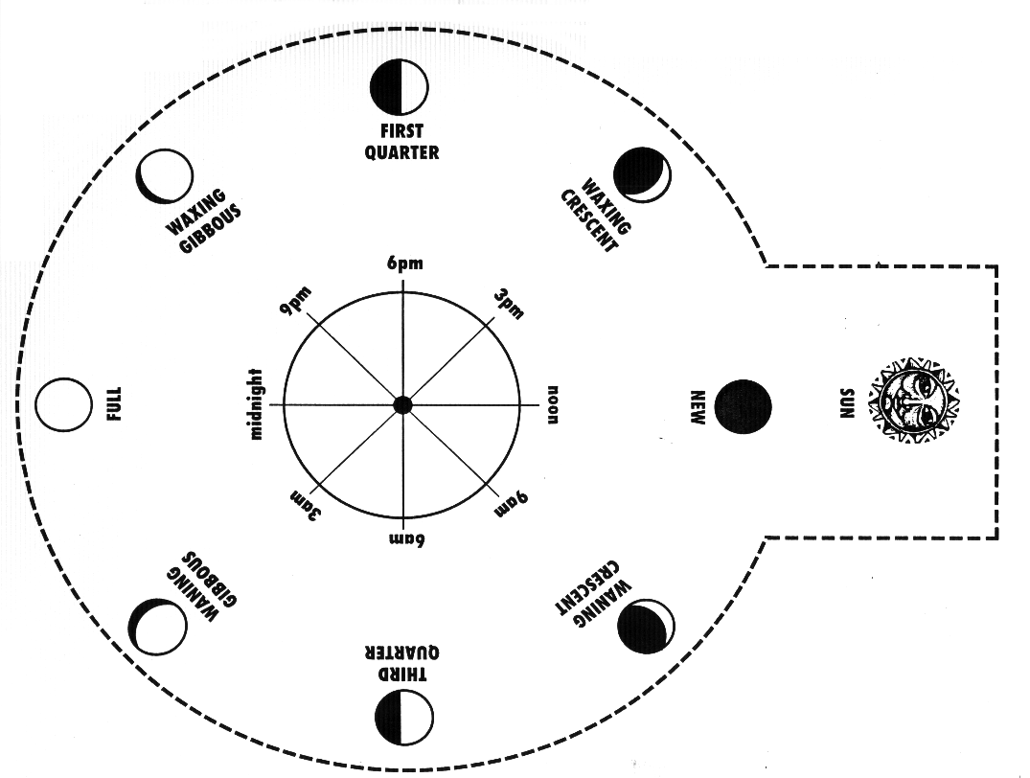
Supplemental Activity: Moon Clock
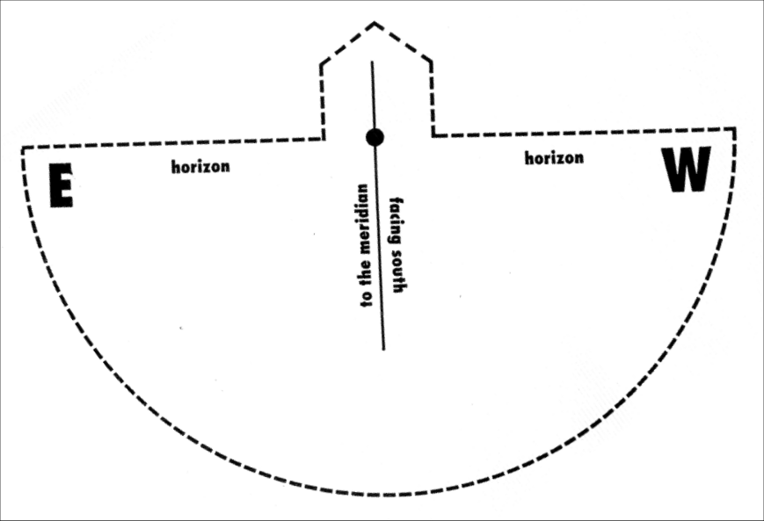

Supplemental Activity Name:________________________

Moon Clock Worksheet
The Moon Clock is a tool. It can be used to tell the time by viewing the moon phase and its position in the sky. In order for the Moon Clock to work there must be a pattern to the rising and setting of the moon. The Moon must have a constant rate of motion (rate is distance traveled over time). There must also be a pattern to the position of the moon in the sky.

Using the Moon Clock answer the questions below.

1. Look at the Moon Clock part with the moon phases on it. Which side of the Moon is lighted?

2. Look at the Moon Clock (all together); what does the part that rotates represent?

3. Find the “horizon” line. What is a “horizon”?

4. Notice that “E” is on the left and “W” is on the right. What direction must you face to use this tool?

5. Use the tool to answer these questions.

A waxing crescent is seen rising in the East, what time is it? __________

- A waxing gibbous moon is seen setting in the west, what time is it? _________

Supplemental Activity (“Moon Clock Worksheet” page 2)

- A waning gibbous is seen at its highest point in the sky, what time is it? _________

- A waning crescent is seen half way between rising and its highest point in the sky, what time is it? _________

- What time is it when a full moon is seen at its highest point in the sky? _________

6. Which way is the horizon dial turned to have the arrow move through time in the correct order, clockwise or counterclockwise?

7. The Moon rises in the ________________ and sets in the _____________.

8. The Earth turns in a _________________________ direction.
Extension Activity Name:________________________
MOON MATH
Day Math
A “day” is defined as the time it takes a celestial object to make one full rotation. Our Earth rotates once every 24 hours. Therefore, one Earth day equals 24 hours of Earth time.
The Moon has a Moon day. It takes 27 1/3 Earth days for the Moon to make one full rotation.
Our Sun also rotates. Since the Sun is made up of large amounts of gases, different parts of the Sun rotate at different speeds. The area of the Sun near its equator ( 0° latitude) takes about 614 Earth hours to makes one full rotation. The areas near the poles take about 864 Earth hours to make one full rotation.

Use the information from the paragraph above to answer the following questions:

            - How many Earth days are equal to one Moon day? _____________

Take the number of Earth days equal to one moon day and round it to the nearest whole number. _____________ Use this number to answer the following questions.

            - How many Earth hours are equal to one Moon day? _____________
(Show your math work.)

3. Write a fraction to show what part of one whole Moon day is 9 Earth days? _______
(Show your math work; show your fraction in simplest form.)

4. If your trip around the Moon took 1/3 of a Moon day, how many Earth
days would that be? ________________

(“Day Math” page 2) Name:________________________

5. How many Moon days are there in one Earth year? (HINT: If the Moon makes one full rotation every 27 days, how many times will it rotate in 365 days?) Round your answer to the nearest whole number. __________

BONUS:
It takes the Moon 27 1/3 Earth days to travel (one revolution) around the Earth once. Round that number to a whole number. _________

About how many times in an Earth month does the Moon make one full trip (revolution) around the Earth? ____________

What do you notice about the relationship between the amount of time it takes the Moon to rotate once and the time it takes to revolve once around Earth?

_______________________________________________________________

6. Does the Sun’s Equatorial region rotate faster or slower than the Polar Regions? ___________

- What is the difference between the time it takes the Sun’s Equatorial regions and Polar regions to rotate once? __________
(Show your math work.)

8. Look at your answer to question 7. How many Earth days is this difference equal to? (Round off your answer to a whole number.) ___________
(Show your math work.)

Rotation Research: The Earth rotates in a counterclockwise direction. What direction does the Moon rotate in? What direction does the Sun rotate in?
Extension: MOON SURVIVOR: Can You Survive on the Moon?
(provided by NASA)

The year is 2040. You are a member of a space crew that was to meet with the mother ship on the lighted surface of the moon. You experienced mechanical difficulties and your ship was forced to land about 200 miles from the point you were to be. During re-entry and landing, much of the equipment on your ship was damaged. Your survival depends on you reaching the mother ship. You will need to survey what is left that is useable and determine the most critical undamaged items that you will take for the 200-mile trip.

Your task is to look over the list below. The list contains the useable and undamaged items left on your ship. You need to rank them in order of their importance for your crew. Remember you need to rank each item in terms of its value in allowing you to reach the mother ship. Copy the list below or print out a copy. Place the number 1 by the most important item and keep going to number 15 which will be the least important. Be ready to explain why you have given each item the rank it received.

Use your knowledge of the Moon and its environment to help you make your decisions. When you are done you can check how you did against the rankings given this same list by NASA. If you are doing this activity in your classroom, compare your rankings with other groups or individuals and hear their reasons for their rankings before checking the NASA list.

How close did you come? Were your top 5 most important and bottom 5 least important items (regardless of ranking numbers) the same ones as others in your class? Or the same as on the NASA list?

Moon Survival Ranking List Name: __________________________
Courtesy of NASA

___ Box of matches  ___ Food concentrate  ___ 50 feet of nylon rope  ___ Parachute silk  ___ Portable heating unit  ___ Two .45 caliber pistols  ___ One case dehydrated milk  ___ Two 100-pound tanks of oxygen  ___ Stellar map (of moon's surface)  ___ Life raft  ___ Magnetic compass  ___ 5 gallons of water  ___ Signal flares  ___ First aid kit containing injection needle  ___ Solar-powered FM receiver-transmitter | 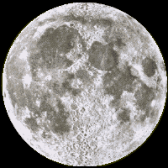

Name: ________________________________

LUNAR LANDING SITES: Moon Mapping (NASA)

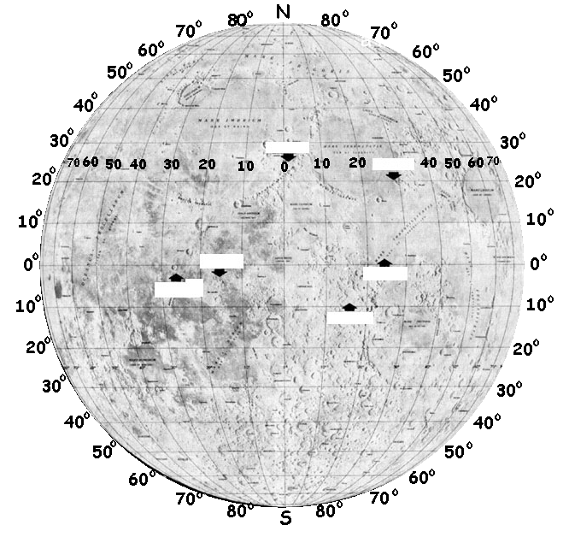
The “Apollo Lunar Landings” data table has a Latitude and Longitude for each of the Apollo Missions listed. Using that information and the map of the Moon below to locate each landing site. Write the number of the Apollo Mission on the map at the correct landing site.

Apollo Lunar Landings (1969 - 1972)
The Apollo program included a large number of un-crewed test missions and 12 crewed missions: three Earth orbiting missions (Apollo 7, 9 and Apollo-Soyuz), two lunar orbiting missions (Apollo 8 and 10), a lunar swing by (Apollo 13), and six Moon landing missions (Apollo 11, 12, 14, 15, 16, and 17).

Two astronauts from each of these six missions walked on the Moon (Neil Armstrong, Edwin Aldrin, Charles Conrad, Alan Bean, Alan Shepard, Edgar Mitchell, David Scott, James Irwin, John Young, Charles Duke, Gene Cernan, and Harrison Schmitt), the only humans to have set foot on another solar system body. Total funding for the Apollo program was approximately $20,443,600,000.

Apollo  Mission | Launch  Date | Landing  Date | LM Name* | Landing Site | Latitude | Longitude | EVA time  (hours) | Impact Site**
11 | Jul 16, 1969 | Jul 20, 1969 | Eagle | Mare Tranquilitatis | 0.674 N | 23.473 E | 2.53 | Unknown
12 | Nov 14, 1969 | Nov 19, 1969 | Intrepid | Oceanus Procellarum | 3.014 S | 23.419 W | 7.75 | 3.94 S, 21.20 W
14 | Jan 31, 1971 | Feb 5, 1971 | Antares | Fra Mauro | 3.645 S | 17.471 W | 9.38 | 3.42 S, 19.67 W
15 | Jul 26, 1971 | Jul 30, 1971 | Falcon | Hadley Rille | 26.132 N | 3.634 E | 19.13 | 26.36 N, 0.25 E
16 | Apr 16, 1972 | Apr 20, 1972 | Orion | Descartes | 8.973 S | 15.499 E | 20.23 | Unknown
17 | Dec 7, 1972 | Dec 11, 1972 | Challenger | Taurus-Littrow | 20.188 N | 30.775 E | 22.07 | 19.96 N, 30.50 E
*LM = Lunar Module **Impact Site = Scientists crashed the LM into the Moon’s surface to study impact effects.
(Chart with web links found at http://www.fi.edu/pieces/schutte/landchart.html )
Name:___________________

What’s wrong with this picture?

This is a commonly found moon picture. Often a form of this picture is found in children’s books or coloring books.
What is incorrect about this picture?

