

Student Science Journal

Rocketry

Kit # 54

Name:_________________________

Revised May 2007
May 2007 - graphic/ text editing only - p. 3 & 7
June 2008 – Logo and footers: revisions

Newton’s Laws & Rocketry

Newton's First Law of Motion
Objects at rest will stay at rest, and objects in motion will stay in motion in a straight line unless acted upon by an unbalanced force.
In rocket flight, forces become balanced and unbalanced all the time. A rocket on the launch pad is balanced. The surface of the pad pushes the rocket up while gravity tries to pull it down. As the engines are ignited, the thrust from the rocket unbalances the forces, and the rocket travels upward. Later, when the rocket runs out of fuel, it slows down, stops at the highest point of flight, then falls back to the Earth.
Newton's Second Law of Motion
F = ma - Force is equal to mass times acceleration.
Force in the equation can be thought of as the thrust of the rocket engine. Mass in the equation is the amount of rocket fuel being burned and converted into gas that expands and then escapes from the rocket. Acceleration is the rate at which the gas escapes. Inside the rocket, the gas does not really move, but as it leaves the engine it picks up speed.
Newton's second law of motion can be restated in the following way: the greater the mass of rocket fuel burned and the faster the gas produced can escape the engine, the greater the thrust of the engine.
Newton's Third Law of Motion
For every action there is always an opposite and equal reaction.
With rockets, the action is the expelling of gas out of the engine. The reaction is the movement of the rocket in the opposite direction. To enable a rocket to lift off from the launch pad, the action, or thrust, from the engine must be greater than the weight of the rocket.

Putting Newton's Laws of Motion Together
An unbalanced force must be exerted for a rocket to lift off from the launch pad (first law). The amount of thrust (force) produced by a rocket engine will be determined by the mass of the rocket fuel that is burned and how fast the gas escapes the rocket (second law). The reaction, or motion, of the rocket is equal to and in an opposite direction from the action, or thrust, from the engine (third law).

Activity 1: What is thrust?
- Read about Newton’s First Law (from page 1). Write a paragraph sharing how you think Newton’s First law describes the motion of the blown up balloon.

- Think about the parts of a rocket (nose cone, body, wings or fins, engine system). Newton’s First Law talks about “rest” and “motion.” Which part of the rocket provides the motion force of a rocket to overcome gravity?

- Read about Newton’s Second Law (from page 1). How does a rocket demonstrate the force part of Newton’s Second Law?

Activity 1 What is Thrust? (Parts of a Rocket Engine)
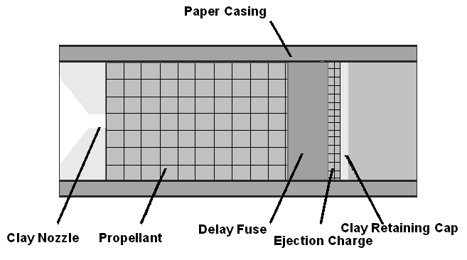
Puzzling over a Rocket Engine: The rocket engine diagram has the parts labeled. The challenge is to match the part with the definition by writing it in the space provided.

PART | Description
 | Part of the engine that speeds up the exhaust gas as it leaves the engine.
 | The explosive charge that makes exhaust gas by burning. This gas pushes the rocket as it leaves the engine.
 | A second charge that gives the rocket time to slow down and leaves a smoke trail to track the rocket.
 | Holds the ejection charge in place.
 | A third charge that pushes out the recovery system (parachute and cord).

Which engine parts release stored energy by igniting (burning)?
_______________________________________________________________

Activity 2: How does a rocket show “Action-Reaction?”
DATA TABLE

1. Read about Newton’s Third Law (from page 1). Write a paragraph sharing how you think Newton’s Third law describes the release of the balloon rocket.

____________________________________________________________________________________________________________________________________________________________________________________________________________________________________________________________________________

2.Challenge: Read about Newton’s First Law (from page 1). How do you think Newton’s First law describes what happens on the release of the balloon rocket?
________________________________________________________________________________________________________________________________________________________________________________________________________________________

Activity 3: How can you use a soda can to show Newton’s Laws?

Please use the following 2 pages to guide you through the activity.

SODA CAN HERO ENGINE

Names of team members:

___________________________ ___________________________
___________________________ ___________________________
A soda can filled with water and with holes in it may spin as the water leaves the can through the holes. You are going to design an experiment that will test the effect that the size of the holes has on the number of spins the can makes. Think about it.
Write a hypothesis for your experiment.

Mark each can to help you to count the spins.
Test each “Hero Engine” and record your data on the cans below.
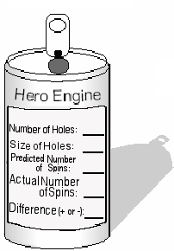
Test Number 1
Test Number 2
Test Number 3

Based upon your results, was your hypothesis correct? ________________
Why do you think that happened?______________________________________
______________________________________________________________________________________________________________________________________________
Activity 3: Soda Can Hero Engine

Design a new Hero Engine experiment. Remember, change only one variable in your experiment. Think about it.

What is your experimental hypothesis? _________________________________
_______________________________________________________________
Compare this engine with the engine from your first experiment that has the same size holes.

Based on your results, was your
hypothesis correct? __________

Why do you think this happened?
________________________________
________________________________
________________________________

Describe what you learned about Newton’s Laws of Motion by building and testing your Hero Engines.
_______________________________________________________________
_______________________________________________________________
_______________________________________________________________
_______________________________________________________________
_______________________________________________________________
_______________________________________________________________
Share your findings with other members of your class.

(Note: the Hero Engine Activity was taken from a prepared NASA activity.)

Major Parts of a Model Rocket

Directions: Fill in the blanks with the correct part of the model rocket.

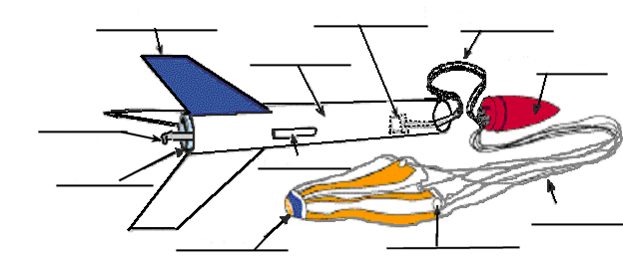
Components of a Typical Model Rocket
In the space below, describe the function of each part of the model rocket.
Part name: Function of the part:

Nose cone - _____________________________________________________
Shock cord - _____________________________________________________
Parachute - ____________________________________________________
Tape rings - _____________________________________________________
Shroud lines - ____________________________________________________
Shock cord mount - ____________________________________________________
Body tube - ____________________________________________________
Engine mount - ____________________________________________________
Engine hook - ____________________________________________________
Fin - ___________________________________________________
Launch lug - ____________________________________________________

Activity 7: How do you use a Clinometer?
(A clinometer is used to find the height of a given object.)

For this activity you will need:
1 Measuring Wheel (for the whole class)
1 Completed Clinometer / Tangent Table Set-up for you and a partner
1 pen or pencil

Use the diagram below to help you understand how to find the height of a flagpole.
Line of Sight
O
p
p
o
s
i
t
e

Tangent of Angle =
68 degrees

Baseline
90 feet
Observer

Opposite (flagpole) = Baseline X Tangent of Angle
Opposite (flagpole) = 90 feet X .40

Opposite (flagpole) = 36 feet

Try It Yourself
* Mark off a baseline of 90 feet with your measuring wheel from the observer to the object being observed. Note: Each full turn of the wheel equals 3 feet.

* The observer sights the clinometer on the top of the object.

* Another student should read and record the angle from the clinometer.

* Use the process above and the Tangent Table to find the height of the object.
With your teacher, select 3 objects outside to measure with a partner. Write the name of each object on the line provided. Use the space below the line to calculate the height of the object.

A._________________ B.__________________ C._________________

Activity 8: How High Will A Model Rocket Go?

The Baseline is now the distance from the Observer to the Launch Site. This distance should be 90 feet. To determine where to sight with the clinometer, you should follow the smoke trail of the rocket. Your partner should then record the angle of tangent when you find the highest point of the smoke trail.

Use the diagram below.
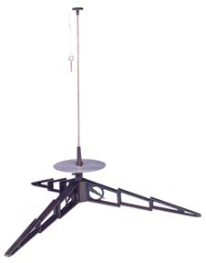
Baseline
90 feet
Smoke trail
Line of Sight
Tangent of Angle =
68 degrees
Observer
O
p
p
o
s
i
t
e

Example

Opposite (maximum altitude of rocket) = Baseline X Tangent of Angle

Opposite (maximum altitude of rocket) = 90 feet X 2.48
Opposite (maximum altitude of rocket) = 223.2 feet

Try These ☺
Below you will find the Tangent of Angle for 3 rocket launches. The Baseline for each launch was 90 feet. Use the space below each to calculate the maximum altitude of each rocket.

Tangent of Angle Tangent of Angle Tangent of Angle
75 degrees 60 degrees 50 degrees

NAR MODEL ROCKET SAFETY CODE

- Materials. I will use only lightweight, non-metal parts for the nose, body, and fins of my rocket.
- Motors. I will use only certified, commercially-made model rocket motors, and will not tamper with these motors or use them for any purposes except those recommended by the manufacturer.
- Ignition System. I will launch my rockets with an electrical launch system and electrical motor igniters. My launch system will have a safety interlock in series with the launch switch, and will use a launch switch that returns to the "off" position when released.
- Misfires. If my rocket does not launch when I press the button of my electrical launch system, I will remove the launcher's safety interlock or disconnect its battery, and will wait 60 seconds after the last launch attempt before allowing anyone to approach the rocket.
- Launch Safety. I will use a countdown before launch, and will ensure that everyone is paying attention and is a safe distance of at least 15 feet away when I launch rockets with D motors or smaller, and 30 feet when I launch larger rockets. If I am uncertain about the safety or stability of an untested rocket, I will check the stability before flight and will fly it only after warning spectators and clearing them away to a safe distance.
- Launcher. I will launch my rocket from a launch rod, tower, or rail that is pointed to within 30 degrees of the vertical to ensure that the rocket flies nearly straight up, and I will use a blast deflector to prevent the motor's exhaust from hitting the ground. To prevent accidental eye injury, I will place launchers so that the end of the launch rod is above eye level or will cap the end of the rod when it is not in use.
- Size. My model rocket will not weigh more than 1,500 grams (53 ounces) at liftoff and will not contain more than 125 grams (4.4 ounces) of propellant or 320 N-sec (71.9 pound-seconds) of total impulse. If my model rocket weighs more than one pound (453 grams) at liftoff or has more than four ounces (113 grams) of propellant, I will check and comply with Federal Aviation Administration regulations before flying.
- Flight Safety. I will not launch my rocket at targets, into clouds, or near airplanes, and will not put any flammable or explosive payload in my rocket.
- Launch Site. I will launch my rocket outdoors, in an open area, and in safe weather conditions with wind speeds no greater than 20 miles per hour. I will ensure that there is no dry grass close to the launch pad, and that the launch site does not present risk of grass fires.
- Recovery System. I will use a recovery system such as a streamer or parachute in my rocket so that it returns safely and undamaged and can be flown again, and I will use only flame-resistant or fireproof recovery system wadding in my rocket.
- Recovery Safety. I will not attempt to recover my rocket from power lines, tall trees, or other dangerous places.

GLOSSARY

acceleration the rate of change in the velocity (speed) of a moving body when going faster

blast deflector plate a metal plate that slides over the launch rod used to prevent the ignited engine propellant from burning or scorching the launcher or the vegetation beneath it

body tube a cylindrical tube that makes up the body of the rocket; typically made of cardboard, fiberglass or carbon fiber

center of gravity the point at which a rocket balances when completely prepped for flight

clay nozzle the part of the model rocket engine that accelerates the exhaust gas to a high velocity as it is expelled from the engine

clay retaining cap holds the ejection charge in place

clinometer an instrument used to measure angles of slope or inclination

delay phase the second of three charges in a model rocket engine; this charge (1) allows the rocket to slow down and (2) provides a visible smoke trail for tracking the rocket

drag the resisting forces of air acting on a model rocket during its upward flight

ejection charge the third of three charges in a model rocket engine is designed to pressurize the body tube and eject the recovery system

engine mount holds the engine in place in the body tube

fin the part of the model rocket at the rear of the rocket used to stabilize it in flight

GLOSSARY page 2

gravity a force that draws all bodies in the earth’s atmosphere toward the center of the earth

igniter a length of high-resistance wire, sometimes coated with a flammable material, which is placed in contact with the motor propellant prior to the rocket’s launch

launch to send off a self propelled object (rocket)

launch area the large open area such as a football field or playground area that is used as a place to safely launch model rockets

launch lug a section of a straw that is mounted parallel to the side of
the rocket to accommodate a launch rod.

launch rod a rod used to hold the model rocket on the launcher before firing; also used to guide the rocket as it leaves the launcher after ignition

micro clips clips used to attach the power source to the igniter

model rocket engine the solid propellant power system of a model rocket designed to perform all power functions during launch, acceleration and activation of the recovery system

nichrome wire a high resistance wire made from nickel and chromium; it is the wire used to make igniter wires; nickel/chromium is chosen as a material because it has high resistance to heat; when exposed to an electrical current, it will glow yellow-hot before burning through

nose cone the pointed object at the front of a rocket; cones are not always strictly cone-shaped; they are sometimes rounded but are most commonly ogive (a pointed arch)

paper casing the outside covering of a model rocket engine

GLOSSARY page 3

parachute a piece of plastic or other material shaped something like an umbrella when deployed, which slows the descent of a rocket

pre-launch test activities used to determine if the rocket is stable and ready for flight

propellant the explosive charges used in model rocket engines

rocket any device, usually cylindrical, containing a solid propellant which when ignited, produces gas that escapes through a nozzle at the rear of the rocket, driving it forward by the principle of action-reaction

shock cord a length of elastic or bungee which provides shock absorption for the rocket components at the point of flight where the deployment charge fires and the parachute opens

shroud lines the strings that connect the rocket to the parachute or streamer

stability the tendency of a rocket to move in a straight line in relationship to the direction it is pointed at the time of launch

streamer a device for slowing the descent of a rocket, sometimes used in place of a parachute in smaller rockets

tangent in trigonometry, it is the ratio between the side opposite a given acute angle to the adjacent side in a right triangle

thrust the forward force produced in reaction to the gases escaping through the nozzle of a model rocket engine

thrust charge the initial stage of the rocket engine designed to provide lift-off and acceleration

GLOSSARY page 4

thrust ring located directly in front of the engine of model rockets that do not have an engine mount tube and engine holder; it prevents the engine from pushing through the body tube during lift-off and acceleration

track to observe the moving flight path of a rocket

tracking station a station used to track the path of a rocket or other missile; here you are able to record certain types of data related to the rocket or missile

trajectory the curved path a model rocket takes from the time it leaves the launch pad, to the time the recovery mechanism is ejected

velocity speed; distance traveled per unit of time

wadding a nonflammable material placed in the body tube between the engine and recovery system; it helps protect the recovery system from the heat of the ejection charge

