

Blackline Masters

Rocketry
Kit #54

Table of Contents

Newton’s Laws 1–4
Checkpoints 5-10
Air Pressure-Balloon 11
Action-Reaction 12
Rocketry Related Reproducible Masters 13-19
Clinometer Sheet 20
Table of Tangents 21
Final Evaluation 22-23
Rocketry Certificates 24-25

Revised August 2006
Logo-footers: revision June2008
1.
Newton’s First Law
of Motion

- Objects at rest will stay at rest, and objects in motion will stay in motion in a straight line unless acted upon by an unbalanced force.

- REST

- MOTION

- UNBALANCED FORCE

2.
Newton’s Second Law
of Motion

- Force is equal to mass times acceleration.
F = ma (Force = mass x acceleration)

- MASS

- ACCELERATION

- FORCE
3.
Newton’s Third Law
of Motion

- For every action there is an opposite and equal reaction.

- ACTION

- REACTION
Newton’s Laws of Motion:
Putting Them Together
with Model Rocketry

Law 1:
An unbalanced force must be exerted for a rocket to lift off from a launch pad.

Law 2:
The amount of thrust (force produced by a rocket engine) will be determined by the mass of the rocket fuel that is burned and how fast the gas escapes the rocket.

Law 3:
The reaction, or motion, of the rocket is equal to and in an opposite direction from the action, or thrust, from the engine.

Checkpoint: Newton’s First Law Name: ______________________

Match the following terms with the diagram. Place the letter of the part of the rocket engine next to the correct word.
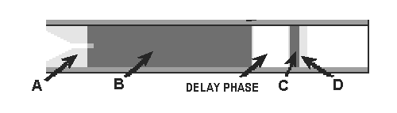
____ clay retaining cap
____ clay nozzle
____ propellant
____ ejection charge

Which of the engine parts provides the thrust for the rocket? _________________
Newton’s First Law states that:
An object at rest will stay at rest unless it is acted on by an unbalancing force.
An object in motion will stay in motion unless acted on by an unbalanced force.

Think of objects that you have put into motion. Use two of those objects to fill in the chart. An example has been done for you.
Object I’ve put into motion | Type of force used | Source of the force
ex. ride on lawn mower | push | gas engine

Think of objects that you have stopped or slowed down. Use two of those objects to fill in the chart. An example has been done for you.
Object I’ve stopped or slowed down | Type of force used | Source of the force
ex. ride on lawn mower | push | rubbing of brake (foot)

Name:__________________________
Checkpoint: Newton’s Second Law

Newton’s Second Law deals with force as the First Law does. The Second Law defines the value of a force needed for motion. It states that the force (f) acting on an object equals the product of the mass (m) times the acceleration (a) of the object.

F = ma

A unit used for force is Newtons (N).
A unit used for mass is kilograms (kg).
A unit used for acceleration is meters per second squared (m/sec²).

For each of the following problems calculate the force: (show your work)
1. A hockey player has a mass of 108 kg including his equipment. He needs to accelerate across the ice at a rate of 2 m/sec² to get up to speed. How much force must he push with to do this?

2. A bicyclist’s mass is 52 kg. The mass of the bicycle is 10 kg. The bicyclist needs to accelerate at a rate of .5 m/sec² to pass a team mate. What is the amount of force that the bicyclist needs to supply to do this?

Math is the language of scientists and engineers!
Checkpoint: Newton’s Third Law Name: __________________
Fill in the boxes by answering each question about Newton’s Third Law.
Newton’s Third Law:
For every action there is always an opposite and equal reaction.
What does it mean to me?
What does a reaction need?

What are two examples of actions and reaction? Think of action-reaction as: if you push on something, it pushes back on you. If you push with more force than the object pushes on you then the object moves.
Example | Action | Reaction
ex. Roller skates | push against the ground | ground pushes you forward

Name: ______________________
Checkpoint: What are the parts of a rocket?
This page is divided into sections. Each section refers to a different part of the rocket’s flight. You task is to sort the parts by the main job that they do. Write the names of the parts in the correct boxes.

Rocket Flight Sections
Rocket Launch
Rocket Flight
Rocket Recovery

Parts List:
parachute | launch lug | fins
engine mount | shock cord | nose cone
body tube | engine hook | shroud lines

Checkpoint: Energy Transfer Name:______________________
What are the forms of energy involved in a rocket flight?

Read the information and answer the questions.

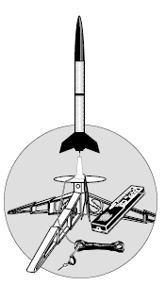
Energy will be transferred or change form during the launch and flight of a rocket.
Let’s start off by visualizing a rocket ready for launch. An engine has been placed in the rocket. An igniter has been inserted into the engine. The clips from the launcher are attached to the igniter wires (see below).
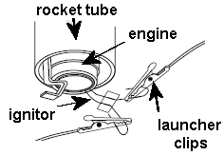

The clips are on wires attached to the launch controller. The launch controller has batteries inside. When the controller is armed it is ready to supply the energy for electricity to flow through the circuit. The rocket igniter is part of the circuit.

1. What form of energy is stored in the batteries of the launcher? _________________
2. When the circuit is open what form of energy moves through the wire? ____________
3. When the circuit is closed what form of energy moves through the wire? ___________
As the circuit is closed, electricity flows through the wire heating up the tip of the igniter. The hot igniter heats the propellant and starts the propellant burning. The propellant burns very rapidly releasing hot gases.

4. What form of energy is stored in the propellant? ________________
5. What form of energy ignites the propellant? ____________________
6. As the propellant burns the energy stored in the propellant is changed to __________ energy as the rocket is launched. This is called a “transfer of energy.”

7. Where else in the rocket’s flight is there a transfer of energy? _________________
Name: _________________________
Checkpoint: Newton’s Laws and Rocket Flight

Newton’s First Law:
1. What provides the unbalanced force for the rocket to lift upwards?
______________________________________________________________
2. What provides the unbalanced force to bring the rocket down to the ground?
______________________________________________________________
Newton’s Second Law
3. In order for the rocket to lift off, a force must act on the rocket. What two properties of the rocket do you need to know to calculate the thrust force?
a.______________________________________________________
b. _____________________________________________________

Newton’s Third Law
4. The upwards motion of the rocket is a reaction to an action. What is the action? (Be very specific as to what the action is, not what provides the force for the action.) __________________________________________________
5. What provides the force for the action in question number 4.
________________________________________________________

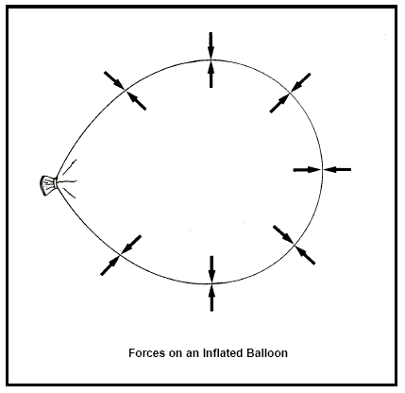

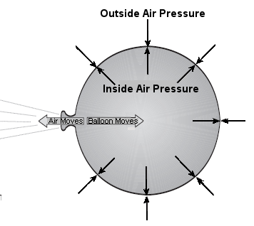

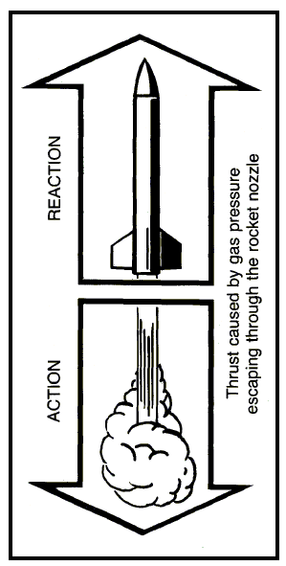
Estes Educator Series
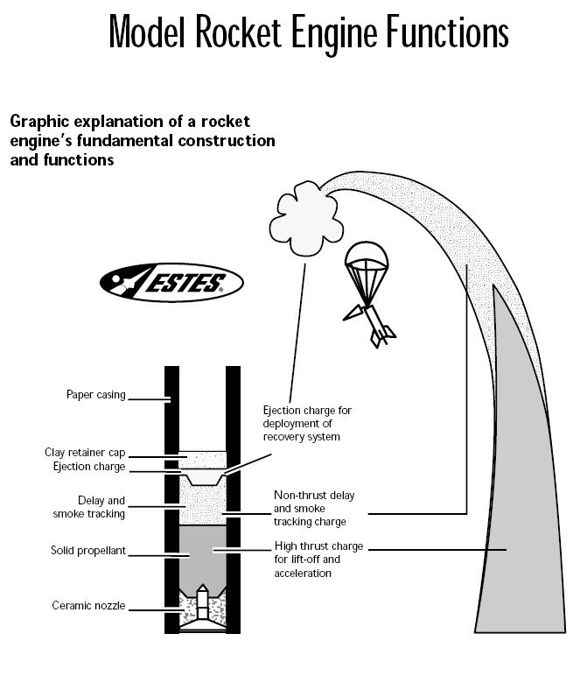

Estes Launcher System
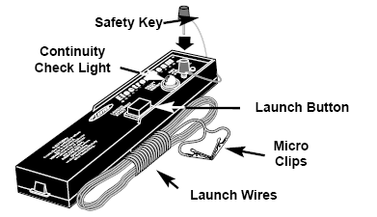

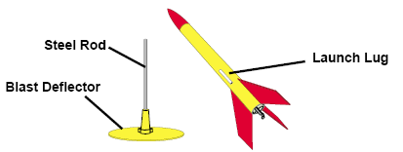
Deflector Plate and Launch Rod

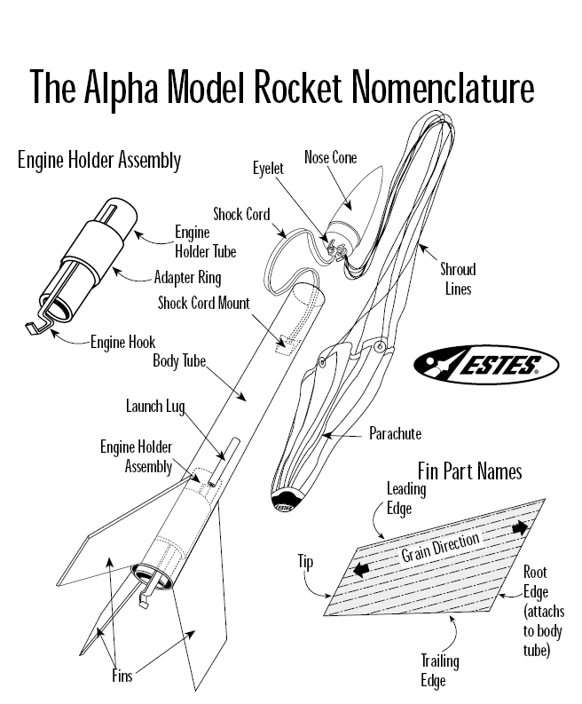

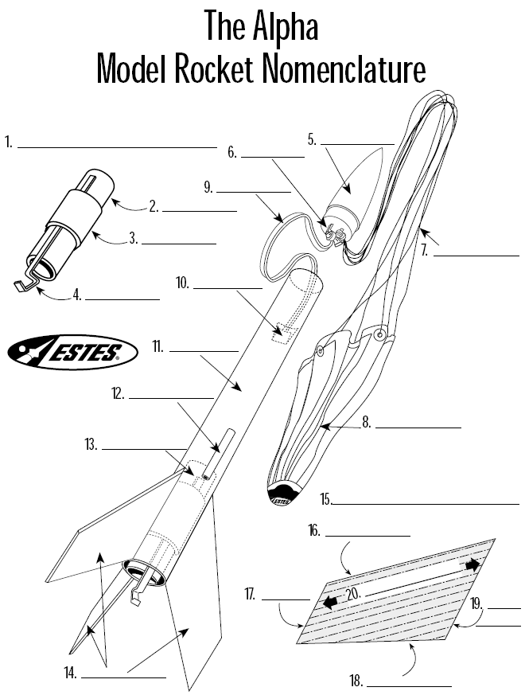

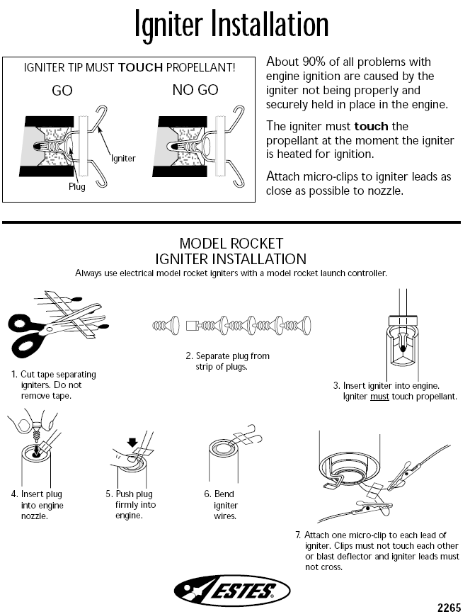
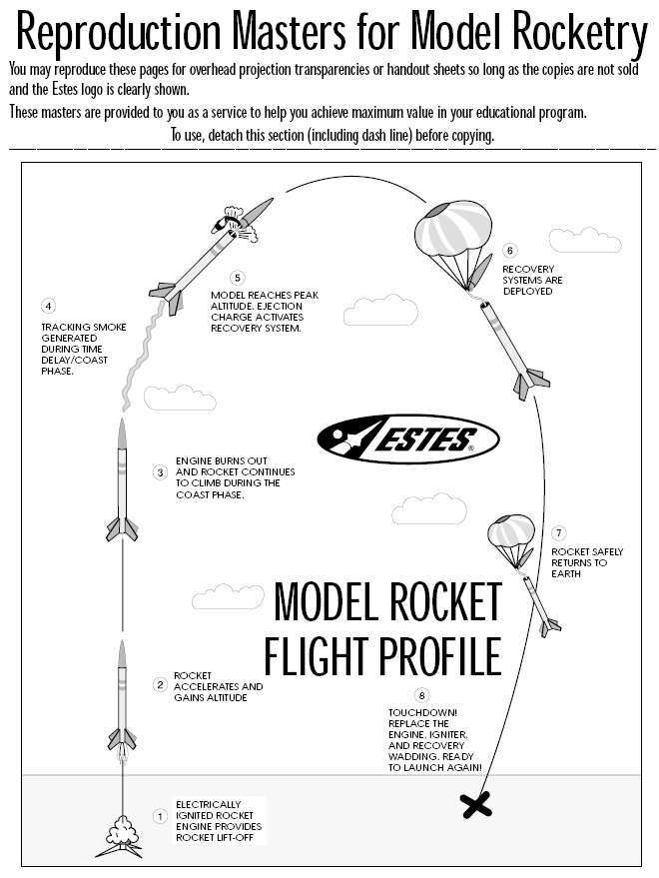
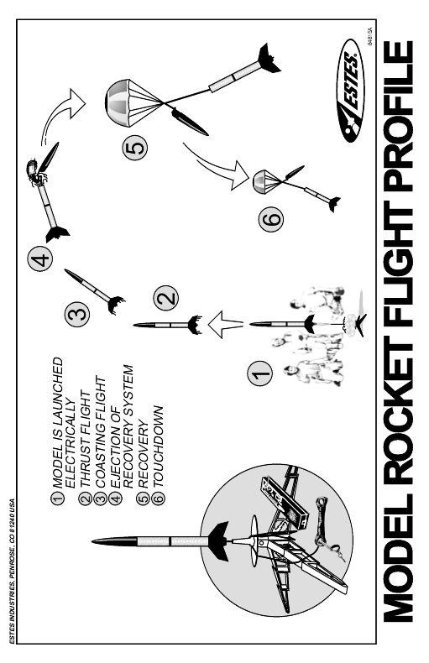
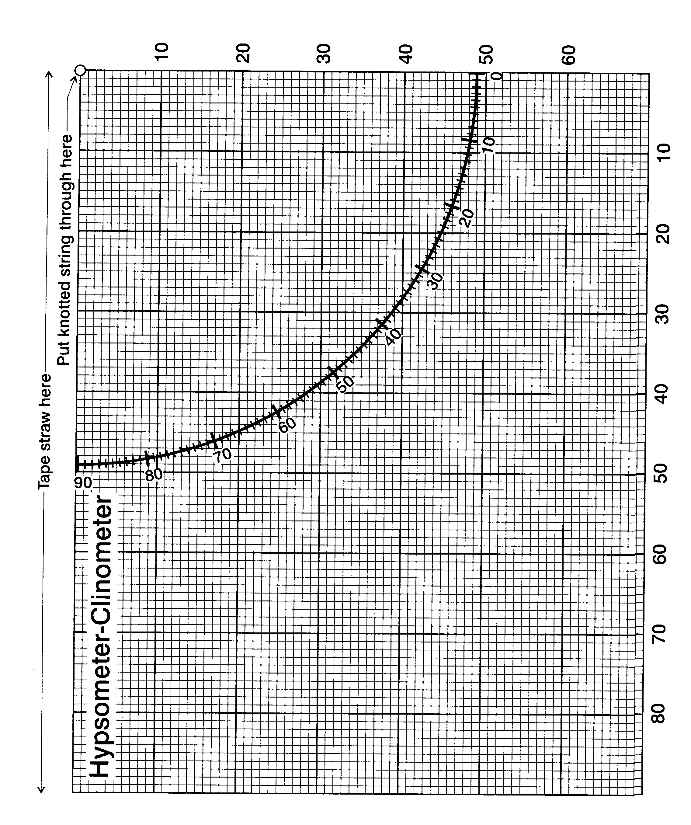
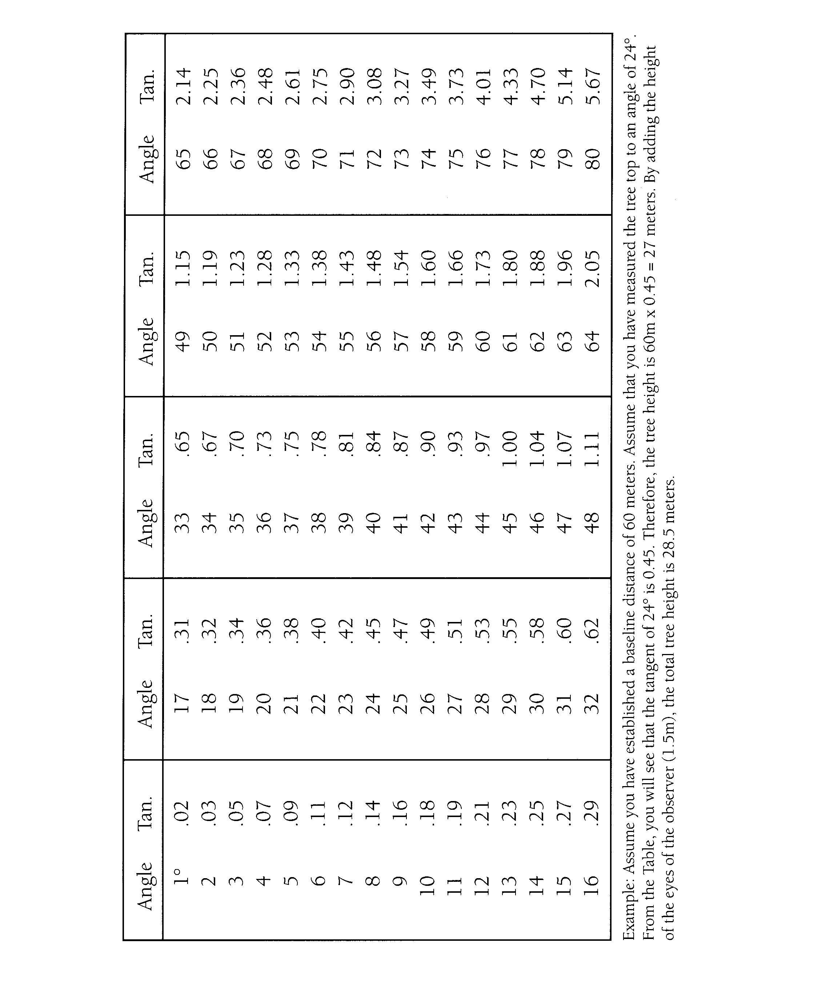

Name___________________________

Final Evaluation PAPER ROCKETS & NEWTON’S LAWS
PART 1

You will construct a paper rocket in order to complete PART 2 of the Assessment.

Materials:
Scrap bond paper *
Oak tag strips
20 Straws (cut each star in half)
Clear Tape *
Scissors *
Sharpened pencil *
*supplied by teacher
- Cut a narrow rectangular strip of paper about 5 inches long and roll it tightly around the fat pencil. Tape the cylinder and remove it from the pencil.
- Cut each end of the tube to make straight edges.
- Fold over one end of the tube and seal it with tape. This will be your nose cone.
- Remove the cylinder from the pencil and gently blow into the open end to check for leaks. If air easily escapes, use more tape to seal the leaks.
- Cut two sets of fins out of the oaktag paper. Tape the fins near the open end of the cylinder. The tabs make taping easy.

FLYING THE PAPER ROCKET:
Slip the straw into the rocket's opening. Point the rocket in a safe direction and sharply blow through the straw. The rocket will shoot away. Be careful not to aim the rocket towards anyone because the rocket could poke someone in the eye.
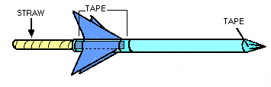

After you have assembled your rocket, you may move on to PART 2 of the assessment.

Name___________________________

PART 2: PAPER ROCKETS & NEWTON’S LAWS

You will need your paper rocket for this activity. You may also wish to use your “Newton’s Laws and Rocketry” from page 1 in your Student Journal as a reference.

Newton's First Law states:
Objects at rest will stay at rest, and objects in motion will stay in motion in a straight line unless acted upon by an unbalanced force.

How can you apply this Law to your paper rocket or to another activity in this unit?
_____________________________________________________________
_____________________________________________________________
_____________________________________________________________
_____________________________________________________________
Newton's Second Law states:
F = ma - Force is equal to mass times acceleration. (Rocket Thrust)

Air has mass(weight). Air can move at a certain rate of speed (acceleration). You launch the paper rocket by blowing through the straw.

What information would you need to have to calculate the force of the air launching the paper rocket?
_____________________________________________________________
_____________________________________________________________
_____________________________________________________________
Newton's Third Law states:
For every action there is always an opposite and equal reaction.

How can you apply this Law to your paper rocket or to another activity in this unit?
_____________________________________________________________
_____________________________________________________________
_____________________________________________________________
