


Kit #87 Energy Studies



NAME:

Revised July 2004
Format Revisions January 2014

Activity 1
NOTES: What is energy?
(This can be done using words, drawings or both.)

Activity 2

Where do we get our energy? (KWL)
Before you begin this unit, fill in the first two columns with your thoughts about where we get our energy. You will be filling in the last column when you are done with the unit.

I know… | I wonder… | I learned…

Activity 2
Do you know where we get our energy?

Welcome to Energy Ant from the Energy Information Administration (www.eia.doe.gov). Energy Ant has a lot of information to share about energy.

Energy comes in different forms. There is heat, light, mechanical, electrical, chemical, and nuclear energy.

There are two places that we find energy. Energy is either stored or energy is at work. Stored energy is called potential energy. Kinetic energy is energy at work. For example, the food you eat has stored energy. Your body stores this energy. You use it when you work or play.

All forms of energy are stored. They are stored in different ways. We use stored energy resources every day. These sources are divided into two groups -- renewable and nonrenewable.

Renewable energy comes from sources that we can use over and over again. Here is a list of renewable energy sources:
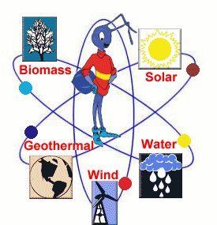
Solar energy is heat and light from the Sun.
Wind is a source of energy of motion. It is energy from moving air.
Hydropower is a source of energy of motion. It is energy from moving water.
Geothermal energy comes from inside the earth. It is in the form of heat.
Chemical energy is stored in matter. Renewable chemical energy can be found stored in plants, as biomass.

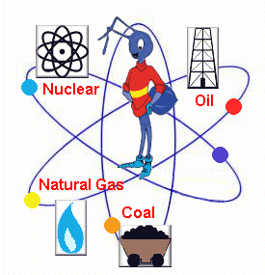
Activity 2, Energy Ant continued:

We get most of our energy from nonrenewable energy sources. This is energy that comes from an energy source we are using up. The source will not re-fill for a long time.

The main nonrenewable sources are the fossil fuels -- oil, natural gas, and coal. They're called fossil fuels because they are formed from dead plants and animals (or fossils). They were formed over millions of years. Another nonrenewable energy source is nuclear energy. We use the heat from splitting the atoms of matter called uranium. Uranium is mined and then processed.

We use all these as heat sources to make electricity. We use electricity in our everyday lives. Electrical energy "energizes" our computers, lights, refrigerators, washing machines, and air conditioners. We use energy stored in gasoline to run our cars. The gasoline we burn in our cars is made from oil. We use energy stored in propane gas to cook on an outdoor grill. The propane used by a grill is made from oil and natural gas. We use energy of motion to soar in a beautiful hot-air balloon.

Energy is in everything. We use energy for everything we do. We use energy to make a jump shot, to bake our favorite cookies and to send astronauts into space. Energy is there; it gives us the power to do it all.

If you look at the big picture, you would see the Sun as the source of much of our energy. It is the heating by the Sun that makes the air move. The heat from the Sun drives the water cycle. All of the fossil fuels were once living things. Living things get their energy from the Sun. So, other than geothermal and nuclear energy, the Sun is the main source of our energy.

Activity 2: Renewable – Nonrenewable Venn Diagram: Compare the properties and the sources of renewable and non-renewable energy.
Renewable Energy

Nonrenewable Energy
Activity 3
Take a note or two. Fill in this outline using the Energy Student Journal pages about Solar Energy (pgs. 7-10).

I. Solar Energy
  - What is it?
    - _________________________________
    - _________________________________
    - _________________________________
  - Electromagnetic Radiation
    - What is it?
      - ___________________________________
      - ___________________________________
      - ___________________________________
    - What types are there?
      - ___________________________________
      - ___________________________________
        - Visible light
          - ___________________________________
          - ___________________________________
        - Infrared radiation
          - ________________ iii. _________________
          - ________________ iv. _________________
        - Ultraviolet radiation
          - ________________ iii. _________________
          - ________________ iv. _________________
Act. 3: What forms of energy do we get from the Sun? (Solar Energy)
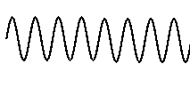
We receive light or daylight from the sun. This is part of the energy that we get from the sun. This energy is called solar energy. Solar energy is a form of radiant energy. Light from the sun contains a vast amount of energy. If that energy can be used there is a great deal of power available.

The energy from the sun is in a form called electromagnetic radiation. Electromagnetic radiation is formed when you have electric and magnetic fields acting together. The sun creates both of these types of fields. Electromagnetic radiation is radiant energy. It travels in waves.

Have you ever seen waves in water? Have you seen a flag wave in the wind? A wave is a repeating up and down motion. Waves are energy of motion. The wave motion sends on the energy. Electromagnetic waves do not need water or air to travel in. They can travel through space. They can also travel through air or water.

There are different types of electromagnetic waves. Radio waves, television waves, and microwaves are all types of electromagnetic waves. So are visible light waves, infrared, ultraviolet, x-rays and gamma waves.

Electromagnetic waves can be tall or short. They can be far apart or close together. How far apart or close together the wave is tells what type of electromagnetic wave you have. Scientists have made a chart that shows types of electromagnetic radiation. This chart lists electromagnetic radiation from the longer waves to the shorter waves. This list is called the “electromagnetic spectrum.”

Radiant energy
travels in waves; the best-known form is light energy. Other forms are radio and TV waves, X-rays and gamma waves.

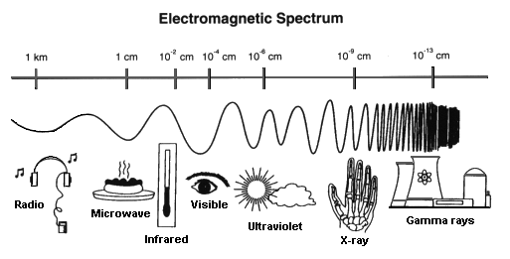
Electromagnetic Radiation: Visible Light Radiation

There is only a small part of the electromagnetic spectrum that we can see. It is called visible light. The Sun radiates energy of visible light. The visible light waves are all the colors of the rainbow.

Color comes from what is called the visible spectrum of light. This range of color goes from red to orange to yellow to green to blue to indigo to violet. This includes all the colors of the rainbow. Scientists measure the wavelengths of light in this spectrum in billionths of a meter. Of the visible light waves, red has the longest wavelength, and violet has the shortest.

In the world around us, color is perhaps what we notice the most about light. Why we see colors the way we do all has to do with light reflection. The reason something appears to be a color is that the object is absorbing all the other colors of light except the ones we see. We see the colors that are reflected back to our eyes. A shirt that looks green reflects the color green. It absorbs all of the other colors. If something absorbs all the colors, it appears black. If it reflects all the colors, it appears white. White light contains all the colors of the spectrum mixed together.

ROY G BIV: a way of remembering the order of the visible light waves from longest to shortest.
Red, Orange, Yellow, Green, Blue, Indigo, Violet

Electromagnetic Radiation: Infrared Radiation

The main source of infrared radiation is heat or thermal radiation. The movement of atoms and molecules in an object produces this energy. The higher the temperature, the more the atoms and molecules move. The more they move the greater amount of heat energy they give off. Infrared rays are invisible but we can feel the heat from them. Any object with a temperature gives off infrared rays. Even objects that we think of as being very cold, such as an ice cube, gives off infrared rays.

Humans give off body heat or radiate infrared energy. Some animals can "see" in the infrared. For example, snakes in the pit viper family (e.g. rattlesnakes) have sensory spots on their heads. They use these to detect infrared energy. This allows the snake to find warm-blooded animals (even in dark burrows). It finds them by sensing the infrared heat that they radiate.

We experience infrared radiation every day. The heat that we feel from sunlight, a fire, a radiator, or a warm sidewalk is infrared. Although our eyes cannot see it, the nerves in our skin can feel it as heat. Some products that we buy use infrared radiation. One example is a television remote control. Other examples are an oven and a toaster.

An object may not be quite hot enough to give off visible light. It will give off most of its energy as infrared. For example, hot charcoal may not give off light but it does give off infrared radiation. We feel this as heat. The warmer the object, the more infrared radiation it gives off.

Infrared Images and Videos: http://www.ipac.caltech.edu/Outreach/Edu/imgvid.html
If you were to look at the electromagnetic spectrum, you would find infrared radiation right next to visible light. Infrared energy waves are longer waves than visible light waves. They are lower energy waves than visible light waves. Longer waves mean lower energy.

Electromagnetic Radiation: Ultraviolet Radiation
Our Sun gives off energy at all the wavelengths in the electromagnetic spectrum. Some of this energy from the Sun can be dangerous. For example, ultraviolet waves are responsible for causing our sunburns. Ultraviolet (UV) light has shorter wavelengths than visible light. The shorter waves have a greater amount of energy.

UV light is sorted into different types: UV-A, UV-B and UV-C. They are sorted by how much energy the waves have. UV-C has a shorter wavelength (more energy) than UV-B. UV-B is shorter than UV-A. Though these waves are invisible to the human eye, some insects, like bumblebees, can see them!

Most of the Sun's energy that gets through our atmosphere is harmless to humans. UV radiation is different. UV radiation can reach a high enough level to damage plants and animals. UV-C is most dangerous and UV-A is the least dangerous to living things.

A lot of UV radiation is blocked before it can get to the Earth’s surface. There is a layer of gases in the atmosphere called the ozone layer. This layer blocks a lot of UV radiation but there is still some that gets through. All of UV-C and some of UV-B are blocked by the ozone layer. UV-A is less dangerous.
On some days more UV radiation gets through than on other days. Clouds can help to block UV radiation. More UV radiation will come through to us when the sky is clear. The National Weather Service reports a daily UV index. This tells people how harmful being in the Sun is on that day.

We are concerned about UV radiation levels for all living things. For people, too much sun can cause sunburn, eye damage, and skin cancer. This is why we use sunscreen on our skin and wear sunglasses that block UV radiation.

Activity 4: Are there different types of visible light waves?

Visible light is a part of the electromagnetic spectrum. It is wave energy at certain wavelengths. Visible light is made up of several different waves. Each of these waves has different wavelengths. These wavelengths are ones that your eyes can see. The following activity shows a way to split visible light.

Materials: mirror, index card, clear plastic box, water, sunlight

Procedure:
You need a sunny day and a place in the Sun to do this.

1) Fill the clear box half full of water.
2) Rest the mirror at an angle inside the box.
3) Place the box so that the sunlight falls on the mirror (near a window).
4) Hold an index card in front of the mirror. Move it around until you see reflected light appear on the card. You may have to move the card or the mirror to get this. Sometimes slanting the card helps.

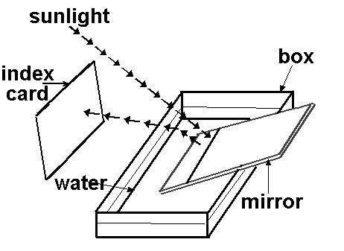

5) Draw your observations. Be sure to label your drawing.
6) Write a conclusion that answers the question “Are there different types of visible light waves?” Be sure to refer to your observations.

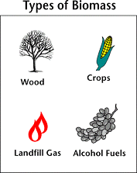
Activity 5: How do plants store energy?
Biomass: Stored Solar energy
Biomass is organic material, which means that it was part of a living thing. This organic material has stored sunlight. It has stored sunlight in the form of chemical energy. Biomass fuels include wood, wood waste, straw, manure, landfill gas and other crops.
How do plants store this energy? Plant cells are able to capture the Sun’s energy through the process of photosynthesis. Animal cells are able to store energy but they are not able to use the Sun as a source of energy.
The diagram below shows the chemical compounds and the chemical reaction that is the basis of photosynthesis. Photosynthesis is the light energy capturing process used by plant cells. Through photosynthesis plants store the Sun’s energy in chemical compounds called sugars. Glucose is a simple sugar.
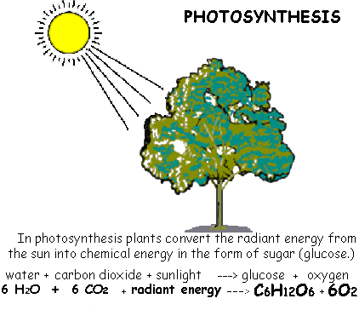
How Are Plant and Animal Cells the Same and Different?

Plant and Animal Cell Comparison:
Materials: plant cell picture, animal cell picture, Venn diagram

Directions:
Look at each of the pictures. Using the Venn diagram compare and contrast the parts of the plant and animal cells. When you are finished, find information about any parts that are only found in plant cells.

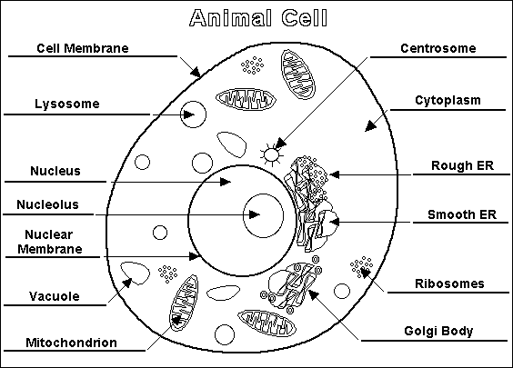

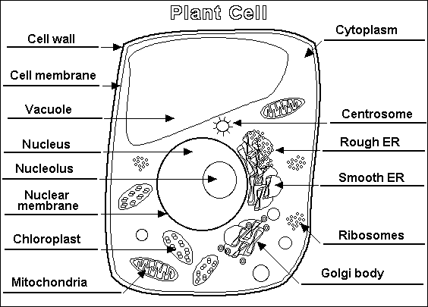

Activity 5A:
Powerful Plant Cells

Question: What are the parts and functions of a plant cell?
Helpful hints: www.eurekascience.com/Icandothat

Name of Plant Cell Part | Function of Cell Part
Cell Wall | Adds support to the cell and the plant. Acts as a gate to allow certain matter in and keep out other material.
Chloroplasts

Cytoplasm

Endoplasmic Reticulum

Nucleus

Vacuole

Mitochondria

Plasma Membrane

Golgi body

Materials:

Paper soufflé cups *Jello/knox mix
*Packageof “Runts” (or other kind of candy with different shapes)
Plastic spoon
*Paper towels

* Teacher Provided



Question: How is sunshine turned into sugar? Describe the process or write the formula down to answer this question.

Powerful Plant Cells Procedure:

1) From the candy shapes in your package choose one shape for each cell part. Use your plant cell diagram as a guide.

2) Fill in the chart below. Use the candy’s shape for the name.

3) Pour the jello mixture provided into a soufflé cup.

4) Place the candy into the cup to show the plant cell parts.

5) Set aside until cooled and ready to eat.

Enjoy a snack on the cells once they are chilled. Your body gets energy from the sugars in the Jello. Energy from a plant cell is given off when an animal eats the plant or when the plant is burned (combustion).
What is the chemical compound that plants make to store energy?

Plants store energy in compounds called sugars. Sugars provide the energy resource for cells. The simplest form of sugar is glucose. Glucose is made up of the chemical elements of carbon, oxygen, and hydrogen. You can write the chemical formula for the glucose molecule. Do this by counting the number of carbon (C), hydrogen (H), and oxygen (O) atoms. Write the number next to the letter in the formula written below. (Write the number smaller than the letter.)
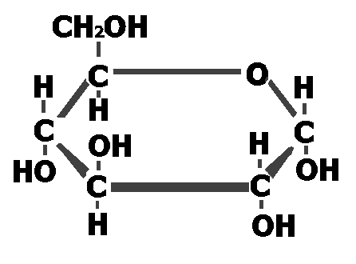

C__H__O__
Glucose

Simple sugars are put together to form complex sugars. Complex sugars are called polysaccharides (poly=many saccaride= sugar). The complex sugars that plants make are called starches.

This storage of chemical energy as sugar is done in the cells of the plant’s leaves. It happens in the parts of the cells called chloroplasts. If a plant or tree has its leaves eaten by an insect, it loses its ability to store energy. The plant uses the energy from the Sun to tie or bond together chemical elements into sugars. It gets the elements from water and carbon dioxide.
6 H₂O + 6 CO₂ + energy → C₆H₁₂O₆ + 6 O₂
water + carbon dioxide + energy → glucose + oxygen
Chemical Reaction of Photosynthesis

Activity 6a: Is there energy stored in a peanut?
Teacher Demonstration

Draw and label a picture of the set up for this experiment:

Create a table to record the information from the experiment for:

- amount of water in the test tube at the start.
- mass of the test tube and water at the start.
- temperature of the water at the start.
- amount of water in the test tube at the end.
- mass of the test tube and water at the end.
- temperature of the water at the end.

Questions: Calories in a Peanut
1) What were some of the things you observed during the time the peanut
was burning?
2) List the different forms of energy in this activity.
Heat value: amount of energy released from burning a substance.

3) Starting with the peanut, give the forms of energy changes that you observed. (What form of energy is stored in the peanut?)

Where did the peanut get its stored energy?
7) What would be your answer to the activity question? (see title of activity) Write a sentence to support your answer.

Activity 6b: How much energy is stored in food?

To start you need to do some research to find out the following information.

How would you find out how much energy is stored in a slice of bread?

What unit is used to measure the energy stored in food?

Look at a lunch menu for a day.
- Which food item do you expect to have the most stored energy?

- Which food item do you expect to contain the least amount of stored energy?

Think of a way of finding out the amount of energy there is in a serving of each menu item.

Fill in the chart with the name of the menu item and the energy per serving.
Name of the food | Energy per  Serving

Total Amount of energy _______________
How much energy do you use?

Were you surprised by the amount of Calories for any of the foods in the menu? Different foods have different energy values. After you eat, the energy from the food is transferred into your body. That energy is either used or stored for future use. The transfer of energy is from energy stored in chemical compounds in the food to energy stored in chemical compounds in your body. Heat is given off as this energy transfer occurs.

Activity | Calories per minute
Sitting in class | Heat value: amount of energy released from burning a substance  Measured in joules (j)  4.2 joules = 1 Calorie  1
Playing video games | 1
Eating | 1
Writing | 2
Walking | 4
Dancing | 5
Running | 10
Jumping rope | 11
Revised from Bonnie Cooks Caloric Burning Activity

Directions: Do each action listed below for 3 minutes. Fill in the chart for each action. (Use the chart above as a reference.)
Action | How did it feel? How is your breathing? How is your heart rate? (Observations) | Total # of calories of energy used.
Reading or Sitting
Walking
Jumping rope / running

Thinking about the activity:

A. Write a short paragraph comparing how you felt to the number of calories used for each action.

B. Energy in and energy out. Fill in the diagram with the forms of energy that were transferred in to do the action and taken out by the action.
Sitting
Walking
Jumping
Energy in:
Energy out:

C. How many minutes would you need to jump rope to "burn off" lunch?

D. Write a conclusion about the relationship between the energy stored in food and the energy that we need for our daily activities.

E. Write a sentence telling how biomass becomes an energy source for animals.

Challenge question! What do you think happens to the Calories of food energy that you may consume but your body doesn’t use?
Can Chemical Reactions Release Energy?

Biomass As An Energy Source
We have found that stored energy can be released. Our bodies release the energy stored in food so we can change it to other forms of energy. We need to reverse the energy storage formula. It needs to be a reaction that gives off energy.
Find the energy storage chemical reaction in your journal. Use it to fill in the blanks to reverse the chemical reaction so energy is released.
Our bodies breathe in oxygen. We consume food. Using oxygen our bodies are able to break apart sugar (glucose) found in the food we eat. When our bodies do this energy is released. We also release heat, carbon dioxide and water. Our bodies can use the energy and water. The carbon dioxide is given off to the air. (We breathe it out.)
C₆H₁₂O₆ + 6 O₂ → _____ + _____ + energy
glucose + oxygen → _____ + ____________ + energy
The same thing happens when biomass is burned. Oxygen is needed to release the energy. Carbon dioxide is given off to the air. It is the energy that we want, but we also get CO₂ gas. (Burning fossil fuels also gives off energy and carbon dioxide.)

As the biomass material is burned, the chemical energy is released. If you have a fireplace, the wood you burn in it is a biomass fuel. What we now call biomass was the chief source of heating homes and other buildings for thousands of years. In fact, biomass is still a major source of energy in much of the developing world.

Biomass is special in that it is renewable. You can grow more plants. Also, plants have a part in the CO₂ cycle. Plants are able to take carbon dioxide out of the air. You will see how this is important later on. Right now we will look at a special project. This project involves using renewable biomass as an energy source. This could be an energy source for power plants to make electricity.
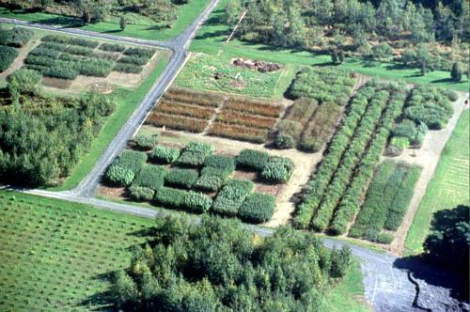
From Burning Peanuts to Burning Willow:
The Benefits of Willow Biomass

Willow Biomass Trials at the SUNY ESF Genetics Field Station in Tully, New York

How does growing willow help supply fuel for our energy needs?
Energy is cycled within our environment. It changes from one form to another. Sometimes it is at work and sometimes it is stored. Biomass crops can be looked at as large batteries. The Sun charges these batteries. In a battery, chemical energy is stored and can be used for electricity. Plants absorb their energy from the Sun. They change it into chemically stored energy within sugars. Some of the sugars are simple sugars. Some of them are complex sugars. The sugars are stored within the plant. These sugars are broken apart during the burning process. The stored chemical energy is converted into heat energy. The heat energy can be used to make electricity.

The Project
SUNY College of Environmental Science and Forestry wanted to find a good biomass source of energy. Through their research they found a type of tree called willow to be a good choice. They studied the growth of willow. They tested the willow as an energy source. They found a type of willow that grows very fast. It also did a good job of storing the Sun’s energy. It was a good “battery.”
As a good battery the willow does a better job of storing energy than fossil fuels. Where is all of the stored energy coming from? The answer is the Sun! The willows collect solar energy and store it as wood as they are growing.
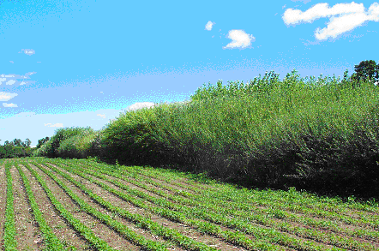
When willow is used as a biomass energy source it is planted like a crop. It is grown for three years and then harvested. The wood harvested is chipped or processed for burning. It can be used instead of coal to produce electricity, heat or both. The following year the willow sprouts again and begins a new three-year growth cycle.

The SUNY ESF (College of Environmental Science and Forestry) scientists have worked to grow a “better” willow. They want to grow the best willow for storing energy. In their study, they measured the density of different woods and measured the heat value of the woods. In this next activity, you will be testing pieces of wood to find out which ones have the most energy stored in them. You will be measuring the wood’s density and comparing density and heat value. Then you will be able to decide which ones have the most energy stored in them.

Biomass can be split into two categories, those coming from animals and those starting from plants. The most commonly used biomass sources are those starting from the plants. Some of the more common sources are listed in the chart below.

Major types of Biomass
Fast-growing trees and grasses  Ex. 1) Willow  2) Poplars  3) Switch grass | Agricultural residues  Ex. 1) Corn Stover  2) Rice straw  3) Wheat straw  4) Vegetable oils | Wood waste  Ex. 1) Sawdust  2) Tree pruning  3) Paper trash  4) Yard clippings | Animal Waste  Ex. 1) Dung/  Manure

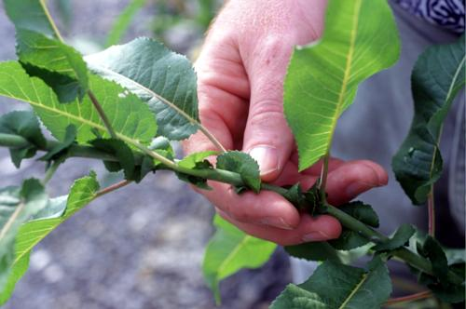
Density Lab: Willow

Problem: What is the density of a willow stem?

Hypothesis: The density of willow can be determined.

Procedure:
This activity will be similar to measuring the density of an irregular shaped object. There are different types of densities that can be calculated for trees. During this activity you will be calculating the “Oven Dried Density” for the willow stem.

1) For Oven Dried Density you take the mass of the willow twig after it has been oven dried.
The stems provided in your kit are oven-dried stems.
In order to measure the mass pick out a willow stem, and use the balance. (Leave the bark on the stem.)
Measure to the nearest gram. Record the dry mass.

2) Using the water displacement method, measure the volume of the stem.

Data Collection:
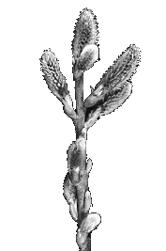
Willow twig | Measurement (units)
Mass
Volume:
Ending volume
Beginning volume
Density

Show your math work:

How can we use density of wood to help us estimate the wood’s heat value?
Investigation 1:
Below is a chart that shows data for heat value and density for different tree species.

- Most of the trees on the data table are called hardwoods. What is the definition of a hardwood? What is softwood?

- Look at the density of the only softwood on the data table. Think about what density means. How do you think the terms softwoods and hardwoods first came about?

- Look at the data table. What happens to the heat value as density increases?

Heat Values and Densities of Some Species of Trees/Shrubs
Tree/Shrub | Heat Value (MMBtu/cord¹) | Density of Dry Wood  g/cm³
Hickory | 27.5 | .74
Sugar Maple | 25.5 | .69
Red Oak | 24.6 | .66
White Ash | 24.5 | .65
Black Cherry | 20.4 | .55
Willow | 17.6 | .48
Cottonwood | 15.8 | .43
White Pine | 14.3 | .42

¹ Note: A cord of stacked wood is 4 ft high, 4 ft wide and 8 ft. long (128 cubic feet).
A MMBtu is a million Btus. A Btu is a “British thermal unit.” One Btu = 1055 joules of energy.
One Calorie = 4.18 joules.
Investigation 2:
1) Your challenge is to graph the data from the data table. You should place MMBTU/cord on the vertical axis (Heat Value). Next, place g/cm³ on the horizontal axis (Density).

2) Look back at the density value that you calculated for your willow sample.
Plot your density for willow on your graph.
Is it equal to the listed density value for willow?____________
Here is some more information about your willow stem.

Willow is Willow is Willow or is it?
Your willow stems are from special willow. Scientists at the SUNY College of Environmental Science and Forestry (SUNY-ESF) have selected this willow from hundreds of others that have been collected from the wild. The willow twigs in your kit are from a species of willow called Salix Dasyclados. (Its nickname is SV1.) SV1 was collected along a stream bank in southern Ontario. It has all the basic characteristics of a willow shrub, but it has wood density that is greater than the hundreds of other willow clones in SUNY-ESF’s collection.
By a clone we mean that the plant has been grown from a piece of a plant, not from seeds. By planting an 8 – 10 inch long piece of one-year old stem a new willow plant can be grown. It is planted so only a half-inch sticks up above the ground. Roots and stems develop from this piece of willow stem. The new plant that grows will be identical to and have the same characteristics as the plant it was cut from. This is why it is called a clone. Your density result should be slightly higher than the .48 in the data table. This is due to the fact that the SV1 clones have been selected for higher density from hundreds of willows.

3) Think about willow as an energy source. What advantage is there in selecting willows that have a higher density? (Why should the SUNY ESF researchers go through the trouble of looking at hundreds of willow plants?)

4) How does the density of SV1 willow compare to the other woods in the data table?

5) Does willow like SV1 have the highest heat value of all the woods?
Hmmm, let’s gather more information to help us understand why SUNY ESF researchers are working with willow as an energy source.

Let’s look at growth rates of different species. The term yield is used as a measure of how much wood that can be harvested from a hectare each year. A hectare is about 2.5 acres in size.

Growth Yields of Some Species of Trees/Shrubs
Tree/Shrub | Yield  Tons/ha/yr | Density of dry wood  g/cm³
Sugar Maple | 1.1 – 2.3 | .69
Red Oak | 1.1 – 2.3 | .66
Beech | 1.1 – 2.3 | .62
Willow | 11.3-16.8 | .48

6) How does the amount of willow that can be harvested compare to the other woods?

7) Do you think willow grows faster or slower than the trees in the data table?

For Your Information:
Willow has an interesting growing pattern. It can be planted using four to eight inch cuttings from a young tree. This small cutting is placed into the ground about ¼ of its length. It will begin to root and grow a new tree. It also coppices. Coppicing relates to how you can start a new tree growing. Once the willow tree is more than several years old, it can be cut down to the ground and will start new sprouts again the next year.
You can research how to identify willow shrubs and try to find them close to your school. In the spring, go to these shrubs and cut eight-inch stems from the willow. Try planting these and watch them grow.

8) Putting it together: In a paragraph tell why you think SUNY ESF researchers are working with willow as a renewable energy source.
(For 1st prize, give three reasons!)

Investigation 4:
Your teacher has an unknown piece of wood for you to study.

1) Calculate the density of your unknown piece of wood. _______________ g/cm³

2) Plot this density on the Investigation 2 graph in a bright color. Looking at the graph and data table, make a hypothesis about the type of wood you think your unknown wood might be.

How do we use these Joules or BTUs of heat energy?
Heat can be absorbed, transferred, and radiated (given off). We use heat to make electricity.
Heat and energy transfer to make electricity
In a power plant electricity is made by converting energy of motion into electrical energy. Power plants have huge generators. Inside the generators are magnets that must be turned to create an energy flow in wires. To turn the magnets you need energy of motion. Many power plants burn fuel to transfer heat energy to energy of motion. They boil water to make steam. The steam has a lot of energy of motion. The force of the steam is used to turn the generator. Think about the steam that comes out of a teakettle. It has a lot of force. It can make the kettle whistle. Other power plants use different heat sources to boil the water, such as solar energy, nuclear energy, or geothermal energy.
Can we capture energy of motion without burning a fuel? We could do this by using a source that has its own motion. This is how we make electricity from the wind or from water. The wind and moving water have energy of motion. That energy is used to turn parts of the generator. Where does the wind get its energy? How about water?
The Sun has a part in causing air to move. It does this by heating the Earth. The heated Earth warms the air and the energized warmed air moves.
The Sun also has a part in the water cycle. Through evaporation water is moved to higher places. The water then comes out of the air as precipitation. This water is pulled downhill by gravity. The stored energy becomes energy of motion. Hydroelectric power plants use moving water to turn the generators.
Below are listed several energy sources.
Heat energy plays a role in our use of each of these sources. In some of these heat is given off by the source. In others heat is used to store energy in the energy source. Tell how heat is a factor in each of the energy sources listed below. Think about whether heat is given off from the source or if heat is used to store energy in the energy source.

Energy Source | Is heat given off or used to store energy?
Hydropower
Solar power
Wind power
Geothermal
Bioenergy
Nuclear energy
Fossil fuels

Heat energy in our lives.
You can see that heat is very important in the production of electrical energy. Heat energy is a part of our lives every day. Think about different ways that we use heat energy. Think about the things that we use that give off heat energy.
Make a list of ten common ways that we use heat energy or use something that gives off heat energy.

For example: We use heat energy to make hot water. We use a lawn mower to mow a lawn but it gives off heat energy.

There is a lot of heat energy radiated in our environment. The next activity looks at variables that affect heating. This will be measured by a temperature change.
Can We Use Our Container Models to Study the Earth?
Conduction:
This is how heat energy moves through a solid. Some solids are better conductors of heat than others.

The activities your class just completed were about energy. Let’s build an information base by filling in the “bricks” found below.
In the experiments energy was radiated, absorbed, and re-radiated.
The source of the radiated energy was the The container allowed the light to pass in freely. One difference (variable) that seemed to affect how the containers heated was
We used a to measure this difference.
If the container had soil in it, the soil the energy. The soil is a solid and can radiate the
back to the air. This would cause the air
temperature to increase.
Let’s say you have two containers and a light source. In one container the air was allowed to leave and in the other it was trapped. The air temperature of the trapped air should . .

If you add to the air in the closed container, the air temperature will increase.
Radiate:
This means to send out rays.This is how waves of energy travel. They are radiated.
Scientific work is like building a home. A solid foundation is first formed. Next, one brick is placed on another until the building is constructed. We build upon the work and discoveries of past scientists. Over time a larger and larger information base is created. Sort of like a large group of people added pages to an encyclopedia. As we add information to our knowledge of science, we also create new questions.

Absorb: (write a definition)

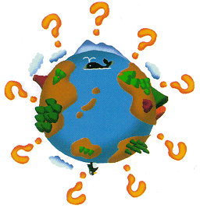
In the activities, you measured the temperatures of small containers. Let’s use your container activity to think about bigger heating questions. These are questions that have to do with global temperatures.
What affects heating of the atmosphere?
Is heat being trapped in our atmosphere?
What is trapping the heat?
How much is it heating differently?
How will this affect our world?
Scientists have discussed these thoughts and questions for over two hundred years.

Svante Arrhennius was a Swedish chemist. He lived in the late 1800’s and early 1900’s. He had a question about our atmosphere. The question was, ” Is our average temperature affected by the gases in the atmosphere?“ He constructed a model. The model was made to answer his question. He was one of the first people to study the effect of gases in the air on our temperature. The type and amount of gases were part of his study. Svante Arrhennius used other scientists’ observations and experiments to help build his ideas. Svante applied his knowledge of science to explain his observations.

Arrhennius came to some conclusions. He concluded that the atmosphere would become warmer. He thought that this would be caused by industry putting more gases into the air. He hypothesized that this warming would have a positive effect on the world. He thought that we would have longer growing seasons. This would allow for more food production. The world would be able to feed its growing population.

Svante Arrhennius used some of the studies from the following people to make some of his conclusions:
Josef Stefan
Arvid Gustaf Hogbom Samuel Langley
Leon Teisserenc de Bort
John Tyndall

What is Global Average Temperature?

Svante Arrhennius had these conclusions about the Earth’s atmosphere warming up during the industrial revolution. During this time machines were used more and more. Energy was needed to run the machines. Fossil fuels became a major source of energy. The burning of coal, natural gas, and oil give off carbon dioxide. The level of carbon dioxide has increased in our atmosphere. Along with this increase in CO_{2,} data has shown changes in the Earth’s surface temperature.
Since the early 1800’s scientists have recorded surface temperatures from different places all over the Earth. They have taken the temperatures and averaged them. This one number, the average, represents the temperature of the world at that time. This average is called the Global Average Temperature.
Let’s look at some data for Global Average Temperature. Some people look at the data and see a warming trend. Other people look at the data and wonder if this is a normal global temperature pattern. See what you think. (See the page titled, “ Changes in Global Average Temperatures”.)

Think about it:
How do we calculate the Average Global Temperature measurement?

How can technology help us to get a better measure of Average Global Temperature?

Changes in Global Average Temperatures

What do you think Global Average Temperature means?

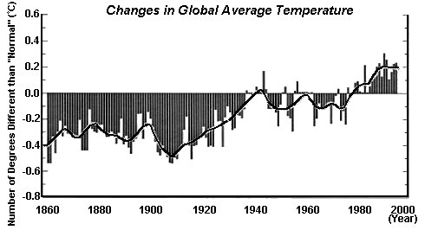

1. Make an observation about the line from 1860 to 2000.

2. Make an observation about the Average Temperature from 1860–2000.

3. The graph represents 140 years (1860 – 2000). Do you think this graph shows a long-term change in Global Average Temperatures?

What Affects Our Atmospheric Temperatures?
A model for a green house:
Compare the covered container (from the activity) to a greenhouse.
Create a Venn diagram to compare/contrast the container and the greenhouse.
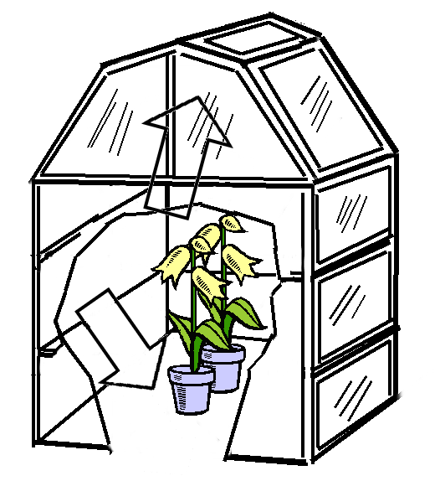
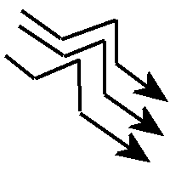
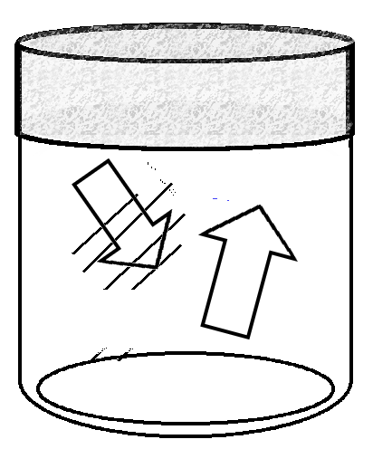

Label the UV rays from the Sun. - UV
Label the Infrared rays given off from the heated surfaces inside. – IR1
Label the Infrared rays trapped inside. – IR2

How is the greenhouse like the Earth? (Think about the picture)
Reading about the “greenhouse effect” may help you do this. (See the next page)



Take a note or two.
Fill in this outline using the Energy Student Journal pages titled, “What is the Greenhouse Effect?”

The Greenhouse Effect
  - About the greenhouse effect
    - _________________________________
    - _________________________________
    - _________________________________
    - _________________________________
  - Greenhouse effect and the Earth
    - _________________________________
    - _________________________________
    - _________________________________
    - _________________________________
  - Why is the greenhouse effect important?
    - __________________________________________
  - Greenhouse gases (Why are they important? What are they?)
    - _________________________________
    - _________________________________
  - Global Warming
    - __________________________________________
    - __________________________________________
    - __________________________________________

What is the “Greenhouse Effect”?
The greenhouse effect has to do with how the Earth keeps warm. This effect occurs naturally. We think that this has been happening for billions of years. We have found that without this the earth's surface would be colder. It would be too cold for many living things. We have calculated that this average temperature would be -17 ° Celsius (1° F). Our current average temperature is about +15° C (59° F).

Did you know?
You can observe all the parts of the greenhouse effect in a parked car in the sun:
- Sunshine (solar energy) passes easily through the glass to heat up things inside the car. Think about how hot the car seat gets in summer.
- The car's interior absorbs the short-wave energy. It heats up. When the seats heat up, they give off long-wave infrared radiation.
- Here's the tricky part: The glass in the car's windows act as a kind of one-way mirror. Short-wave solar energy enters with out any problem. Much of the long-wave infrared radiation is stopped from leaving.
On a much larger scale, this is what's happening to the earth:
- Energy from the sun hits the earth's atmosphere as solar radiation. Some of it is bounced back into space by the atmosphere. Most of it passes through the atmosphere. It warms the surface of the earth.
- The earth is warmed by the short-wave solar energy. The heat from the earth is radiated back into the environment. This heat is long-wave infrared radiation.
- Some of the gases in earth's atmosphere act like the glass in the car windows. They let in solar energy and block the infrared energy from leaving. As a result, the atmosphere gets warmer.
Go back a page and fill in your “Model of a Greenhouse” page.

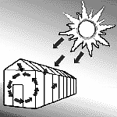

What do gases in the air have to do with it?
Thirty greenhouse gases have been discovered. This list includes carbon dioxide (CO2), water vapor, methane, and ozone. These gases help to trap heat close to the earth. Think about your “Warming” activities. One of them measured the temperature of a closed container with water in it. Did your results show that water vapor increases warming?
Cars, factories, and other human activities produce some of these gases.
Many scientists feel that the gases we are adding to the environment add to the greenhouse effect. This means that the earth’s atmosphere will become warmer. The term used to describe this is global warming.

Too Much of a Good Thing?
The greenhouse effect is important. Without the greenhouse effect, the Earth would not be warm enough for humans to live. But if the greenhouse effect becomes stronger, it could make the Earth warmer than usual. Even a little extra warming may cause problems for humans, plants, and animals.

Why Worry? The Effects of Global Warming

The concerns about global warming are still with us today.
Global warming has been thought to cause changes, such as:
Increasing ocean temperatures
Ice melting in areas where there are usually big sheets of ice
Sea levels rising as the ice melts
Coastal environments changing
Global weather patterns changing
The number and intensity of severe storms increasing
Patterns of El Nino that affect our weather

Are these the positive effects that Arrhennius hypothesized about?
Scientists look to understand the possible effects of a warmer world. Some scientists have become very concerned. Other scientists are studying more to see if this is a short-term problem. Will the effects of warmer temperatures last for a long time or a short time?

A Solution to Global Warming?
Scientists who are concerned about Global Warming have a solution. Their solution is for people to put less greenhouse gases into the air. We have to decrease the output of some of these gases.
Some of these chemicals compounds are used by industry. They are put into the air as they are used. The government has limited companies from using some of these chemicals. An example of this is a compound that was once used in aerosol spray cans, refrigerators, and air conditioners called chlorofluorocarbons (cfc).
Some of these chemicals are given off by chemical reactions. Remember the chemical reaction for releasing energy?

You can see that water and carbon dioxide are given off. Water and carbon dioxide are on the list of greenhouse gases.

One solution for decreasing these gases in the air is to burn less fuel so that there is less carbon dioxide given off. Energy conservation is a way of burning less fuel.

Another solution is to use sources of energy that do not use burning to release energy. Can you think of any of these energy sources? (There are four, write them here.)

A third possibility is the use of biomass as an energy source. How would this help? Let’s look at carbon dioxide in our environment for the answer.
C₆H₁₂O₆ + 6 O_{2 →} 6 H₂O + 6 CO₂ + energy
glucose + oxygen → water + carbon dioxide + energy
Does Carbon Dioxide Cycle in Our Environment?
You’ve heard of the water cycle. There is also a carbon dioxide cycle. The carbon dioxide cycle shows where carbon dioxide is absorbed and released in our environment. Sometimes it is part of our atmosphere as a gas. At other times it is tied up in chemical compounds, like sugars. Carbon dioxide returns to the atmosphere when it is given off from a chemical reaction. Carbon dioxide is thought to be the main greenhouse gas.

On page 45 there are two forms of the carbon dioxide cycle.
Look at each diagram. How are they the same? How are they different?
Fill in the Venn diagrams below by comparing and contrasting the two diagrams.

Diagram 1
Diagram 2

A cycle is a series of events that repeat. Does carbon dioxide cycle in our environment?

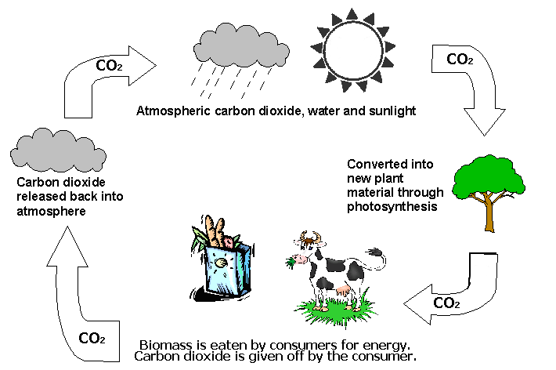
Diagram 1: Carbon Dioxide Cycle with Consumer

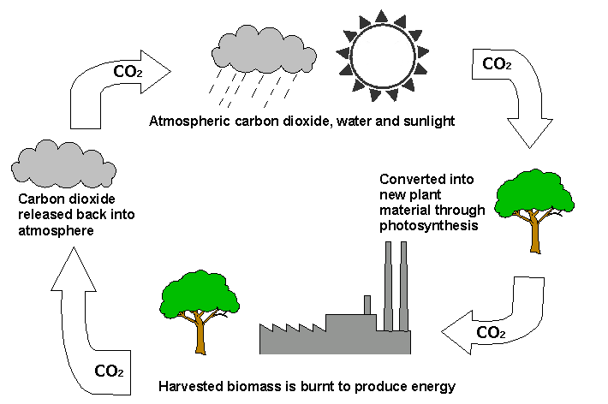
Diagram 2: Carbon Dioxide Cycle with Biomass Burned
More on carbon dioxide cycles-
On the next page there are two more diagrams of the carbon dioxide cycle. Look at each diagram. How are they the same? How are they different? Fill in the table below by comparing and contrasting the two diagrams (CO2 cycle with Biomass and CO2 cycle with Fossil Fuels).

Things that are the same | Things that are different
Fill in the blanks: (use your diagrams)
Carbon Dioxide Cycle with Biomass
Output CO₂ from burning biomass becomes input for _______________.
Output CO₂ from the atmosphere becomes input for _______________.
CO₂ output as stored energy in trees becomes input for _____________.

Carbon Dioxide Cycle with Fossil Fuels
Output CO₂ from burning fossil fuels becomes input for _____________.
Output CO₂ from the atmosphere becomes input for _______________.
CO₂ output as stored energy in trees becomes input for _____________.

In the “Carbon Dioxide Cycle with Biomass” CO₂ is output by which parts?

In the “Carbon Dioxide Cycle with Fossil Fuels” CO₂ is output by which parts?

Which of the diagrams show carbon dioxide kept in the cycle?

Which of the diagrams show a cycle with carbon dioxide leaving?

Carbon Dioxide Cycle with Biomass

Carbon Dioxide Cycle with Fossil Fuels
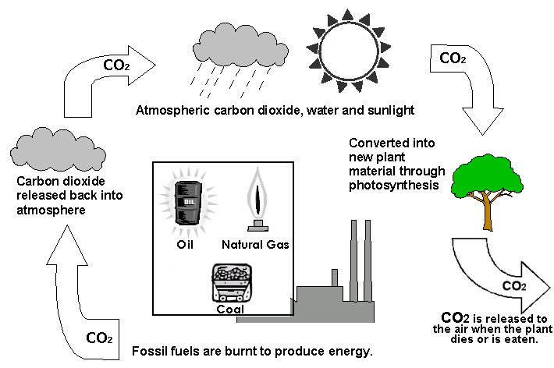

Summary of “Using Willow as a Biomass Energy Source” (www.esf.edu/willow)

When willow is used as a biomass energy source it is planted like a crop. It is grown for three years and then harvested.
The mass of wood harvested is chipped or processed for burning. It is used instead of coal to make electricity, heat, or both.
In the following year the willow sprouts again (coppice) and begins a new three-year growth cycle.
During this energy cycle, CO₂ is taken up during photosynthesis. The carbon and oxygen is bonded and stored in the wood of the willow.
When the wood is burned the carbon and oxygen are released as CO_{2.}
We call this complete cycle a closed loop system. The system includes growing, harvesting, and use of the biomass. It is closed because all the CO₂ that goes into growing the crop is equal to the amount of C0₂ that comes out.
A closed loop system is 100% efficient at recycling CO₂. That means all the CO₂ is contained in the cycle. The diagrams you used showed this process.
The use of willow as an energy source can make a big difference in how we affect the atmosphere. This process of burning biomass to produce energy allows us to have a renewable energy source. It helps to lower the amount of CO₂ in the air and lowers our concerns about global warming.
Research projects like the Willow Biomass Project at ESF are some of the ways that people can be more environmentally friendly. It is one way that the students and staff at ESF are working to protect the natural environment for the future.
For a link to information about Environmental Science and Forestry careers go to www.esf.edu/jobs.

