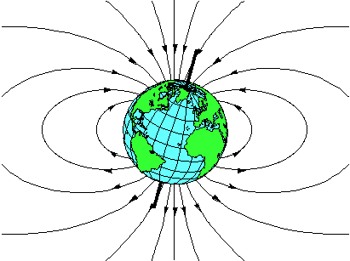

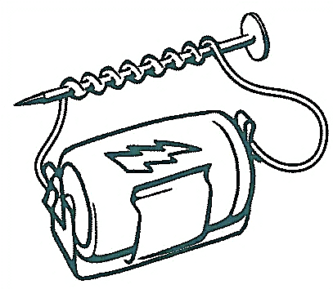
Electromagnetism
Kit # 13
Student Journal

Name: _______________________

Revised December 2014
Diagrams; pg. 10 & 11
Activity 1: How can a force field be detected?
Materials: battery, 20 cm insulated wire with ends stripped, magnet, thread, compass

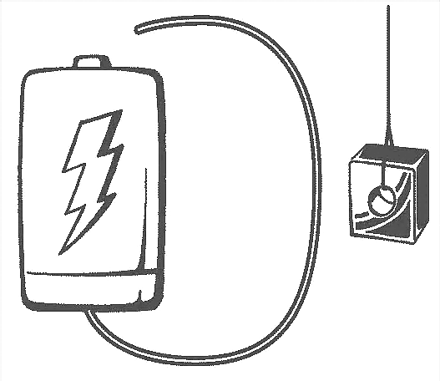
Exploring an electric circuit using a magnet

- Hang a magnet from a thread so that it swings freely. Hang the thread from a desk or ruler.
- Bring a wire that is part of an open circuit close to the hanging magnet. Make observations.
- Bring a wire that is part of an open circuit close to the hanging magnet. Hold the wire against one pole of the battery. Close and open the circuit by touching and releasing the other end of the wire to the other pole of the battery. Make observations.
Caution: HOT! Holding the wires to the battery poles will cause the wire to heat. Use the touch-release method to close and open the circuit.

My Observations:

Activity 1, continued

Exploring an electric circuit using a compass

You will be exploring magnetic fields using a compass.
What does a compass show us?

How does a compass work?

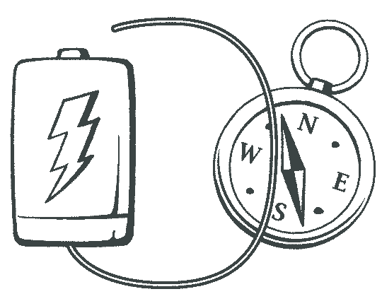
Set up your battery circuit and a compass as shown. Allow the wire to lay right on the compass. When you are ready, close and open the circuit using the TOUCH –RELEASE method.

Try different positions around the compass. Note any direction of movement, such as “to the east,” clockwise... Try flipping the battery.

Share your observations.

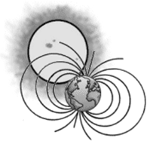
Activity 2
What is a magnetic force field like?
How can I observe a magnetic force field?

What materials did your teacher use for the demonstration?

Describe how your teacher was able to demonstrate magnetic force fields.

Draw sketches of the magnets and their lines of force. Label the poles of the magnets in your sketches.

Poles attracting Poles repelling
Compare the force field of poles attracting to that of poles repelling.

ACTIVITY 4
Can we create a magnetic force field in an object using an electric circuit?

Hypothesis: Using an electric circuit we can create a force field around an object.

Materials:
● “D” cell ●2 m piece of magnet wire ●small square sanding cloth
●10 D nail ●battery holder with clips ●8 small paper clips

Task:
Your job is to create a temporary magnetic force field in a nail using an electric current.

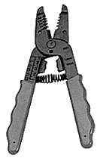
1) Cut a 2 m piece of magnetic wire. (Be sure to hold the wire down;
it can move and injure you.)

2) Use the sanding cloth to sand the coating off the last 2 cm of each end of the wire. (Do a good job of sanding.)

3) In order to magnetize the nail, the wire needs to be wrapped around it. Measure in 23 cm from one end of the wire. This will be the wrapping starting point. You will have a 23cm long “tail” of wire.

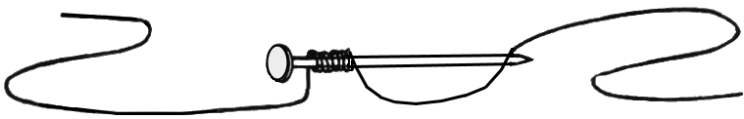
4) Starting at the head of the nail (and at the 23 cm point on the wire) wrap the wire around the nail 10 times (10 wraps). Keep the wraps tight and close together.

5) Place the battery holder on the battery.

6) You will be putting an electric current through the wire. Will this magnetize the nail? You will test this by seeing if it can pick up paper clips.

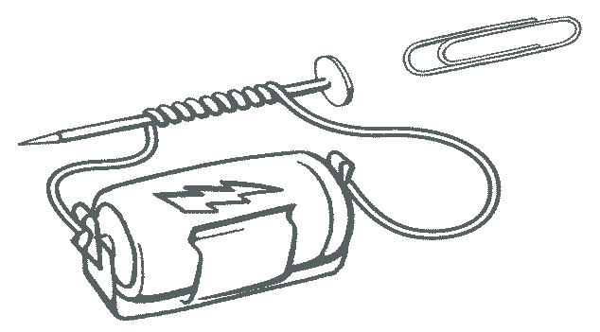
7) Attach each end of the wire to each end of the battery. Try to pick up a paper clip using the head of the nail.
Caution!
Battery will overheat. Close the circuit for only short amounts of time.

8) If it can pick up one paper clip, try adding more clips one at a time, end to end (see picture). Keep a record of how many clips can be picked up with 10 wraps.
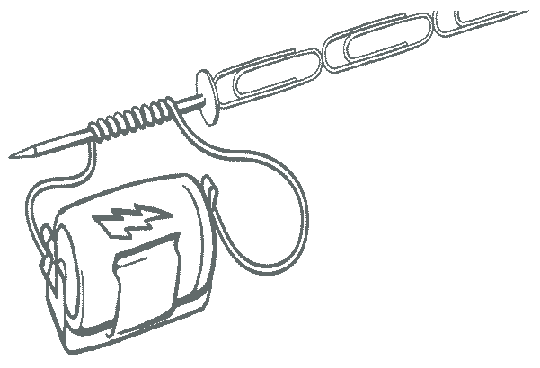

Caution!
Battery will overheat. Close the circuit for only short amounts of time.

Where are you going to record your data?

9) Add 10 more wraps. Test the nail using paperclips. Keep a record of your observations.

10) Repeat step 9 until you have 100 wraps on the nail. DO NOT UNWRAP THE NAIL. You will need it for the next activity.

Make a graph to compare the number of paperclips picked up to the number of turns of wire around the nail.

Create a line graph comparing the number of paperclips picked up by the electromagnet to the number of turns of wire.

Part 2: Does the number of batteries affect the strength of the magnetic field?
Carry out an experiment to answer this question. Graph your data.

Using your results (graph) as a guide, write a conclusion statement telling the relationship between the number of turns of wire and the strength of the electromagnet.

In each box there is a word. Draw a picture that defines or shows the meaning of the word. Under the picture write a definition using your own words.

magnetic field | attract
repel | magnetism
compass | electromagnet

For each of the following words, complete the definition by filling in the blanks.

force field: an invisible area of _________________ surrounding an object

lines of force: imaginary __________ that show the direction of a force field

temporary: something or an event that lasts for a ____________ time

variable: something that ____________________
ACTIVITY 5
Can we use the interaction between matter and energy to make sound?

Materials per set up:
●1 large project board | ●1 large wood screw | ●1 screw driver
●1 piece sanding cloth | ●1 small washer | ●1 wire stripper
●1 metal buzzer arm | ●1 - 3d box nail | ●3 “D” cell batteries
●1 metal angle | ●1 - #30 rubber band | ●3 battery holders
●1 tapping screw | ●1 electromagnet (nail with wrapped wire) | ●1 hammer
●1 fahnestock clip | ●2 - 15 cm pieces of insulated copper wire

Hypothesis: We can use batteries, wires, screws and pieces of metal to build an electrical circuit. By opening and closing the circuit we can cause a piece of metal to vibrate and produce a sound.

TEST: Your job is to test the hypothesis. To do this you will be building an electrical circuit. Your electromagnet, built in the last activity, will be part of the circuit. The directions will guide you in building the circuit and testing it.

Step 1 – Setting up the buzzer arm

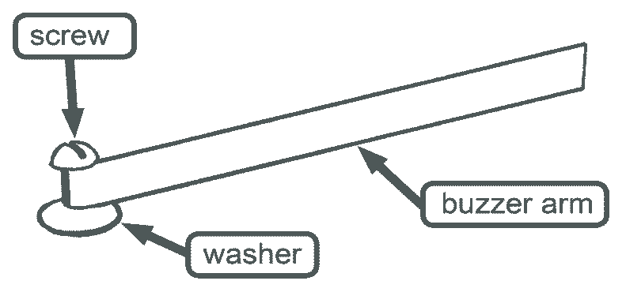

Step 2: Attaching the buzzer arm to the board
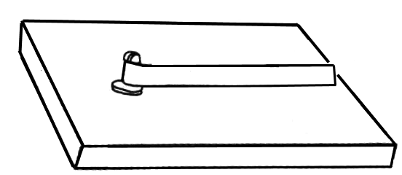
Use the hammer and a 3d nail to start a hole for the screw. Mount the buzzer arm onto the board.

Step 3: Adding the metal angle and fahnestock clip
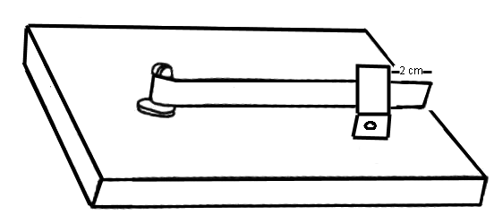

Add the metal angle and fahnestock clip using a tapping screw. Position the metal angle against the buzzer arm at about 2 cm from the free end.

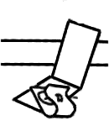

Step 4: Adjusting the metal angle

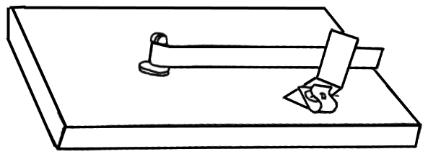
Turn the metal angle so that the side edge would touch the buzzer arm.

Step 5: Adding the rubber band
Hammer the 3d nail firmly into the board. Attach the rubber band by looping it around the buzzer arm.
The rubber band pulling on the nail holds the buzzer arm against the metal angle. The buzzer arm must be able to be pulled away from the metal angle.
Move the arms of the rubber band to tighten or loosen the buzzer arm. You may also need to move the nail.

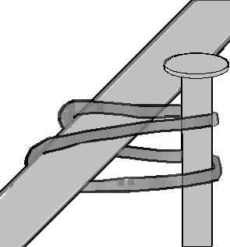
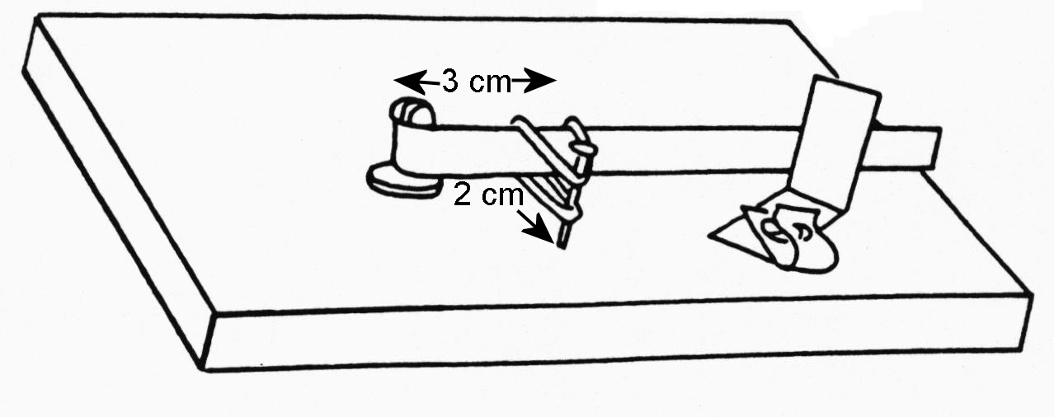

Step 6: Connecting the batteries
Cut one of the insulated copper wires in half. Use the pieces to connect the batteries in series.
Connect the electromagnet to the batteries and buzzer arm, as shown.
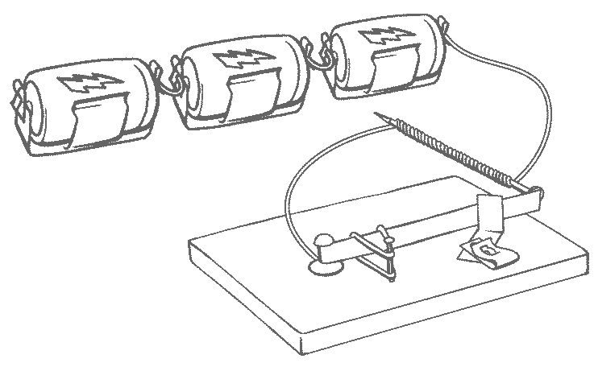

Step 7: Completing the circuit (read Step 8 before you do this)

Use a 15 cm piece of insulated wire to attach the batteries to the metal angle. Use the fahnestock clip for this connection.

Step 8: Making the buzzer sound.

Pick up the nail (electromagnet) and hold it close to (but not touching) the buzzer arm. It should buzz (this may take a bit of adjusting to work).

CAUTION: Do not leave the buzzer connected for more than a few minutes as the nail will heat up and the D cell batteries will go dead.
Touch the nail head to the buzzer arm to check to see if it is magnetized. If it is then you have a closed circuit.

Hold the nail head so close to the buzzer arm that it barely misses touching. In order to hold it so close, you may have to place part of your hand on the table or use your free hand for support.

Trouble shooting
If the buzzer doesn’t work:

- Make sure that all the batteries are properly connected.
- Move the metal angle so that only an edge touches the buzzer arm.
- Sand where the two metals touch as a coating may form which may open the circuit.
- Check to see if there is an overall coating on the buzzer arm or metal angle which needs to be sanded off.

ACTIVITY 5 Worksheet: “What’s the buzz?”

In this activity you set up a system: an electromagnetic buzzer system. The parts of this system work together to release sound energy. The following set of questions asks about the parts of the system and the energy flow in the system.

1. For each of the following, write the name of the part (matter) of the buzzer system that is most directly involved.

Energy | Matter
chemical energy
electrical energy
motion energy
electromagnetic force
sound energy

What two general groups are interacting to release sound energy? Look at the table to help you decide.

______________________________ and _______________________________

2. The interaction of matter and energy can have an effect. Magnetism is a force that can interact with matter and energy. In the buzzer system, magnetism has an effect on the release of sound energy. On a piece of paper write about each of the following:

- Tell how the nail becomes magnetized.

- Tell how the magnetized nail acts on the buzzer arm.

- Tell how the pulling of the buzzer arm away from the metal angle affects the electric circuit.

D. Tell how the opening and closing of the circuit causes the buzzer to buzz.

3. Often, in a system, there is energy input, energy changing form and energy output. Fill in the blanks to show the energy flow in the buzzer system. The first one is done for you.
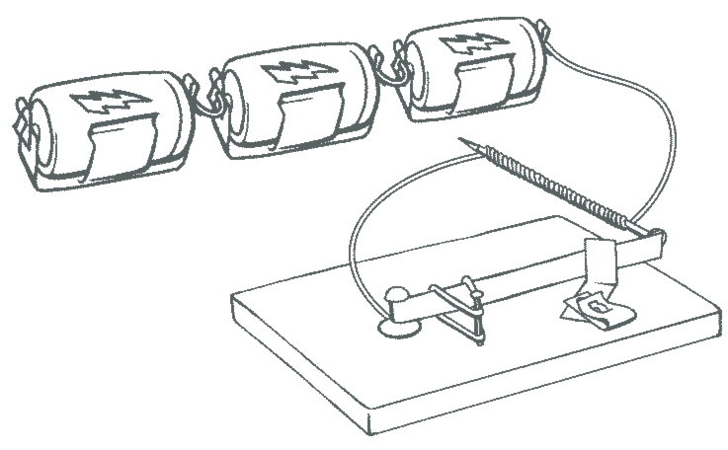

A. Energy is input into the system by the batteries .

B. The chemical energy from the battery changes to electrical energy in the
__________________.

C. The electrical energy creates a magnetic force field around the ________________.

D. The energy of motion in the buzzer arm causes the buzzer arm to vibrate against the metal angle. This hitting against the metal angle outputs energy in the form of ___________________.

E. The electric current in the coils of wire around the nail releases ______________ energy. This causes the coiled nail to get hot.
ACTIVITY 6
How can electrical energy transform to mechanical energy?

Materials:
●1 wire stripper | ●2 rubberized magnets
●1 screwdriver | ●1 piece sanding cloth
●1-30cm piece of bare copper wire | ●1 “D” cell battery
●1-30cm piece magnetic wire | ●1- battery holder
●1-20cm piece of insulated copper wire | ●1 hammer
●4 small screws | ●2 fahnestock clips
●1-3d nail | ●1 small project board (homosote)

Hypothesis: (you will write a hypothesis when you are done with the activity)

Making a Motor: a motor transforms energy of electricity to energy of motion

Step 1:
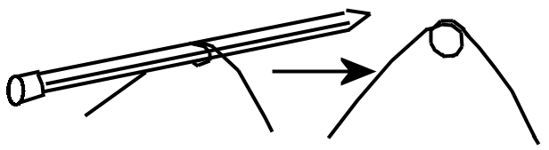
Cut the 30cm piece of copper wire into 2 pieces. Make a loop in the middle of each piece by wrapping it around a pencil.

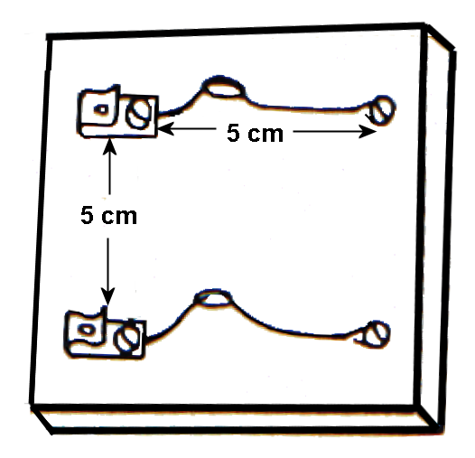

Step 2: (Constructing the “motor mount”)
Attach the wire loops and fahnestock clips to a small project board using the 4 small screws. Use a nail to make starting holes for the screws.

Step 3:
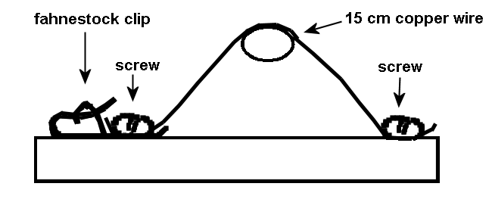
Adjust the loops so that they are standing up. Try to make the two loops the same height. (You can put your pencil through the holes to help you to adjust the loops.)

Step 4: (Constructing the armature – the turning part of the motor.)
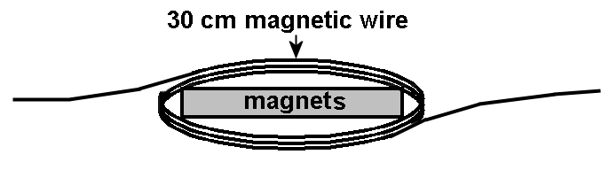
The moving part of the motor is made from the 30 cm piece of magnetic wire. Leaving a 4 cm tail, wrap the wire three times around the width of 2 rubberized rectangular magnets. Remove the magnets.
2

Step 5:
To hold the wire ring together, each end of the wire needs to be looped through the coil and pulled snugly.
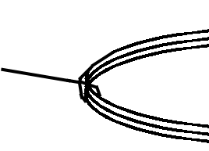
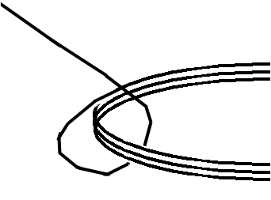

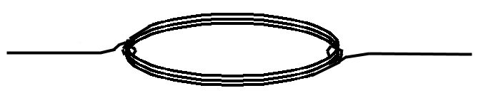
These “arms” of the armature should be in the middle of each end of the wire coil. Otherwise the armature will not be balanced and will not turn properly. Flatten the coil as shown.

arm
arm
coil

Give the armature a SPIN TEST on the motor mount. It needs to spin smoothly. Make any needed changes or adjustments.

Step 6: A VERY IMPORTANT STEP

THIS STEP WILL TAKE SOME PATIENCE!!

You need to sand the enamel coating off of the arms of the armature. When you are done you will have just the top and bottom with the coating sanded off and the two sides with it left on.

Use a sanding cloth to sand the TOP and BOTTOM of the arm. Do this by laying the armature flat on the table. (You may want to protect the table top with a piece of paper or cardboard.) Carefully, sand the top of each arm. Do this by sanding from the coil out towards the end. This will avoid catching the end and bending the arm. Next, turn the armature over and sand the bottom.

When you are finished give your armature another spin test.

Step 7:
Set up the motor as shown in the diagram. You will need to add a battery and battery holder, 2 pieces of insulated wire and 2 magnets.

Place the magnets under the armature. You may have to give the armature a little “flick” to get it started.

If the armature does not rotate then check the evenness of the motor mounts legs and the balance of the armature. Move the magnets so they are not directly under the armature and if all else fails … sand, sand, sand some more to get a better wire contact.

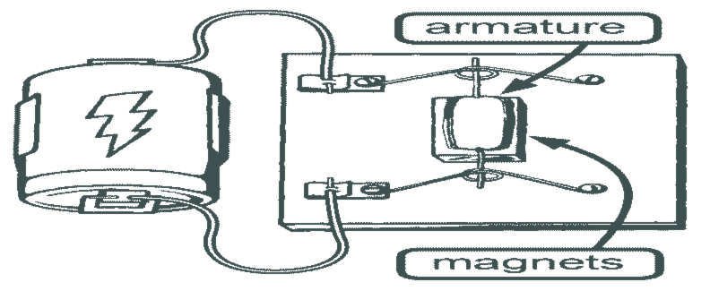

Now, write a hypothesis that answers the activity question.

Activity 6 Worksheet: Who’s got the motion?

In this activity you set up a system: an electromagnetic motor system. The parts of this system worked together to produce mechanical energy. The following set of questions asks about the parts of the system and the energy flow in the system.

1. For each of the following write the name of the part of the motor system that is most directly involved.

Energy/force | Matter
chemical energy
electrical energy
mechanical energy
electromagnetic force
magnetic force

What form of energy and what force interact to produce the motion energy in the motor? Look at the table to help you decide.

___________________________ and ______________________________

2. The interaction of matter and energy can have an effect. Magnetism is a force that can interact with matter and energy. In the motor system, magnetism has an effect on the production of energy of motion. Write about each of the following on a sheet of paper.

- Tell what transfer of energy magnetizes the armature (moving part).

- Tell how the magnet acts on the armature.

- Tell how the motion of the armature affects the electric circuit.

D. Tell how the opening and closing of the circuit causes the armature to turn.
3. Often in a system there is energy input, energy changing form and energy output. Fill in the blanks to show the energy flow in the motor system. The first one is done for you.

A. Energy is input into the system by the batteries.  B. The chemical energy from the battery changes to ______________ energy in the wire. | 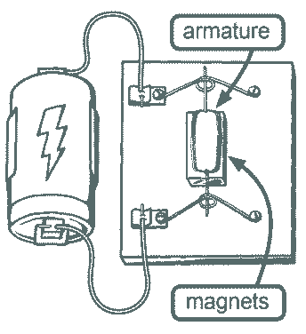
C. The electrical energy creates a magnetic force field in the ______________.
D. The magnetic force field is _____________ or ________________ by the magnet.
E. The interaction of the two force fields causes the armature to have energy of ______________________.
F. As the armature turns, the electrical circuit is _________________ and ______________________.
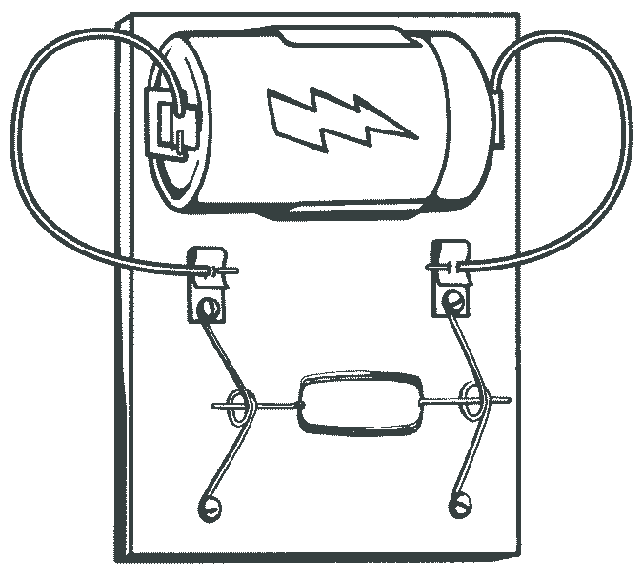
G. Draw arrows on the diagram to show the flow of electrical energy through the circuit.

