PONDS
AND
WETLANDS
Kit #17

Student Journal
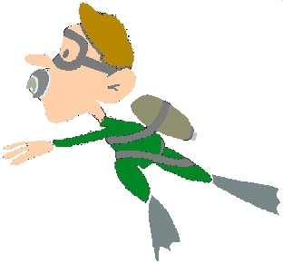

NAME: ______________________________________

Revised May 2013 OCM BOCES Science Center
Teacher Edit Copy
NAME: _____________________________________ Activity 1

What are wetlands? Why are they important? (DVD)

Wetlands: More Than Just Wet Land
Listen for the answers to these questions. Write them down.

- List three reasons why wetlands are important (the DVD gives you 5 reasons)
  - ___________________________________________________________________________
  - ___________________________________________________________________________
  - ___________________________________________________________________________
(Listen to find out which wetland is most common in New York State _________________________)
- What is one type of wetland? ____________________
  - What type of plants are in this wetland?__________________________________________
  - What type of animals are in this wetland?_________________________________________
- What is a second type of wetland? ________________________
  - What type of plants are in this wetland?__________________________________________
  - What type of animals are in this wetland?_________________________________________
- What is a third type of wetland? ____________________
  - What is one type of plant found in this wetland?_____________________________________
- How many acres of wetland was there 300 years ago? _________________________________
How many acres of wetland are there today? _________________________________________
- Over the 300 years, why were wetlands drained or filled in? (Give two reasons)
  - __________________________________________________________________________
  - __________________________________________________________________________
- Which do you think are more important to us: farmland, roads, buildings and homes OR wetlands?
Why? _________________________________________________________________________
______________________________________________________________________________

Name: _________________________________ Activity 1

A CLOSER LOOK AT WETLAND LOSS:
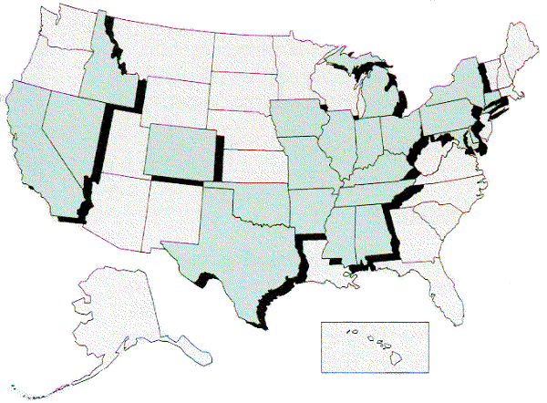
States that lost more than 50 percent of their wetlands between the 1780's and mid-1980's (Listed States shaded)

State | Percent Lost |  | State | Percent Lost
Alabama | 50 |  | Maryland | 73
Arkansas | 72 |  | Michigan | 50
California | 91 |  | Mississippi | 59
Colorado | 50 |  | Missouri | 87
Connecticut | 74 |  | Nevada | 52
Delaware | 54 |  | New York | 60
Idaho | 56 |  | Ohio | 90
Illinois | 85 |  | Oklahoma | 67
Indiana | 87 |  | Pennsylvania | 56
Iowa | 89 |  | Tennessee | 59
Kentucky | 81 |  | Texas | 52

map, WETLANDS STATUS AND TRENDS, U.S. Fish and Wildlife Service (USFWS), 1991

Using the above information answer the following questions:

- What state has lost the greatest percent of wetland? _________________________________
- How many states have lost more than 80% of their wetlands? __________________________
- What is the range of percent of U.S. wetland lost? ___________________________________

NYS reaction to wetland loss: Freshwater Wetlands Act of 1975
The Freshwater Wetlands Act (Act), gives the DEC* and the Adirondack Park Agency the authority to regulate freshwater wetlands in the state. The NYS Legislature passed the Freshwater Wetlands Act in 1975 in response to uncontrolled losses of wetlands and problems resulting from those losses, such as increased flooding. The Act regulates those uses that would have a negative impact on wetlands, such as filling or draining. Permits are needed for projects that may change a wetland or an area near a wetland. (*Dept. of Environmental Conservation)
Why did NYS pass this “Act”? ______________________________________________________

______________________________________________________________________________
Name: _______________________________ Activity 2

Water Distribution: How is the available water distributed on the Earth?

Activity Directions: Divide each of the tasks between group members.

- Fill a 1000 ml beaker with tap water. Add a few drops of food coloring.
hydrosphere
- Pour 27 ml into a graduated cup (30 ml cup). Call this “Cup A”.
- Put the 8 ml of the 27 ml into a graduated cup (Cup B). There should be about
19 ml left in Cup A.
- Using an eye-dropper, place 8 drops from Cup A into a graduated cup (Cup C).
- Using an eye-dropper, place 2 drops from Cup A into a graduated cup (Cup D).

Use the hints or clues to place each of the 4 small containers on the proper circle.

ground water

water as ice

surface water

water in air and soil

The amount of:
- Earth’s salt water (oceans, salty lakes) is the largest amount in a container. (put this aside)
- Earth’s freshwater in the atmosphere and soil is the smallest amount in a cup.
- Earth’s freshwater found as surface water (in lakes, rivers, streams, ponds and wetlands) is the largest number of drops in a cup.
- Earth’s freshwater found as ice (in glaciers and icecaps) is the largest amount in a graduated cup.
- Earth’s freshwater as ground water is the second largest measurable amount in a graduated cup.

In the table below list the major storage locations for water on the Earth.
With your teacher’s guidance fill in the percent of the total water found in each location.

LOCATION | Percent |  | LOCATION | Percent
All Earth’s water (hydrosphere) | 100%

List two things that you learned from this activity?

_____________________________________________________________________________
_____________________________________________________________________________
_____________________________________________________________________________
Name: _________________________________ Activity 2
Where is Earth's water located and in what forms does it exist?
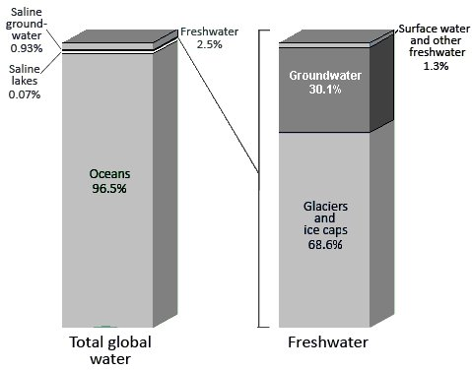

Water Column Diagram

Total global water-
the column represents 100% of the water in the world and how it is divided up.

Freshwater –
the column represents 100% of the freshwater in the world and how it is divided up.

Source: http://ga.water.usgs.gov/edu/earthwherewater.html

Use the above Water Column Diagram to answer the questions.
a. What percent of all water is in the oceans? __________
b. Where else is salt (saline) water found on Earth? ____________________________
c. What percent of all Earth's water is fresh water? ________________
d. What percent of this fresh water is locked up in glaciers and icecaps? ___________
FYI: This glacial water is found mainly in Greenland and Antarctica.
e. Where is most of the remaining fresh water found? __________________________
FYI: No matter where on Earth you are standing, chances are that somewhere deep below you the ground is saturated with water.
f. Under which part of the Freshwater column would you find rivers and lakes?
_______________________________________
FYI: Of all the freshwater on Earth, less than 1 percent is contained in rivers and lakes. Rivers and lakes contain most of the water we use in our everyday lives.
Name: _________________________________ Activity 3
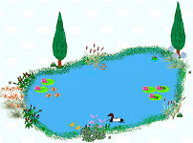
How are ponds formed?

Your group will need 4 paper cups, 4 plastic cups, a 30 ml graduated cup and 300 ml of water (in a plastic jar). Read through the directions and assign each group member a job.

Directions:
- Using a pencil poke 6 holes in the bottom of each paper cup. Try to make the holes the same size and no more than 5 mm in diameter.
- Place 90 ml of gravel in cup #1. Pack the gravel down. (light force)
- Place 90 ml of soil in cup #2. Pack the soil down. (light force)
- Place 90 ml cups of peat moss in cup #3. Pack the peat moss down. (light force)
- Cover the bottom of cup #4 with a piece of clay. Pack the clay into the cup.

Observations: For each cup you will be observing the speed of the water motion and the amount of water that leaves the cup.
- For each cup: Place the cup over a plastic “catch” cup and pour 60 ml of water into the cup. Record your observations and measure the amount of water in the catch cup.
If the water doesn’t pass through the material, place the cup in the catch cup and wait 5 – 10 minutes. Make any observations.

Use drawings to “tell the story” of this activity. Think about how this relates to where we find surface water (ponds, lakes …). Be sure to use labels, arrows and other graphic symbols in addition to written text.

Notes: What we did and what I observed.

Name: _________________________________ Activity 4
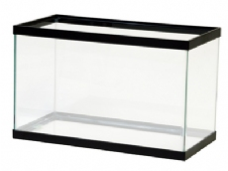
Modeling a pond: Building a pond model

What parts of a pond system are important in building a model of a pond?
Notes:

What resources need to be available for the living things within the model pond?
hydrosphere: Earth’s water

lithosphere: the solid matter of the Earth (rocks, soil, bedrock)

Does the aquarium glass represent parts of the hydrosphere or of the lithosphere?

______________
Notes:

What environmental factors can affect the living things within the model pond?
Notes:

Draw a sketch of the pond model. Be sure to label the parts.
NAME: ________________________________ Activity 5
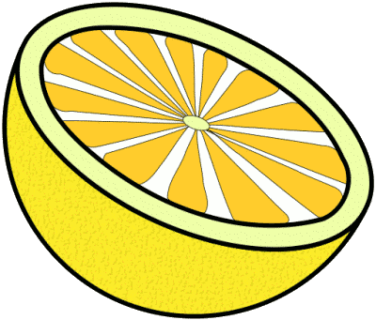
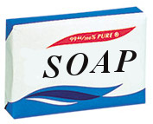
What is pH and How Does it Affect a Pond?

- Record the pH of the following liquids:

Liquid | pH level |  | Liquid | pH level
water (school)
water (home)
vinegar
ammonia
baking soda solution

What are you measuring? What is pH?
pH is a measure of whether a liquid is more acidic, more basic or in between (neutral).

Why does this matter?
Whether a liquid has acidic, basic or neutral properties affects how that liquid will react with other matter, such as the taste buds in your mouth. Liquids that are strong acids or strong bases can react very strongly with matter, especially with living matter. Strong acids or bases can destroy skin (burn). They can irritate or harm moist body tissue (nose, mouth, eyes, lungs). They can affect normal body functioning. Neutral is midway between an acid and a base. The closer the pH of a substance is to “neutral” the less it will react with other matter.

What do the pH measurements mean?
pH is measured on a scale from 1 – 14. On a pH scale the “in between” an acid and base (neutral) is a 7. As the numbers decrease from 7 to 1 the substance is more acid like. As the numbers increase from 7 to 14 the substance is more basic.

- Mark on the pH scale the pH of the liquids you tested:

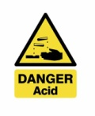

Acid 1____________________________7________________________________14 Base

Neutral
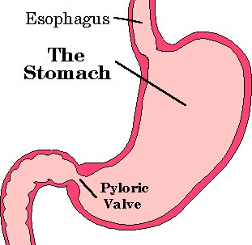
FYI: Every liquid you see will probably have either acidic or basic traits.
You produce acid in your stomach. Stomach acid pH ranges from 1.5 – 3.0. Your saliva has a pH between 6 and 7.4. The pH of urine is around 6. Your body need to maintain a blood pH of 7.4 Your body has buffering chemicals to help to regulate pH.

All living things have internal pH levels to maintain. All living things are affected by substances that are strong acids or strong bases.
NAME: ________________________________ Activity 5

pH and Aquatic Organisms: In what range of low pH can organisms survive?
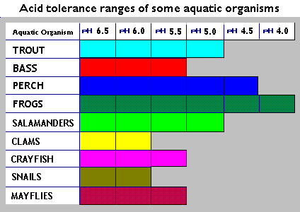

Answer the questions. Use the chart as a guide.

- Does acidity increase or decrease with a smaller pH number? _______________________
- Which of the organisms are most quickly affected by a lower pH?
___________________________________________________________________________
- Which organism is the least affected if the pH lowers? _____________________________
- Snails are prey for Salamanders. If the pH of a pond drops below 6.0 how would this affect the snail and salamander?
___________________________________________________________________________
- A local bog has a pH of 4.5. Which of the organisms can live in the bog?
___________________________________________________________________________
- What have you learned about living things and pH from this chart.

NAME: _______________________________ Activity 6
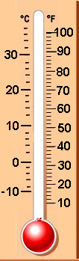
How does pond shape affect temperature changes?

Activity Direction: You will be measuring and recording the temperature of a container of water. Your teacher will share with you the measurement schedule.

- Fill your container with cold water.
- At the start, measure and record the temperature of the water in the container
- Monitor and record the temperatures of the container at the proper times.

Measurement data for my _________ ml container.

Make the thermometer level equal to “room temperature”.

Conclusions: Include how this applies to a body of water in the natural world.
Use drawings to “tell the story” of this activity. Be sure to use labels, arrows and other graphic symbols in addition to written text.

Follow up Activity Conclusion (dish pan vs 1000 ml beaker):

How does this apply to a body of water in the natural world?

NAME: _______________________________ Activity 6

Cold-Blooded or Warm-Blooded: Temperature and Living Things

What does cold-blooded or warm-blooded mean? Does cold-blooded mean that an animal has no feelings? Do cold-blooded critters have really cold liquids in their body? Are warm-blooded animals very friendly? Are the liquids in their body hot to the touch? Well, yes and no, sort of.
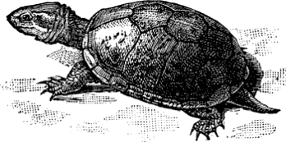
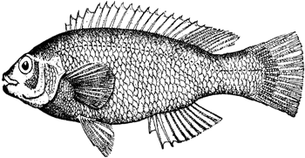
Cold-blooded animals
Cold and warm blooded refers to the inside body temperature of an animal.

Cold-blooded animals have limited ways of controlling their body temperature. The temperature of their insides will become the same as the temperature of their surroundings. Cold-blooded animal groups include: fish, amphibians, reptiles, insects, worms and any smaller organisms.

For cold-blooded animals, if the air temperature becomes cooler, so will the animal’s body temperature. The workings of the animal’s internal body parts will slow down. If the air temperature increases, so will the animal’s body temperature. The workings of the animal’s internal body parts will speed up. They may need more energy (food) and more oxygen to live.

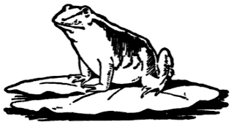
Cold-blooded animals have limited control of their body temperature. There are some ways that their bodies can make adjustments. Some cold-blooded animals are designed to live in colder or warmer water. The bodies of some amphibians, such as some frogs, make chemicals so that they don’t totally freeze during the winter. There are also actions that the animals can take to get warmer or cooler. Cold-blooded animals will look for warm places to go to when it is cold. A turtle will leave the water and “sunbathe” on a log. They will go to cooler places when it is too warm. On a hot summer day, a fish may swim to deeper water where it is cooler or find a shaded part of the pond.

Warm-blooded animals’ bodies will maintain a certain body temperature. Think about some of the things your body does when it is warm or cold. The bodies of warm-blooded animals are constantly working to keep the body temperature near a set temperature. This set temperature for humans is 98.6°F. For ducks this temperature is near 105.0°F. Actually, these two examples – a human and a duck, represent the two groups of living things that are warm-blooded. These two groups are mammals and birds. Warm-blooded animals have fur, hair or feathers.

If you think about the animals that live in a water body, like a pond, most all of them do not have fur, hair or feathers; most all of them are cold-blooded. Most animals in nature are cold-blooded.

Think about what you have just read. If needed, re-read the section. Why do you think changes in water temperature can be important to organisms living in a pond?
NAME: _______________________________ Activity 7
What is oxygen?
What is dissolved oxygen?
What affects dissolved oxygen in the water of a pond system?

Use drawings to “tell the stories” of this activity.
Be sure to use labels, arrows and other graphic symbols in addition to written text.

NAME: _______________________________ Activity 7

What affects dissolved oxygen in the water of a pond system?
Is dissolved oxygen important to a pond system? Yes, it is! Aquatic animals and plants need oxygen. Organisms need oxygen for their cells to release the energy stored in food.
You may be asking yourself, how is oxygen in water? Think about the following: if you put salt in a glass of water and then stir, the salt disappears. However, the salt is still there. If you taste the water, it is salty. A similar thing happens with oxygen in water! It is there, in with the water, but you cannot see it. Oxygen in with liquid water is called “dissolved oxygen”.
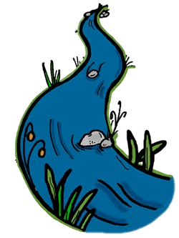
Is there a difference in the amount of dissolved oxygen in different bodies of water? Yes, there can be a huge difference! Rapidly moving water (whitewater) may contain as much oxygen as the water can hold. A quiet pond may contain very little. There are several reasons that the amount of dissolved oxygen can be different in different bodies of water.
Oxygen enters water in two basic ways:
- from the air
- from plant photosynthesis (water plants)
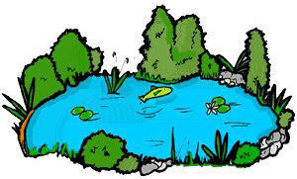
Oxygen enters water naturally. This can be increased by increasing the water motion. Water motion is a result of wind and gravity. Wind causes waves and water flow. Gravity causes water to tumble downhill (whitewater, “bubbling brooks”, waterfalls). In addition to motion there are plant activities. Plants give off oxygen as a waste product from photosynthesis. A plant living in the water releases oxygen into the water.
Oxygen leaves water in three basic ways:
- goes into the air
- used by living things (both plants and animals)
- forced out of the water by higher water temperatures
Oxygen leaves the water naturally. This is affected by the water temperature. Warmer temperatures result in less dissolved oxygen. Colder temperatures result in greater amounts of dissolved oxygen. The oxygen in the waters is also related to the number of living things. It is related to the amount of activity of the living things. The greater number of living things means that there will be more oxygen used. In addition, just like us, the more active the living thing, the more it “breathes” or needs oxygen.

From where does the model pond’s oxygen come? ____________________________________

On a sheet of paper, list 10 important pieces of information about oxygen and ponds.

NAME: _______________________________ Activity 8

How does the amount of light energy affect the pond ecosystem?

Activity Notes: What we did and why. Use text and sketches.

NAME: _______________________________ Activity 8

What affects how much light energy reaches a pond ecosystem?

Sketch a pond that is receiving a lot of sunlight. (Be sure to sketch in the area around the pond.)

Sketch a pond that is receiving less sunlight. (Be sure to sketch in the area around the pond.)

List two ways that the amount of sunlight is important to a pond system? (think about the previous activities)
NAME: ________________________________ Activity 9

The Hand Lens You will be expected to correctly use the hand lens and define “field of view”.

Materials: -hand lens -newspaper
Field of View 1
magnification = __x
Field of View 2
magnification = __x

Activity Steps and Questions:

- Look at the hand lens. How many lenses can you find? _____
- Using magnification or “power” levels:

a. Use the 3x lens and a piece of newspaper.
- Find some letters to magnify. Make sure that one of the letters is the letter “e”.
- Move the magnifier so the letters are large, sharp and clear.
- Draw what you see in Field of View 1.
- Using the 6x lens, the same newspaper and the same letters, focus on the letters.
Draw what you see in Field of View 2.

- What does 3x or 6x mean? __________________________________________ Do you think this measurement is the number of times an image is made large or smaller? _____________
- Which lens (3x or 6x) should have magnified the letters the most? ______ Did it do this? _____
- Using a metric ruler, measure the field of view for the 3x lens and the 6x lens. Do this by holding the lens over the ruler at a level where the lines are the largest and clearest. Next, count the number of mm in the view. This is the field of view measurement.
3x field of view = ______ 6x field of view = _____
- Which lens has the largest field of view? _____ Which lens had the smallest? __________
- What do you think a “field of view” represents? (Hint: it has to do with “area” )
field of view: _______________________________________________________________

- Finish each statement so that it is a true statement.
- The higher the magnification, the _________________ field of view.
b. To increase the field of view you need to __________________the magnification.

NAME: ________________________________ Activity 10

How to Make a Slide

Materials: -eye dropper -thread -scissors -water
-standard microscope slide -tweezers -plastic cover slip

Procedure:
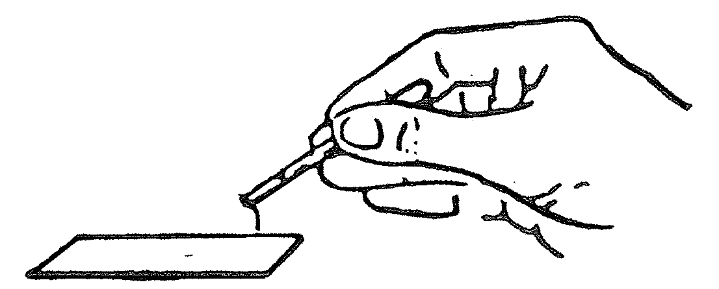
- Place the specimen (a thread) on the slide.

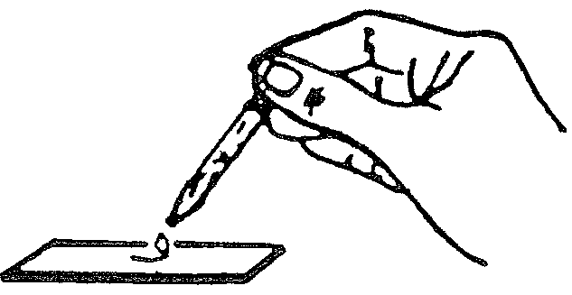
- Very carefully add a drop of water on the specimen.

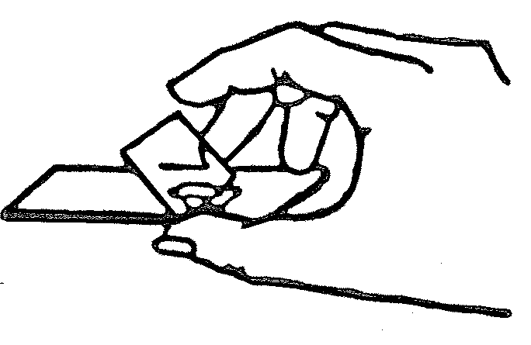
- To cover the specimen with a cover slip, touch one edge of the cover slip to the drop of water.
Next, gently lower the cover slip onto the specimen.
Keep the bottom of the slide dry.

- If bubbles occur, remove cover slip and repeat Step #3. Lower cover slip more slowly to allow air to escape.

- Save this slide. It will be used with the pocket microscope.
- Repeat these steps using a letter “e” cut from a newspaper.
NAME: ________________________________ Activity 11

How to Use a Pocketscope

A pocketscope (microscope) is a scientific instrument that must be handled with care. You must be able to use and care for your pocketscope if you are to be successful with your study of Pond Life.

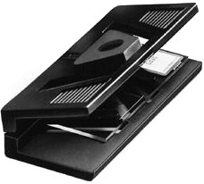
All microscopes work on the same principle: light passes through the specimen, through the lens (where it is magnified) and into your eye. Beyond this, it is only necessary to focus these rays of light. Focusing is done by changing the distance between the lens and specimen. With a pocketscope you do this by gently squeezing the halves together or releasing the pressure which allows the halves to move apart.

Materials: -pocketscope -prepared slide from Activity #3

Procedure:
The pocketscope is one of the easiest microscopes to use.

- Insert the slide made in Activity #3 under the two clips so that the specimen is over the round light hole on the bottom of the pocketscope.
Drawing of specimen

- Close pocketscope firmly and hold.

- Aim toward indirect light source or white paper while looking through lens opening.

- Slowly let pocketscope open until the specimen is in focus.
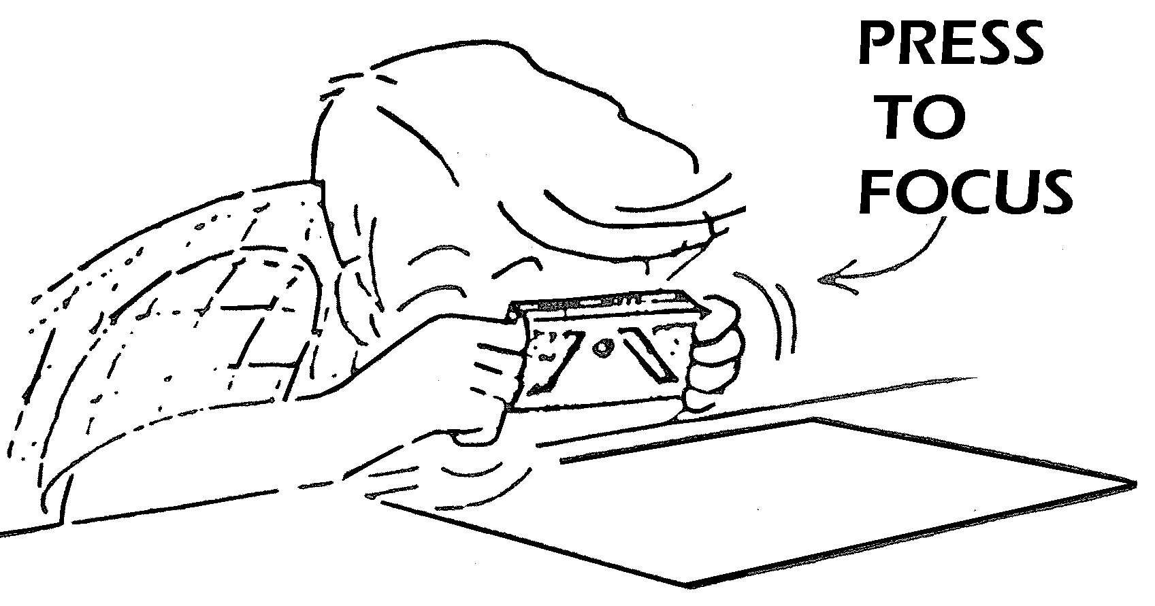

Challenge: What is the field of view measurement for the pocketscope? ______

Your challenge is to find a way of measuring the field of view for the pocketscope lens.
If you are able to do this the next question is: “From this information, make a comparison between the magnification level of the pocketscope and the 6x hand lens?” (higher? lower?) Why do you think this?

____________________________________________________________________________________________________________________________________________________________
______________________________________________________________________________
NAME: ________________________________ Activity 12

Using What You Have Learned—Classroom Samples
Part A:
Observe your specimens using the hand lens and pocket microscope and record your observations below.
3X
6X
pocketscope

Specimen #1:___________

3X
6X
pocketscope
Specimen #2:___________

3X
6X
pocketscope
Specimen #3:___________

Part B: Onion Skin
Slide with stain
Slide without stain
Compare/contrast Notes:

Activity 13
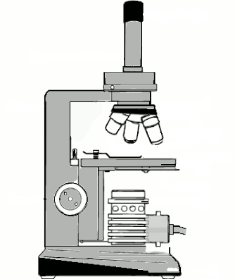
Magnification System: Compound Microscope
Objective lenses
Eyepiece lenses
Light path
Like the hand lens and pocketscope, this system is used to magnify a specimen. Unlike the hand lens and pocketscope, the compound microscope is a system of lenses. Compound microscopes depend upon the ability of light to move up and through a specimen. They need a light source below the specimen.

The light passes from below the image through a lower set of lenses (objective lenses) up and through an upper set of lenses (eyepiece lenses). The person viewing the image will look through the eyepiece lenses to receive the image into their eye.

In addition to the lenses, the compound microscope has components (parts) that help to view the specimen, hold the specimen, or change the amount of light used.
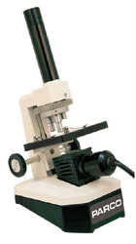
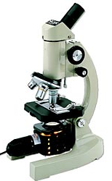
There are many different styles of compound microscopes but they all have some basic parts in common. In this section there will be a list of the basic components of the microscope system. Each component will have a description. Your task will be to read the description and, using that information, find the component on the microscope diagram. As you go along, label each component on the diagram with its name. Next, find these components on a classroom microscope.
After you have done this, return to this page and read the next section on magnification and field of view.

Magnification and field of view
Magnification: Similar to the hand lens and pocketscope the microscope will allow you to view an image that is several times larger than the specimen. The hand lens was able to magnify an image 3x and 6x. A microscope can magnify an image from tens to hundreds of times. In order to find out the magnification of an image viewed under a microscope you must use the magnification power number of the eyepiece lens and of the objective lens that is being used.

Using a classroom microscope:
On the eyepiece lens find a number that tells you the power of the lens. ________
On the objective lens find a number that tells you the power of the lens. ________
Multiply these two numbers to calculate the magnification of the image. _____ X _____ = _______

Field of view: What is the field of view measurement for this magnification? ____________
(To review “field of view, look at Student Journal p. 16.)

COMPONENTS OF A COMPOUND MICROSCOPE Activity 13
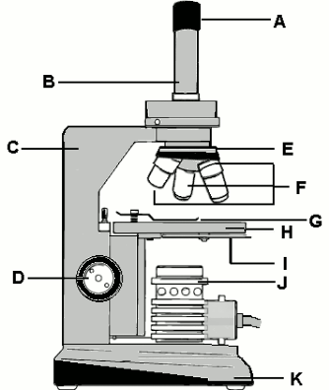

ARM: | frame of the microscope that supports all components above the base
BASE: | stand that rests on the table surface and supports the instrument
TUBE: | section connecting the objective and eyepiece lenses
NOSEPIECE: | holds the objective lenses and turns (revolves)
EYEPIECE LENS | lens that you look through
OBJECTIVE LENSES: | the first set of lenses that the light travels through – may be several of these on the nosepiece
STAGE: | rectangular platform of the microscope where the slide is placed
STAGE CLIPS | clips that hold the slide on the stage
FOCUS: | control knob which will move the stage platform up or down to bring the specimen into focus
ILLUMINATOR: | the light source
ILLUMINATION CONTROL: | allows different amounts of light to enter the lenses, can be a revolving disc located below the stage (disc diaphragm) or a light control wheel that is turned to increase or decrease the amount of light

NAME: ________________________________ Activity 13

Checkpoint: Parts of a Microscope
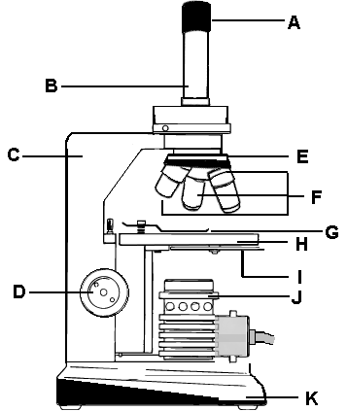
Match the letter on the diagram with the correct part name.

1. Base
2. Nosepiece - revolving
3. Stage
4. Focus knob
5. Tube
6. Arm
7. Stage clip
8. Objective lenses
9. Illuminator
10. Disc diaphragm (Illumination Control)
11. Eyepiece lens
Bonus: What are the letters of the parts that magnify the object?

NAME: ________________________________ Activity 13

Viewing a specimen using a Compound Microscope – Record Sheet
View one slide using the three different nose piece objectives.
(Only do field of view measurements for the two lowest objectives.)

Specimen - ____________________

Magnification - _________

Field of view - _________

Specimen - ____________________

Magnification - _________

Field of view - _________

Specimen - ____________________

Magnification - _________

Field of view - _________
NAME: _______________________________ Activity 14

What basic food chain organisms are found in an aquatic environment?

Specimen - ____________________

Magnification - _________

Field of view - _________

Specimen - ____________________

Magnification - _________

Field of view - _________

Specimen - ____________________

Magnification - _________

Field of view - _________

NAME: _______________________________ Activity 14

Specimen - ____________________

Magnification - _________

Field of view - _________

Specimen - ____________________

Magnification - _________

Field of view - _________

Specimen - ____________________

Magnification - _________

Field of view - _________
NAME: ________________________________ Activity 14

What basic food chains are found in an aquatic environment?

- Below you will see pictures of some pond micro and macro-organisms. There is information about how each of these organisms get their energy. By drawing arrows between the organisms create a basic food chain. The arrows should show the direction of the flow of energy.

Organisms need energy:
Algae get their energy from sunlight. |  | The Hydra will catch and consume Didinium.
The Flatworm will consume Hydras. |  | The Didium will consume Parameciums
The Chilimonas will consume algae |  | The Parameciums will consume Chilimonas.
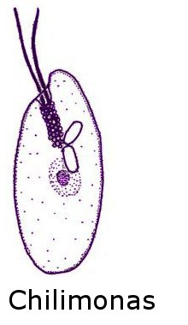
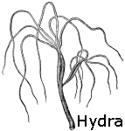
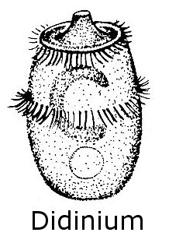

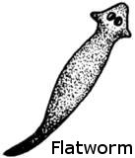

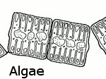
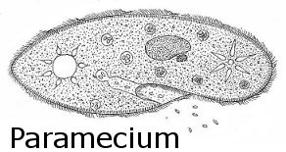

What energy source is missing from the food chain above? ______________________________

- On a sheet of paper, using the information below, create another food chain diagram.

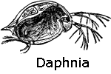
How some aquatic animals get their energy:
The adult form of Eastern Newt lives in ponds and lakes.
Newts prey on snails, mussels, fish eggs and small tadpoles.
Daphnia, a macroscopic organism, feeds on algae.
Tadpoles, a stage in the frog life cycle, will prey on algae and on small aquatic animals such as daphnia.

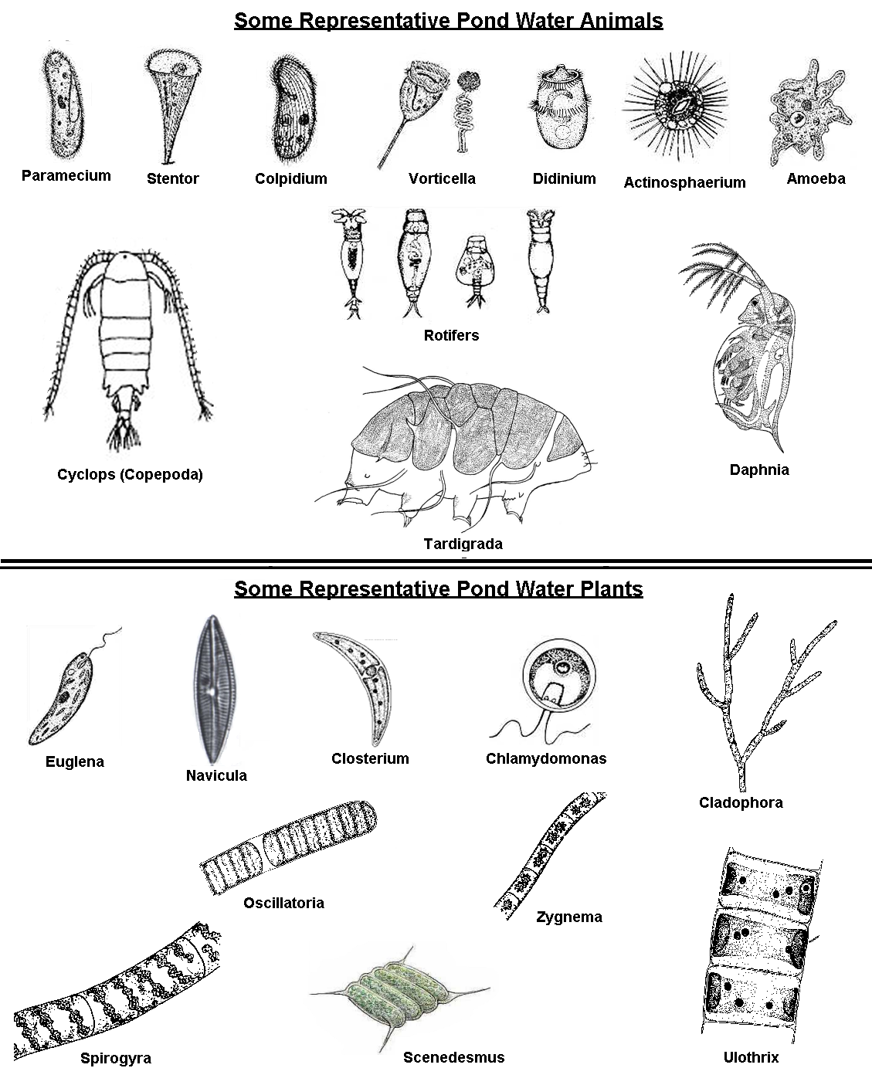
NAME: ________________________________ Activity 14
NAME: ________________________________ Activity 15

Living things in and around a pond:
Like animals, plants are adapted to live in certain places. Places that have certain characteristics. Places where the type of plant can grow and live.

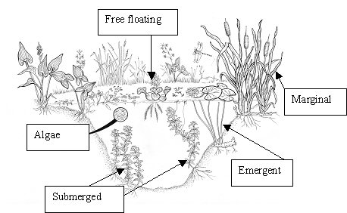
In this picture the different places in and around a pond for a plant to live are labeled.

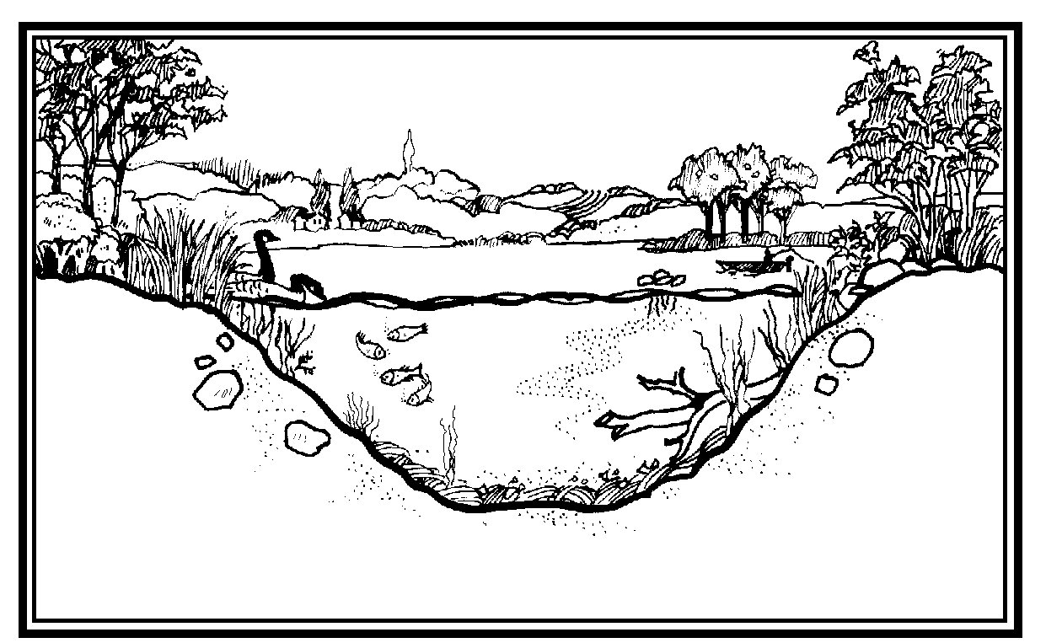
In this picture, below, find and label plants that are: free floating, submerged, emergent and marginal.

NAME: ________________________________ Activity 15
The Interface Between the Aquatic and Terrestrial Ecosystems

A Venn diagram can be used to organize information on how plants and animals occupy the habitats.

List two animals that live in the water in the circle on the left.
List two animals that live on land in the circle on the right.
List two animals that need both habitats in the middle.

Place the four pond plant groups in the proper circles (sections) of the Venn diagram.

aquatic
terrestrial
both

NAME: ________________________________ Activity 16
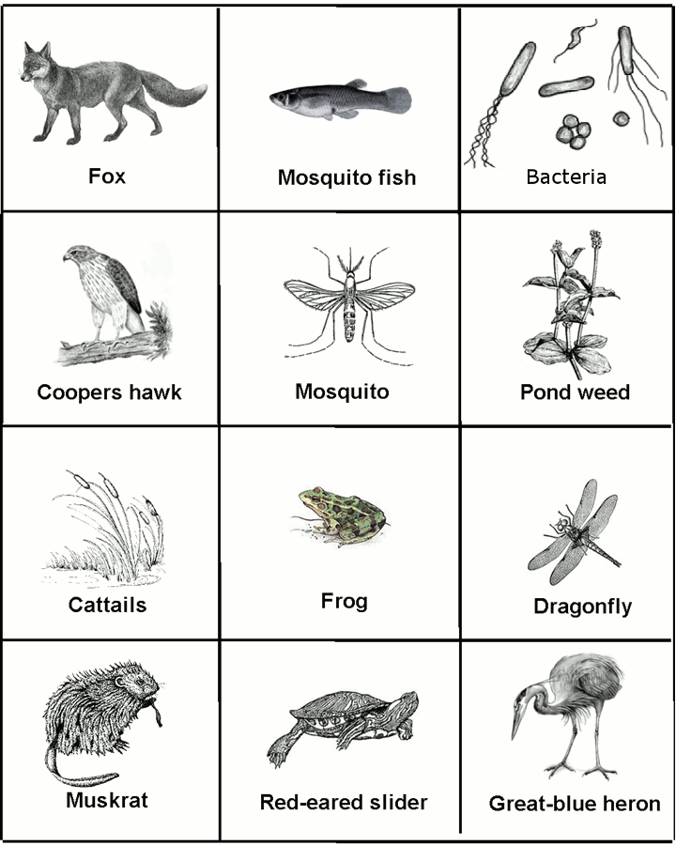

NAME: ________________________________ Activity 16

Energy Pyramid
What “story” is the graphic trying to tell?

List your thoughts:

__________________________________

__________________________________

__________________________________

__________________________________

__________________________________

__________________________________
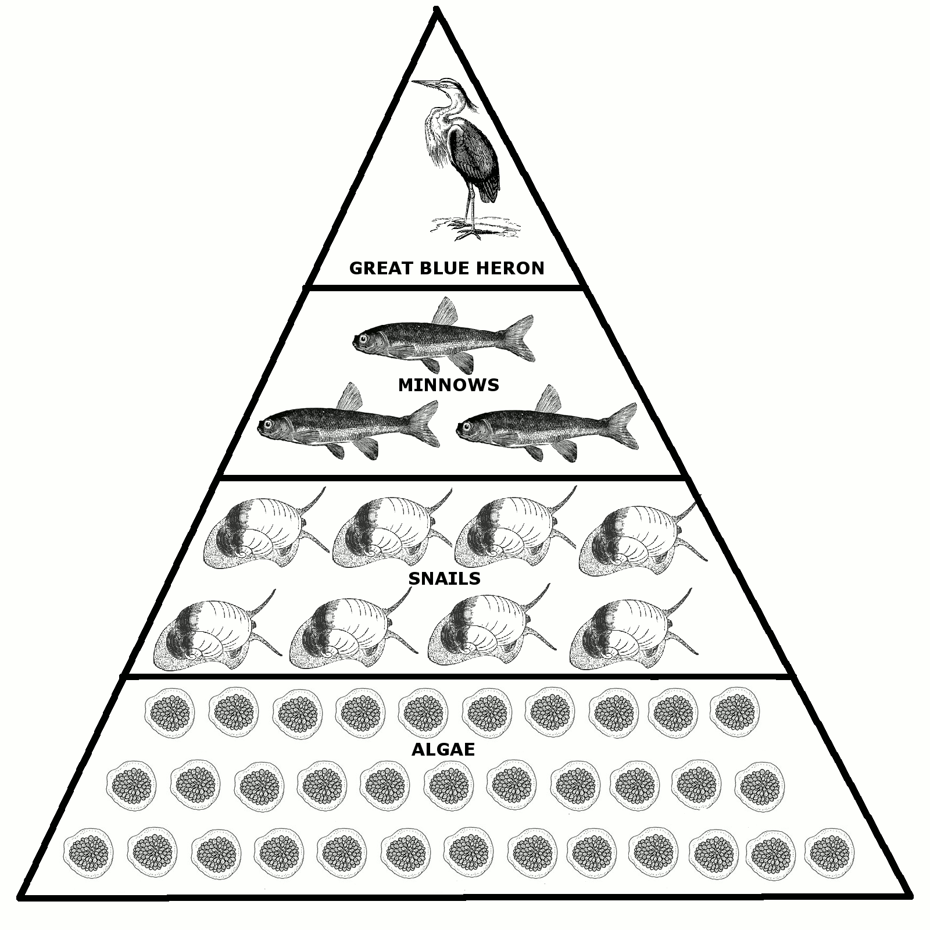

On the graphic, what are the producers?____________

How many levels of consumers are shown? ____

My Pond Energy Pyramid
NAME: ________________________________ Activity 16

Pond Critters Research Cards:
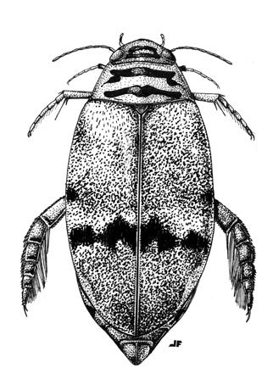  Predaceous Diving Beetle | Snapping  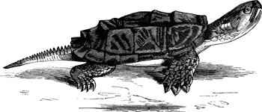  Turtle | 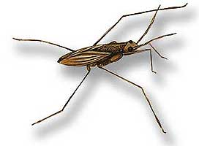  Pond Skater
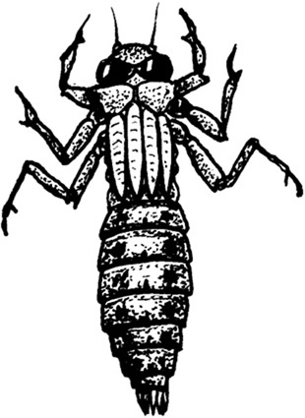  Dragonfly  Larvae | 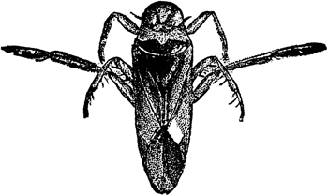  Boatman | 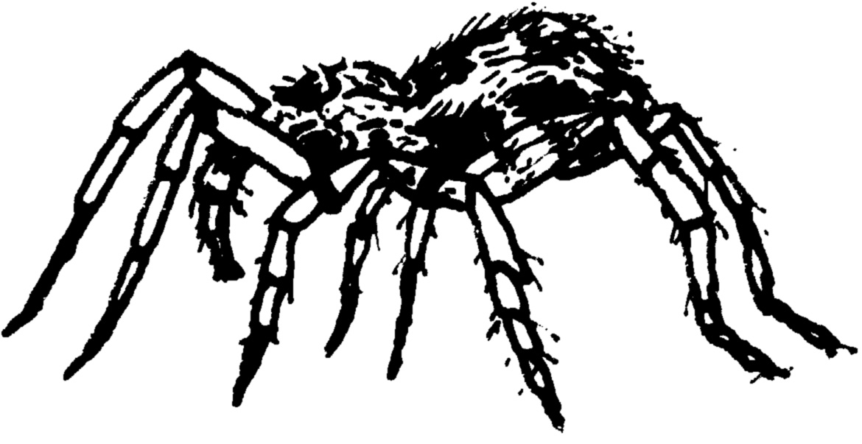  Fishing Spider
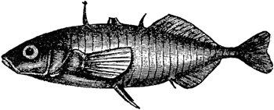  Stickleback | 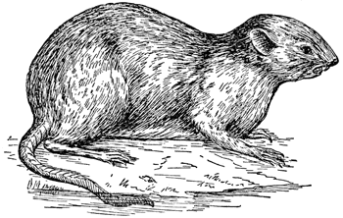  Muskrat | 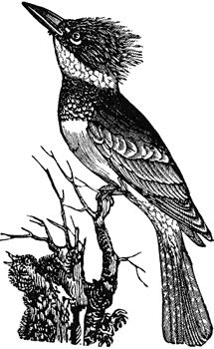  Kingfisher
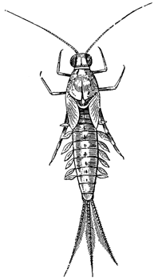  Mayfly  Larvae | 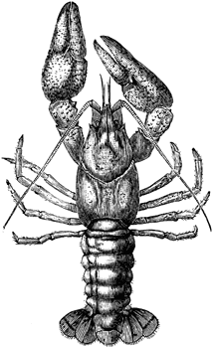  Crayfish | 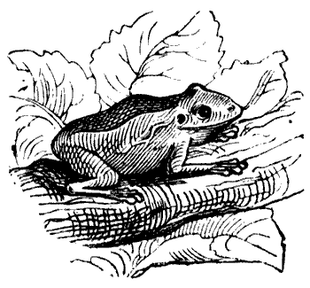  Green Frog

