Kit # 74
Animal Responses

Blackline

Masters

Revised August 2003
Revised Graphics Feb. 2016

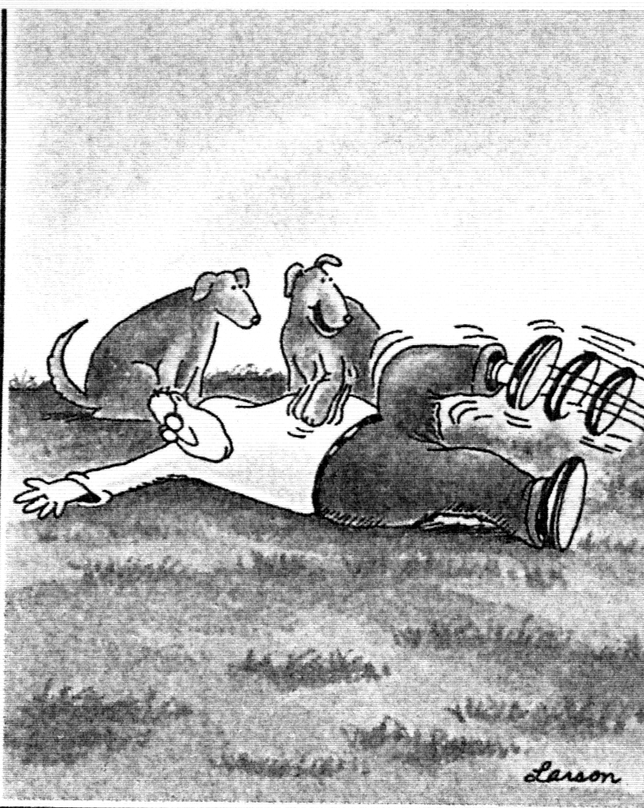

Welcome

To

Animal Responses

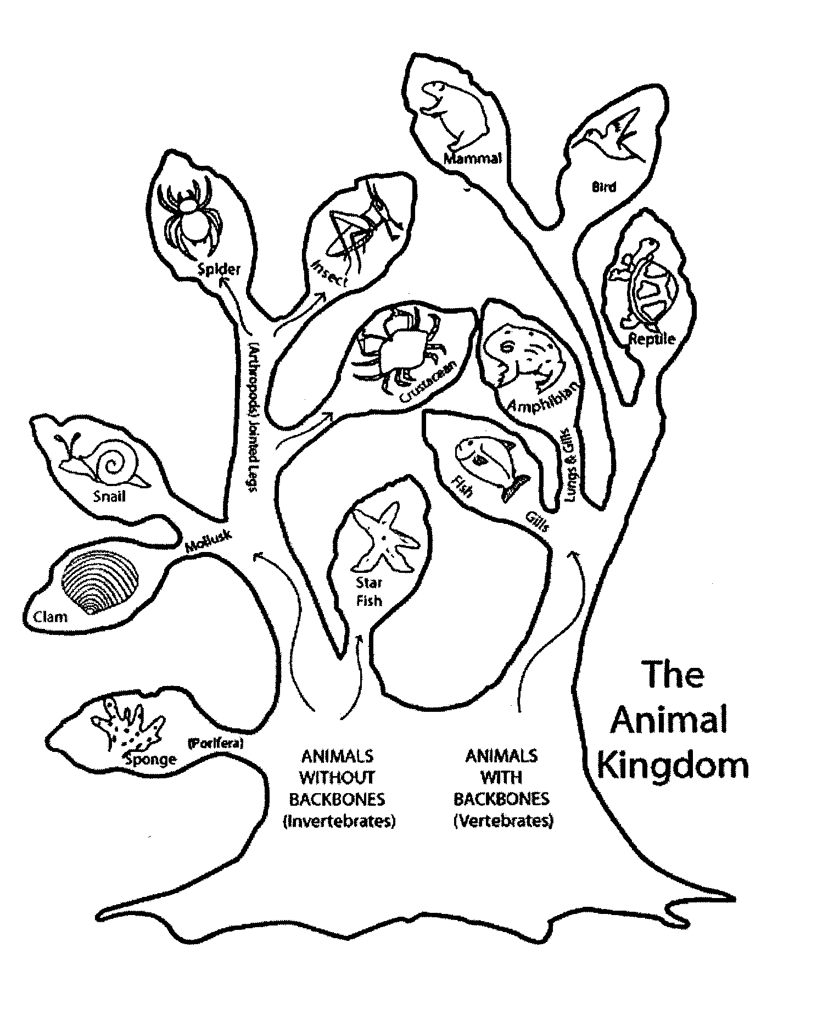

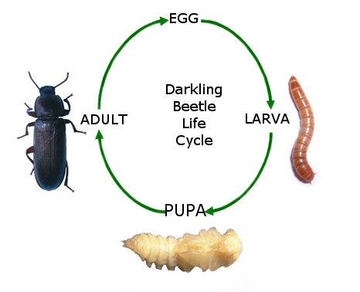

Mealworm

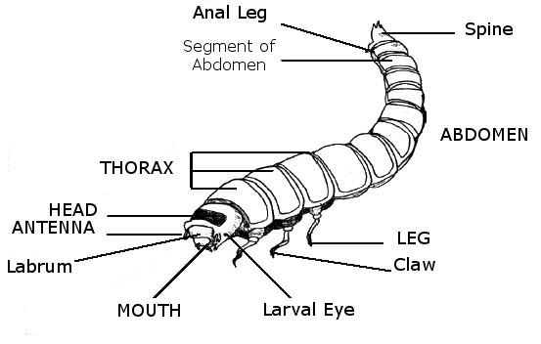

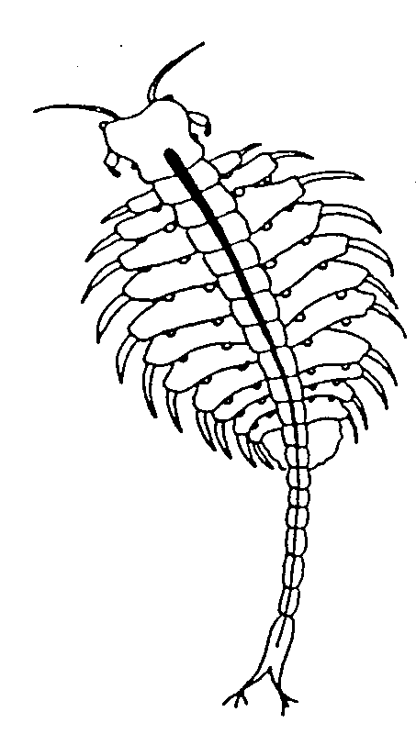
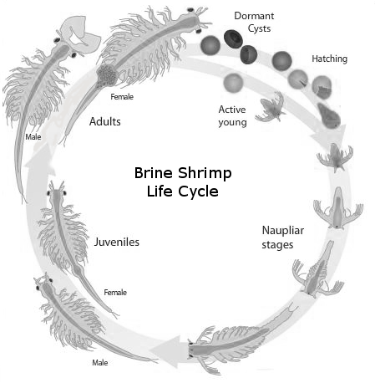
Brine shrimp - Artemia

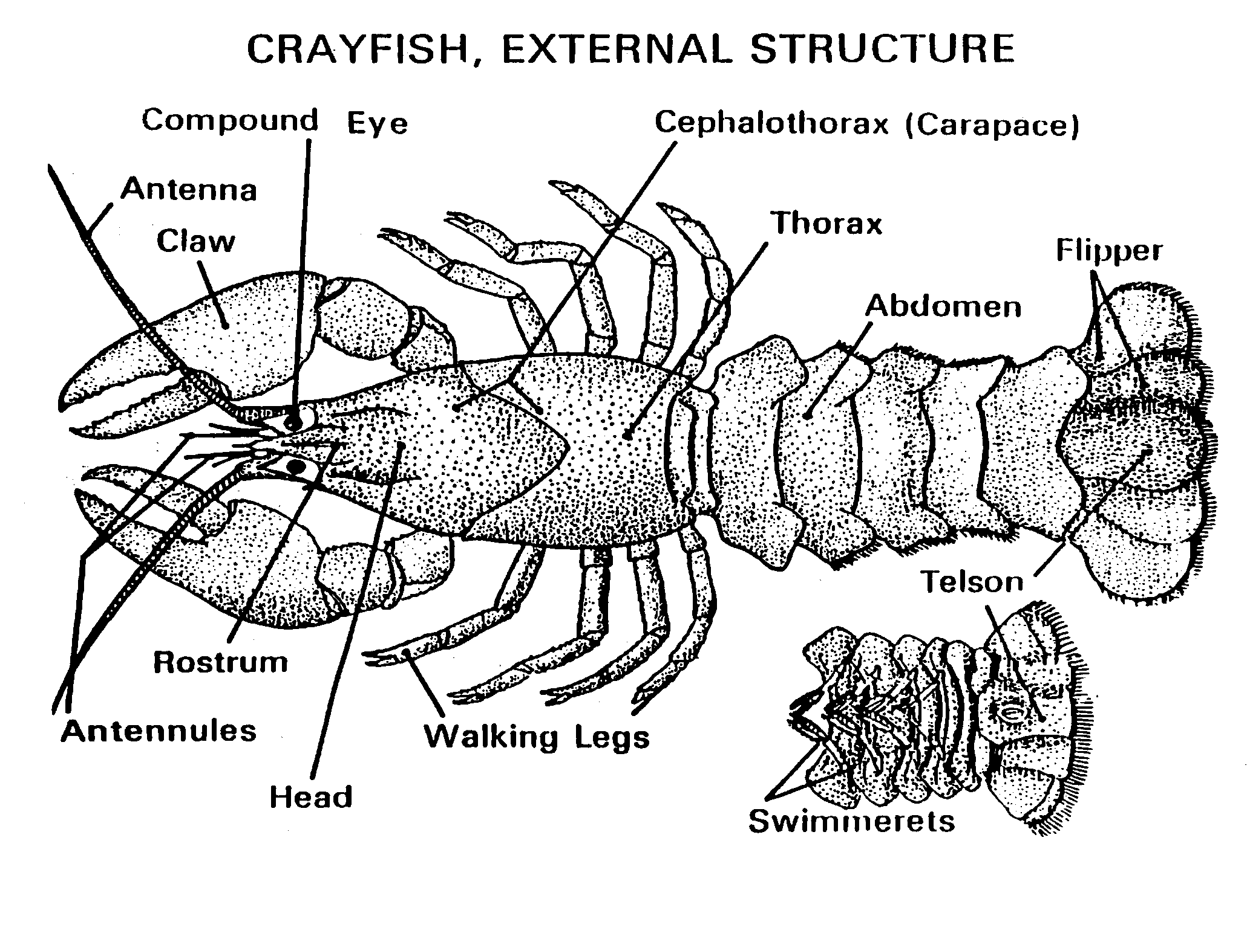

Scientific Process Planning Form

Identifying Problem / Hypothesizing
What do you want to find out? (Question)

What do you think will happen? (Hypothesis)

Why do you think it will happen?

Planning

What are you going to do? What materials will you use? (You may need to continue to write your plan on another sheet of paper, step by step.)

These things will vary (variables): | These things will always be kept the same (controls):

Making Observations
What are you are going to measure / observe?

Recording Results
How are you going to record your observations?

If you are using a data table, what types of data will you place in it?

Create Your Data Table

Conclusions
What happened? Why do you think it happened? Was your hypothesis correct?

