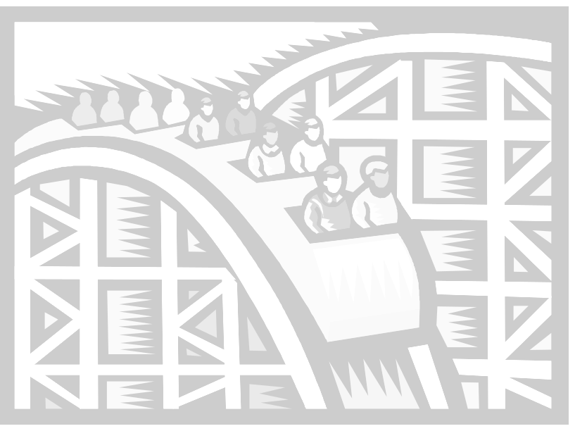
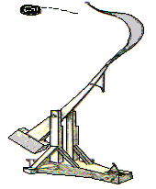

Kit #77
Simple Machines
Student Journal
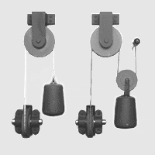

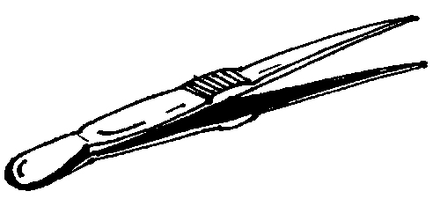
Name:__________________
Revised March 2009

SIMPLE MACHINES KIT PARTS

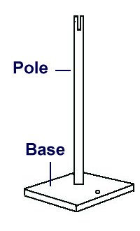
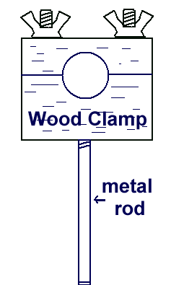
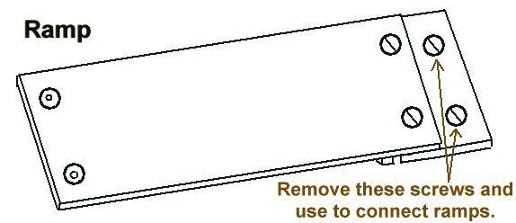

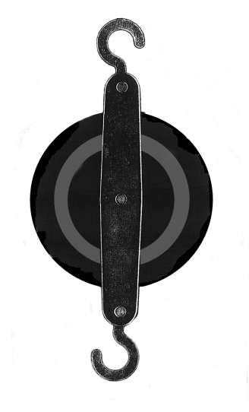
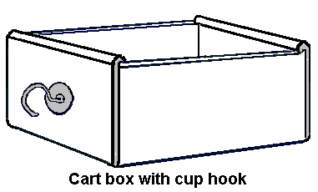
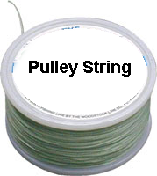
50 cm meter stick with drilled holes
Pulley

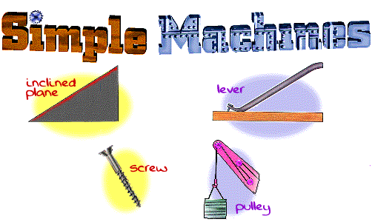
What machines can you think of? What do machines do? Can you imagine cutting grass in your yard without a lawn mower? Can you imagine digging a hole without a shovel? Machines are tools that we use to make work easier.

Machines can be sorted into two types: simple and compound. Simple machines are simple tools used to make work easier. Compound machines have two or more simple machines working together to make work easier. In science, we define work as force acting on an object to move it across a distance. People do work when they push a lawn mower across the lawn. (The engine can help reduce the work we do.) People also use a shovel to reduce the work needed to dig a hole.

In this unit you will learn about simple machines, study force and how machines help us to apply force. You will look at the amount of force and the direction of the force used to move an object. You will experiment with three simple machines to find out how each one makes work easier. You will learn how machines affect the amount of force needed, the distance the load travels, and the direction of the force. To learn about force, we need to learn to use a special kind of measurement tool. A ruler is a tool that measures length or width. What do you think a spring scale measures?

Activity 1a: How do you read a spring scale?

Look closely at a spring scale. Look at the spring that you can see through the clear plastic tube. Look at the two scales labeled on either side of the plastic tube. How do you think the spring scale works? What does it measure?
Hang one or two washers from the spring scale hook, and hold the spring scale in an up-down position. Add three more washers. What happens to the spring inside of the clear plastic tube?
The scale labeled N on the side of the spring scale tube measures the force the hanging washers pull on the spring scale spring. This downward pull is due to the Earth’s gravity. It is measured in units called newtons. A newton is a measure of force.

Activity 1a: Reading a Scale

The N scale on your spring scale is divided into parts of whole numbers. A short line shows each part. The N scale has some of the whole numbers labeled.

- Find the labeled whole numbers and write them here:__________________

- Are there whole numbers on the scale that are not labeled? ____________

From working with your teacher you should know that the scale for your spring scale is in steps of .1 N or 1/10 N. The distance between each line represents 1/10th of a newton.

- When the inside tube of the spring scale is pulled down it moves a certain distance. The distance it moves tells you the amount of force used. How many newtons of force does each of the lettered lines on the picture show?

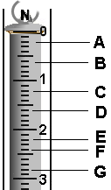
A _______

B _____

C _____

D _____

E _____

F _____

G _____

Activity 1b: What does weight measure?
Read all of the directions before starting.
What is weight?
Weight is a measure of force.

In the next activity you will hang washers from the spring scale. You will be measuring the amount of pull or force by reading the newtons on the N scale.
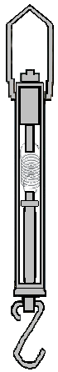
To use the spring scale:
- Hold the spring scale with the hook on the bottom.
- Bring your eyes to the level of the top disk.
- The disk should start at the zero line.

You will be using a spring scale to take measurements and you will be creating a data table to record your data. Being careful and correct in taking measurements is very important.

Materials: spring scale, washers (8), plastic bags

- Hold your scale so that the hook is on the bottom.

- Look at your spring scale. Check to see if the flat section of the disk is at zero. If it is not, please ask your teacher to help you set it to zero.

- Hang two washers on the scale. Read the scale measure in newtons.
Record the measurement in your data table.
Data table

- Hang four washers on the scale. Read and record.

- Hang six washers on the scale. Read and record.

- Hang eight washers on the scale. Read and record.

- Answer the questions on the next page.

Activity 1b: Questions

- In what direction do the washers pull on the spring scale? Why?

- What are you measuring by using the spring scale?

- When you stand on a scale, like at the doctor’s office, what is being measured?

- What happens to your measurements as you add more washers to the scale?

- Draw a graph of your data using “Number of Washers” and “Weight” as your labels. Use the graph paper on the next page.

- From your graph, predict what the weight would be for 12 washers.

- Choose two different small objects in your classroom. First predict how many newtons of force it would take to lift each object. Next, lift each object and record the newtons of force for each one.
OBJECT | Predicted Force | Force (N)

- What else do we find the weight of using a scale?

- What is weight a measure of?

Graph for Number of Washers and Weight of Washers

PLAN Form for Activity 2: How does an inclined plane help you to move an object?

What are you thinking?
What do you want to find out? (This should be a question.)

What do you think will happen?

Why do you think it will happen?

How are you going to explore your question?
What are you going to do?

What will be different (variable) for each test? | What will be kept the same (constant) for each test?

Observing and measuring.
What are you going to measure / observe?

Do you have questions about what you are going to do?

Activity 2 Directions:

How does an inclined plane help you to move an object?

Materials: one spring scale 2 ramps (not connected) plastic bag
30 metal washers wood clamp w/metal arm cup hook cardboard cart box pole and base sandpaper
screw driver ruler/meter stick* graph paper*
*teacher provided

Procedure: Write your measurements on your Activity 2 Worksheet.
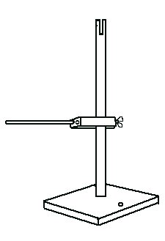  Put the pole, base and wood clamp together.  1 | 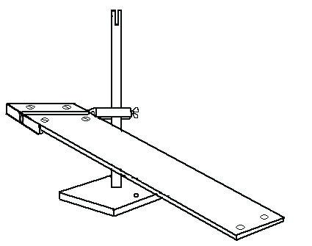  Add the ramp.  Measure the length of the ramp in cm.  2
3  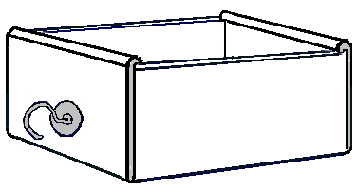  If needed, put the cardboard cart box together. Screw the screw hook into the middle of one end of the box. | Place 30 washers in a plastic bag and hang them from the spring scale.  4  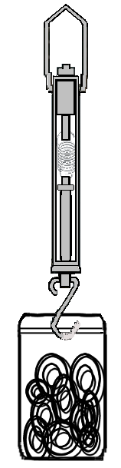  Measure the amount of force that the washers pull on the scale. This is the lift weight or force of the load. Record this on the Activity 2 worksheet.  .

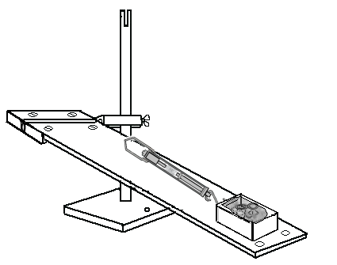
1. Pull the washers up the ramp in the cart using the spring scale. Do this slowly.

2. Measure the amount of force that the washers pull on the spring scale spring.

3. Do this three times.

4. Record all measurements on your Activity 2 worksheet.

5

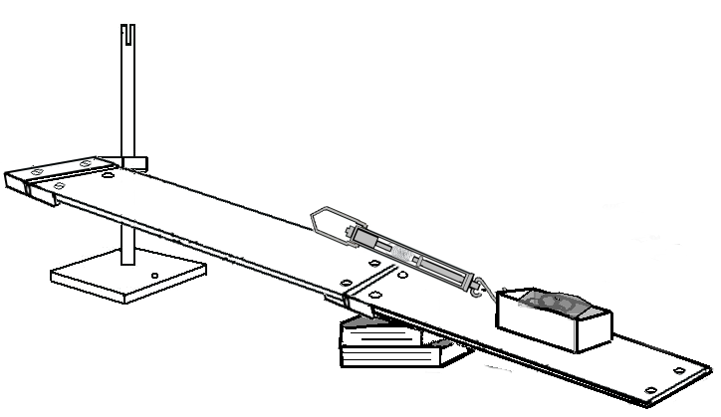
BE CAREFUL NOT TO PUSH DOWN ON THE MIDDLE OF THE RAMP.
6
1. Screw two ramps together. Place a few books under the ramp to support it.

2. Measure the length of the new, longer ramp in cm.

3. Pull the washers up the ramp in the cart using the spring scale. Do this slowly.

4. Measure the amount of force that the washers pull on the spring scale spring.

5. Do this three times. Record your measurements on your Activity 2. Worksheet.

Activity 2 Worksheet:
How does an inclined plane help you to move an object?

Data table
What is the force needed to lift the load straight up? ____________ (weight of washers)
Weight of Washers | Height of the Ramp | Length of Ramp | Force Measure 1 | Force Measure  2 | Force Measure 3

  - Now you need to write observations about your data and experiment. Write four observations. THINK about what was kept the same (constant) for each ramp setup. What was different (variable)? Make sure one of your observations is about what was different. (The first observation is done for you.)

Observations:
1. The height of the ramp was the same for each measurement.

  - Share your data and data observations with other groups in your class. Look for what is the same and what is different. Describe what you notice on the next page.

How is your data the same and different from the other class measurements?

3. A conclusion is a statement that you write. It answers the question your experiment started with. A conclusion may also explain why you do or do not think your experiment was a good experiment.

Write a conclusion by answering the questions below.
What did you want to find out?

What were the results? What happened?

Why do you think it happened?

Discussion Questions: (Answer these questions on a separate sheet of paper.)

- Which used less force, lifting the load straight up or using a ramp?
- Which one is steeper, the shorter ramp or the longer ramp?
- How does the steepness of an inclined plane affect the force needed to move an object?
4. Why do workmen use an inclined plane (ramp) to move a heavy item into a truck?
5. List 2 other examples of where inclined planes are used.
Challenge!! What is a variable in an experiment?
Activity 3a: Defining Work
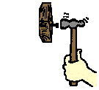

ENERGY THAT CAN DO WORK

Work is using energy to force something to move.

A hammer is able to use its energy to move a nail into a piece of wood.
The hammer does work on the nail.

Your arm uses energy to move the hammer. Your arm does work on the hammer.


A bowling ball hits the pins causing them to move.
The bowling ball does work on the pins. The bowling ball has mechanical energy.

A bow shoots an arrow. The bow does work on the arrow. The bow has mechanical energy.

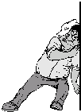
For work to be done, a force must be used to cause some object to move. The force can be a push or a pull. The work is done on the object.
If there is not a force or the object doesn’t move then NO work is done!!

(*Read this paragraph again because it is important!)

WORK = FORCE x DISTANCE
W = F x D

The Science of WORK

Is the man in the picture doing work? ______ Why do you think this? ____________________ _____________________________________________________________________________________________________________________

The Science of Work
To scientists, WORK is action done on one object by another.

Like a hammer on a _____________________

Like a bowling ball on ____________________
Like a bat on a _______________________

Like a ________________________ on a ________________

(Draw a picture below.)

Continue➔➔
To do work a
The Science of Work
To do work you need a force and you need a distance.

So to do work:
The hammer has to hit the nail and the nail has to ____________________.
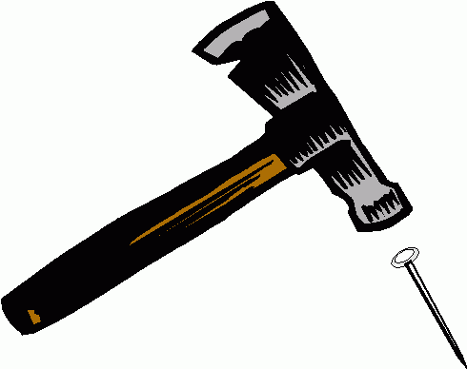

The bowling ball has to hit the pins and the pins have to ________________.
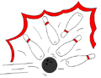

A hand pushes a door and the door ____________________.

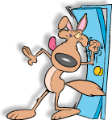

The force can be a push or a pull.

Make up your own sentence about work, and write in the space below.

Activity 3b Worksheet: Measuring Work

Mechanical energy is the ability to do work. For work to be done we need a force and a distance. As you discovered from your experiment with ramps, we can measure force and distance. That means we can calculate the amount of work done.
For each of the problems below, calculate the amount of work done by using this work formula:
Force x Distance = Work
(The first one is done for you: 5 x 2 = 10)

 | Force (in newtons) | Distance (in centimeters) | Work (in newton-centimeters)
A. | 5 N. | 2 cm. | 10 N-cm
B. | 2 N. | 5 cm. | N-cm
C. | 6 N. | 5 cm. | N-cm
D. | 2 N. | 0 cm. | N-cm
E. | 4 N. | 6 cm. | N-cm
F. | ? | ? | 36 N-cm

Let’s try to use math to calculate the amount of work it took to move the load up the short and long ramps.

Complete the data table below.
Write in the force measurement for moving a load up each of the ramps.
Do the math to calculate the work done on each load.
(Remember: Force X Distance = Work)

Item | Force (N) | Distance (cm) | Work (N-cm)
Load up ramp 50 cm long |  | 50
Load up ramp 100 cm long |  | 100

1. Make two observations about your data. (One is done for you.)

The distance is greater each time.

2. Write a thought about how you might use a ramp to do work on an object.

Optional Practice Activity: Work and Inclined Planes Problem

You will be drawing 2 pictures below, each showing a skate park ramp.

In one picture draw a ramp where the person would need a lot of force to travel up the ramp.

In the second picture draw a ramp where the person would need less force to travel up the ramp.
Picture 1
Picture 2

PLAN Form for Activity 4: How does a lever help you to move an object?

What are you thinking?
What do you want to find out? (This should be a question.)

What do you think will happen?

Why do you think it will happen?

How are you going to explore your question?
What are you going to do?

What will be different (variable) for each test? | What will be kept the same (constant)for each test?

Observing and measuring.
What are you are going to measure/observe?

Do you have questions about what you are going to do?

Activity 4 Directions: How does a lever help you to move an object?

Before you do this activity, read all of the directions.
Think about the following questions:
- How do you use a lever?
- What is a lever used for?

Materials: 50 cm meter stick with holes drilled spring scale 1 paper clip
pole and base 15 washers plastic bag

wooden clamp with rod Student Journal pp. 19-23

Definitions: lever: a stiff bar resting on a fixed point which makes work easier
fulcrum: the fixed point for a lever

load arm: the side of the lever doing the lifting (where the load is)
force arm: the side of the lever to which you are applying the force

This is your lever set up. You will be moving the meter stick by placing different holes on the metal rod. The metal rod will be the fulcrum. You will change how much of the meter stick is on each side of the fulcrum.
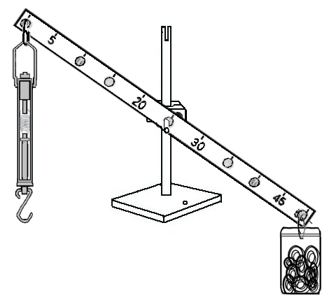
Bag of washers at 50 cm end.
fulcrum
Spring scale attached by paper clip at 0 cm end.
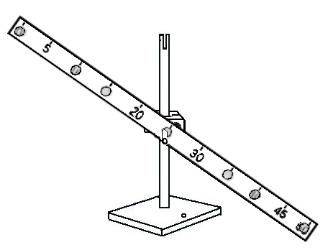
wood clamp with metal arm
50 cm stick with holes drilled

Use a paperclip to attach the load

Activity 4 Directions continued

1. Set up the meter stick lever as shown in the diagram. Place the set up so that the spring scale does not hit the table top.

2. The metal rod is the fixed point or fulcrum for the meter stick lever. Set the meter stick so that it is attached at the 25 cm hole.

3. With the spring scale and washer load attached to the lever, make your first measurement at 25 cm by pulling down on the spring scale until the load is lifted off the table. Read the force needed to lift the load in newtons. Record your results in this data table.

Fulcrum point | Force in newtons | Length of Load Arm | Length of Force Arm
25 cm.

4. How long is the load arm? How long is the force arm? Record this on your data table.
REMINDER ☺

The load arm is the side that the load is on.

The force arm is the side that the force is on.

5. THE CHALLENGE:
How does the length of the force arm affect the amount of force needed to move a load?

Your task is to find out the answer to the above question.
To do this, you can use your lever set up.
You can use the data table on p. 21 to organize your data.

6. Fill in the rest of pg. 21 to help you to look at your data and draw a conclusion.

Activity 4 Worksheet: How does a lever help you to move an object?

Data table: Levers and Forces
Fulcrum point | Force in newtons | Length of Load Arm | Length of Force Arm

Write two observations about your data.

Write about your experiment.
What did you want to find out?

What were the results? What happened? (Conclusion)

Why do you think it happened?

Let’s try a different lever question. If you can only pull down with a force of 3 N, what is the greatest number of washers can you lift using your lever system?

Predict how many you can lift. ___________ How many did you actually lift? _____________

Discussion Questions

- Look at your data table. Where was the fulcrum set when you used the least force to lift the weight?

- Look at the column titled “Length of Force Arm”. When the force arm was longer, did you need less force to move the load or more force?

3. To lift a load, where would you place the fulcrum to make the force arm longest, near or far from the load?

4. In the picture below, draw in the fulcrum so that Person 1 could lift Person 2.
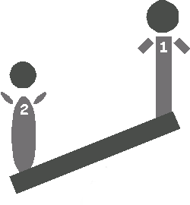
Load
Force

5. Fill in the blanks in the following sentences. It is easier to lift a load when the fulcrum is ___________________ the load. It is easier because the force arm is ______________ and you use _______________ force.
6. Do some research to discover different objects that are levers. List some of them.

7. How does a lever make work easier?

Activity 4 Student Worksheet: Fulcrum

FIND THE FULCRUM: Believe it or not, each item in the pictures shown can do work as a lever. Find the fulcrum point for each lever and circle it.

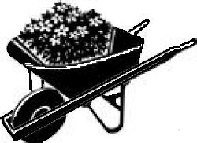

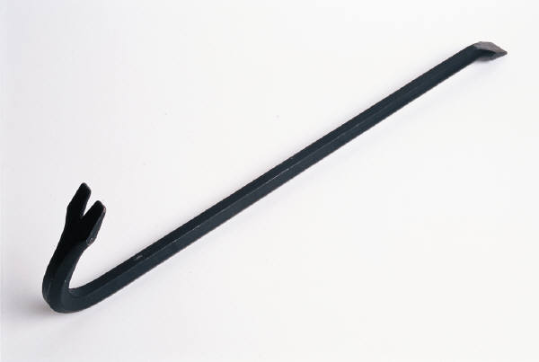

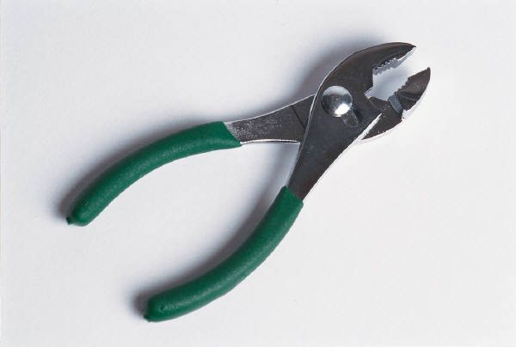

PLAN Form for Activity 5: How does a pulley system help you to move an object?

What are you thinking?
What do you want to find out? (This should be a question.)

What do you think will happen?

Why do you think it will happen?

How are you going to explore your question?
What are you going to do?

What will be different (variable) for each test? | What will be kept the same (constant) for each test?

Observing and measuring.
What are you are going to measure / observe?

Do you have questions about what you are going to do?

Pulleys, Pulleys Everywhere

Using elevators, escalators, cranes and boatlifts, things are moved up and down by the use of pulleys. By the power of pulleys we are able to lift loads. These loads would be difficult or impossible to lift up by hand. Sometimes a single pulley is enough to do the job. Other times a more complex system of wheels and rope is needed.

A pulley system is made up of wheels with axles and a rope that runs over the wheels. A pulley has a wheel and an axle. Often the wheel has a groove for the rope to run in. There are different styles of pulleys, like the two types found in your Simple Machines Kit. The rope can actually be a cotton rope, a belt or even a cable or chain.

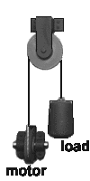
A simple pulley system is made up of one pulley and a rope. Let's say you have to lift a heavy load, like a bale of hay, up to the second floor of a barn. You could tie a rope to the bale of hay. You could then stand on the second floor and pull it straight up. Another choice is to put a pulley at the second floor. Then you could stand at the first floor and lift the bale of hay by pulling straight down. Whether you pull up or down, you do the same amount of work lifting the bale of hay.

When you pull down, it feels easier. That is because you're working with the force of gravity. By pulling down, you are able to add your body weight. This type of pulley would be a fixed pulley. A fixed pulley is bolted or tied in place. It doesn’t move about. It just turns. A fixed pulley can change the direction you pull from. (For example, you raise the flag by pulling down, using a pulley at the top of a flag pole.)

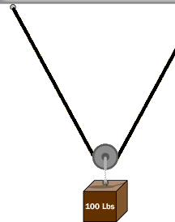
A moveable pulley is a pulley that moves along the pulley rope. The object you are moving is tied to the moveable pulley. One end of the rope is tied to a place above the moving pulley. The rope shares the weight of the load. As the pulley moves the load along the rope, the rope helps to hold it up. Less force is needed. A moveable pulley decreases the force you need. The direction you have to pull with this type of pulley is upwards.
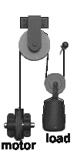
A complex pulley system uses more than one pulley and a longer rope. Look at the diagram to the left and find the fixed pulley. Find the moveable pulley. The fixed pulley is attached to the wood beam and the moveable pulley rides on the rope. The load is hooked to the moveable pulley. This set up is called a block and tackle.

By using many moveable pulleys, you can really decrease the force needed to lift something. By using fixed pulleys you can change the direction you pull. Of course, the more pulleys you have the longer the rope has to be. You have more moving parts. A block and tackle is a complex pulley system made up of fixed and moveable pulleys.

A pulley is a simple machine because it has one basic moving part. Put many pulleys together and you have a pulley system.
Fixed pulley
Moveable pulley
Activity 5 Directions: How does a pulley system help you to move an object?

**BEFORE YOU DO THIS ACTIVITY, READ IT ALL THE WAY THROUGH.**

In this activity you will be experimenting with a simple machine called a pulley. You will be looking for an answer to the title question.

Materials: pole and base spring scale plastic bag

wooden clamp with metal arm paper clip 2 single pulleys
books (to hold the base)* 30 washers string (see note**)
Student Journal pp. 27-30
(**note - the piece of string should be about two times
the distance from your desk top to the floor)
*teacher provided
Beginning Set Up
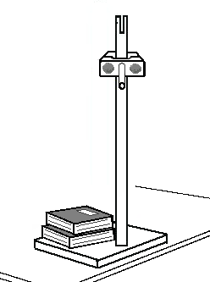  Put together the pole, base and wooden clamp as shown. Use the hole for the pole that is near the edge of the base.  You will need to put a weight, such as some books, on the base so it does not tip over.  Measure the amount of force that the washers pull on the scale. This is the lift force for the load without a pulley system.  Place 30 washers in a plastic bag.  Hang them from the spring scale.  1 | 2  Write the measurement in the data table on the “Activity 5 Worksheet”.

Exploring a Fixed Pulley System

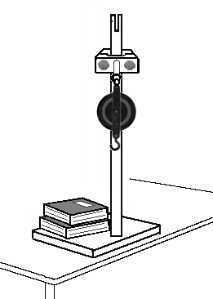  1  Hook a 2-pulley block onto the clamp rod. (If the rod is too large use a paperclip to hang the pulley.)  Tie a loop in each end of the string. | 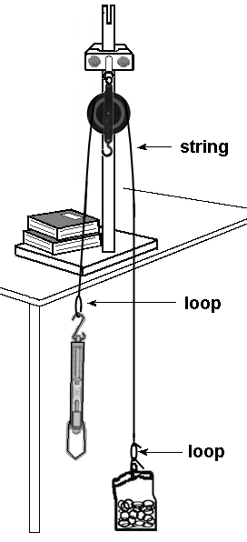  2  Using a paperclip attach the washers (load) to one end of the string.  Hook the spring scale to the other end of the string.

3. Pull on the spring scale in the direction needed to raise the weight. (You need to pull it down.)

4. Record the force measurement on the Activity 5 Worksheet data table.

5. Record the direction that you pulled the spring scale on the Activity 5 Worksheet data table.
Exploring a Moveable Pulley System

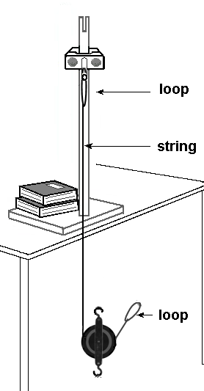  1  Set up a moveable pulley using the pulley and string, as shown. A team member will have to hold the pulley and the string by the bottom loop until you get the load attached. | 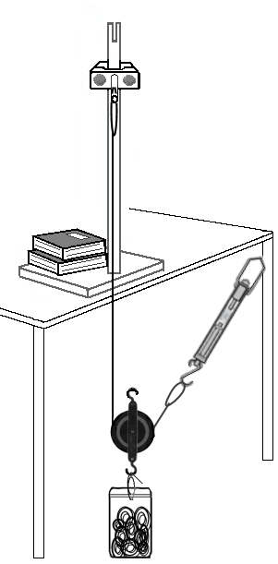  2

3. Pull on the spring scale in the direction needed (up) to raise the weight.

4. Measure the force needed to raise the load. Record your answer on the Activity 5 Worksheet data table.

5. Write down the direction that you pulled in on the Activity 5 Worksheet data table

Activity 5 Worksheet: How does a pulley system help you to move an object?

Pulley Activity Data Table
Pulley Set Up → | No Pulley, Weight of Load | Fixed Pulley | Moveable Pulley
Load Force (weight)
Lift Force
Direction Load Moves
Direction of Force

Make two observations about the data on your data table.

Write about your experiment.
What did you want to find out?

What were the results? What happened?

Why do you think this happened?

PLAN Form for Activity 6: How do surfaces affect the force you need to move an object?

What are you thinking?
What do you want to find out? (This should be a question.)

What do you think will happen?

Why do you think it will happen?

How are you going to explore your question?
What are you going to do?

What will be different (variable) for each test? | What will be kept the same (constant)for each test?

Observing and measuring.
What are you are going to measure/observe?

Do you have questions about what you are going to do?

Friction Forces

In a game of tug-of-war, one team of five children stands on a frozen pond. The other team of five children stands on the sandy shore. Would this be a fair game? Which group would have an advantage? Does friction have a part in this? Yes, it does. Friction can be helpful or it can be a problem.
Friction is a force that acts when two objects rub against each other. Friction tends to keep objects from moving. Rough surfaces make more friction than smooth surfaces. Pushing a box across a rough floor will take more force than pushing one across a smooth, polished floor. Sometimes friction is a problem. It may stop something from moving easily. Sometimes it is useful. We may not want something to move or slide easily.

Friction is a force that slows moving things. There are ways that you can have less friction. By having less friction we can use less force to do work. One way of decreasing friction is by using rollers or wheels and axles. Another is by using small steel balls called ball bearings. These small balls roll easily next to each other. Roller skates and skateboards make use of ball bearings. Making things slippery is another way of reducing friction. This is called lubricating. You can lubricate something by using a liquid between the moving parts. Water, oil, grease, and soap can be used as lubricants.
Friction can be very helpful. The rubbing of two objects can cause heating. We get heat when there is friction. One of the first uses of friction was to make fire. Early humans found that rubbing two sticks together caused heat. The friction between the sticks could make them hot enough to cause a fire.

Friction Forces continued

In bicycle brakes, the rubber of the brakes rubs against the metal of the wheel. If you touch the brakes they would feel warm. The friction between the brakes and wheel slows you down.

In our daily lives, the right amount of friction is important. Without friction, we could not walk, stand, run or sit in a chair.

Too much friction makes heavy objects hard to move. Too much friction wears away surfaces. It causes machine parts to heat up. This is why we put oil in our car engines. Oil decreases the friction between the moving parts. Too much friction or rubbing between your foot and your shoe can cause blisters to form.

Too little friction is a problem on wet or icy roads and sidewalks. If you wax a floor or spill water on a floor, you have less friction and can make the floor slippery. Someone can slip and fall. Sometimes we put rugs on floors so that people do not slip. In these cases, friction must be increased. On our roads this is done by putting grooves in the pavement and by using salt to melt any ice. Sometimes sand is thrown on a road and chains are put on the car tires. This is all done to make increase friction.

The right amount of friction can be useful. Too little friction can make surfaces too slippery. Too much friction can make it hard to move something and make surfaces heat up.

Try rubbing your hands quickly together. Feel the little bit of heat? Feel the friction? If you rub your hands together with some hand cream or oil on them they will feel much different.
Activity 6: How do different surfaces affect the force needed to move an object?

Your challenge is to modify the cart box set up so that you reduce the force the greatest out of all the groups in your class.

- Set up the ramp using the pole and base
- Place the load of washers in the cart box.
- Using the spring scale pull the cart box up the ramp. Write down the amount of force needed in newtons.
- Without changing the height or length of the ramp, think of changes that you could make so that it will use less force and more force to move the washers up the same ramp. (Do not change the amount of washers.)
- Decide on two ways of making changes – one for using less force and one for using more force.
(The next page has space for you to draw/write your plans.)
- Test out your changes and record the amount of force needed.
- Compare the measurements. Write a paragraph about what you did and what were the results.
Data Chart
Cart | newtons
original cart box
cart using less force -
cart using more force -

Discussion Questions:
- What change did you make to use less force?
What property did you change? _________________________________
- What change did you make to use more force?_______________________
What property did you change? __________________________________
3. What is the word used to describe rubbing surface forces? _____________

My plan for using less force and my plan for using more force:
Less force More force

Glossary for Simple Machines

axle a rod on which a wheel turns

ball bearings small metal balls, used to reduce friction

block and tackle fixed and moveable pulleys used together

compound machine a machine made up of two or more simple machines

distance the space between two objects

efficiency the amount of work done by a machine compared to the amount of work put into it

energy the ability to do work

equal of the same quality, value, degree, or intensity

fixed pulley a pulley that stays in place as the load moves

force a push or a pull

force arm on a lever, the distance from the force to the fulcrum

friction a force that slows the motion of two objects rubbing against each other

fulcrum the turning point of a lever

gravity the pull between the earth and other objects

inclined plane slanted surface that connects one level to a higher level

increase to become greater in amount, size, degree

joule acting through a distance of one meter

lever a bar resting on a turning point

load object to be moved or lifted by a lever

load arm on a lever, the distance from the fulcrum to the load

lubrication a way of reducing friction by using a liquid on the moving parts

machine anything that makes work easier

moveable pulley a pulley that moves with the load

multiple having or consisting of many parts

newton metric unit of force

predict what one believes will happen

pulley (fixed, moveable) a wheel with a rope moving around it

reduce to lessen in any way, as in size, weight, amount, value

resistance the opposition of a thing to movement by a force

simple machines one of a variety of things used to make work easier

slope any inclined line, surface position; slant

spring scale (force measurer) device used to measure force or weight

steep sharpness of rise or slope

unequal not the same amount

weight the measure of the pull of gravity on an object

work equals force used times distance moved; what is done when a force moves an object

