
Science Center

Kit #77

Simple Machines

Blackline Masters

Revised March 2009

Spring Scale Master

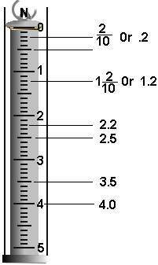

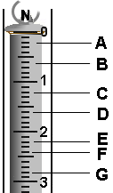

Activity 1 Student Evaluation: Name ________________________________

Weight and the Spring Scale

Materials: spring scale, washers

A. Task: Using the spring scale measure the weight of 5 washers and 10 washers. Write down the spring scale measurement and the units.

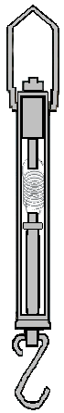
5 washers = ___________ 10 washers = _____________

B. What is the force pulling on the washers causing the washers to pull on the spring scale?

C. What is the direction of this force?

D. What is weight a measure of? _______________________________________

Read the spring scales and write the measurement below the scale.

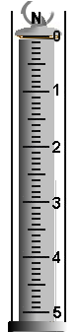
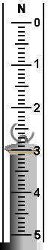
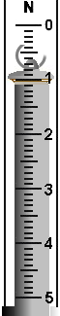
E. F. G.

Activity 2 Student Evaluation: Ramps Name:___________________________
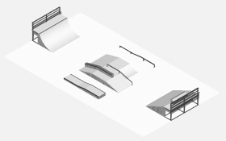


Skateboard Park Design Plan

$24,000 Design

On the skateboard park picture, plan the route you might use to ride in the park. Use arrows to show the path you would take through the park.

Draw a red arrow where you would need an upward pushing force.
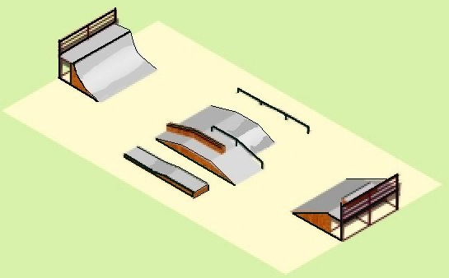
Draw a blue arrow where you would be pulled downward by the force of gravity.
A

Circle the two ramps where you would need the most force to go up and would have the most motion going down.
What is the characteristic of a ramp that makes it harder or easier to go up?
_____________________________________
How could you change ramp “A” to get to the same ramp height using less force?
Extension: A Turn of the Screw
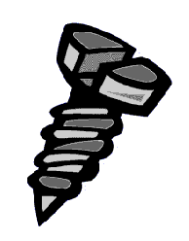
You won’t find it in Ripley’s Believe It or Not, but, believe it or not, a screw is a simple machine. It makes work easier. We have some “work” for you. Your task is to answer the question “which of the simple machines is the screw most like?” When you are done with the activity below you should have the answer.

Materials: 2 screws with different pitches ruler* tape*
scissors* 2 pencils* crayon*
*teacher provided
Look at the 2 screws.
1. How are they alike?

2. How are they different?

Cut a piece of paper into a right triangle. It should be 10” long and 5”high.
Mark both sides of the slanted edge with a crayon.

crayon mark, both sides
5 inches

10 inches

3. Which edge of the paper has the shape of an inclined plane?

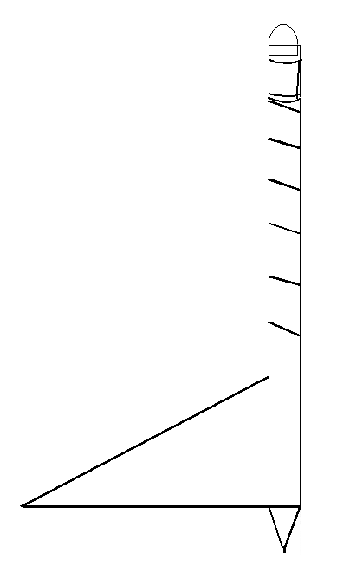
Starting at the top of a pencil, wrap the triangle around the pencil.
Fasten with tape. Try to keep the wraps equal in size.

4. What does the colored edge wrapped around the pencil look like now?

5. Which is longer, a path straight up the side of the pencil or a path spiraling around it?

“A Turn of the Screw” continued

6. Which needs more force, going straight up or moving up an inclined plane?

Cut out one more paper inclined plane. Make it 5” high and 5” long. Mark the inclined plane on both sides with a crayon.

crayon mark, both sides

5 inches

5 inches

Wrap it around a different pencil. Tape it in place.

Look at both pencils and answer the questions:

- How are the wrapped pencils different?

- On which pencil are the lines the closest?

- On which pencil are the lines farther apart?

- Which “pencil screw” would need less force to move?

- Look at the two screws (not the “pencil screws”). Which would need less force to put into the wood?

Which of the simple machines is the screw most like?

Activity 4 Student Evaluation: Levers Name______________________________

During the Middle Ages, being able to take control of a castle was very important. This is because a lord owning a castle could control the countryside around it for miles. The castle would be a safe place from which knights could ride out to attack an enemy.

Sometimes an invading army chose not to attack a castle because it was so hard to get in. This made it easy for the army in the castle to attack and then run back to the castle for safety. Sooner or later an invading army would have to attack and capture the castle in order to take over the country. This led to the invention of ways to take over a castle.

When an invading army was attacking a castle, special weapons were often used against the strong castle walls. They were: battering rams, siege towers and catapults.

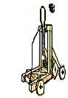
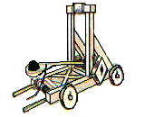
A Mangon was a form of catapult that could throw stones the size of a football over the castle walls. Catapults are forms of levers.

A Trebuchet (tray-boushay) was also a catapult. It was more powerful than a Mangon. It could throw stones further and with more force.
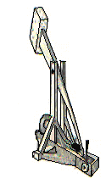
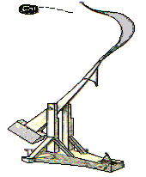

Medieval Warfare continued Name:_________________________

Both the Mangon and Trebuchet (tray-boushay) were forms of levers with a force arm, load arm, and a fulcrum.

On the Trebuchet picture, label the force arm, load arm and fulcrum. What is the direction of the force? What is the direction of motion?

Trebuchet

A Trebuchet was more powerful than a Mangon. From what you have learned about levers and looking at the picture, write about how a Trebuchet does work on the load.

Extension: Levers

Catapult Shooter

A catapult is a tool used to launch a load into the air by applying a force. It is actually a lever. Your task will be to create a simple catapult using some simple materials. Your challenge is to have your catapult launch a small washer a certain distance into a small cup.

Materials per Team
10 popsicle sticks
fulcrum - ? (your choice of object)
meter stick or tape*
small washer
small cup
glue (tape)*
5 paperclips
*teacher provided

Task: Launch a small washer a distance of _____cm into a cup.

- Design and build a catapult using the popsicle sticks and any other materials that you need.
- Test the catapult. See what you need to do to launch different distances.
- Launch the small washer several times to find the best set up to do the task. (You may mark the popsicle.)
- Get everything ready for the contest.

Record Results
Draw a sketch of your catapult. Identify the fulcrum point, the load arm and the force arm.
Write down how the task or contest went for your team. Where you able to put the washer in the cup? What affected your being able to do this.

Conclusions
How did the design of a catapult affect launching the load??
Were there other variables that affected the catapult?

Pulley Challenge

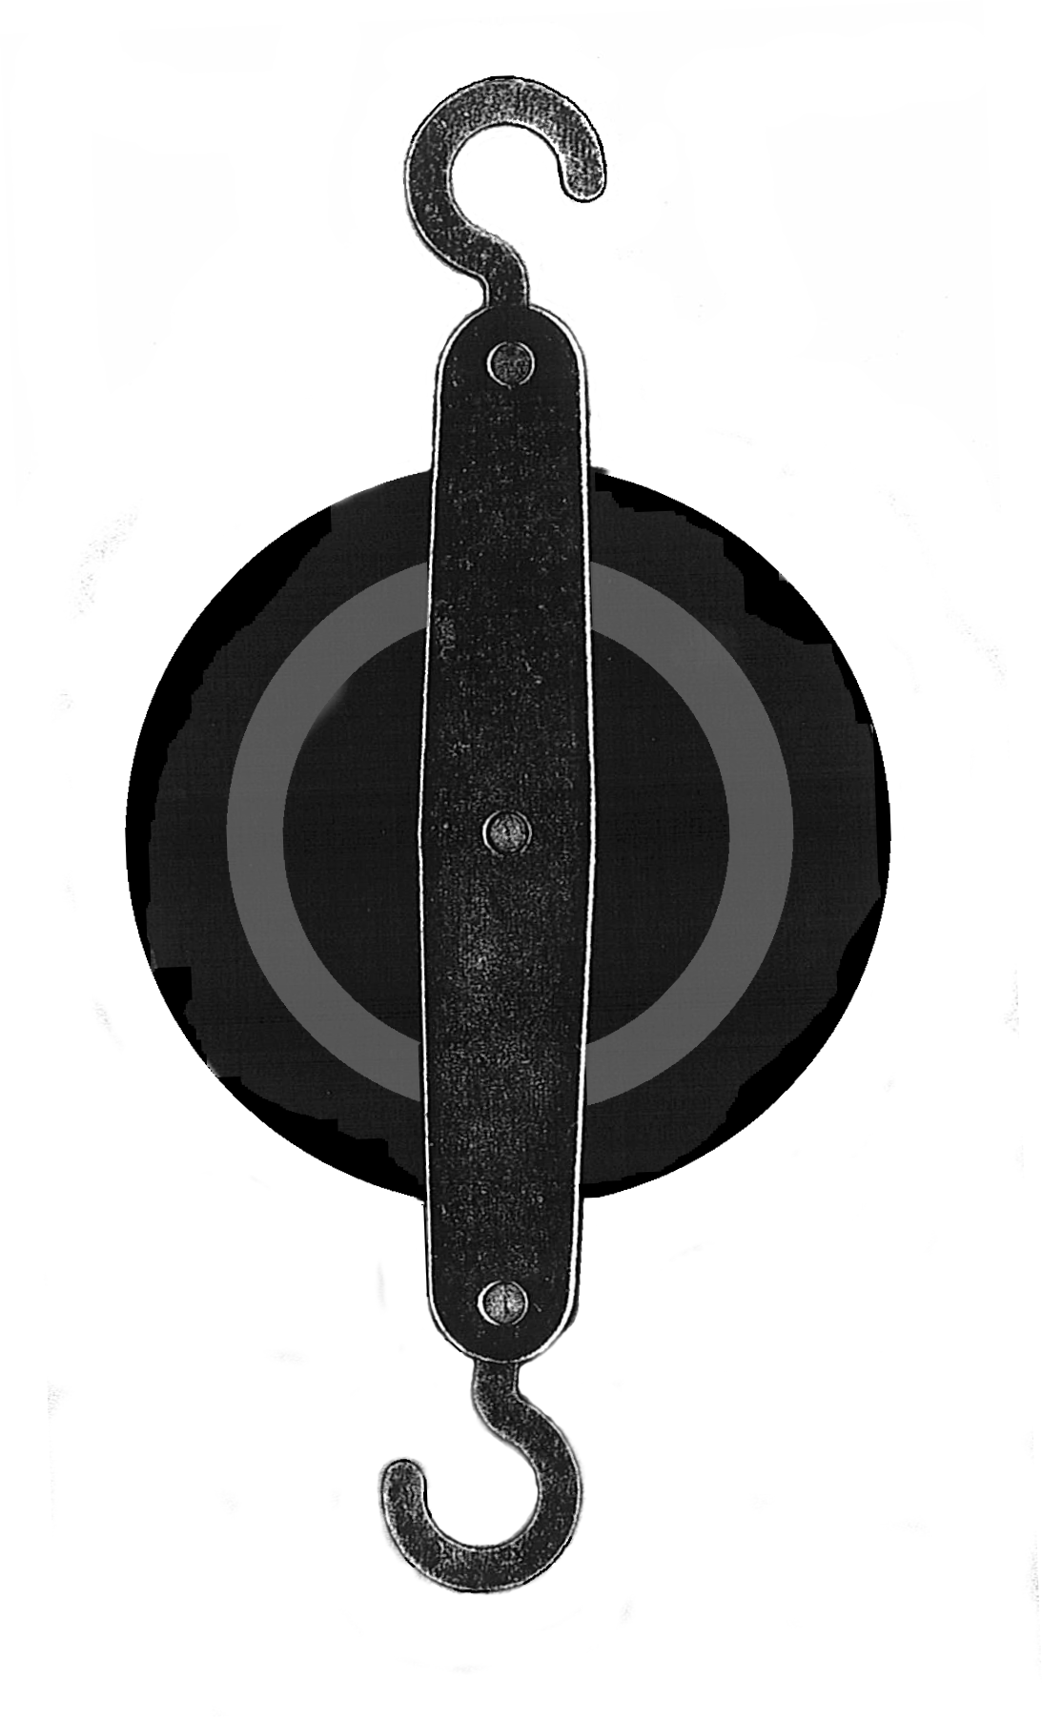

You have found out that there are two basic types of pulley systems. There are fixed pulley systems and moveable pulley systems. Each of these has a major advantage over the other. Your challenge is to create a pulley system that will have the best of both systems. It needs to lift a load using less force than the weight of the load. It needs to lift the load with a downward pulling force.

For your plan use a bag of washers as the load, a pole and base, pulleys, and string. Use the area below to write or draw your plan. When you are ready check it out with your teacher then carry out your plan and show how it works.

Activity 5 Student Evaluation: Pulleys Name__________________________

1. (Fill in the blank) A pulley is a simple machine that makes work ______________________.

2. As you can see, Mr. Williams is having a difficult time lifting the box to load it into the truck. There is no help in sight. On the back of this paper make a drawing showing how he could use a simple machine to raise the box. How could he use a down force instead of an upward force?

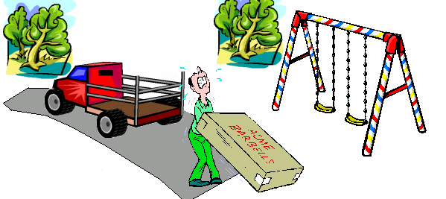

3. For the pulley system below, label the following: the force, the load, moveable pulley, fixed pulley. Draw an arrow showing the direction of movement of the load when you apply the force.
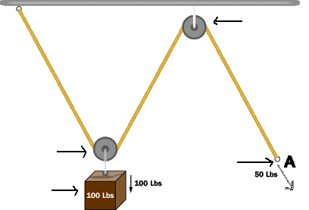

Bonus: What is the special name for the pulley system in #3?______________________________

Optional Extension Activity (materials not provided)

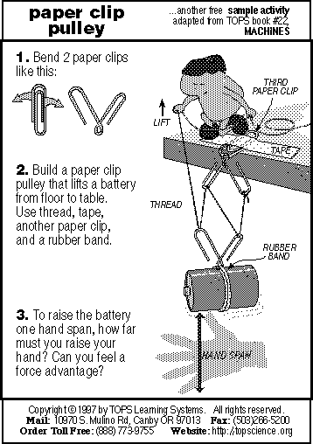
Tops Learning Systems
http: //topscience.org

p.1
Name: Simple Machines Evaluation

Pictures A and B show two pulley systems. Answer the questions 1 – 3 about these pulley systems.

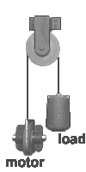
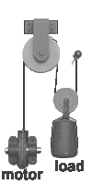

A

B

1) List the parts of Pulley System B.
__________________________________________________________________________________________________________________________________________
2) Describe what happens when the motor pulls down on the rope in Pulley System B.
__________________________________________________________________________________________________________________________________________

3) Which above Pulley System is a simple system?

Which above Pulley System is a complex system?
4) The picture below shows a model of a simple machine.
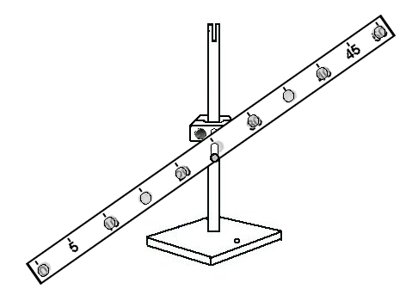
Which simple machine does this model show?

- Draw a picture of a real simple machine that works like the model simple machine in question 4.
(Label the force and the load parts.)

p. 2

6) A person uses 15 newtons of force to move a chair 7 meters to the next table. How much work on the chair did the person do? (Remember: Work = F x D)

____________________

(Show your math work.)

7) On the small graph there is a line that shows a force being used to move a load. Circle the place on the graph where the most force is used.
Distance
Force

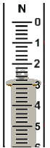

8)

Read the spring scale measurement.
Write the measurement down (write the units.)

What does a spring scale measure?

9) You have a block of wood on a table in front of you. You are asked to measure the mass of the block of wood. Which tool would you use?

a) a metric ruler b) a spring scale
c) a gram mass balance d) a graduated cylinder

p. 3
Use the Cart and Ramp picture to answer questions 10 – 15.
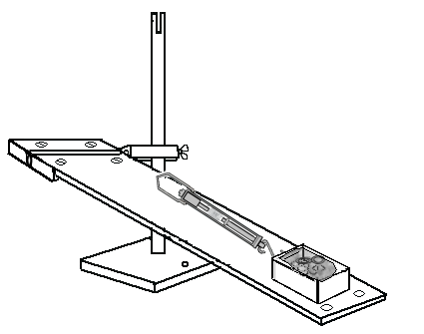

10) When the cart is pulled up the ramp, what type of energy is used?

a) electrical b) heat
c) motion d) light

11) When you pull the cart up the ramp, what is putting the energy in?

___________________________________________________________________

12) Where does the energy go?

___________________________________________________________________

13) What is the force that is trying to pull the cart down the ramp?_______________

14) Describe the position of the cart in the picture.

___________________________________________________________________

15) How does friction affect the motion of the cart?

a) speeds up the cart b) pulls the cart down the ramp
c) slows the cart down d) makes the cart go further

p. 4
PART 2

1) Mechanical energy is energy of motion. It is energy that can do work. Simple machines can do work. Simple machines can change how much force is used to do work. For each sentence fill in the blank with one of the following choices:

-more- -less- -changes- -keeps the same-

a. A steeper inclined plane needs _____________________ force to move a load.

b. A longer lever force arm needs _____________________ force to move a load.

c. A fixed pulley _______________________ the direction of the force.

d. A longer inclined plane needs _____________________ force to move a load.

e. A fixed pulley _________________ the amount of force needed to move a load.

f. A moveable pulley needs _____________________ force to move a load.

g. A fulcrum close to the load needs ___________________ force to move a load.

2) For each item write the letter of the simple machine that matches it.

A. inclined plane B. lever C. pulley system

 | uses a wheel and axle |  |  | load arm
 | fulcrum |  |  | block and tackle
 | ramp |  |  | lifting force direction can be up or down
 | force arm |  |  | used to load a truck
 | used to lift a large rock |  |  | used to raise a flag

