
Science Center

Plant Life Cycles

Student Science Journal

Name: Date:

Revised April 2006
Logo Revisions 6/09
Name Date

Activity 1a: Living and Non-Living

My partner’s name is _____________________________________.

5 things we see that are living are:

- ________________________________________________________
- ________________________________________________________
- ________________________________________________________
- ________________________________________________________
- ________________________________________________________
5 things we see that are non-living are:

- ________________________________________________________
- ________________________________________________________
- ________________________________________________________
- ________________________________________________________
- ________________________________________________________
In the space below, explain the differences between living and non-living things.

Name Date

Activity 1b: How Sure Are You?
Topic: Plants
In-Pencil Facts (List those facts that you think you know, but you aren’t very certain about. It’s okay to be wrong!)

In-Ink Facts (List those facts that you are pretty certain are true, but you think there is a chance you might be incorrect.)

In-Stone Facts (List those facts that you are absolutely sure about.)

Name Date
Name Date

Activity 2: Are All Plants the Same?

Draw a picture to support your answer:

Name _________________________________ Date __________________

Activity 3c:
Relative Order of Seeds

1. Place the five seeds in order from largest to smallest in the boxes below. 2. Draw a picture of each seed in each box to record your answers.

smallest largest

3. Choose another unit of measurement to order the seeds. Some ideas are longest, tallest, heaviest, widest.
4. Write your choice on the lines below the boxes.
5. Place the five seeds in order using this quality. Place the five seeds in the boxes below.
6. Draw a picture of each seed in each box to record your answers.

______________ ________________
Name _________________________________ Date __________________
Description of a Seed

Directions:

1. Draw the seed in the
box to the right.
Include many details in
your drawing. Fill most
of the space.

2. Some of the properties of the seed are:

- ________________________________________________
- ________________________________________________
- ________________________________________________
- ________________________________________________
- ________________________________________________
- ________________________________________________
(Continued on next page)

3. My hypothesis of how this seed was dispersed is:

___________________________________________________
___________________________________________________
___________________________________________________
___________________________________________________
4. I think this because:

___________________________________________________
___________________________________________________
___________________________________________________
___________________________________________________

5. Questions I have about this seed are:

___________________________________________________
___________________________________________________
___________________________________________________
___________________________________________________

Name _________________________________ Date __________________
Activity 4: Engineering a Seed
Planning my design:
My design will look something like this:

After testing my design:
The distance my design flew was:
1st trial 2nd trial

On a scale of 1 to 10, with ten being highly successful, I rate my design a ____________ because __________________________
___________________________________________________.
To improve my design, I think I need to _____________________
___________________________________________________
___________________________________________________.

Name Date

Activity 5: My Plan for Inquiry on Seeds

Members of my group:___________________________________
Research question: _____________________________________
____________________________________________________
How will we collect information? ___________________________
____________________________________________________
____________________________________________________
Materials we need are:___________________________________
____________________________________________________
____________________________________________________
____________________________________________________
How will we record the information?_________________________
____________________________________________________
____________________________________________________
Our hypothesis of what will happen is ________________________
____________________________________________________
____________________________________________________
Name _________________________________ Date __________________
Activity 5: Reflection on My Inquiry Project

The conclusion I made after my investigation is ________________
____________________________________________________
The evidence that I have to support this conclusion is ___________
____________________________________________________
____________________________________________________
____________________________________________________
These parts of my investigation went well: ____________________
____________________________________________________
____________________________________________________
____________________________________________________
I would change these things if I did this investigation again: _______
____________________________________________________
____________________________________________________
____________________________________________________
The question I still wonder about seeds is ____________________
____________________________________________________
Name _________________________________ Date __________________
Activity 6: Observations of a Tree

Name _________________________________ Date __________________
Activity 6: Close-up Observations of a Tree

Name _________________________________ Date __________________
Activity 7: Inherited or Acquired Traits?
Inherited traits: These are traits that I’m sure this tree has that are similar to its parents and other trees of its species.

Acquired traits: These are traits that I’m sure this tree has that resulted from its environment.

Are these traits inherited or acquired? I’m not sure about these:

Tree Detectives!

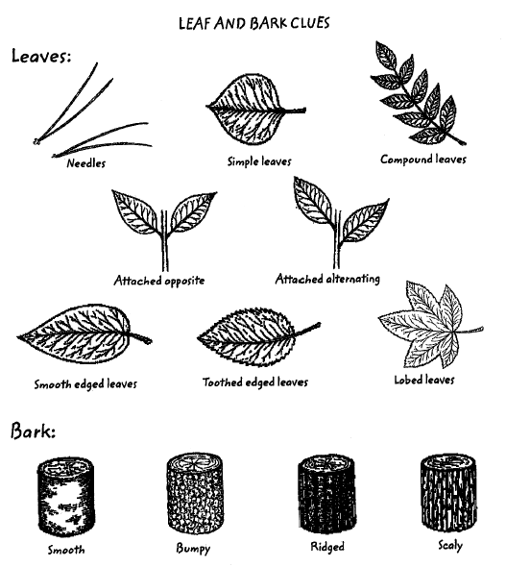

Name _________________________________ Date __________________
Activity 8: Leaf Clue Sheet

DIRECTIONS: Draw a picture of your leaf in the middle circle. Briefly describe or draw each characteristic of the leaf in the graphic organizer below.

Leaf

Source: National Wildlife Federation
Name _________________________________ Date __________________

Activity 9: Measurements of a tree
Directions for measuring the trunk circumference:
Wrap a string around the tree, about 4 ½ feet above the ground. Mark the string, then measure its length using a ruler or meter stick. Record the number and unit of measurement below.

The circumference of the tree is __________________________.

Directions for measuring the height of a tree:
Hold a stick at eye level. The measurement of the stick above your hand has to equal the measurement of the stick from your eye. Be careful not to move the stick. Carefully walk until the bottom of the tree trunk looks like it is at the bottom of the stick. The top of the tree should look like it is at the top of the stick. Measure how far you are from the tree. That measurement, in feet, is the height of the tree.

The height of the tree is ________________________ feet.

Directions for finding the average crown spread:
Use four pencils or sticks. Put one stick in the ground under the edge of the tree crown. Walk across to the other side and put a second stick under the opposite edge of the tree crown. Measure the distance between the two sticks.
The first measurement is ____________________ feet,

Now pretend you are making the letter t. You just measured the line going up and down. Move to the place where you would make the cross line, but stand under the edge of the crown. Put a pencil here. Move straight across to the opposite side of the crown. Put the last pencil here. Measure the distance between the two sticks.
The second measurement is __________________ feet.

Add these two numbers and divide by two. This is the average. Do your work on the back of this page. The average is ______________.
Name _________________________________ Date __________________

Activity 10a: My ideas on the life cycle of an apple tree
Name _________________________________ Date __________________
Activity 10b: Flower Observation Table
- Describe your flower:

Color: _________________ Smell:_______________

Shape: _________________ Size: ________________

- Directions for completing the table on the next page:
  - Dissect your flower by pulling it apart carefully, one piece at a time.
  - Tape one of each structure to the first column.
  - Count the number of each structure. Write your answer in the second column.
  - Predict what you think the function of this flower part might be. Write your answer in the third column.
  - Wait to fill in the structure name and function. We will do this as a class.

3. Draw a sketch of your flower before you dissect it.

4. What questions do you have about flowers?
Flower Structure  (Tape it to your paper.) | Number of These on Flower | Predicted Function of Flower Structure | Name of Structure | Function of Structure

