Plant Life Cycles

Kit #73

Blackline Masters

Revised April 2006
Logo Revisions 6/09

Lewis and Clark: Explorers and Scientists

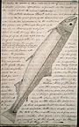
In the early 1800s, the United States was east of the Mississippi River and growing. Thomas Jefferson was the new President of the United States. He believed that the land west of the Mississippi River
would be part of the United States someday. He wanted to learn more about the native people that lived there, as well as the land, plants, and animals.

The only forms of travel at that time were horse and boat. President Jefferson also wanted to find out if there was a way to travel on the water from the Mississippi River to the Pacific Ocean. This would speed up travel across the land. He sent two famous explorers, named Lewis and Clark. A page from Lewis’ journal
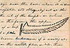
Lewis’ description
and drawing of a
a fern.
President Jefferson told Mr. Lewis to observe everything very closely. He told him to keep journals of details about the geography, soils, animals, rocks, and climate of the country. Jefferson also told him to record the dates that certain plants bud, leaf out, and lose their flowers or leaves.

Why do you think President Jefferson thought it was so important to learn details about the animals and plants?
WHAT IT IS AND WHAT IT IS NOT

Directions: Write the word to be defined in the center section. In each box, enter information about the word that defines and describes it. Be sure to use the descriptive words in each box as a guide.

Word
Definition
Characteristics
What it is.
And what it is not.
What Shapes Trees?

There are many reasons why tree shapes are different. Different kinds of trees have their own special form. The environment also affects the form of trees. For example, a tree growing in poor soil may be shorter than it should be because of lack of nutrients. A tree growing right next to a building may have more leaves on the side facing the sun.
Crown shape is the shape of the top of the tree. The maple tree has a round crown shape. The pine tree has a crown that looks like an ice cream cone upside down.

The form of leaves can be broad and flat, like maple leaves. Leaves can also be thin rods, like pine needles.
Sunshine and water are both important for a tree to live. Sunshine and water also affect the tree height, crown shape, and the form of leaves.

Some kinds of trees grow very tall and receive lots of sunshine. What about the trees left below in the shadows? Many trees collect little pieces of sunlight called filtered sunlight. Filtered sunlight is light that comes between the leaves of the taller trees. A tree with a rounded crown gathers filtered sunlight the best.
The shape of the tree’s crown also has to do with where it lives. Closer to the equator, the sun at noon is almost directly overhead all year. Tall trees with flat crowns are very common there. These kinds of trees have more leaves gathering sunlight. This makes it easier for the tree to survive.
Close to the Arctic Circle, the sun is never directly overhead. The sun is usually quite low in the sky. Trees in this part of the world are usually cone shaped. Cone shaped trees, like pine trees, have leaves from the top of the tree to the bottom. This shape helps the leaves gather the most sunlight.

The shape of the tree helps the tree gather sunshine for survival. The shape of the leaves helps the tree gather and store water. Many trees that have to survive in cold, snowy weather have needles instead of broad and flat leaves. Spruce, pine, and fir trees have needles. Needles are especially adapted to cold, dry climates. Needles keep water better than broad-leafed trees like oaks and maples.

Source:
http://www.units.muohio.edu/dragonfly/itd/learn.htmlx

IF ONCE IS GOOD, TWICE IS EVEN BETTER
Reading Assignment: ___________________________________________
Directions: On the left side, write down key facts or information you remember after your first reading of the assignment. On the right side, jot down key facts or information you remember after a second reading or after a group discussion.

Type of tree
Leaf:
Color of leaf:_______________ Shape of leaf: _______________
Texture of leaf: ____________ Size of leaf: big medium small
Sketch or tape your leaf here.

Tree:
Color of bark:________________ Texture of bark:_____________
Information I found about this tree:

Tree name__________________
Size of tree: big medium small
Other interesting things: ___________
_______________________________
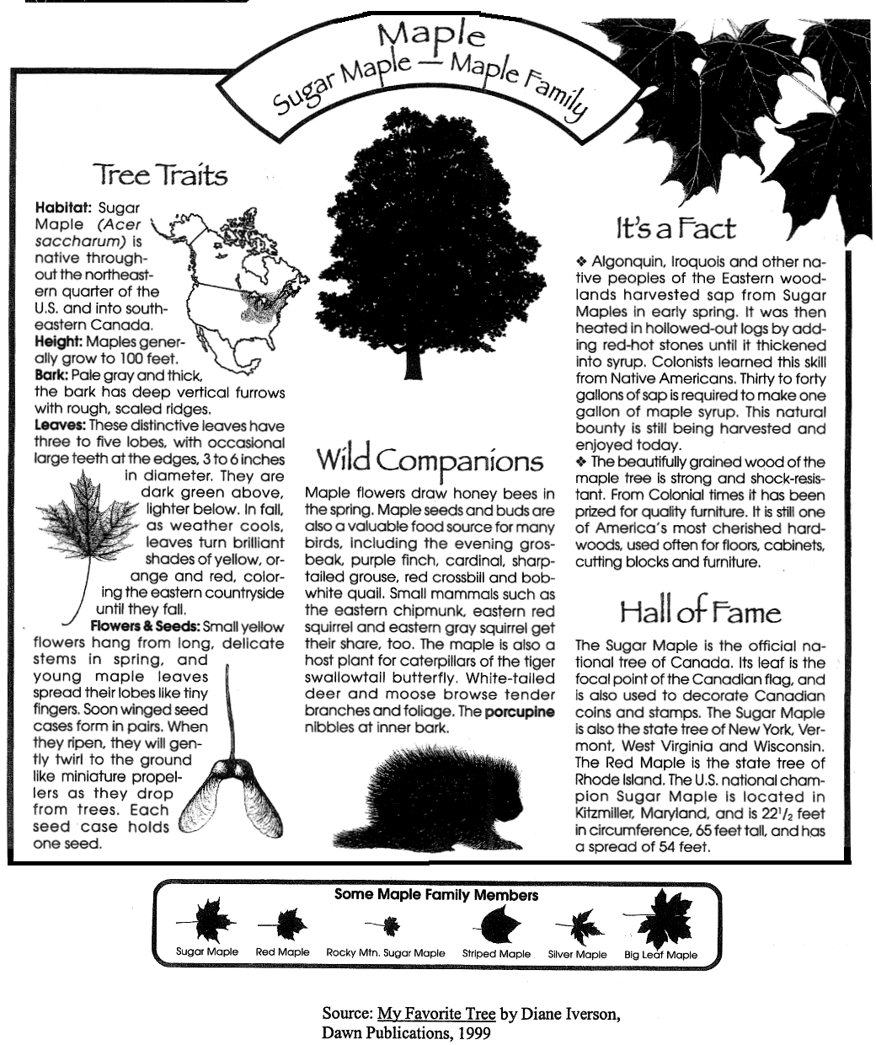
Maple-Sugar Maple Family
Measuring Trees
(Source: www.americanforest.org)

Trunk Circumference

Circumference is measured at 4 ½ feet above ground level in inches.
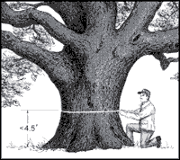 | 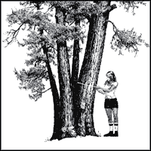
Images courtesy of Robert Van Pelt, Forest Giants Of The Pacific Coast.

If the tree forks below 4 ½ feet, measure the circumference of the thickest branch above the 4 ½ feet. (Note: You may use string to wrap around the tree, then cut the length of the string. Use a ruler or meter stick to measure the length of the cut string to find the trunk circumference.)

Tree Height

The vertical height of a tree is measured in feet, which includes the whole tree, dead or alive. It can be measured using the stick method:
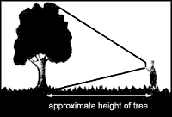

Hold the stick at its base vertically, making certain that the length of the stick above your hand equals the distance from your hand to your eye. Staying on ground level (or on the same contour as the base of the tree), move away from the tree while sighting the trunk base above your hand. Stop when the top of the stick is level with the top of the tree. You should be looking over your hand at the base of the tree and, moving only your eyes, looking over the top of your stick at the top of your tree. Measure how far you are from the tree and that measurement - in feet - is the tree's height.

Average Crown Spread

Average Crown spread is measured in feet. Add the widest and narrowest crown spread and divide the total by 2.

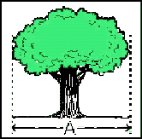 | 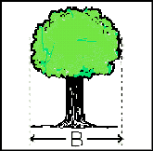
(Widest spread + narrowest spread) / 2 = Average Crown Spread.

You can also use the pencil method outlined below to measure the average crown spread:
- 1. Outline the tree's crown by sticking pencils into the ground along the outer tips of the tree's branches.
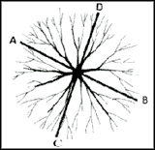
Images courtesy of Art Cowley, California's Big Tree Coordinator and Kay Fermann, Tennessee Division of Forestry.
- 2. Measure the distance between the two pencils that are the farthest apart (C&D). Write down that number.
- 3. Measure the distance between the two pencils that are the closest together (A&B) but still on opposite sides of the tree. Write that number down.
- 4. Add the two numbers and divide by two. This new number is the tree's average crown spread.

Tree Rings
Directions: The illustration below shows a cross-section of a tree. Use this illustration to answer the following questions:

- Each ring, or space between the circular lines, represents one year of growth. Count the rings to figure out the age of this tree.

This illustration shows a tree close to __________ years old.
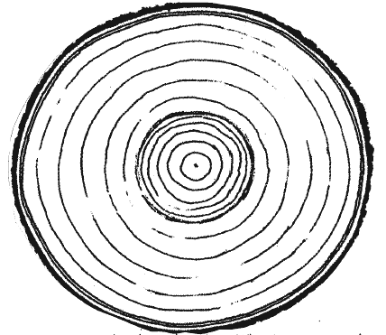

- What year did this tree germinate? (Show your work.) ________

- Some rings are wider than other rings. What is one reason that the tree grew more some years than others?

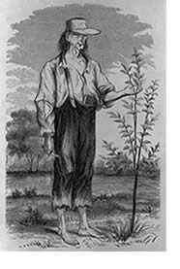
“Johnny Appleseed”
John Chapman
(1774-1845)

Johnny Appleseed was the name given to John Chapman, an American pioneer. John Chapman planted large numbers of apple trees along the early frontier. He became a folk hero as the result of many books, stories, and poems written about him. Most of the stories about him were probably imaginary.

Chapman was born in Leominster, Massachusetts on September 26, 1774. Nothing is known about his childhood. From 1797 until his death, he traveled along from western Pennsylvania through Ohio, Indiana, and Illinois. He planted orchards as the settlers moved westward. He eventually owned about 1,200 acres of orchards.

The most famous folk story about Chapman tells that he gave apple seeds and young apple trees to everyone he met. Some people say that he wore a tin pot as a hat, a coffee sack as a shirt, and no shoes. Some stories say that he was a medicine man to the Native Americans.

None of the folk stories about Chapman has ever been proven true. The folk tales became well known after a magazine article was written about him in 1871.
Source: Pennsylvania Historical & Museum Commission, World Book Encyclopedia
(http://www.dep.state.pa.us/dep/PA_Env-Her/biographies/johnnyappleseed.htm)
The Benefits of Trees
Imagine a world without trees. How would the world be different? Maybe it would be a little less green, a little less shady. But would it really be different?
Just like in the story of The Lorax by Dr. Seuss, our environment would be very different without trees. In the summer, trees provide shade and can help cool our house. In the winter, trees provide protection from the cold winds and snow. This means that trees help us use less energy to heat and cool our homes.
Even the air we breathe is better because of trees. When we breathe, we need to breathe in oxygen and breathe out something called carbon dioxide. Leaves absorb carbon dioxide and use it to make their food, along with water and energy from the sun. The trees then store the carbon part of the carbon dioxide inside of them and give off oxygen. Did you know that a tree gets bigger and bigger because it is storing more and more carbon? Trees are also air filters. They trap pollutants from the air.
Another way trees help is by preventing some flooding. Their roots absorb lots of water. Their large area of roots underground can be as wide as the crown of the tree! The roots also help hold the soil in place so the wind or water can’t move it away easily.
When the leaves fall off of trees, the leaves help keep moisture close to the ground. This helps other plants near the trees get moisture. It also covers some plants to keep them warmer in winter. The old leaves decompose, and turn back into new soil. This helps trees and other plants get more nutrients from the soil. Many insects use the old leaves to protect themselves and stay warm through the winter, too.
Trees are homes to many birds and animals. They provide food for many animals – including us! Many of our fruits and nuts grow on trees. Apples, oranges, cherries, peaches, walnuts, and pecans are some that grow on trees. Where would the grocery stores get these foods without trees? Maple trees produce a sap that people turn into maple syrup. Some of our spices for cooking come from trees, too. Originally ‘root beer’ was even made from boiling the roots of the sassafras tree.
Something that you may not know is that trees also give us medicine. Tea made from some leaves, tree seeds, roots, or even bark can be used to treat diseases.
Think of all of the things that we use that are made from trees. Look around you at school. What do you see that is made from trees? Wooden furniture is easy. Our paper is made from trees, as well as toothpicks, bats, baskets, and wood floors. Some of the things you may not have known that have parts from trees are: carpet, fabrics, car windshields, sponges, plastic for eyeglasses, combs, steering wheels, rubber-soled shoes, glue, ink, and hundreds of other things! Just to take care of the food, house, and things you need, how many trees need to be on the Earth?
Trees are important in many stories, songs, poetry, movies, and books. We wouldn’t even have paper for our books if we didn’t have trees!
Trees also provide a place for fun and relaxation. Trees are part of some holidays, like Christmas and Arbor Day. Many of us have climbed trees, built forts, hid behind trees, and swung from a rope on a strong branch. Lying in a hammock under a tree, just relaxing and listening to the leaves move softly is a great summer activity. Walking through the woods can be relaxing and help us think. Artists paint and photograph trees, which become art that we enjoy. In the fall, many people enjoy looking at the leaves turning color. Children enjoy running through piles of leaves. In every season, trees help us in many, many ways.

