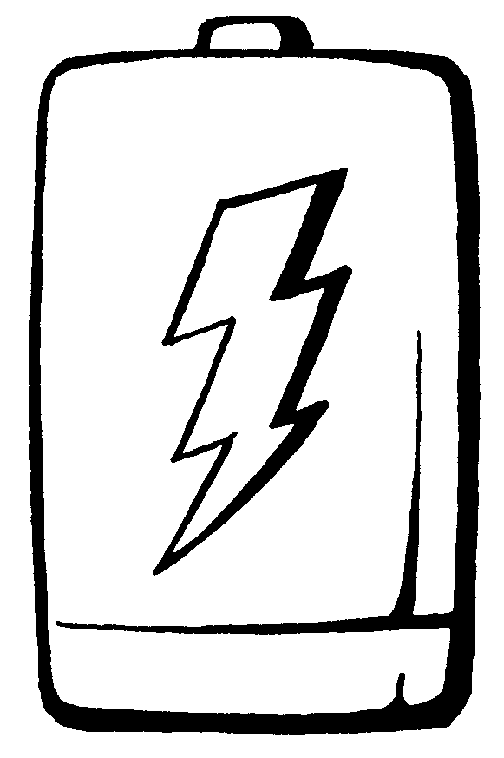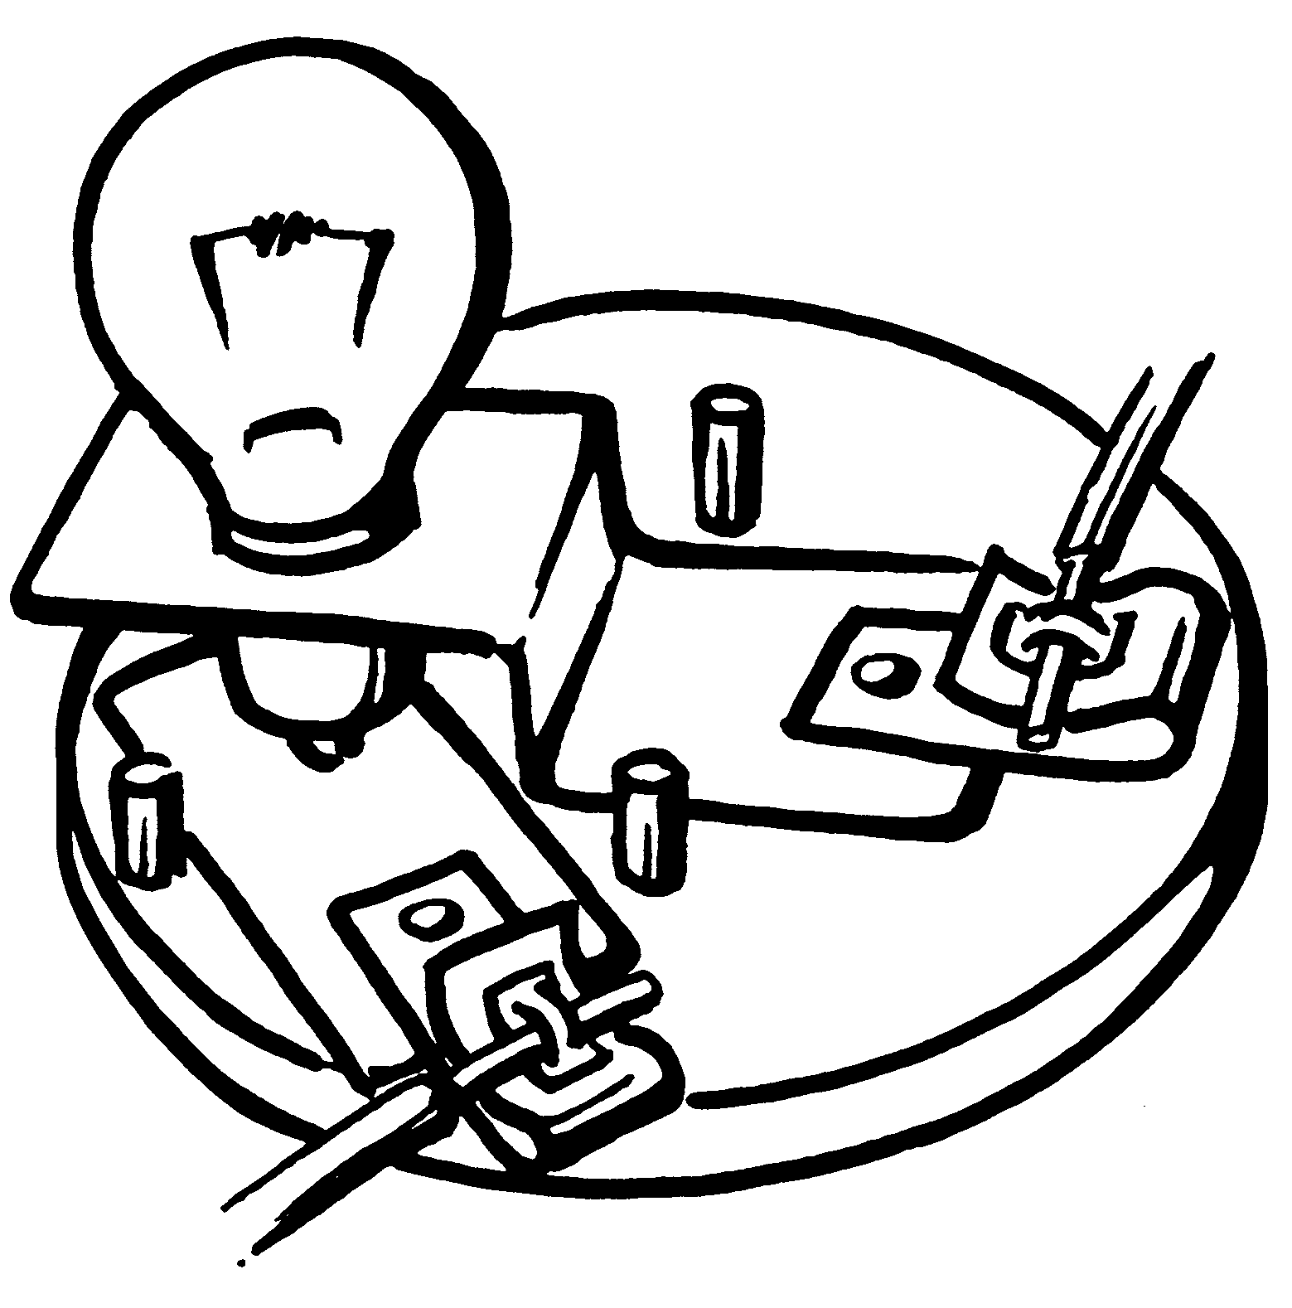

**NAME: ____________________________**



**Activity 1: How can we get a light bulb to light? Activity Sheet A**

**Materials:** one battery, one light bulb, one piece of wire

Your task is to try to discover 4 ways of getting the light bulb to light. Show how you got the light bulb to light. Do this by adding a light bulb and wire to each of the battery pictures. You can cut and paste the light bulbs. You will have to draw the wire.

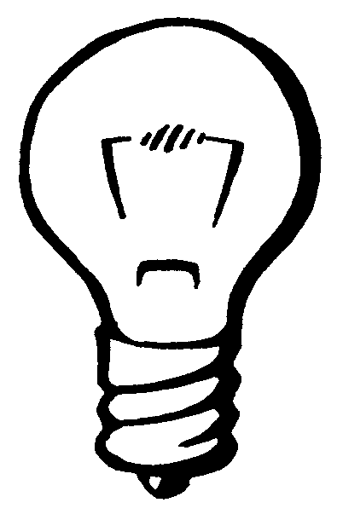

**Activity 2: How do we complete a circuit? Activity Sheet B**

**Materials:** one battery, one light bulb, 2 pieces of copper wire

Your task is to complete the circuit in each of these diagrams. The battery and bulb pictures are set up for you. Make your prediction by drawing in the wires on each picture.

2.

1.

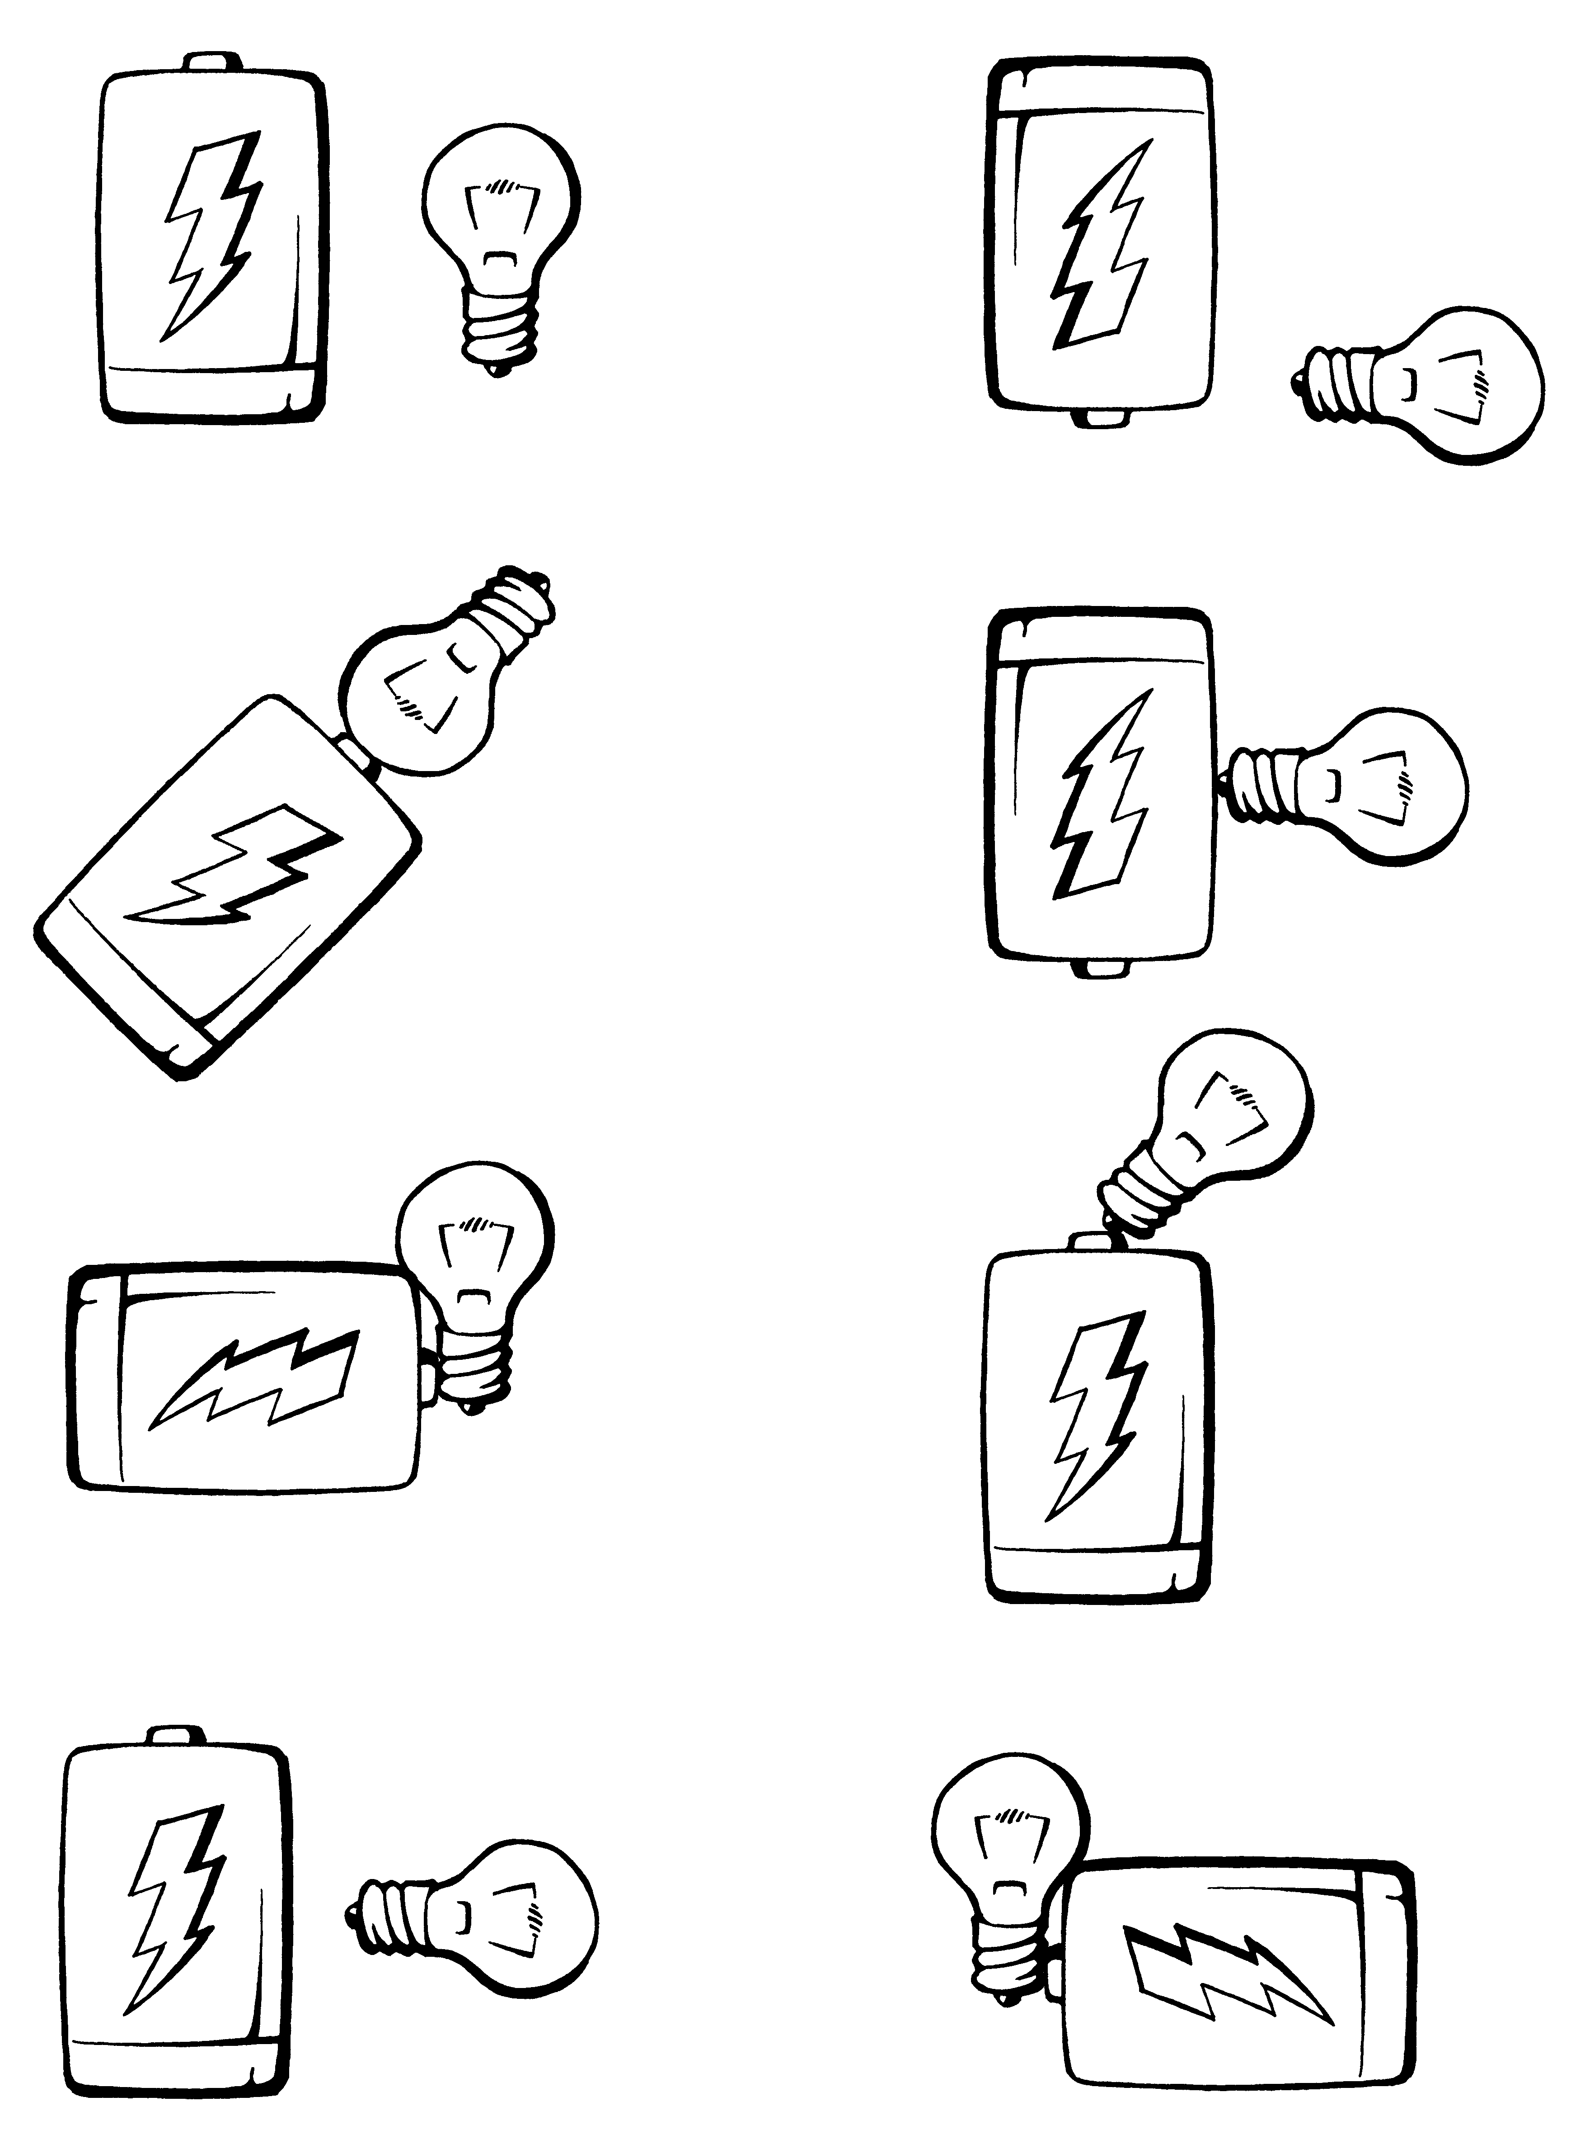

3.

4.

6.

5.

8.

7.

*Now find out if you are correct.* Use your supplies to make each circuit.

Does the light bulb light in each one?

**Information Sheet**: **Battery and Bulb Holders Activity Sheet C-1**

You have been using a battery and some wire to light a light bulb. Has it been easy to connect all of the parts? Have you found that the wire gets hot? Technology has made this an easier task. We have some other parts to add to your circuit. Now you will add a battery holder with some special clips attached to it. These clips are called Fahnestock clips.

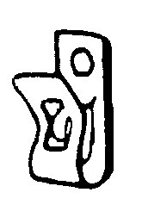

**Fahnestock clip**

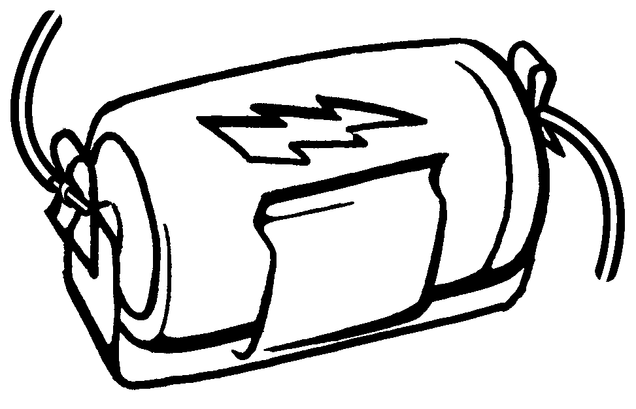

**Battery Holder**

A **Fahnestock clip** is used to hold wire. This clip is attached to the battery holder for you.

**Battery Holder**

**Using the Fahnestock clips**:

Squeeze the open ends of the clip. When you do this you can slide the end of a piece of wire under the loop. Letting go of the clip catches the wire in the loop. The clip is made of metal. It becomes part of your circuit.

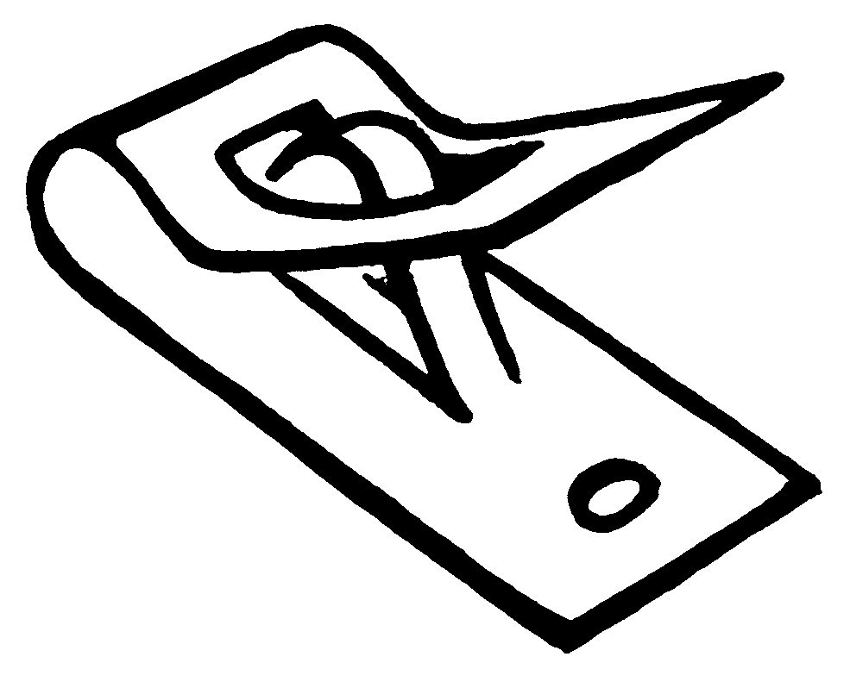

**Loop** **Spring to hold wire into loop.**

**Mounting Hole**

**Fahnestock Clip**

# Activity Sheet C-2

Light Bulb Holder

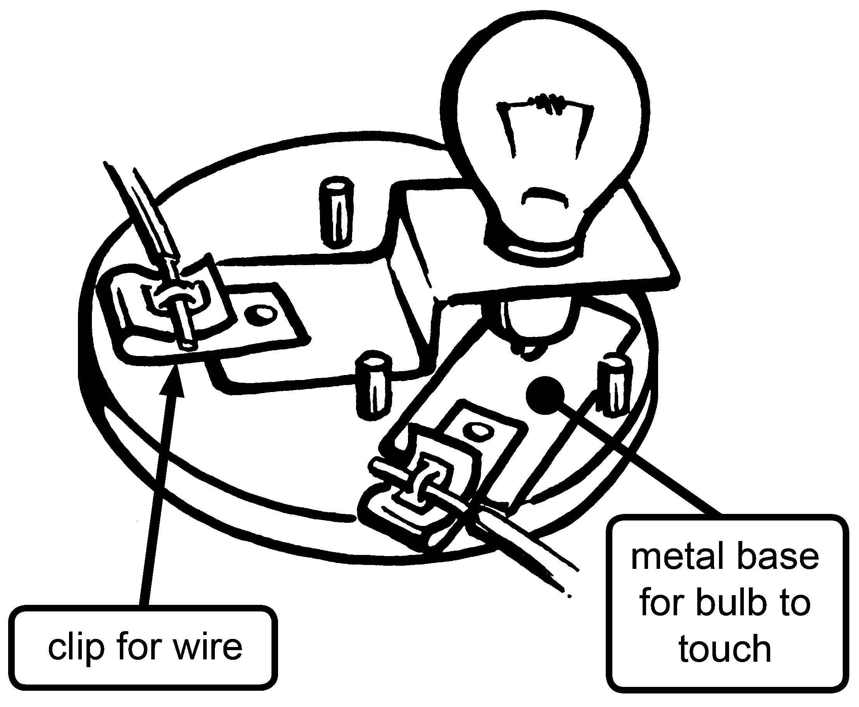

The **light bulb holder** is used to hold the light bulb. The light bulb screws into the holder. It does not need to be real tight. The bottom of the bulb should touch the metal base of the holder.

You will see Fahnestock clips on the holder. They are used to connect the wires to the light bulb.

**Task:**

Using the materials listed, put together a simple circuit.

Light the light bulb.

**Materials:**

1. pieces of copper wire, 20 cm long each
2. battery holder (with clips)

1 light bulb (#48)

1. “D” cell battery
2. bulb holder

Draw a picture of your circuit. Label the parts.

**What is the brightness of your light bulb? Use a Brightness Meter.**

**Building a “Brightness Meter”** **Activity Sheet D-1**

**Materials:** scissors, stapler **Directions:** Cut out the 10 strips. Make a stack of strips

|  |  |  |  |  |  |  |  |  |  |
| --- | --- | --- | --- | --- | --- | --- | --- | --- | --- |
|  |  |  |  |  |  |  |  |  |  |
|  |  |  |  |  |  |  |  |  |  |
|  |  |  |  |  |  |  |  |  |  |
|  |  |  |  |  |  |  |  |  |  |
|  |  |  |  |  |  |  |  |  |  |
|  |  |  |  |  |  |  |  |  |  |
|  |  |  |  |  |  |  |  |  |  |
|  |  |  |  |  |  |  |  |  |  |
|  |  |  |  |  |  |  |  |  |  |
|  |  |  |  |  |  |  |  |  |  |

with the longest on the bottom and shortest on top. Staple strips together at one end.

## Building a “Brightness Meter” (Measure It Up) Activity Sheet D-2

**Materials:** scissors, stapler, ruler **Goal:** Your job is to make 10 strips of paper.

|  |  |  |  |  |  |  |  |  |  |
| --- | --- | --- | --- | --- | --- | --- | --- | --- | --- |
|  |  |  |  |  |  |  |  |  |  |
|  |  |  |  |  |  |  |  |  |  |
|  |  |  |  |  |  |  |  |  |  |
|  |  |  |  |  |  |  |  |  |  |
|  |  |  |  |  |  |  |  |  |  |
|  |  |  |  |  |  |  |  |  |  |
|  |  |  |  |  |  |  |  |  |  |
|  |  |  |  |  |  |  |  |  |  |
|  |  |  |  |  |  |  |  |  |  |
|  |  |  |  |  |  |  |  |  |  |

Make the first one 2 cm. long. Make each one 2 cm longer than the one before (4, 6, 8, 10, …)

**Using the Brightness Meter Activity Sheet D-3**



### Putting it together

1. After you cut out the strips of paper, put them in a pile. Pile them with the shortest on top and the longest on the bottom. Staple them together at the one end.

**1**

**2**

**3**

**4**

**5**

**6**

**7**

**8**

**9**

**10**

**Staple**

2. Number your strips from 1 – 10. One is the longest strip.

### Using the Brightness Meter

1. Place the Brightness Meter in front of the bulb. Start with the thickest part, number 10.

2. Slowly move the meter so the bulb is behind smaller numbered sheets (less thickness)

3. The layer or number when you first see the bulb is the brightness.

For example: If you first see the bulb through strip 6, the bulb has a brightness of six.

When you measure brightness be sure to do it “fairly.” This way you could compare the brightness measurements. If the lights are on then always do it with the lights on. To get the best results measure in a dark area.

|  |  |  |
| --- | --- | --- |
| Using the secret language symbols, make a drawing to show this circuit.  This is a simple closed circuit. Electricity can flow in a closed circuit. It is like a racetrack. The energy (cars) can go around and around without stopping.  MY Secret Language of electrical circuits book:  **4** |  | Secret Language Book (Sshhhhsh) These are the symbols of the secret language of electrical circuits. You will get a lot of practice with this secret language. When you are done with this kit you will belong to the “Electrical Circuit Decoder Club of America.”  Now don’t leave this booklet lying about and don’t lose it! Ok, are you ready? Here are the special symbols you will need to know.  Cell Battery  **1**  =  **+** end of battery  **-** end of battery |

|  |  |  |
| --- | --- | --- |
| 2 Battery CellsWires bare wire    cell battery with wires  =  =  insulated wire (wire with a covering)  **2** |  | **Resistance** (Light Bulb, bulb and holder)  = Other fuse  test point  (may be an alligator clip  or the end of a wire )  wires joined wires crossed, not joined  **3** |

#### Mystery Circuit # 1 Activity Sheet F-1

**Materials per person:** 1 “D” cell battery

light bulb (#48) and bulb holder

bare copper wire, four 10 cm pieces

1 battery holder

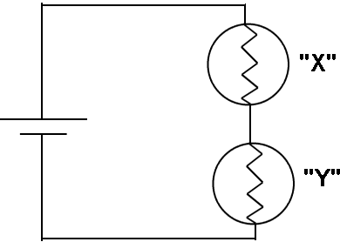

Using the materials, put together the circuit. Use the secret language diagram as your guide.

* 1. Did you get the light bulbs to light? How many bulbs were lit? ____________

2) What is the brightness of your bulbs? _________

3) Unscrew bulb “X”. What happens?

4) Tighten bulb “X” and unscrew bulb “Y”. What happens?

5) Have your group work together to see how many bulbs you can light using the one battery. Connect the light bulbs together in a line.

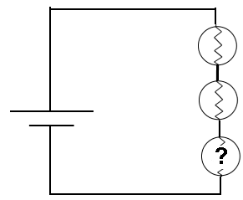

6) Add more bulbs to your circuit. Use your Brightness Meter to measure the change.

#### Mystery Circuit # 2 Activity Sheet F-2

**Materials per person:** 1 “D” cell battery

light bulb (#48) and bulb holder

bare copper wire, four 10 cm pieces

1 battery holder

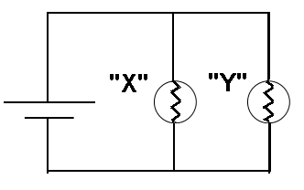

Using the materials, put together the circuit. Use the secret language diagram as your guide.

1) Did you get the light bulbs to light? How many bulbs were lit? ____________

2) What is the brightness of your bulbs? _________

2) Unscrew bulb “X”. What happens?

3) Tighten bulb “X” and unscrew bulb “Y”. What happens?

4) Have your group work together to see how many bulbs you can light using the one battery. Add more bulbs by connecting them as you did above,

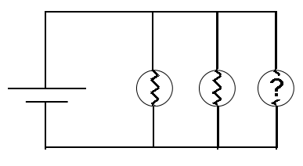

5) Use your Brightness Meter to measure what happens as you add more bulbs.

**Comparing Mystery Circuits #1 and #2 Activity Sheet F-3**



#2



#1

What is the same and what is different in the two circuits? In the Venn diagram below, write words that compare Circuit #1 and Circuit #2.

# 2

# 1

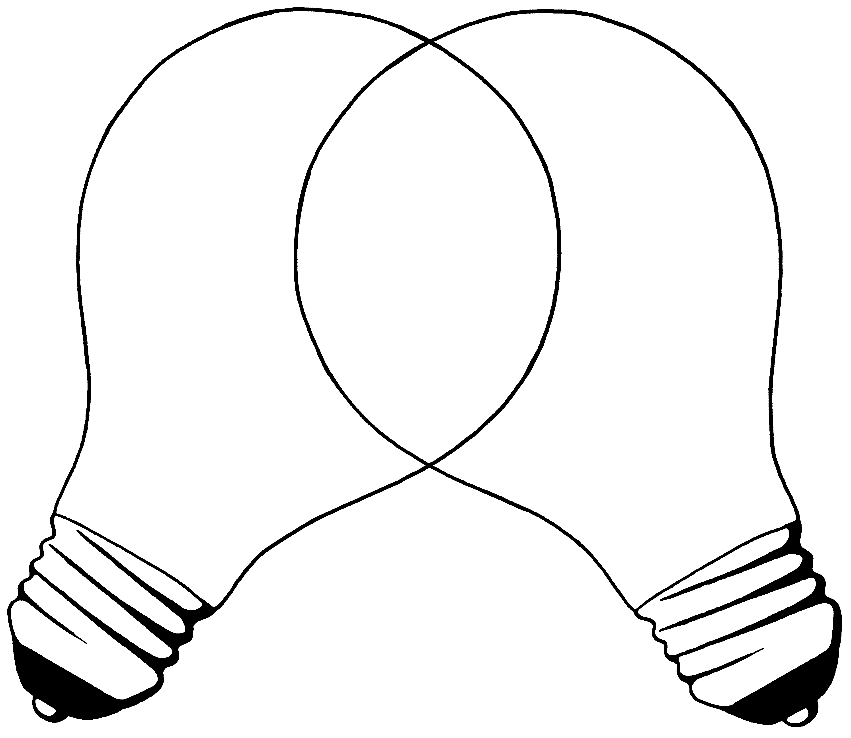

**Let’s Name Mystery Circuit #1 and #2** **Activity Sheet F-4**

Using the Venn diagram information below, match Mystery Circuit #1 and #2 with the properties. (Is each a Series Circuit or a Parallel Circuit?)



**Parallel Circuit:**

The light bulbs are not in a line.

When one light bulb goes out the other stays lit.

There is an electricity path for each light bulb.

###### ALL CIRCUITS

Wires connect all the parts of the circuit.

Each part (battery, bulb and holder) has two wires connected to it.

The light bulbs light up when all the parts are connected.

Series Circuit:

The light bulbs are in a line.

When one light bulb goes out both go out.

There is one path for the electricity.

Mystery Circuit match: (Series or Parallel)

Mystery Circuit #1:

Mystery Circuit #2:

#### Mystery Circuit #3 Activity Sheet G-1

More Mystery Circuits

**Materials per person:** 1 “D” cell battery

light bulb (#48) and bulb holder

bare copper wire, four 10 cm pieces

1 battery holder

Using the materials, put together this circuit. Use the Secret Language Book as your guide. You will have to cut some shorter pieces of wire.

Look closely at the battery lines. Remember that they are - or + .

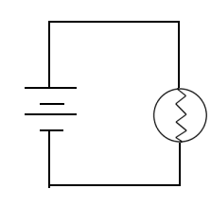

1) What is different about this circuit?

Compare it to the simple closed circuit in your Secret Language Book.

2) Are the batteries in a line or are they in a different path in the circuit?

3) Measure the brightness of the bulb.

4) Look at your brightness measurement for one battery and one light bulb.

(Activity Sheet C-2) How is lighting a bulb with this 2-battery circuit different than using one battery?

5) Disconnect a wire from between the batteries. What happens in the circuit?

6) Add more batteries to this circuit. What happens to the brightness of the bulb as more batteries are added? (Use your Brightness Meter to compare.)

#### Mystery Circuit #4 Activity Sheet G-2

**Materials per person:** 1 “D” cell battery

light bulb (#48) and bulb holder

bare copper wire, four 10 cm pieces

1 battery holder

Using the materials, put together this circuit. Use the Secret Language Book as your guide. You will have to cut some shorter pieces of wire.

Look closely at the battery lines. Remember that they are - or + .

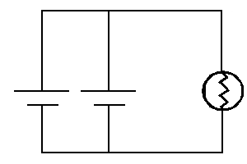

1) What is different about this circuit?

2) Are the batteries in a line or are they in different paths in the circuit?

3) Measure the brightness of the bulb.

4) Look back at your brightness measurement for one battery and one light bulb.

[Activity Sheet C-2]

How is lighting a bulb with this 2-battery circuit different than using one battery?

5) Disconnect a wire from between the batteries. What happens in the circuit?

6) Add more batteries to this circuit. What happens to the brightness of the bulb as more batteries are added?

**Activity Sheet G-3**

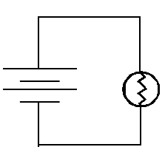

**Comparing Mystery Circuits #3 and #4**

Using the Venn diagram, write what is the same

and what is different in the two circuits.

# 3

# 4

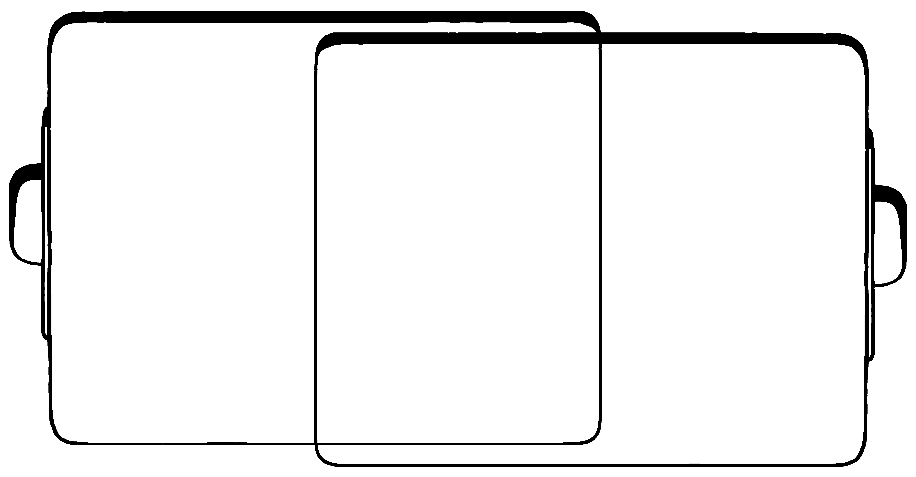

Let’s try to name Mystery Circuit #3 and #4.

**Activity Sheet G-4**

Using the Venn diagram below, match the circuit with the properties.



Series Circuit:

The batteries are in a line.

When one battery is not connected, the light goes out.

There is one battery path for the electricity.

The light is brighter (more energy.)

Parallel Circuit:

The batteries are not in a line.

When one battery is not connected the light stays lit.

There is an electricity path for each battery.

The light’s brightness stays the same (no change in amount of energy.)

###### ALL CIRCUITS

Wires connect all the parts of the circuit.

Each part (battery, bulb and holder) has two wires connected to it.

The light bulbs light up when all the parts are connected.

Mystery Circuit match: (Series or Parallel)

Mystery Circuit #3:

Mystery Circuit #4

# Activity Sheet H

What does a switch do? How does a switch work?

There is a list of materials written below. Your challenge is to use them to build a switch.



**Materials:**

1. 20 cm pieces of copper wire

1 10 cm piece of copper wire

1. #48 bulb
2. “D” battery cell
3. battery holder
4. paper fasteners
5. paper clip

1 piece of cardboard, cardstock, index card

1) Your job is to figure out how to put together a circuit with a switch in it.

2) The purpose of a switch is to open and close a circuit.

3) There is a circuit drawing below. It is drawn with a switch in it. Use this diagram to help you construct a circuit with a switch.

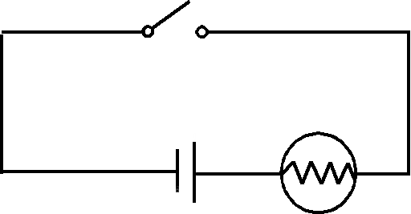

Activity Sheet I-1

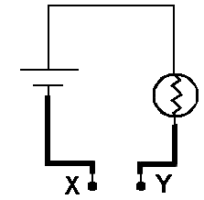

**Materials per pair of students:**

1 “D” cell battery

1 light bulb (#48) and bulb holder

1 piece bare copper wire, 10 cm piece

2 wires with alligator clips (for wire X and Y)

1 battery holder

Using the diagram as a guide, put together your tester. (Don’t forget to use your Secret Language Book as a guide.)

An open circuit is a circuit that does not have a complete path for the energy to flow through.

A closed circuit is a circuit that is complete. The path for the energy to flow is not broken.

**1)** Look at the circuit diagram for the tester. Does it show an open or closed circuit?

**2)** Touch wire “X” and “Y” together. Does the light bulb light?

Is this an open or closed circuit?

You can complete the circuit by touching the wire ends together. Placing something between the wires the circuit can also complete the circuit.

You are going to complete the circuit by placing objects between the wire ends. When you do this, you will be testing items to see if the item completes the circuit.

**3)** Fill in the table with the names of the objects that you will be testing.

**4)** Predict whether each item will complete the circuit. (See the table on the next page.)

**Activity Sheet I-2**

**5)** Test each item by touching wire “X” to one side and wire “Y” to the other side of the object. If the bulb lights, it is a closed circuit.

|  |  |  |  |  |  |
| --- | --- | --- | --- | --- | --- |
| Testing Results | Prediction | |  | Closed circuit* | |
| OBJECT | YES | NO | Material made of | YES | NO |
| 1. |  |  |  |  |  |
| 2. |  |  |  |  |  |
| 3. |  |  |  |  |  |
| 4. |  |  |  |  |  |
| 5. |  |  |  |  |  |
| 6. |  |  |  |  |  |
| 7. |  |  |  |  |  |
| 8. |  |  |  |  |  |
| 9. |  |  |  |  |  |
| 10. |  |  |  |  |  |

(*Be sure to test the Tester when the light bulb does not light.)

**6)** Which materials closed the circuit?

**7)** Which materials did not close the circuit?

**8)** Which materials allowed electrical energy to flow through them?

**9)** Which materials did not allow electrical energy to flow through them?

**\*BONUS! Find out the word for:**

“material that allows electricity to flow through it” _________________

“material that does not allow electricity to flow through it” ____________________

**Activity I-3**

***Can your body complete a circuit?***

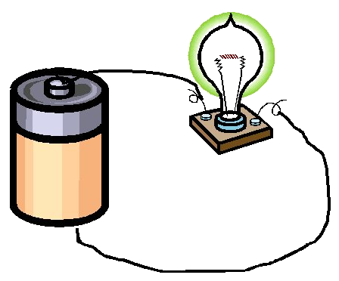

***Can electricity flow through you?***

***Are you a good conductor?***



Yes, yes and yes!! You can conduct electricity through your

body. The power of some electricity sources, like a small battery, will not go through us. A strong electric current can go through us and do damage. This damage can be a small shock that hurts. It can be an electric current that burns you or even stops your heart.

Electricity will take the easiest path to complete a circuit. It likes to flow to the ground. To do this it will take a path into the Earth. Sometimes people accidentally get between a source of electricity and the ground. The person then completes the circuit to the ground. This allows the energy to flow from the source through the person to the ground.



The source of energy can be an electric wire. It can be outside, like an electric fence. It can be inside, like an appliance at your house. For example, if your toast is stuck down in the toaster, don’t be tempted to put a knife or fork into the toaster to get it out. If the toaster is plugged in, you may become part of the complete circuit and get a very bad shock. Touching a “live” wire can make you part of an electric circuit.



**Lightning** is a natural source of electrical energy. It is a *very* strong source of energy. When lightning goes to the ground you do not want to be part of the path. That is why we stay indoors and away from windows during thunderstorms.

People who work around electricity follow special rules. They wear protective clothing. They do not want to become part of a closed electrical circuit. They do not want to let the energy go to the ground through them.

**\*Bonus question:**  How can a bird sit on a wire and not be shocked??

**Activity Sheet J**



**Materials:**

3 “D” cell batteries

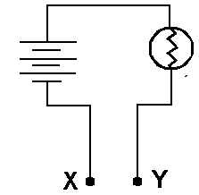

3 battery holders

3 pieces of copper wire 15 cm long

2 pieces of copper wire 20 cm long

1 bulb and holder

plastic cups (one for each liquid)

2 Fahnestock clips

* 1. Using the diagram as a guide put together your tester. You will need to cut one of the wires into smaller pieces. (Use your Secret Language Book as a guide.)

* 1. Attach one Fahnestock clip to test point “X.” Attach one clip to test point “Y.”
  2. Touch clip X and clip Y together. Does the bulb light? If not, correct your circuit.
  3. Create a data table for testing liquids. Have a place on your data table for each of the following:
* name of the liquid
* a place for a prediction of whether it will conduct electricity (yes or no)
* a place for the results of the test (yes or no)

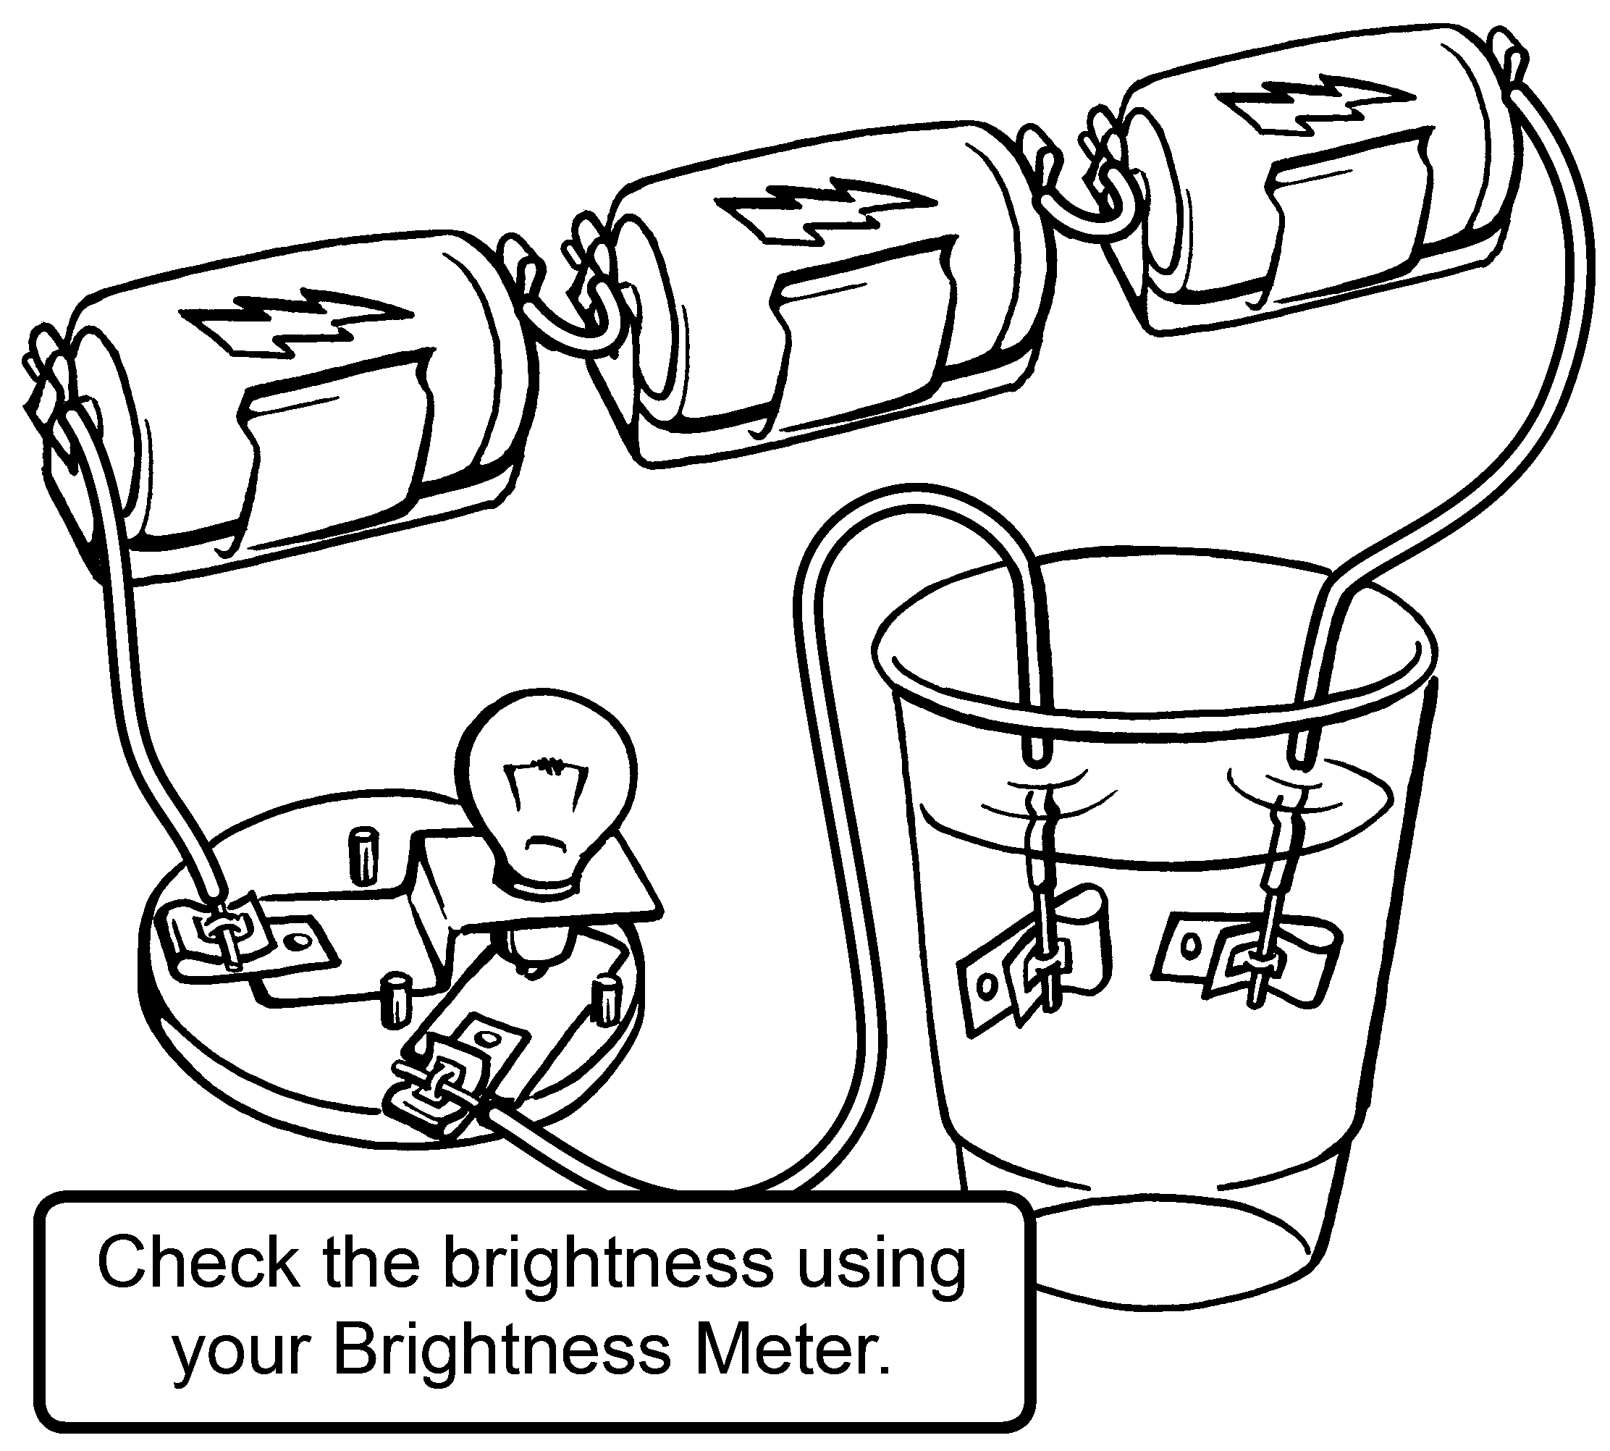

* 1. Pour the liquid to be tested in a plastic cup.
  2. Put clip X and clip Y of the tester into the liquid.
  3. Move the clips so that they are close together

but **not** touching.

* 1. Write your results on the data table.
  2. Use clean wires to test each liquid.

**Activity Sheet K**

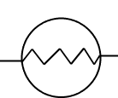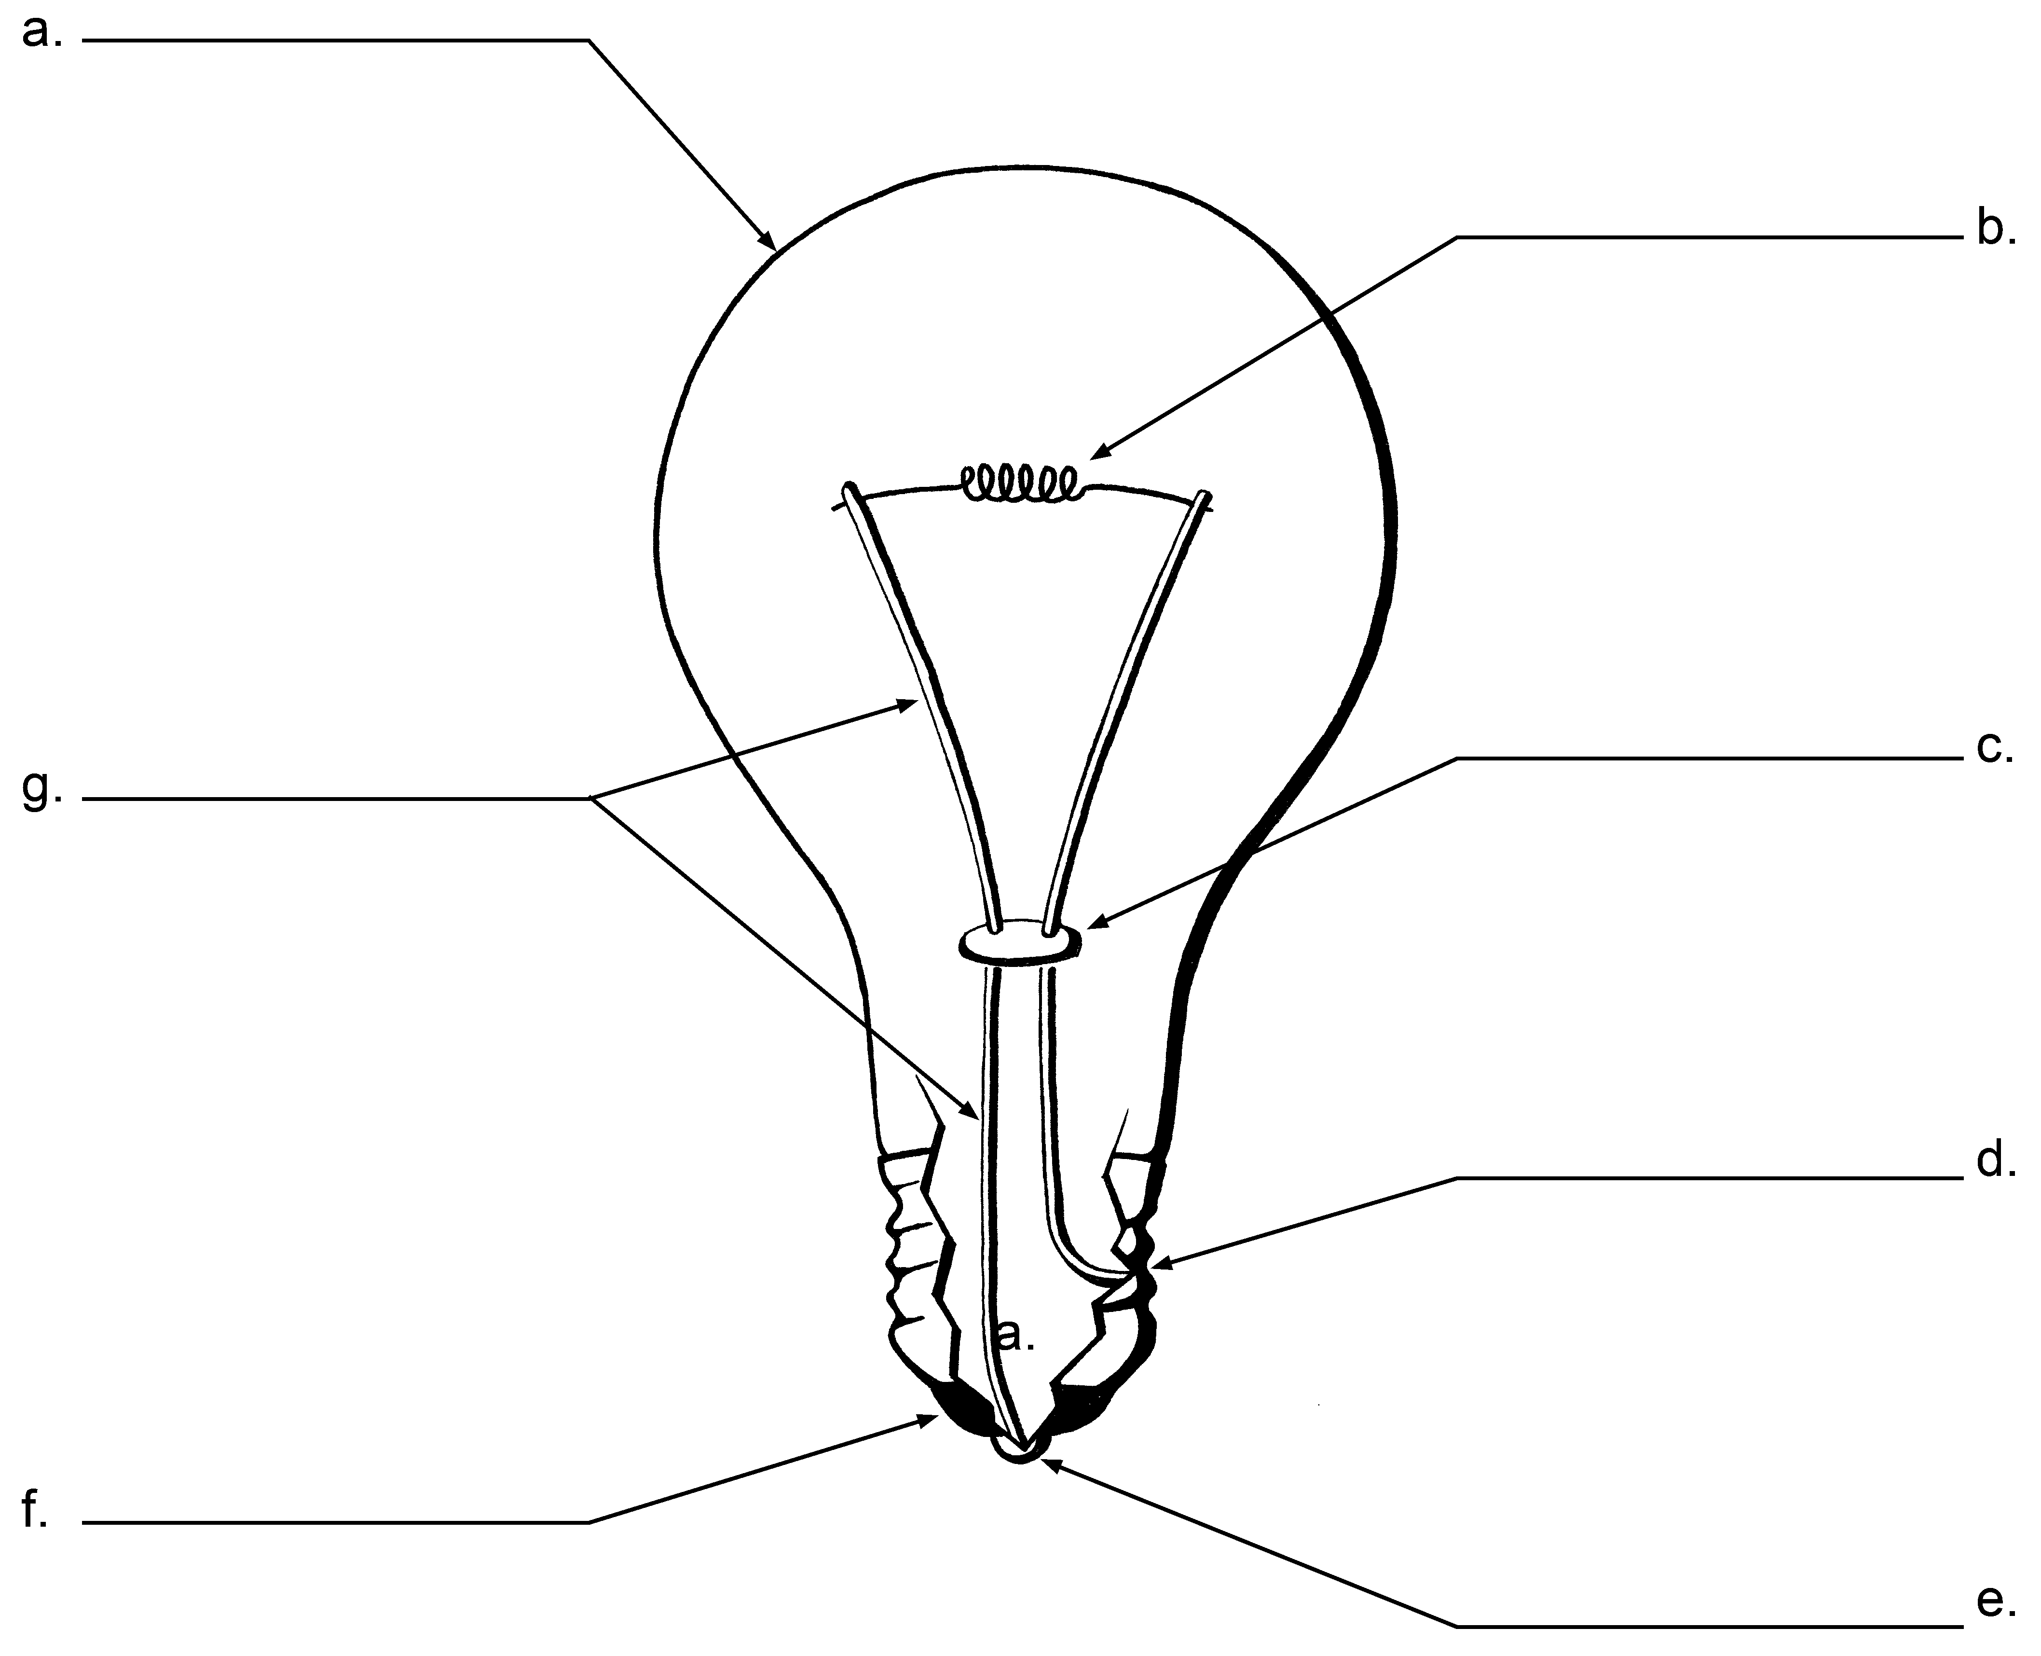

**Word Bank**

**wire solder filament**

**insulator bead insulator globe**

Bonus: After you label the parts of the light bulb, circle the names of the parts that conduct electricity.

**Activity Sheet L-1**

**What does heat have to do with electricity?** One of the ways people use electricity is to make heat. Some of the ways we use this heat are: to cook, blow dry our hair, heat our homes and to make light bulbs produce light. To do this we need to cause something to heat up. If you look closely at the objects we use to make heat, you will see coils of wire. When electricity is passed through these coils of wire they heat up.



Look closely at a light bulb. You will see a very thin piece of wire called a **filament**. When electricity passes through the filament it gets very hot. It becomes so hot that it glows. The bright light we see comes from this glowing filament.

**Why does this piece of wire get so hot?** Why doesn’t the wire to the light bulb get this hot? This has to do with two things. One has to do with what material the wire is made from. The other has to do with how thick the wire is. Both of these have to do with **resistance**.

**What is resistance?** Resistance is a force that causes things to slow down or not move at all. The size of the wire is one cause of resistance. It may take more “push” to get the energy through. The material that the wire is made from is another cause of resistance.

A thinner wire allows less electricity to flow through at a time. As electricity is pushed through the thinner wire, some electrical energy is changed into heat energy. The resistance of the wire increases the friction. Friction occurs when matter rubs together and causes heat.

**Activity Sheet L-2**

Think about two water hoses. One hose is a garden hose; the other is a fire hose. Which hose will let the water flow through more easily? Which hose will have more resistance? You can get more water through a fire hose. It is harder for water to flow through a smaller garden hose. There is less space for the water to move through. As the resistance becomes greater the force becomes greater. If I want to wash my car I put a nozzle on the hose. The nozzle has a small opening that the water has to pass through. Think about how much force there is with the nozzle on the end of the hose. There must be a lot of resistance.



The second reason that can cause resistance is the type of matter that the wire is made from. Silver, copper and aluminum wires are good conductors of electricity. They give a low amount of resistance. The wires heat up less. We use insulated copper wire in our homes to keep our homes safe.



Nichrome wire is very resistant to electricity. Nichrome wire will heat up when electricity passes through it. Sometimes we want electricity to create heat. This kind of wire is used in appliances like toasters to make heat.

**Activity Sheet L-3**

**Directions:** Answer the following questions using information from the reading.

When does electricity cause something to heat up?

Why does the piece of wire in a light bulb get so hot?

Why doesn’t the wire to the light bulb get this hot?

Electricity has a property that is very much like a property that water has. It is a property that we have. It has to do with energy of motion.

Water can have energy of motion but it does not flow in all directions. It doesn’t flow uphill. It takes the easier way. Water will flow around something rather than over it. There are directions that we try not to go, like uphill or the long way around something. It takes an extra amount of energy to do these things.



Electricity takes the path that uses the least amount of energy, too. Given two paths it will flow down the easier one. If one path has a strong resistance it will take the path with less resistance.

The next activity is about **short circuits**. Short circuits deal with paths of least resistance.

**Activity Sheet M-1**

A short circuit is like a short cut. A short cut is an easier path to travel somewhere. You may take a short cut home from a friend’s house. The short cut allows you to get home faster. It also allows you to use less energy because you don’t have to go as far.

Given the chance, electricity will take a short cut in a circuit. If there is a path in a circuit that has less resistance, the electricity will flow that way. Resistance in a circuit can be a thinner wire, like the thin filament in a light bulb. If possible the electricity will not travel through the light bulb. If there is another path to follow it will flow that way. It will short circuit the path.

**Materials:**

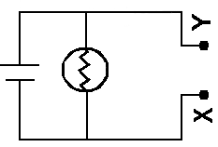

1 “D” cell batteries

1 battery holder

4 pieces of copper wire, 20 cm. long

4 pieces of copper wire, 10 cm. long

1 bulb and holder

Use the diagram as a guide to put together this circuit. Use your Secret Language Book as a guide.

1) Does the bulb light?

2) Touch point “X” and “Y” together. What happens?

3) On a piece of paper draw the circuit above with points “X” and “Y” touching. Use arrows to show the flow of electricity in this circuit.

4) Explain why this circuit is called a **short circuit**.

More on Short Circuits **Activity Sheet M-2**

5) Use the diagram as a guide to construct a new circuit.

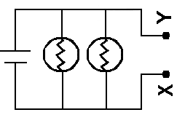

6) Do the bulbs light?

7) Touch point “X” and point “Y” together. What do you observe?

8) On a piece of paper, draw the circuit with points “X” and “Y” touching. Use arrows to show the flow of electricity in this circuit.

9) Explain why this circuit is called a **short circuit**.

10) Challenge: Which circuit is a short circuit? Circle it.

Remember: Electricity takes the path of least resistance.

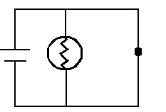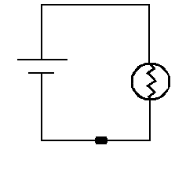

**Activity Sheet O-1**

You are going to start by making a fuse. Use your observations to decide what a fuse is and what it does.

**FUSE**

**Materials:** for each group

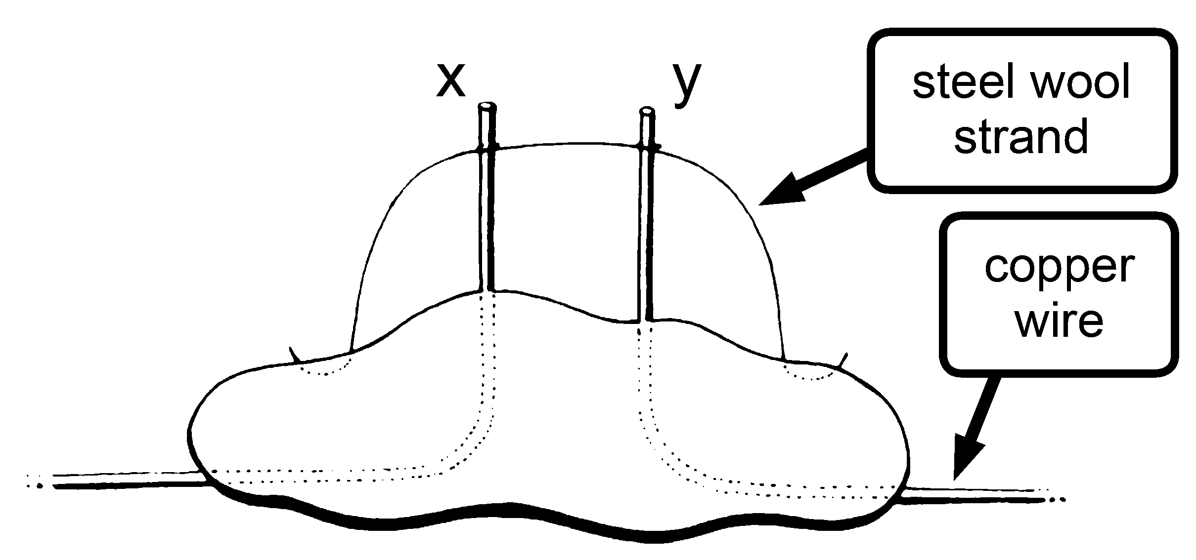

3 “D” cell batteries

3 battery holders

pieces of copper wire, as needed

2 #48 bulbs

1. bulb holders
2. #41 bulb

1 lump of plasticine

1. alligator clips

1) Make a fuse from plasticine, two copper wires and one strand of steel wool as shown above.

Do this by pushing the two copper wires (X and Y) through the plasticine.

Place the wires about 1 cm apart.

Have 2 cm of the wire sticking up.

Wrap the strand of steel wool around the “X” wire. Next wrap it around the “Y” wire.

(You can use the alligator clips to help hold the steel wool onto the copper wire.)

2) Construct the circuit below using two #48 bulbs. Place the fuse you made in the circuit where the symbol for the fuse is shown.

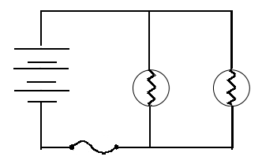

**Activity Sheet O-2**

**Fuses, page 2**

3) Do the bulbs light?

4) Think about the flow of electricity in the circuit. Does the electricity flow through the strand of steel wool?

5) Take out one of the #48 bulbs. Is the other bulb still lit?

6) Put a #41 bulb into the empty bulb holder. What do you observe?

7) Take out the #41 bulb and replace the strand of steel wool. As you put the #41 bulb into the holder again, watch the steel wool carefully.

Write your observations:

8) What do you think is happening? Use your observations to make a conclusion about open and closed circuits.

9) What is a fuse?

10) What do you think we use fuses for?

**Activity Sheet P**

**Materials:**

1 piece of cardboard, manila folder (8”x11” or larger)

aluminum foil

masking tape

1 basic tester circuit (battery, light bulb, wires) with two 20 cm long test wires

hole punch

Your mystery answer game will have a set of questions and a set of answers. If the correct answer is matched with the correct question the light bulb will light. You will need a set of 4-6 questions and answers on a topic.

* 1. Put the questions on one side of the cardboard.
  2. Put the answers on the other side of the cardboard. (Mix up their order.)
  3. Punch a hole in the cardboard near each question.
  4. Punch a hole in the cardboard near each answer.
  5. On the back of the cardboard run a strip of aluminum foil from an answer to a question. Be sure to cover the hole with the foil.

(Do not go over any holes that have not been covered with foil yet.)

* 1. Cover the aluminum foil strip with masking tape.
  2. Do this for each set of holes.
  3. When you are done all of the questions should be connected to the answer with a piece of aluminum foil. Use your circuit tester to make the bulb light by connecting the question and the correct answer.

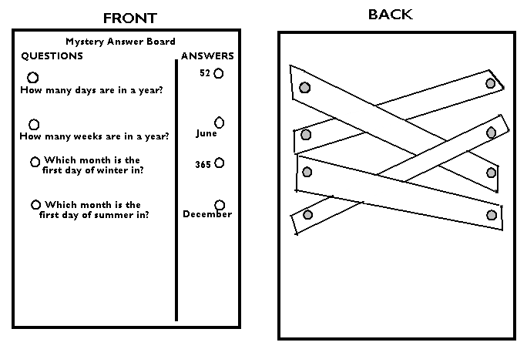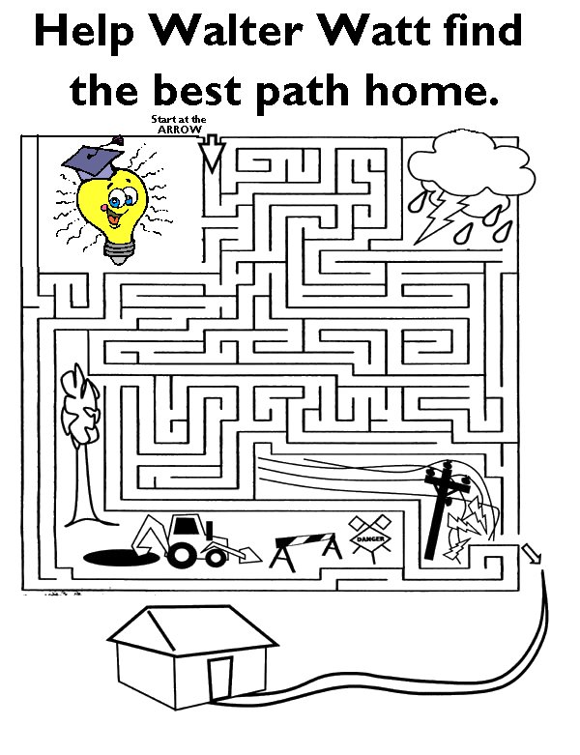

**Samuel Morse:**  
 Samuel Morse (1791-1872) was an American inventor and painter. Morse built the first American telegraph in 1835. A telegraph sends electrical signals. The signals can be sent over a long distance. It does this over wires. The electrical energy can be used to light a light, ring a bell or buzz a buzzer.

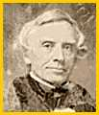

Messages can be sent by electrical signal using Morse Code. Morse Code uses something you see (a light or a flag) or hear (a buzzer or bell) to send messages. A short signal is a dot. A longer signal is a dash. If you were using flags you would wave it to the left for a dash and to the right for a dot. If you were using a buzzer it would be a short buzz and a long buzz. The dots, dashes and spaces are put together to form the letters of the alphabet and the numbers. See the chart below for the dot –dash code for each letter and number. Spaces are moments of quiet that are used to separate the letters.

By 1838, Morse could send 10 words per minute. The U.S. Congress decided to provide funds for building a telegraph line. It was built between Washington D.C. and Baltimore, Maryland. Morse sent the first telegraphic message on May 24, 1844. The message was: "What hath God wrought?” The telegraph totally changed long-distance communication.

Secret Communication : Morse Code

|  |  |  |  |  |  |
| --- | --- | --- | --- | --- | --- |
| A | B | C | D | E | F |
| G | H | I | J | K | L |
| M | N | O | P | Q | R |
| S | T | U | V | W | X |
| Y | Z | 0 (zero) | 1 (one) | 2 | 3 |
| 4 | 5 | 6 | 7 | 8 | 9 |

**How can you use your electrical circuit knowledge to communicate using the Morse Code?**

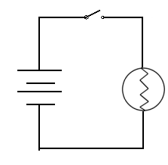

**MEMBER’S NAME**:

Local Chapter President:

*My T. Bright*

Date: ___________________

