# Electrical Circuits

Kit # 11

**Blackline Masters**

### Revised July 2005 OCM BOCES Science Center

LOGO, footers- Revision May 2008

10/2015 Removed Word Search pg 23

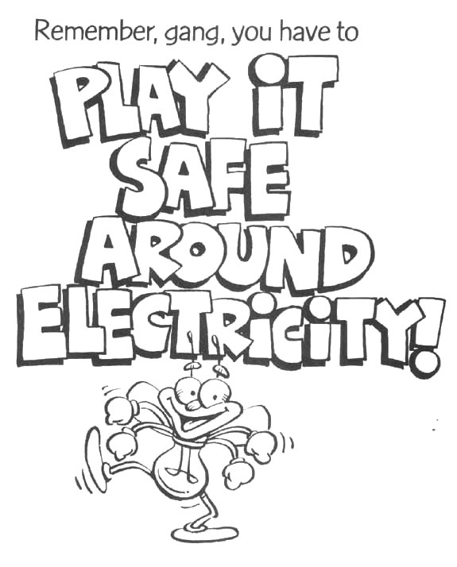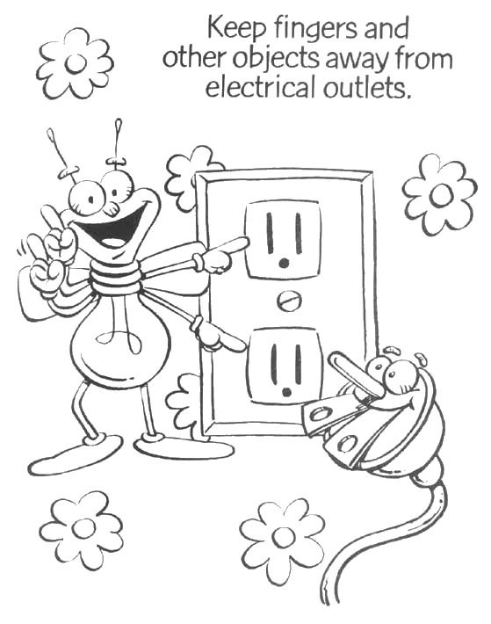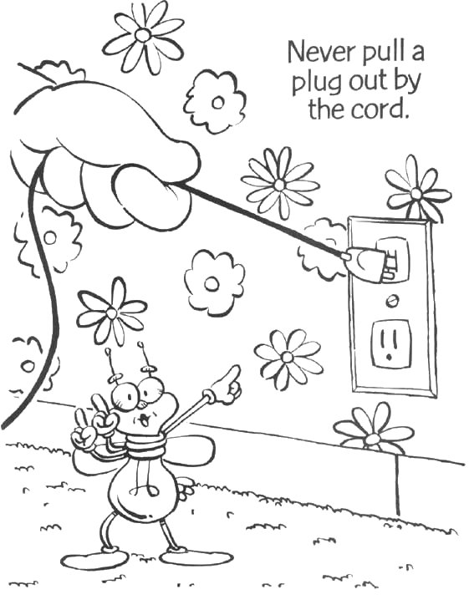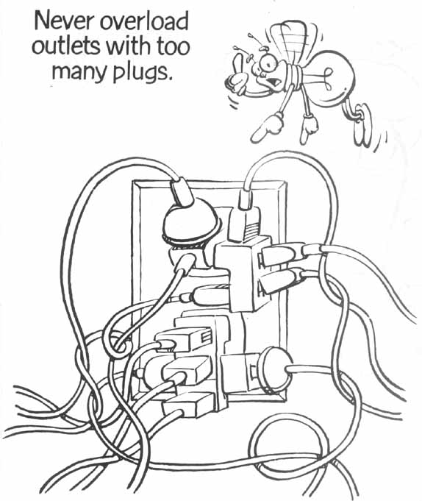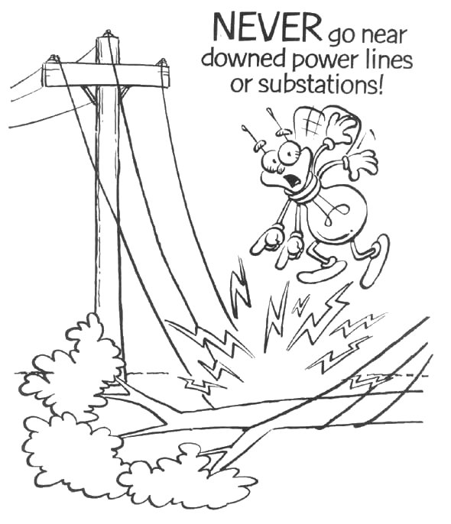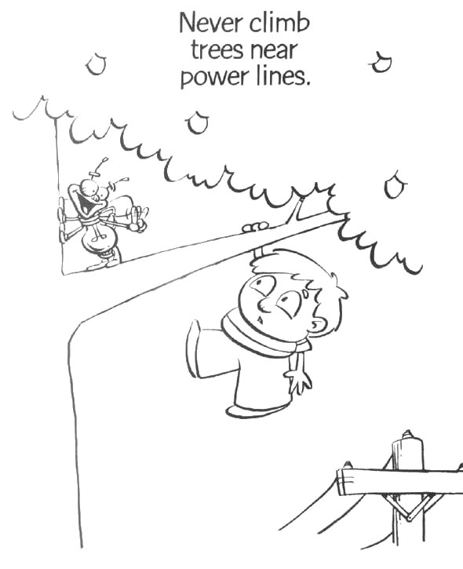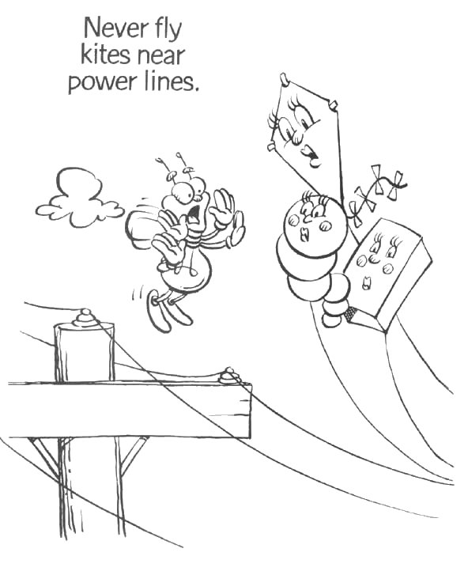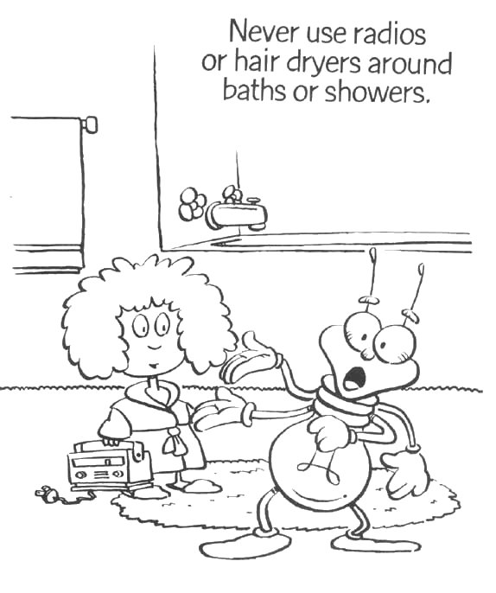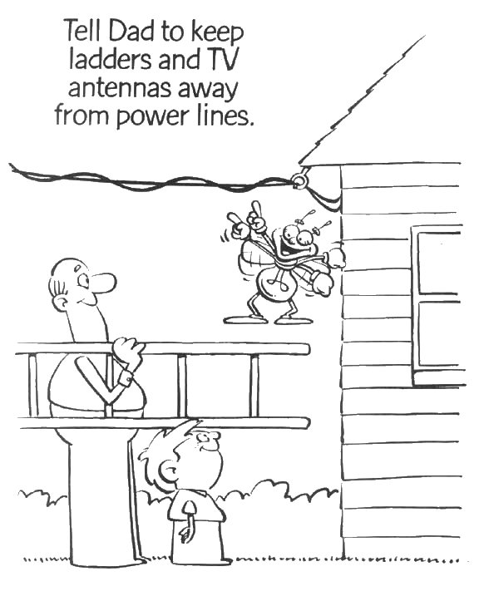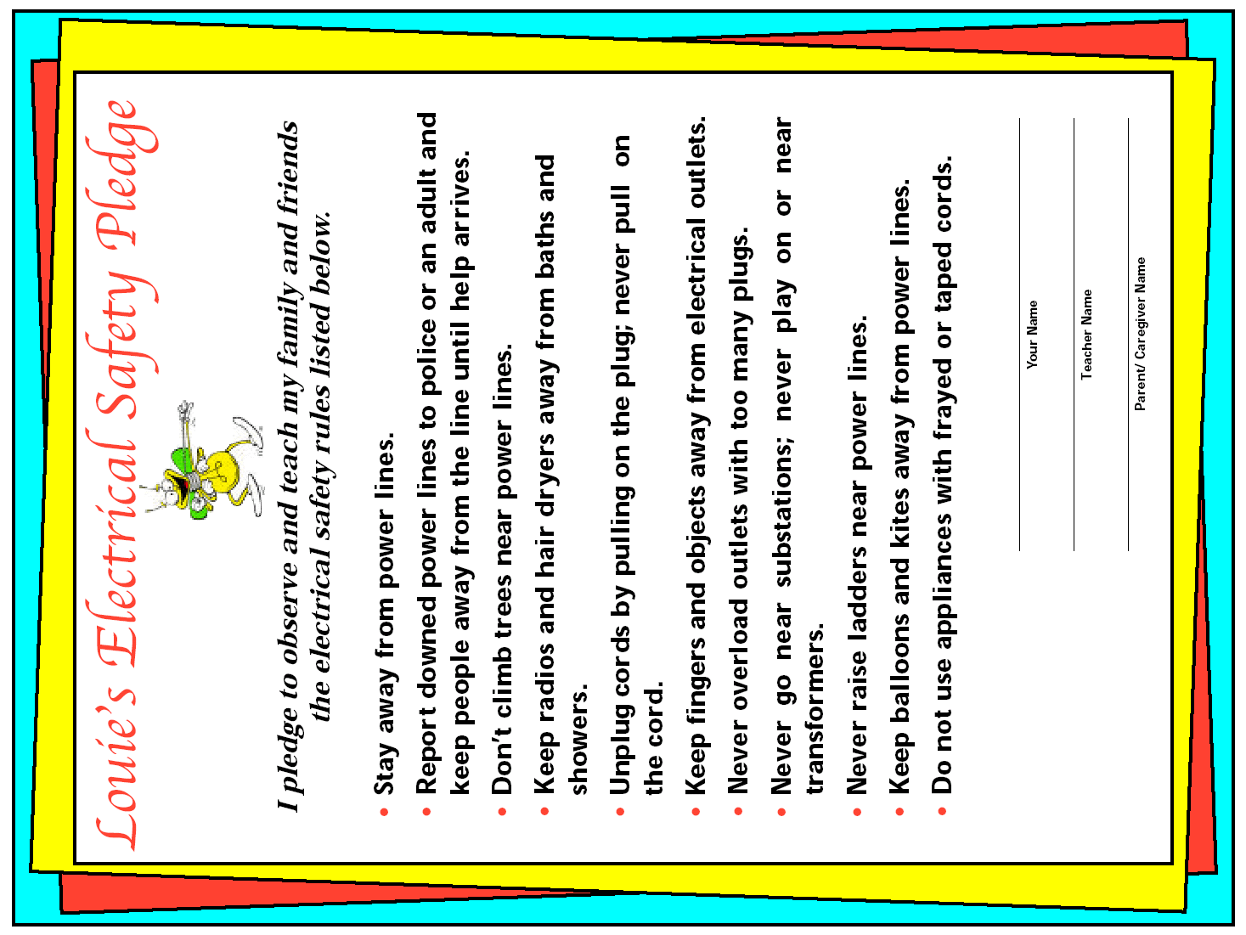

**Extension Activity:**

**$**

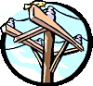

# **Energy, how much does it cost?**

The energy that is used to light a flashlight is paid for when you buy the batteries. You use energy when you plug something into a socket or turn on a switch. That energy is paid for when your parents get a utility bill. Power from the power company is measured in units of energy called a kilowatt-hour (KwH). A kilowatt is equal to 1000 watts.

Our power bills measure electricity in kilowatt-hours. This is the kilowatts of energy times the number of hours. A kilowatt is 1000 watts.



A kilowatt-hour of energy (kWh) is the amount of energy needed to light ten 100-watt light bulbs for 1hour.

The table below has 5 columns. One column is labeled **Wattage**. The Wattage is the amount of energy each item needs to run. The table also shows the cost to run that item for one hour. This number is in the **Cost** column.

The **Monthly Cost** is what you would pay to run that item every day for one hour for a month (30 days).

**$**

# **Energy Costs Table**

|  |  |  |  |  |
| --- | --- | --- | --- | --- |
| Item | Wattage  (watts) | Number of Hours | Cost for  1 hour | Monthly cost to run 1 hour every day |
| Personal Computer | 400 | 1 hour | $0.03 | $0.90 |
| Color TV | 120 | 1 hour | $0.01 | $0.30 |
| Toaster | 1000 | 1 hour | $0.07 | $2.10 |
| Refrigerator | 850 | 1 hour | $0.06 | $1.80 |
| Washing Machine | 500 | 1 hour | $0.04 | $1.20 |
| Clothes Dryer | 2500 | 1 hour | $0.18 | $5.40 |

This table is based upon a cost of .07 per kilowatt and does not include basic service fees.

Continued on page two

**Energy, how much does it cost? page 2**

**$**

Answer the following questions. Use the **Energy Costs Table** to help you.

Show any math work on a piece of paper and attach it to this worksheet.

1. How much energy does the Personal computer need to run? _________________

2. What is the unit used to measure wattage? _________________

3. Which item in the table uses the most energy? __________________________

4. Which item costs the most to run for 1 hour? ___________________________

5. What would be the monthly cost to run the washing machine for 1 hour every day?

_____________

6. What would be the monthly cost to run the washing machine for 3 hours every day? _____________

7. Not all household items are used the same number of hours every day. Below is a list of items and the number of hours they are used each day. Calculate the total number of watts used by each item to run for that amount of time. When you are done find the total used by this house in one day.

|  |  |  |  |
| --- | --- | --- | --- |
| **Item** | **Watts** | **Time runs** | **Total Watt-hours for Item** |
| washing machine | 500 | 2 hours |  |
| dryer | 2500 | 4 hours |  |
| refrigerator | 850 | 24 hours |  |
| color TV | 120 | 7 hours |  |
| personal computer | 400 | 8 hours |  |
| **Total Watt-hours for one day =** | | |  |

Using the number in the box for **Total Watt-hours for one day** calculate the amount used for one week. ______________

8. A common light bulb uses 60 watts of energy.

How many light bulbs use the same amount of energy as a color TV? _______

How many light bulbs use the same amount of energy as a refrigerator? _______

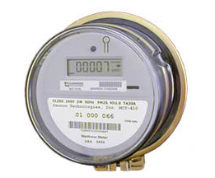

**Household Energy Use:**

**Reading an Electric Meter**

Your home has an electric meter that measures how much energy is used. It is connected to your household circuit. Energy use is measured in kilowatt-hours (kWh).

Digital Meter

By reading the meter at the same time each day, you will get an idea of the amount of electricity you used.

By writing each daily reading in an "Energy Diary," you can chart increases and decreases in energy use.

Newer electric meters are digital. You can just read the number.

Most electric meters in use today are older and have dials on them.

Each dial has a hand that moves. The dials are read from left to right. Look at how the numbers on some dials are different than the numbers on a clock.

Each dial goes a different way. Be careful how you read each dial.

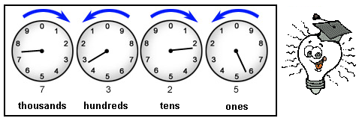

**This meter reading shows 7,325 kilowatt-hours (kWh).**

**Rules to remember when reading an electric meter:**

* Always read the faces of the meters from left to right
* The first and third dials are read counterclockwise and the second and fourth dials are read clockwise.
* Each of the dials on a meter form part of one number. The dials from left to the right build a number. The first dial is thousands, the next is hundreds, then tens, and lastly ones.
* If the arm of the dial falls between two numbers, record the smaller number.

**Electric Meter Reading Practice:**

Read each meter by writing a number under each dial. Then write the whole number on the line.

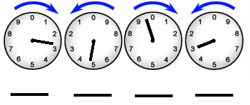

**Day 1 8:00am**

Meter reading:

**Day 2 8:00am**

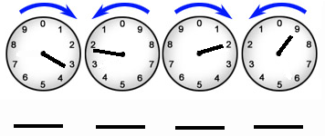

Meter reading:

**Day 3 8:00am**

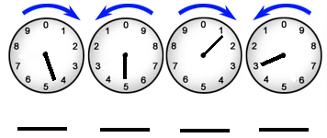

Meter reading:

You can calculate the amount of energy used each day. Do this by subtracting one day’s reading from the next day’s reading. For example, if the reading starting a day was 1500 and the next day it was 2000, the total energy used for the day would be 500 kWh. (2000 – 1500 = 500 )

Find the amount of energy used for Day 1 and Day 2.

**Energy used**: Day 1 ___________ kWh Day 2 ____________kWh

Your Household Energy Use Diary

You can work with your parents to find your home energy use. The best way to do this is to read the electric meter the same time each day.

Make a chart to write down the date, time and meter reading. One has been started for you. Subtract the numbers to get the amount of energy used.

Energy Use Diary (Chart)

|  |
| --- |
|  |
|  |
|  |
|  |
|  |
|  |
|  |

If you can, do this for one week. What days of the week are the highest amounts of energy used by your family? What days of the week are the least amounts of energy used? Why do you think there is a difference?

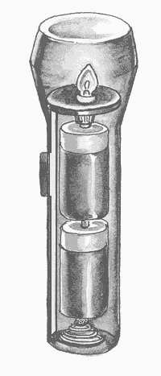

System, system what is a system?

A system is a “set of parts.”

It is a set of parts that work together.

They work together to do a certain job.

What is the job that a flashlight system does?

A flashlight system changes chemical energy into electrical energy. The electrical energy is changed into light energy in the light bulb.

During this energy change heat energy is given off.

Using the flashlight picture and your knowledge of electrical circuits, answer the questions.

1. What is the source of energy? _______________

2. What part of the system opens and closes the circuit? __________________

3. What two forms of energy are given off by the light bulb? ________________ __________________ What form of energy is in the battery? ____________

4. Is this a series or parallel circuit? _________________________

5. What would happen if the light bulb were taken away from the system?

**Label these system parts** on the diagram: battery, switch, spring, light bulb holder, light bulb, metal strip, case

**Energy Use. What do we use energy for in the United States?**

The pie chart shows what we use energy for in our nation and how all the energy we use is divided up.

Use the information in the pie chart to complete the table. List the ways we use energy from the largest use to the smallest use.

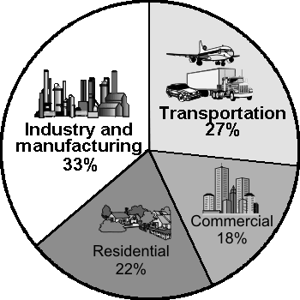

|  |  |
| --- | --- |
| **How we use energy** | **%** |
|  | largest |
|  |  |
|  |  |
|  | smallest |

Do any math work for questions 1 – 5 on a separate sheet of paper. Attach the sheet of paper to this page when you are done.

1. The “Industry and Manufacturing” part of the pie is companies that make products to be sold. A farm is industry. The “Commercial” part is businesses that sell products and services. A grocery store is commercial.

How much greater is the percent of energy used for “Industry and Manufacturing” than the percent used for “Commercial”?

2. What is the percent total of the 2 largest energy uses?

3. What is the least percent of energy used for? __________________________

4. What is the total of all of the percents of energy use? ______________

**Energy Use. What do we use energy for in our homes?**

The pie chart shows what we use energy for in our homes and how all the energy we use is divided up.

Use the information in the pie chart to complete the table. List the ways we use energy from the largest use to the smallest use.

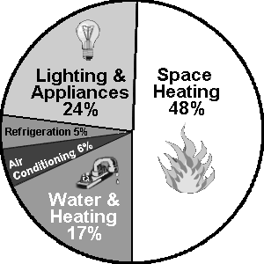

|  |  |
| --- | --- |
| **How we use energy** | **%** |
|  | largest |
|  |  |
|  |  |
|  |  |
|  | smallest |

Do any math work for questions 1 – 5 on a separate sheet of paper. Attach the sheet of paper to this page when you are done.

1. The “Space heating” part of the pie is energy used to heat our homes. The “Water and Heating” part of the pie is energy used to do things such as cooking, drying clothes, blow drying hair, ironing clothes, heating water and getting water to our homes.

How much greater is the percent of energy used for “Space Heating” than the percent used for “Water and Heating”?

2. What is the total of the 3 largest energy uses?

3. What is the least percent of energy used for? _________________________

4. What is the total of all of the percents of energy used? ____________

5. Think about how you use energy in your home. Write a sentence about what you could do to use less energy.



# **Electrifying Word Study**

1. Circle all of the words with double consonants.

battery bulb parallel circuit series

copper socket insulator wire dimmer

2. Write the number of syllables in each word.

___system ___circuit ___positive

___parallel ___insulator ___socket

___series ___electricity ___bulb

___negative ___switch ___conductor

3. Number these words in alphabetical order.

___battery ___insulator ___attract

___positive ___socket ___negative

___bulb ___wire ___fuse

___series ___copper ___parallel

#### Electrifying MATH

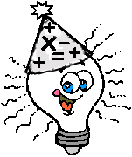

Work Space

1. There are 4 groups of 6 children each.

How many children in all?

_______children

2. If each child needs 2 wires, how many wires will we need for 27 students?

______wires

3. The groups have: 4 batteries, 3 batteries, 5 batteries and 6 batteries. How may did they have all together?

______batteries

4. Each group of 4 students is going to have 6 batteries. If there are 7 groups of students how many batteries will be needed?

______batteries

5. Four children decided to put one bulb in their circuit, 8 decided to put two bulbs. How many more children decided to use two bulbs?

______more

6. Eighteen children got their bulbs to light. Six children did not. How many more children were successful?

______children

7. If 25 children each need 32 centimeters of wire, how many centimeters of wire are needed in all?

______centimeters

How many meters is this? ______meters

**Cause Effect** = **Why did it Happen What Happened**

We deal with causes and effects (or effects and causes) every day. We can look at our behaviors and predict what will happen (the effects) from those behaviors, OR we can look at what happened and reflect on the causes.

For example, I know that if I get a flat tire (the cause), I may fall off my bicycle and get hurt (the effect). I may try to avoid that effect by checking my tires before I go for a ride.

There are many causes and effects to think about with electrical safety. The effect to avoid is getting a shock. A large shock can be very dangerous.

This graphic organizer separates the CAUSE and EFFECT. Your task is to write causes for things that happen in an electric circuit. In the first two boxes, you need to write in a cause for the effect that is given. For the last boxes, you need to write in a different effect of electricity and a cause for that effect.

EFFECT

The light bulb gives off light energy.

CAUSE

EFFECT

The wires become hot.

CAUSE

EFFECT

CAUSE

**Electrifying Crosswords**

