Blackline Masters

Astronomy 4
Kit #64

Revised July 2003
Revised p.3 (data table) – Feb. 2011
Compass Rose
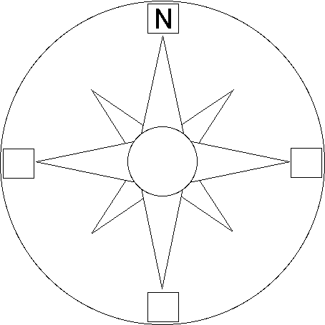
A compass rose is a design on a map that shows directions. It shows North, South, East, West, Northeast, Northwest, Southeast, and Southwest.

On the compass rose above, only North is filled in.
Fill in the rest of the directions on the compass rose, using:
N=North, S=South, E=East, W=West.
Helpful Hint: When North is at the top of the compass rose (as it often is), South is at the bottom, East is on the right, and West is on the left.

Challenge: Find the location on the Compass Rose for each of the following compass directions and write the abbreviations in:

NE=Northeast, NW=Northwest, SE=Southeast, SW=Southwest

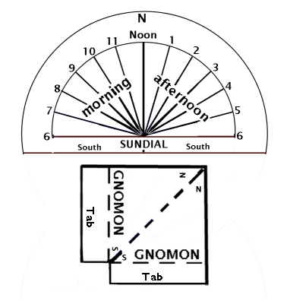
Activity 1.1A: SUNDIAL
Finished sundial can be glued to a paper plate or stiff paper

- Cut out the Sundial.
- Cut out the Gnomon and fold it along the dotted lines.
- Cut a slit in the Sundial along the Noon line.
- Insert the Gnomon tabs, spread them and tape them. The Gnomon should stand up on the sundial.
- The high part is North.
- Hold the sundial matching the compass directions to N and S.

Activity 1.1B: Sunrise Times for Three Cities across the United States (East, Central, West)

Month | NYC | Chicago | Sacramento
September 21 | 5:42 AM | 6:37 AM | 8:53 AM
October 21 | 6:14 AM | 7:10 AM | 9:21 AM
November 21 | 6:50 AM | 7:48 AM | 9:55 AM
December 21 | 7:16 AM | 8:15 AM | 10:20 AM
January 21* | 7:15 AM | 8:13 AM | 10:19 AM
February 21 | 6:42 AM | 7:38 AM | 9:49 AM
March 21 | 5:58 AM | 6:53 AM | 9:08 AM
April 21 | 5:08 AM | 6:01 AM | 8:21 AM
May 21 | 4:33 AM | 5:25 AM | 7:49 AM
June 21 | 4:25 AM | 5:16 AM | 7:42 AM
July 21 | 4:42 AM | 5:34 AM | 7:58 AM
August 21 | 5:12 AM | 6:05 AM | 8:25 AM

Activity 1.1B: US Cities Sunrise/Sunset Times: U.S. MAP
Sunrise Time
Sunrise Time
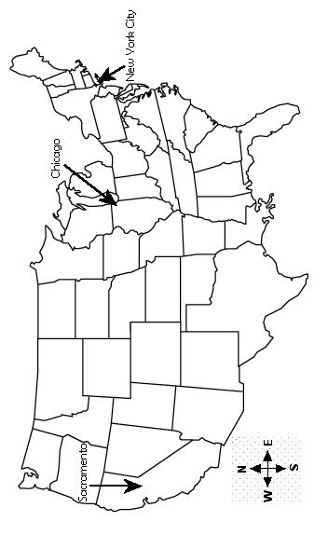
Sunrise Time

Activity 1.1B: U.S. Cities Sunrise Times Datasheet

Month Name | N.Y.C. | Chicago | Sacramento
1
2
Prediction for month 3
3
4
5
6
7
8
9
10
11
12

Looking at the data for the first three months, write a sentence about a pattern in the sunrise data for each city.

Does your pattern work for the rest of the sunrise data?
If not, look for another data pattern to share.

Central New York (CNY) Area Sunrise and Sunset Data Sheet
 | Sept. | Oct. | Nov. | Dec. | Jan. | Feb. | March | April | May | June | July | Aug.
Sunrise Times | 5:51 AM | 6:25 AM | 7:04 AM | 7:33 AM | 7:29 AM | 6:54 AM | 6:07 AM | 5:14 AM | 4:36 AM | 4:25 AM | 4:44 AM
Rounded  Sunrise Times | 6  AM | 6  AM | 7  AM | 8  AM | 7  AM | 7  AM | 6  AM | 5  AM | 5  AM | 4  AM | 5  AM
Sunset Times | 6:04 PM | 5:12 PM | 4:36 PM | 4:33 PM | 5:02 PM | 5:43 PM | 6:18 PM | 6:54 PM | 7:31 PM | 7:47 PM | 7:37  PM
Rounded Sunset Times | 6  PM | 5  PM | 5  PM | 5  PM | 5  PM | 6  PM | 6  PM | 7  PM | 8  PM | 8  PM | 8  PM
Total Hours of Daylight

Total
Hours of Nighttime

Total Number of Hours in a Day

Central New York (CNY) Area Sunrise and Sunset Data Sheet (Rounded times)

 | Sept. | Oct. | Nov. | Dec. | Jan. | Feb. | March | April | May | June | July | Aug.
Rounded  Sunrise Times | 6  AM | 6  AM | 7  AM | 8  AM | 7  AM | 7  AM | 6  AM | 5  AM | 5  AM | 4  AM | 5  AM
Rounded Sunset Times | 6  PM | 5  PM | 5  PM | 5  PM | 5  PM | 6  PM | 6  PM | 7  PM | 8  PM | 8  PM | 8  PM
Total Hours of Daylight

Total
Hours of Nighttime

Total Number of Hours in a Day

Class Bar Graph Labels

JANUARY | JUNE | OCTOBER
FEBRUARY | JULY | NOVEMBER
MARCH | AUGUST | DECEMBER
APRIL | SEPTEMBER | MONTHS
MAY | Total Hours of Nighttime
 | Total Hours of Daylight

Sun Data for Denver, Colorado Name:

This data table shows the number of hours of daylight for a day in each month for Denver, Colorado.
Date | Hours of Daylight
September 21 | 12
October 21 | 12
November 21 | 10
December 21 | 10
January 21 | 10
February 21 | 11
March 21 | 12
April 21 | 12
May 21 | 14
June 21 | 15
July 21 | 14
August 21 | 14

Let’s make some observations about the number of “Hours of Daylight” on the data table:

- Which month has the most number of daylight hours?

- Which months have the least number of daylight hours?

- How many months have 12 hours of daylight?

- The winter months are the coldest and have the least amount of day light (shorter days). Which of the months in the data table would be winter months?

- Are the winter months for Denver the same winter months for us living here in New York?

Name - ___________________

Bar Graph for Denver, Colorado Data
Using this grid, make a bar graph for the Denver “Hours of Daylight” data.
The sides have been labeled for you.
Number of Hours of Daylight

Months

Let’s make some observations about the number of “Hours of Daylight” on the graph:

6. Color each bar on the graph that shows the greatest hours of daylight in RED.

7. Color each bar on the graph that shows smallest number of daylight hours in BLUE.

8. Find the bars that show 12 hours of daylight and color each YELLOW.

- The winter months are the coldest. They have the smallest amount of daylight. Find the bars that would be winter months and lightly color them “ LIGHT BLUE”.

- The summer months are the warmest. They have the greatest amount of daylight. Find the bars that would be summer months and lightly color them “ LIGHT RED”.

Name - ___________________

Line Graph for Denver, Colorado Data
Using this grid, make a line graph for the Denver “Hours of Daylight” data.

Let’s make some observations about the number of “Hours of Daylight” on the graph:

- Use a RED marker to circle the point on the graph that shows the greatest number of daylight hours.

- Use a BLUE marker to circle each point on the graph that shows the smallest number of daylight hours.

- Find the points that show 12 hours of daylight. Place an “X” on each.

9. The winter months are the coldest. They have the smallest amount of daylight. Find the points that would be winter months and color the line through them “BLUE”.

10. The summer months are the warmest. They have the most amount of daylight. Find the points that would be summer months and color the line through them “RED”.

Sun Data for Sydney, Australia Name:

This data table the number of “Hours of Daylight” for a day in each month.
Date | Hours of Daylight
September 21 | 12
October 21 | 13
November 21 | 14
December 21 | 14
January 21 | 13
February 21 | 13
March 21 | 12
April 21 | 11
May 21 | 10
June 21 | 10
July 21 | 10
August 21 | 11

Let’s make some observations about the number of “Hours of Daylight” on the data table:

- Which months have the most number of daylight hours?

- Which months have the least number of daylight hours?

- How many months have 12 hours of daylight?

- The winter months are the coldest and have the least amount of daylight. Which of the months in data table would be winter months?

Bonus: Make a line graph for the months and the number of daylight hours. How is the Sydney graph the same or different than the Denver graph?

Reading for Information: Time Zones

Does Anyone Really Know What Time It Is?

Yes, they do! There are "timekeepers" for the world and they are very important to everyone.

You probably already know that when it is time for us to get up in the morning people on the other side of the world are getting ready to go to bed. Just as our side of the world is turning toward the sun their side of the world is beginning to turn away from the sun. The world turns completely around once every day.

If you did not remember that the world turns you might think that everyone is having daytime at the same time you are! Let’s talk about time differences in the United States. If you have a friend that lives in Chicago and you say to them “I’ll call you when I see the sun rise.” they might be angry! Why? Because the phone ringing would wake them up before the sun has come up! It will be another hour before the earth turns so that Chicago will see the sun. Sunrise for you may be at 6:00am. In Chicago their clocks say “5:00am”. There is a difference in the time. You have to think about the turning world and try to figure out what time it is where your friend lives.

How can you decide when to call your friend? The "timekeepers" for the world know the secret. They would tell you that the world is divided up into time zones. Each time zone is one hour different than the next one. If you know how many time zones away your friend lives you can figure out what time it is there. You friend in Chicago was one time zone away. That is why the clocks were one hour different.

Time Zones:
People in different places have to set their clocks where they live so that as the sun rises their clock says that it is early in the day. When the sun is in the middle of the sky their clock says that it is noon. And as the sun goes down their clock says that it is the end of the day. The time their clock is set to is called "local time." Wherever people live they use their own "local time" to live their lives. Time zones help the world to set their local time.

If you want to know what the "local time" is at another place you need to know how their clock is set differently from your clock. We need to do this by knowing the difference in the hours between the time their clock shows and the time our clock shows. Sounds hard? Well, we can also do this by counting the number of times zones between us.

"Local times" are set by time zones. We use time zones to keep track of all the "local times." The earth has been divided into 24 different time zones. It takes the earth 24 hours to turn once. There are 24 hours in one Earth day. Twenty-four is a good number to use. This way each time zone has a time that is different by one hour.

Here is an example to think about. In Syracuse, New York when the sun is high in the sky our clock shows 12 o'clock noon. In one hour the earth will turn so that the next time zone will have the sun high in the middle of the sky. Since they are one hour away from having the sun in the middle of the sky their clocks show one hour of difference from our clocks. In one hour their clock will move from 11:00 to 12:00.

That means when the "local time" in Syracuse is 12 o'clock noon the "local time" in Chicago is 11 o'clock in the morning. The people in Chicago need to wait one hour for their "local time" to be noon. It will take one hour for the earth to rotate so that the sun is in the middle of the sky for Chicago.

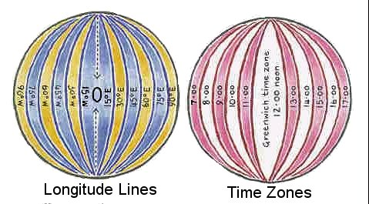
This is a rule that you can use for time zones. When you travel west and across a time zone, you must put your watch back by one hour. When you travel east and across a time zone, you must put your watch forward, by one hour. This way you change your watch to the "local time" of the area you are in. Time zones are one hour apart; longitude lines can also be drawn one hour apart. This way you can draw time zones on a map.

Many countries have decided to have a single time zone, so people change their watches as they cross at the borders. Large countries may be divided into a number of time zones. The continental United States is large enough to have 4 time zones: Eastern Standard Time (EST), Central Standard Time (CST), Mountain Standard Time (MST) and Pacific Standard Time (PST).
For more information on "Time" and the world's "Timekeepers" go to:
http://greenwichmeantime.com/info/time.htm (Greenwich 2000)
http://www.boulder.nist.gov/timefreq/ (National Institute of Standards and Technology)
http://www.timeanddate.com/worldclock/

Local Times
We begin to face the sun in New York State at about 6 o'clock in the morning. We like to start our day near the time when the sun rises. We call it 6 o'clock in our time zone so that we can use this the time of "sunrise" to get up, get dressed and have breakfast.

You have a friend in China. The world has to turn a lot more before Changchun, China gets sunrise. In fact, it would take 13 more hours before your friend could see the sun rise! What time would that be in New York State? Hmmm, let's see, you may need a clock to count the 13 hours! Use the clock below to count the 13 hours of difference starting at 6 o’clock.
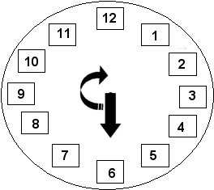

That's right, it would be 7 o'clock at night in New York State. If we all had our clocks set the same, 7:00 pm would be sunrise in China. Wow, that is the time when the sun should be setting! It would be funny to have the day begin sat a time when the sun should be setting. Life would be very confusing.

In your friend's time zone people still want to start their day with the sunrise. So the "local time" of sunrise would be about 6 o'clock in the morning in Changchun, China too. Your friend's "local time" in his time zone is different from "local time" in your time zone. And you both start your day at 6 o'clock in the morning!

Remember, all the people in the world want to set their "local time" so that they start their day when the sun rises, eat lunch when the sun is in the middle of the sky, and eat supper when the sun is in the West going down. That is why there the world has so many time zones.

Time Zones Worksheet Name - ___________________

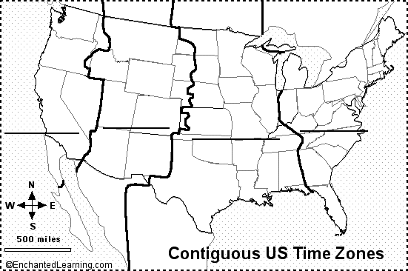
12:00
Chicago
Syracuse

The Earth is divided into 24 time zones so that everyone in the world can be on their own daily schedule (like noon being when the sun is highest in the sky). Time zones were first used in 1883 by railroads in order to set their train schedules. The US is divided into four time zones. Whatever time it is in one time zone, it is one hour different in the next time zone. It is one hour later in the time zone to the east of you. It is one hour earlier in the time zone to the west of you.

Label the four US time zones:
- Eastern (the eastern US)
- Central (just west of the eastern time zone)
- Mountain (between Central and Pacific)
- Pacific (the far-western US).

The US time zones are one hour apart. If it is 4:00 in Eastern Time, it is 3:00 in Central time, 2:00 in Mountain Time, and and. 1:00 in Pacific Time
- Find New York and label it (NY) on the map.
- What time zone is our state in? ___________________________
- What is the time zone to the west of our time zone?
- Label the Atlantic Ocean (east of the USA), the Pacific Ocean (west of the USA).
- Color the bodies of water light blue; color each of the time zones a different color.
SunMonTueWedThuFriSat1
Crescent Moon
2
Crescent Moon
3
Crescent Moon
4
Crescent Moon
5
Crescent Moon
6
Crescent Moon
7
NEW MOON
8
Crescent Moon
9
Crescent Moon
10
Crescent Moon
11
Crescent Moon
12
Crescent Moon
13
FIRST QUARTER MOON
14
Gibbous Moon
15
Gibbous Moon
16
Gibbous Moon
17
Gibbous Moon
18
Gibbous Moon
19
Gibbous Moon
20
Gibbous Moon
21
FULL MOON

22
23

24
25
26

27

28

29

30

Websites:
U.S. Naval Observatory: Astronomical Applications Department information about Phases of the Moon and Percent of the Moon Illuminated
http://aa.usno.navy.mil/faq/docs/moon_phases.html
Moon Phases: Calendar showing the phase of the moon for this month or a month/year of your choice. http://www.googol.com/moon/
2002
Moon Phase Calendar 1 for Sample Month: September

SunMonTueWedThuFriSat1
Crescent Moon
2
Crescent Moon
3
Crescent Moon
4
Crescent Moon
5
Crescent Moon
6
Crescent Moon
7
NEW MOON
8
Crescent Moon
9
Crescent Moon
10
Crescent Moon
11
Crescent Moon
12
Crescent Moon
13
FIRST QUARTER
14
Gibbous Moon
15
Gibbous Moon
16
Gibbous Moon
17
Gibbous Moon
18
Gibbous Moon
19
Gibbous Moon
20
Gibbous Moon
21
FULL MOON

22
Gibbous Moon
23
Gibbous Moon
24
Gibbous Moon
25
Gibbous Moon
26
Gibbous Moon
27
Gibbous Moon
28
Gibbous Moon
29
LAST QUARTER
30
Crescent Moon
→ Crescent phase continues for about 5 days to New Moon

U.S. Naval Observatory: http://aa.usno.navy.mil/faq/docs/moon_phases.html
Moon Phases: http://www.googol.com/moon/
2002
Moon Phase Calendar 2 for Sample Month: September

Moon Phases: Full to New (Waning part of Moon Phases Cycle)
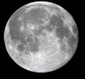
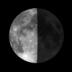
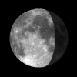
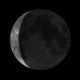
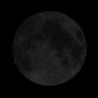

Full Moon

Gibbous Moon

Last Quarter

Crescent Moon

New Moon

