
Science Center

Astronomy 4

Student Journal

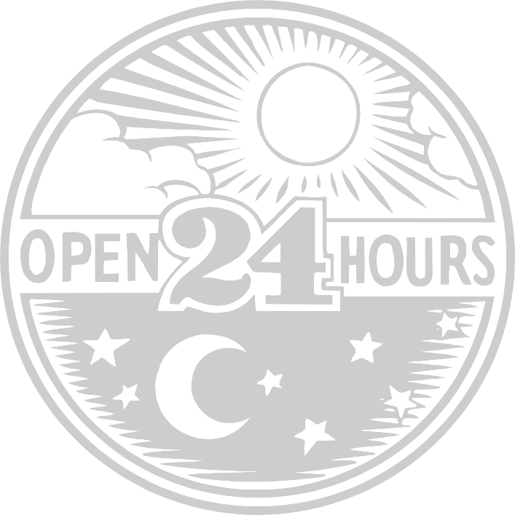

Student Astronomer’s Name:

Act 1.1: My Sunrise and Sunset Times
Date | Sunrise Time | Sunset Time

SunMonTueWedThuFriSat

Moon Phases for the Month of:

Activity 1.1A: Is there a pattern to the Sun’s motion across the sky?

You have made some observations about the Sun’s movement across the sky. Write about your observations. Write about any daily patterns that you observed.

Activity 1.1B: “My Sunrise and Sunset Times Data” Worksheet
Is there a pattern to the sunrise and sunset times?

Look at the sunrise data that you have written down on your data sheet.
Do the sunrise times change each day?
Is the time getting earlier or later?

Let’s think about tomorrow.
Let’s make some predictions. (What do you think in going to happen?)

Do you think the sun will rise tomorrow at an earlier time or at a later time?

At what time do you think the sun will rise tomorrow?

Look at the sunset data that you have written down.

Do you think the sun will set tomorrow at an earlier time or at a later time?

At what time do you think the sun will set tomorrow?

As your class gets more sunrise time data, look to see if your predictions are correct.

Try to predict the next day’s sunrise and sunset times for a week.

Is there a pattern that you are using to make your predictions? ______
If there is, what is the pattern you are using?

Activity 1.2: Can we build a model to answer a question?

A good scientist is always looking at the world about them, thinking about and questioning what they see. You have just completed some Sun observations. Try to think of a WHY question about the Sun.
Write Your WHY Question:

Once a scientist has a why question they try to answer it. They may do an experiment. They may create a model to explain what they observe. A model can be a picture, a diagram or something that has pieces. It is made to show an answer to a question.
For example, I may ask you how you are going to decorate a cake. You can answer me by drawing a picture of the cake.
You are going to use some materials to build a model.

Your group will be working to make a model that answers the question:

Think of a possible answer. Write it here.

Here are you model-building directions:

Get these materials for your group: Flashlight, Globe, masking tape, colored dots

Procedure: (Student Directions)
- You have a question and a possible answer. Use the materials provided to try to show your answer to the question. This is called “making a model.”

2. Describe your model using words and pictures (drawings).
(You may use a larger piece of paper.)

Activity 1.2 Review: Fill in the blanks
Patterns
East
West

There is a daily pattern to:
- where the sun is first seen in the morning (rising), it is to the _ _ _ _.

- where the sun is at noontime, it is highest in the sky and to the _ _ _ _ _ .

- where the sun is at the end of the day (setting), it is to the _ _ _ _ .

There is a pattern of change to the sunrise and sunset times.
For this month, each day the sunrise time is a little _____________.
For this month, each day the sunset time is a little _____________.

Model Building Review

We build models all the time. You have built models using blocks, legos, or K’nex. Scientists build models too. They do this to show something that is not easy to observe. You did this with the globe and the flashlight. The globe played the part of the _ _ _ _ _ . The flashlight played the part of the _ _ _.

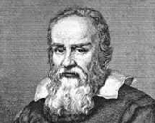
The pieces of a model are put together in a way that shows our observations.
It shows what we see, hear, smell, feel or measure. Models can be built out of matter, like wood or clay. Models can be drawings. Models can even be built using math. (6 = 3 + 3)

From a model we try to answer a _ _ _ _ _ _ _ _ .

Read the story about Galileo Galilei and his work to build a model. His model was made to answer his questions about the Sun, Earth and Moon.

Reading for Information (Activity 1.3)
Galileo Galilei
Galileo Galilei was born in Pisa, Italy. He was born in the year 1564.
Galileo wanted to study the stars and sky. He built a telescope to help him study the sky.
As he studied the sky Galileo found out that the Moon had mountains just like Earth. He found that Jupiter had moons.
You cannot teach a man anything. You can only help him find it within himself.

Galileo Galilei

Galileo looked at the moons of Jupiter. He watched how they moved. He said, “I think that they move around Jupiter.” Galileo watched other planets. He thought that they moved around the Sun. He studied the Sun and the planets. He made a model. His model was about how the planets move in our Solar System.

Galileo lived 400 years ago. At the time people thought that the Sun moved around the Earth. Galileo said that this was not right. Galileo had read about another astronomer named Copernicus. Copernicus lived many years before Galileo. Copernicus thought the Earth moved around the Sun. Galileo thought that Copernicus was right.
When Galileo was alive the people wanted to believe that the Earth was in the center of the universe. Everyone said that the Sun moved around the Earth. It looked like the Sun moved across the sky. Galileo was told not to say that the Earth went around the Sun. He could not be silent. Galileo wrote a book. It said the Earth went around the Sun.
Galileo was arrested. He was put him on trial for telling lies. He was still under arrest when he died on January 8, 1642. People found out later that Galileo was right. He lived and died searching for the truth.
An important lesson we can learn from Galileo is to watch everything around you. Then you should ask questions and try to find answers. You may be the one to find the right answer.

Activity 1.3: Reading for Information, Galileo Galilei
Reading for Information Questions: (Answer these questions after reading about Galileo)

1. What tool did Galileo use to make observations about the Solar System?

2. Which of the models did he choose as the right one, the Sun going around the Earth or the Earth going around the Sun?

3. Where was Galileo born?

4. What year was Galileo born in?

5. What was the name of the other astronomer in the story?

Challenge: How old was Galileo when he died? ___________

Activity 2: Can We Use Time to Show Patterns?

Timely Math: Making Predictions

You have looked at your “My Sunrise and Sunset Times” data sheet.
You have made some observations about the sunrise and sunset times.
You have made predictions about when the sun will rise the next day.
You have made predictions about when the sun will set the next day.
You have decided if the times were getting earlier or later from day to day.

Sunrise and Sunset time observations.

- Write a sentence telling why it is useful to know about sunrise and sunset times.

2. Sunrise Prediction: Write a sentence telling what you think the sunrise times for next month will be. Will they be earlier in the morning, later in the morning or be the same time each morning. (It is OK to make a guess.)

Act. 2.1 Can I use a data table to look for patterns?
Now we are going to look at a way of helping you to make a good guess about sunrise times. How can we predict what the sunrise times will be like for next month? To do this we are going to look at past sunrise and sunset times for Central New York. The times will be for 10 of the months of a year.
Look at the “C.N.Y. Sunrise and Sunset Data Sheet.” What does the sheet show you about your guess about the sunrise time for next month?
Do you think your prediction was correct? ____________

You have discovered that the sunrise and sunset times are different for each day in a month. You know that the times are written in hours and minutes. Now you are going to compare days in different months.

You are going to count the number of daylight hours a day may have.

Then you are going to count the number of nighttime hours a day may have.

You are going to do this for a day in different months.
Steps to follow:
- Find the sunrise and sunset times for a month.
- Count the total number of hours of daylight.

The total number of hours of daylight is the number of hours between sunrise and sunset.

You will need to count the number of hours between when the sun rises and when the sun sets.

3. Write the number in the row labeled “Total Hours of Daylight.”
4. Do this for each of the months.
page 2

If you need help on getting the total number of hours, ask for the “Count the Hours Clock” sheets. If you follow the directions on the sheet it will help you.

Steps to follow:
5. Find the sunrise and sunset times for a month.
6. Find out the total number of hours of nighttime.

The total number of hours of night is the number of hours between sunset and sunrise.

You will need to count the number of hours between when the sun sets and the when the sun rises.

7. Write the number in the row labeled “Total Hours of Nighttime.”
8. Do this for each of the months.

“Count the Hours Clock”

Directions:
Cut out the "Count the Hours Clock" and glue it to a paper plate. Fill in the numbers (12, 1, 2….) just as they are on your classroom clock.

Cut out the arrow pointer for the "clock". Using a paper fastener, attach the arrow to the center of the "clock."

Find out the total number of hours of daylight for a day in each month, by using the "clock". You’ll be using the whole numbers (“rounded” numbers) for Sunrise and Sunset. Start the arrow at the sunrise time. Place your finger on the clock at the sunset time. Move the arrow from sunrise time to sunset time. Count each hour as the arrow moves past it. The box below helps you to work this out.

The rounded Sunrise time for September is 6:00am.
The rounded Sunset time for September is 6:00pm.
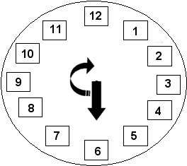
Using a clock start the hour hand at 6:00. Move the hour hand in the direction that a hand on a clock moves, clockwise.

As you pass each number count (1, 2, 3...) until the hour hand reaches the sunset time for September of 6:00.

How many hours of daylight are there between 6:00am and 6:00pm? _________

Count the hours of daylight for a day and record your answers on the data sheet.

Count the Hours Clock

Activity 2.2a: Can I use a data graph to look for patterns? (Bar Graph)

In this activity you will help to make a large bar graph. Each month will need to have 2 bars. One bar will show the number of hours of daylight. One bar will show the number of hours of nighttime.

Materials: Completed “C.N.Y. Sunrise and Sunset Data Sheet”
"Blocks of Time" sheet for Daytime
"Blocks of Time" sheet for Nighttime
crayons (yellow, gray)
“Working with Bar Graphs" journal sheet

Directions:

- Your teacher will be telling your group which month to create a set of bars for.

- Look up the “Total Hours of Daylight” for the month you were given to do.

- Look at the "Blocks of Time (daylight)" sheet. Cut out the number of blocks to match the number of hours of daylight.
You may have to tape two strips of paper together to get the right number of blocks.

- Write the name of your month on the strip of blocks.

- Color the correct number of blocks yellow.

- Look up the “Total Hours of Nighttime” for the month you were given to do.

- Look at the "Blocks of Time (nighttime)" sheet. Cut out the number of blocks to match the number of hours of nighttime.

You may have to add two strips of paper together to get the right number of blocks.

- Write the name of your month on the strip of blocks.

- Color the blocks gray.

Your class will be joining all of the bars together to make two large bar graphs. One will be for hours of daylight. One will be for hours of nighttime.

Blocks of Time (daylight)

10 |  | 20
9 |  | 19
8 |  | 18
7 |  | 17
6 |  | 16
5 |  | 15
4 |  | 14
3 |  | 13
2 |  | 12
1 |  | 11

Blocks of Time (nighttime)

10 |  | 20
9 |  | 19
8 |  | 18
7 |  | 17
6 |  | 16
5 |  | 15
4 |  | 14
3 |  | 13
2 |  | 12
1 |  | 11

Bar Graphs Journal Sheet: Can I use a data graph to look for patterns?

1. Write an observation about the Hours of Daylight bars:

2. What is the pattern of the height of the Hours of Daylight bars from September to December?

What does that tell you about the daylight part of the day?

3. What is the pattern of the height of the Hours of Nighttime bars form September to December?

What does that tell you about the nighttime part of the day?

4. For each of these sets of months, write down if the daylight part of the day is getting longer or shorter. (Use your bar graph as a guide.)

Months | Daylight hours | Nighttime hours
September - December
December - March
March - July

Now do the same for the Nighttime hours.

5. The Hours of Daylight bar for June is at 16 and September is at 12. Do you think the bars for July and August are shorter or longer than June's?

Activity 2.2b: Can I use a data graph to look for patterns? Line Graphs

The Line Graph
This activity involves the creation of a line graph. The line graph will have 2 lines placed upon it. One line will be for the number of hours of daylight in each month and one line will be for the number of hours of nighttime.

- You will be constructing a line graph using the data on the “C.N.Y. Sunrise and Sunset Data Sheet” and the "Working with Line Graphs" journal sheet.

- On the journal sheet there is a grid that you can use for making your graph.

- Using the "Total Hours of Daylight" data from the “C.N.Y. Sunrise and Sunset Data Sheet”, place the points on the graph for “Total Hours of Daylight” for each month of the year.

- Connect the points with a line to complete the line graph.

- On the same graph, place the points for “Total Hours of Nighttime”.

- Connect the points with a line to complete the line graph (use a different color for the second line).

- Make observations about each of your graph lines and write those observations in your Science Journal on the journal sheet.

Working with Line Graphs Journal Sheet, Page 1
Line Graph of Hours of Daylight/Nighttime for C.N.Y.

Look carefully at your line graph and make some observations. What do you notice about the two different lines?

Working with Line Graphs Journal Sheet, Page 2

A. Write one observation about the lines on your graph.

B. Look at your line graph. Predict the number of hours of daylight for August using your graphs as a guide. Do the same for the number of hours of nighttime.

Month | Hours of daylight | Hours of Nighttime
August

C. With your teacher, find out the number of hours of daylight and nighttime for August. See if your prediction was correct. Place the points for this month on your line graph.

Let’s make some more observations about the line graph:

1. For which month is the “Total Hours of Daylight” line at the highest point?
____________________________

2. For which month is the “Total Hours of Daylight” line at the lowest point? ____________________________

3. How many months have 12 hours of daylight? ________

- The summer months are the warmest and have the most amount of daylight. Which month has the most daylight? ________________________

- Using your finger, follow the “Total Hours of Daylight” line from September to March. Describe the line’s path.

Working with Line Graphs Journal Sheet, Page 3

- Using your finger, follow the “Total Hours of Daylight” line from March to August. Describe the line’s path.

____________________________________________________________________________

- How can you find out the “Total Number of Hours in a Whole Day”?

What is the total number of hours in a day?

8. Write an observation about the total number of hours in a whole day.

__________________________________________________________________________
__________________________________________________________________________

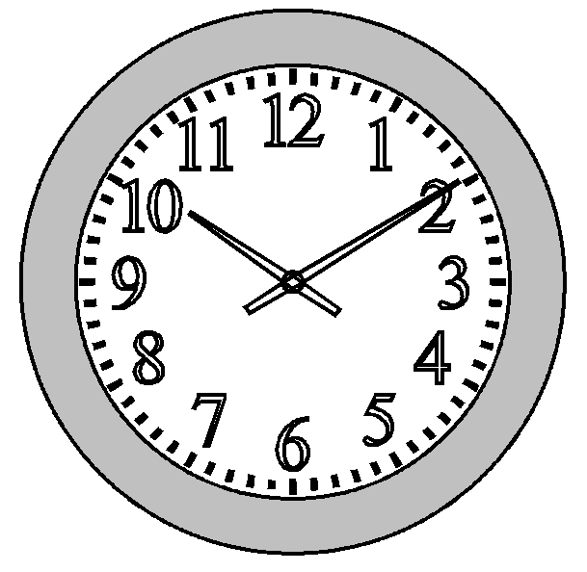
9. Look at the statement written below. Do you agree or disagree with this statement. Tell why you agree or disagree. Give an example from your line graph.

Clocks show 12 hours of the day . They do this because there are 12 hours of daylight and 12 hours of darkness in a whole day.

Activity 3: Are there Seasonal Patterns?

Materials:
Graph of Hours of Daytime/Nighttime for C.N.Y. Crayons

- On your graph, find the point where the Total Hours of Daylight is:
- the greatest
- the smallest
- equal to the Total Hours of Nighttime.
Darken each of these points on the graph so that you can see them more easily.

- Draw 4 vertical lines (up and down lines) on the graph through each of the points that you darkened. A ruler will help you to do this. Start drawing the lines from the axis labeled with the months.
- Draw a line through the “longest day” point.
- Draw a line through the “shortest day” point.
- Draw a line through each of the points where the hours of daylight are equal to the hours of nighttime.
You should have four vertical lines drawn.
Your graph now has four parts.

- Write one name of a season in each area between the lines that you drew. Use your own “knowledge bank” about the hours of daylight in each season to help you.

- Shade or color each area with a color for that season.

- Research the dates of the first day of each season.

- Answer the questions found on the Science Journal page titled
″Are there Seasonal Patterns?”.

Act.3 Journal Sheet: Are there Seasonal Patterns?

Answer the following questions on loose-leaf paper. Add the paper to your Science Journal.

Make a comparison about the “seasons” graph and the dates for the beginning of each season.

- Look at the places where the two lines cross on the graph. Write a sentence comparing the number of hours of light and the number of hours of dark for those points.

- Look at the lines when each is at their highest point and lowest point on the graph. Write a sentence comparing the lines at these points.

- Find out what each of these words mean: vernal equinox, autumnal equinox, summer solstice, winter solstice.

- Use these terms on your graph by labeling your graph (you can create a key).

- Write a sentence telling about a pattern that you see in your graph.

- Cycles are patterns that repeat over time. If your graph continued into the next September, where would you place the points for the lines?

Words to Know:

revolve-

revolution-

rotate-

Sun-

Earth-

The Reasons for the Seasons

The Earth's seasons are caused by the tilt of the Earth. The Earth is tilted as it travels around the Sun. Some people believe that during the summer the Earth is closer to the Sun. They believe that the Earth is farther away from the sun in the winter. The Earth's path around the sun is like a circle. There are only small changes in the Earth’s distance from the sun. The seasons are not caused by how far or close the Earth is to the sun. The seasons are caused by the tilt of the Earth.
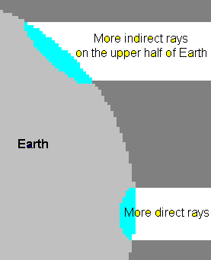

The Earth is a sphere, like a ball.
The surface of the Earth is curved.
The rays of the sun hit the Earth more directly toward the middle section (near the Equator) and less directly as you move nearer to the poles.

We have discovered that the round Earth is not straight up and down. It is tilted to one side. We say that it is tilted on its axis.
Axis
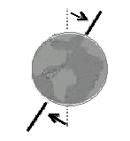
Sometimes part of the Earth is tilted to the sun. This part gets more direct sunlight. The more direct sunlight has more energy. This part is warmer.
Sometimes part of the Earth is tilted away from the sun. It gets the sunlight less directly. Places tilted away from the Sun get less energy from the sun’s rays so it is colder.
The sun’s light shines more directly on different parts of the globe at different times of the year.
The Reasons for the Seasons, page 2
Think about a summer day. Think about the morning when the sun is low in the sky. How warm does the sunlight feel? Now, think about noontime on that summer day. The Sun is more higher in the sky and more directly overhead. How warm does the sunlight feel then? That is the difference between less direct sunlight and more direct sunlight.
As the Earth goes around the sun the part of the Earth tilted to the Sun gets more direct sunlight. It is summer when the Sun's rays are hitting that place on Earth more directly.
The part of the Earth tilted away from the Sun gets less direct energy from the Sun’s rays. Less direct sunlight means colder temperatures. It is winter there. These seasons are due to the tilt of the Earth and the Earth's orbit around the Sun.
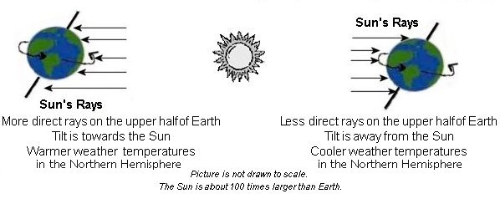
Sometimes the north half of the Earth receives more direct light rays from the Sun. This is when the south half receives less direct light rays from the Sun. At this time the north half (Northern Hemisphere) would have warmer temperatures. It would be summer. The south half (Southern Hemisphere) would have cooler temperatures. It would be winter.
N
N
S
The Reasons for the Seasons

The Reasons for the Seasons, page 3
The Earth is always tilted in the same direction. The Earth does not change the direction the North Pole points into space. It always points to one special star, the North Star
S
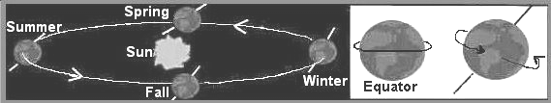

Solstices
The word "solstice" is used for two days in the year. One day is the Summer Solstice. This is the first day of summer. The other is the Winter Solstice. This is the first day of winter. If where you live is having its longest daylight day then that day is the Summer Solstice. This is the first day of summer. What if where you live is having its shortest daylight day? Then that day is the Winter Solstice. It is the first day of winter.
For the Northern Hemisphere the Winter Solstice is always near the date of December 21st. The Northern part of the Earth is tilted away from the Sun. On this day the Sun's path across the sky is very low. The hours of daylight are the shortest of the year. That is because the Sun’s energy is not shining directly on the Northern Hemisphere.

If you live in the Northern Hemisphere the Summer Solstice is always near the date of June 21^{st.} This is the beginning of summer. The Sun’s energy is shining more directly on the Northern Hemisphere. On this day the Sun is in the sky for a longer part of the whole day. The Sun's path across the sky is higher and takes more time. There are more hours of daylight.

If you live in the Southern Hemisphere, your seasons are opposite to the Northern Hemisphere. That means summer begins near the date of
The Reasons for the Seasons, page 4

December 21st and winter begins near the date of June 21st. In the Southern Hemisphere, New Year’s Day is in the middle of the summer! Many people picnic and swim at the beach. The 4th of July would be in the winter. People would wear winter coats!
Equinoxes
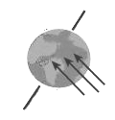
The word equinox means, “equal night.” There are two equinox days during the year. One of these days is the Autumnal Equinox. This is the first day of Fall. The other is the Vernal Equinox. It is the first day of Spring. Equinoxes are days when the hours of daytime and nighttime are equal. On these days there are twelve hours of daylight and 12 hours of nighttime.
An equinox happens when tilt of the Earth is not away from the Sun. It is not tilted toward the Sun. The Sun shines most directly on the middle of the Earth, near the equator. On an equinox day all parts of the Earth have 12 hours of daytime and 12 hours of nighttime. Day and night is divided equally.
The Northern Hemisphere has an Autumnal Equinox around September 21st.
In the Northern Hemisphere the Vernal or Spring Equinox happens around March 21st. What do you think is happening in the Southern Hemisphere on these two days?


September 21st
Leaves are changing colors and the flowers are dying.
Leaves are budding and the flowers are starting to grow.

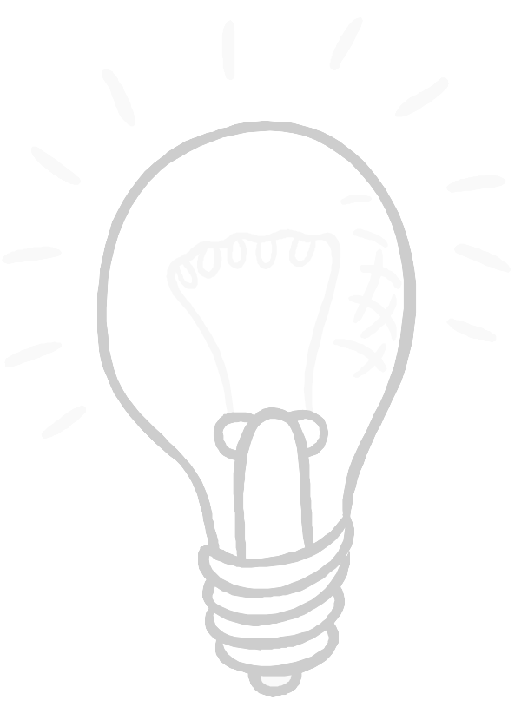
Activity 4.1: What Does Light on a Sphere Look Like?
Using a blank sphere.
Hold the blank sphere, turn it in the light and make observations.
Your observations can be written or drawn. Make 4 observations.

In your drawings try to show where the light source is for each picture.
One observation is done for you.
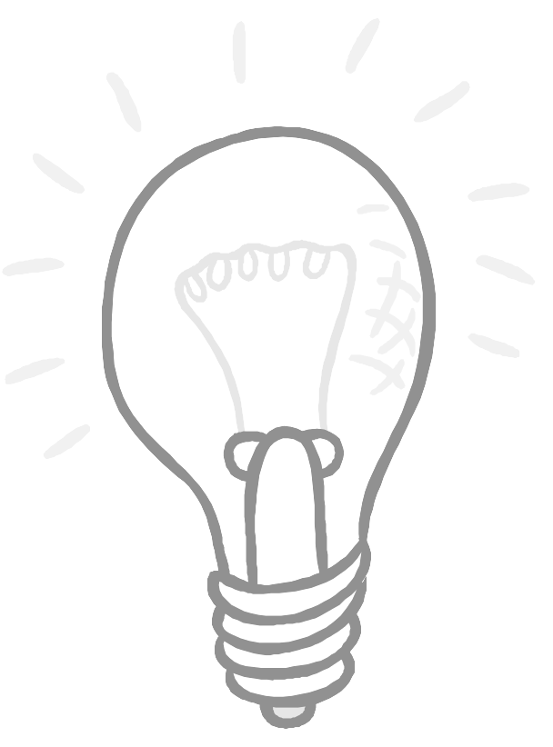
If you stand behind the sphere (and the light is on the other side) the back of the sphere is all dark.

Using the sphere with the colored dots, answer the following list of questions on a piece of paper and add it to your Science Journal:

  - How many dots can you get in the light at the same time?

  - Can you hold the ball so that no dots are in the light?
If so, how did you do it? (A drawing may help you explain how you did it.)

  - Hold the ball with one dot on the top and one dot on the bottom.
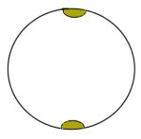
How many dots can you see on the ball if you hold the ball directly above the light?

  - Hold the ball so that the light source is from the side and the dots are on the top and bottom.

- Figure out how to hold the ball so that the dot at the top of the ball is in the light and the bottom dot is in the dark.

Draw a picture of the ball showing how you got the top dot in the light and the bottom dot not in the light.

- If you rotate (turn) the ball as you hold it in the light, what do you see happening to the light on the dots?

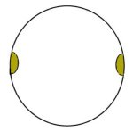
- Turn the ball so that the dots are on the sides. If you rotate (turn) the ball as you hold it in the light, what do you see happening to the light on the dots?

e. Make a paper cone stand out of a piece of construction paper. Place your sphere on top of it. (You can use the “Sphere holder cone pattern”.)

Place the sphere on top of the cone so that the dots are on the sides.
Place it in a place where the light source is from the side.

Look at the sphere from different sides. Draw pictures showing how the light and dark sides of the sphere change. Make 4 observations (pictures): one from the front, the back and from each side.

Front | Back
Side | Side

Activity 4.1: Sphere holder cone Pattern

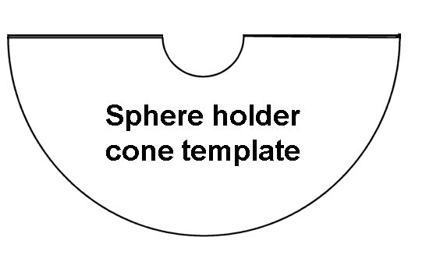

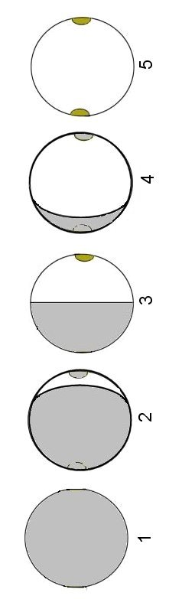
Activity 4.1: Phases of a Sphere
Shadow area
Lighted area

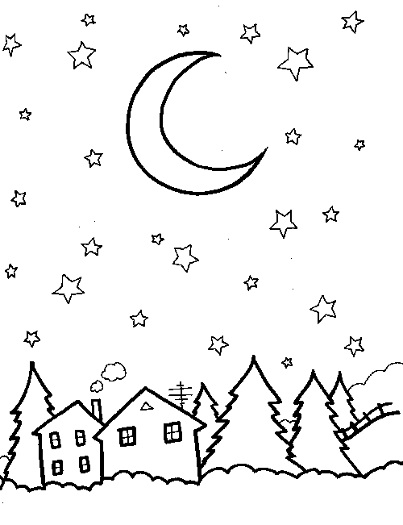
Earth’s Moon
A moon is a natural object in space that revolves around a planet. Some planets have no moons and others have one or more moons. The Earth has only one moon. The Earth’s moon is about one-fourth the size of the Earth.

The Moon is easily visible from the Earth because it is close to the Earth. If the sky is clear, people who are located on the side of the Earth that is facing the Moon can see the moon.

You see, the Moon travels in an orbit around the Earth while the Earth is turning. So the Moon is always changing its position in the sky. Also, the part of the Earth that you live on is always turning away from or toward where the Moon is in the sky. Sometime you can see the moon in the day and sometimes in the night.


The Moon does not make its own light. The Moon is visible from the Earth because the Moon is lit up by light from the Sun. The Moon’s surface reflects sunlight. Because the Moon is a sphere in space with a light source nearby (the Sun), the side of the Moon facing the Sun receives and reflects the sun’s light. The other side is dark. We see the side of the Moon that is facing us.

The entire side of the Moon that is facing us is not always completely lit up by the Sun. Therefore, often we can only see part of the side that is facing us. These “parts” of the side that we can see are called the “phases” of the Moon.

There are five different names for the phases of the Moon. The phases are called the New Moon, Crescent Moon, Quarter Moon, Gibbous Moon and Full Moon. As you see the Moon go through its phases it always seems to get bigger each day until it becomes the Full Moon. Then it seems to get smaller and back to the New Moon. It takes about one month for the moon to go through all of its phases and back again to the New Moon. This happens because it takes about one month for the Moon to make one trip around the Earth.

The Moon does not really change its shape; it just looks like it does! It is just that we cannot always see the entire lit side of the moon; we only see the side facing us. When we can only see a part of the lit side it is because most of the sunny side is facing away from us.

When all of the sunny side faces away from us we call this a New Moon. We cannot see the Moon when all of the sunny side faces away from us.

If a small part of the sunny side faces us we call it the Crescent Moon.

If half of the sunny side faces us we call it the Quarter Moon.

If we can see almost all of the Moon’s sunny side we call it the Gibbous Moon.

If we can see all of the sunny side facing us we call it the Full Moon.

Before calendars were printed people marked the passing of time using the phases of the Moon as a guide. The phases of the Moon follow a pattern. This pattern repeats itself every 29.5 days. When a pattern repeats itself over time we call it a “cycle”. One complete Moon cycle was called a “Moonth.” The number of days in each of our months is very close to the length of a moon cycle. Over time the year’s calendar was changed to 12 months with each having 28 to 31 days.

THINKING TASK: On the page titled “Moon Phases, New to Full Moon” you will find some pictures of different Moon phases. Your thinking task will be to cut out the 5 pictures and place them in order starting with the “New Moon.”

SUPER THINKING TASK: Your 5 pictures show one-half of the Moon’s cycle. The cycle is completed when the phases change from a “Full Moon” back to a “New Moon”. Using the blank “Moon Phases, Full to New Moon” sheet try to draw the rest of the cycle starting with a full moon and ending with a new moon.
(HINT: The phases are like the ones you put in order but there are two differences. The order is backwards and the “other side” of the moon is lighted.)

Moon Phases, New to Full Moon (Cut out boxes and put them in order.)

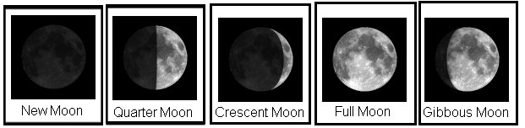
New Moon Full Moon

Moon Phases, Full to New Moon

Full Moon New Moon

Act 5: Patterns in the Solar System
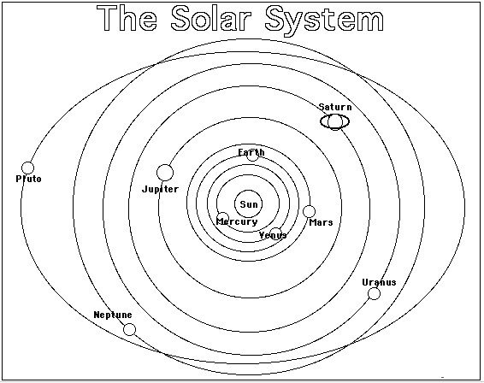
This diagram shows a view of our Solar System. Each of the planets is labeled and a line is drawn showing their path with in the Solar System.

List 5 observations of patterns or cycles that you can see in this diagram.

Pattern: a design or order of objects that lasts for a period of time.

Cycle: an event or series of events that repeat.

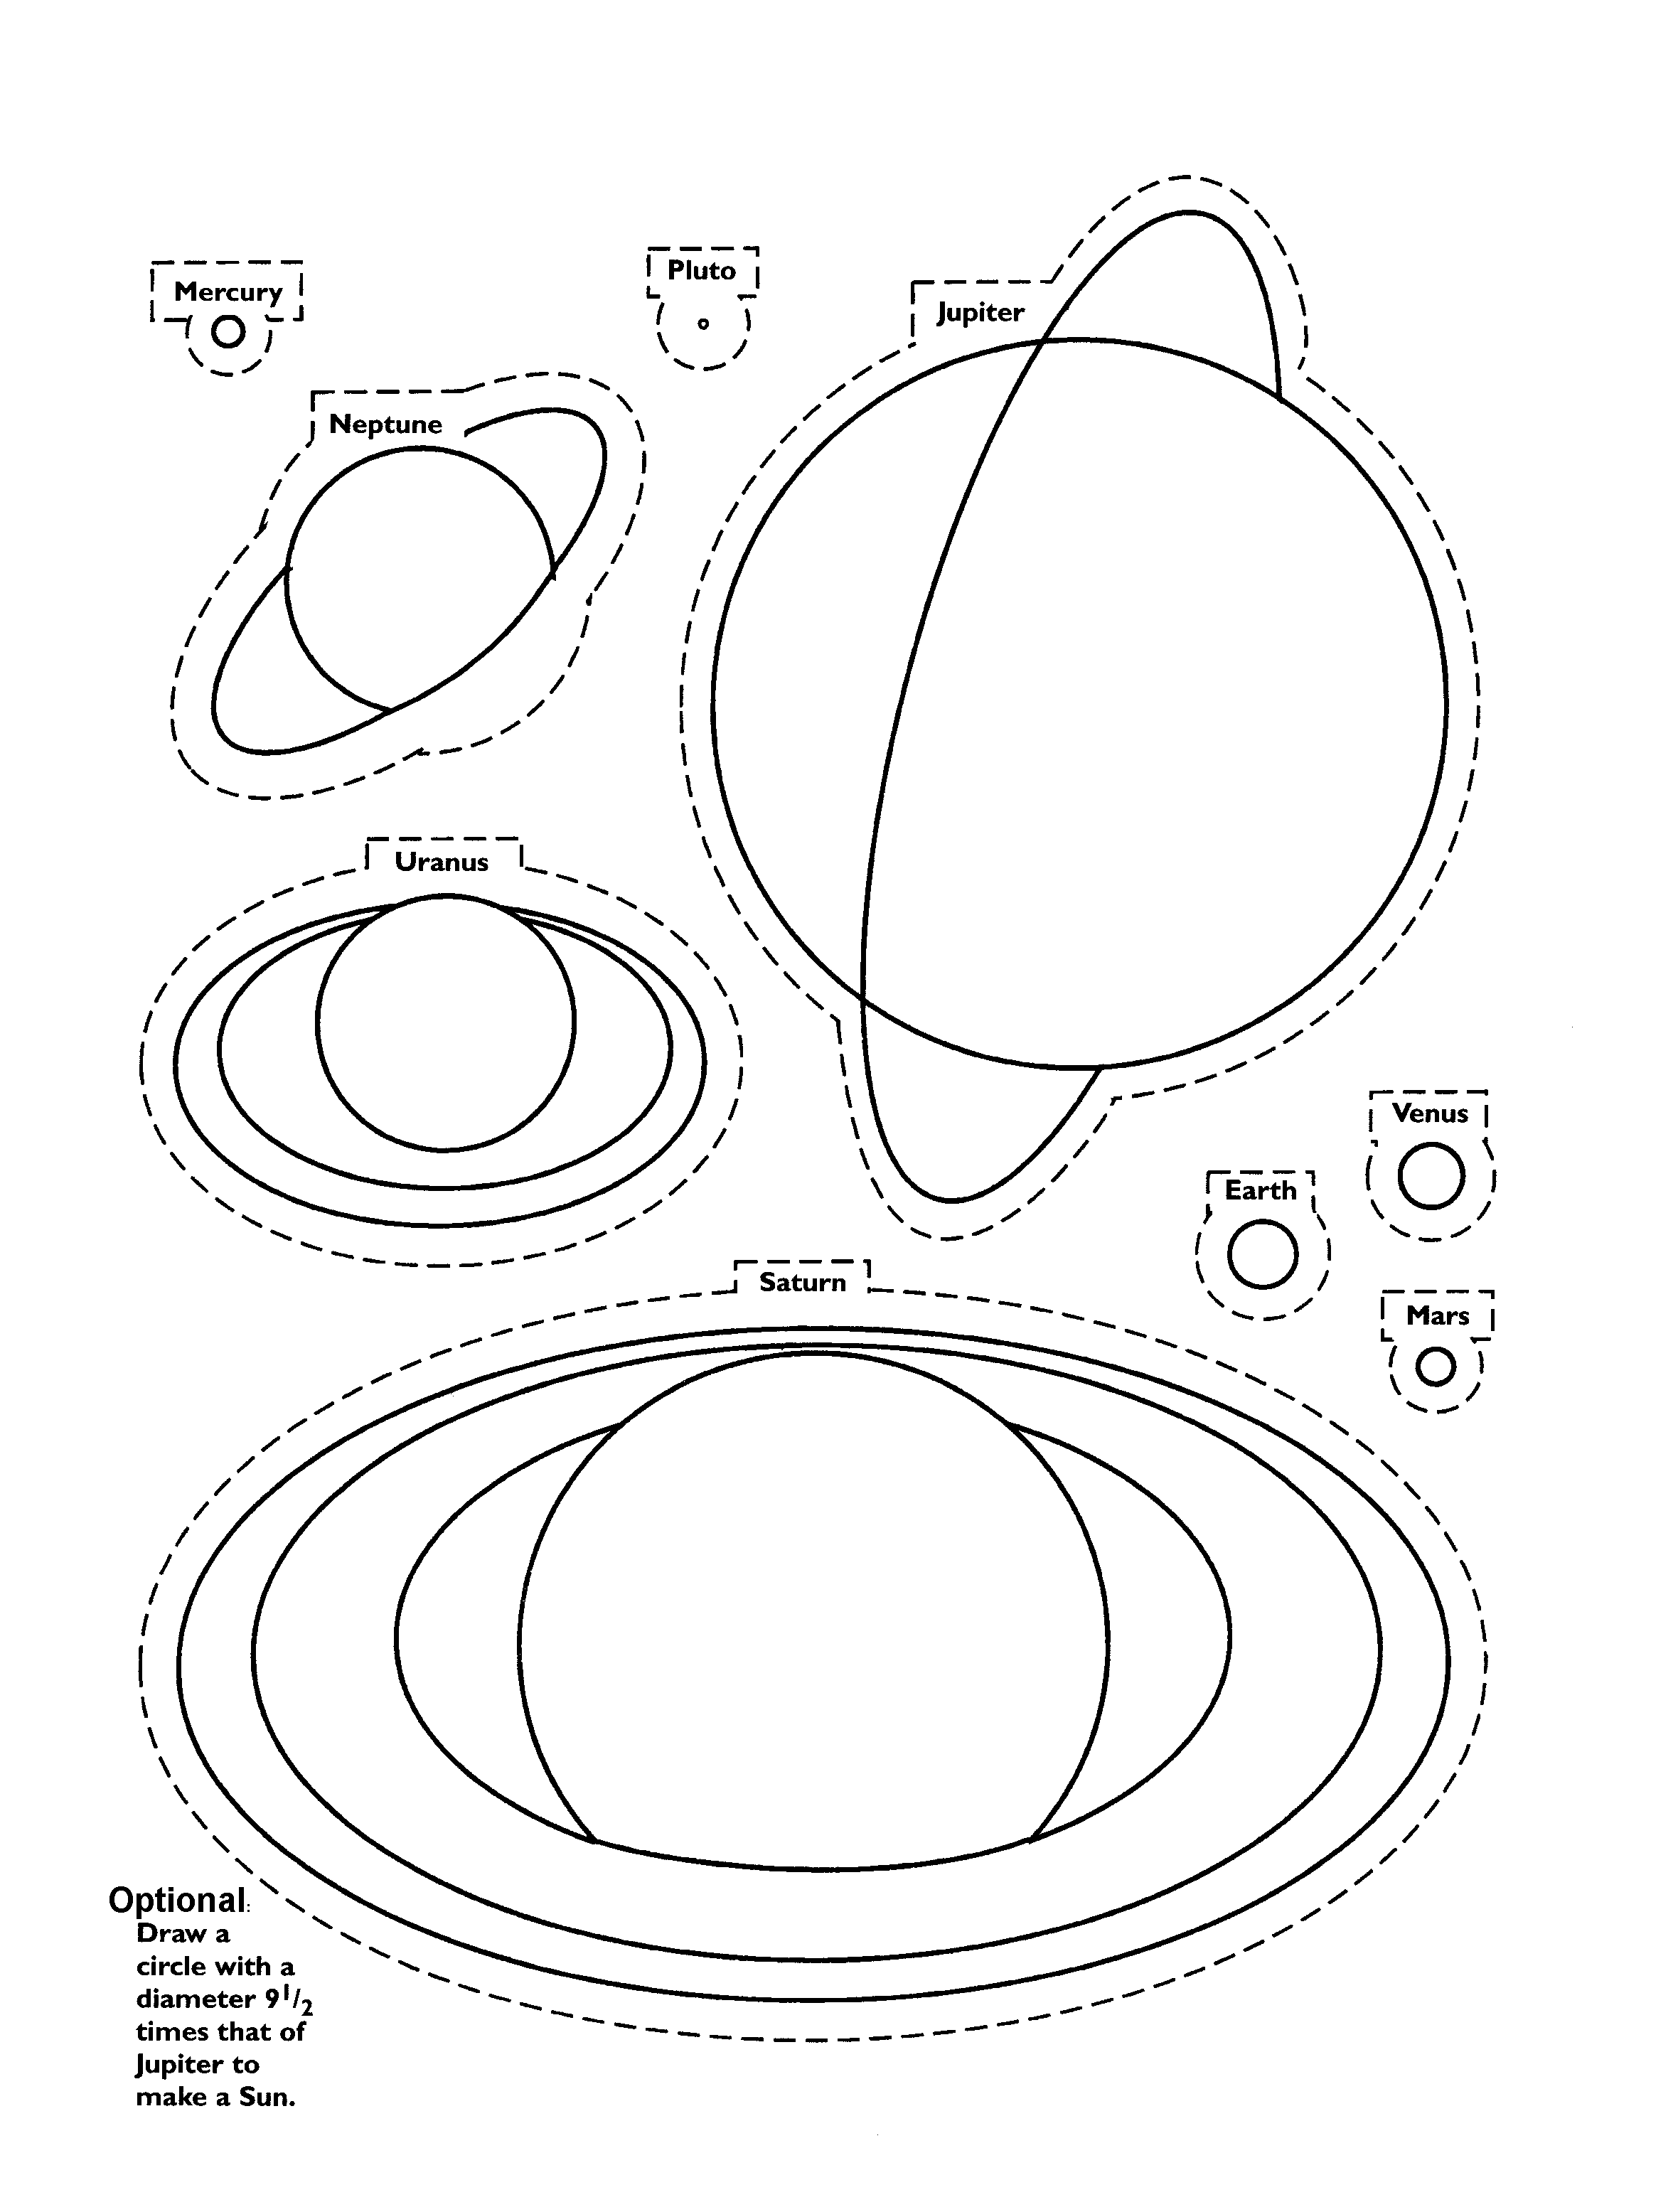
Activity 5: Size is Relative

