Water Cycle Probe Name: __________________________

What’s the state?

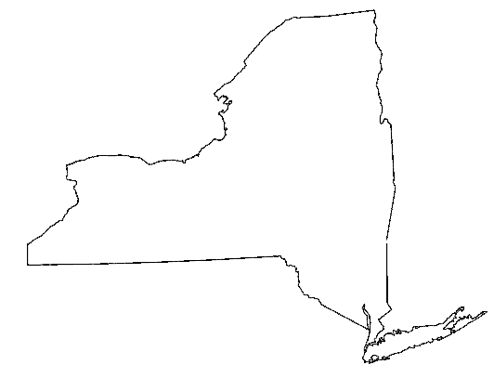
What are states of matter?
?

Put an X next to each item that you think would show a state of matter.

______ a rock

______ a sound

______ juice

______ magnetic pull

______ cold temperature

______ wind

Explain why you chose those items?

