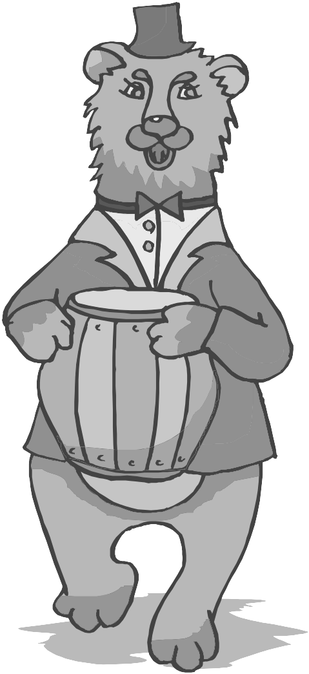

Name: __________________
Student Journal

Revised November 2012

Activity 1: What causes Sound?

Materials: For each pair of students:
1 tongue depressor
1 wooden dowel

Procedure:

- Using the materials provided, find as many ways as you can to make sound with each item.
- You should be thinking about what is the same and different in how the sounds are made (what you do) and the type of sound created.
- Use the data table to record your observations.

What I used | What I did | What the sound was like...

Reading for Information: Our Voice is Vibrations
Your larynx, or voice box, is found in your neck. It has three important jobs. These jobs have to do with your speaking and breathing.

The larynx is the place where your breathing and food tube splits. There is a change from one tube to two tubes. One of the two tubes carries the air you breathe into your lungs. It is called your trachea, (trāy-key-ă) or windpipe. The other tube carries the food you eat into your stomach. This is called your esophagus (e-să-fay-gus).
Your larynx has three important jobs:
- it controls the air coming in and out during breathing.
- it protects your airway.
- it produces sound for you to speak.
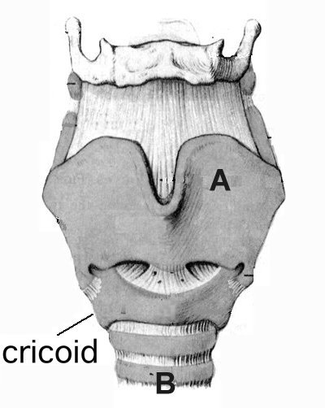
If you were to look at the outside of your larynx it would look like this picture. Your larynx (A) rests on a ring of cartilage (very tough and strong material). This area is called the cricoid (cry-koid). Below the cricoid are the rings of the trachea (B). The trachea is the breathing tube that goes to your lungs. The front part of your larynx appears to stick out. It can be easily felt in people with thin necks and is called the "Adam's apple". This area is very easy to see in most men. It is very painful if you get hit in the “Adam’s apple”.
In the center of your larynx are the vocal cords. The vocal cords are the most important part of the larynx. The vocal cords are important in all three jobs listed above.
The vocal cords are bands of muscle. There is a right and left cord. They form a "V" shape. This “V” is pulled apart during breathing and opens the airway. During speech the “V” (the vocal cords) are brought close together. As your lungs push air past the closed vocal cords, they vibrate. They vibrate like reeds on a musical instrument and you produce a sound. Your throat, tongue, and lips help to make different sounds.
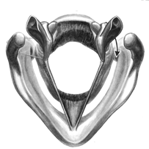
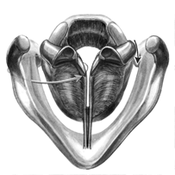

The diagram above shows the cords in the open position. The cords should open like this during breathing.
The cords above are shown in the closed position as during speech.

TO DO: With your pencil find and trace the “V” shaped vocal cords on each picture.

Answer these questions about the reading:
- What is another word for your larynx? ___________________

- How many main jobs does your larynx have? ______________

- Write down the job that your larynx does that has something to do with sound.

- What is the front part of the larynx that appears to stick out called?

5. How do the vocal cords produce sound?

Activity 2: What are properties of Sound?

Procedures:

READ ALL THE DIRECTIONS FIRST BEFORE STARTING

- You will be listening to a CD of sounds.

- As you hear each sound you will be making observations about that sound.

- You can identify the sound by numbering each sound (1, 2, 3, …) and making an observation about what it sounds like. When making your observations, think about how the sounds are the same or different. You need to make a chart to record your observations, like the one below.

Sound Number | Observations
1
2
3

- After you are done listening and observing, think of a characteristic that you could sort some or all of the sounds by. What graphic organizer could you use to sort the sounds?

Use a graphic organizer to sort the sounds.

Activity 3: How Do We Hear?

Read the following selection and answer the questions.

Our Ears Vibrate

The External Ear
Your external ear is made up of two parts. One part is the outer part of the ear. You can see this part on the side of your head. The other part is the ear canal.

The outer part has a special shape. The shape helps us tell where sounds around us are coming from. Sounds coming from the front are more easily heard. The shape helps to move the sound into the ear canal.

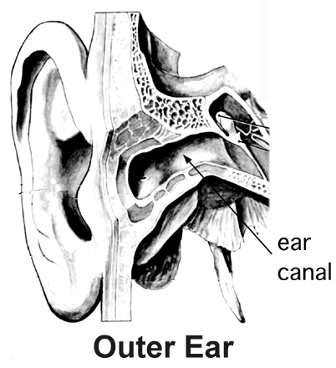
The ear canal is a tube about one inch long. It leads to the eardrum. Small glands in the ear canal make wax. The wax helps to protect the external ear. Earwax will fall out by itself. You should not try to remove it. Using a cotton swab (Q-tip) or other object often pushes the wax farther into the ear canal. You can also hurt the canal wall skin. Sometimes water gets trapped in the ear canal. If it becomes infected, you can have a problem called swimmer's ear.

The Middle Ear
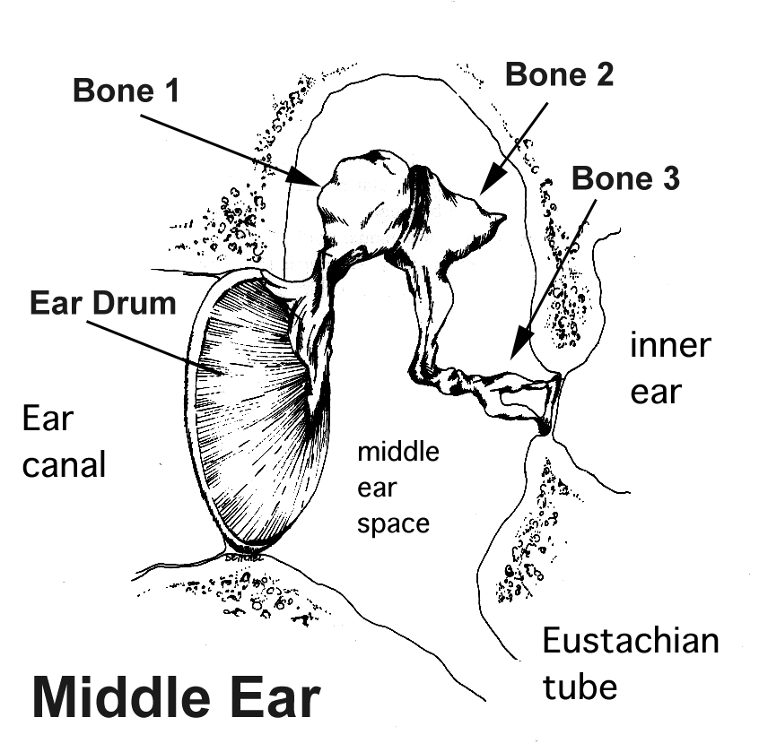
Your ear canal is a tube about one inch long. It leads to the eardrum. The eardrum starts the area called the middle ear. Your eardrum is thin like a tissue. It covers the opening to the middle ear space.

As sound hits your eardrum, it vibrates like a drum. This movement is passed onto the three small bones of your middle ear. (Find the three small bones in the middle ear diagram.)

The movement of the eardrum and these bones help to make the sound vibration stronger. At the end of Bone 3 there is an area called the footplate. The footplate is connected to the inner ear. As the bones vibrate, the footplate moves in and out. It sends the sound vibrations into the inner ear. (Find the footplate in the middle ear diagram and label it.)

Your middle ear is filled with air. Sometimes the middle ear fills with liquid. This liquid comes from your body. If this liquid gets infected (which means that small organisms are living in it), you can get an ear infection. Doctors have found that ear infections, very loud noises, or getting hit in the head, can hurt your eardrum. It can get a hole in it. Your eardrum cannot vibrate very well with a hole in it. You cannot hear as well. Eardrums can heal but sometimes they end up with scars on them. An eardrum with scars doesn’t vibrate as well. This could cause you to not hear as well.

The Inner Ear
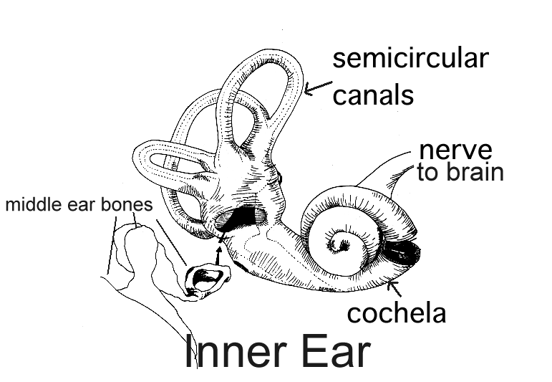
For you to know that there is sound, your brain has to know that there is sound. Your inner ear is where sound vibrations are sent on to the brain. The sound vibrations are passed on in tiny fluid-filled tubes. These tubes or “canals” are found in some of the hardest bones in your body. They are part of the inner ear.
The hearing part of your inner ear is the cochlea (coke-lē-ă). It is shaped like a snail. (Find the cochlea in the inner ear diagram and circle it.) The cochlea has liquid in it. The bones of the middle ear move the cochlea. These moving bones jiggle the cochlea and make the liquid in the cochlea move. These little waves cause the movement of tiny hair cells. As these hair cells vibrate, they send messages to your brain. Your brain thinks of these messages as sounds.
There are other parts of the inner ear. These other parts help you to keep your balance. Balance helps you can stand up without falling over.
This is how your body helps you keep your balance. The three big semicircular canals have liquid in them. When you move, the liquid in the semicircular canals moves. Your brain uses the movement of the liquid to know which way is up. As you turn your head, the movement of the liquid in these canals lets your brain know which way you are turning. It tells your brain how much you are turning. That is why, when you spin in circles, you get dizzy. The liquid in the semicircular canals is swirling in circles. Your brain gets jumbled messages.
As you can see from your reading, there are many parts of the ear. These parts work together as a system. This system is made to pass on vibrations. Sound is energy in the form of vibrations. Your brain is able to “listen” to sound vibrations. Your brain decides if they are loud or soft, high or low, and where they are coming from. You can decide if you know the sound and whether you like the sound or not.
- Go back through the reading to find the words “vibrate” or “vibration”. Circle the words each time you see them written.

- Make a list of the ear parts that move or vibrate to send sound energy from the outside world to your brain. (Try to find six.)
Ear System Parts
1. | 4.
2. | 5.
3. | 6.

- What happens if any of the parts that vibrate get damaged or broken?

Activity 4: What causes sound?
Follow the directions on each Station Card then record your observations and conclusions. For your conclusions, fill in the blanks showing how energy is passed on in the “Energy In, Energy Out” section.
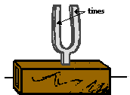

Station 1
Observations:

Conclusion: Energy In, Energy Out

Energy In plastic cup Energy Out

Station 2
Observations:

Conclusion: Energy In, Energy Out

Energy In Energy Out
Tap Knee

Station 3
Observations:

Conclusion: Energy In, Energy Out

Energy In Energy Out

Activity 4: Stations [cont.]

Station 4
Observations:

Conclusion: Energy In, Energy Out

Energy In Energy Out

Station 5
Observations:

Conclusion: Energy In, Energy Out

Energy In Energy Out

Activity 5: What is pitch? What Affects Pitch? (Rubber Band Sounds)
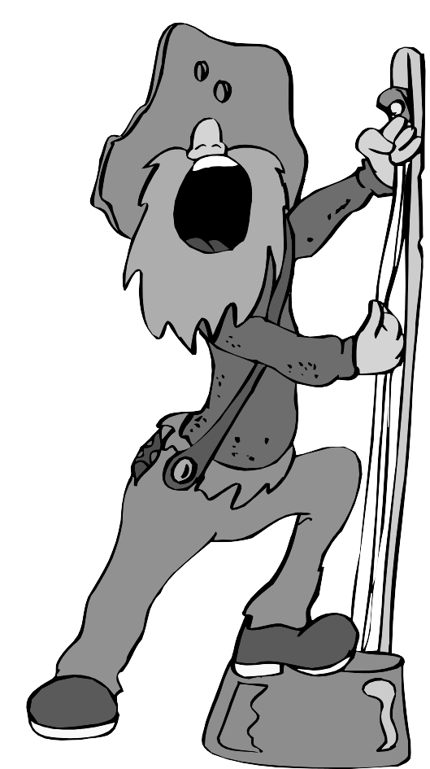
READ ALL STEPS BEFORE STARTING

Materials: For each pair of students:
1 foam tray
3 different rubber bands
Procedure:
Read through the directions and fill out the Planning Form for “Rubber Band Sounds” on Journal page 14.

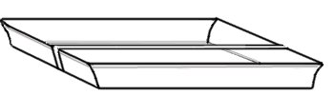
  - Stretch one rubber band across the foam tray.
Pluck the rubber band. Using your sense of hearing and sight, write your observations in your Science Journal.
Observations:
__________________________ ______________________________
__________________________ ______________________________
__________________________ ______________________________
  - Draw a picture of the tray with the rubber band in your Science Journal.
    - When the rubber band is plucked, which part of the picture first has energy of motion (vibrates)? Using an arrow label this part “Energy In”.
    - Which part does the rubber band pass energy of motion (vibration) on to? Using an arrow label this “Energy Transfer”.
    - Draw an arrow pointing away from the tray; label this arrow for the type of energy that reaches your ears.

  - Try different ways or directions of placing the rubber band across the foam tray – are there differences in the sound? List your observations. Use drawings to show how the rubber bands were placed.
Observations | Drawing
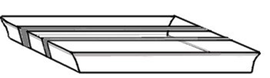
  - Stretch a second rubber band across the foam tray.
You decide which direction to place the rubber bands.
Compare the sound from the second rubber band to the first one.
How are they alike when plucked? How are they different?
List your observations. Draw a picture of the tray with the two rubber bands.

Observations | Drawing

- Look back at your drawing of the tray with the two rubber bands. Give each rubber band a one or two word label. Have the label describe how each rubber band sounds when plucked.

- Stretch the third rubber band across the tray.
Compare the sound from the third rubber band to the first and second.
How are they alike when plucked? How are they different?
List your observations. Draw a picture of the tray with the three rubber bands.

Observations | Drawing

- Look at your drawing of the tray with the three rubber bands. This is your rubber band sound system. Using arrows, label where your system has “energy in”, “energy transfer” and “energy out”. You may use these labels more than once.
- Challenge: Set up your Styrofoam tray so that only one rubber band is stretched across the tray. Your task is to change the pitch of the sound the rubber band makes when plucked. Do this without moving where the rubber band is placed on the tray.
How I made the pitch change. What is pitch?

Activity 5: Planning Form for “Rubber Band Sounds”

Identifying Problem / Hypothesizing
What do you want to find out? (This one is filled in for you.)

What will happen when I pluck each of the rubber bands? Will they sound the same or different?

What do you think will happen?

Why do you think it will happen?

Planning
What are you going to do?

The rubber bands will be different in these ways (variables): | These things will always be kept the same (controls):

Making observations
What are you going to measure / observe?

Do you have questions about your procedure?

Recording results
Where are you going to record your observations?
Activity 6: How can a reed instrument produce sound?

Materials: Plastic straw
scissors*
ruler* (* teacher provided)
Procedure:
- Take a plastic drinking straw and flatten a section about 2 cm. long at one end.
- Use scissors to cut the two sides of the flattened portion as shown below.

Top View of straw
Flattened end
Cut Areas

Side View

- To play the straw reed, put the cut end of the straw into your mouth.
Press your lips and/or teeth together a little beyond the end of the cut.
Blow into the straw.
You should get a sound from the straw reed.

If you don't get a sound, change how hard you press with your lips or teeth and change the position. Eventually you will get a sound.

Press teeth or lips here

Try cutting off bits of straw while you blow and listen to the sound, as the straw gets shorter.

Questions to think about: What has to happen in order for you to get sound from the straw? Why use a straw? ____________________________________________ ________________________________________________________________
________________________________________________________________

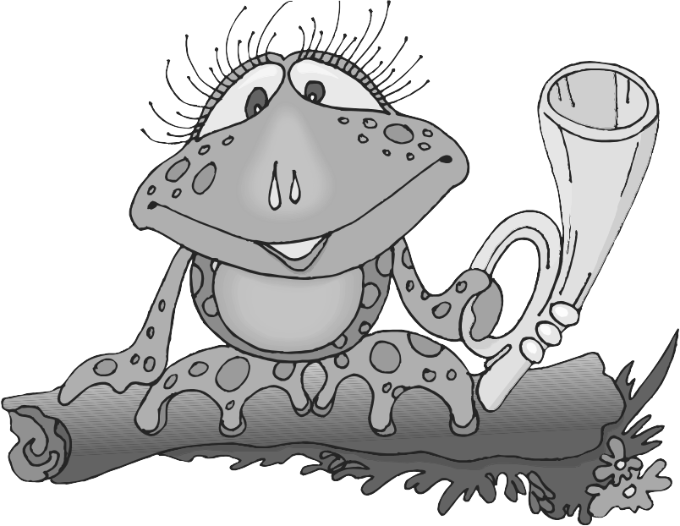
Activity 7: How many different sounds can be produced

by vibrating the air in a tube?

Materials: one piece of ½ inch plastic tube
one ½ inch plastic plug
water* (* teacher provided)

- Place the plastic plug into one end of the piece of tube.
- Practice blowing across the tube to make a sound.
- Put a small amount of water in the tube and blow across it to make a sound.
- Fill the tube with different amounts of water, each time blowing across the tube to make a sound.
- Write down your observations about the sound produced with different amounts of water in the tube.
- Draw a conclusion. How does the pitch of the sound change when the amount of water in the tube changes?
Observations:
Conclusions:
Questions:
What is vibrating to cause the sound that you hear?

What is growing and shrinking in size to cause the different pitches of sound?
Activity 9.1: Why does a fish line telephone work?

Materials: 2 Small (1 oz) plastic cups
4 meters of fishing line
Procedure:
- If there is not a small hole in the bottom of the cup, ask your teacher about the best way to punch a hole in the bottom.
- Measure and cut four meters of fishing line.
- Take one end of the line and put it through the hole in the bottom of the cup from the outside to the inside.
- Make a large enough knot to keep the line from pulling through the hole.
- Do this with the second cup at the other end of the line.
- Have 2 people hold each cup and walk apart until the line is tight.

- Have one person put the cup to the ear and have the other person speak into their cup.
- Make observations and conclusions using the data table for this activity.

Observations:
Conclusion (Why is this happening?):
Question:
What is vibrating to cause the sound that you hear?

Fill in the Energy chain for the fish line phone:
Energy In Energy Out
Activity 9.2: What transfers energy better: solid or gas?

Materials: 2- 24” pieces of string
hanger*
(*teacher provided)

Procedure:
- Tie one end of two pieces of string to the hanger hook.

- Take the other end of each string in each hand.

- Lay the strings over your thumbs (one string for one thumb) and put your thumb in your outer ear (lightly).

- Bend forward so the hanger can hang free.

- Have someone gently tap the hanger with a pen, pencil, or ruler. (Doing this gently is important!)

- Take your thumbs out of your ears and have the person tap the hanger again. Compare the difference.

- Write a paragraph about your observations and conclusions. (Use the concepts and ideas you have learned about sound. Think about “energy in, energy out”.)

Activity 10: How much vibration is too much for our ears?
Study the Noise Sound-meter and answer the questions listed below.
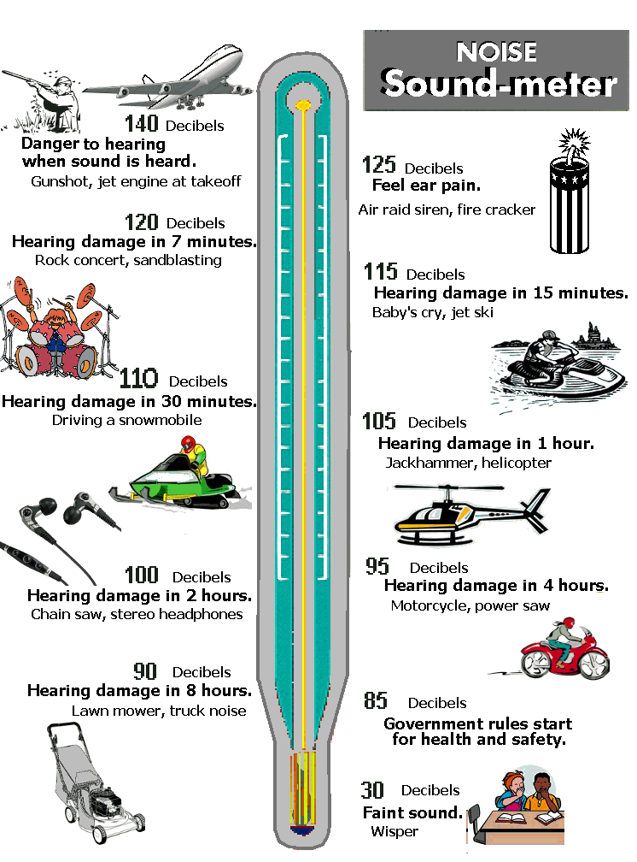

Activity 10: Questions for you about the Noise Sound-Meter
- How long can you listen to stereo headphones before you risk hearing damage? ___________________

- At what decibel reading is a lawn mower? ____________

- At what decibel reading is a firecracker? ____________

- What do your ears feel like when listening to a lawn mower compared to hearing a firecracker that is close to you?

- What types of decibel levels do you think your ears are comfortable?

- At what decibel level do you start to feel pain?

  - What do you do when the noise level is so loud that it hurts your ears?

  - What do people do who work at places where it is noisy?

- Look at the Noise Sound-Meter. Does it matter to your ears how loud a sound is? ______________________________________________________________
- Look at the Noise Sound-Meter. Does it matter how long your ears hear the sound?

- What do you think a “decibel” measures?

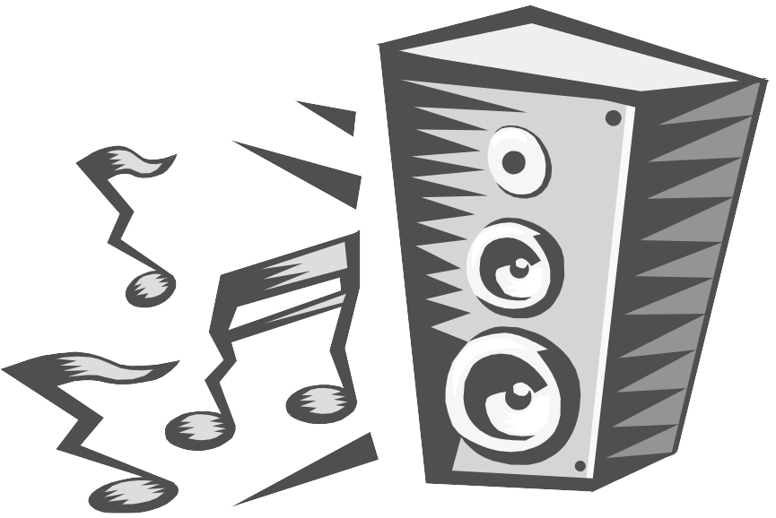
Protect your ears!!

Keep the decibel level low.

