Blackline Masters

Motion
Kit #16

Revised January 2006 OCM BOCES Science Center
Removed Word Search Jan. 2014


Student’s Name: _______________________________ Date:___________________

Science Kit Activity: __________________________

Student Science Journal Rubrics

Score | Criteria | Comments
3 | The writing/drawing shows detail and accuracy in recording observations;  The child uses rich science vocabulary, and is able to answer related questions.
2 | The writing/drawing includes mostly accurate details; some may be inaccurate or missing.
1 | The writing/drawing shows partial knowledge; lacks detail.
0 | There is little or no response, or the writing/drawing is inaccurate or unrelated.

Name: ________________________ Date: ____________________

My Science Journal

How did I do?

I am looking at my journal entry about _______________________________

Color one


1. Did I organize my writing and pictures so
that my journal is easy to understand?

2. Did I use words and pictures to tell what I
did and observed?

3. Did I use science words in my writing?

4. Does my journal tell the story of what I
am doing and learning in science?

Complete these sentences.
5. What I like best about my science journal is _______________________

____________________________________________________________

6. In my next journal section I will try to _____________________________

_____________________________________________________________

7. A question or problem that I have with my science journal is ___________

_____________________________________________________________

Name: __________________________________ Date:___________________

Our Science Group
How well did we work together?

Who was in our science group:

Color one

1. Our group was able to work together
to get our science work done.

2. Each person in our group was able to
participate. Everyone was able to share his or her ideas.

3. Our group was able to follow directions.

4. If I was an employer I would hire our
group to do this work.

Working with a group of people can make the work easier. Sometimes working with a group of people can make the work harder.
Think about your group for science and complete these sentences.

6. Our group had problems ________________________________________

____________________________________________________________________

7. Our group worked best at ________________________________________

____________________________________________________________________

Name: _____________________________ Date:________________

Science Skills

Read each statement.
Check the boxes to tell about your science journal.
 | I did great! | I did okay. | I need to work on this.
1. I described what I saw.
2. I used accurate measurements. I used careful details.
3. I described what was the same and what was different.
4. I used pictures to help tell what I saw or did.
5. I labeled my pictures.
6. I used the information I collected to draw a conclusion.





Happy and Sad Ball Observations

You have two balls in front of you. Each ball wanted to be chosen for the Science Center bouncing ball activity. One was chosen and one was not. One is the Happy ball and one is the Sad ball but which is which? Your job is to compare the properties of the two balls and decide.

- What property of the balls is important to be chosen for the science activity?

- How are you going to find out which ball is happy or sad?

- Decide which one is the Happy ball. Write a sentence telling why you chose that ball as the Happy ball.

- Use a Venn Diagram to compare all the properties of the two balls. You should be able to think of at least 4 properties.
(Ask your teacher where you should draw your Venn diagram.)

Defining Motion.
Fill in the squares with words that tell about the term motion.
You may use words from the Word Bank below.

What is it?

What causes it to happen??

Motion

Riddle: When are you still and moving at the same time?

Give 2 examples of you in motion.

Word Bank:
change | push | pull | energy | same | position

Marble-ous Questions About Force

Fill in the squares with words that tell about the term “force.”
You may use words from the Word Bank below.
What powers it?
What does it cause?

force
What are its properties?
What is an example of you using a force?

Is your example a push or a pull?

Word Bank
force | push | pull | energy | motion | transfer of energy

Write 2 sentences about shooting a marble. In each sentence use one of the words listed in the Word Bank.

Motion Power
Fill in the squares with words that tell about the term “motion.”
You may use words from the Word Bank below.

How does it get started?
What powers it?

Motion

What are some sources of energy for motion?
What affects it?

Word bank:
gravity | push | pull | energy | friction
sun | air | oil | food | transfer of energy

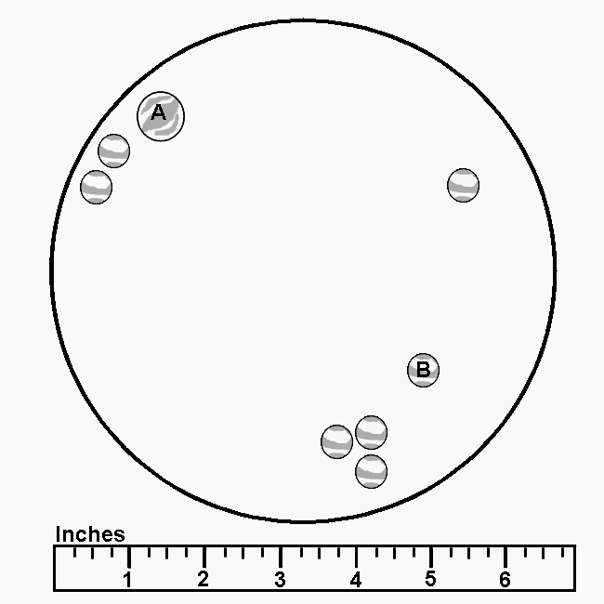
Marble-ous motion

Directions:
There are three diagrams on these pages. Each diagram shows a marble game. The marbles are inside a circle.

Two of the marbles have the letters A or B on them.

Use the diagrams and your knowledge of motion to help you to answer the questions.

Diagram 1

Fill in the blank with a word that would finish the sentence or answers the question.

1. Marble A will not move unless there is a ________________ .
2. If Marble A rolls towards Marble B it will have energy of ____________.
3. A source of energy to roll Marble A could be ___________________.
4. Draw an arrow on the Diagram 1 to show the direction Marble A would move to hit Marble B.

In order to describe where something is you have to tell its location in relation to some other object. For example, you may say that your desk is near the door. You may state that it is in the row near the window.
- Write a sentence to describe where Marble A is in the circle.

6. Write a sentence to describe where Marble B is in the circle.

Marbel-ous motion (page 2)
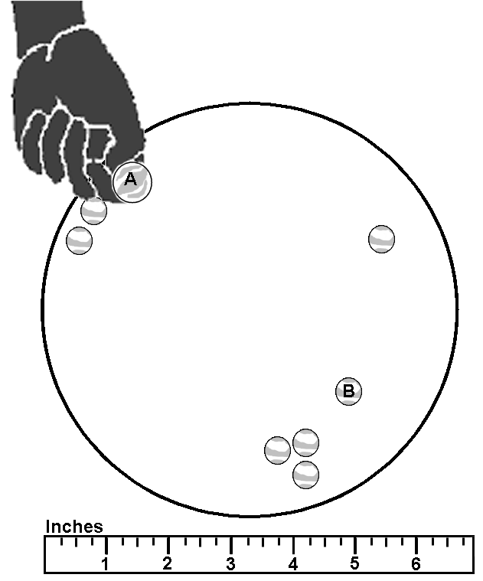
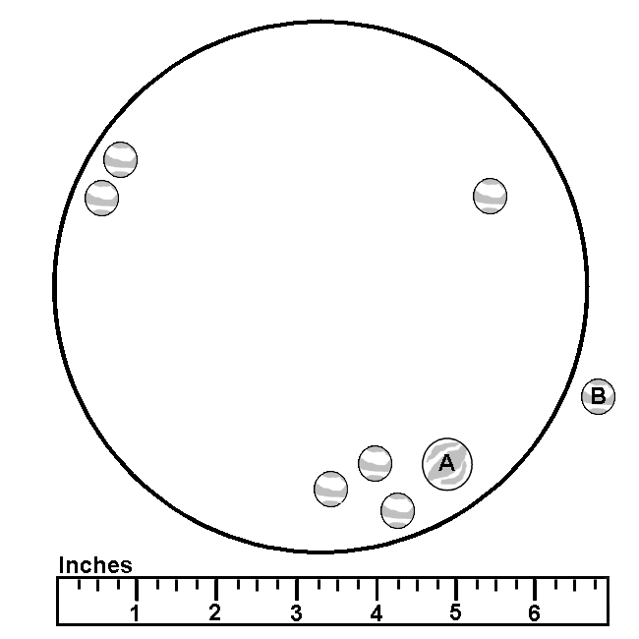
Diagram 3
Diagram 2

7. In Diagram 2 the hand will use a _____________ force to move Marble A.
8. In Diagram 3 Marble B has been forced to move by ________________.
9. The energy needed for Marble A to move came from _______________.
10.The energy needed for Marble B to move came from _______________.

Use your observations of Diagram 2 and Diagram 3 to answer each question.

11. Look at Diagram 2 and 3. How do you know that Marble A has moved?

12. How do you know that the three marbles near Marble A have moved?

Design a Marble
You have been using marbles from the Science Kit. Here is your chance to design your own marble! What can a marble be made of? What shape can it have? What color or colors can it have? Can you describe its texture or any designs on it?

Use the lines at the bottom of this page to write about the marble that you designed.

My marble’s properties:

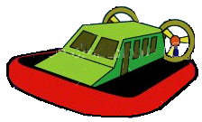
Acme Company
Air Powered Racer Results Final Report Sheet

Sketch your racer. Label the parts in your design.

1. Why do you think your design will make it move better?

2. How did your racer do? Describe where your racer started and where it stopped.

Air Powered Racer Results Final Report Sheet page 2

3. If you could start over with your design, what would you do the same or differently?

4. On a piece of paper, sketch a picture of your racer showing it racing.

Add the following to your picture:
- motion: Draw a fat arrow to show the direction of motion of the racer.
- energy: Draw a box in your picture. Write in the box the form of energy the racer has.
- force: Next to the motion arrow write the type of force (push or pull) that is used.
- gravity: Draw an arrow to show the direction of the force of gravity on the racer. Color the arrow blue.

Kite Building
Your job is to build a basic kite and test it to see how well it flies. After you test the kite, your task is to change the design in some way. This change can be changing the diamond shape to a different shape. (You may use a different geometric shape or an animal shape). It can be changing a part of the kite. You decide! Then you will build the new kite and test it to see how well it flies.

Material list:
- 1 sheet of 8 1/2" x 11" copy paper
- an 8" stick
- a 5-foot piece of crepe paper streamer (A plastic bag cut in a 1" wide spiral all around will also make a great tail.)
- 1 roll 1/2"wide masking tape or any type of plastic tape
- 10 foot long piece of string
- a piece of 1"x 3" cardboard on which to wind the string
- Scissors
- Hole punch (optional)

Directions:
1. Fold a sheet of 8 1/2" x 11" paper in half (hamburger style). | 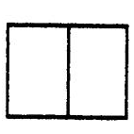
2. Fold again along the diagonal line A.  To help you do this, measure from the fold at the very top of the page and draw a dot at 3/4".  Draw a dot at 2 1/2" in on the bottom edge.  Lay a ruler across the paper to connect the dots and draw a line. This is where the diagonal fold will go. You can keep the ruler along the line to help you fold the paper back.  3. Fold back one side forming the kite shape. Place tape firmly along fold line AB. | 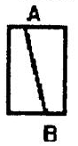  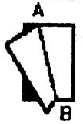

Kite Building

4. Place the stick from point C to D and tape it down firmly. The kite will not be flat after you do this. | 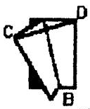
5. Tape the streamer to the bottom of the kite at B.  6. Flip kite over onto its back and fold the front flap back and forth until it stands straight up.(Otherwise it acts like a rudder and the kite spins around in circles.) | 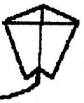
7. Punch a hole in the front flap about 3 inches down from the top point A.  8. Tie one end of the string to the hole and wind the other end onto the cardboard string winder. | 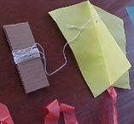  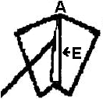

For over 15 years the Big Wind Kite Factory has been giving kite building classes for the children on the island of Molokai in Hawaii. These are the instructions to get kids making their own kites and flying them in 20 minutes

http://www.molokai.com/kites/20kidskites.html

Acme Company
Air Powered Flyer Results Report Sheet

1. Describe how your basic kite flew.

2. What changes will you make to the basic design?

Sketch your kite. Label the parts that you changed or added to the design.

Air Powered Flyer Results Report Sheet page 2

3. How did your new kite design do? Tell if the kite flew any differently than the basic kite.

4. What would you do the same or differently if you were able to do your design again?

5. On a piece of paper, sketch a picture of your kite showing it flying.

Add the following to your picture:
- motion: Draw a fat arrow to show the direction of motion of the flyer.
- energy: Draw a box in your picture. Write in the box the form of energy the flyer has.
- force: Next to the motion arrow write the type of force (push or pull) that is used.
- gravity: Draw an arrow to show the direction of the force of gravity on the flyer. Color the arrow blue.

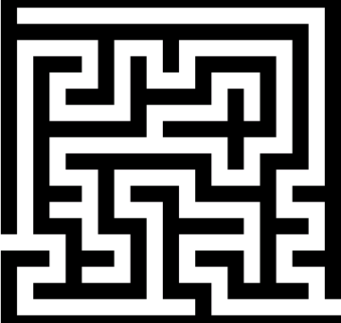
Maze Game Report

You should have a piece of paper with your plan for your maze. Attach that plan to this report sheet.

- What are two things that you had to think about in planning your maze?

- What materials did you decide to use in your maze?

- Do you like your design? What would you do differently if you were to make a new maze?

- There are forces involved in your game. Tell where each of these forces are found in the game.

friction:

gravity:

- Matter and energy play a part in your game. What form of

energy is used in the game?________________________ What

object (matter) had this energy during the game?_______________

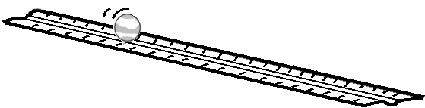
Marble Derby Report

1. In this activity I planned a simple system. The three basic parts of my simple system are:

2. My group built one Marble Derby system using a pre-planned design. We set up the system and used the stopwatch to time the energy flow. The energy moved from one object to the next. This is the sequence of the energy flow:

hand -> ______________ -> ________________ -> ______________

The number of energy transfers was ________.

The actual time from start to finish was ________________.

3. My partner and I planned a Marble Derby system to share with our whole group. While we were drawing our plan we thought that the most important part of the planning was

4. My whole group got together and shared our ideas. We decided on a design. Next, we tested our design and made any changes.
I am going to write out the sequence of the objects in our design. In the sequence I will write a number in front an object to tell how many there are.

For example, for the pre-planned design the sequence would be:

1 hand -> 1 marble -> 3 dominos -> 1 marble

My Sequence of Motion Diagram page 2
5. We ran our Marble Derby and earned these points.
Number of energy transfers: _______

Number of seconds from start to finish:________

What I have learned. What I can do.(Fill in or do each of the following items.)
A. I know that __________________ is being transferred or passed on from one moving object to the next.

B. The form of energy that the marbles have is __________________

C. I can use descriptive words to describe the position of one of the rulers in the derby.

D. On the sequence of motion diagram I can draw circles around the objects that are moved by a pushing force. I can draw squares around the objects that are moved by a pulling force.

E. I know that the places in my derby plan where friction is slowing the marble’s motion are

MOTION Unit Crossword Puzzle
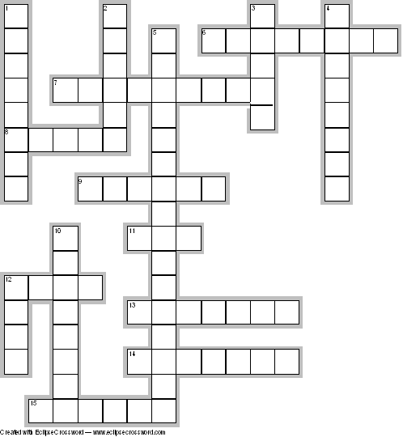

Across Down
6. an observable characteristic  7. a line along which an object moves  8. a push or a pull  9. an action that is a change in the position of an object  11. the shooter marble  12. a force against an object  13. a resistance to change  14. the force that pulls objects towards the center of the Earth  15. the ability to do work | 1. to pass something on from one object to another  2. the beginning or starting point  3. the shape of a marble  4. a rubbing force between two objects  5. the ability to do work by using motion  10. a certain location  12. a force on an object that moves away from an object

Teacher: __________________________ Date:______________________

Part 1- Vocabulary: Match the word and its definition by writing the letter in front of the word.

Letter Word Definition
 | transfer |  | A. a push or a pull
 | friction |  | B. resist change
 | position |  | C. to pass something on
 | pull |  | D. a rubbing force between objects
 | property |  | E. a certain location
 | force |  | F. a force against an object
 | inertia |  | G. an observable characteristic
 | gravity |  | H. the force that pulls objects to the Earth
 | energy |  | I. the ability to do work
 | push |  | J. a force on an object that moves away from the object

Part 2- Complete the statement using the science concept.

Transfer of energy
1. In the game of bowling, energy is transferred to the pins when

2. When you ride a bicycle energy is transferred to the wheels when

Friction
3. By spreading sand on icy roads, highway crews are trying to make the friction

4. I like to slide on smooth floors because the friction is

PART 3- Base your answers to questions A - G on the story and your knowledge of science.

It was almost the end of the basketball game. The two teams were playing hard to get ahead of the other. The Hawks were in the lead by 2 points.

Then the Eagles got the ball and Joan was dribbling the ball down the court. Joan saw that Kim was too far away. She heard the steps of a player behind her. Joan saw that it was #5 of the Hawks. Joan thought, “She’s too slow to be a good player. I can get through her.” Joan made her move and quickly passed the ball to Mary. Mary shot the ball at the basket. It hit the rim and flew away from the basket. Running and leaping, Kristen reached for the ball and brought it towards her. In next moment she jumped again, reached out with the ball and flicked it over the rim into the basket! The ball swished through the basket and fell to the floor. With a roar the crowd jumps to its feet. The game was tied!

A. Give 2 examples of a pushing force in the story.

B. Give one example of a pulling force from the story.

C. Where is the ball getting its energy from when Joan passed it to Mary?

D. List 4 objects that have energy of motion in the story.

E. What is the force that caused the ball to “fall to the floor” after it went through the basket?

F. Write down an observation that is made by someone in the story.

G. Write down an opinion given in the story.

PART 4- Multiple Choice

1. What type of energy does a ball have as it moves through the air?
A. light energy C. heat energy
B. mechanical energy D. gravity energy

2. Third graders are planning a roller skating race. Which surface would be the best for the race?
A. gravel C. sand
B. blacktop D. grass

3. Which is NOT an example of energy of motion?
A. a wheel turning C. a hand throwing
B. a bulb lighting D. a rock rolling

4. Which is an example of people using energy of motion?
A. a rocket blasting off C. a person growing
B. a pot heating D. a computer

5. A ball is tossed in the air and comes back down. The ball comes back down because of
A. gravity C. friction
B. erosion D. magnetism

6. You need to tell a friend where your house is. The best information you can give them is
A. your county and state C. your house number
B. your last name D. your street and house number

7. Which is NOT an observation of the properties of your house?
A. it is pretty C. it is green
B. it is small D. it has many windows

