1 The diagram below shows the stages of development of a plant
at which stage has germination begun?
A A
B B
C C
D D

2. Living things depend on energy from
A the Sun
B the Moon
C soil
D water

3. A decomposer is an organism that
A preys on other animals
B eats only plants
C recycles nutrients
D uses sunlight to make food
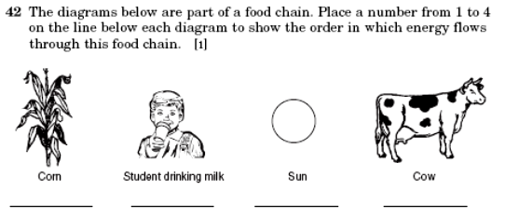
4.
5. A student puts two identical plants in the same type and amount of soil.
She gives them the same amount of water. She puts one of these plants near a sunny window and the other in a dark room. This experiment tests how the plants respond to

A light
B air
C water
D soil

Base your answers to questions 6 through 9 on the diagram of a food chain below and on your knowledge of science.

6. The energy that all organisms need to survive comes from
A the air
B the Sun
C water
D grass

7. Which organism is a producer?
A grasshopper
B raccoon
C grass
D frog

8. The raccoon in this food chain represents a
A prey
B predator
C decomposer
D producer
Note that question 9 has only three choices.

9. If all the frogs died, the raccoon population would most likely
A decrease
B increase
C remain the same

Base your answers to questions 10 through 12 on the diagram of a food
chain below and on your knowledge of science.

10. Which organisms in this food chain are needed for all the other
organisms to survive?
A caterpillars
B frogs
C plants
D snakes

11. Which organisms in this food chain are predators?
A plants and caterpillars
B caterpillars and frogs
C frogs and snakes
D snakes and plants

Note that question 12 has only three choices.

12. If the population of snakes increases, the population of frogs will most
likely
A decrease
B increase
C remain the same

