
STUDENT NOTEBOOK
Science Center

Name: ________________________

Teacher: ______________________

Page Number |  | Topic or Main Idea
1 |  | Are you a sinker or a floater?
2 |  | Float and Sink Predictions
3 - 4 |  | Does clay sink or float?

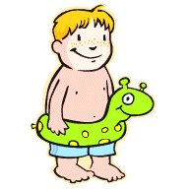
Activity 1: Sink or Float Team

Are you a sinker or a floater?

It seems that some people can float in a pool better than others. There are people that float up near the surface. There are people that float more below the surface. Now, I think of myself as a floater. I think so even though my head stays near the top of the water while my legs want to sink. There are different types of floaters. Then there are plain old sinkers. They sink to the bottom like a rock.

Do you think of yourself as a sinker or a floater?

Draw a picture of something floating.  What is your object floating on? | Draw a picture of something sinking.  What is your object sinking in?

Activity 1: Predict, Test, Tell: Float and Sink Predictions

Let’s take your experiences with buoyancy and put them to a little test. There is a group of objects that you are going to make predictions about. You are going to predict whether they will sink or float. Then you are going to test them to see if your predictions are correct.

Predict and Test:
Object | Type of Matter | Prediction | floats/sinks

Tell:
1. What seems to be the same about the floaters?

2. What seems to be the same about the sinkers?

3. Which properties of an object are most important for float or sink: the color, the size, the shape, hard or soft or the type of matter in it?
Activity 2: Does clay sink or float?

Materials:
-2 sections of clay -buoyancy container -water -paper towels

Directions:
- Roll the clay into a ball.
- Measure the mass of your clay ball. ______________
- If you place the ball of clay into the water, do you think it will sink or float? __________________
- Place the ball into the water.
Draw a sketch showing your ball of clay in the water.

- Take your clay out of the water and dry it off. Can you change the clay so that it will float? Try to do this.
Draw a sketch to show your clay floating.

Dry out your clay boat. Measure its mass. ______________

Activity 2

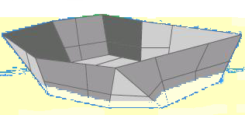
- What was different about the clay when it floated and sank? What was the same? Write a short paragraph. Describe the clay’s shape when it sank. Tell what was different about the clay when it was floating.

Was it the water or the clay?
Answer each question using the words water or clay.

- Which had more pushing force when the clay sank? ___________
- Which had more pushing force when the clay floated? _________
- Which had less pushing force when the clay floated? __________
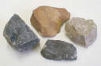
Activity 2: What are the float and sink forces

You have heard the phrase, “It sank to the bottom like a rock.” I have found that most rocks sink. Have you ever seen a rock that floats? When you drop most rocks into water they fall to the bottom. Why does a rock do that?

1. What force do you think is pulling the rock to the bottom of the water?

Unlike the rock, a piece of wood will float. If you force the wood to the bottom of the water and then let go, it will be pushed back up to the surface. What is happening here?

2. What is trying to pull the wood to the bottom?

You have had a lot of experiences with objects that float and sink. This is a property of matter. Whether an object floats is its “buoyancy.” To be buoyant is to float. Buoyancy is caused by a force pushing upwards. This force is called a “buoyant force.”

3. What pushes the wood to the top of the water?

4. Write the name of an object that is NOT buoyant.

Buoyant force: The upward buoyant force comes from the matter into which the object is placed. The object can be a rock or a boat. The matter can be a liquid, like water. The matter can be gases, like air. It becomes a pushing contest.
An example of this is a ball floating on water. By having enough water to push it up the ball floats. How does this happen? The ball has to be light enough for its size. If the ball is large it can get a lot more water to push on it than if the ball is small. If the ball is too heavy for its size, it pushes more than the water. The lighter you are for your size the better chance you have of being pushed to the top.
The pushing buoyant force is affected by the size and weight of the object.
Think about the smaller clay ball and the larger clay boat.

Activity 2: Float and Sink Forces
This is a picture of a buoy. A buoy is used to give information to boats. It floats on the water to show the boats where to go. Gravity is pulling the buoy downward. Is a pushing or pulling force moving it upwards causing it to float? Where is the upward force coming from?

5.

Think about what you have to do to get to the bottom of a pool. How do you force yourself to the bottom of all that water? How do you overcome the upward pushing force of the water?

6.

7. Write down the names of two objects that are buoyant in water.

8. Write down the name of one object that is buoyant in air.

Activity 3: How does a boat’s size and shape allow it
to carry a load?
Materials:
-clay boat -ceramic masses -buoyancy container
-water -paper towels

1. Look back at the table on page 2 titled, “Float and Sink Predictions.” Which column in the table tells about a property of the object?

2. In the last activity the same amount of clay was able to sink and then float. What property of the clay was changed to cause it to float?

3. Let’s test your clay boat by adding more matter to it.
Predict how many masses your boat will hold.
How many ceramic masses can your boat hold?
Measure the mass of your filled boat. ________________
4. What happened to your clay boat as you added more matter to it?

5. Did all the clay boats carry the same amount of matter?_________
What was the range of masses that the boats could hold?

6. What two properties of a boat affect it being able to float and to carry a load?

7. Why do boats sink?

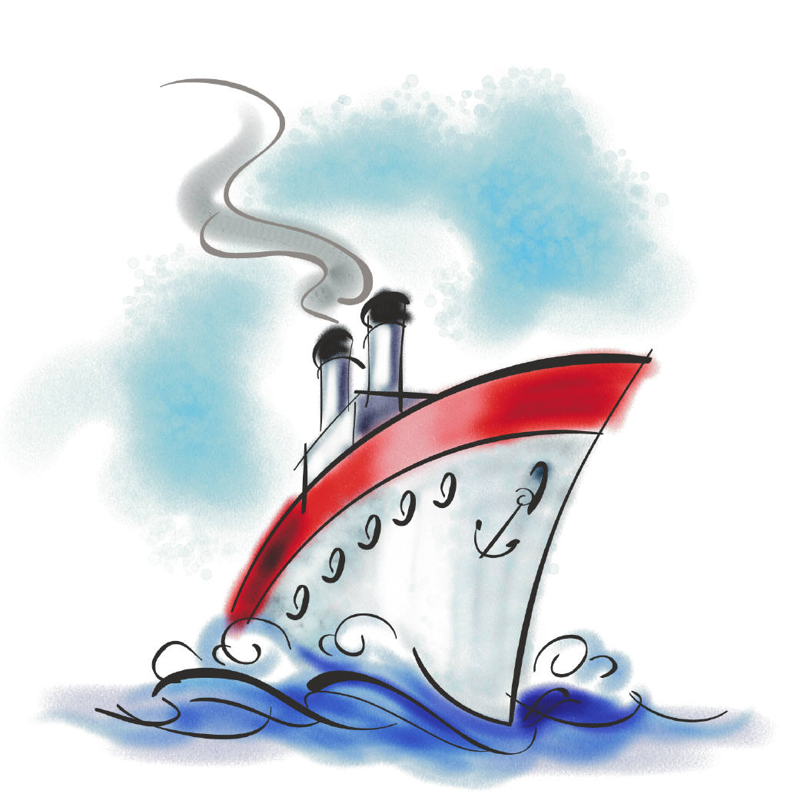
Activity 3
What do I think about my boat?
How does my boat compare to the other boats?

Look at the class’s boats and the amount of matter each boat could hold.
Write a short paragraph telling how your boat compares to the others in the class. Think about:
- Did your boat hold the same as, more than, or less than the others?
- Is your boat the same as others or different?
- What do you think about your boat’s design?
- How could you change your design to hold more?

Activity 3

Activity 4

If you have boats with the same shape, and made of the same matter, will they carry the same load?

Materials:
-small plastic cup -buoyancy container -paper towels
-ceramic masses -water -clay

1. Look at the plastic cups that everyone is using. Do you predict that they will float the same amount of load or different amounts?

2. How many ceramic masses do you predict your floating cup can hold? _______ Test it. How many did it hold? _____________

3. How did the number your cup held compare to the rest of the class?

If you have boats with the same shape, and made of different matter, will they carry the same load?

Now you need to make a clay boat with the same shape as the plastic cup. Test the clay cup-shaped boat to see what load it can float.

4. How many ceramic masses do you predict the clay cup boat will hold? _______ Test it. How many did it hold? _____________

5. Was the capacity of the plastic boat more or less than your clay boat? Tell why this happened. In your answer, be sure to use the words “weight” and “pushed.”

Activity 5:
How can we make a boat out of metal?
How much of a load can it carry?

Planning a new boat

Let’s use a different material to make a boat. We know that clay can be made to float but we don’t see boats made out of clay. There are boats made out of metal. Doesn’t metal sink? Let’s test a piece of metal to see if it sinks. Then let’s try to make a boat using the metal. To do this we need a metal that is easy to work with. Let’s use aluminum.

Materials: -one 10 cm square piece of aluminum foil,
-two-liter container
-water

- Test the piece of aluminum foil to see if it floats.
Does it float? _____ If it does float then use the ceramic masses to see how much of a load it can hold and still float.
Flat metal raft floating capacity = __________
- Think about how you can make the metal carry a greater floating load. Make your changes to the metal and test it.
Draw a small sketch of your metal boat.

Test the metal boat’s floating capacity.
Metal boat floating capacity = _____
Activity 5
- Was the flat metal raft or the metal boat able to carry a greater floating load? _________________

- Did you change the mass of the metal when you made it into a boat that carried a greater load? _______ Why do you say that?

- What did you change in order to make the metal float? ________
- Measure the mass of the metal boat filled with air.
Mass of empty metal boat= ___________

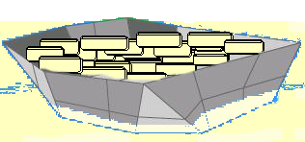
- Fill the boat with the load that it could hold before sinking. Measure the mass of the aluminum boat plus its load.
Mass of filled metal boat= ___________
- Do you change the mass of the metal boat to sink it? _______
Why do you say that?

- Which has more downward pushing force or weight, the empty metal boat or the full one? ____________

10.What force pulls on the whole boat giving it weight? _________

Activity 6: What happens to the water when an object sinks into it?

Materials:
-small plastic cup -plastic drinking cup -towels (paper)
-ceramic masses -piece of masking tape -pen/pencil

Draw a sketch of the drinking cup with water in it before you added the small cup.
Draw a sketch of the drinking cup with water in it after you floated the small cup and the ceramic masses.

1. What pushed the cup up to make it float? ___________________
2. What do we call the force that causes something to float?

3. What happened to the cup as you added more masses? ____________
4. What happened to the water as more matter was added to the small cup?

Activity 6
As more matter was added to the cup gravity had more matter to pull on. Filling cup made it heavier so it pushed down harder on the water, pushing the water out of the way. As the cup sank it “displaced” the water or pushed it out of the way. The water pushed back and made the cup float. When the cup sank it was too heavy to be pushed up. As weight was added there was not enough water displaced to push back hard enough to force the cup upwards. To float the cup again you need to make it lighter or make it larger so it can have more water pushing on it.

5. What does it mean to “displace water”?

6. What happens to the water when a boat sits in it?

7. When have you displaced water?

8. What do we call the force of the displaced water that causes objects to float? ___________________________.

9. Use your observations from this activity to answer the question below.

Scientists say that two objects cannot take up the same space at the same time. How do your observations prove this to be true?

Buoyant Events: How is buoyancy at work? Page ____

Buoyant Events: How is buoyancy at work? Page ____

Activity 8: What other material can we use to make a boat?
How much of a load can it carry?

Planning a new boat.
Think of some other material that you could use to make a boat. The boat has to be small enough to float in the buoyancy container. You will be testing the boat to see if it floats and how much it can carry.

Plan: (Draw a sketch of your boat. Tell of what it is made.)

Was it more or less buoyant than the water? ______________

How much could it carry? _________________

What do you like about your boat? What may be a problem with your boat?

