
Science Center

Kit #7
Buoyancy

Blackline Masters

Revised July 2009
Activity 2 Check Point NAME: ____________________

1. Below is a Venn diagram which compares a clay ball and a clay boat. Write, in the correct places on the diagram, how the ball and boat are different and how they are the same.
Clay ball
Clay boat

2. What is the force that was trying to pull the clay boat to the bottom of the container? ______________________

3. What is the name of the force that pushed up or floated the boat?
______________________________

4. You are fishing from a small boat on a lake.

a. What is pushing your boat to the top of the lake?

b. What is pulling your anchor to the bottom of the lake?

c. Add another object to the picture that is buoyant in water. Label the object.

Activity 3 Check Point NAME:________________________

- Which boat has a greater capacity to carry cargo? Boat A or B? ___________
A.
B.
- How are air and water the same? Circle the 2 best answers.
A. They are both wet and dry. C. They are both made of matter.
B. They both have color. D. They both fill up space.

- What force causes an anchor to sink to the bottom of a lake?

- A soccer ball will float. What property of the soccer ball would I have to change to make it sink to the bottom?
- There are a soccer ball and bowling ball pictured here. They are the same size. The bowling ball has more mass. The soccer ball has less mass. Tell how that can be so.

- What does weight measure? ________________________________________
_____________________________________________________________
- What is capacity a measure of? _____________________________________
_____________________________________________________________
Activity 4 Check Point NAME:________________________

- In our everyday life there are things that can be changed. There are things that we can’t change or choose not to change. In the list below, place a “C” in front of the items that usually stay the same. They are constants. Place a “V” in front of those items that often change. They are variables.
 | A. | The room that is the school library.
 | B. | The temperature outside.
 | C. | Number of inches in a yard.
 | D. | Your first and last name.
 | E. | The students that are in your school each year.
 | F. | How old you are.

- In baking or cooking there are constants and variables. In a kitchen there are measuring cups. When you bake the recipe calls for certain amounts of ingredients to be measured in the measuring cups. Is the capacity of a ½ cup measuring cup a constant or a variable? Tell why you think that.
- You have to carry a bag of groceries home. (Yes, you have to walk home carrying the bag.) The capacity of the bag is 4 items. Pick one item from each line of the list below that would give the grocery bag the least mass.
Check the items you would choose for the lightest load.
 | quart of milk | OR |  | gallon of milk
 | a large bag of flour | OR |  | a small bag of flour
 | 2 pounds of cookies | OR |  | 1 pound of cookies
 | small can of soup | OR |  | large can of soup

Activity 5 Check Point NAME:________________________
- How are aluminum foil and water the same? Circle the 2 best answers.
A. They both attract mass. C. They are both made of matter.
B. They both take up space. D. They both have the same hardness.

- What property of the aluminum did you change to allow it to float? (Circle the answer.)
A. The gravity attraction. C. The mass of the metal.
B. The shape of the metal. D. You took away air.

3. You and two of your friends are going to take an aluminum canoe out on a lake. The three of you get into the empty canoe and start paddling. Answer the following questions by circling the best answer.
A. What happens to the mass of the loaded canoe as people are added?
B. What happens to the pushing force of the canoe as people are added?
C. What happens to the weight of the canoe as people are added?
D. What force is pulling the canoe and its load downward, causing it to have the property of weight?
becomes greater OR becomes less
becomes greater OR becomes less
increases OR decreases
gravity OR buoyancy

4. What matter is giving the buoyant force for the canoe to float?
5. What would happen if a lot of water entered the canoe with you and your friends?
Why would this happen?

Activity 6 Check Point NAME:________________________

You and one of your friends are going to go fishing using an aluminum canoe. The two of you get into the empty canoe and start paddling. You have brought along two buckets to place the fish into when you catch them.

- In order to be ready for the fish your friend is going to fill a bucket with water. She wants to fill the bucket with water to the top. You have a concern about adding fish to the filled bucket. What will happen when you add fish to the water filled bucket?
Why will that happen?
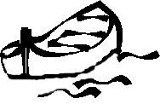
- As you fish you add a second water bucket and many fish to the canoe. Which picture best shows the canoe sitting on the water after the load has been increased? (Circle the letter.)
A.
B.
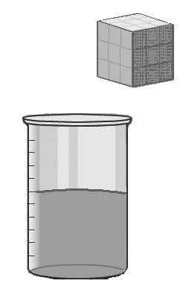
- (Circle the best word.)
As the canoe becomes heavier it ( pushes, pulls ) more water out of the way.
- If the cube in the picture is placed in the water in the beaker it will sink to the bottom.
A. Draw a line on the beaker to show the water level after the cube is added.
B. Why does the water level change?
C. Write the word that means “to push out of the way”.

Buoyancy Check Point: Buoyancy Wheel
The topic is buoyancy. In each of the 8 sections of the wheel you will write a word. The word will tell about something about buoyancy.

Use these 8 clues to help you:
1. Tell what it is. | 2. Tell what it is not. | 3. Name an object that is buoyant. | 4. Name an object that is not buoyant.
5. Name a property that affects an object’s buoyancy. | 6. Tell when buoyancy is important to you. | 7. Name a force that pulls. | 8. Name a force that pushes.
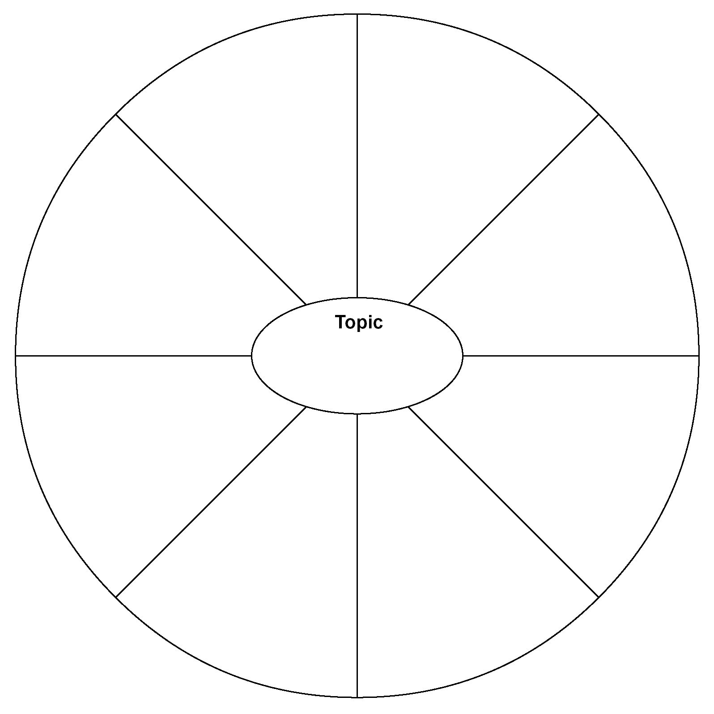
buoyancy

1
8

2
7

3
6

4
5

Exploration: Diving into Buoyancy with a Cartesian Diver

You are going to explore the up and downs of buoyancy by building a diving chamber and a special diver. Read through the directions before starting.

Procedures:
- Fill the plastic bottle with water leaving a 4 inch space at the top. (This will be the diving chamber.)

2. Take the plastic medicine dropper and cut off the stem to about ½ inch below the top ring or ridge. (This will be the diver.)
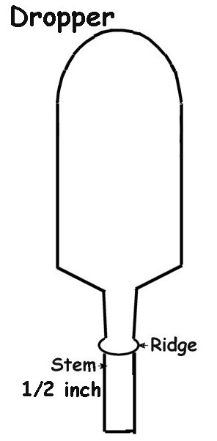
3. Slide 4 small washers onto the shortened dropper stem. Push them up against the dropper bulb. (The ring or ridge should hold the washers in place. If not, a piece of plastic tape can be added.)

- The dropper bulb diver may still be too light to float properly. The top of the diver needs to be just below the water’s surface.

- You will need to:
- Test the diver in a container or cup.

- If the diver is too heavy, put fewer washers on. If the diver is too light, squeeze some air out and suck in some water.

- Test the diver in a container or cup.

- If needed, add or remove water (squeeze out) and test the diver until it floats properly.

6. When the diver floats properly, put it in the plastic bottle and cap the bottle.

7. Squeeze the sides of the bottle (hard) and watch the diver. Release the sides and watch the diver.

8. Why do you think the diver sinks and floats?
Evaluation: The City of Clayville story or The Saga of Captain Cathy

Once upon a time there was a city that was split in half by a river. The river was named the Silt River. The people who settled here found that in the soil there were large amounts of special clay. This clay did not break down in water but a ball of it did not float. They found many uses for this clay. In fact, making things out of clay became a big business in town. As time went on the city became to be know as Clayville.

The people who founded this city built their homes, stores and schools on one side of the river. They built the factories on the other side of the river. They realized that they would need to often travel from one side of the river to the other. So it wasn’t long before they built a bridge. Many boats were built to travel on the river. One such boat owner was “Captain Cathy.”

Captain Cathy grew up in Clayville and had spent many hours cruising the river. One of her major goals was to build a boat that could transport the greatest number of people or goods across the river. Since there was a lot of clay in Clayville, her current thought was to design a clay boat. Captain Cathy gathered the best minds in Clayville. They formed the Clayville Float or Sink Project committee. Buoyancy Barb was voted the committee leader.

Buoyancy Barb wants your opinion. She is worried about making a good report to Captain Cathy. Barb has heard that you are doing some buoyancy experiments. She would like you to write down your thoughts about how they should build their boats.
----------------------------------------------------
1. Start out by re-reading the story and underlining any important information.
2. Next, think about the items listed below and make a list of your thoughts.
3. Make a sketch.
4. Lastly, write a final report. (Be sure to include your final picture.)

- Should the boats be made of this special clay or another material? Tell how what it is made of might make a difference.
- What should the shape and size be? Tell how the size and shape may make a difference.
- Draw a picture of the boat that you think would work best.

