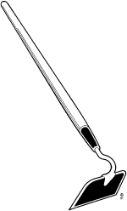
Kit #1
Plants-Grade 2
Student Science Journal

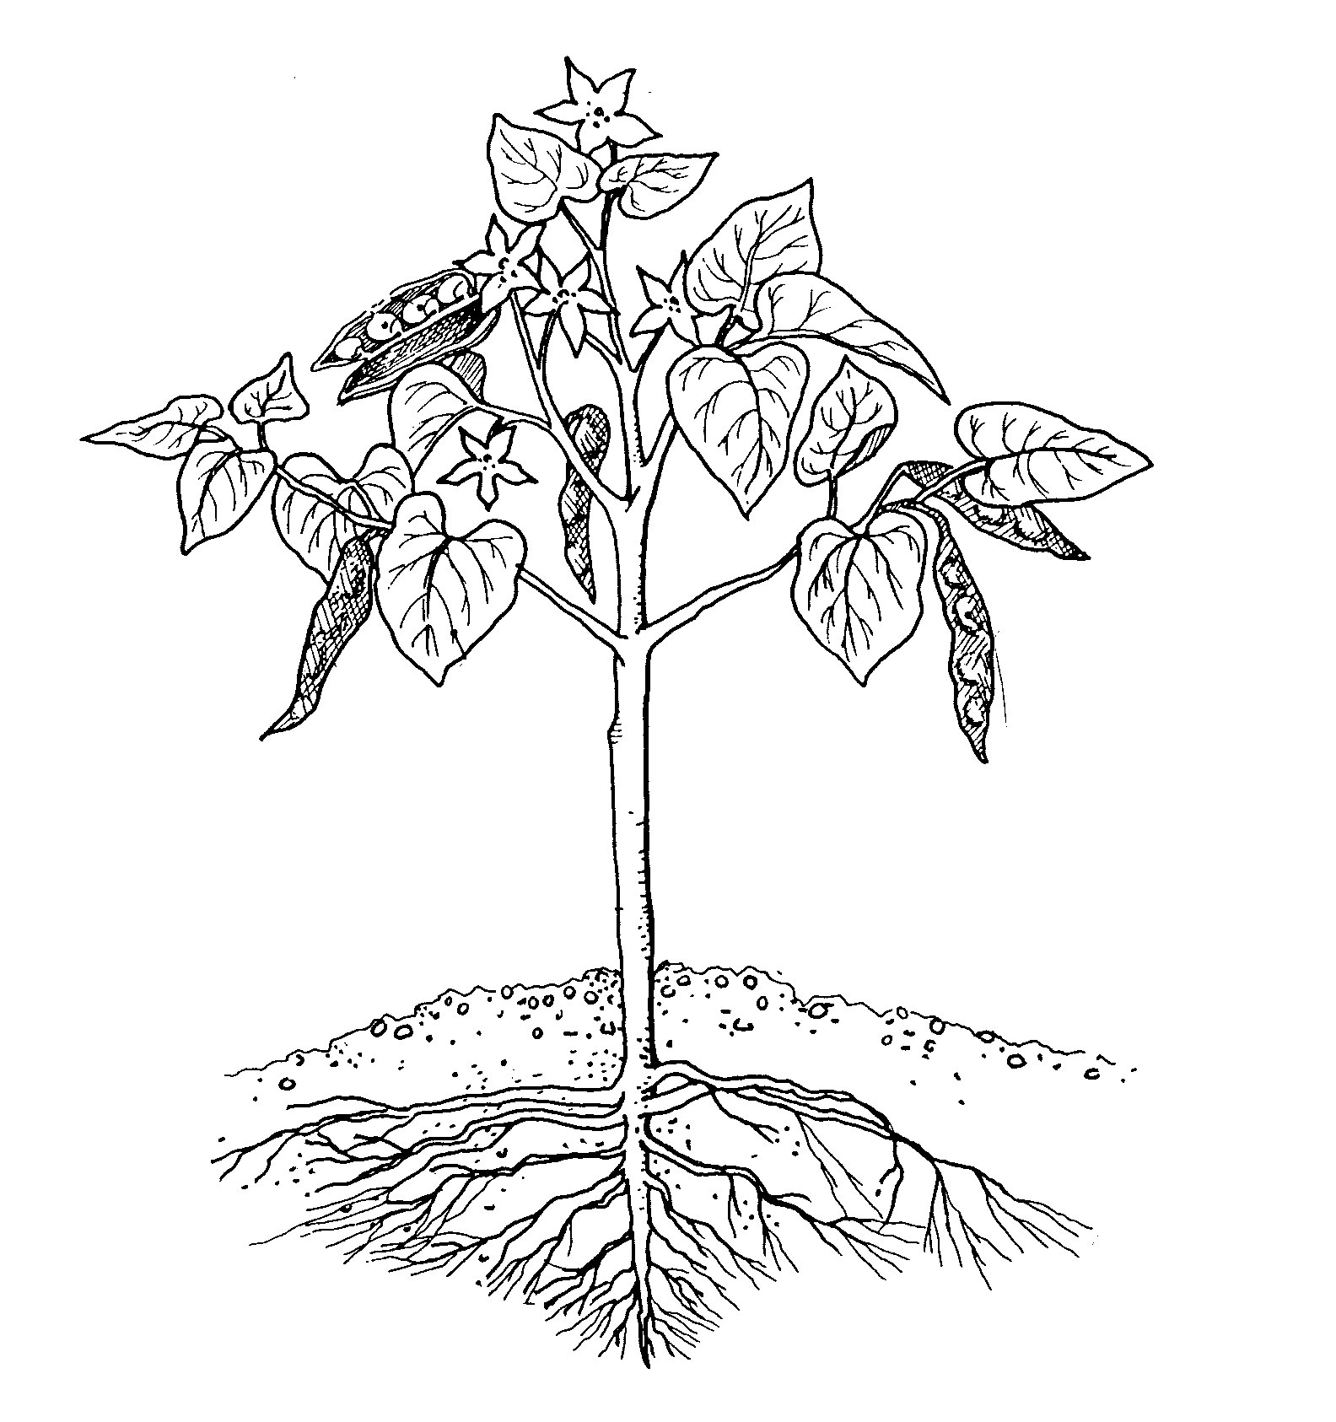

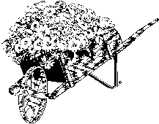

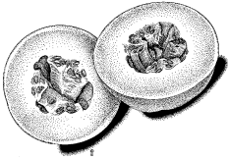

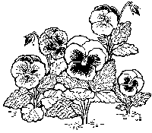

Student Scientist’s Name:


Revised July 2006
Logo/Formatting Revisions Nov. 2009
Activity 2: Plant Marigold Seeds

Directions:
- Fill each part of the egg carton or the peat pot with enough potting soil to cover the seeds.
- Plant two seeds in each part of the egg carton or in each peat pot. Seeds should be about 1 cm deep.
- Water the seeds. Do not over water them.
- Count the days until the plant grows flowers.
- When the plants are 10 cm tall, move the plants into cups.
- Look at the marigold flowers. Draw a marigold flower.
- Let the flowers die on the plant.
- Take the flower apart and find the seeds.

- When were the marigold seeds planted? __________

- How many seeds were planted? __________

- How many seeds germinated? ___________

- When did the marigold bloom?_____________

- How many days did it take for the marigold to bloom? ___________

- Let the flower dry for 1 week.
How many seeds were in the flower?__________

Draw a picture of your marigold plant:

Activity 3: Class Garden

Draw a picture of the seed or plant every third day.

Day | Corn | Pea | Sunflower | Radish
Day 1

Beginning
Date_____

Day 4

Date_____

Day 7

Date_____

Day 10

Date_____

Day 13

Date_____

Activity 4: Lima Bean Seed

- Make observations about the lima bean seeds.
- Plant one seed in the 5 oz cup (twice as deep as the seed is wide).
- Use a toothpick to remove the seed coat from the other seed.
- Split open the seed and find the embryo.
- Record your observations by writing a description of what you see, feel and smell.
- Draw a picture. Label the parts of the seed.

My seed observations.

Draw and label the parts of the lima bean seed.

After one week, draw a picture of the bean plant in the cup.

Activity 5: Proper method to plant a seed

Directions:
- Put a little potting soil in the bottom of a cup.
- Plant a squash seed at the bottom of the cup. Place it by the side so that you can see it.
- Fill the cup with potting soil almost to the top (leave some space at the top of the cup).
- Plant another seed at a depth of twice the width of the seed.
- Water the seeds daily for one week (just enough water to wet the soil.)
6. Record your observations in the science journal table below.

Draw the seed or plant every other day.
Day | Seed Planted at Twice the Width | Seed Planted at Bottom of Cup
1

3

5

7

Write about your observations of the two seeds.
How did the seeds grow during the 7 days? What was the same and what was different? When a seed is planted, what do you think is important for a seed to grow?

Activity 6: Roots

Directions: (You will need to know what a dandelion and grass looks like.)
- Dig up a dandelion, some grass, and one other weed.
- Take the plants back to the classroom.
- Draw and label pictures of the root systems.
Draw a picture of a dandelion root.

What type of root does the dandelion have, a taproot or fibrous?_____________

Draw a picture of grass plant roots.

What type of root does the grass have, a taproot or fibrous? ______________

Look at the third plant’s roots.
Are they like the dandelion or like the grass’ roots? _______________
What type of root does this plant have? Circle one.
a taproot or fibrous roots

Activity 7: Leaves

Look at the top and bottom of the leaf.

Draw a picture of the top of the leaf in the space below.

Activity 7: Leaves-continued

Plants and sunlight
Write about the plant that was covered with the paper bag (with the hole in it).

Activity 7: Leaves-continued

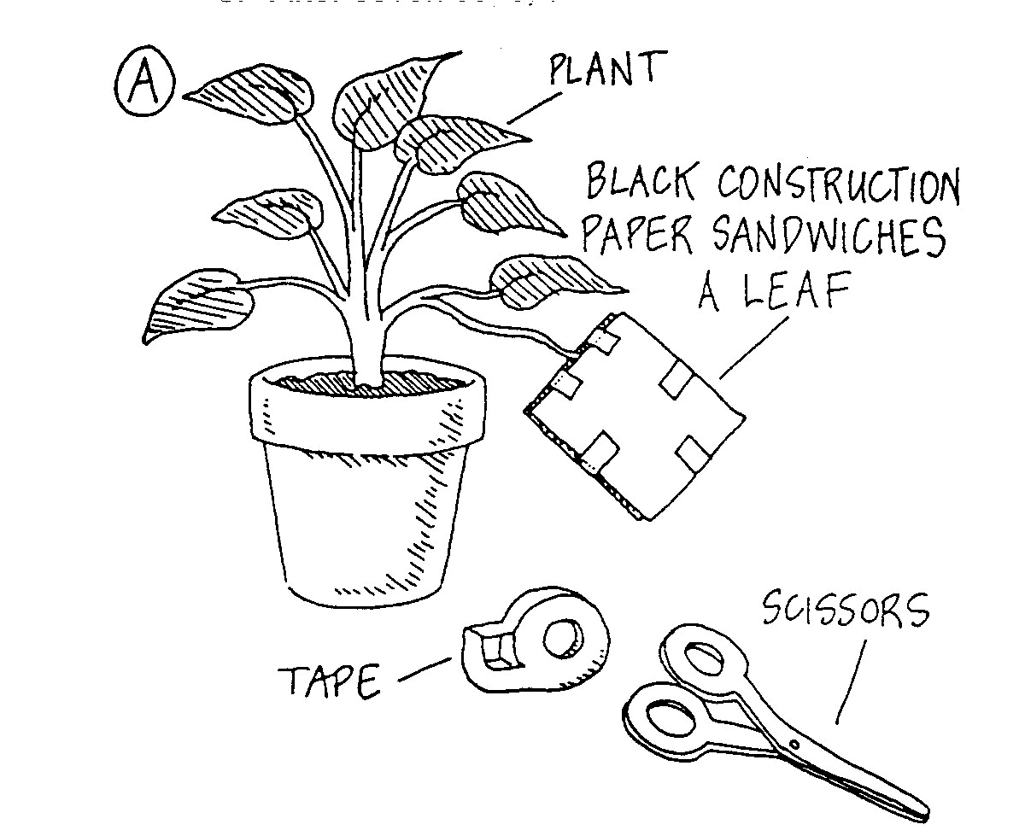
There was a plant that had a leaf covered with paper. Write about the plant. What happened to the leaf? Tell your observations. Tell why you think this happened. This is called writing a “conclusion”.
Activity 8: How does the stem help a plant grow?
Draw a picture of the carnation at the beginning.
Record your observations each day by adding to the drawing.

Observation Drawing

Activity 8-continued

Carnation conclusion:

Celery Taste Test:
Observation 1:

Observation 2:

Celery Conclusion:

Activity 9: Seeds
Directions:
- On your walk you will be looking for seeds to collect. (Look high and low!)
- Put the seeds in a baggie.
- Examine the seeds with a magnifier.
- How do you think the seeds may be carried to different places? Sort seeds by how they may be spread.
- Answer the questions. If you need more seeds ask your teacher if you can check with another person or group and share some of their seeds.

1. Draw two seeds that may float in the air.

2. What happens to seeds if the wind blows?

3. Draw two seeds that stick to animals.

4. What happens to the seeds if they stick to an animal?

Activity 9: Seeds-continued

5. Draw two fruits that get eaten by animals.

6. What happens to seeds if they get eaten?

Activity 9: Seeds-continued
Setting Seeds Free Worksheet
Draw a line from the way that a seed can travel or be “set free” to the type of seed.
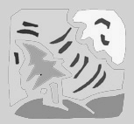  Wind |  | 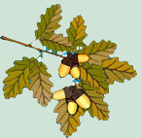  Acorns
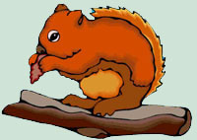  Animals eating seeds |  | 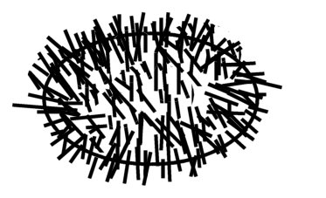  Prickly Seed
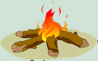  Fire |  | 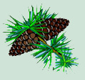  Pine Cone
Animal fur |  | Dandelion

Activity 10: Bulb

Directions:

Word Bank

Outer Papery Scale

Basal Plate

Leaves

Daughter Bulb

Roots

Flower Bud

1. Look at the bulb with a magnifying glass.
2. Find the parts of the bulb.
3. Label parts of bulb in the picture.

Label the parts of a bulb.

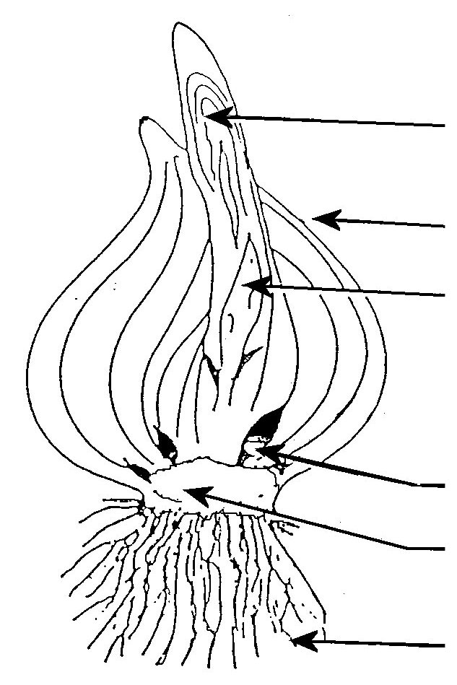

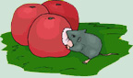
Activity 11: What happens when plants die?

Plants live their lives and die just as animals do. Just like animals, some plants die young. Some plants live for many years. Plants can die from disease. They die when they are pulled out of the ground. Animals can eat them.
You will be using a piece of a plant to look at what happens when a plant dies. The part is called a fruit. The fruit of a plant contains seeds. Once the fruit falls from the plant it is no longer part of a living thing. It is called “organic” matter. We call it organic matter instead of “non living.” Organic matter is something that was once living. It was part of a living thing. Organic matter can be a living thing that has died.

Directions:
- Place a piece of a fruit in a petri dish.
- Put a lid on the dish. (You can tape the dish closed)
- Put a label on the dish that says “Do Not Open.”
- Draw a picture of the fruit in the dish.
- Observe the fruit each day, but do not open.
- Draw a picture of the fruit after 7 days.

Fruit Day 1 | Fruit Day 7

A decomposer is a living thing that helps organic matter to rot.

Activity 12: Plant Hunt: Circle each word as you find the item.
How many did you find?
seed | root | seedling
leaves, leaf | taproot | decomposer
stem | flower | sun
food | water | air
fibrous root | bulb plant | pine cone
wind | acorn | yellow flower
blue flower | grass | dead plant

