Kit #1
Plants
Grade 2

Blackline Masters


Revised March 2003
Logo/Formatting Revisions Nov. 2009

Lima Bean Seed
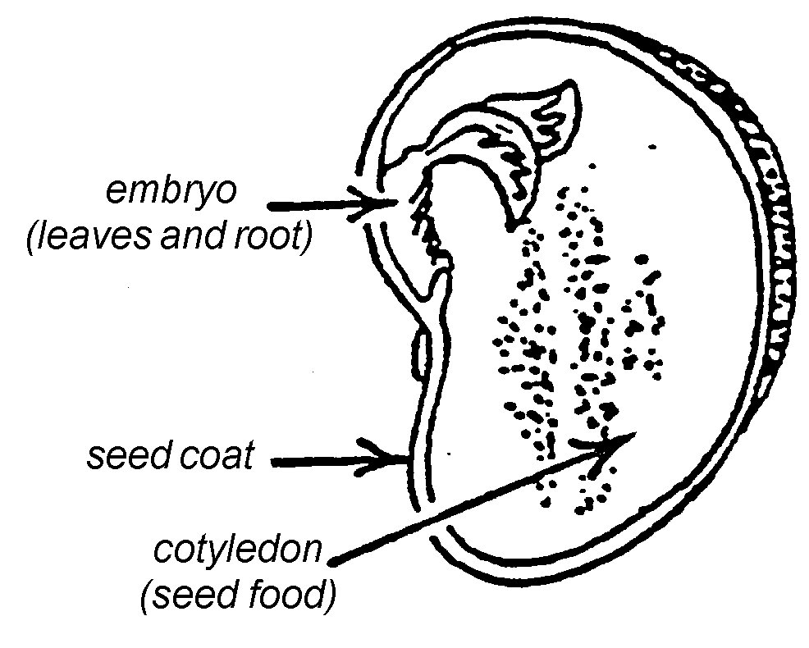

Young Bean Plant

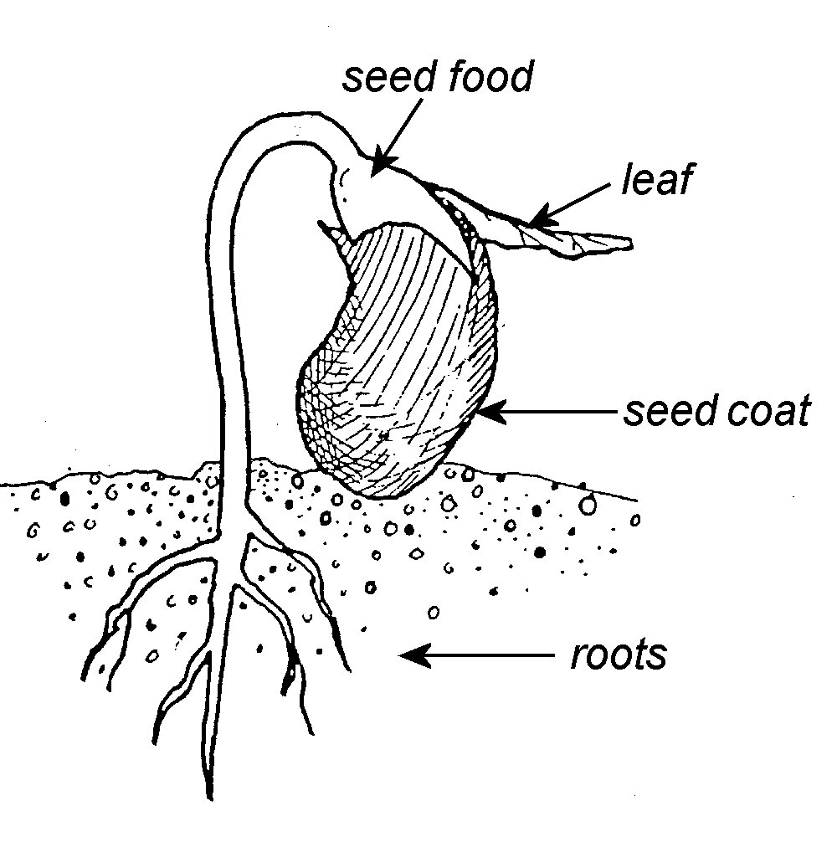

Examples of Fibrous Roots and

Taproots
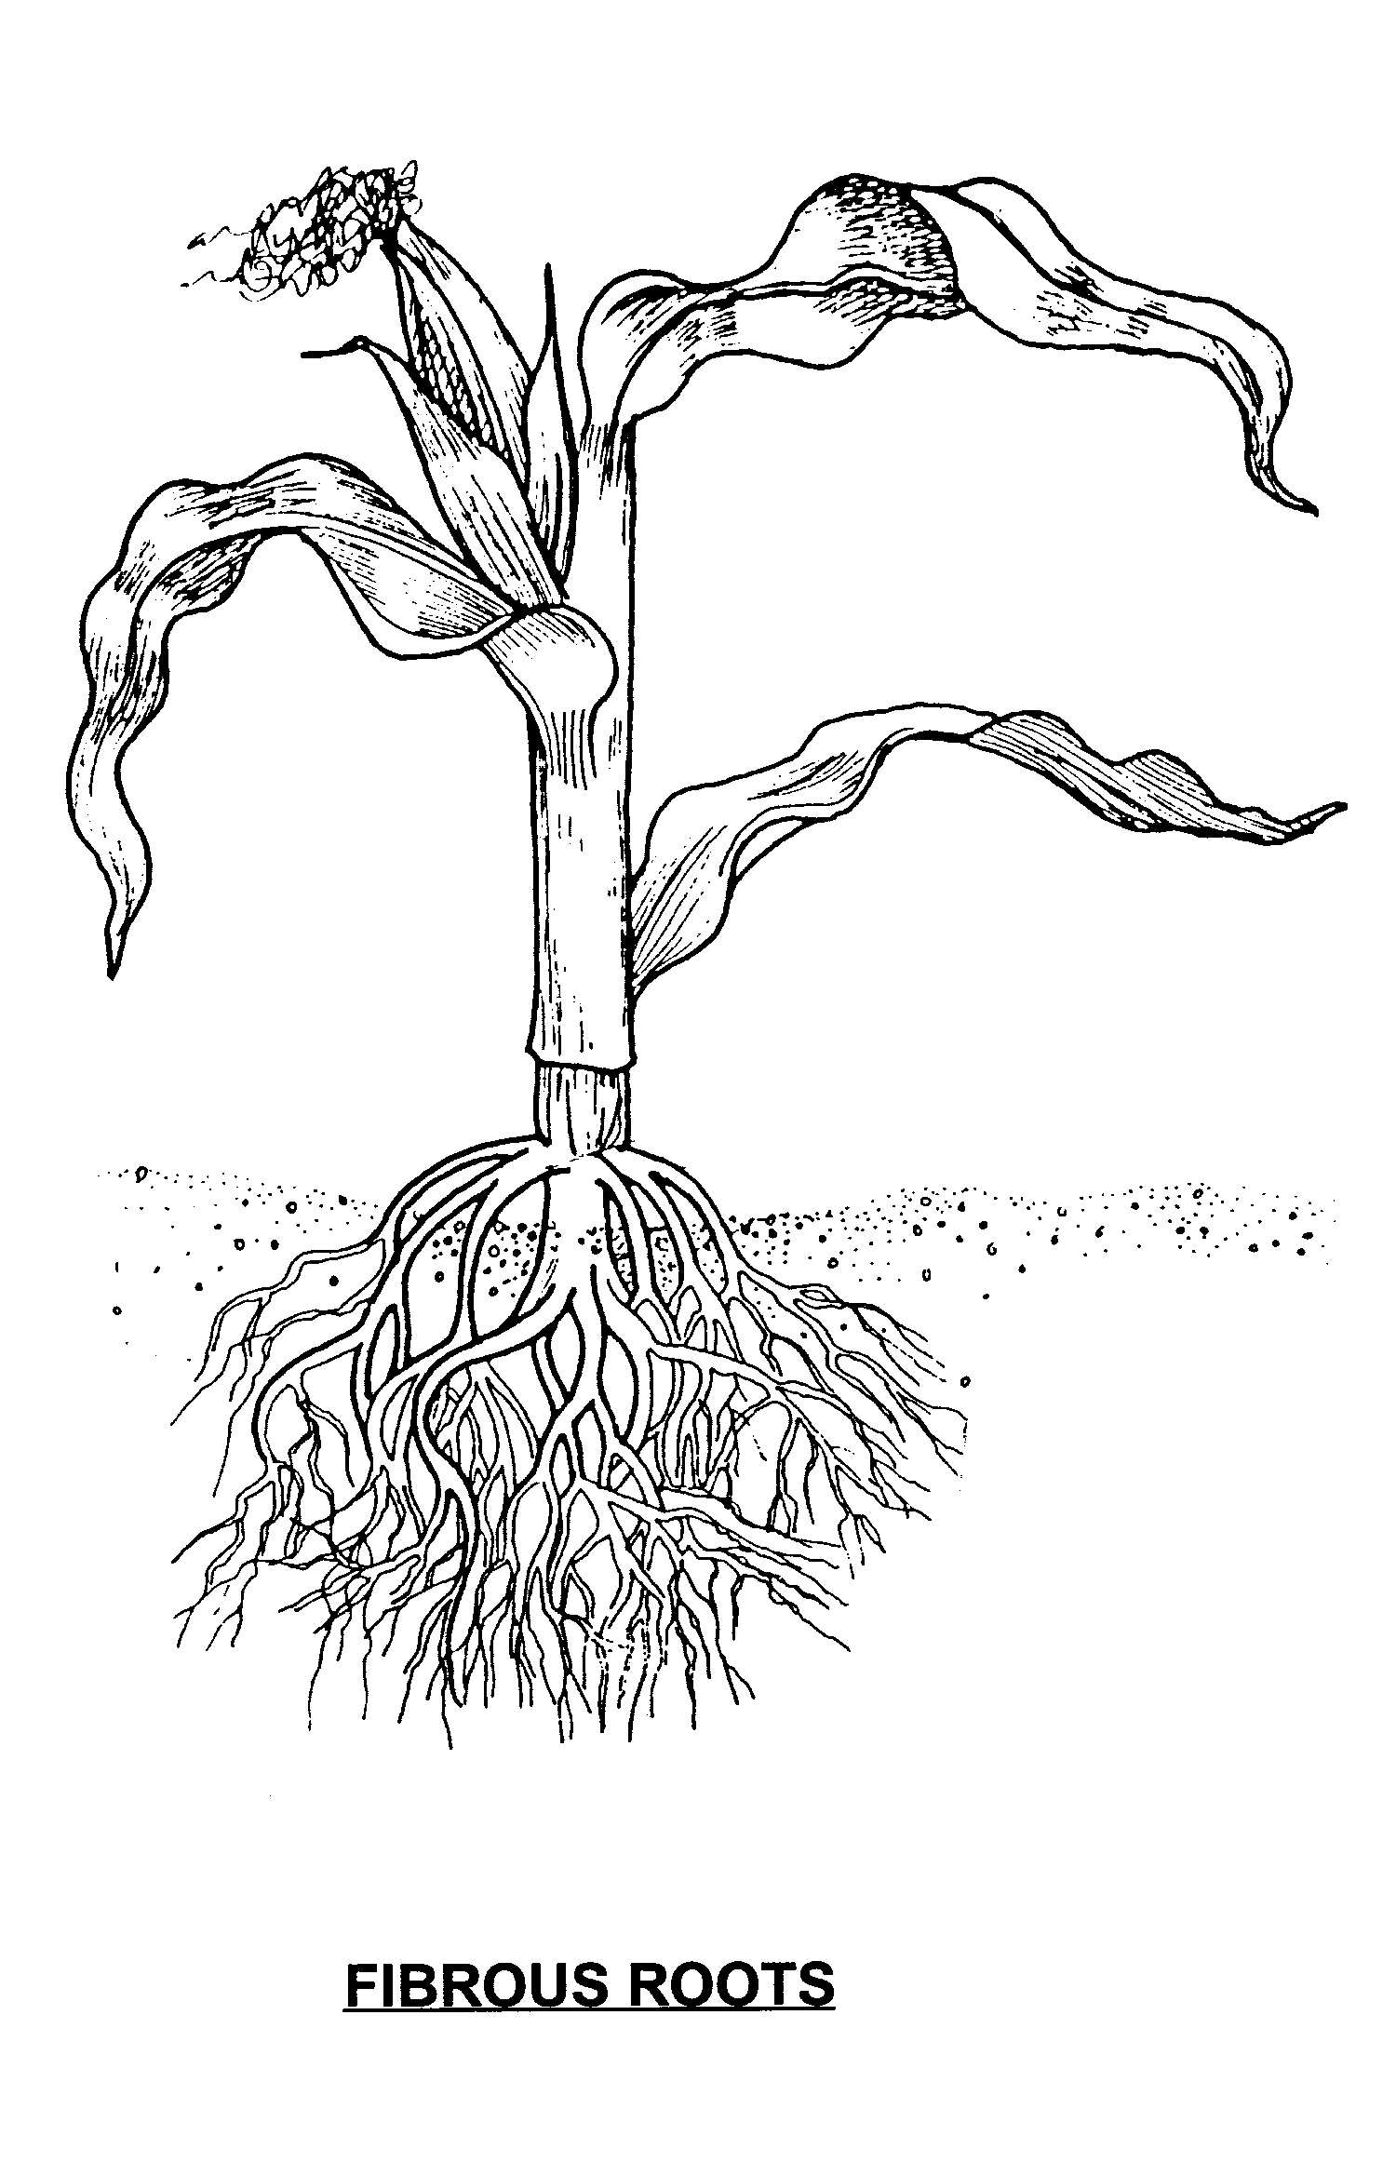

Corn Plant
Dandelion Plant
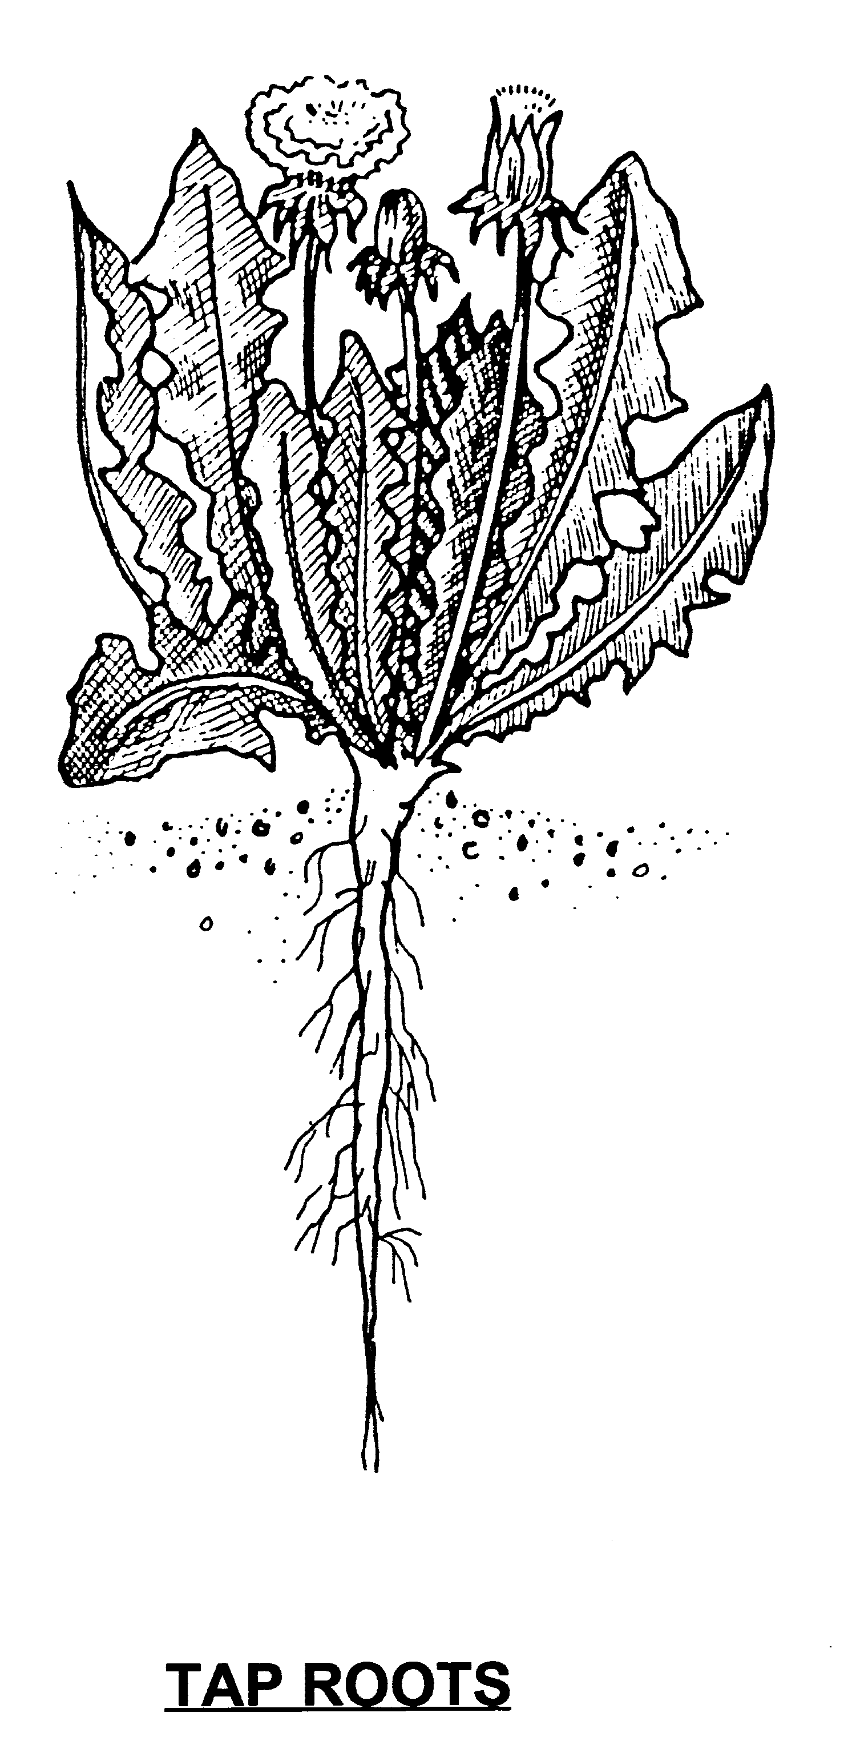

Parts of a bulb
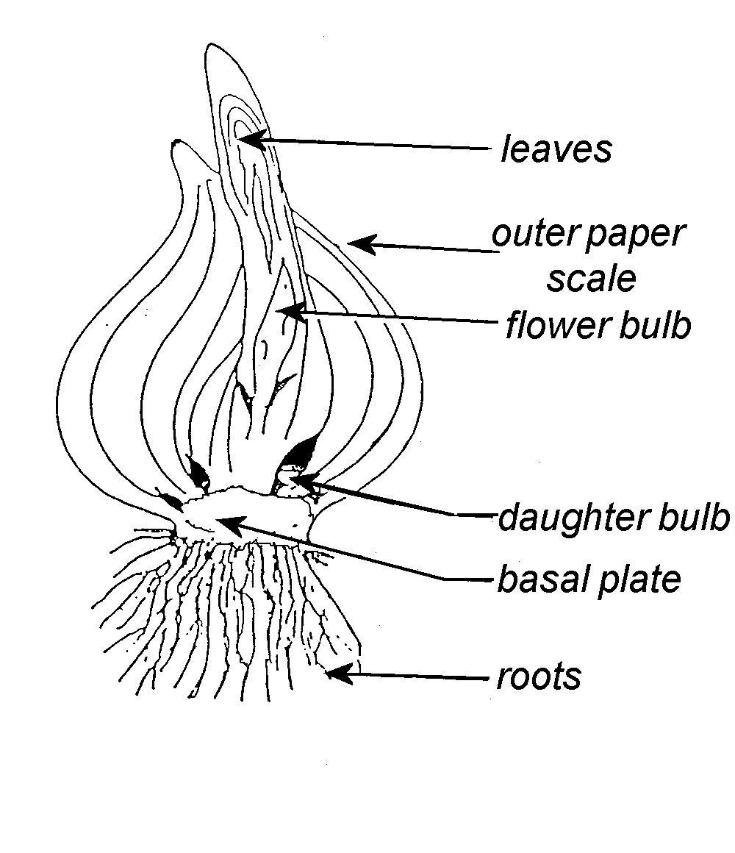

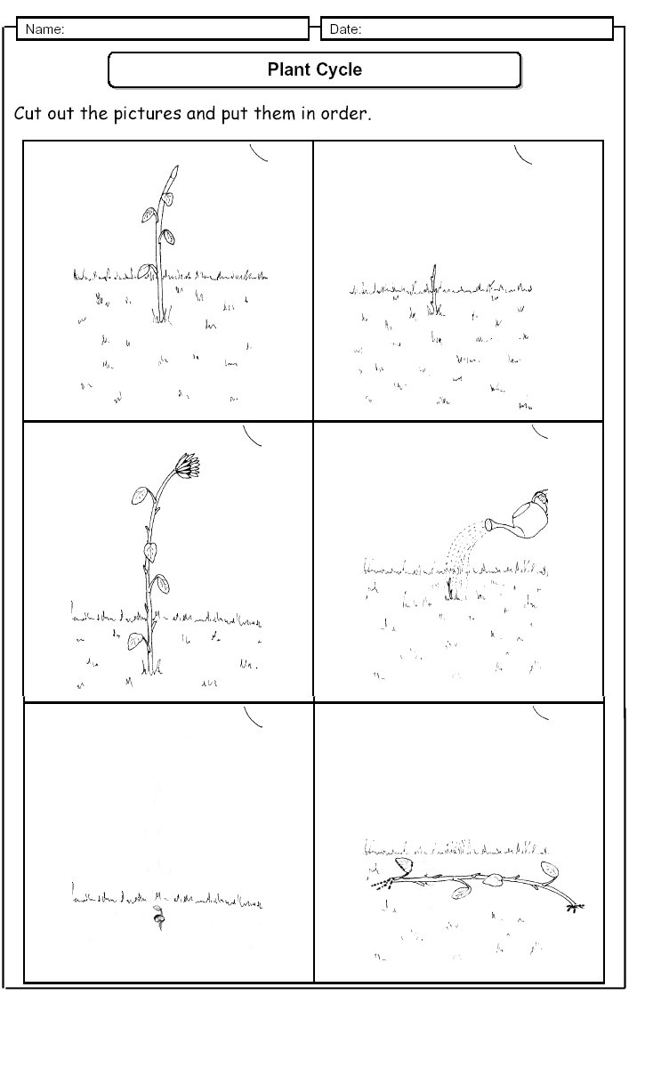

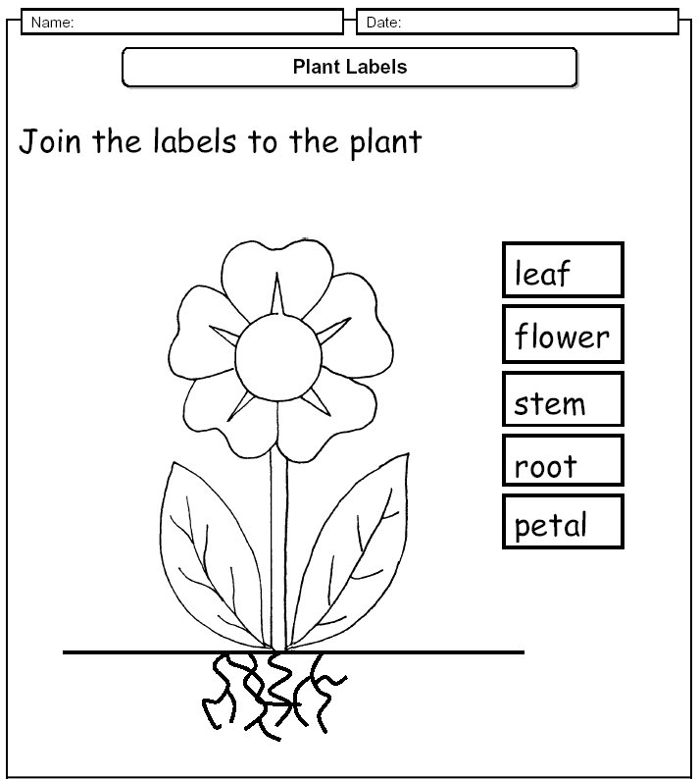
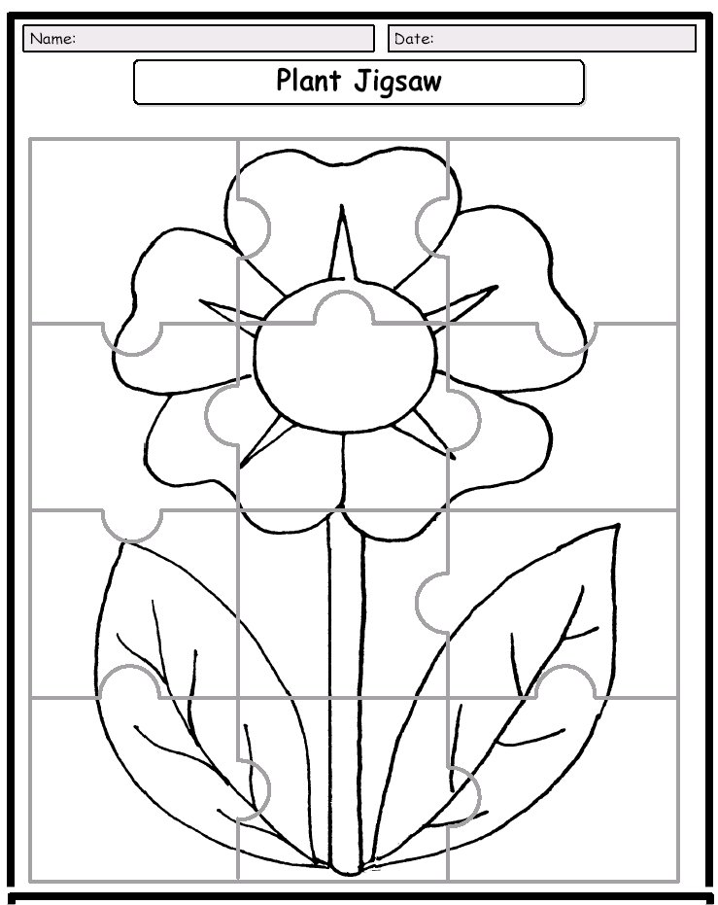

Write a Plant Story

Write a story about the life of a plant. Start your story with a seed. Tell about the plant as it grows. Tell as much as you can about how a plant lives and grows. See if you can use all the words in the word bank.

WORD BANK

seed  leaves, leaf  stem  food | root  rain  flower  water | seedling  decomposer  sun  air
Start here, add more paper if needed.

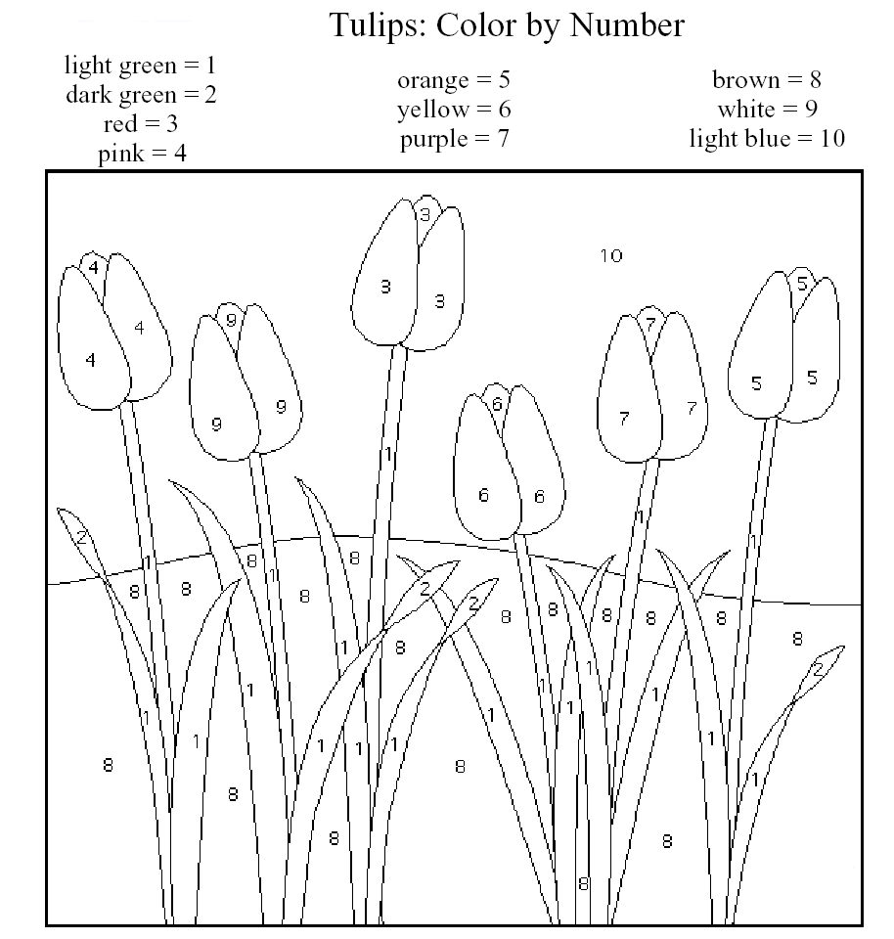
Name: ___________________________

Name: __________________________
