Magnets: Attract or Repel NAME ___________________________

Do you think each set of magnets will attract or repel each other?
Write the word, attract or repel, in the numbered space next to the magnets.
N S
N S
1. 1. __________________

N

S
N

S
2. 2. __________________

3. 3. __________________
S ___
___ N
(First, write in the missing pole letters. Next, tell if the magnets attract or repel.)

4. Write another word that means the same as “repel” 4. __________________

5. Write another word that means the same as “attract”. 5. __________________

6. Write the name of an object that you know is attracted
to a magnet. 6. __________________

7. Magnetism is a force.
Give two words that describe what a force is. 7. __________________
__________________
Write sentences for questions 6 and 7.
6. When do magnets attract each other?

7. When do magnets repel each other?

Puzzle Solving Compass Name_____________________________

Try this puzzle. Use the compass to find the answers. Match the compass direction on the inside of the circle to the letter on the outside. As you find the letters fill in the word blanks. The words tell about something you have been learning about.

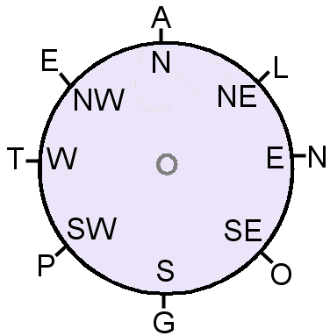
M ___ ___ ___ ___ ___
N S E NW W

S ___ ___ ___ ___
W NW NW NE

___ ___ ___ ___ S
SW SE NE NW

R ___ ___ ___ ___
NW SW NW NE

___ ___ ___ R ___ C ___
N W W N W

Use the words from above to fill in the blanks.

1. This word means to push away. ___________________________
2. This object attracts some metals. ___________________________
3. This is made from metals. ___________________________
5. The North and South parts of a magnet are called this. ______________________
4. This word means to be pulled towards. ___________________________
6. A compass needle will point to the North one of the Earth. ___________________
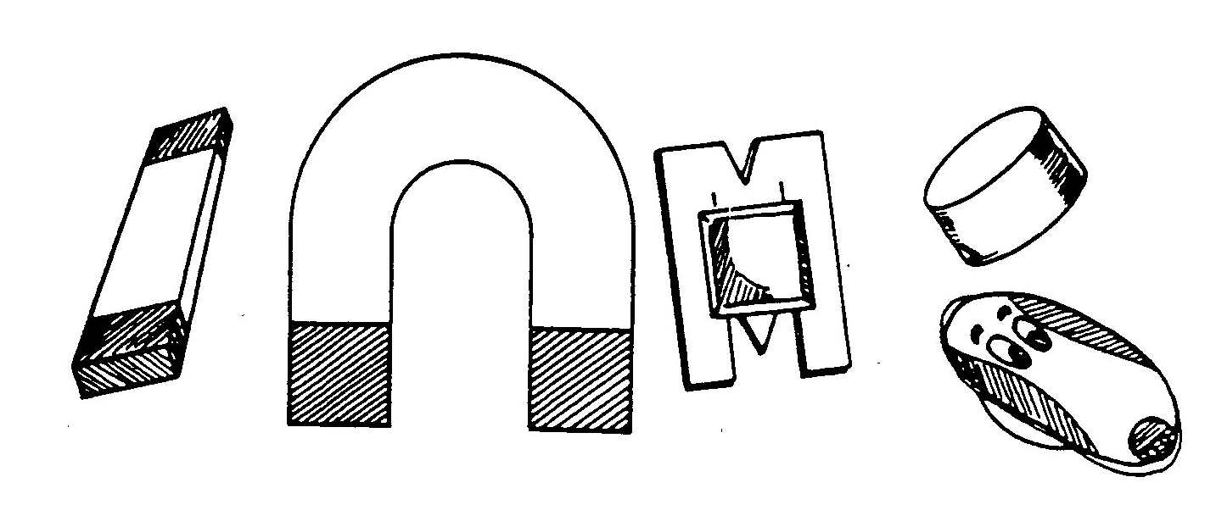
MORE ABOUT MAGNETS NAME _________________________

Fill the spaces for the missing words.
Magnets come in many s i ___ ___ ___ and s h ___ p ____ ____.
Unscramble the words and write them in the boxes – use the clues to help you.

T E H R A

E T L S E

O E P S L

CF E R O
The compass needle will point to the north pole of the _______________.
Magnets will pull objects made of _______________.
Magnets are strongest at the ______________.

A push or pull is a ______________.

