

**. . . are fun!**

**This Journal belongs to . . .**

Revised March 2016

Removed strong magnet, reworked pages

What do you know about magnets?



What would you like to know about magnets?

Activity 1

 **Magnets have properties. Some properties are color, shape, size, texture, and weight.**

**Draw a picture of it.**

The name of my magnet is:

_______________________________________

**What is the color? ______________________**

**What is the shape? _____________________**

**Do you think the magnet is heavy or light? _________________________**

**Write one other word to describe the magnet. _________________________**

**Draw a picture of it.**

**The name of my magnet is:**

**_______________________________________**

**What is the color? ______________________**

**What is the shape? _____________________**

**Do you think the magnet is heavy or light? _________________________**

**Write one other word to describe the magnet. ______________________**

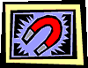

**Pick a magnet that you have not described before.**

**Draw a picture of it:**

###### Write four words that tell the properties of this magnet:

1.

**2.**

**3.**

**4.**

Activity 2

**What kinds of things will a magnet pull?**

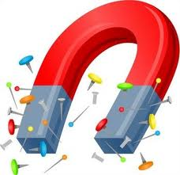

What type of magnet do you have? __________________

Draw a picture of it:

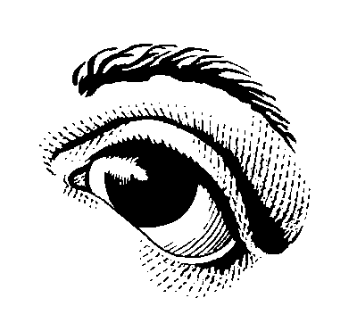

**Look at the objects you are going to be testing. Make a prediction. *Remember there is no such thing as a wrong prediction!**

### Which objects do you think will be pulled by the magnet? ______________________________________________________________________

__________________________________________________________________________________

Which objects do you think will not be pulled by the magnet?



Scientists always do the same test two times. Now test your objects two times. Fill in the chart on the next page.

|  |  |  |
| --- | --- | --- |
| Name of object | Pulled by a magnet | Not pulled by a magnet |
| Plastic spoon |  |  |
| Wooden stick |  |  |
| Paper clip |  |  |
| Iron Nail |  |  |
| Rubber band |  |  |
| Write in an object to test: |  |  |

Did your magnet pull all of these objects? ____________________

Look at the chart above. How are the pulled objects the same?

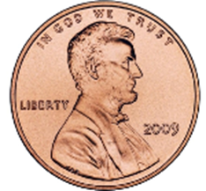

**Now test a copper penny, aluminum nail, and iron nail.**

### Did the magnet pull the copper penny? _____________

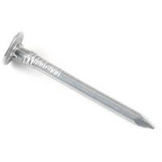

Did the magnet pull the aluminum nail? _____________

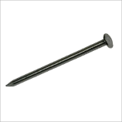

Did the magnet pull the iron nail? _____________

**What kinds of things will a magnet pull? Write a sentence.**

Activity 3 Can you make an object move without touching it?



* **Color and cut out a car.**
* **Tape your car to a large paper clip.**
* **Draw out a “race course” on a sheet of paper.**
* **Tape the paper to a piece of tag board.**

What is one way that you can make the car move without touching it?

###### What is another way that you can make the car move using a magnet?



**How can you use the magnet to move the car? Do not touch the car!**

**Conclusion:**

### How did you use the magnet to move the car? ________________________

Why do you think this happened? _____________________________________

#### Activity 4

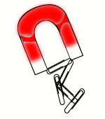

**What materials allow magnets to pull through them?**

### Test your magnet. Does it attract paper clips? _____________________

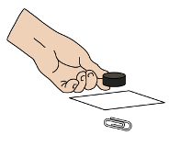

**Now lay a piece of paper on top of the paper clips.**

### Will the magnet attract the paper clips now? _________________

What happened? ____________________________________________________

What materials allow magnets to pull through them? Let’s do an experiment to answer the question. Collect some materials to test. Record your findings in the chart below.

|  |  |  |
| --- | --- | --- |
| **The Magnet pulled through**: | YES | NO |
| **plastic wrap** |  |  |
| **wax paper** |  |  |
| **aluminum foil** |  |  |
| **cardboard** |  |  |
| **thin piece of wood** |  |  |
|  |  |  |
|  |  |  |
|  |  |  |

Place the paper clips in a small amount of water in a cup.

**Predict:**



### Do you think the magnet will attract

### paperclips through water?

Hold the magnet to the side of the cup.

Does it pull the paperclips?

**Conclusion:**

**What can you say about a magnet‘s pulling force through water?**

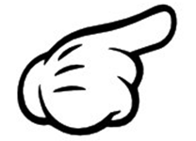

Try attracting the paper clips with different levels of water.

**Each time hold the magnet at the top of the water.**

**Does putting the paperclips in more water make a difference?** Put the paperclips in different amount of water. See if the magnet pulls them.

What happens? ____________________________________________________

**Is it the amount of water or is it the magnet’s pulling force?**

How can we find out?

______________________________________________________________________

What did you find out?

##### Activity 5



**Where is a magnet the strongest?**

Place one paperclip on each picture.



Place bar magnet here.

For this activity you will need to slowly slide the magnet.

1. Slide the bar magnet towards the paperclips.
2. Stop when the magnet pulls the paperclips.
3. Slide the magnet back to where it started.

a. How many paperclips moved with the magnet? __________

b. How many paperclips did not move with the magnet? __________

c. Which part of the magnet did not pull a paperclip? ____________

d. Which part of the magnet was the strongest? ____________

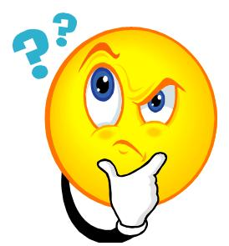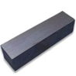

**What do you think?**

**Is there a part of a magnet that has a stonger pull?**

**Explore this using a small bar magnet and a paperclip.**

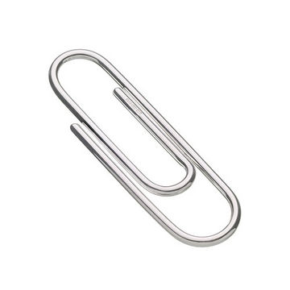

**Draw a picture of your results:**

What do you think? **______________________________________________**

**____________________________________________________________________________________________________________________________________**

**__________________________________________________________________**

**Science Big Idea:**

**The place where the magnet is the strongest is called its poles.**

**A magnet has two poles. There is a north pole and a south pole.**

**Where do you think the poles are on this bar magnet?**

Label the poles. Give one pole an N and the other an S.

Where does the magnet have the strongest pull?

Activity 6

***Where are the poles?***

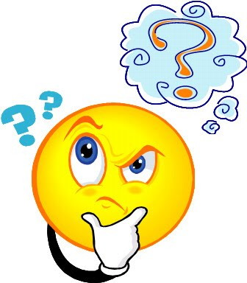

**Group Members: ____________________________________________**

###### How are you going to find the poles of these magnets?

###### __________________________________________________________________

###### ______________________________________________________________________________________________________________________________________________________________________________________________________



### Did your plan work? ___________

### Draw your magnets and label the poles.

Color the magnet where it is the weakest.

#### Activity 7

**What do magnets do to each other?**

Put the poles of two magnets near each other. What happens?

Now turn one of the magnets around and bring them near each other.

### What happens this time? __________________________________________

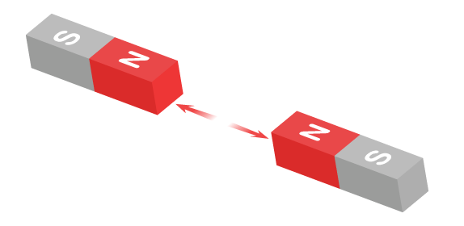

**When the same poles are brought together,**

**they will push away or repel one another.**

**When different poles are brought together,**

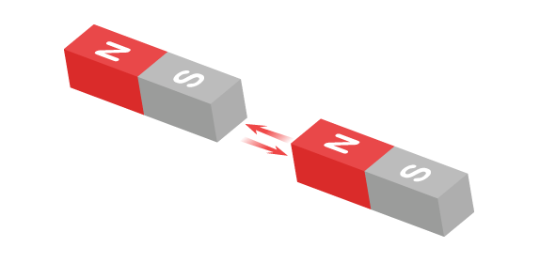

**they will pull toward one another or attract.**

**What is happening in each picture?**

Circle the correct word in the sentence.

**A. B.**

The magnets in  **A**. are **(** **attracting repelling )** one another.

The magnets in **B.** are **( attracting repelling )**  one another.

## Use pictures and words to answer the following questions.

## What is a magnet?

###### What does it do?

Activity 7

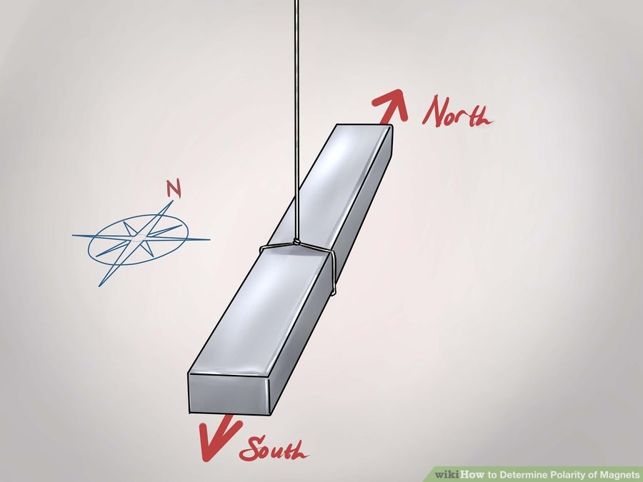

N

S

Look at the hanging magnet, whose poles are marked.

**Bring a second magnet near the N pole of the hanging magnet.**

Did the hanging magnet push away from the mystery magnet or was it attracted to it?

Which pole was brought next to the hanging magnet? (Circle one.)



The North Pole The South Pole

Draw a picture of your experiment:

**When will magnets be attracted to one another? ___________________**

**When will they repel one another? _________________________________**

**Activity 8**

**Do all magnets have the same pull?**



###### Partner’s Name ____________________________

**Draw and label each of the magnets you are using:**

You and your partner are going to find out if all magnets have the same pull.

###### How are you going to figure this out? ______________________________



Draw a picture explaining how you are going to figure out if all magnets have the same pull.

**Predict:**



### Do all magnets have the same pull? _______________________

**Conclusion:**

### Were all the magnets equally strong? ______________________________

Explain your thinking. ______________________________________________

Which magnet was the strongest? _________________________________

Which magnet was the weakest? _________________________________

Was your plan successful? ________________________________________

Why or why not? __________________________________________________

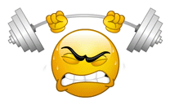

#### Activity 9

***Can we make a magnet?***

###### Do you think you can make a magnet? __________________

Explain your thinking.

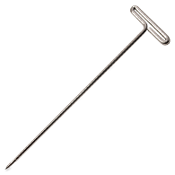

**Rub a T-pin with a magnet about 20 times.**

**Make sure you rub in one direction.**

**Now try to pick up a paper clip with the T-pin.**

Did the T-pin become a magnet? _________________________________

How do you know? _______________________________________________

Do you think the T-pin is as strong as the original magnet?

Now try to magnetize other objects. Record your results.

|  |  |  |
| --- | --- | --- |
| **Became magnetized:** | **YES** | **NO** |
| **nail** |  |  |
| **toothpick** |  |  |
| **paper clip** |  |  |
| **rubber band** |  |  |

Do all materials magnetize? ______________________________________

What kinds of materials can become magnetized? ________________

#### Activity 10

***How can we use magnets?***



###### What did your magnets find in the sand?

_________________________________________________

**Bury the objects deeper in the sand. How deep can you bury them and still find them with the magnet?**

### What does this experiment tell you about the use of a magnet?

Put the paper clip under the bag of “mystery” substance.



What do you think the “mystery” substance is?

_______________________________________________________

How can you use magnets in our everyday world? _________________

What are three different uses of magnets?

___________________ ____________________ ___________________

#### Activity 11

**What is a compass?**

## A compass is a magnet that can be used to find a direction.

### 

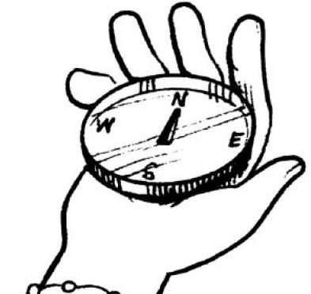

### 

## Stand facing North in the center of the room.

What direction is the window? ______________

What direction is the sink? ________________________

What direction is the chalkboard? _________________

What direction is your teacher’s desk? _____________

### What direction is the door? ________________________

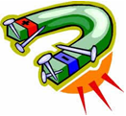

What did you learn about magnets?

What do you still wonder about magnets?

__________________________________________

Draw a picture of your favorite experiment with magnets.