Blackline Masters

Magnets Kit #70

Revised January 2014 OCM BOCES Science Center
Removed Word Search Jan. 2014
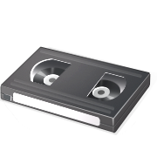
VCRs
Computers
TVs
Credit cards
Recording tapes
CAUTION
DO NOT PLACE MAGNETS NEAR:


NO
MAGNETS
HERE
NO
MAGNETS
HERE
NO
MAGNETS
HERE
NO
MAGNETS
HERE
NO
MAGNETS
HERE
NO
MAGNETS
HERE
NO
MAGNETS
HERE
NO
MAGNETS
HERE

Take Home Activity

Ask an adult in your household when he or she uses magnets. It might help to think about the way things are held in place, picked up, or used.

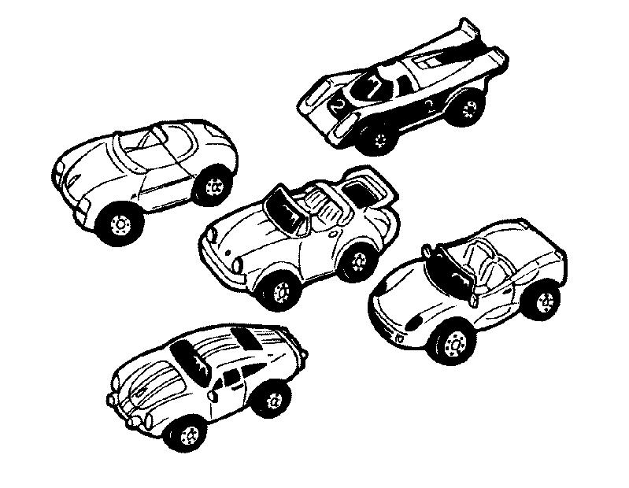Car Pattern



Divide your class into groups. Copy these three problems and give them to each group. Ask them to solve one or more. After a given time, discuss the children’s answers.

1. Chris dropped a whole box of pins on the floor. Two minutes later the pins were back in the box. How did she do it?
2. Paul dropped a pair of scissors in a fish tank. He took them out of the fish tank, but his hands did not get wet. How do you think he did it?
3. Jay said that he could make a paper clip stick to a wooden ruler without using glue or tape. How would he do this trick?

