Butterflies
Kit #8

Blackline
Masters

Revised June 2009
My

B _ _ _ _ _ _ _ _ _ s

Journal

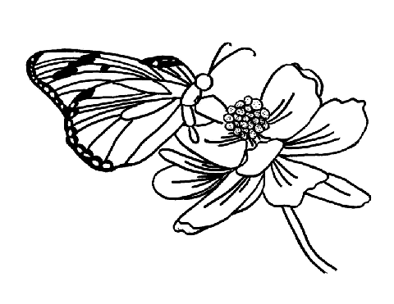
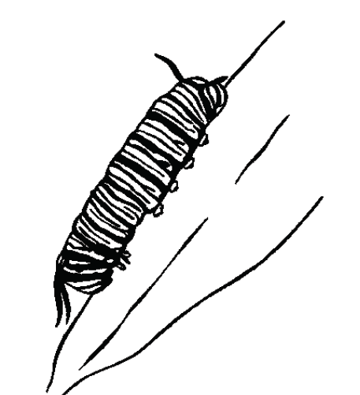
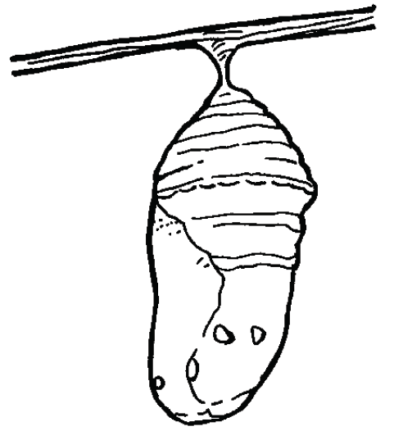

This journal belongs to

____________________________________________________
Butterfly Journal Checklist:

Activity 1 What questions do I have about butterflies?
____ I have listed 4 things I would like to know about butterflies.
____ I have written one fact that I know about butterflies.

Activity 2 How should we care for living things in the classroom?
____ I have made a poster of our class plan for proper treatment of butterflies.

Activity 3 What do butterfly larvae need to live?
____ I have completed the page titled “Draw your caterpillar in its new home?”.

Activity 4 What do butterfly larvae look like?
____ I have completed the page titled “What does your caterpillar look like?”.

Activity 5 How do the caterpillars change their home?
____ I have completed the page titled “What changes are happening?”.

Activity 6 How can changing the surroundings affect the larvae?(optional)
____

Activity 7 What happens to the larvae as they become older?
____ I have completed the page titled “What does your chrysalis look like?”.

Activity 8 How can we build a home for a butterfly?
____ I have completed the page titled “What does the butterfly home look like?”.

Activity 9 What happens to the pupa?
____ I have completed the page titled “Into what does a butterfly chrysalis change?”.

Activity 10 How does a butterfly respond to a stimulus? (optional)
____

Activity 11 What is the next part of the butterfly life cycle?
____ I have completed the page titled “What is the order of the butterfly’s life stages?”.

Activity 12 What are the stages of the life cycle of a butterfly?
____ I have completed the page titled “What is a life span? What is a life cycle?”.

Activity 13 What should be done with the butterflies when the study of them is finished?
____ I have written about some of the problems of releasing an animal into a new environment.

Activity 14 Is it a butterfly or a moth?
____ I have completed the page titled “Venn Diagram: Butterfly and Moth?”.
Draw your caterpillar in its new home. Act. 3
Write a sentence. Tell what your caterpillar needs to live in its new home.

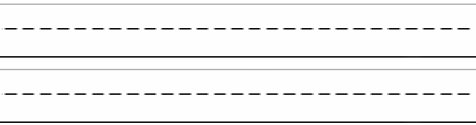
What does your caterpillar look like? Act. 4
Draw a picture of your caterpillar.
Next to the picture write four words that describe your caterpillar.
1
2
3
4
Drawing Describing words

What changes are happening? Act. 4, 5
You are looking into the cup from the top.
Draw a picture of any changes you see inside the caterpillar cup.
Write the date under the picture.

cup
food

Write a sentence that tells about a change in the caterpillar.

What change does the caterpillar make to its home?

What changes are happening? Act. 4, 5
You are looking into the cup from the top.
Draw a picture of any changes you see inside the caterpillar cup.
Write the date under the picture.

How is the caterpillar changing?
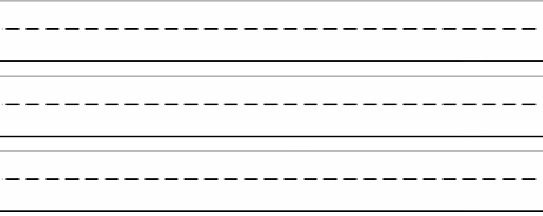

What changes are happening? Act. 4, 5
Draw what you see looking into the caterpillar cup from the side.
Write the date under the picture.
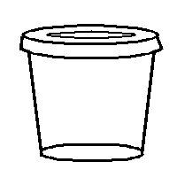

Write a sentence that tells about a change in the caterpillar.

What change does the caterpillar make to its home?

What does your chrysalis look like? Act. 7
Draw a picture of the chrysalis.
Next to the picture write four words that describe the chrysalis.
1
2
3
4
Drawing Describing words

What does the butterfly home look like? Act. 8
Draw a picture of the home.
Drawing Write a sentence that tells why this is a
good home for the chrysalis.

Into what does a butterfly chrysalis change? Act. 9
Draw a picture of the next and last stage of the butterfly’s life, the adult.
What is the order of the butterfly’s life stages? Act. 11

Cut out the pictures and glue them in the boxes in the correct order.
Under each picture write the name of the butterfly’s life stage.

1  _________________ | 2  __________________ | 3  __________________
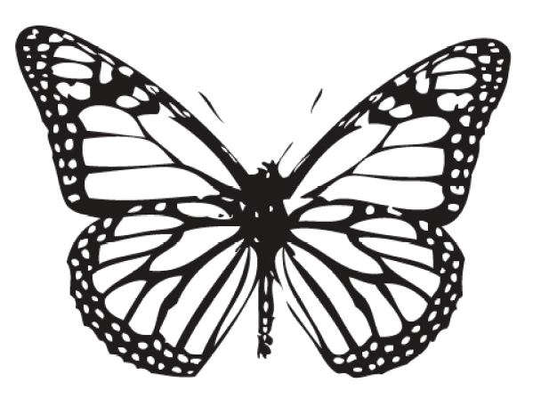

What is a life span? What is a life cycle? Act. 12

A butterfly has a life span. Its life has a beginning and an end. We see butterflies from year to year because all butterflies take part in the life cycle of butterflies. A life cycle is like a circle. It does not have a beginning or an end. It goes round and round. Butterflies lay eggs so that a hatching larva can live, eat and grow into an adult. Next, the new adult lays eggs so that another larva can hatch. It happens over and over again – it is a cycle, a life cycle.
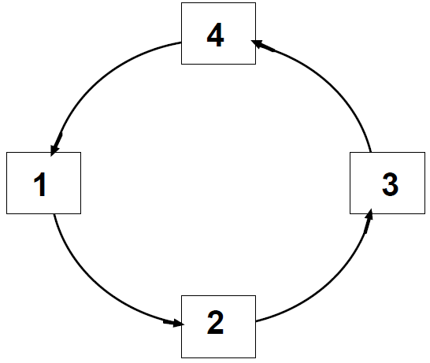
This numbered picture shows a life cycle circle. Cut out the life cycle stages of the butterfly. Glue them onto the life cycle circle. Glue each picture on a number to show the proper order of a butterfly life cycle.

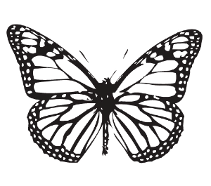
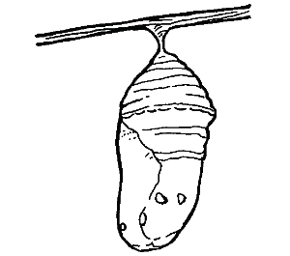
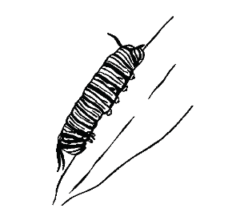
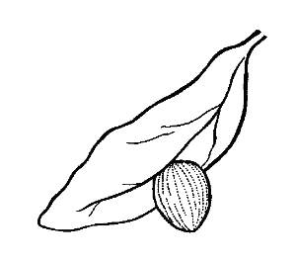

Are a butterfly and moth the same insect? Act. 14
What is an insect? Insects are animals that have hard outer bodies, 3 main body parts, 6 legs,
2 antennae and 2 sets of wings.
Are these insects? ____________
Label the body, legs, antennae and wings that you can see.
Look at the insect drawing below.
Can you see the 3 body parts? Color them yellow.
Can you find the 6 legs? Color them red.
Color the antennae red too.
Color the wings a different color.
Can you find the eyes? Color them black.

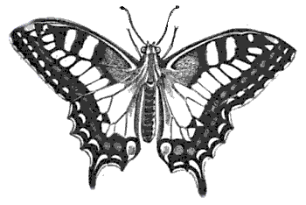

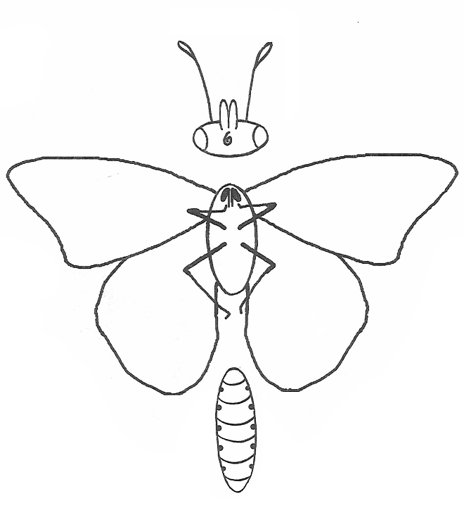

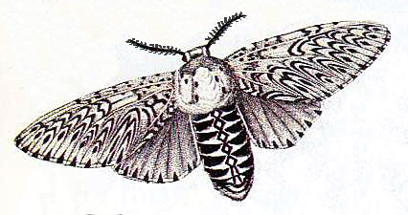

Venn Diagram: Butterfly and Moth – How are they the same and different? Act. 14
butterfly
moth

BUTTERFLY OR MOTH?

Circle the pictures you think are moths, Act. 14
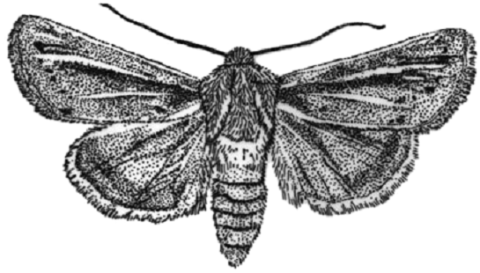
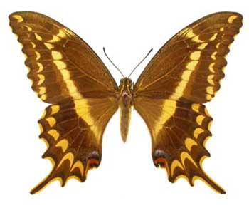
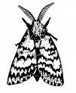
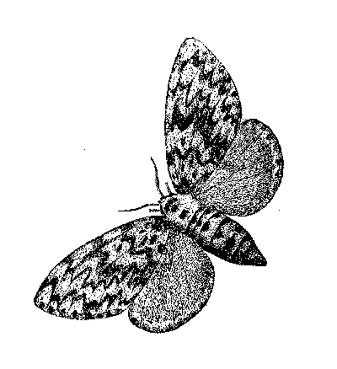
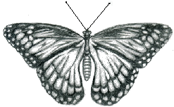
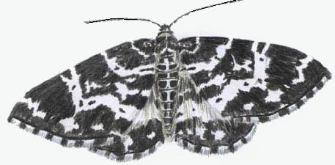
Butterfly or moth?
Sometimes it is hard to tell the difference. You may have to know other facts, like what time of day it is out. This insect is out at night.

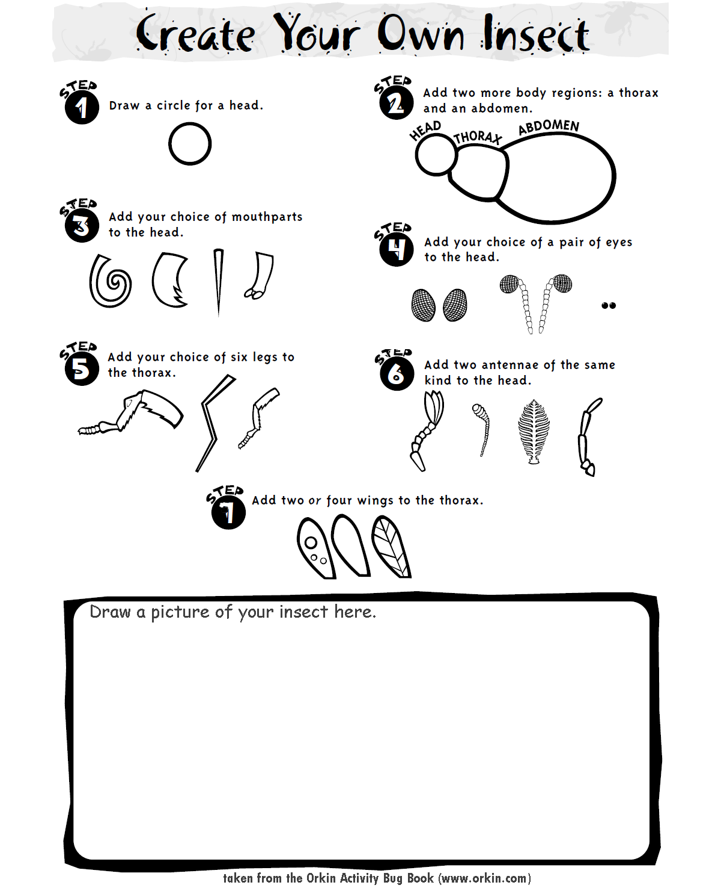

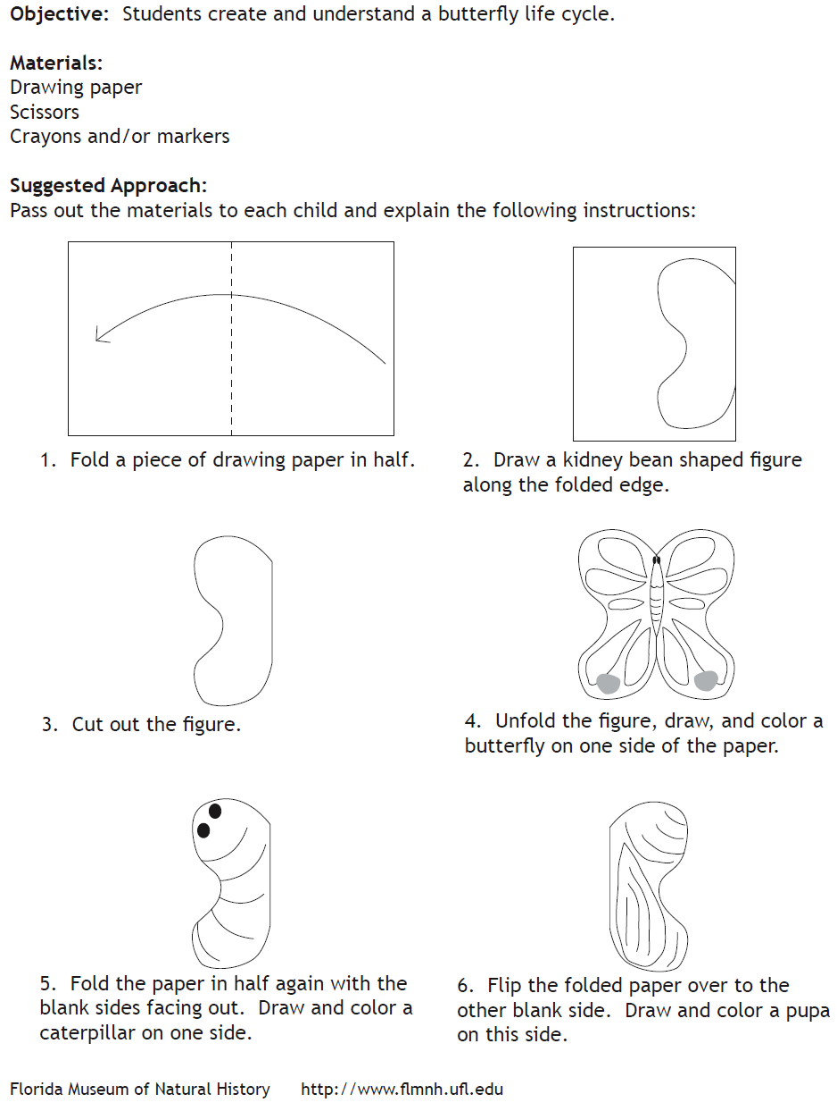
Life Cycle Stages FoldableAct. 12

